Avonbank Mineral Sands Project
Environment Effects Statement

Chapter 18 – Human Health

TABLE OF CONTENTS
18 Human Health 18-1
18.1 Introduction 18-1
18.2 Scope and Methods 18-1
18.2.1 Scope 18-1
18.2.2 Study Area 18-1
18.2.3 Methodology 18-1
18.3 Operational Context 18-5
18.4 Existing Conditions 18-6
18.4.1 Characterisation of Environmental Conditions 18-6
18.4.2 Population Profile 18-6
18.4.3 Health Profile 18-6
18.4.4 Socioeconomic Profile 18-7
18.5 Potential Hazards 18-8
18.5.1 Hazards and Potential Exposure Pathways 18-8
18.5.2 Sensitive Receptors 18-8
18.5.3 Risk Characterisation 18-11
18.6 Avoidance and Mitigation Measures 18-12
18.7 Residual Risks 18-13
18.7.1 Airborne Particles 18-13
18.7.2 Dust Deposition and Metals 18-15
18.7.3 Noise 18-16
18.7.4 Groundwater 18-18
18.7.5 Surface Water 18-18
18.8 Management Framework 18-19
18.8.1 Environmental Objectives 18-19
18.8.2 Monitoring and Management 18-19
18.8.3 Audits 18-19
18.9 Cumulative Impacts 18-19
18.10 Conclusions 18-20

TABLES
Table 18-1: Population profile of the towns Horsham, Cavendish, Dooen and Jung – census 2016 18-6
Table 18-2: Health indicators – Horsham and Victoria 18-7
Table 18-3: Socioeconomic factors – Horsham LGA and Victorian State 18-7
Table 18-4: Potential hazards 18-8
Table 18-5: Sensitive receptors 18-8
Table 18-6: Benchmarks 18-11
Table 18-7: Key avoidance and mitigation measures 18-13

FIGURES
Figure 18-1: Study area 18-4
Figure 18-2: Study area showing haulage route and proposed mining licence (MIN) 18-5
Figure 18-3: Sensitive receptors in and around the proposed development extent 18-9
Figure 18-4: Cavendish Road noise receptors 18-10
Figure 18-5: Dooen Road noise receptors 18-10

Human Health

Introduction
This Chapter provides an overview of the human health risk assessment for the Avonbank Mineral Sands Project (the Project). It has been prepared to address the Environment Effects Statement (EES) Scoping Requirements and is supported by a detailed risk assessment prepared by Tonkin and Taylor Pty Ltd (Tonkin and Taylor) (Appendix M).
The key evaluation objective relevant to this Chapter, as defined in the Scoping Requirements, is to ‘Protect the health and wellbeing of the community, and minimise effects on air quality, noise, visual and social amenity’ (DELWP, 2020). The associated issues and Project Scoping Requirements are detailed in Appendix A of this EES.
This Chapter describes the existing health profile of the local population, the potential risks associated with the Project and details the avoidance and mitigation measures to minimise the residual risks so far as reasonably practicable.

Scope and Methods

Scope
The scope of this Chapter covers the potential hazards identified in the Human Health Risk Assessment (HHRA) (Appendix M) and addresses the relevant Scoping Requirements listed in Appendix A. The risk assessment focused on the mining and mineral processing activities that may affect human health over the life of the Project and considered the Heavy Mineral Concentrate (HMC) haulage route to the Port of Portland (PoP). Project related aspects that are well understood and are considered to be relatively low risk with standard controls in place are addressed in the Project Aspects and Risk Register (Attachment 5).

Study Area
The HHRA focused on activities within the proposed mining licence (MIN), WIM Base Area (WBA) and the haulage route to the PoP. The study area extended to around 4 km from the proposed mining licence and included the settlements of Cavendish, Dooen and Jung, as shown in Figure 18-1 and Figure 18-2. Sensitive receptors that fall within the study area are described in Section 18.5.2.

Methodology
The HHRA characterised the existing conditions, identified potential hazards to human health and assessed the residual risks. The risk assessment conducted by Tonkin and Taylor was informed by the relevant findings from other technical reports prepared for this EES, including:
- Air Quality Impact Assessment (AQIA) (Appendix H).
- Noise and Vibration Impact Assessment (NVIA) (Appendix G).
- Surface Water Impact Assessment (SWIA) (Appendix K).
- Groundwater Impact Assessment (GWIA) (Appendix L).
The tasks undertaken that are relevant to the HHRA are summarised below and detailed in Appendix M, Section 5 and Section 6.

Existing conditions:
- A population profile was developed for Horsham, Cavendish, Dooen and Jung (refer Appendix M, Section 6.2). This comprised:
- An age and gender profile for the study area based on Australian Bureau of Statistics (ABS, 2016) census data.
- A health profile using baseline health statistics for the Horsham area, published by the Western District Public Health Network (PHN).
- A socioeconomic profile based on statistics for the Horsham area, published by the Western District PHN.
- Air quality monitoring was undertaken for a 12-month period between August 2018 to July 2019 for PM₁₀, PM_{2.5}, heavy metal analysis in PM₁₀ and respirable crystalline silica in PM_{2.5}, as outlined in Appendix H, Section 5.
- Baseline ambient and background noise levels were monitored at six representative locations during two separate monitoring rounds in 2020, as outlined in Appendix G, Section 6.2.
- Representative groundwater samples were collected from bores within and surrounding the mining footprint, as outlined in Appendix L, Section 6.
- Representative surface water samples were collected from four surface water locations during the summer and winter months as outlined in Appendix K, Section 7.
- Baseline water samples were taken from three rainwater tanks situated within 2 km of the Project area during March of 2022 (refer Appendix M, Appendix F).
Potential hazards:
- The Project design elements including the mining operations and transportation of HMC, were documented to define the key variables relevant to the detailed HHRA.
- Potential sensitive receptors were identified with consideration to the plausible effects relating to the Project.
- Key potential hazards were identified where source-pathway-receptor linkages were considered plausible.
Residual risks:
- Residual risks were assessed with avoidance and mitigation measures in place in accordance with the:
- enHealth ‘Guidelines for Assessing Human Health Risks from Environmental Hazards’ (enHealth, 2012), enHealth ‘The Health Effects from Environmental Noise’ (enHealth, 2018) and WHO ‘Environmental Noise Guidelines for the European Region’ (WHO, 2018).
- The potential health risk from exposure to environmental pollution was quantified, where possible. This included:
- Considering possible or theoretical community exposures predicted from air dispersion modelling in the AQIA (refer Appendix H) from PM₁₀, PM_{2.5}, metals, respirable crystalline silica, impacts on crops and rainwater tanks.
- Considering possible or theoretical community exposures predicted from noise modelling in the NVIA (refer Appendix G) and applied for the modelling of health indicators to assess residual risk from operational and road traffic noise.
- Adopting conservative safety margins into the risk assessment analysis to ensure protection of public health.
- Information from other supporting studies, including the GWIA (Appendix L) and SWIA (Appendix K), were applied to assess residual risks from groundwater, storage of hazardous chemicals and surface water.
- Measures described in supporting studies were reviewed to identify if further measures were required to avoid and/or minimise impacts to sensitive receptors so far as reasonably practicable.
- A qualitative review was undertaken of the potential for this Project to contribute to potential cumulative risks to human health.
Key assumptions relating to the HHRA are detailed in Appendix M, Section 5.
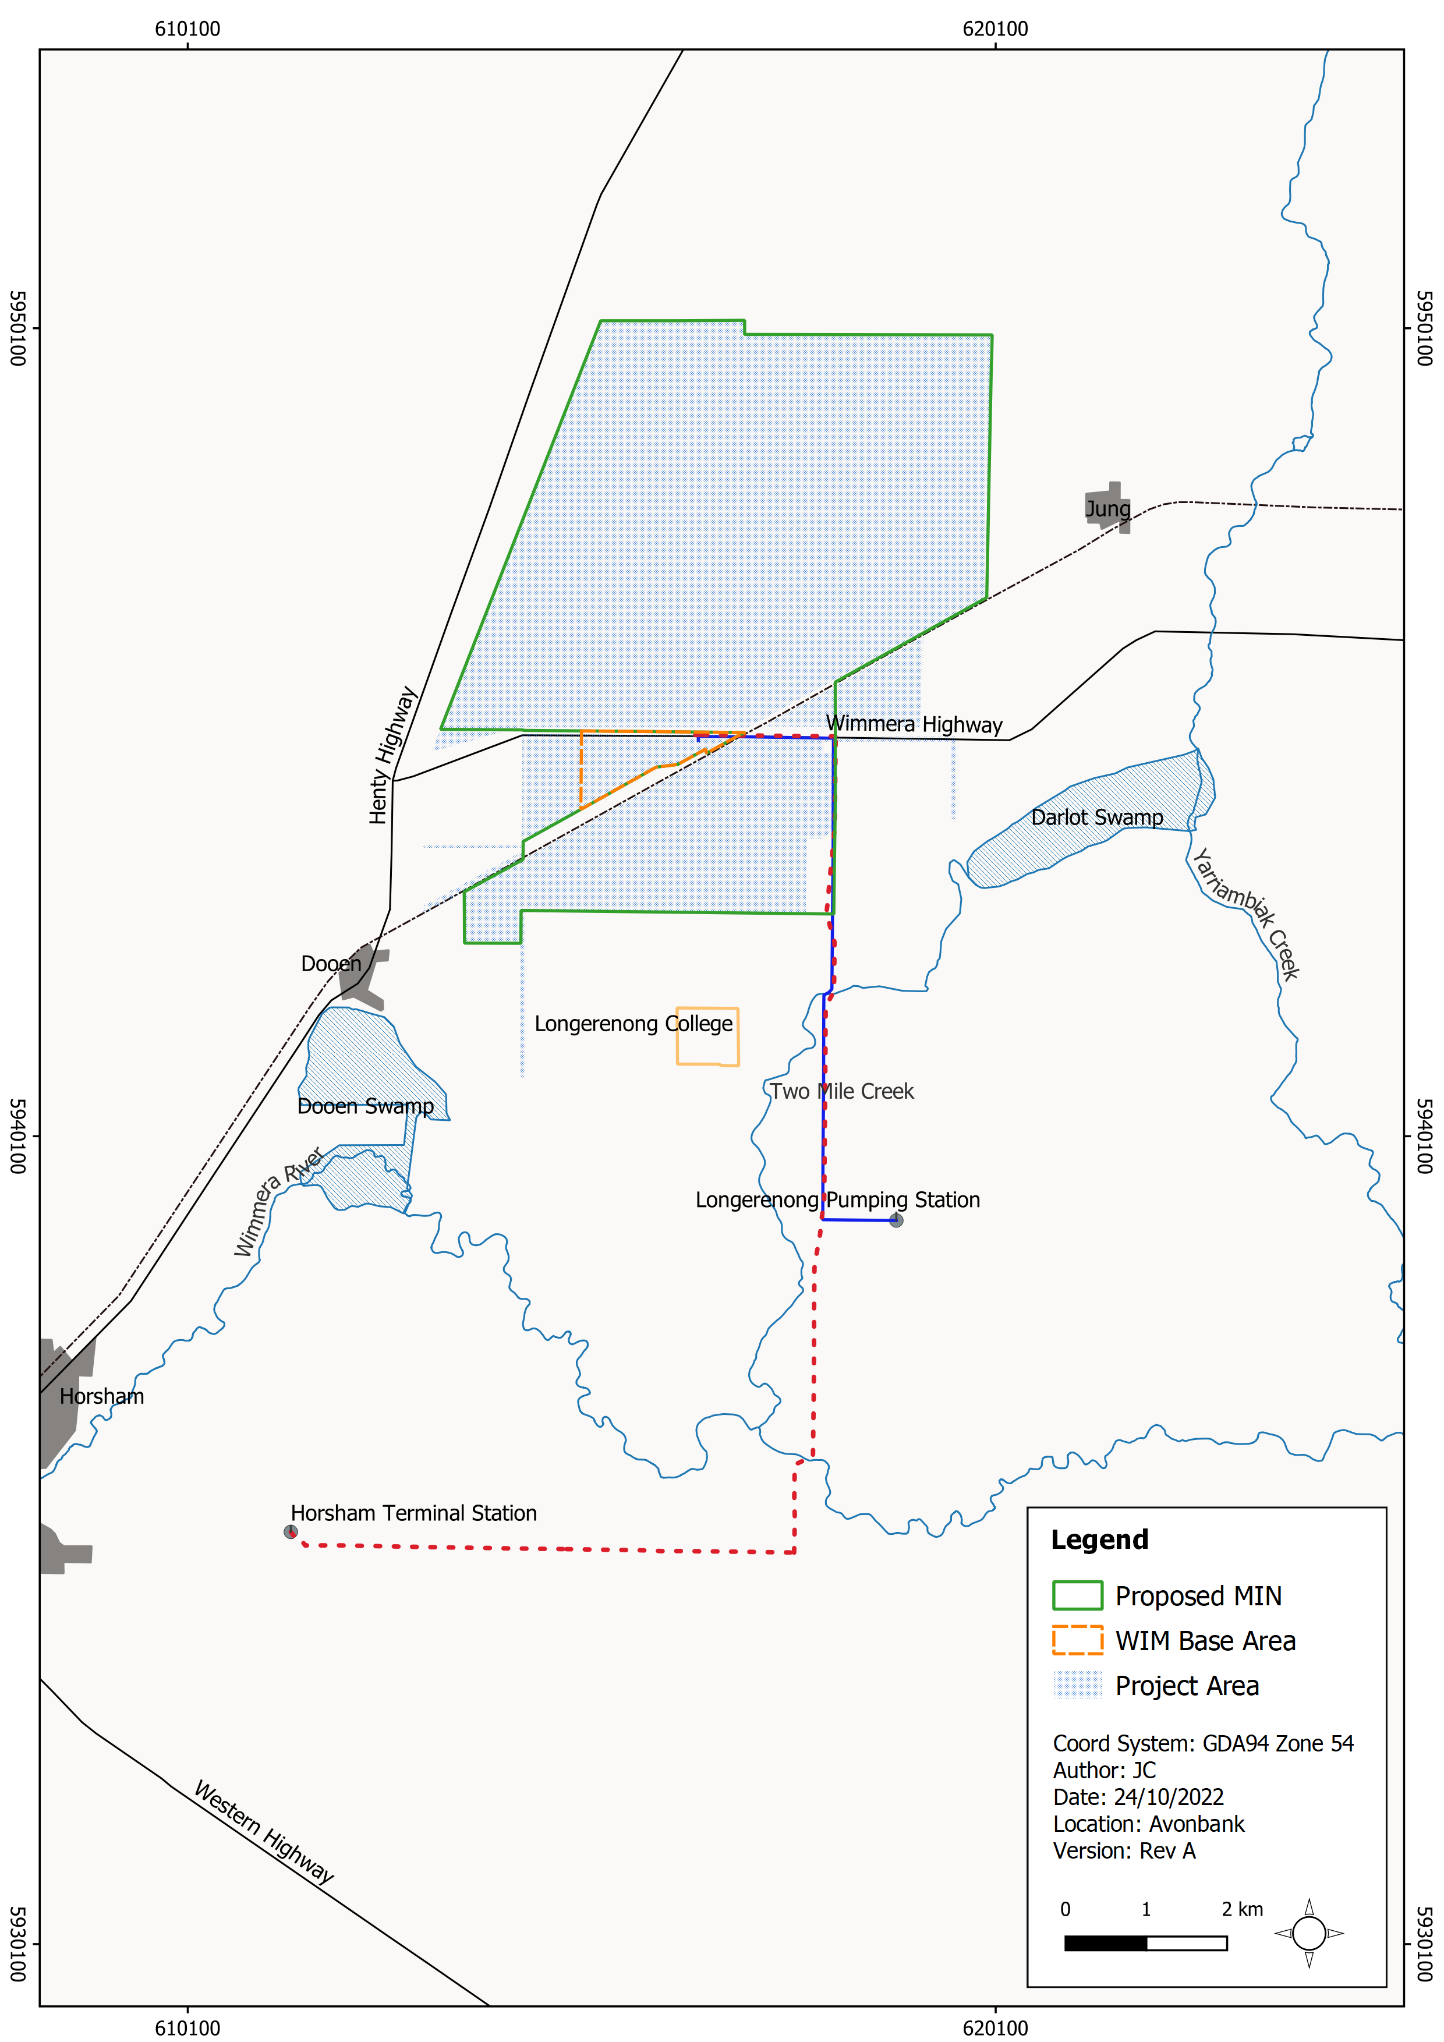
Figure 18-1: Study area
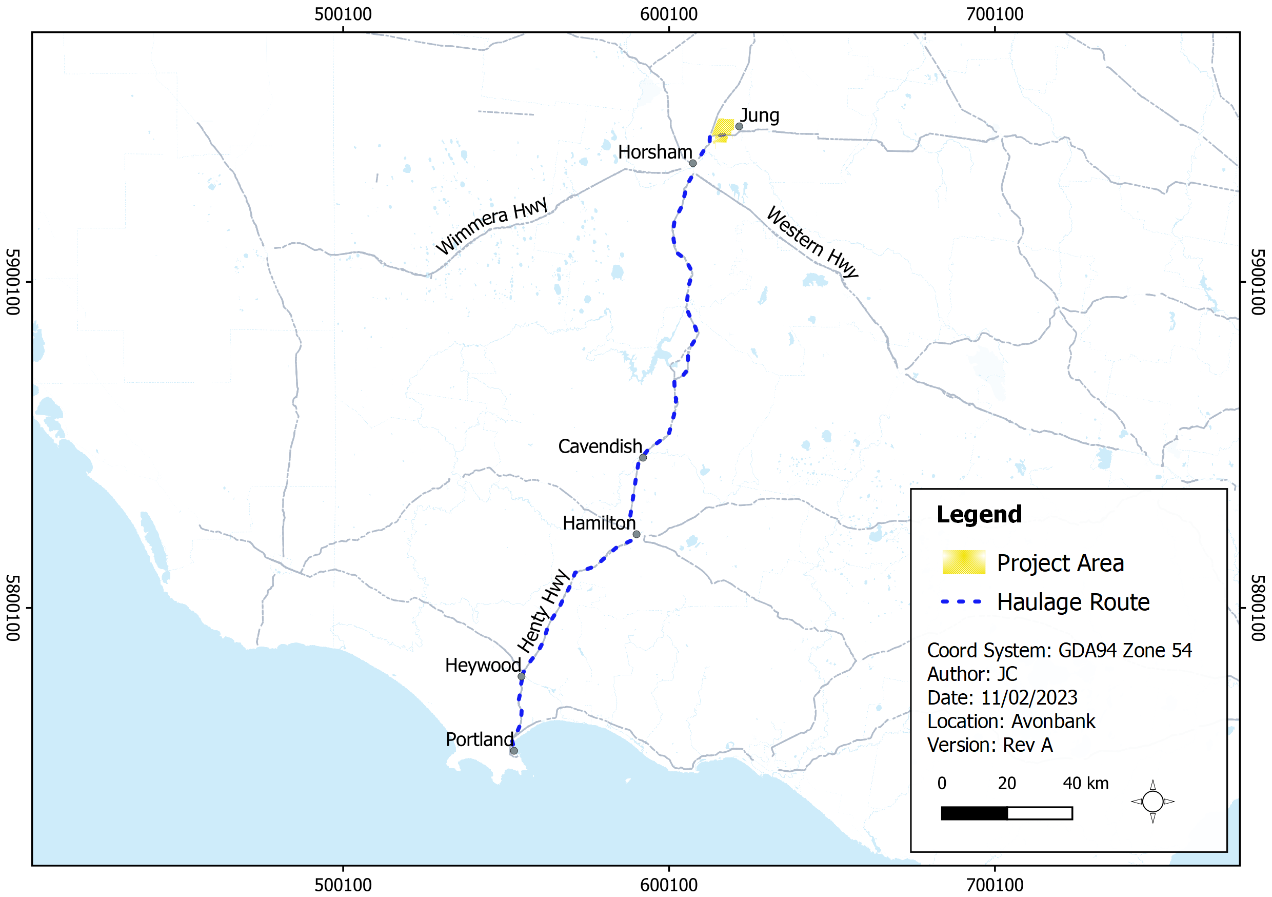
Figure 18-2: Study area showing haulage route and proposed mining licence (MIN)

Operational Context
As described in Chapter 2 (Project Description), construction of the Wet Concentrator Plant (WCP) and preparation for the starter pit will be undertaken in year 1, followed by progressive mining in the southern areas of the mine footprint in year 2 (Block A). Mining operations will move to Block B north of the Wimmera Highway in year 7.
Typically, overburden will be used to progressively backfill the mine void, along with tailings from the WCP. After the void is backfilled and tails have dried sufficiently, subsoil and topsoil will be placed. It is expected that rehabilitation will be completed within 4 years after initial topsoil disturbance in each mining cell.
For the purposes of the AQIA, representative construction and mining scenarios were developed to characterise the activities, equipment used and proximity to sensitive receptors. Scenarios with the worst-case potential air emissions, with avoidance and mitigation measures in place, were modelled.
There was one construction scenario developed that included site preparation for the WCP and earthworks to establish the starter pit and stockpiling of overburden. The operational scenarios included progressive mining and rehabilitation through years 2, 7 and 22. The year 30 scenario includes rehabilitation with no mining activity.
The NVIA considered three construction scenarios which included site preparation for the WCP, earthworks to establish the starter pit and WCP construction and fit-out. The operational scenarios included progressive mining and rehabilitation through years 1, 2, 22 and 26 (refer Chapter 12, Section 12.3). The haulage route scenario includes the haulage of HMC from the Project area to the PoP.
The GWIA considered groundwater modelling that covered the life of mine (30 years) and the postmining groundwater flux. The model assumes that dewatering will be required to access the ore and that tails water will be discharged to the mine void and will infiltrate to the aquifer. This results in a groundwater flux (drawdown and mounding) which is described in Chapter 17 (Groundwater).
The SWIA considered surface water catchment modelling that represented a worst-case operational scenario which included concurrent disturbance areas at year 2 and year 7, as described in Chapter 16 (Surface Water). The Project design included sufficient water holding capacity within the mining void and process water dams, such that there will be no discharge outside the operational areas.

Existing Conditions

Characterisation of Environmental Conditions
The existing environmental conditions are detailed in supporting studies, namely AQIA (refer Appendix H), NVIA (refer Appendix G), GWIA (refer Appendix L) and SWIA (refer Appendix K). Background monitoring was conducted to characterise the baseline conditions of the study area as reported in these respective studies.

Population Profile
Outlined in Table 18-1 is the age of the populations of Horsham, Cavendish and Dooen and Jung compared to the Victorian average.
The age of the population in Horsham, Cavendish and Dooen is higher than the Victorian average. For Dooen, this is driven by a larger percentage of the population in the 15–64 year age group compared to the Victorian average. For Cavendish and Horsham, there is a much higher percentage of people greater than 65 years of age, a cohort that is known to be more vulnerable to the effects of air pollution and noise.
By comparison, the population of Jung is younger than that of the other towns and the Victorian average. This is driven by a much larger percentage of children in the population. Children also fall into a vulnerable group, to the effects of air pollution and noise.
Table 18-1: Population profile of the towns Horsham, Cavendish, Dooen and Jung – census 2016
Data | Horsham | Cavendish | Dooen | Jung | Victoria
Total population | 14,543 | 334 | 240 | 241 | 5,929,624
Female | 52.4% | 48% | 45.7% | 44.8% | 50.9%
Male | 47.6% | 52% | 54.3% | 55.2% | 49.1%
Age group:
0 – 14 years | 18.5% | 17.7% | 15.8% | 25.8% | 18.2%
15 – 64 years | 59.9% | 61.6% | 65.9% | 60.5% | 66.2%
Over 65 | 21.6% | 20.7% | 18.3% | 13.7% | 15.6%
Median age | 41 | 47 | 46 | 32 | 37

Health Profile
The baseline health statistics for the Horsham area were obtained from the ‘Western Victoria Private Health Network’ (PHN, 2021). Table 18-2 summarises the health indicators for the Horsham Local Government Area (LGA) and Victorian State. The health indicators shown in Table 18-2 are those that have been linked with adverse health outcomes arising from exposure to air pollution and noise.
The data shows that the baseline health profiles of people in the Horsham LGA, which includes the towns of Dooen and Jung, are better than the Victorian average. The rates of admissions for respiratory and cardiovascular disease and asthma are lower than those for Victoria as a whole.
Table 18-2: Health indicators – Horsham and Victoria
Health Indicators | Horsham LGA | Victoria State
Cardiovascular – Hypertension
Standardised rate per 1,000 persons – VHISS 2018–2019 | 0.25 | 0.5
Average bed days – VHISS 2018–2019 | 1.86 | 2.49
Cardiovascular – Stroke
Proportion of population diagnosed with stroke (%) – VPHS 2017 | 1.4 | 2.4
Cardiovascular – Disease Indicators
Proportion (%) of adults ever diagnosed with heart disease – VPHS 2017 | 4.3 | 6.7
Avoidable deaths from ischaemic heart disease, persons aged 0–74 years p/100,000 – PHIDU 2013–2017 | 24.5 | 20.2
Respiratory Conditions – Asthma
Standardised rate per 1,000 persons – VHISS 2018–2019 | 1.13 | 1.25
Average bed days – VHISS 2018–2019 | 2.14 | 2.04
Respiratory – Chronic Obstructive Pulmonary Disease (COPD)
Standardised rate per 1,000 persons – VHISS 2018–2019 | 2.94 | 2.42
Average bed days – VHISS 2018–2019 | 4.79 | 5.39

Socioeconomic Profile
Socioeconomic factors for the Horsham LGA and for Victoria are shown in Table 18-3. The baseline socioeconomic statistics were obtained by the Western Victoria Private Health Network (PHN, 2021). Those presented in Table 18-3 have been linked with adverse health outcomes arising from exposure to air pollution and noise.
Low socioeconomic status is a known risk factor that makes the exposed population more vulnerable to the effects of air pollution and noise. This is largely due to the fact that people within these groups usually have poorer health status than people with higher socioeconomic status. They may also have poorer access to medical care.
The key indicator in Table 18-3 is the Socioeconomic Indexes for Areas (SEIFA) index, which is the relative indicator of socioeconomic advantage/disadvantage. The SEIFA index for Horsham LGA is lower than the Victorian average and the unemployment rate is slightly lower.
Table 18-3: Socioeconomic factors – Horsham LGA and Victorian State
Socioeconomic Factors | Socioeconomic Indexes for Areas
 | Horsham LGA | Victoria State
SEIFA Index of Relative Socioeconomic Disadvantage (Index score based on an Australian score of 1000) (PHIDU 2016) | 980 | 1010
Unemployment (%) (PHIDU,2019) | 3.1 | 4.8
Proportion of low-income households (PHIDU, 2016) | 47 | 40.9
People who left school at year ten or below or did not go to school (standardised rate per 100 people aged 15 years and over) (PHIDU, 2016) | 31.7 | 26
Estimated number of people aged 18 years and over who, in the past 12 months, felt that they had experienced discrimination or have been treated unfairly by others (ASR per 100) (PHIDU, 2014) | 17.1 | 17.4

Potential Hazards

Hazards and Potential Exposure Pathways
Potential hazards were identified in the HHRA with consideration to the Project activities and the location of sensitive receptors (refer Appendix M, Section 5.4). Where an exposure pathway was considered plausible, a risk assessment was undertaken as part of the HHRA. The potential hazards are listed in Table 18-4 and are described in Section 18.7.
Table 18-4: Potential hazards
Item | Potential Hazards | Phase
IP-01 | Inhalation of airborne particles from mining activities and truck movements resulting in potential hazards to human health. | C, O
IP-02 | Consumption of deposited dust on crops, pasture and in rainwater tanks resulting in potential hazards from metals to human health. | C, O
IP-03 | Noise from Project activities and related traffic resulting in potential hazards to human health. | C, O
IP-04 | Changes to groundwater from mining activities resulting in potential hazards to human health during recreational activities or stock water use. | C, O, D
IP-05 | Changes to surface water from mining activities resulting in potential hazards to human health during recreational activities. | C, O
Risks relating to chemical and waste management are addressed in the Waste and Emissions Impact Assessment (WEIA) (Appendix Q).

Sensitive Receptors
The HHRA considered the relevant sensitive receptors identified in the supporting impact assessments for air quality, noise, groundwater and surface water, as described in Table 18-5 and shown in Figure 18-3, Figure 18-4 and Figure 18-5.

Table 18-5: Sensitive receptors
Impact Assessment | Sensitive Receptors
Air quality  (Chapter 13) | The AQIA identified sensitive receptors within the air quality study area that may be impacted by air emissions from the Project. The study area was taken to extend approximately 4 km from the source activities (refer Figure 18-3).
Noise and vibration (Chapter 12) | Residential receptors that may be impacted by noise from the mining operations (Figure 18-3) or road traffic noise from the transport of the HMC through Cavendish and Dooen (Figure 18-3, Figure 18-4 and Figure 18-5). These receptors are representative of the closest and/ or potentially most affected ‘noise sensitive areas’ as defined in the Environmental Protection Regulations 2021 or ‘environmental value’ as defined in the Environment Reference Standard (ERS) (EPA, 2021).
Groundwater  (Chapter 17) | Includes users of groundwater for consumption and other uses such as recreation. Two groundwater bores were identified in the GWIA as being licensed for domestic uses and stock watering and could be potentially impacted by mining operations (Figure 18-3). The assessment of groundwater risk focused on users of groundwater for recreational purposes (via extraction and/or discharge to surface water bodies).
Surface water  (Chapter 16) | The main surface water bodies in the Project area including the Wimmera River, Dooen Swamp, Darlot Swamp, Two Mile Creek and Yarriambiack Creek (Figure 18-3).  The assessment of surface water risk focussed on users of surface water for recreational purposes.
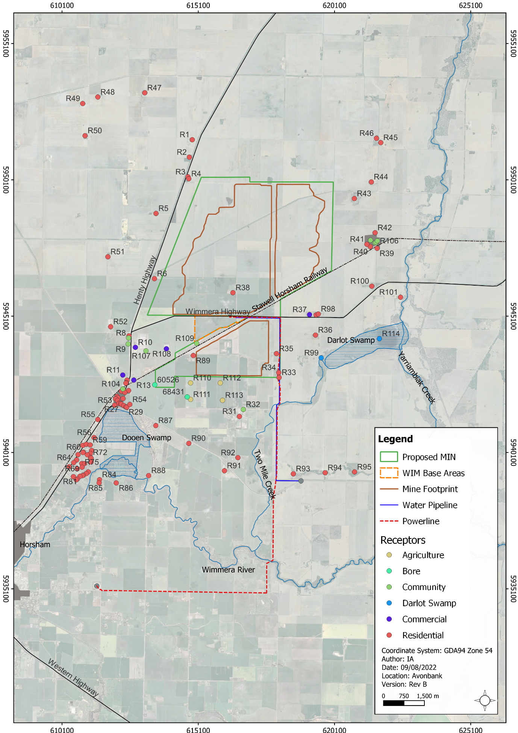
Figure 18-3: Sensitive receptors in and around the proposed development extent
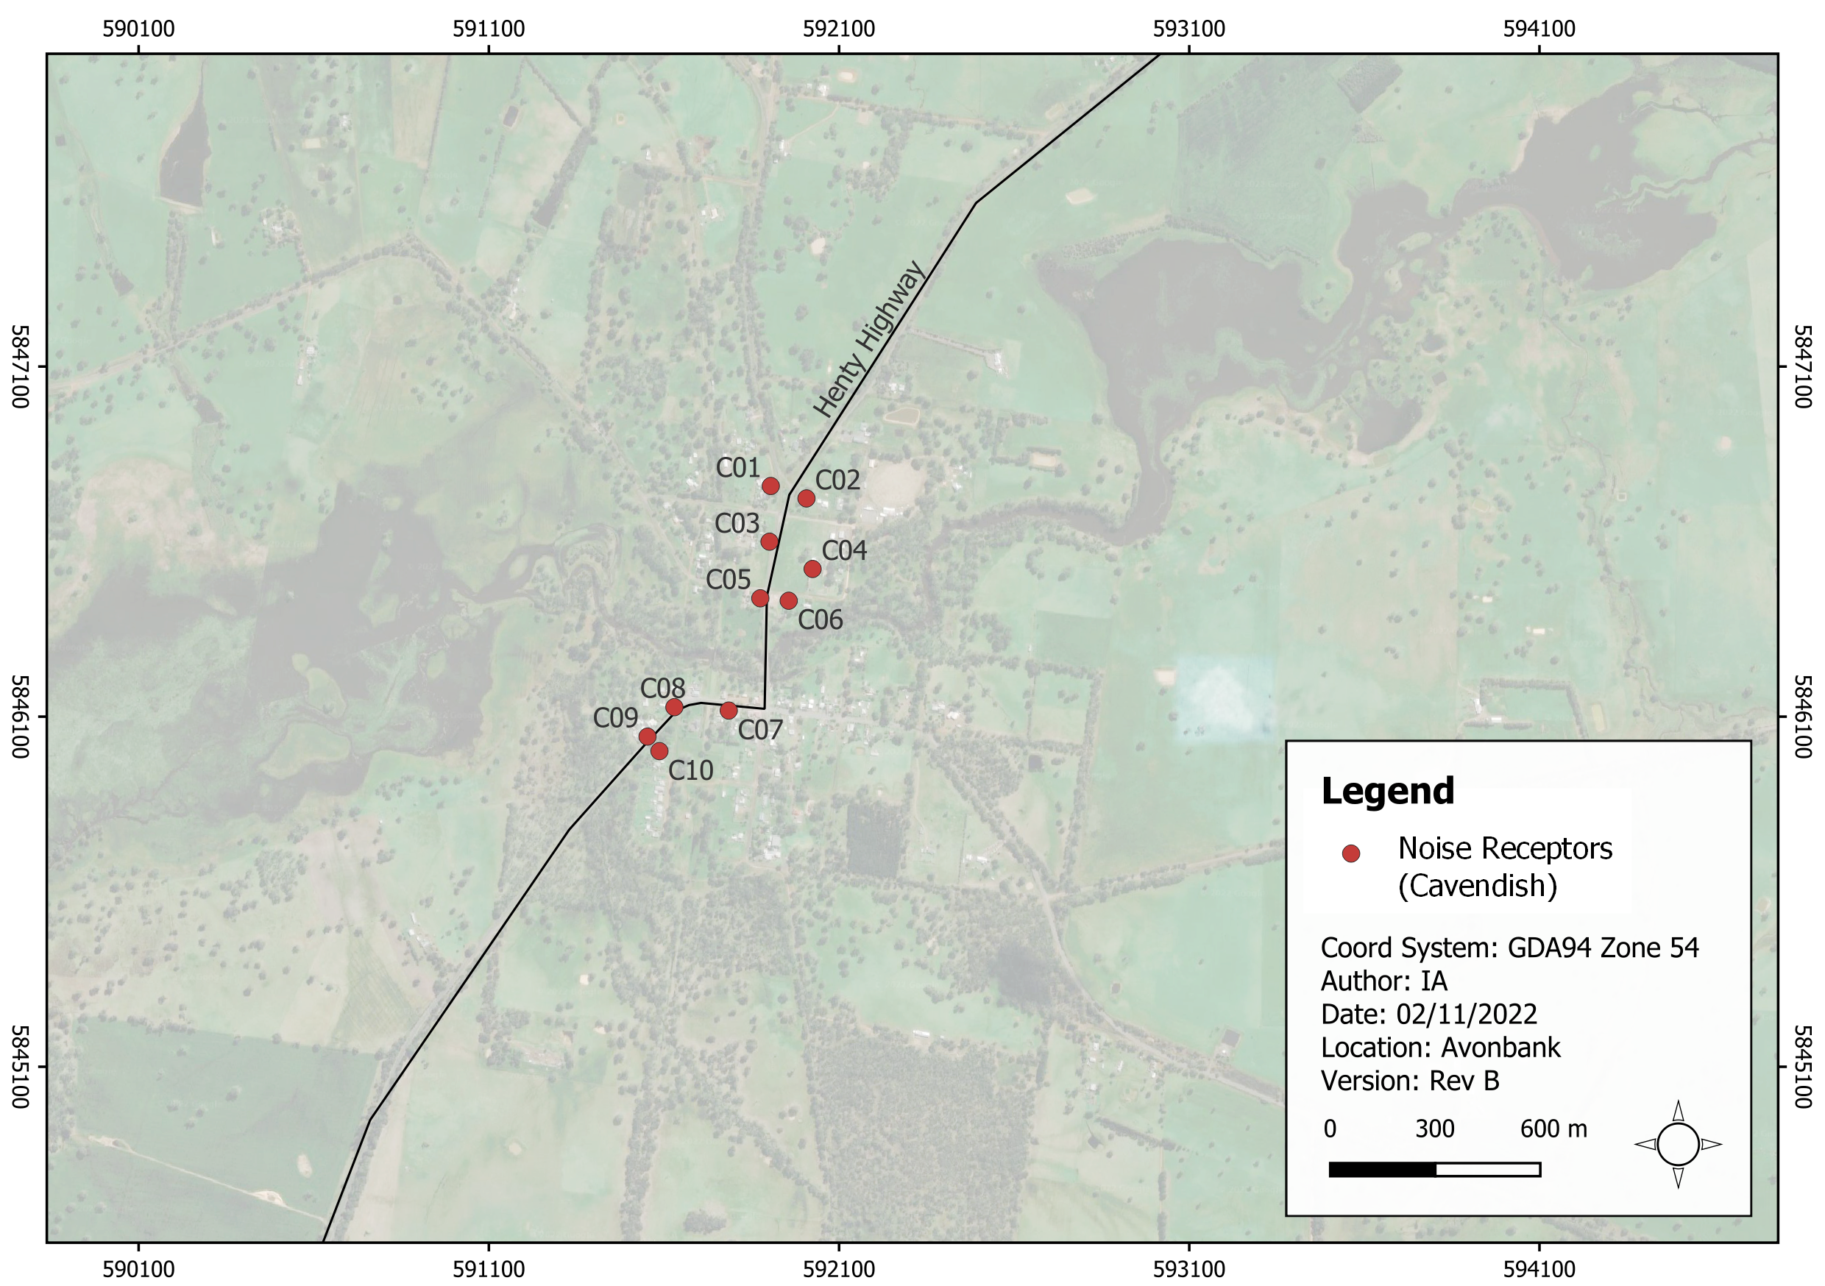
Figure 18-4: Cavendish Road noise receptors
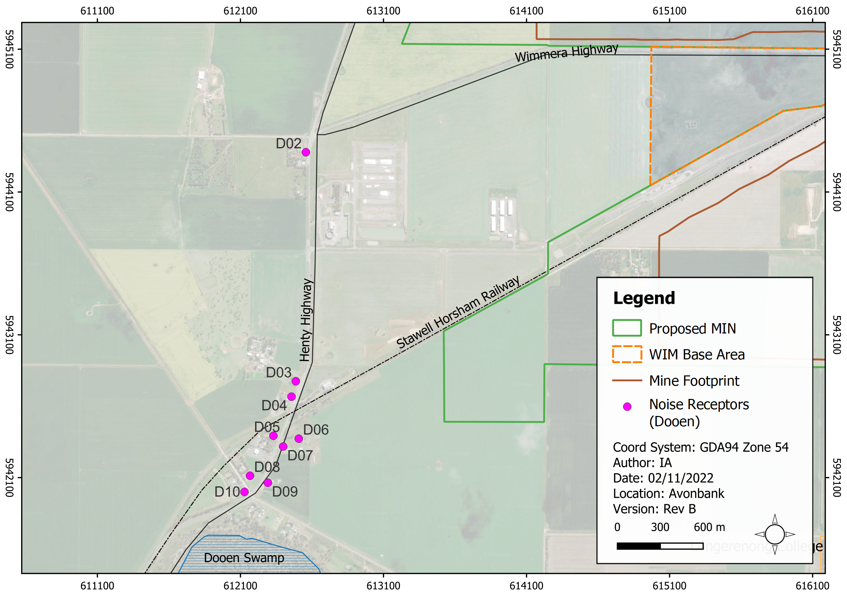
Figure 18-5: Dooen Road noise receptors

Risk Characterisation
The characterisation of human health risks relied on data from other supporting studies undertaken for the Project, as described in Section 18.2.3. Human health exposure pathways and risks to human health through effects on air quality, crops, rainwater tanks, noise, and to the quality of groundwater and surface water are assessed in Section 18.7 of this Chapter.
In characterising risks and hazards to the health of the local community from noise and air quality, the enHealth human health risk assessment guidelines (enHealth, 2012) were applied, wherever relevant to do so.
Conservative benchmarks were built into the risk assessment analysis to ensure protection of public health. Consideration of the most vulnerable subgroups within the population formed part of the risk characterisation process.
The principle guidelines used in the HHRA to characterise the risks to human health are listed in Table 18-6.
Table 18-6: Benchmarks
Reference | Commentary
Guidelines for Assessing Human Health Risks from Environmental Hazards (enHealth, 2012) | Presents a general environmental health risk assessment methodology applicable to a range of health hazards.  This guidance was applied to assess the potential risks to the health of the local community from noise and air quality arising from Project activities.  The guideline explains that the aim of the risk assessment is to determine whether the exposure exceeds an appropriate risk-based guideline value. This is expressed as a hazard quotient (HQ). HQ = predicted noise level/health-based guideline.  This methodology has been applied in Sections 18.7.1 and Section 18.7.3 in Appendix M, Sections 7 and 10.
enHealth Health Effects from Environmental Noise (enHealth, 2018). | Provides noise thresholds to protect against sleep disturbance and cardiovascular impacts. These have been used to assess the residual risk from the construction and mining operations.  The guidance recommends the following noise limits to protect the public from sleep disturbance and cardiovascular disease arising from exposure to environmental noise:  During the night-time, an evidence based limit of 55 dBA at the facade of the building using the Leq, night, or similar metric and an 8-hour night-time period is recommended.  During the daytime, an evidence based limit of 60 dBA outside measured using the Leq, day, or similar metric and a 16-hour daytime period is recommended.  These benchmarks have been applied in Section 18.7.3 and in Appendix M, Section 10.3.
WHO Environmental Noise Guidelines for European Region (WHO, 2018) | The WHO Guidelines have been used to assess the potential impact on sleep disturbance and cardiovascular disease from road traffic. This assessment was conducted for the townships of Cavendish and Dooen.  For road traffic noise, the WHO recommend two guidelines to protect against adverse health effects and sleep disturbance. These guidelines are based on the annual average Lden and Lnight indicators and are:  Lden 53 dB.  Lnight 45 dB.  The overall relative risk of ischaemic heart disease was 1.24 (95% CI: 1.08–1.42) per 10 dB Lden increase in road traffic noise levels.  WHO also identified a quantitative relationship between road traffic noise and mortality from ischaemic heart disease with a residual risk of 1.05 (95% CI: 0.97–1.13) per 10 dB Lden increase in noise levels.  These benchmarks have been applied in Section 18.7.3 and in Appendix M, Section 10.3.
EPA Guideline for the Assessment and Minimisation of Air Pollution in Victoria (EPA, 2022) (The Guideline) | This document provides technical guidance and a framework for assessing and controlling risks associated with air pollution. The Guideline also includes guidance on how to conduct risk assessments for air quality in Victoria.  The approach in this document differs depending on the type of pollutant. For air toxics and other non-criteria pollutants, the use of hazard indices for threshold pollutants and incremental lifetime cancer risk (ILCR) estimates is recommended. This approach was adopted for the assessment of the health effects of the metals and respirable crystalline silica.  For criteria pollutants, including PM₁₀ and PM_{2.5}, a multiple lines of evidence approach is recommended, including:  The total predicted number of exceedances of the relevant criteria.  Whether exceedances were attributable to background pollution or were associated with the emissions from the proposed/current activity.  Incremental contribution to ground level concentrations. Where the incremental concentration is less than 4% of the criteria, no further assessment of risk was undertaken.  These benchmarks have been applied in Sections 18.7.1 and in Appendix M, Sections 7.
Air Toxics Hot Spots Risk Assessment Guidelines in (Californian Environment Protection Agency Office of Environmental Health Hazard Assessment) (OEHHA, 2015) | The guidelines provide a methodology to assess the impacts of dust deposition on crops and the potential risk through the consumption of crops/vegetables. This methodology was applied to assess the potential risk from the deposition of metals from the mining operations on the crop areas and farming properties on crops and private vegetable gardens.  The OEHHA guideline for respirable crystalline silica is 3 μg/m³ as an annual average.  For the carcinogenic metals – arsenic, beryllium, cadmium, chromium VI, cobalt, lead and nickel – the OEHHA unit risk factors have been used to calculate the incremental lifetime cancer risk from the Project.  These benchmarks have been applied in Sections 18.7.2 and in Appendix M, Sections 8.
National Environment Protection (Assessment of Site Contamination) Measure (NEPM) (NEPC, 1999) | This document provides Health Investigation Levels (HILs) for soil for residential properties. The assessment of risks from metal deposition onto soils were compared to the thresholds in this document.  These benchmarks have been applied in Section 18.7.2 and in Appendix M, Section 8.
Australian Drinking Water Guidelines (ADWG, 2021) (National Health and Medical Research Council (NHMRC) | In the assessment of consumption of metals in tank drinking water, concentrations have been compared to the ADWG for each of the metals to determine the residual risk. The ADWG establish two types of guidelines for chemical contaminants – health-based guidelines and aesthetic guidelines.  These benchmarks have been applied in Section 18.7.2 and are listed in Appendix M, Table 9.3.
Food Standards Australia and New Zealand (FSANZ, 2022) | In the assessment of metal deposition onto crops, the calculated levels have been compared with Maximum Residue Levels (MRLs) for food established by FSANZ.  These benchmarks have been applied in Section 18.7.2 and in Appendix M, Section 8.
National Environment Protection (Ambient Air Quality) Measure (NEPM)(NEPC, 1998) | The NEPM provides the Ambient Air Quality criteria thresholds. The criteria that have been used are the Ambient Air Quality NEPM criteria (PM₁₀ 24 hour 50 μg/m³ and annual average 25 μg/m³, PM_{2.5} 24 hour 25 μg/m³ and annual average 8 μg/m³).  These benchmarks have been applied in Section 18.7.2 and in Appendix M, Section 7.
In addition to the benchmarks described above, the relative significance of each residual risk was summarised in the HHRA on a scale ranging from negligible through to severe. These are detailed in Appendix M, Section 5.

Avoidance and Mitigation Measures
This Section outlines the measures identified to avoid and minimise potential hazards so far as reasonably practicable. The HHRA assumes implementation of the avoidance and mitigation measures associated with each environmental discipline, as documented in each relevant impact assessment report. Table 18-7 provides a cross-reference to the key avoidance and mitigation measures for each environmental discipline. Further context is provided in each of the relevant Chapters.
It is noted that in line with the requirements of the environmental management system (EMS) described in Chapter 24, the Environment Protection Act 2017 and the Mineral Resources (Sustainable Development) Act 1990, additional measures may be required during implementation to ensure the risks have been minimised so far as reasonably practicable.

Table 18-7: Key avoidance and mitigation measures
Environmental Discipline | Reference to Key Avoidance and Mitigation Measures Relevant to Human Health Risk
Air Quality  (Appendix H) | Chapter 13, Section 13.6.  Total area disturbed to be minimised (AQ-02), roads and open areas watered (AQ-04), activities to be scheduled to high wind conditions (AQ-06), and Air Quality Management Plan to be developed and implemented (AQ-08).
Noise and vibration  (Appendix G) | Chapter 12, Section 12.6.  Fleet type (NV-01), haulage route (NV-02), construction noise level management (NV-03), earthen bunds and stockpiles (NV-04), noise abatement on equipment (NV-05), Noise and Vibration Management Plan (NV-06), and Traffic Management Plan (NV-07).
Groundwater  (Appendix L) | Chapter 17, Section 17.6.  Tailings Strategy (GW-02), tails placement (GW-03), groundwater bore network (GW-04), contaminated sites investigations (GW-06), chemical storage and management (GW-07), Groundwater Management Plan (GW-08), PASS Management Plan (GW-09), Waste Management Plan (GW-10), and Rehabilitation Plan (GW-11).
Surface water  (Appendix K) | Chapter 16, Section 16.6.  Mine Planning and site drainage (SW-04), Surface Water Management Plan (SW-06), and Rehabilitation Plan (SW-07).

Residual Risks
This Section describes the likely residual risks to human health with avoidance and mitigation measures in place. The residual risks have been characterised as described in Section 18.5.3.

Airborne Particles
There is one potential hazard (IP-01) identified in Section 18.5.1 that relates to the residual risk to human health from airborne particles. As a result of mining, processing and transport operations, there is a potential for the public to be exposed to off-site dispersal of airborne dust through inhalation. These risks are discussed in the sections below.

Inhalation of PM₁₀ and PM_{2.5}
There is one potential air quality exposure pathway that relates to the inhalation of PM₁₀ and PM_{2.5} that could result in a potential risk to human health.
The results of epidemiological studies have shown that a wide range of health effects can be associated with long-term exposure to particulate matter, including PM₁₀ and PM_{2.5}. Several international studies have shown strong associations between long-term exposure to particulate matter and increases in mortality.
The AQIA (Appendix H) modelled the annual average and 24-hour average PM₁₀ and PM_{2.5} concentrations. The annual average concentrations were used to calculate the long-term health risks, and the daily 24-hour averages were used to calculate the short-term risks.
Using the predicted annual average and 24-hour average PM₁₀ and PM_{2.5} concentrations, the populations at Jung and Dooen were assessed to determine the attributable health effects. The predicted number of attributable cases due to PM₁₀ from construction and mining operations, in both Jung and Dooen, for all scenarios were considered to be low.
For Jung, the highest risk from long-term exposure to PM₁₀ from mining operations (annual average concentration) was low (0.01 attributable cases). The highest long-term risk predicted for Dooen was also low (0.004 attributable cases).
As indicated by the HHRA results presented in Appendix M, Section 7.1, the residual risk to the local populations in Jung and Dooen from PM₁₀ was very low and would not be detected in the population.
The predicted number of attributable cases due to PM_{2.5} from construction and mining operations associated with the Project in both Jung and Dooen, were low for all scenarios.
For Jung, the highest risk from long-term exposures in year 22, attributable to PM_{2.5} from the mining operations was low (0.004 attributable cases). The highest long-term risk predicted for Dooen was in year 7 (0.0008 attributable cases). The residual risks to the local populations in Jung and Dooen from PM_{2.5} were assessed to be very low, would not be detected in the population and were considered to represent a negligible residual risk.
The HHRA report considered that no further management measures in addition to those listed in Table 18-7 and detailed in Chapter 13 are likely to be required.

Inhalation of respirable crystalline silica
There is one potential air quality exposure pathway that relates to the inhalation of respirable crystalline silica that could result in a potential risk to human health.
Respirable crystalline silica can bioaccumulate in the lungs and cause disease in the respiratory system. Large bioaccumulated loads of respirable crystalline silica in the lungs can cause a build-up of connective tissue, termed silicosis, a specific form of pneumoconiosis. Respirable crystalline silica was classified by the International Agency for Research into Cancer (IARC) as a category 1A carcinogen, as it has been shown to cause cancer in humans.
The modelling, as documented in the AQIA (refer Appendix H), was undertaken using the conservative assumption that the predicted PM_{2.5} concentrations were 100% respirable crystalline silica. This will lead to an overestimation of the risk posed by the increase in respirable crystalline silica. For the assessment of health risks where there is a known threshold for effect, the predicted annual average respirable crystalline silica concentration were compared to the health-based guideline values.
The health-based guidelines adopted were from the Californian EPA Office of Health Hazard Assessment (OEHHA, 2015). The OEHHA ‘Air Toxics Hot Spots Risk Assessment Guidelines’ is 3 μg/m³ as an annual average. This guideline has been established to protect against silicosis and has been adopted by EPA Victoria as an Air Quality Assessment Criteria. It should be noted the annual average background concentration of respirable crystalline silica is 0.134 μg/m³.
The predicted respirable crystalline silica concentrations were estimated for a number of sensitive receptors. The closest receptors of Jung and Dooen were considered, as well as the Longerenong College, for all scenarios assessed.
The HHRA results, (refer Appendix M, Section 7.2) showed that all hazard quotients for all receptors were below 1 and within acceptable enHealth risk benchmarks. The sites of Viterra and Johnson Asahi (R107 and R108) were included in the assessment to account for the potential risk to workers at these locations.
Given that the results for all locations were well below the acceptable hazard quotient of 1, in some cases by an order of magnitude or more, the residual risks from respirable crystalline silica arising from the Project were assessed to be negligible. The HHRA report considered that no further management measures in addition to those listed in Table 18-7 and detailed in Chapter 13 are likely to be required.

Inhalation of dust and absorption of metals
There is one potential air quality exposure pathway that relates to the inhalation of dust and absorption of metals that could result in a potential risk to human health.
Dust particles can carry potentially toxic metals, which can have a range of toxic effects if elevated, including carcinogenicity (for arsenic, cadmium, chromium and nickel), neurological effects (lead and mercury) and renal damage (chromium, cadmium and mercury).
The residual risks were calculated using data from the air quality modelling conducted, assuming the adoption of the avoidance and mitigation measures outlined in the AQIA (refer Appendix H).
For non-carcinogenic risks, the metals considered are listed in Appendix M, Table 7-10. The hazard quotients were calculated to be less than 1, and the residual risk for all non-carcinogenic metals were considered to be negligible.
For the carcinogenic metals of arsenic, beryllium, cadmium, chromium VI, cobalt, lead and nickel, the OEHHA unit risk factors were used to calculate the incremental lifetime cancer risk from the Project. The enHealth acceptable risk level of 1x10⁻⁵ was used to assess the carcinogenic risk from the Project.
The results of the assessment detailed in Appendix M, Table 7.12, shows that all carcinogenic risk levels were below 1x10⁻⁵ by several orders of magnitude, even at the most impacted receptors. The enHealth guidelines (enHealth, 2012), consistent with WHO air quality guideline (WHO, 2006), considers that risks below 1x10⁻ ⁶ are negligible. All carcinogenic risks calculated for the metals associated with the Project were below this level. The HHRA report considered that no further management measures in addition to those listed in Table 18-7 and detailed in Chapter 13 are likely to be required.

Dust Deposition and Metals
There is one potential hazard (IP-02) identified in Section 18.5.1 that relates to the potential risk to human health from the ingestion of dust deposited on crops and consumption of dust deposited in rainwater tanks. This hazard is described below as two separate exposure pathways.

Ingestion of dust deposited on crops
There is one potential dust deposition exposure pathway that relates to metals in dust from the Project being ingested after settling on crops, which could result in a potential risk to human health.
Dust deposition was modelled as part of the AQIA (Appendix H) for the Project construction and operational phases. The residual risks were calculated using data from the air quality modelling, assuming the adoption of the avoidance and mitigation measures outlined in the AQIA.
The metal concentrations in deposited dust, which can affect pasture crops and homegrown produce by direct deposition on the plants and soil, were compared to the Maximum Residue Levels adopted by Food Standards Australia and the NEPM values.
A screening risk assessment was undertaken to assess the potential residual risk to human health from the consumption of food either grown commercially or homegrown produce.
The predicted metal deposition directly onto produce in both commercial facilities and residential properties were orders of magnitude below the Maximum Residue Levels. The resulting soil concentrations from deposition were also orders of magnitude below the NEPM ‘Health Investigation Levels’ (NEPC, 1999).
The results of this screening risk assessment, as detailed in Appendix M, Section 8, indicate that the residual risks from metals due to dust deposition arising from the Project on commercial crops and home-grown produce are negligible. The HHRA report considered that no further management measures in addition to those listed in Table 18-7 and detailed in Chapter 13 are likely to be required.

Consumption of dust deposited in rainwater tanks
There is one potential dust deposition exposure pathway that relates to metals from the Project being consumed after settling in rainwater tanks, which could result in a potential risk to human health.
It has been assumed that residential properties have rainwater tanks that may be used for drinking water, and as such, an assessment of metal deposition and potential impacts on water quality was undertaken.
The focus of this assessment is on metals listed in the Australian Drinking Water Guidelines (ADWG) (ADWG, 2021).
The metal concentrations were calculated with consideration to the rainfall recorded at the Longerenong Bureau of Meteorology site for 2018–19 and the long-term average. The resultant metal concentrations were compared with the ADWG.
The assessment focused on residential properties, including isolated residences, properties in Jung and Dooen and the Longerenong College. The maximum impacted receptors were assessed for each of the scenarios modelled.
The results of the risk assessment, as detailed in Appendix M, Section 9, show that none of the health-based ADWGs were exceeded for either rainfall scenario modelled. The predicted concentrations were well below the relevant ADWG and were assessed to pose a negligible risk. The HHRA report considered that no further management measures to those listed in Table 18-7 and detailed in Chapter 13 are likely to be required.

Consumption of livestock
There is one potential dust deposition exposure pathway that relates to metals from the Project being ingested by livestock which are subsequently consumed, that could result in a potential risk to human health.
A screening risk assessment was undertaken to assess the potential residual risk to human health from the consumption of sheep or chicken meat or eggs produced within the Project area. The metal concentrations in deposited dust were compared to the ‘Maximum levels of contaminants and natural toxicants’ adopted by Food Standards Australia and New Zealand (FSANZ, 2022).
The predicted metal deposition and subsequent uptake into sheep and chicken meat were assessed to be well below the MRLs. The results of the screening risk assessment indicated that the residual risks from metals due to dust deposition arising from the Project on sheep and chicken meat or eggs were negligible.
The HHRA report considered that no further management measures to those listed in Table 18-7 and detailed in Chapter 13 are likely to be required.

Noise
There is one potential hazard (IP-03) identified in Section 18.5.1 that relates to noise impacts created by the Project, resulting in a potential risk to human health.
Epidemiological studies have found that cardiovascular diseases are consistently associated with exposure to environmental noise. Annoyance is the most prevalent community response in a population exposed to environmental noise and can also be accompanied by stress-related symptoms, leading to changes in heart rate and blood pressure.
Children may be particularly vulnerable to the effects of noise because they may have less cognitive capacity to understand environmental issues and anticipate stressors and they may lack appropriate coping strategies to deal with noise.
The potential health risks were assessed with consideration to road traffic noise along the HMC transport route, in particular, Cavendish and Dooen (refer Section 18.7.3.1) and potential risks associated with mining operations (refer Section 18.7.3.2).

Noise from road traffic
There is one potential noise exposure pathway that relates to noise impacts from road traffic created by the Project that could result in a potential risk to human health.
For road traffic noise, the WHO recommend threshold noise limits to protect against adverse health effects, such as increases in the incidence of ischemic heart disease and sleep disturbance. The thresholds are based on the annual average Lden (day, evening and night) and Lnight (night):
- Lden 53 dB.
- Lnight 45 dB.
Traffic noise was assessed for the transportation of the product through the towns of Dooen and Cavendish. The WHO thresholds were used in the calculation of the hazard quotients to determine the risk to the health of the communities exposed to road traffic noise arising from the Project.
The residual risk attributable to noise from Project road traffic, as detailed in Appendix M, Section 10 are:
- Predicted existing daytime and night-time road traffic noise levels exceeded the WHO benchmarks at most receptors in both Cavendish and Dooen prior to Project commencement (i.e. existing conditions).
- For receptors assessed in Cavendish and Dooen, one additional receptor was predicted to be highly annoyed by road traffic, above those due to existing traffic.
- The increment from the Project did not lead to an increase in sleep disturbance in either Dooen or Cavendish above that due to existing traffic.
The overall risk to the exposed receptors in Cavendish and Dooen due to the increase in traffic noise due to the Project were assessed to be minor.
Consideration was given to reducing the speed of trucks through the townships of Dooen and Cavendish to further reduce truck noise associated with the Project, however, that option was not considered to be reasonably practicable. Slowing trucks could have unintended consequences relating to road safety if the trucks are travelling at a speed that is not commensurate with the broader traffic flow. The Department of Transport is responsible for setting speed limits in line with the ‘Speed Zone Policy’ (DoT, 2021).
A construction and operational Traffic Management Plan will be prepared to manage Project traffic movements (refer Chapter 9). The AS/NZS ISO:2016 14001 EMS (Chapter 24) sets out a system to investigate and respond to community complaints. This will include a process to resolve issues by identifying the root cause and applying corrective measures, so far as reasonably practicable, in consultation with the complainant.

Noise from mining operations
There is one potential noise exposure pathway that relates to noise impacts from the Project, for which the potential human health risk was assessed.
The health risk assessment for noise was undertaken in accordance with the enHealth Guidelines ‘The Health Effects of Environmental Noise’ (enHealth, 2018). The noise indicators used for the health risk assessment differ from those that were used to assess amenity impacts (NVIA). The noise indicators used in the HHRA are:
- 55 dBA Leq 8h (10pm to 6am average); and
- 60 dBA Leq 16h (6am to 10pm average).
The ambient and Project noise emissions were modelled for construction and operational scenarios (refer to Appendix G, Appendix E). There were no receptors for which the modelled noise emissions were predicted to exceed the noise indicators due to noise from Project activities.
At receptors R1 through R6, R31, and R32, the existing ambient noise level exceeded the criteria by 1 dB. At receptors R1 through R6, the predicted effect of the Project was inaudible for all scenarios (i.e. change in noise due to the Project is 0 dB).
At receptors R31 and R32, the predicted effect of the Project was inaudible during the day period. During the night when noise levels are lower, the predicted increase in noise level at these receptors was between 0 and 5 dB during operational scenarios and between 1 and 9 dB during construction scenarios. All noise levels remained below the night-time noise indicators.
Receptors R33 to R38 were predicted to experience an increase in the night-time noise level of between 5 and 9 dB. During the day, the increase was predicted to be 2 dB or lower. Noise emissions at all receptors R33 to R38 were modelled to be below the noise indicators for all time periods.
The HRRA found that the hazard quotient remained below 1 except for those instances described above that relate to ambient noise emissions.
Predicted maximum night-time noise levels indicate the Project will not increase sleep disturbance or result in an increase in cardiovascular disease related to the Project. From these predictions, the incremental increase in noise from the construction and operations of the Project will result in a negligible risk to the local community. The HHRA report considered that no further management measures in addition to those listed in Table 18-7 and Chapter 12 are likely to be required.

Groundwater
There is one potential hazard (IP-04) identified in Section 18.5.1 that relates to groundwater quality impacts that could result in a potential risk to human health during recreational activities or from stock water use.
In the vicinity of the Project area, the Total Dissolved Solids of the Loxton Parrilla Sands aquifer were measured at greater than 3,500 mg/L, which would preclude the use of local groundwater as a drinking water source.
Although local groundwater could be used for stock water use, it is more likely that water from the Grampians Wimmera Mallee Water pipeline would be used for this purpose due to the relatively high salinity of the groundwater. Furthermore, the GWIA notes that while there could be detectable changes in the concentrations of some metals in the groundwater due to mining, there is not expected to be a change to the groundwater environmental value associated with stock water use.
The risk of contact through recreational activities from groundwater discharge to surface water was assessed in the GWIA. The seepage of tailings water to groundwater is not expected to impact the locations of Dooen Swamp, Darlot Swamp, Two Mile Creek, Yarriambiack Creek or the Wimmera River, which are hydraulically upgradient from the mine. The risk of this being a complete exposure pathway was assessed to be negligible.
Overall, the assessed risk from the Project to human health from changes to groundwater quality was considered to be negligible. The HHRA report considered that no further management measures in addition to those listed in Table 18-7 and Chapter 17 are likely to be required.

Surface Water
There is one potential hazard (IP-05) identified in Section 18.5.1 that relates to surface water quality impacts that could result in a potential risk to human health during recreational activities, ingestion or from stock water use/irrigation.
The potential impacts of stormwater run-off from the Project on surface water bodies were assessed in the SWIA (Appendix K). The main surface water bodies within the study area include the Wimmera River, Dooen Swamp, Darlot Swamp, Two Mile Creek and Yarriambiack Creek.
The Project has been designed to provide sufficient storage capacity to contain significant rainfall events in excess of a 1% AEP. All mine impacted run-off will drain to sumps to be recycled or used for operational purposes, such as dust suppression. There will be no discharge from operational areas to surface water bodies and as such, there is considered to be a negligible risk to human health. The HHRA report considered that no further management measures in addition to those listed in Table 18-7 and detailed in Chapter 16 are likely to be required.

Management Framework
An AS/NZS ISO 14001:2016 EMS will be established for the Project as detailed in Chapter 24 (Environmental Management). The EMS will address matters relating to planning, operational control, monitoring, and continuous improvement over the life of the Project. Relevant matters relating to monitoring, auditing and corrective actions are summarised below.

Environmental Objectives
Environmental objectives will be established as part of the EMS to articulate the outcomes to be achieved during Project implementation. These will reflect the expected and achievable outcomes based on the studies undertaken as part of this EES.
The key environmental objective relevant to the Project is to avoid impacts on the health of the community and the general public. Performance standards will be established to measure/assess if the environmental objectives have been achieved during Project implementation.

Monitoring and Management
Monitoring programs will be established for each discipline discussed in this Chapter, including air quality, noise emissions, groundwater, rainwater tanks and surface water. The human health benchmarks considered in this Chapter will be incorporated into each of these monitoring programs.

Audits
Periodic internal and independent audits will be undertaken to assess the effectiveness of the EMS. An internal audit program will be maintained, which details the frequency, methods, responsibilities, and reporting requirements.
Audits will be undertaken by a suitably qualified person to assess the effectiveness of the EMS and associated management plans to minimise or avoid risks to human health so far as reasonably practicable. Any non-conformity identified in the audit will be investigated and corrective actions will be identified.
The outcomes of audits will be communicated to the Project’s Management team and records of the audit findings will be retained in the record management system. Significant findings will be reported to relevant Regulators and stakeholders where appropriate to do so.

Cumulative Impacts
Cumulative impact assessments are presented in the respective chapters for noise and vibration (Chapter 12), air quality (Chapter 13), surface water (Chapter 16) and groundwater (Chapter 17). These assessments identify several projects (proposed and operating) within the region of the Avonbank Mineral Sands Project. Given the minor cumulative impacts associated with these projects, a further detailed assessment was not undertaken for the HHRA.

Conclusions
This Chapter provides an overview of the Human Health Risk Assessment prepared to address the EES Scoping Requirements for the Avonbank Mineral Sands Project.
The potential hazards associated with Project activities were assessed as part of the Tonkin and Taylor risk assessment. Consideration was given to the potential hazards to human health associated with changes to air quality, noise, groundwater and surface water. Avoidance and mitigation measures identified in the respective studies were assumed to be in place for the purposes of this risk assessment.
The Project contribution to air emissions was assessed to be low and the residual human health risk associated with the inhalation of PM₁₀, PM_{2.5}, respirable crystalline silica and metals were assessed to be negligible.
The predicted level of metals deposited on crops were well below maximum residue levels for the safe consumption of food and was assessed to pose a negligible risk. Similarly for rainwater tanks, all metals were well below the relevant ADWG benchmarks and assessed to pose a negligible risk.
Predicted existing daytime and night-time road traffic noise levels were determined to exceed the WHO benchmarks at most receptors in both Cavendish and Dooen prior to Project commencement. There was one additional receptor predicted to be affected in Dooen and Cavendish, above those already affected due to the existing traffic noise and the associated residual risks were assessed to be minor.
There were some perceptible increases in noise from the Project during construction at some receptors, however, these were assessed to pose a negligible risk to human health.
Based on the outcomes of the risk assessment for groundwater and surface water, the residual risks to human health were considered to be negligible.
The above residual risks are all considered to be minor to negligible. Overall, the proposed Project is unlikely to result in significant risks to human health and it is anticipated that the associated risk can be managed with avoidance and mitigation measures in place to achieve the evaluation objectives.

Victorian Health Information Surveillance System (VHISS)
Public Health Information Development Unit (PHIDU)
Construction (C); Operations and rehabilitation (O); Decommissioning and closure (D)
Day-eventing-night weighted sound pressure level as defined in Section 3.6.4 of ISO 1996-1:2016.
Equivalent continuous sound pressure level when the reference time interval is the night as defined in Section 3.6.4 of ISO 1996-1:2016

