Avonbank Mineral Sands Project
Environment Effects Statement

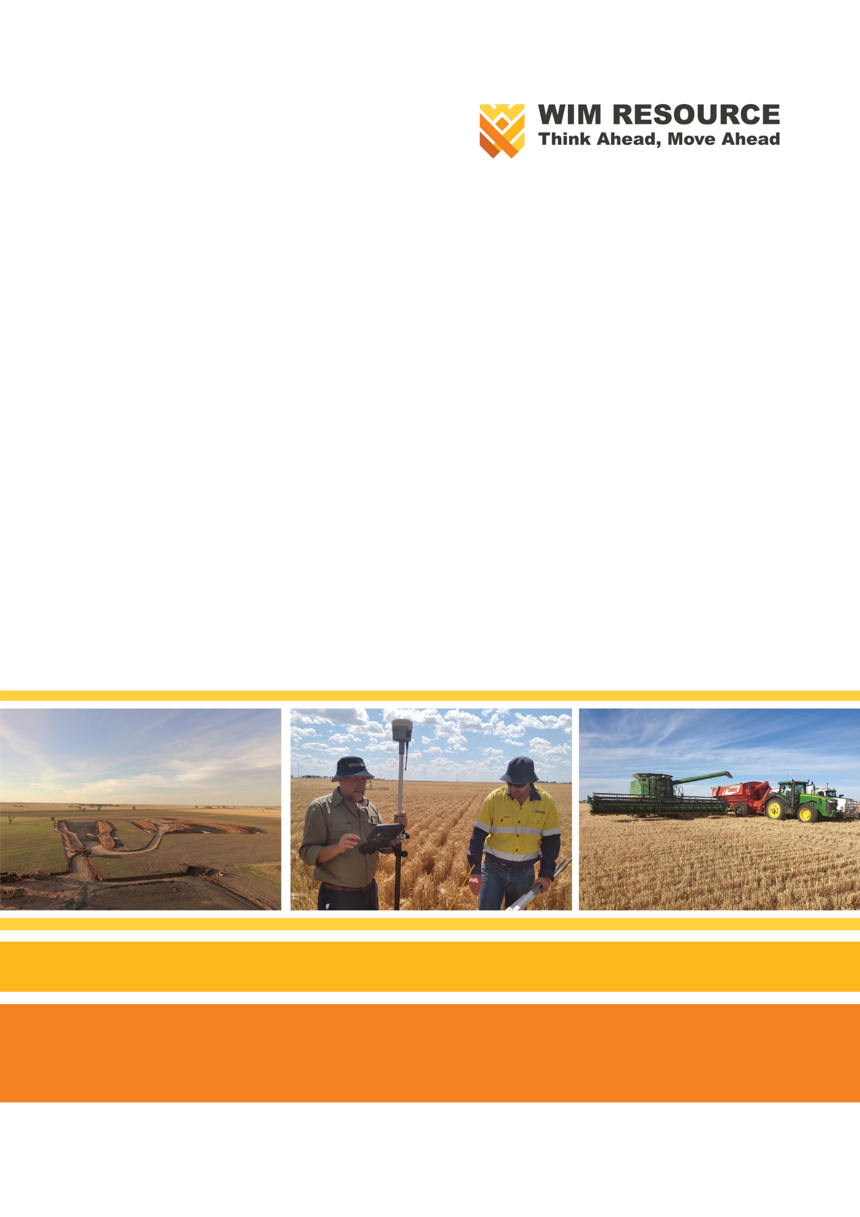
References

References
AECOM Australia Pty. Ltd. (AECOM, 2023), Avonbank Mineral Sands Project, Flora and Fauna Impact Assessment (Appendix P).
Australasian Code for Reporting of Exploration Results, Mineral Resources and Ore Reserves, Joint Ore Reserves Committee (JORC, 2012), Measured and Indicated Category.
Australian & New Zealand Environment and Conservation Council (ANZECC) and Agriculture and Resource Management Council of Australia and New Zealand (ARMCANZ) (ANZECC and ARMCANZ, 2000), Australian and New Zealand Guidelines for Fresh and Marine Water Quality, Volume 1, The Guidelines.
Australian & New Zealand Environment and Conservation Council (ANZECC) and Agriculture and Resource Management Council of Australia and New Zealand (ARMCANZ) (ANZECC and ARMCANZ, 2000a), Australian and New Zealand Guidelines for Fresh and Marine Water Quality, Volume 3, Primary Industries.
Australian & New Zealand Guidelines for Fresh and Marine Water Quality (ANZG, 2018), Water Quality Guidelines Level of Protection.
Australian National Committee on Large Dams (ANCOLD, 2012), Guidelines on tailings dams, Planning, Design, Construction, Operation and Closure.
Australian National Committee on Large Dams (ANCOLD, 2019), Guidelines for Design of Dams and Appurtenant Structures for Earthquake.
Australian Soil Resource Information System (ASRIS, 2013), National Acid Sulfate Atlas.
Australian Standard AS ISO 31000:2018: Risk Management – Guidelines.
Australian Standard AS 1692: Design and Construction of Steel Tanks for the Storage of Flammable and Combustible Liquids.
Australian Standard AS 1940-2004: The Storage and Handling of Flammable and Combustible Liquids.
Australian Standard AS 2159: 2009: Piling – Design and Installation.
Australian Standard AS 4282: Control of Obtrusive Effects of Outdoor Lighting.
Australian Standard AS 4970-2009: Protection of Trees on Development Sites.
Australian Standard AS ISO 9011:2018, Guideline for Auditing Management Systems.
Australian Standard AS 3580.19: 2020, Methods for Sampling and Analysis of Ambient Air Quality Date Validation and Reporting.
Australian/New Zealand Standard AS/NZS ISO 14001:2016: Environmental Management System - Requirements with Guidance for Use.
Bureau of Meteorology (BOM, 2022), Wimmera Mallee Rainfall and River Conditions.
Californian EPA Office of Environmental Health Hazard Assessment (OEHHA, 2015), Air Toxics Hot Spots Risk Assessment Guidelines.
Commonwealth of Australia, Australian Bureau of Statistics (ABS, 2016).
Commonwealth of Australia, Australian Bureau of Statistics (ABS, 2016a), Census (Journey to Work).
Commonwealth of Australia, Australian Bureau of Statistics (ABS, 2016b), National Regional Profile: Wimmera (Statistical Division).
Commonwealth of Australia, Australian Bureau of Statistics (ABS, 2017/18), National Input/Output Tables.
Commonwealth of Australia, Australian Bureau of Statistics (ABS, 2019), Gross State Product.
Commonwealth of Australia, Australian Radiation Protection and Nuclear Safety Agency (ARPANSA, 2005), Radiation Protection Series 9, Code of Practice and Safety Guide – Radiation Protection and Radioactive Waste Management in Mining and Mineral Processing.
Commonwealth of Australia, Australian Radiation Protection and Nuclear Safety Agency (ARPANSA, 2008), The Radioactive Content of Some Australian Drinking Waters.
Commonwealth of Australia, Australian Radiation Protection and Nuclear Safety Agency (ARPANSA, 2011), Radiation Protection Series No. 9.1, Monitoring, Assessing and Recording Occupational Radiation Doses in Mining and Mineral Processing.
Commonwealth of Australia, Australian Radiation Protection and Nuclear Safety Agency (ARPANSA, 2015), Ionising Radiation and Health.
Commonwealth of Australia, Australian Radiation Protection and Nuclear Safety Agency (ARPANSA, 2015a), Radiation Protection Series G-1, Guide for Radiation Protection of the Environments.
Commonwealth of Australia, Australian Radiation Protection and Nuclear Safety Agency (ARPANSA, 2017), Radiation Protection Series G-2, Guide for Radiation Protection in Existing Exposure Situations.
Commonwealth of Australia, Bureau of Meteorology (BOM, 2017), National Atlas of Groundwater Dependent Ecosystems (GDE Atlas).
Commonwealth of Australia, Clean Energy Regulator, National Greenhouse and Energy Reporting Act 2007.
Commonwealth of Australia, Clean Energy Regulator, National Greenhouse and Energy Reporting Regulation 2008, National Greenhouse and Energy Reporting (Measurement Determination) (as amended 2022).
Commonwealth of Australia, Customs Act 1901.
Commonwealth of Australia, Customs (Prohibited Exports) Regulations 1958.
Commonwealth of Australia, Environment Protection and Biodiversity Conservation Act 1999 (EPBC Act).
Commonwealth of Australia, Native Title Act 1993, Register of Indigenous Land Use Agreement.
Commonwealth of Australia, Department of Agriculture, Water and the Environment (DAWE), Bilateral Agreements under Environment Protection and Biodiversity Conservation Act 1999.
Commonwealth of Australia, Department of Health and Ageing, Environment Health Standing Committee (enHealth, 2012), Environmental Health Risk Assessment: Guidelines for Assessing Human Health Risks from Environmental Hazards.
Commonwealth of Australia, Department of Health and Ageing, Environment Health Standing Committee (enHealth, 2018), The Health Effects of Environmental Noise.
Commonwealth of Australia, Department of Industry, Science and Resources (DISR, 2022), Critical Minerals Strategy.
Commonwealth of Australia, Department of Sustainability and Environment, Cheal D, Lucas A, Macaulay L, (Cheal et al., 2011), Recovery Plan for Buloke Woodlands of the Riverina and Murray-Darling Depression Bioregions.
Commonwealth of Australia, Department of Sustainability, Environment, Water, Population and Communities (DSEWPaC, 2012), Approved Conservation Advice for Natural Grasslands of the Murray Valley Plains Ecological Community.
Commonwealth of Australia, Department of Climate Change, Energy, the Environment and Water (DCCEEW, 2013), Significant Impact Guidelines 1.1 - Matters of National Environmental Significance.
Commonwealth of Australia, National Greenhouse Accounts Factors (NGAF, 2019).
Commonwealth of Australia, National Greenhouse Accounts Factors (NGAF, 2020).
Commonwealth of Australia, National Health and Medical Research Council (NHMRC), Australian Drinking Water Guidelines (ADWG, 2011), Paper 6 National Water Quality Management Strategy.
Commonwealth of Australia, National Health and Medical Research Council (NHMRC), National Resource Management Ministerial Council, Australian Drinking Water Guidelines (ADWG, 2021).
Commonwealth of Australia, National Health and Medical Research Council (NHMRC, 2008), Guidelines for Managing Risks in Recreational Water.
Commonwealth of Australia, National Water Commission (NWC, 2012), Australian Groundwater Modelling Guidelines.
Cupper, M. (Landskape, 2022), Cultural Heritage Management Plan (CHMP).
David Bannear Historic Heritage and Archaeology (DBHHA, 2022), Avonbank Mineral Sands Project, Historic Heritage Impact Assessment (Appendix D).
DBH Radiation Pty Ltd. (DBH, 2023), Avonbank Mineral Sands Project, Radiation Risk Assessment (Appendix I).
Ecology Australia (EA, 2018), Desktop Assessment of Significant Flora and Fauna Values of the Avonbank Mineral Sands Project.
Ecology Australia (EA, 2020), Avonbank Mineral Sands Project: Survey Findings 2018 – 2020.
EMM Pty. Ltd. (EMM, 2023), Avonbank Mineral Sands Project, Soils and Landform Impact Assessment (Appendix J).
Environment Protection Authority (EPA, 2020), Civil Construction Building and Demolition Guide (publication 1834).
Environmental Protection UK and Institute of Air Quality Management (IAQM, 2017), Guidance for the Consideration of Air Quality within the Land-use Planning and Development Control Processes.
Environmental Resources Management Pty Ltd (ERM, 2023), Avonbank Mineral Sands Project, Noise and Vibration Impact Assessment (Appendix G).
Food Standards Australia and New Zealand (FSANZ, 2022), Australia New Zealand Food Standards Code – Schedule 19 – Maximum Levels of Contaminants and Natural Toxicants.
Geoanalytica (Geoanalytica, 2021), Avonbank Mineral Sands Project Geotechnical Site Investigation – Interpretive.
GHD Group Pty. Ltd. (GHD, 2023), Avonbank Mineral Sands Project, Groundwater Impact Assessment (Appendix L).
GHD Group Pty Ltd (GHD, 2023), Avonbank Mineral Sands Project, Waste and Emissions Impact Assessment (Appendix Q).
Grieve and Gillet, (Grieve and Gillet, 2012), Horsham Heritage Study Prepared for Rural City of Horsham.
International Atomic Energy Agency (IAEA, 2010), Quantification of Radionuclide Transfer in Terrestrial and Freshwater Environments for Radiological Assessments.
Isbell, R. (Isbell, 2016), The Australian Soil Classification, Australian Soil and Land Survey Handbooks Series, 2nd Edition, CSIRO Publishing, Victoria.
Land and Marine Geological Services (LMGS, 2021), Avonbank Mineral Sands Project Subsidence Assessment.
Landform Architects (Landform Architect, 2023), Avonbank Mineral Sands Project, Landscape and Visual Impact Assessment (Appendix F).
Landloch Pty. Ltd. (Landloch, 2021), Avonbank Mineral Sands Project, Memorandum: Comparison of Potential Erosion Rates in Rehabilitated and Unmined Areas.
Marchant, S. & P.J. Higgins (Marchant et al., 1990). Handbook of Australian, New Zealand and Antarctic Birds. Volume One - Ratites to Ducks.
Matrix Planning Australia Pty Ltd (Matrix Planning, 2022), Avonbank Mineral Sands Project, Land Use and Planning Impact Assessment (Appendix B).
Menkhorst, P., Rogers, D., Clarke, R, Davies, J., Marsack, P. and Franklin, K. (Menkhorst et al., 2017). The Australian Bird Guide. CSIRO Publishing.
Murphy, B and Hazelton, P. (Murphy et al., 2016), Interpreting Soil Test Results – What Do All the Numbers Mean? 3rd Edition, CSIRO Publishing, Victoria.
National Environment Protection Council (NEPC, 1998), National Environment Protection (Ambient Air Quality) Measure (NEPM), (as amended 2016).
National Environment Protection Council (NEPC, 1999), National Environment Protection (Assessment of Site Contamination) Measure (NEPM), (as amended 2013).
Public Place Melbourne Pty Ltd (Public Place, 2023), Avonbank Mineral Sands Project, Social Impact Assessment (Appendix O).
Ratio Consultants Pty Ltd (Ratio, 2022), Avonbank Mineral Sands Project, Road Traffic Impact Assessment (Appendix C).
REMPLAN Pty Ltd (REMPLAN, 2021), Avonbank Mineral Sands Project, Economic Impact Assessment (Appendix N).
Robinson N., Rees D., Reynard K., Imhof M., Boyle G., Martin J., Rowan J., Smith C., Sheffielf K., Giles S. (Robinson et al., 2005), A Land Resource Assessment of the Wimmera region.
South-East Soil and Water Pty. Ltd. (SESW, 2019), Pre-Condition Agricultural Assessment – Avonbank Exploration Test Costean Study.
South-East Soil and Water Pty. Ltd. (SESW, 2022), Post mining Agricultural Assessment - Avonbank Exploration Test Costean study.
State Government of New South Wales, Department of Environment Climate Change and Water (DECCW, 2011), NSW Road Noise Policy.
State Government of Victoria, Aboriginal Heritage Act 2006.
State Government of Victoria, Aboriginal Heritage Regulations 2018.
State Government of Victoria, Catchment and Land Protection Act 1994.
State Government of Victoria, Climate Change Act 2017.
State Government of Victoria, Crown Land (Reserves) Act 1978.
State Government of Victoria, Environment Effects Act 1978.
State Government of Victoria, Environment Protection Act 2017.
State Government of Victoria, Environment Protection Act, Environment Reference Standard 2021 (ERS).
State Government of Victoria, Environment Protection Regulations 2021.
State Government of Victoria, Flora and Fauna Guarantee Act 1988.
State Government of Victoria, Heritage Act 2017.
State Government of Victoria, Land Act 1958.
State Government of Victoria, Mineral Resources (Sustainable Development) Act 1990.
State Government of Victoria, Mineral Resources (Sustainable Development) (Mineral Industries) Regulations 2019.
State Government of Victoria, Occupational Health and Safety Act 2004.
State Government of Victoria, Planning and Environment Act 1987.
State Government of Victoria, Port Management Act 1995.
State Government of Victoria, Radiation Act 2005.
State Government of Victoria, Radiation Regulations 2017.
State Government of Victoria, Road Management Act 2004.
State Government of Victoria, Transport Integration Act 2010.
State Government of Victoria, Water Act 1989, Ministerial Guidelines for Groundwater Licensing, and the Protection of High Value Groundwater Dependent Ecosystems.
State Government of Victoria, Wildlife Act 1975.
State Government of Victoria (Vic Gov, 2012), Securing Victoria’s Economy – Planning, Building, Delivering.
State Government of Victoria (Vic Gov, 2014), Wimmera Southern Mallee Regional Growth Plan (WSMRGP).
State Government of Victoria, Agriculture Victoria (Agriculture Victoria, 1981), Guidelines for Land Capability Assessment in Victoria.
State Government of Victoria, Department of Environment, Land, Water and Planning (DELWP, 2005), Native Vegetation - Modelled 2005 Ecological Vegetation Classes (with Bioregional Conservation Status).
State Government of Victoria, Department of Environment, Land, Water and Planning (DELWP, 2017), Guidelines for the Removal, Destruction or Lopping of Native Vegetation.
State Government of Victoria, Department of Environment, Land, Water and Planning (DELWP, 2020), Scoping Requirements for the Avonbank Environmental Effects Statement.
State Government of Victoria, Department of Environment, Land, Water and Planning (DELWP, 2020a), Guidelines for Assessing the Impact of Climate Change on Water Availability in Victoria.
State Government of Victoria, Department of Environment, Land, Water and Planning (DELWP, 2021), Impact Assessment Guidance, Use of Impact Assessment and Risk Assessment in Environment Effects Statements.
State Government of Victoria, Department of Environment, Land, Water and Planning (DELWP, 2022), Flora and Fauna Guarantee Act Threatened List.
State Government of Victoria, Department of Sustainability and Environment (DSE, 2006), Ministerial Guidelines for the Assessment of Environmental Effects under the Environment Effects Act 1978.
State Government of Victoria, Department of Transport (DoT, 2021), Speed Zoning Policy.
State Government of Victoria, Department, Environment, Land, Water and Planning (DELWP), Water Measurement Information System (WMIS).
State Government of Victoria, Department of Environment, Land, Water and Planning (DELWP, 2015), Ministerial Guidelines for Groundwater Licensing, and the Protection of High Value Groundwater Dependent Ecosystems.
State Government of Victoria, Earth Resources (ERR, 2022), ERR Guidelines for Rehabilitation Bonds – Mineral, Exploration, Mine and Quarries.
State Government of Victoria, Earth Resources Regulation (ERR, 2020), Work Plan Guidelines for Mining Licences.
State Government of Victoria, Earth Resources Regulation (ERR, 2021), Community Engagement Guidelines for Mining and Mineral Exploration in Victoria.
State Government of Victoria, Environment Protection Authority (EPA, 2016), Code of Practice – Onsite Wastewater Management (Publication 891.4).
State Government of Victoria, Environment Protection Authority (EPA, 2016a), Code of Practice – Guidelines for Environmental Management, Septic Tanks (Publication 891).
State Government of Victoria, Environment Protection Authority (EPA, 2018), Liquid Storage and Handling Guidelines (Publication 1698).
State Government of Victoria, Environment Protection Authority (EPA, 2020), Reasonably Practicable (Publication 1856).
State Government of Victoria, Environment Protection Authority (EPA, 2021a), Noise Limit and Assessment Protocol for the Control of Noise from Commercial, Industrial and Trade Premises and Entertainment Venue (Publication 1826.4).
State Government of Victoria, Environment Protection Authority (EPA, 2021b), Civil Construction, Building and Demolition Guide (Publication 1834).
State Government of Victoria, Environment Protection Authority, (EPA, 2021c), Waste Disposal Categories – Characteristics and Thresholds (Publication 1828.2).
State Government of Victoria, Environment Protection Authority (EPA, 2022), Guideline for the Assessment and Minimisation of Air Pollution in Victoria (Publication 2044).
State Government of Victoria, Environment Protection Authority (EPA, 2022a), Guideline for Minimising GHG Emissions (Publication 2048).
State Government of Victoria, Environment Protection Authority, Protocol for Environmental Management (PEM, 2001): Greenhouses Gas Emissions and Energy Efficiency in Industry.
State Government of Victoria, Environmental Protection Authority (EPA 2007), Protocol for Environmental Management: Mining and Extractive Industries.
State Government of Victoria, Environmental Protection Authority (EPA, 2022), Guideline for Assessing and Minimising Air Pollution in Victoria, Publication 1961.
State Government of Victoria, Horsham Rural City Council (HRCC, 2017), Road Management Plan.
State Government of Victoria, Vicflora (VicFlora, 2022), Flora of Victoria.
State Government of Victoria, VicRoads (Vic Roads, 2005), Traffic Noise Reduction Policy.
State Government of Victoria, Victorian Aboriginal Heritage Register (VAHR).
State Government of Victoria, Victorian Water Register (VWR, 2015).
State Government of Western Australia, Department of Water and Environmental Regulation (DER, 2015), Identification and Investigation of Acid Sulphate Soils and Acidic Landscapes.
The Commonwealth Scientific and Industrial Research Organisation (CSIRO, 2017), Guidelines for Mine Waste Dump and Stockpile design.
The Norwegian Radiation and Nuclear Safety Authority (DSA, 2022), ERICA Tool.
Tonkin (Tonkin, 2020), Avonbank Mineral Sands Project, Dooen Victoria - Soil, Landform & Geology - Existing Conditions Study.
Tonkin and Taylor Pty Ltd (Tonkin and Taylor, 2022), Avonbank Mineral Sands Project, Air Quality Impact Assessment (Appendix H).
Tonkin and Taylor Pty Ltd (Tonkin and Taylor, 2022a), Avonbank Mineral Sands Project, Human Health Risk Assessment (Appendix M).
United Nations Scientific Committee on the Effects of Atomic Radiation (UNSCEAR, 2000), Sources and Effects of Ionising Radiation.
University of Adelaide (UoA, 2019), Potential Acid Sulfate Soil (PASS) Investigation.
University of Adelaide (UoA, 2020), Acid and Metalliferous Drainage Study for the Avonbank HMS Project.
Water Technology (Water Technology, 2023), Avonbank Mineral Sands Project, Surface Water Impact Assessment (Appendix K).
Water Technology, (Water Technology, 2015), Warracknabeal and Brim Flood Investigation.
Water Technology, (Water Technology, 2019), Horsham and Wartook Valley Flood Investigation, Riverine Hydraulic Modelling.
Western Victoria Private Health Network (PHN, 2021), Available at https://www.phnexchange.com.au/home.php?phn=206 in September 2021.
WIM Resource Pty Ltd. (WIM, 2021), Avonbank Minerals Sands Project – EES Consultation Plan.
World Health Organization (WHO, 2006), WHO Air Quality Guidelines for Particulate Matter, Ozone, Nitrogen Dioxide and Sulfur Dioxide: Global Update 2005: Summary of Risk Assessment.
World Health Organization (WHO, 2018), Environmental Noise Guidelines for the European Region.

