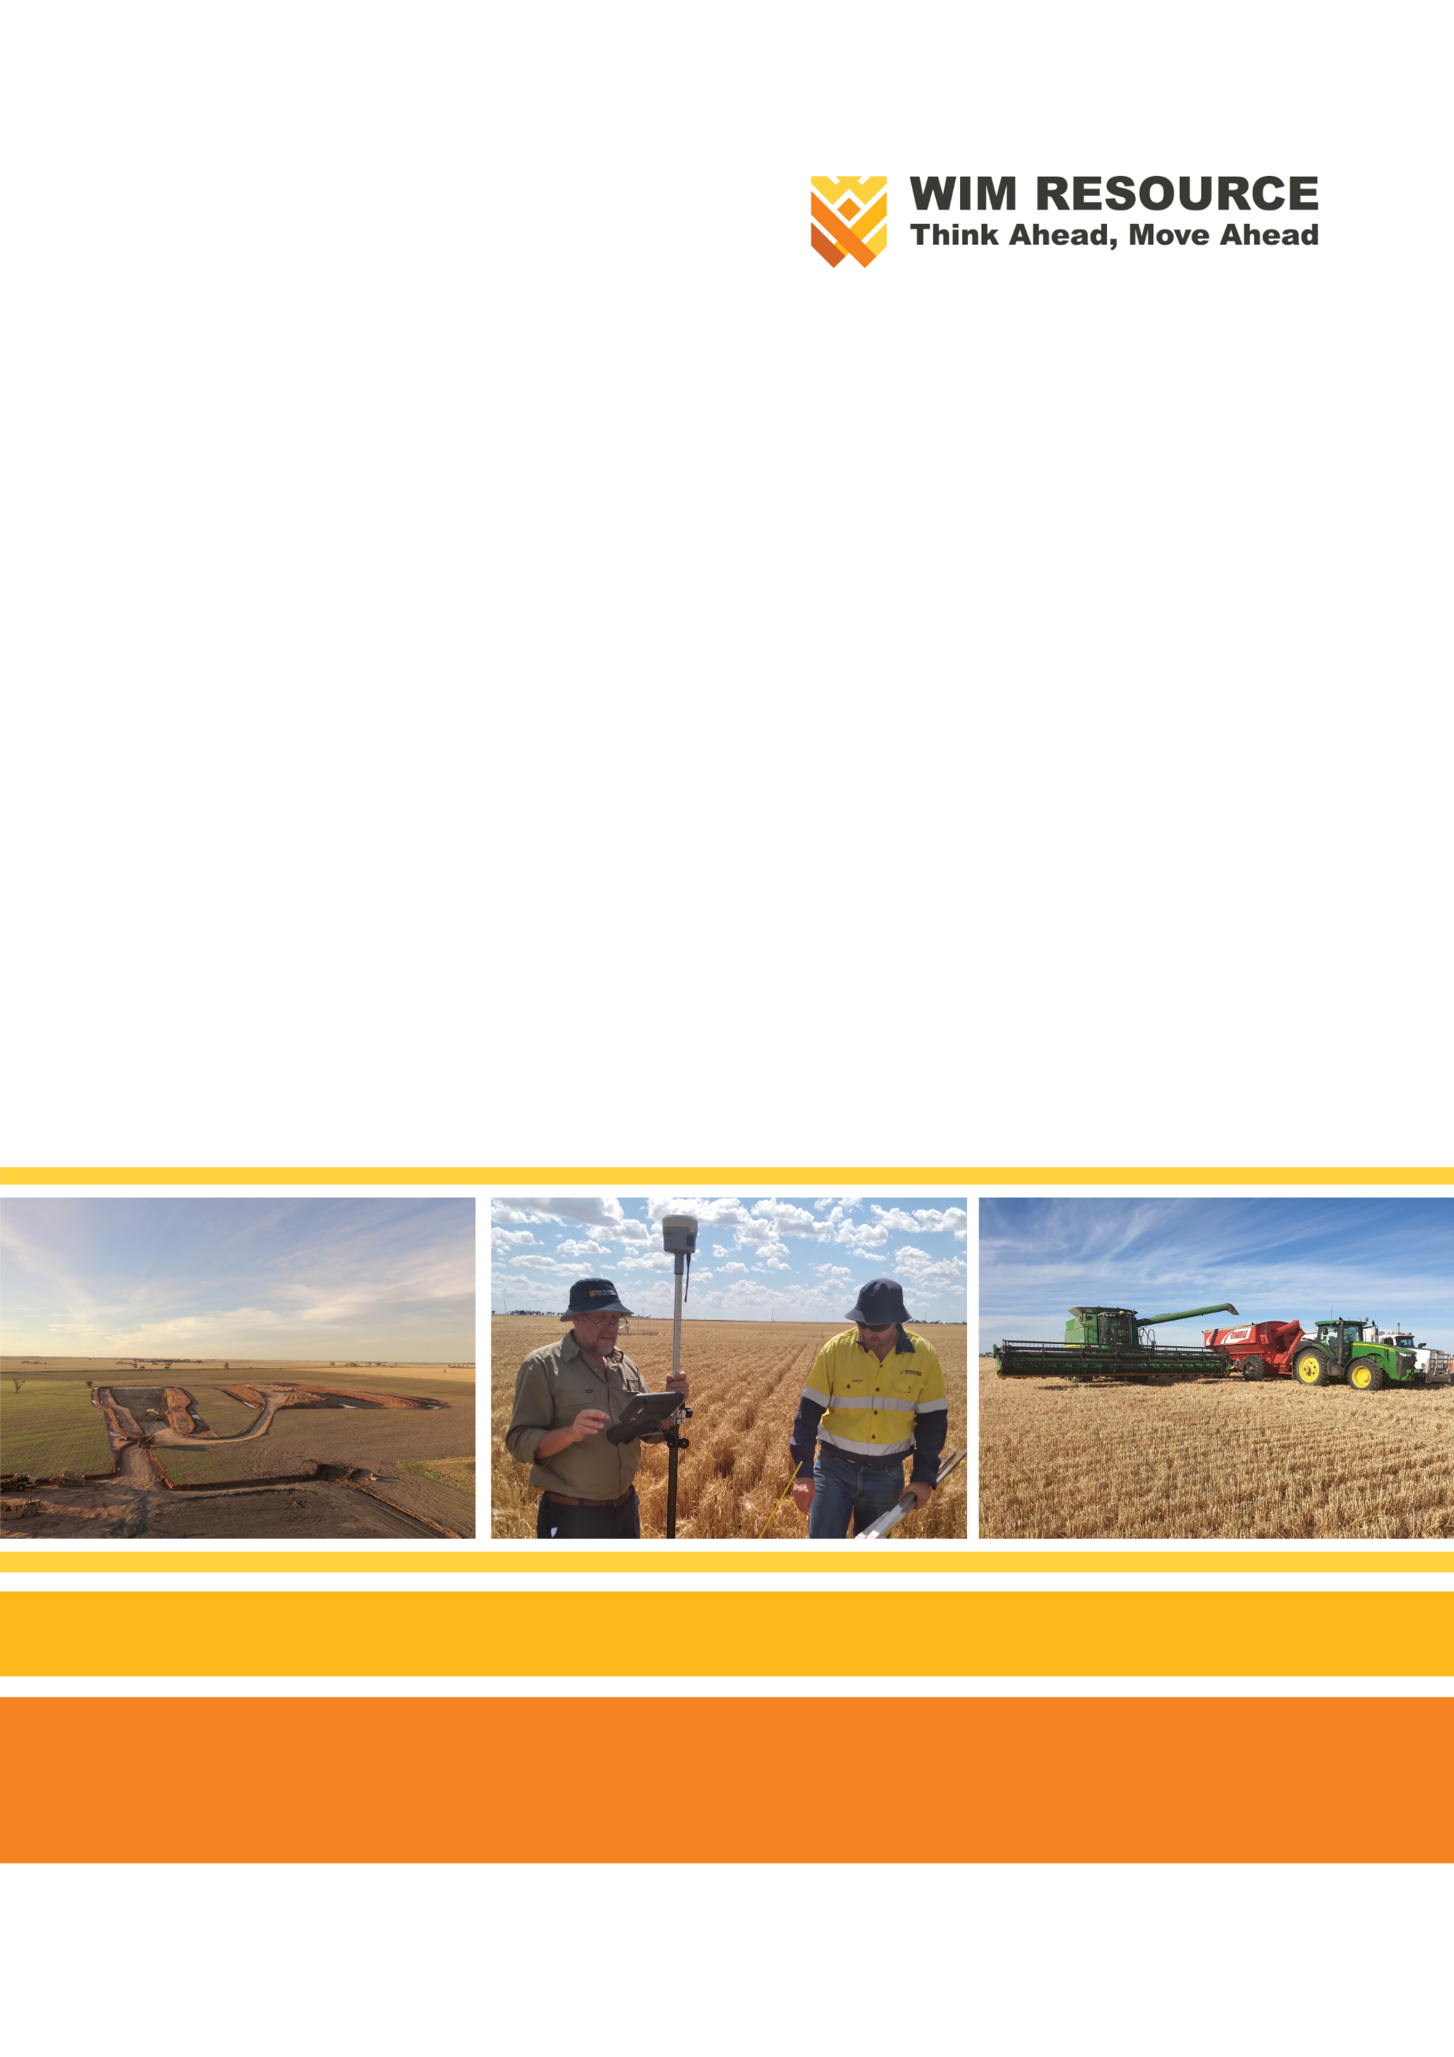

Avonbank Mineral Sands Project
Environment Effects Statement

Chapter 1 – Introduction

TABLE OF CONTENTS
1 Introduction 1-1
1.1 Context 1-1
1.2 The Project 1-1
1.2.1 Project Description 1-1
1.2.2 Project Proponent 1-5
1.3 Project Objectives and Rationale 1-5
1.3.1 Objectives 1-5
1.3.2 History 1-5
1.3.3 Rationale 1-6
1.3.4 Avonbank Demonstration Trial 1-7
1.4 Project EES 1-7
1.4.1 Requirement for an EES 1-7
1.4.2 Structure of the EES 1-8

TABLES
Table 1-1: Annual operational economic impacts on the State and regional economy 1-7
Table 1-2: EES report content 1-9
Table 1-3: EES Appendices and Attachments 1-10

FIGURES
Figure 1-1: Project location and regional surrounds 1-3
Figure 1-2: Project location and HMC haulage route 1-4
Figure 1-3: WSM local government areas 1-4

Introduction

Context
This Environment Effects Statement (EES) has been prepared for the Avonbank Mineral Sands Project (the Project) located in western and south-western Victoria. The Project entails the mining and processing of mineral sands to produce a Heavy Mineral Concentrate (HMC) and the transport, storage and loading of HMC for overseas export from the Port of Portland (PoP).
The EES addresses all aspects of the environment including the physical, biological, heritage, cultural, social, health, safety and economic aspects of human surroundings, including the wider ecological and physical systems within which humans live.
The purpose of the EES is to describe the Project, and assess the potential environmental impacts that may occur as a direct or indirect result of Project activities, providing measures through which adverse impacts can be avoided or minimised so far as reasonably practicable. The EES considers all Project related activities undertaken throughout construction, operation and rehabilitation/closure.
The EES enables stakeholders and decision-makers to understand how the Project will be designed, constructed, operated, progressively rehabilitated and closed, and the likely environmental and socioeconomic impacts of implementing the Project.
The EES has been prepared to address the Scoping Requirements for the Avonbank Mineral Sands Project (DELWP, 2020). These Scoping Requirements detail the specific matters to be investigated in the EES and the evaluation objectives against which the Project is to be assessed. The Scoping Requirements are presented in Appendix A of this EES.

The Project

Project Description
The Project comprises mining of the Avonbank mineral sands ore body, processing works to produce HMC, road transportation, and loading of HMC for overseas export at the PoP (refer Figure 1-1). The Project will be owned and operated by WIM Resource Pty Ltd (WIM).
The area in which mining and processing will occur is approximately 15 km north-east of the City of Horsham and 5 km north-east of the township of Dooen, within the Horsham Rural City (HRC) local government area (LGA) in the Wimmera Southern Mallee (WSM) region of Victoria (refer Figure 1-2 and Figure 1-3). Project works, including construction, active mining (approximately 30 years) and rehabilitation/closure will extend to 36 years.
The Avonbank ore body comprises mainly zircon, titanium-rich mineral concentrate and minor amounts of rare earth products. Mining activities will be conducted on a mining licence (MIN) to be secured within a granted retention licence 2014 (RL 2014).
The development extent of the Project will total 3,546 ha, comprising mining and related activities within the proposed mining licence (3,426 ha) and secondary processing within the WIM Base Area (WBA) (90 ha). There will also be a linear infrastructure corridor to the WBA for power and water, which will extend 14 km (~30 ha). Of this area, 2,215 ha will be mined over the life of the Project.
Standard heavy earth moving methods and equipment will be used to mine the ore body progressively over the life of the Project. Using this ‘moving pit’ mining method at any given time, the extent of Project disturbance will be, on average, less than 300 ha. Mining will involve excavation to a target depth of 24 - 30 m. The mining method involves the direct return of tailings and overburden into the mined cell, as the mining front advances. This enables progressive site rehabilitation and therefore minimises disruption to productive agricultural land use.
Mining operations will be undertaken over a period of around 30 years. The progressive mining method will enable each area to be mined and rehabilitated within 4 years after initial disturbance. The disturbed land will be rehabilitated to a safe, stable and sustainable state to enable the return of the disturbed area to its previous productive land use.
Secondary ore processing to concentrate the target minerals (HMC) will take place adjacent to the mining licence at the WBA, primarily located in the Special Use Zone established within the Wimmera Freight Intermodal Terminal (WIFT) Precinct. The Special Use Zone was established for industrial purposes, including the processing, storage and handling of mineral sands. Minor utilities (power and water) infrastructure will extend from their respective terminal stations to the WBA.
Conventional mineral sands processing techniques will be used to produce around 12.75 Mt of HMC over the life of the Project. Target minerals will be separated from non-mineralised fine and coarse sands by means of a simple wet gravity circuit to produce the HMC product. No chemicals will be used in the ore processing circuit, but the fine tailings stream will be dosed with a polymer flocculant to promote water recovery. Support infrastructure for mining and processing includes roads, offices, warehouses, workshops, laydown areas, fuel storage, pipelines and power lines.
The HMC product will be transported approximately 230 km in B-double articulated trucks from the WBA to the PoP using the Henty Highway, passing through the areas of Horsham, Cavendish, Hamilton, Branxholme, Heywood and Portland. An estimated 26 loads of HMC will be transported to the PoP each day.
At the PoP, the HMC will be temporarily stored in a leased bunker prior to loading and shipment to offshore markets. The PoP is a commercial deep-water port specialising in the export of bulk commodity products, including mineral sands.
The Project will operate on a 24 hour, 365 days per year basis, directly employing approximately 150 personnel during construction and 230 personnel during operation. The workforce is expected to reside primarily in Horsham and surrounding areas during Project operation.
More detail regarding the Project description is provided in Chapter 2 (Project Description). The Project design rationale and alternatives are described in Chapter 3 (Project Alternatives).
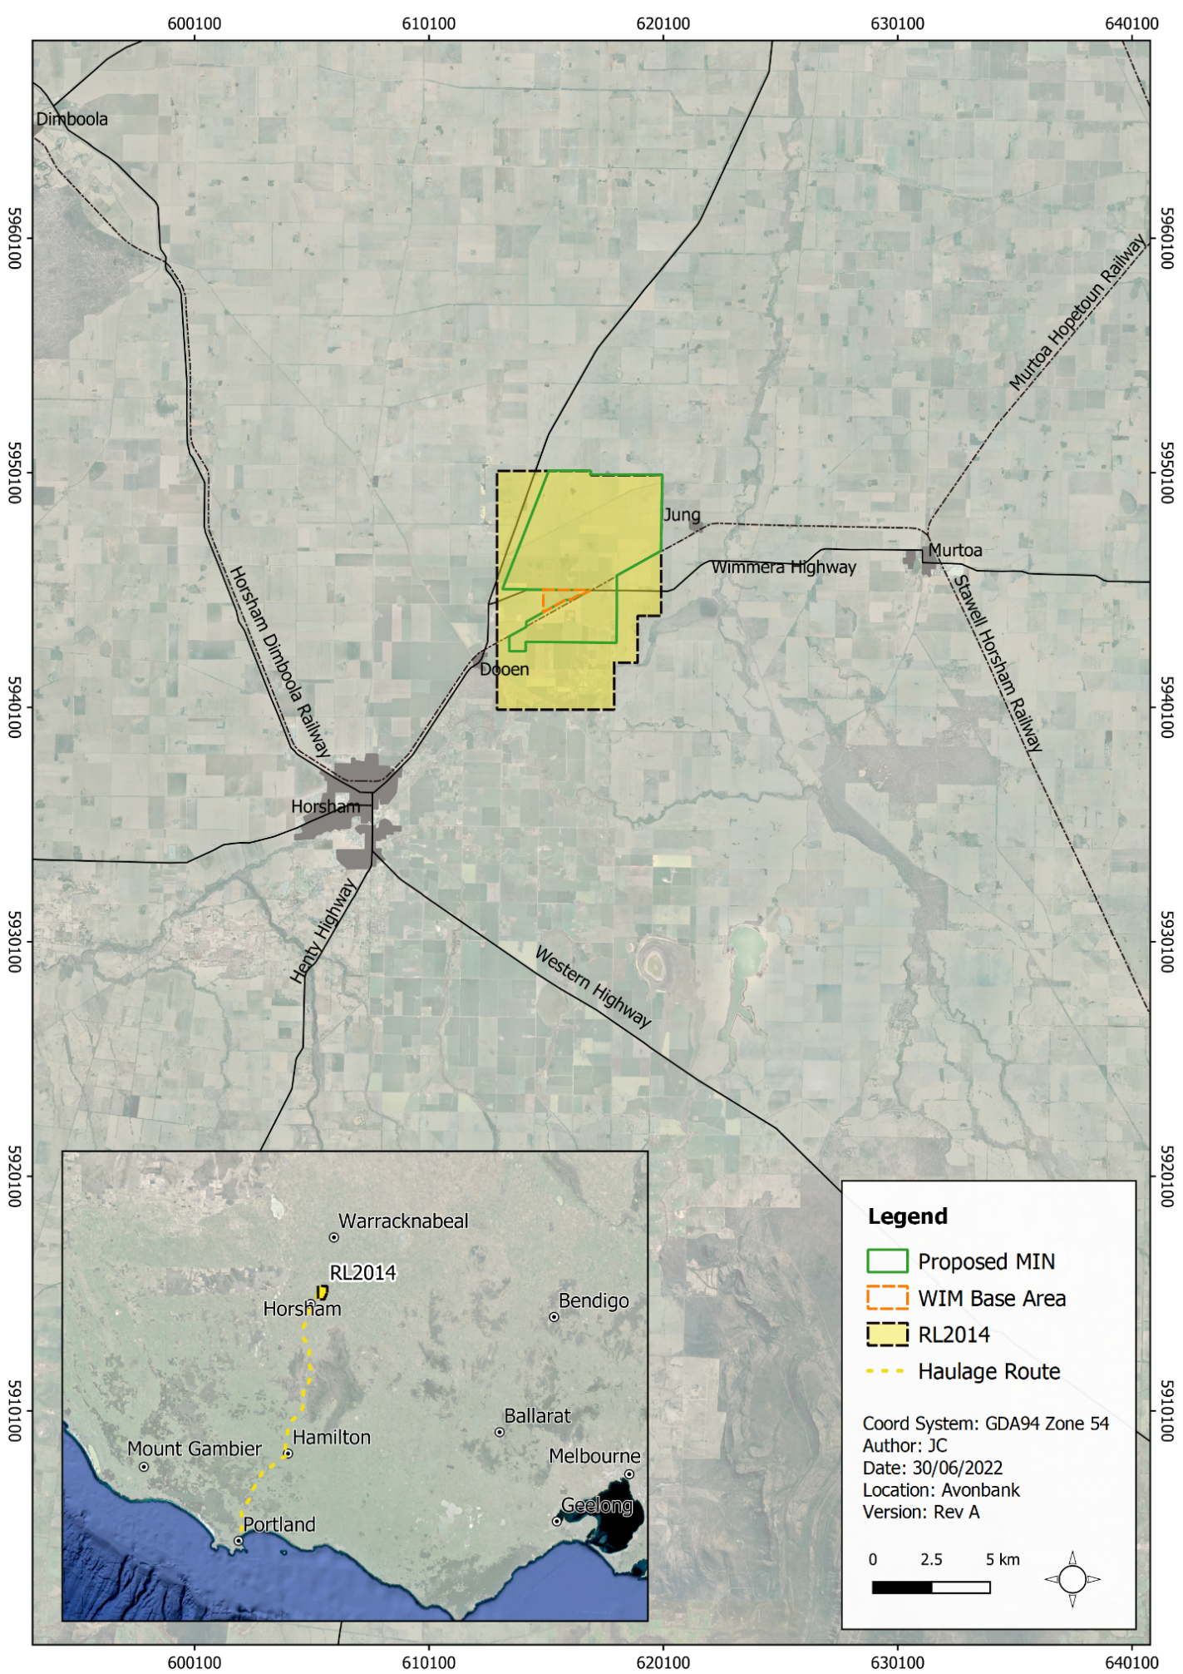
Figure 1-1: Project location and regional surrounds
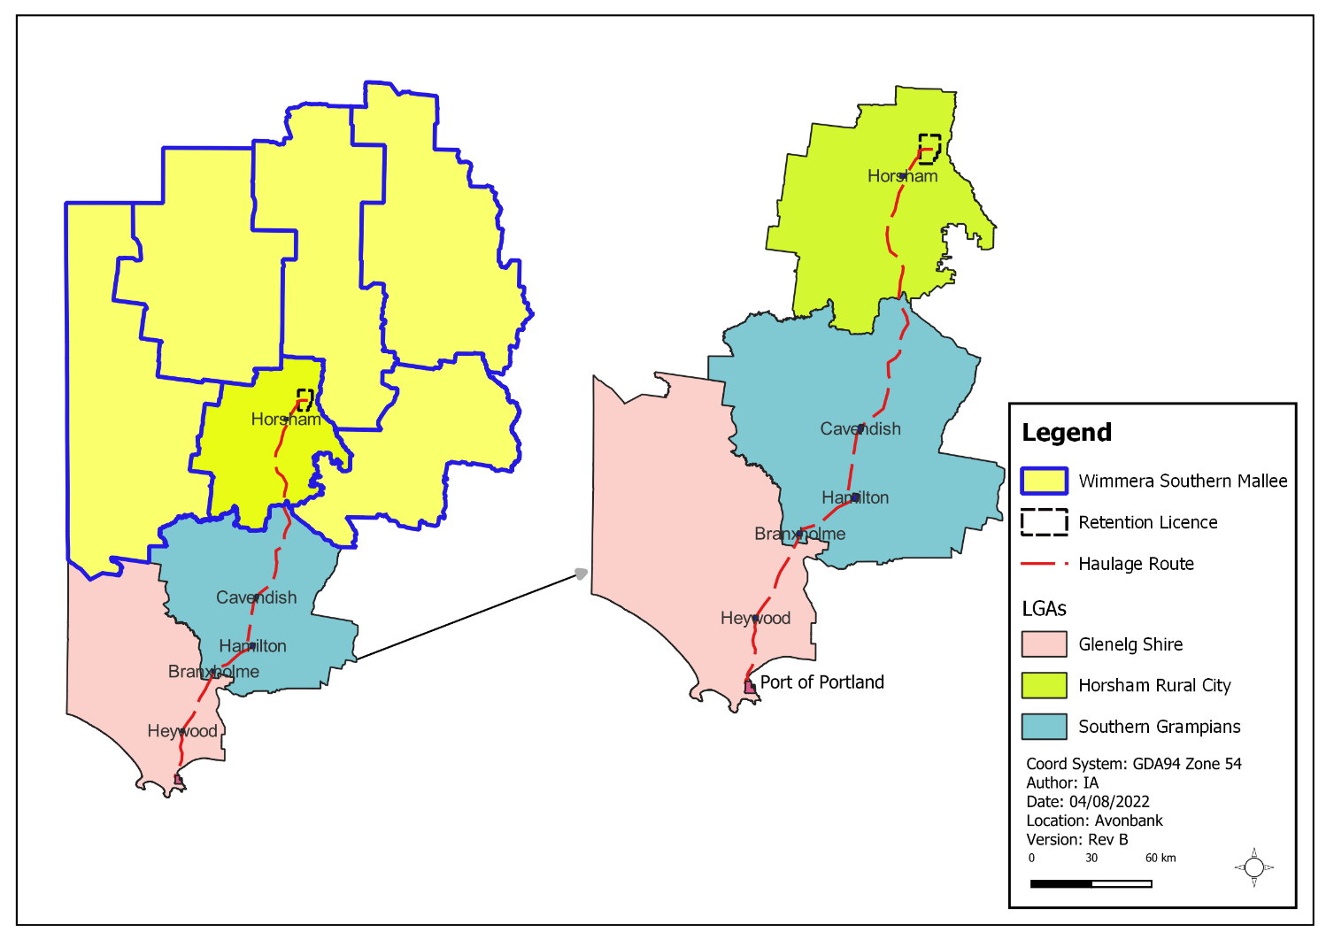
Figure 1-2: Project location and HMC haulage route
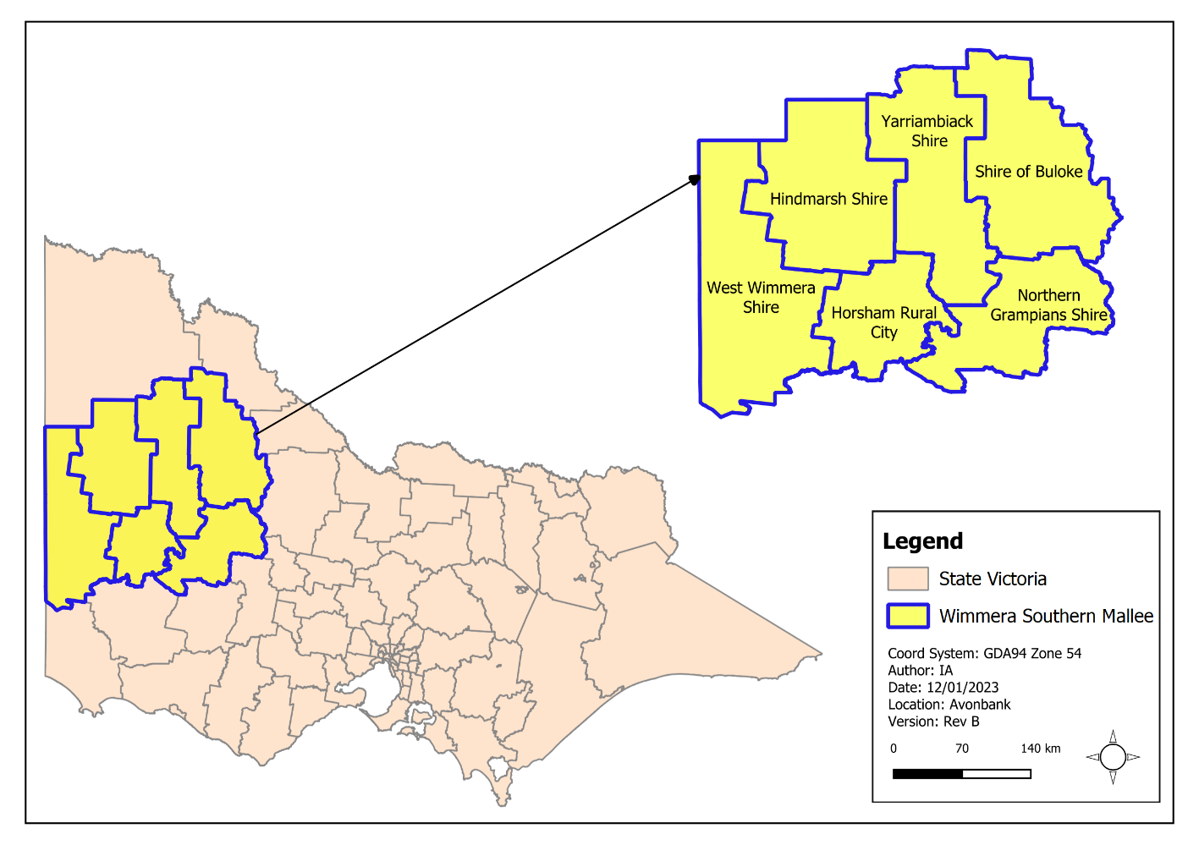
Figure 1-3: WSM local government areas

Project Proponent
WIM Resource a privately held, unlisted company with Australian and international shareholders. The company was incorporated in 2012 and has been solely focused on developing a strong portfolio of mineral sands projects in Victoria. Exploration activities commenced at Avonbank in 2013, and since this time WIM has been systematically defining the resource, developing the metallurgical flow sheet for treating the ore, assessing the environmental conditions, and consulting stakeholders.
WIM has a proven track record of respectful, honest and transparent engagement with Project stakeholders and the broader community. WIM values promote inclusion, environmentally sustainable mining practices and a safe workplace.
WIM is committed to complying with all relevant regulatory requirements and ensuring all phases of the Project are conducted in a manner that protects the natural environment, public safety and amenity and achieves agreed environmental outcomes.
The Board and Management team has a proven and demonstrated record of developing, constructing and safely operating successful mineral sands projects across Australia, including the Mindarie Mineral Sands Mine in South Australia (Murray Zircon Pty Ltd), which was recognised for its excellent rehabilitation, and the Boonanarring Mineral Sands project in Western Australia (Image Resources Pty Ltd), which is currently operating and undergoing successful progressive rehabilitation.

Project Objectives and Rationale

Objectives
The objective of the Project is to establish a world class mining operation and concentration plant which will safely and efficiently produce a premium quality mineral concentrate for export overseas.
Through its activities, the Project aims to make a significant positive socioeconomic impact on the region and the State of Victoria.

History
Victoria has globally significant mineral sands resources, with extensive deposits of minerals, including titanium minerals (rutile and ilmenite), zircon and rare earth minerals such as monazite and xenotime. Approximately 39% of Australia’s zircon resources (used in digital printing, dentistry and the production of ceramics and electrical components) occur in Victoria. To date, most mineral sands activity in Victoria has been focused on the Murray Basin in the State’s west.
The Project is located within a specific Proven and Probable Reserve of 311.8 million tonnes (Mt) of ore, with a head grade of 4.3% Total Heavy Mineral, known as the Avonbank Reserve. WIM currently holds a retention licence (RL2014) for the Project’s mining area.
Several major resource definition exercises involving drilling and bulk sampling have been undertaken over the deposit within the past 9 years by the proponent, and previous to that by several other mining companies, including CRA Exploration (now Rio Tinto) in the late 1980s.
In 2019, a trial mining activity was completed by excavating a test mining pit and establishing a pilot-scale Wet Concentrator Plant (WCP), referred to as the Avonbank Demonstration Trial (refer Section 1.3.4). The trial confirmed the geological model, grade and ore characteristics. Rehabilitation works in the trial area demonstrated that a safe, stable landform with a productive agricultural end land use could be developed following mining.

Rationale

Location and employment
The development extent is located within the Avonbank Reserve, a specific Proven and Probable Reserve of 311.8 Mt of ore. The Avonbank Reserve is suitable for Project activities because of its positive geological and metallurgical attributes and the existence of major infrastructure in the area, such as the WIFT Precinct and suitable road access to the PoP. In addition, the Project can draw on a skilled local workforce from the WSM, and this region has existing businesses with the capacity to support the Project.

Product demand
The HMC produced from the Project will include valuable minerals that belong to one of the three following groups: zircon, titanium minerals (ilmenite, leucoxene and rutile), and rare earth minerals (monazite and xenotime). The use, global demand and projected Project contribution of these mineral groups are summarised below.

Zircon
Approximately 50% of all zircon supplied worldwide is used in the production of ceramics, including tiles, sanitary ware and tableware. Zircon is also used in a range of other applications, including zirconium chemicals, refractories, fused zirconia, catalytic fuel converters, and foundry applications, as well as in water and air purification.
The current global demand for zircon sand is approximately 1.2 Mt per annum, with an annual growth rate for the past 5 years of around 1.5%. The Project aims to be able to supply approximately 5% of the global demand for zircon over the next 30 years.
The federal government’s 2022 ‘Critical Minerals Strategy’ promotes Australia’s capacity to meet the increasing global demand for critical minerals. Zircon is a critical mineral, and by contributing to Australia’s supply, the Project supports the government’s strategy (DISR, 2022).

Titanium minerals
The titanium minerals of ilmenite, leucoxene and rutile are the principal components for pigment production. The titanium materials are used to make a pure white additive, which is light refractive, and used in protective house and car paints, paper, plastics, ink, rubber, textiles, cosmetics, sunscreens, leather and ceramics.
The global demand for titanium feedstock is generally accepted to be in the order of 7 to 8 Mt per annum. The Project aims to be able to supply 2 to 3% of the global demand for titanium over the next 30 years.

Rare earth minerals
The rare earth minerals of monazite and xenotime within the Project ore are present in relatively low levels and considered to be minor by-products, when compared to the zircon and titanium minerals.
Rare earth minerals are critical components in various applications, in particular electric vehicles and wind turbines, with future demand expected to remain strong, driven by the clean energy economy through e-mobility and wind power.
Global consumption of rare earths reached 158,500 t in 2019 and is forecast to increase to 280,000 t by 2030. The Project aims to be able to supply approximately 5% of the global demand for rare earth minerals over the next 30 years.

Economic benefits
The Project will create and sustain significant long-term employment and economic activity in the WSM region and in the state of Victoria. If the Project were not to proceed, the socioeconomic benefits explained in this Section would not be realised.
Royalties for the State of Victoria will be approximately $180 million over the 30 year Project life (approximately $6 million per annum). Over the operational life of the Project, an increase in the Gross State Product (GSP) for Victoria of $5,772 million is projected, and a gross revenue output in the WSM of $335 million per annum.
The Project offers a significant opportunity for local and regional businesses to provide a range of goods and services. The Project will provide economic benefit to Horsham, the WSM region and the State of Victoria and offers increased and diversified job opportunities. The Project will result in the direct employment of approximately 150 personnel during construction and 232 personnel through its 30 year operational life.
During operation, the Project is projected to result in the creation of 588 FTE jobs per annum in the WSM region and 967 FTE jobs per annum in Victoria.
A summary of the economic impacts the Project will have on the State and regional economy every year it is operational, inclusive of direct flow-on supply chain and consumption effects, is provided in Table 1-1.
Table 1-1: Annual operational economic impacts on the State and regional economy
Area | Gross Revenue | Employment | Wages and Salaries | Value Added
Victoria | $512.8 million | 967 FTE jobs | $93 million | $192.4 million
WSM Region | $335 million | 588 FTE jobs | $56.7 million | $116.7 million
This represents a significant positive economic impact on the State and the region. The economic benefits of the Project are described in further detail in Chapter 20 (Socioeconomics).

Avonbank Demonstration Trial
The Avonbank Demonstration Trial was undertaken in 2019-2022 to test the feasibility of mining, processing and rehabilitation within the Avonbank ore body.
Prior to the commencement of trial mining activities, soil surveys were undertaken to characterise the soil profiles and to inform the rehabilitation strategy. The overarching rehabilitation strategy was to recover as much of the effective rooting zone as practicable and to separate the upper soil horizons from the lower more hostile units.
The topsoil and subsoils were stripped from operational areas and four separate stockpiles were established for topsoil, upper and lower subsoil units and excavated overburden. Following removal and stockpiling of the upper soil profile and overburden, ore excavation commenced with material trucked to the pilot plant for processing. The excavated ore was processed in the pilot plant to separate the HMC from the coarse and fine sand tailings.
Coarse sand tails and fine tails were co-disposed back to the mining cell. In-pit tailings were left to consolidate before overburden placement commenced. Rocky overburden and residual low-grade ore were placed on top of the tailings, followed by overburden and the placement of subsoil in two separate cuts. Topsoil was then placed, ameliorated with gypsum, and disc ploughed. Following topsoil placement, the area was seeded with barley.
Rehabilitation monitoring showed that the rehabilitation strategy had been implemented as planned and confirmed the outcome was suitable for broadacre agriculture as intended. Crop yields within the rehabilitation areas were shown to be commensurate with the unmined areas.

Project EES

Requirement for an EES
The initial stage of the environmental assessment process is a referral (normally by the project proponent) to Victorian and Commonwealth authorities to determine whether an assessment is required.
The Project was referred to the Victorian Minister for Planning, and in August 2019, the Minister determined the Project has the potential to result in significant environmental effects and therefore required an EES under the provisions of the Environment Effects Act 1978 (EE Act).
In November 2019, the Project was referred to the Commonwealth Department of Agriculture, Water and the Environment (DAWE), now the Department of Climate Change, Energy, the Environment and Water (DCCEEW). In July 2020, the Commonwealth Minister for the Environment determined the Project is a ‘controlled action’ as it is likely to have a significant impact on matters of national environmental significance (MNES) protected under Part 3 of the Environment Protection and Biodiversity Conservation Act 1999 (EPBC Act), these being: listed threatened species and communities (Section 18 and 18A); and protection of the environment from nuclear actions (Section 21 and 22A).
The EES process is accredited to assess impacts on MNES under the EPBC Act through the Bilateral Assessment Agreement between the Commonwealth and the State of Victoria.
This EES was prepared in consultation with the Department of Environment, Land, Water and Planning (DELWP) and under the guidance of a Technical Reference Group (TRG) convened by DELWP. The EES addresses the Scoping Requirements issued by the Minister for Planning in August 2020 (DELWP 2020).
During the EES public exhibition period, any person or organisation can make a submission on the potential impacts of the Project and on the information and conclusions presented in the EES.
Following a review of the EES, the Minister for Planning will issue an assessment on the acceptability of the Project’s environmental effects to guide and inform statutory decision-makers responsible for Project approvals. A separate approval decision on the Project will be made under the EPBC Act once the Minister for Planning’s assessment report has been released.
The Commonwealth Minister or delegate will decide whether the Project is approved, approved with conditions or refused under the EPBC Act after having considered the Minister for Planning’s assessment under the EE Act.
Further detail about the EES process is provided in Chapter 4 (Regulatory Framework).

Structure of the EES
The EES has three main components:
- The EES main report: The main report is an integrated, plain English document that assesses the potential positive and negative impacts of the Project and describes how adverse environmental and social effects will be avoided or mitigated so far as reasonably practicable.
- EES Appendices: The appendices are supporting documents or technical reports relating to specialist studies, investigations and analyses. These provide the basis for the EES main report.
- EES Attachments: The attachments address topic specific matters pertaining to the Project’s operation.
Table 1-2 and Table 1-3 summarise the structure and contents of the EES.

Table 1-2: EES report content
Chapter/ Reference |  | Content, Matters Addressed
Summary brochure |  | A concise non-technical summary of the Project and key issues, including details of the EES exhibition, public submission process and availability of EES documentation.
Main EES Report
Executive summary |  | A summary of the Project and its potential environmental effects, including potential effects on identified MNES. The executive summary provides an overview of the assessed residual impacts assuming the application of avoidance and minimisation measures.
Chapter 1 | Introduction | Introduces the rationale for the Project and outlines the purpose and structure of the EES.
Chapter 2 | Project Description | Describes the proposed Project, including construction, operations and rehabilitation activities.
Chapter 3 | Project Alternatives | Describes the various alternatives considered in developing key components of the Project presented in the EES and how the preferred options were identified.
Chapter 4 | Regulatory Framework | Summarises the key approvals required for the Project with consideration to the relevant local, State and federal government legislation.
Chapter 5 | Community Engagement | Identifies the Project stakeholders and provides an outline of the engagement/ consultation activities that will be undertaken for each stakeholder group through the life of the Project.
Chapter 6 | Impact Assessment Framework | Provides an overview of the environmental impact assessment framework applied to assess and characterise the significance of the residual environmental impacts.
Chapter 7 | Regional Setting | Presents a regional scale overview of the environmental, social and cultural heritage values of the Project, which provides the context for the Project impact assessment.
Chapter 8 | Land Use and Planning | Presents the planning framework and current and proposed land use within which the Project will be sited, describing potential Project impacts on land use and alignment of Project activities with planning requirements.
Chapter 9 | Traffic and Transport | Presents the baseline characterisation of traffic and transport infrastructure in the Project locality. The Chapter describes potential Project impacts on traffic, transport infrastructure and elements of public safety and how these can be avoided, mitigated and managed.
Chapter 10 | Historic Heritage | Presents a description of existing historic heritage assets in the Project locality and describes potential Project impacts as a result of Project activities and how these can be avoided, mitigated and managed.
Chapter 11 | Landscape and Visual Amenity | Describes the existing visual landscape setting of the Project and the predicted impact of the Project on local and regional visual amenity, detailing proposed avoidance, mitigation and management measures.
Chapter 12 | Noise and Vibration | Describes the existing noise environment and provides an assessment of the potential amenity impacts of the Project from noise and vibration on surrounding sensitive receptors and proposed measures to avoid, mitigate and manage these impacts.
Chapter 13 | Air Quality | Presents the results of baseline characterisation of ambient air quality in the Project locality and describes the potential amenity impacts from airborne particulates generated by Project activities and proposals to avoid, mitigate and manage these impacts.
Chapter 14 | Radiation | Presents a description of the existing radiological setting of the Project area, including soils, dust and ground and surface waters, the predicted changes to the setting during Project operations, and measures proposed to avoid, mitigate and manage potential impacts to ensure the protection of public health.
Chapter 15 | Soils and Landforms | Describes the soils and landforms potentially impacted by the Project and the management actions proposed to ensure the integrity and productivity of these soils and landforms are maintained through the construction, operations and rehabilitation phases of the Project.
Chapter 16 | Surface Water | Characterises the surface water catchment of the development extent and the potential hydrologic and water quality impacts of the Project on beneficial users of surface water within the catchment. The Chapter describes proposed measures to avoid, mitigate and manage potential adverse impacts.
Chapter 17 | Groundwater | Characterises the groundwater conditions within the area of the development extent and the potential hydrological and water quality impacts of the Project on beneficial users of groundwater, including potential groundwater dependent ecosystems. The Chapter describes proposed measures to avoid, mitigate and manage potential adverse impacts.
Chapter 18 | Human Health | Describes the existing conditions and presents an assessment of predicted Project risks on human health and describes how potential risks will be avoided, minimised and managed.
Chapter 19 | Wastes and Emissions | Identifies the wastes and emissions, including greenhouse gas emissions, that will arise from Project activities and describes how these will be avoided, minimised and managed.
Chapter 20 | Socioeconomics | Describes the existing socioeconomic conditions and presents an assessment of predicted Project impacts on social and economic conditions within the WSM region and Victoria and describes how these will be avoided, minimised and managed.
Chapter 21 | Flora and Fauna | Characterises the existing native vegetation, habitats, fauna and flora. The Chapter describes measures to avoid, mitigate, manage or offset potential impacts to flora and fauna, including threatened species and vegetation communities, and describes the assessed residual impacts.
Chapter 22 | Land Rehabilitation | Describes the rehabilitation measures proposed to return areas impacted by Project activities within the development extent to a safe, stable and productive land use.
Chapter 23 | Aboriginal Cultural Heritage | Presents the existing Aboriginal cultural heritage conditions and provides an assessment of potential Project impacts on tangible and intangible cultural heritage values and measures proposed to avoid, mitigate and manage potential impacts. This Chapter reflects the assessment methods and findings of the Cultural Heritage Management Plan for the Project area.
Chapter 24 | Environmental Management | Sets out the environmental management system (EMS) to be implemented for the Project, with reference to the Australian and New Zealand Standard for Environmental Management Systems (AS/NZS ISO14001:2016).
Chapter 25 | Matters of national environmental significance | Provides an assessment of potential impacts on MNES, as set out in the EPBC Act.
Chapter 26 | Summary and Conclusions | Provides a concise summary assessing the potential impacts of the Project against the evaluation objectives as set out in the Scoping Requirements.
Chapter 27 | Glossary, Abbreviations and Acronyms | Defines specialised or technical terms, abbreviations and acronyms used throughout the EES.
References |  | A summary of all references cited in the EES.
Table 1-3: EES Appendices and Attachments

Chapter/ Reference | Report Title
EES Appendices
Appendix A | Scoping Requirements
Appendix B | Land Use and Planning Impact Assessment
Appendix C | Road Traffic Impact Assessment
Appendix D | Historic Heritage Impact Assessment
Appendix E | Cultural Heritage Management Plan Summary
Appendix F | Landscape and Visual Amenity Impact Assessment
Appendix G | Noise and Vibration Impact Assessment
Appendix H | Air Quality Impact Assessment
Appendix I | Radiation Risk Assessment
Appendix J | Soils and Landform Impact Assessment
Appendix K | Surface Water Impact Assessment
Appendix L | Groundwater Impact Assessment
Appendix M | Human Health Risk Assessment
Appendix N | Economic Impact Assessment
Appendix O | Social Impact Assessment
Appendix P | Flora and Fauna Impact Assessment
Appendix Q | Waste and Emissions Impact Assessment
EES Attachments
Attachment 1 | Stakeholder Engagement Report
Attachment 2 | Draft Planning Scheme Amendment
Attachment 3 | Rehabilitation Plan
Attachment 4 | Work Plan Framework
Attachment 5 | Aspects and Risks

