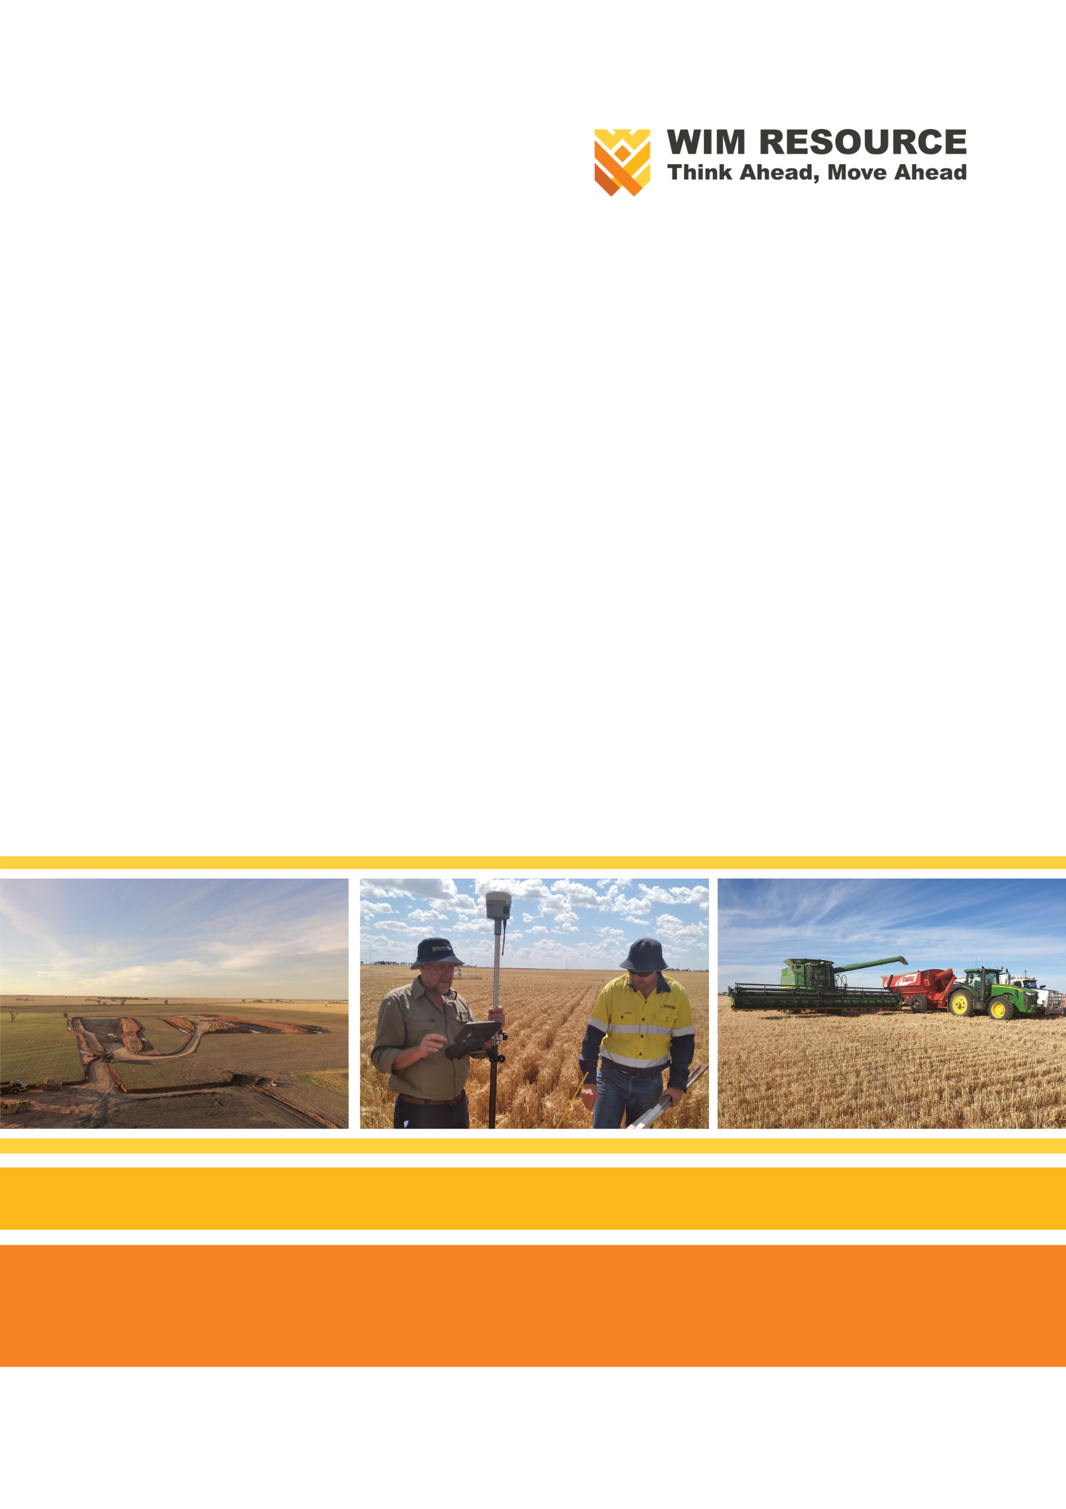

Avonbank Mineral Sands Project
Environment Effects Statement

Chapter 9 – Traffic and Transport

TABLE OF CONTENTS
9 Traffic and Transport 9-1
9.1 Introduction 9-1
9.2 Scope and Methods 9-1
9.2.1 Scope 9-1
9.2.2 Study Area 9-1
9.2.3 Methodology 9-1
9.3 Operational Context 9-4
9.3.1 Road Transport Elements 9-4
9.3.2 Road Transport Requirements 9-5
9.4 Existing Conditions 9-8
9.4.1 Arterial Road Network 9-8
9.4.2 Project Local Road Network 9-9
9.4.3 Traffic Volumes 9-10
9.4.4 Accident Data 9-11
9.4.5 Road Improvement Projects 9-11
9.4.6 Pedestrians and Cyclists 9-12
9.4.7 Public Transport 9-12
9.4.8 Rail Level Crossings 9-12
9.4.9 Rest Areas 9-13
9.5 Potential Impacts 9-13
9.5.1 Identified Potential Impacts 9-13
9.5.2 Sensitive Receptors 9-13
9.5.3 Characterisation of Impacts 9-14
9.6 Avoidance and Mitigation Measures 9-14
9.6.1 Avoidance 9-14
9.6.2 Minimisation 9-15
9.6.3 Rehabilitation 9-17
9.7 Residual Impacts 9-17
9.7.1 Road Network Capacity 9-17
9.7.2 Road Network Infrastructure 9-19
9.8 Management Framework 9-20
9.8.1 Environmental Objectives 9-20
9.8.2 Monitoring and Management 9-21
9.8.3 Audits 9-21
9.9 Cumulative Impacts 9-22
9.10 Conclusions 9-22

TABLES
Table 9-1: Road closure timing 9-8
Table 9-2: Local road classification 9-10
Table 9-3: Potential Impacts 9-13
Table 9-4: Sensitive receptors 9-14
Table 9-5: Significance ratings 9-14
Table 9-6: Level of Service Criteria 9-18

FIGURES
Figure 9-1: Study area haulage route 9-2
Figure 9-2: Study area local roads 9-3
Figure 9-3: Local roads effected 9-7

Traffic and Transport

Introduction
This Chapter provides an overview of the road traffic and transport effects for the Avonbank Mineral Sands Project (the Project). It has been prepared to address the Environment Effects Statement (EES) Scoping Requirements (DELWP, 2020) and is supported by a detailed impact assessment prepared by Ratio Consultants Pty Ltd (Ratio) (Appendix C).
The key evaluation objective relevant to this Chapter, as defined in the Scoping Requirements, is to ‘minimise adverse social, land use and infrastructure effects’ associated with the Project (DELWP, 2020). The associated issues and Project Scoping Requirements are detailed in Appendix A of this EES.
This Chapter describes the potential impacts associated with the Project related traffic and transport, and details the avoidance and mitigation measures to minimise the residual impacts so far as reasonably practicable.

Scope and Methods

Scope
The scope of this Chapter covers the potential impacts identified in the Road Traffic Impact Assessment (RTIA) (Appendix C) and addresses the relevant Scoping Requirements listed in Appendix A. The impact assessment focused on traffic and transport related activities that may impact the community over the life of the Project. It focused on activities associated with mining and mineral processing and considered the haulage route to the Port of Portland (PoP). Project related aspects that are well understood and considered to be relatively low risk with standard controls in place are addressed in the Aspects and Risk Register (Attachment 5).

Study Area
The RTIA focused on activities within and surrounding the mining licence (MIN), WIM Base Area (WBA), haulage route to the PoP and arterial roads likely to be used for construction related transport of materials (refer Figure 9-1 and Figure 9-2). The study area extended to communities adjacent the proposed haulage route, including but not limited to the City of Horsham and the settlements of Dooen and Cavendish. Sensitive receptors that fall within the study area are described in Section 9.5.2.

Methodology
The RTIA characterised the existing conditions, identified potential impacts and assessed the residual impacts with avoidance and mitigation measures in place. The tasks undertaken are summarised below and detailed in Appendix C, Section 2.
Existing conditions:
- Project traffic sources and destinations were identified.
- Key road networks and viable access routes to and from site during all phases of the Project were characterised.
- Consultation with the Department of Transport (DoT) was undertaken to understand specific local road conditions.
- A desktop assessment of route options, including traffic volumes, road characteristics and accident data was undertaken.
- Access routes and roads within the Project area were inspected to understand road standards, conditions and current baseline conditions (undertaken 2 November 2020).
Potential impacts:
- Project construction, operation and decommissioning phases were characterised.
- Existing road users and stakeholders were identified.
- Potential impacts to sensitive receptors were identified with consideration to the above elements.
Residual impacts:
- Project traffic was modelled for all phases of the Project (refer Appendix C, Section 11.1).
- Mitigation measures were identified to avoid and/or minimise impacts on sensitive receptors, so far as reasonably practicable.
- Residual impacts following the implementation of avoidance and mitigation measures were assessed.
- Potential cumulative impacts associated with existing and proposed projects within the region were qualitatively assessed.
Key assumptions associated with the impact assessment are detailed in Appendix C, Section 11.1.2.

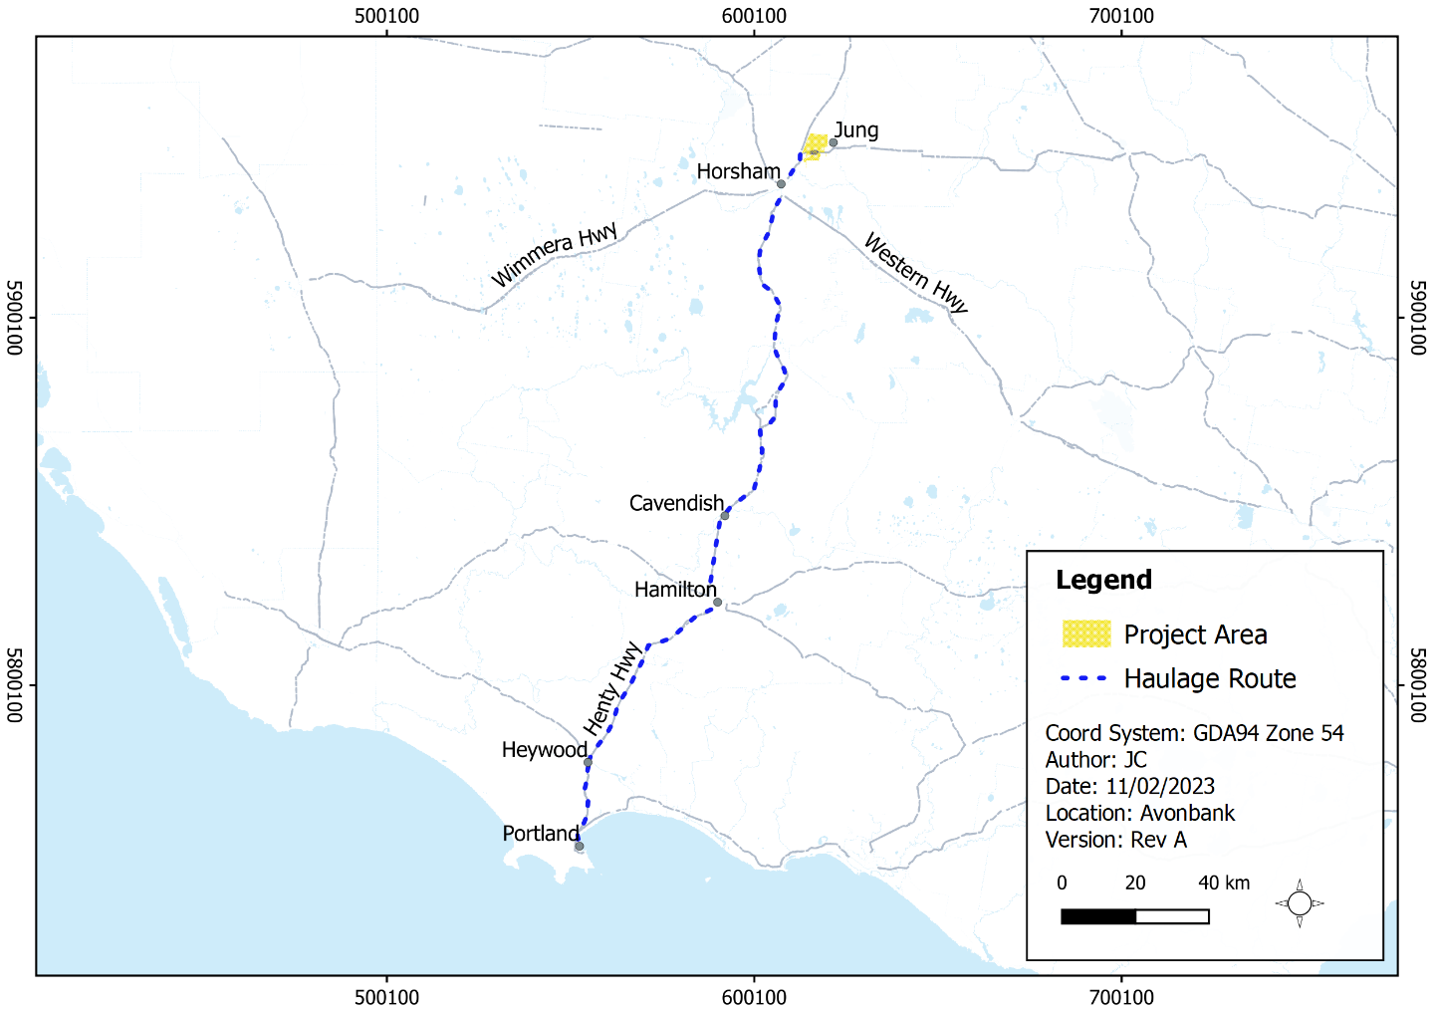
Figure 9-1: Study area haulage route
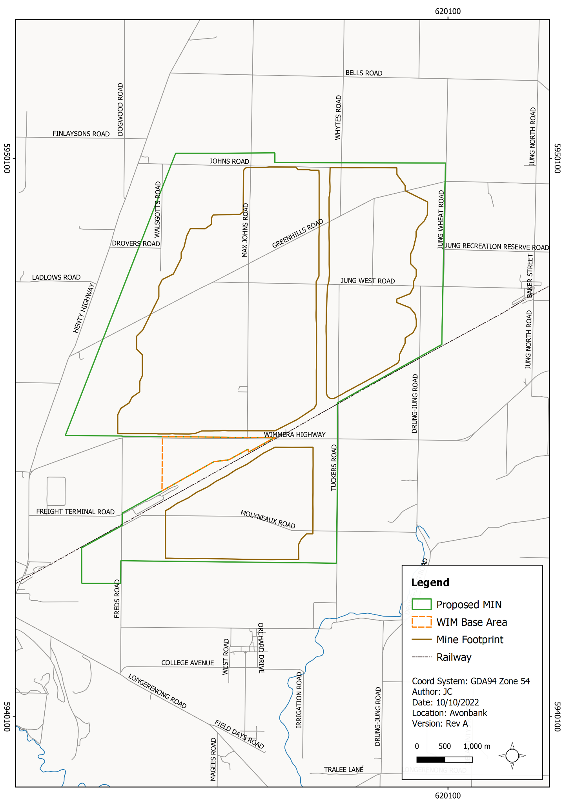
Figure 9-2: Study area local roads

Operational Context
As described in Chapter 2, Project establishment activities will primarily include construction of the Wet Concentrator Plant (WCP) and ancillary buildings/structures in the WBA during the first 12-months of the Project. During operations, ore will be progressively mined, and HMC will be separated from the tails components. HMC will be transported by road to the PoP, where it will be shipped to overseas markets.
The following Sections provide further detail relevant to road traffic and transport to and from the mine and WBA. Matters relating to the shipping of product are discussed in Chapter 2 (Project Description).

Road Transport Elements
The Project will include a 12-month construction phase, 33-year mining and rehabilitation phase (operations), followed by a 3-year decommissioning and closure phase. Each phase will have road traffic and transport requirements commensurate with the planned activities and operational settings, as summarised below.
Project construction:
- Personnel movement and construction activity associated with the establishment of the WBA, resulting in around 280 movements per day (to and from the mine/WBA).
- Mining plant and equipment haulage to the site from Perth, Adelaide and Melbourne, resulting in up to 19 heavy vehicles per day and nine Oversize Overmass (OSOM) vehicles per day (peak period).
- Construction activity 24 hours per day and 7 days per week, with a peak of 200 personnel per day over two shifts.
- Construction activity and associated establishment of Port end facilities.
Mining and rehabilitation (operations):
- HMC road transport using B-double articulated vehicles (trucks) to the PoP resulting in 52 movements per day (to and from mine/WBA).
- Operational personnel movement to/from site resulting in around 215 movements per day (to and from mine/WBA).
- Mining and processing operations 24 hours per day, days per week, with 232 personnel per day over two shifts.
- Operational personnel movement between the WBA and mining areas.
- Local road closures and detours within the proposed mining licence to support mining operations.
- Fuel delivery, operational deliveries and waste collection.
Decommissioning and closure:
- Personnel movement and construction activity associated with the decommissioning and closure of the WBA, resulting in around 225 movements per day (to and from the mine/WBA)
- Mining plant and equipment haulage to the site from Perth, Adelaide and Melbourne, which will result in up to 10 heavy vehicles per day and five OSOM deliveries per day (peak period).
- Decommissioning activity 24 hours per day, 7 days per week, with around 165 personnel per day over two shifts.

Road Transport Requirements

Arterial road network
Project construction and decommissioning phases
The Western Highway from Adelaide and Melbourne to Horsham and the Henty Highway has been identified as plant/equipment and construction aggregate haulage routes. This route has been selected on the basis that the:
- Western Highway, combined with Henty Highway between Horsham and the proposed mining licence/WBA, provides the most direct interstate/intrastate link from plant and equipment source locations and is the highest standard connection between these locations.
- Western Highway is suitable for OSOM plant delivery.
- Access to Tuckers Hill Quarry relies on Western Highway.
- Access to the Dooen Ladlow Road Quarry relies on Henty Highway.
Traffic on these routes will be limited to the Project construction and decommissioning phases (~12 months each).
Operations
Figure 9-1 shows the proposed HMC haulage route via Wimmera Highway and the length of Henty Highway to the PoP, as established by the Preliminary Road Haulage Options Route Assessment (refer Appendix C, Appendix A).
Alternative arterial route options were ranked with consideration to the following criteria:
- Route traffic volumes and relative traffic impact.
- Geometric and road/infrastructure constraints.
- Road standards and conditions.
- Potential amenity impact.
- Known road conditions and planned road network improvements.
- Safety and accident history.
The preferred route was selected because it:
- Provides the most direct road connection between the Project and the PoP;
- Road construction and road safety standards are generally better compared to all roads on other route options; and
- The relative increase in total traffic and heavy vehicle traffic as a result of additional Project haulage is less than all other route options.
The preferred route is gazetted to cater for the B-double vehicles generated by the Project.

Local road network
Local roads that will be closed and/or diverted for periods whilst mining and ancillary activities are undertaken are shown in blue in Figure 9-3 and listed in Table 9-1. Further detail relating to the timing of road closures and detours is provided in Appendix C, Section 3.
In general, east-west movements will be directed to Wimmera Highway, with north–south traffic encouraged to rely on Henty Highway (west of the proposed mining licence) and Jung North Road (east of the proposed mining licence). Public access to land impacted by mining will be managed on a landholder-by-landholder basis coordinated by WIM and in consultation with the Horsham Rural City Council (HRCC).
Internal access roads will be established within the proposed mining licence/WBA to minimise the reliance on local public roads. Internal access roads will not have direct access to Wimmera Highway but will extend from existing local roads.

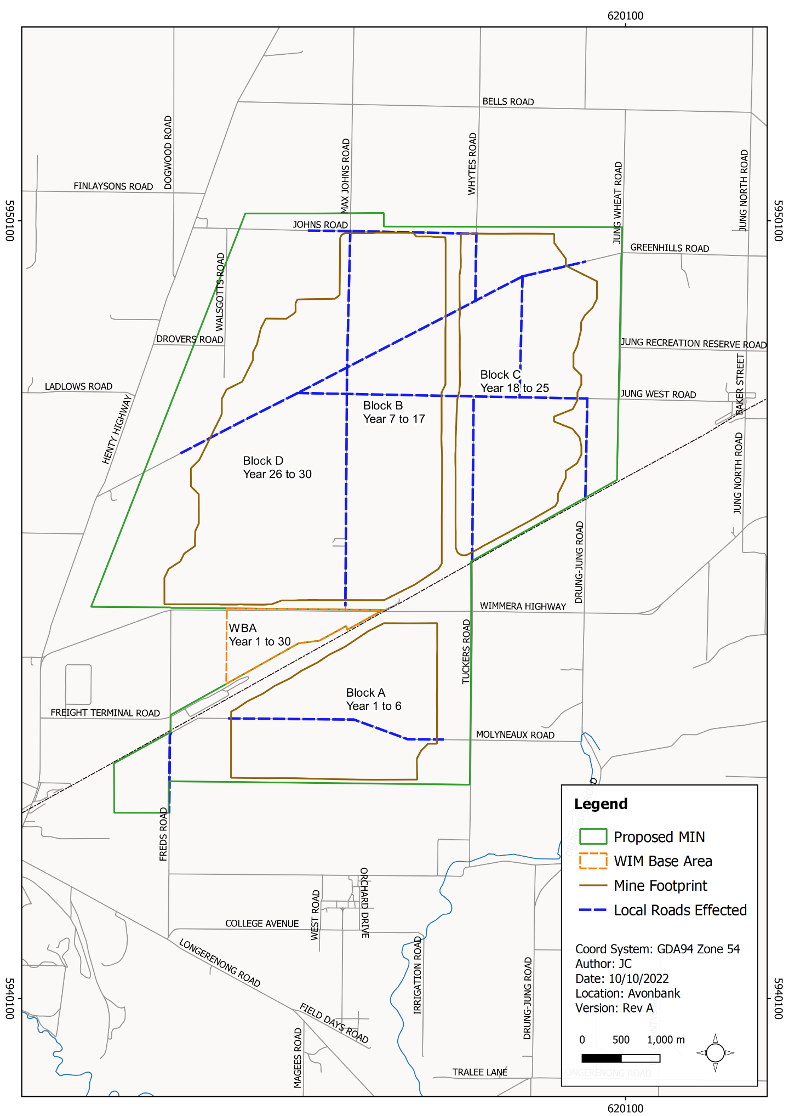
Figure 9-3: Local roads effected
Table 9-1: Road closure timing
Mining Block | Road | Closed (Years Since Commencement)
Block A | Molyneaux Road | 1 to 10
 | Freds Road | 1 to 10
Block B | Max Johns Road | 6 to 20
 | Jung West Road | 7 to 20
 | Greenhills Road | 7 to 20
 | Johns Road | 8 to 20
Block C | Johns Road | 18 to 20
 | Whytes Road | 17 to 21
 | Greenhills Road | 17 to 28
 | Jung West Road | 17 to 28
 | Tuckers Road | 17 to 28
 | Drung-Jung Rd | 21 to 28
Block D | Max Johns Road | 25 to 32
 | Jung West Road | 26 to 32
 | Greenhills Road | 26 to 32

Proposed upgrade
Vehicle access to the WBA will be from Wimmera Highway, approximately 1.6 km to the east of Molyneaux Road and 1.1 km from the Wimmera Highway level crossing to the west. The access intersection will include widening on Wimmera Highway to accommodate a channelised right turn lane and basic left turn lane, and will be designed to accommodate B-double and A-double articulated vehicle movements. This intersection will be delivered as the initial package of works during Project construction and will be in place for the duration of the Project (refer Appendix C, Appendix B).

Existing Conditions

Arterial Road Network

Wimmera Highway
Wimmera Highway (B240) extends through the proposed mining licence and across the northern edge of the WBA. The Highway is the primary arterial link that extends east from Henty Highway through to Calder Highway at Marong, west of Bendigo.
Through the proposed mining licence, the Wimmera Highway is a two-lane single-carriageway road with a posted speed limit of 100 km/h, reduced to 80 km/h locally at the level crossing east of the WBA.
Wimmera Highway forms part of the DoT gazetted B-double road network and is under assessment for inclusion within the A-double road network. From visual inspections undertaken on November 2020, the pavement condition of Wimmera Highway through the proposed mining licence was observed to be generally very good.

Henty Highway
Henty Highway (A200/B200) is a key north-south arterial road extending north from Portland to Sunraysia Highway south of Lascelles. It links the key regional towns of Portland, Hamilton, Horsham and Warracknabeal. The Highway forms part of the gazetted B-double road network and A-double road network.
The standard of Henty Highway reflects the status of the road as part of the High Productivity Freight Vehicle (HPFV) network and as a gazetted A-double route. Between townships, the road cross section and construction standard are consistent with the DoT Highways A classification.

Western Highway
Western Highway (A8) will be relied on by Project construction traffic. This route is classified as a national highway from the Sunraysia Highway, north-west of Ballarat to the South Australian border. Western Highway is part of the HPFV and is a gazetted A-double route. From the Sunraysia Highway to the outskirts of Melbourne, the road is known as the Western Freeway.
The presentation and standard of Western Highway reflects the status of the road as a national highway and the primary east-west arterial road linking Melbourne to Adelaide.

Key intersections
Key intersections identified on the haulage route where Project generated traffic will pass through and be required to make turns through the intersection (as opposed to continuing straight through) are as follows:
- Wimmera Highway/Henty Highway, Dooen.
- Henty Highway/Western Highway (North), Horsham.
- Henty Highway/Western Highway (South), Horsham.
- Riley Street/Scott Street, Cavendish.
- Henty Highway/Glenelg Highway, Hamilton.
- Glenelg Highway/Mt Bainbridge Road, Hamilton.
- Mt Bainbridge Road/Scoresby Road, Hamilton.
- Henty Highway/New Street, Portland.
- Western Highway/Allanvale Road, Great Western.
Henty Highway is a gazetted A-double route, with all intersections along the length of the Highway relied on by the Project capable of accommodating A-double vehicles up to 36.5 m in length, subject to vehicle configurations complying with applicable DoT guidelines.

Project Local Road Network
All local roads within the proposed mining licence/WBA area are listed in Table 9-2. Advice from HRCC is that, with the exception of Freight Terminal Road (not relied on by the Project), traffic volumes on local roads within the proposed mining licence/WBA area are very low, with not more than 50 vehicle movements per day on any one road. These roads generally provide access to local properties.
It is expected that roads will be used by a variety of vehicle types, including but not limited to light vehicles and some farm machinery, depending on seasonal road conditions.
The local road network in the vicinity of the proposed mining licence/WBA is arranged in a regular grid, is well connected and provides multiple access points to the arterial road network (Henty Highway and Wimmera Highway).

Table 9-2: Local road classification
Local Road | Road Section | Road Type
WBA
Molyneaux Road | Wimmera to Freight Terminal | Unsealed (Access Rural)
Freight Terminal Road | Molyneux to Henty | Sealed (Access Rural)
Molyneaux Road | Freds to Residence | Unsealed (Access Rural)
 | Residence to Tuckers | Unsealed (Paper Rural)
Tuckers Road | Wimmera to Molyneux | Unsealed (Access Rural)
Blocks B-D
Max Johns Road | Wimmera to Residence | Unsealed (Access Rural)
 | Residence to Johns | Unsealed (Minor Rural)
Greenhills Road | Henty to Jung West | Unsealed (Minor Rural)
Drung Jung Road | Wimmera to Jung West | Unsealed (Minor Rural)
Johns Road | Henty to Walgotts | Unsealed (Access Rural)
 | Walgotts to Whytes | Unsealed (Minor Rural)
Whytes Road | Greenhills to Johns | Unsealed (Minor Rural)
Tuckers Road | Wimmera to Jung West | Unsealed (Minor Rural)
Jung West Road | Greenhills to Jung Wheat | Unsealed (Minor Rural)
Walcotts Road | Johns to Residence Access | Unsealed (Access Rural)
 | Residence Access to Greenhills | Unsealed (Minor Rural)
Drovers Road | Henty to Walgotts | Unsealed (Minor Rural)

Traffic Volumes
The average annual daily traffic (AADT) volumes for relevant roads were derived from DoT open-source data (refer Appendix C, Section 8.4).
In summary:
- Traffic volumes on Wimmera Highway and rural sections of Henty Highway north of Portland are low compared to the capacity of a two-lane, two-way arterial road (maximum of 4,000 vehicles per day (vpd) versus a capacity of 18,000 vpd).
- Urban and duplicated/4-lane segments of Henty Highway carry higher traffic volumes of up to 12,000 vpd.
- Away from Portland, heavy vehicles typically represent 15–20% of all traffic volumes on sections of Henty Highway, increasing to around 30% on more remote sections that carry less overall vehicle traffic.
- Around the PoP, heavy vehicles typically represent in the order of 25–35% of all traffic. This is commensurate with the use of the road as the principal access to the Port.
- Western Highway, to the east of Horsham, carries less than 9,300 vehicles per day in all sections reviewed, including through the townships of Stawell and Great Western.
- Heavy vehicles represent in the order of 20–40% of all traffic, reflecting the status of Western Highway as the principal east-west arterial road link between Melbourne and Adelaide across western Victoria.
To estimate future road network volumes at the end of the Project operation and decommissioning, DoT open-source data was interrogated to identify current traffic growth rates, with these then applied as a compound growth rate and projected 30 years from the expected commencement of operations to 2052. Current heavy vehicle percentages were adopted.
Adopted annual growth rates, based on DoT open-source database are:
- Wimmera Highway; 0.0%.
- Henty Highway North of Hamilton: 1.5%.
- Henty Highway South of Hamilton: 2.0%.
- Western Highway: 1.5%.
Future 2052 road network traffic volume estimates are presented and provided in Appendix C, Section 8.4.

Accident Data
The last five available years of accident data for key Project roads were sourced from the DoT Crashstats database. Data covers the period of 2 January 2014 to 19 June 2019.
To provide a comparative assessment, accident data was processed for each road segment against AADT traffic volumes, presented as an accident rate per 100 million vehicles kilometres travelled across the data period. Fatality accidents along each road segment were identified. Complete accident data is presented in Appendix C, Section 8.5.
On review of this data, it is noted that:
- The greatest number of accidents correlates with road segments that have the greatest traffic volumes, typically within township areas.
- The highest rate of crashes generally reflects the highest trafficked sections of roads (within Horsham and Portland). The exception is the length of Henty Highway between Horsham and Cavendish, which is over-represented as a low-volume road section.
- Outside of townships, most recorded accidents are away from intersections and are single vehicle incidents involving cars/light vehicles.
- Within township areas, accidents by in large occur at intersections and involve more than one vehicle.
- Heavy vehicles are under-represented across recorded accidents when viewed against the percentage of light vehicle and heavy vehicle traffic on roads assessed.

Road Improvement Projects
State Government funding committed in late 2019 has seen significant investment in regional Victoria. Relevant to arterial roads between the Project site and PoP, completed and planned road improvement projects are listed below:
- Wimmera Highway: various pavement reconstruction and improvement projects (completed and planned) on sections to the east and west of Horsham.
- Henty Highway: planned pavement reconstruction and improvement projects from Wimmera Highway to Hamilton and completed surface improvement works at Condah.
- Glenelg Highway: various pavement reconstruction and improvement projects (completed and planned) between Hamilton and Casterton.
- Horsham-Noradjuha Road: planned pavement works at Lower Norton.
- Coleraine-Edenhope Road: completed pavement surface improvement works south of Harrow and north of Coleraine.
- South-west Victoria Green Triangle Freight Routes: work program involved improving key arterial roads in the south-west region of Victoria to the South Australian border supporting increased freight movements and regional productivity.
- Western Highway Duplication: An upgrade of the Western Highway to freeway standard between Ballarat and Stawell has been completed.
- Stawell Road (Western Highway) Hamilton Road (Henty Highway): An upgrade to the intersection is planned.
- Great South Coast HPFV planning commenced.
Further detail on these projects and other projects are included in Appendix C, Section 8.6.

Pedestrians and Cyclists
No bicycle infrastructure is provided along Wimmera Highway adjacent to the proposed mining licence/WBA or along the sections of Henty Highway or Western Highway relied on by the Project outside of townships. No pedestrian infrastructure is provided along rural sections of the Project road network or along roads within the proposed mining licence/WBA.
Pedestrian paths are typically provided along one or both sides of roads within urban areas and township centres. Where paths intersect with the road carriageways, pedestrian crossing facilities are provided. Unless signalised, these crossings require pedestrians to give way to vehicle traffic.

Public Transport
There are currently V/Line coach service routes that extend along Wimmera Highway between Murtoa and Henty Highway (through the Project and past the WBA area), as well as:
- Henty Highway between Horsham and Warracknabeal.
- Glenelg Highway through Hamilton.
- Scoresby Street and the section of Henty Highway between Mt Bainbridge Road and Hamilton-Portland Road, Hamilton.
- Henty Highway between Heywood and Portland.
Public buses operate within the townships of Horsham, Hamilton, and Portland. School bus routes operate on roads that will be relied on by Project traffic, primarily Henty Highway, but no routes operate on local roads within the proposed mining licence area.

Rail Level Crossings
Level crossings of Henty Highway are located at:
- Dooen, 600 m north of Longerenong Road.
- Branxholme, adjacent to Beesons Road.
- Coondah, adjacent to Condah-Hotspur Upper Road.
- Heathmere, adjacent to Heathmere Siding Road.
All Henty Highway level crossings are of a high standard and include flashing signals, advanced warning signage and local speed limits of 80 km/h.
Local roads run alongside the rail corridor at the Dooen, Branxholme and Heathmere level crossings. Roads at the Branxholme (Beesons Road) and Heathmere (Heathmere Siding Road) crossings intersect with Henty Highway on the departure side of the crossing such that there is negligible potential for short stacking associated with queues forming behind turning vehicles at these locations.
Shoulder widening is provided on the west side of Henty Highway at the access to the Dooen Siding on the north side of the Dooen level crossing that allows northbound traffic to bypass a vehicle waiting to turn right.
Local level crossings within the immediate vicinity of the proposed mining licence include:
- Molyneaux Road, south of Freight Terminal Road.
- Tuckers Road north of Wimmera Highway.
- Drung-Jung Road north of Wimmera Highway.
These level crossings are all lower order and include signage that requires traffic to stop and give way to trains.

Rest Areas
All rest areas on Henty Highway between the WBA and PoP are truck only parking bays and offer minimal/basic facilities only. Distances between rest areas or between townships and rest areas are up to 50 km. Rest areas along Western Highway are more closely spaced, typically provide more amenities and are often shared with cars and other road users.

Potential Impacts

Identified Potential Impacts
Potential impacts were identified in the RTIA with consideration to the proposed Project activities, the existing conditions, stakeholder concerns and the issues identified in the referral document and Scoping Requirements. The potential impacts are listed in Table 9-3, and the residual impacts with avoidance and mitigation measures in place are described in Section 9.7.
Table 9-3: Potential Impacts
Item | Potential Impacts | Phase
IP-01 | Additional traffic (workforce and heavy vehicles) exceeding the local road network capacity resulting in increased congestion for other users. | C, O, D
IP-02 | Additional traffic (workforce and heavy vehicles) during construction and decommissioning exceeding the capacity of the arterial road network resulting in increased congestion for other users. | C, D
IP-03 | Additional traffic (workforce and heavy vehicles) during operations exceeding the capacity of the arterial road network resulting in increased congestion for other users. | O
IP-04 | Arterial road infrastructure may not be of suitable standard to cater for Project vehicle types, resulting in compromised road function and safety for other users. | C, O, D
IP-05 | Road/lane closures on Wimmera Highway may impact traffic during the WBA site access intersection construction, resulting in increased congestion and road safety issues for other users between Henty Highway and Murtoa. | C
IP-06 | Road closures during mining and rehabilitation operations may impact public access through the proposed mining licence resulting in longer travel distances. | C, O, D

Sensitive Receptors
Potential sensitive receptors identified in the RTIA are listed in Table 9-4. These receptors are situated within the worst-case plausible extent of identified potential impacts.
Table 9-4: Sensitive receptors
Sensitive Receptors | Description
Local road users | Road users commuting within and around the operational areas.
Arterial road users | Road users between WBA and the PoP, as well as routes associated with construction and decommissioning.
Public road infrastructure | Local and arterial roads relied upon by the Project.
Environmental/social receptors along the road network | Other environmental/social receptors affected by Project traffic are addressed in Chapter 12 (Noise and Vibration), Chapter 13 (Air Quality) and Chapter 14 (Radiation) and Chapter 18 (Human Health).

Characterisation of Impacts
The RTIA considered the magnitude, spatial extent and duration of the road traffic effects as they relate to the sensitive receptors identified in Section 9.5.2. The relative significance of each residual impact was summarised on a scale ranging from negligible through to severe (refer Table 9-5).
Table 9-5: Significance ratings
Rating | Description
Negligible | Local, small-scale, easily reversible change in road user experience. Road users can easily adapt or cope with change.  No detectable change in a local transport operational setting.  Negligible adverse impact on traffic conditions or road safety.
Minor | Short-term recoverable change in road user experience. Road users have a substantial capacity to adapt and cope with change.  Short-term, reversible changes in a local transport operational setting.  Detectable change in traffic conditions and increased risk of collisions by 5%.
Moderate | Medium-term recoverable change in road user experience. Road users have some capacity to adapt and cope with change.  Long-term but limited changes to transport operational setting that are able to be managed.  Detectable change in traffic conditions and increased risk of collisions by 10%.
Major | Long-term recoverable change in road user experience. Road users have a limited capacity to adapt and cope with change.  Long-term, significant changes resulting in risk to the function of the transport network beyond the Project area.  Traffic congestion and delays exceed acceptable levels and increase risk of collisions by 20%.
Severe | Long-term, irreversible change in road user experience. Road users have a limited capacity to adapt and cope with change.  Irreversible, significant changes resulting in widespread risks to the function of the transport network at a regional scale.  Traffic congestion and delays severely restrict accessibility and increase in risk of collisions by 20% or an increase in number of fatalities.

Avoidance and Mitigation Measures
This Section outlines the measures identified to avoid and minimise residual impacts. It is noted that in line with the requirements of the proposed environmental management system (EMS) and relevant legislation, additional measures may be required during implementation to ensure risks and potential impacts have been minimised so far as reasonably practicable.

Avoidance

TM-01: Haulage route
Ratio undertook a road haulage route assessment to determine the most appropriate haulage route from the WBA to the PoP (refer Appendix C, Appendix A). The proposed haulage route was designed to rely on higher-order roads and/or routes gazetted as appropriate to cater for the types of traffic generated by the Project. As such, impacts to lower-order local roads were avoided where practicable.
Of the four routes assessed, the preferred haulage route was identified to have the:
- lowest percentage increase in traffic from existing conditions; and
- highest standard of road (Classification A or B).
The preferred route comprises the highest standard of road best suited to the B-double vehicles transporting HMC from the WBA to the PoP. The preferred option also has the lowest percentage increase in traffic from existing conditions.
This is considered to be an avoidance measure as lower-order roads (Classification C) are avoided in the preferred route option, which is not the case for the other three options assessed.

Minimisation

TM-02: Traffic Management Plan
A Traffic Management Plan (TMP) will be prepared prior to Project commencement. The TMP will provide a management framework and specific requirements relating to traffic movement to and from the proposed mining licence/WBA to mitigate residual impacts.
The TMP will be reviewed and updated at an appropriate frequency as established in the overarching EMS with consideration to the level of risk, statutory requirements, monitoring results, community complaints and in response to audit findings.
Initially, the TMP will address matters relating to worksite construction traffic, and as the Project progresses, it will be reviewed and updated to address subsequent Project phases.
In line with the broader Avonbank EMS, the TMP will:
- Explain the relevant statutory requirements and context (including any relevant approvals).
- Describe the avoidance and mitigation measures to be implemented to minimise impacts so far as reasonably practicable.
- Identify specific environmental objectives and performance standards to be achieved with avoidance and mitigation measures in place.
- Detail the monitoring to be undertaken to verify the effectiveness of the avoidance and mitigation measures.
- Describe mechanisms to determine when/if corrective actions and contingency measures are required (refer Section 9.8).
- Detail a program to investigate and implement ways to improve the environmental performance of the Project over time.
- Detail appropriate review periods and/or triggers to ensure the plan remains fit for purpose.
- Establish procedures to manage:
- incidents and any non-compliance.
- stakeholder and community complaints.
- failure to comply with statutory requirements and/or performance criteria.
- roles and responsibilities for implementing the plan.
- a protocol for periodic review of the plan.
- Include a program to consult with the community and landholders prior to local road closures and changes to the local road network.
- Include periodic reporting requirements to the HRCC and DoT to facilitate review and amendments where necessary.
In addition to the above framework, the TMP will have specific requirements to:
- Identify detour routes for local landholders impacted by road closures.
- Consider impacts to travel times and accessibility for road users, including but not limited to emergency services and public transport during any public road works.
- Consult the HRCC and/or relevant road authority prior to any local road closure.
- Detail Project traffic activity, including hours, expected volumes, traffic types, haulage activity, and access routes.
- Identify Project traffic operation expectations and requirements (vehicle operating speeds, driver behaviour and conduct, compliance and enforcement).
- Include mitigation measures to minimise noise impacts on sensitive receptors with particular regard to driver behaviour (refer Chapter 12, Noise and Vibration).
- Outline strategies to be implemented that seek to ensure the safety and health of the public and others who may be impacted by Project traffic during site operations.
- Ensure that stakeholders are aware of any proposed changes to Project traffic conditions and that risks associated with such changes are identified and mitigated.
It is expected that a Road Safety Audit will be required prior to the TMP being approved by the relevant road authority.

TM-03: Green Travel Plan
A Green Travel Plan (GTP) will be developed to promote sustainable transport initiatives and to minimise private vehicle use by project personnel (where appropriate). The GTP will be relevant to all phases of the Project, from construction through to decommissioning and will focus on Project related personnel activity to encourage carpooling and/or Project provided transit services where appropriate. The GTP will be prepared in consultation with HRCC and will include:
- Sustainable transport initiatives and associated incentives.
- Travel mode targets and timeframes.
- Mechanisms to monitor, review and amend the GTP, where required.
While this mitigation measure will not materially affect the outcomes of the impact assessment, it is considered good practice to minimise Project related traffic and greenhouse gas emissions.

TM-04: Road maintenance and management
Road maintenance and management agreements will be established between HRCC and WIM for local roads that are directly relied upon by the Project or used as detours for public traffic. This agreement will likely include:
- Identification of maintenance responsibilities, triggers and standards for local roads that are relied on by Project traffic.
- The process and standard of road reinstatement post-mining operations to the pre-existing condition and/or to the relevant road standard described in the HRCC ‘Road Management Plan’ (HRCC, 2017).
- A dispute resolution process.
The agreements will be in place prior to Project construction works commencing. The HRCC will be consulted on all matters relating to road closures and detours.

TM-05: Road infrastructure improvements
Road infrastructure improvements will be undertaken at the Wimmera Highway/WBA intersection so that it complies with Austroads and DoT design requirements (refer Appendix C, Appendix B). The design of the intersection will be subject to a Road Safety Audit during the functional and detailed design stage. The TMP will be reviewed periodically over the duration of the Project to determine if other infrastructure improvements are required to roads that are relied upon by the Project.

TM-06: Community engagement
A Community Engagement Plan (CEP) will be developed to identify interested and affected stakeholders and will outline the level of engagement required for each stakeholder or group of stakeholders. It will identify a range of consultation measures to inform and seek feedback from stakeholders. The CEP will be integrated into the overarching EMS to ensure feedback and complaints are addressed appropriately (refer Chapter 5). There will also be specific stakeholder engagement strategies embedded within the TMP as required.

Rehabilitation

TM-07: Rehabilitation of locally impacted roads
A Rehabilitation Plan will be established for the Project that will address matters relating to progressive rehabilitation and closure. It will cover all work areas within the proposed mining licence and within the broader development extent, and the PoP.
The Rehabilitation Plan will include a schedule of progressive rehabilitation and will describe the strategy to establish a safe, stable, sustainable landform capable of supporting the proposed end land use. It is expected that land will be rehabilitated as soon as reasonably practicable after mining, typically within 4 years.
The Rehabilitation Plan will define the end land use with consideration to the views of the landholders and the broader community where appropriate. As described in Section 9.6.2.3, a road management and maintenance agreement will be established with the HRCC for local roads that are impacted by the Project.
A preliminary Rehabilitation Plan for the Project has been developed to meet the intent of the Scoping Requirements, and is included with this EES as Attachment 3. This plan will be refined prior to commencement with consideration to the detailed operating plans, stakeholder and community feedback and the Minister’s assessment of the EES.

Residual Impacts
This Section describes the likely residual impacts with avoidance and mitigation measures in place. The residual impacts were characterised, as described in Section 9.5.3 and Chapter 6 (Impact Assessment Framework).

Road Network Capacity

Arterial road network
There are two potential impacts (IP-02, IP-03) identified in Section 9.5.1 that relate to the network capacity of the arterial road network during different phases of the Project.
The HMC haulage vehicles will utilise arterial roads to transport product from the WBA to the PoP, during the operations phase of the Project, from year 2 through to year 33 (refer Section 9.3.2.1). Vehicles associated with construction and decommissioning work will rely on the arterial road network during year 1 and at the end of the Project (for around 12 months each).
The Level of Service (LOS) of the arterial road network was analysed to characterise the cumulative impacts of the traffic generated by the Project on current and future baseline operating conditions. This qualitative measure was based on calculating volume-to-capacity ratios and maximum service flow rates. The qualitative criteria applied in the analysis are provided below in Table 9-6.
Table 9-6: Level of Service Criteria
LOS | V/C Ratio (Maximum) | Flow Conditions
A | 0.35 | Free flow operation | Uncongested
B | 0.50 | Reasonably free flow
C | 0.75 | Stable flow
D | 0.90 | Unstable flow | Approaching capacity
E | 1.0 | Extremely unstable | Near capacity
F | > 1.0 | Forced or breakdown operation | Congested
The LOS analysis detailed in Appendix C, Section 11.3.1 shows that:
- All arterial roads currently operate with a LOS A or B which corresponds to stable uncongested flow.
- There is no change to LOS, across all arterial roads, during Project establishment (construction) or during the operations phase of the Project.
- There is expected to be a reduced LOS on urban sections of arterial roads through Horsham, Portland and Stawell in 2052 (during the decommissioning phase), typically by a single level and with all roads operating at LOS C or better (stable uncongested flow).
The analysis showed that all LOS changes in future scenarios are the result of assumed base traffic growth and are not directly related to Project traffic. As such, Project generated traffic is not the driver of changes to LOS or associated increases in congestion and/or vehicle delays.
The residual impacts associated with all phases of the Project were assessed to be negligible to minor. During the Project establishment and operation phases, it was determined there would be no change to the LOS, and during decommissioning (~12 months), there will be a single-level change with all roads operating at LOS C or better.
As described in Section 9.6.1.1, the preferred HMC haulage route comprises the highest standard of road and has the lowest percentage increase in traffic from existing conditions of the options considered. The avoidance and mitigation measures described in Section 9.6 are expected to effectively minimise the impacts associated with the arterial road network capacity so far as reasonably practicable.

Local road network
There is one potential impact (IP-01) identified in Section 9.5.1 that relates to the capacity of the local road network across all phases of the Project.
Incidental use of local public roads outside the proposed mining licence/WBA will occur primarily to enable personnel to move between their place of residence and the arterial road network. Local roads may also be used for the supply of goods and materials to the Project.
It is expected that Project traffic will result in a marginal increase in local road usage across all phases of the Project. The local roads used will be spatially dispersed, and the same roads will not be relied upon by all vehicles. The additional traffic is not expected to materially impact levels of congestion or compromise safety, and the residual impacts associated with all phases of the Project are expected to be negligible.
The Green Travel Plan will be developed and implemented to encourage carpooling to and from the site as described in Section 9.6.2.2.

Road Network Infrastructure

Arterial road network
There is one potential impact (IP-04) identified in Section 9.5.1 that relates to the suitability of the arterial road infrastructure to cater for the Project vehicle types.
Arterial roads relied upon for the haulage of HMC to the PoP are all gazetted B-double routes, with sections of Henty Highway and Western Highway gazetted as A-double routes. Arterial roads relied upon are all declared main roads managed by DoT.
The classification and status of these roads require that the road authority ensure these roads are “fit for purpose”. This means that:
- Road geometry, cross section and typology are appropriate for the road classification and function.
- Intersections relied on by permitted vehicles be of an appropriate standard to safely cater for these vehicles and other road users.
- The condition of roads and roadside infrastructure is maintained to a suitable standard.
Under the Road Management Act 2004, the onus for maintenance and upkeep of these roads is the responsibility of the relevant road authority.
Visual inspections undertaken by Ratio during November 2020 suggest these roads:
- Are of an appropriate standard to cater for Project vehicles (noting use by OSOM vehicles is subject to a separate consent).
- Have pavement surfaces that are in good physical condition.
The related arterial road intersections to be used by the Project are of suitable geometry and standard to cater for vehicle types and traffic generated by the Project. The Wimmera Highway/WBA site access intersection will however be widened to accommodate a channelised right turn lane and basic left turn lane. This will enable haulage trucks to access the WBA safely, with minimal disruption to the traffic flow (refer Section 9.6.2.4).
The residual impacts associated with all phases of the Project on the arterial road infrastructure are expected to be negligible. The preferred route selection and WBA intersection upgrade are expected to minimise the residual impacts on the arterial road infrastructure so far as reasonably practicable, as described in Section 9.6.

Local road network
There is one potential impact (IP-06) identified in Section 9.5.1 relating to road closures during mining and rehabilitation operations.
The operations phase of the Project will result in the temporary closure and diversion of existing local roads as described in Section 9.3.2.2. Roads will be progressively reinstated over the life of the Project as soon as reasonably practicable after mining and/or ancillary activities are complete.
Local roads that will be closed are shown in blue in Figure 9-3 and Table 9-1. Users that are reliant on these roads to pass through the proposed mining licence will be diverted to existing roads resulting in longer travel distances of up to 5 km. Public access to land within the operational areas during mining will be managed on a landholder-by-landholder basis, coordinated by WIM and in consultation with HRCC.
In general, east-west movements will be directed to Wimmera Highway, with north-south traffic encouraged to rely on Henty Highway (west of the proposed mining licence) and Jung North Road (east of the proposed mining licence). Local road closures and detours will seek to avoid directing additional traffic across the Tuckers Road and Drung Jung Road level crossings, with local traffic between Jung and Horsham encouraged to rely on the higher-order Jung North Road level crossings.
Project traffic between the WBA and Mining Block A will avoid using the Molyneaux Road/Freds Road level crossing and will rely on Wimmera Highway and Tuckers Road, which is considered a safer option. North of Wimmera Highway, Project traffic will rely on Max Johns Road to access Mining Blocks B-D (refer Figure 9-3).
Project traffic is not expected to have a material impact on pedestrians and cyclists on the basis that there is no public pedestrian or cyclist infrastructure within the proposed mining licence/WBA.
The residual impacts on local road users across all phases of the Project were assessed to be minor. It is expected that road closures will cause an inconvenience, particularly as users adapt to new travel routes. As described in Section 9.6.2.1, the TMP will include a program to consult with the community and landholders prior to local road closures and changes to the local road network. The TMP will include periodic reporting requirements to the HRCC and DoT to facilitate review and amendments where necessary.
Road maintenance and management agreements will be established between HRCC and WIM for local roads that are relied on by the Project as described in Section 9.6.2.3. A rehabilitation plan and associated bond will be established in line with the requirements of the Mineral Resources (Sustainable) Development Act 1990 for relevant roads within the proposed mining licence area.

WIM Base Area site access upgrade
There is one potential impact (IP-05) identified in Section 9.5.1 that relates to lane closures on Wimmera Highway during the WBA site access intersection construction.
The proposed WBA site access intersection will be upgraded to comply with Austroads and DoT design requirements. It is located clear of nearby intersections, the Wimmera Highway level crossing to the east and provides sufficient sight lines to the east and west along Wimmera Highway.
The preliminary design of the intersection is shown in Appendix B of the RTIA (Appendix C). The design will be subject to a Road Safety Audit during the functional and detailed design stage.
Construction of the WBA site access will involve works on Wimmera Highway and will temporarily disrupt road traffic for up to 3 months. All road users during this period may be subject to intermittent land closures, and speed limits will be reduced. Detours are not expected to be required for these works, and access along Wimmera Highway will be maintained.
The residual impacts relating to the construction of the WBA intersection were assessed to be minor. As described in Section 9.6.2.1, the approved TMP will require that stakeholders are made aware of any proposed changes to traffic conditions and that works are conducted safely.

Management Framework
An AS/NZS ISO14001:2016 EMS will be established for the Project, as detailed in Chapter 24. The EMS will address matters relating to planning, operational control, monitoring and continuous improvement over the life of the Project. Relevant matters relating to road traffic monitoring, auditing and corrective actions are summarised below.

Environmental Objectives
Environmental objectives will be established as part of the EMS that articulate the outcomes to be achieved during Project implementation. These will reflect the expected and achievable outcomes based on the studies undertaken as part of this EES.

The key environmental objectives are to ensure that:
- Local roads closed and removed by mining operations will be reinstated as soon as practicable after mining.
- Project traffic will result in no change to LOS on arterial roads during Project operations.
Performance standards will be established to measure/assess if the environmental objectives have been achieved during operations, as further discussed below in Section 9.8.2.

Monitoring and Management
A monitoring program will be incorporated into the EMS to measure, analyse and evaluate the effectiveness of the avoidance and mitigation measures and overall environmental performance.
As described in Section 9.6.2.3, an agreement will be established with the HRCC relating to the management and maintenance of local roads relied on by the Project. The agreement will include requirements to conduct:
- Pre-condition assessments to establish a benchmark standard against which roads are to be reinstated after rehabilitation.
- Post-condition assessments to confirm the reinstated roads meet the necessary regulatory standards and the agreed pre-condition benchmark.
- Periodic monitoring of local roads relied upon for Project traffic for signs of deterioration resulting from the Project.
Assessments will be undertaken by a suitably qualified person as detailed in the HRCC agreement (refer Section 9.6.2.3). The agreement will detail maintenance responsibilities, triggers and standards for local roads relied on by Project traffic.
If community complaints are received on matters relating to road condition, traffic or driver behaviour, a root cause investigation will be undertaken, and corrective actions will be identified and implemented where appropriate. Contingencies and corrective actions that may be applied in response to a root cause investigation may include:
- Training and awareness programs to be provided to employees if driver behaviour is reported as an issue.
- In consultation with the HRRC and/or DoT, WIM may undertake or contribute to the repair of certain local roads if there are signs of deterioration, in line with the road maintenance and management agreement (refer Section 9.6.2.3).
- The application of corrective actions relevant to road traffic noise as described in Chapter 12 (Noise and Vibration).

Audits
Periodic internal and independent audits will be undertaken to assess the effectiveness of the EMS. An internal audit program will be maintained, which details the frequency, methods, responsibilities and reporting requirements.
Audits will be undertaken by a suitably qualified person to assess the effectiveness of the EMS and associated management plans (including the TMP and GTP) to minimise or avoid impacts so far as reasonably practicable. Any non-conformity identified in the audit will be investigated and corrective actions will be identified.
The outcomes of audits will be communicated to the Project Management team and records of the audit findings will be retained in the record management system. Significant findings will be reported to the relevant Regulators and stakeholders where appropriate to do so.

Cumulative Impacts
Other known major projects that may rely on the Project road network in the foreseeable future include:
- Donald Mineral Sands Project.
- WIM150 Mineral Sands Project.
- Wimmera Mineral Sands Project.
- Wimmera Plains Energy Facility.
These projects have been considered separately from the underlying traffic growth already captured within the impact assessment modelling. All will contribute to additional heavy vehicle movements and will likely rely on key roads and access routes that overlap with the Avonbank Project.
Given the lack of publicly available specific information on these projects, a qualitative assessment was undertaken as summarised below.
Construction activity
Construction traffic from Donald Mineral Sands (DMS) may interact with the Project subject to the location of the source material. The level of interaction is likely to be limited, noting concrete batching is available closer to the site, and proximate aggregate resources are typically to the south or east of the DMS site.
The location of the WIM150 and Wimmera Mineral Sands projects to the south of Horsham will result in limited potential for project interaction, except for traffic on Western Highway from the Tuckers Hill Quarry. Any interaction will be temporary and limited to the construction phase.
Wimmera Plains Energy Facility construction traffic will rely on Henty Highway north of Horsham and is expected to generate up to 80 vehicle movements per day along this section of the Highway. Given that the current traffic volumes on Henty Highway are well below the traffic capacity, the additional traffic will not result in volumes above the capacity of the Highway.
Product road haulage
All of the mineral sands projects listed above have the potential to rely on road transport to the PoP. Should this occur, it is estimated that an additional 60 heavy vehicles may use Henty Highway north of Horsham, and up to 180 heavy vehicles will rely on Henty Highway south of Horsham.
The cumulative increase in vehicle traffic is considered to be low in the context of baseline traffic volumes and the traffic capacity of Henty Highway, such that it is unlikely that there would be a material change to the Level of Service.

Conclusions
This Chapter provides an overview of the Road Traffic Impact Assessment prepared to address the EES Scoping Requirements for the Avonbank Mineral Sands Project.
The potential impacts on sensitive receptors associated with the Project activities were assessed as part of the Ratio impact assessment. Consideration was given to potential impacts associated with the capacity of road networks, suitability of road infrastructure and road closures.
Avoidance and mitigation measures were identified to reduce the residual impacts so far as reasonably practicable. Listed below are the key measures identified:
- A Traffic Management Plan will be maintained to manage Project traffic movements and mitigate specific short and long-term traffic impacts.
- A Green Travel Plan will be maintained to encourage sustainable travel and to minimise Project traffic generation.
- Local road diversions will be established to maintain access to all properties and to maintain continuity of the local road network.
- Road maintenance and management agreements will be established with the HRCC for local roads that are relied on by the Project.
- A Community Engagement Plan will be established to identify and consult affected and interested stakeholders.
- Local roads will be progressively rehabilitated and reinstated over the life of mine.
Project traffic will result in a minor increase in local road usage, which is not expected to impact levels of congestion or compromise safety.
It was assessed to result in no change to the Level of Service (LOS) across all arterial roads during Project establishment or operation. A change to the Level of Service is expected during decommissioning, typically by a single level with all roads operating at LOS C or better, which corresponds to a stable uncongested flow.
Project heavy vehicles will rely on arterial roads which are of a suitable standard (at least gazetted B-double) for the proposed vehicle types, and as such, there are expected to be no material impacts that would compromise the function or safety of these roads. Arterial roads relied upon are declared main roads managed by DoT.
Roadworks to construct the Wimmera Highway WBA intersection will result in lane closures and cause minor temporary delays for road users.
Mining operations will require temporary closure and diversion of existing local roads resulting in longer travel distances (up to ~5 km) and are expected to have a minor impact on road users.
Cumulative traffic impacts caused by other proposed projects are unlikely to result in a material change to the Level of Service.
The above residual impacts are all considered to be minor or negligible. The proposed Project work/activity is not considered to result in a significant environmental effect, and the associated impacts can be managed with avoidance and mitigation measures in place to achieve the evaluation objectives.

Data for Wimmera Highway indicates negative traffic growth of 3–6%
Short stacking occurs when the trailer hangs over the crossing due to insufficient room
Construction (C); Operations and rehabilitation (O); Decommissioning and closure (D)

