Avonbank Mineral Sands Project
Environment Effects Statement

Chapter 20 – Socioeconomics

TABLE OF CONTENTS
20 Socioeconomics 20-1
20.1 Introduction 20-1
20.2 Scope and Methods 20-1
20.2.1 Scope 20-1
20.2.2 Study Area 20-1
20.2.3 Methodology 20-4
20.3 Operational Context 20-4
20.4 Existing Conditions 20-7
20.4.1 Regional Context 20-7
20.4.2 Development Extent and Immediate Surrounds 20-8
20.4.3 Community Resources 20-11
20.4.4 Community Consultation 20-11
20.5 Potential Impacts 20-12
20.5.1 Identified Potential Impacts 20-12
20.5.2 Sensitive Receptors 20-12
20.5.3 Impact Characterisation 20-13
20.6 Avoidance and Mitigation Measures 20-13
20.6.1 Avoidance 20-14
20.6.2 Minimisation 20-14
20.6.3 Rehabilitation 20-16
20.7 Residual Impacts 20-16
20.7.1 Direct Land Use Impacts 20-16
20.7.2 Amenity Effects 20-19
20.7.3 Social Profile Impacts 20-20
20.7.4 Community Impacts 20-21
20.7.5 Economic Impacts 20-22
20.8 Management Framework 20-23
20.8.1 Environmental Objectives 20-23
20.8.2 Monitoring and Management 20-23
20.8.3 Audits 20-23
20.9 Cumulative Impacts 20-23
20.10 Conclusions 20-24

TABLES
Table 20-1: Potential impacts 20-12
Table 20-2: Sensitive receptors 20-13
Table 20-3: Assessing the significance of socioeconomic impacts 20-13
Table 20-4: Annual operational economic impacts on the State and regional economy 20-22

FIGURES
Figure 20-1: Local study area including the proposed mining licence (MIN) 20-2
Figure 20-2: Haulage route Horsham to the Port of Portland 20-3
Figure 20-3:Wimmera Southern Mallee Region 20-3
Figure 20-4: Mining Blocks and timing 20-6
Figure 20-5: Landholdings in the proposed mining licence (MIN) and WBA (each colour represents a discreet landholding) 20-10
Figure 20-6: Receptors directly affected by mining 20-18

Socioeconomics

Introduction
This Chapter provides an overview of the social and economic effects for the Avonbank Mineral Sands Project (the Project). It has been prepared to address the Environment Effects Statement (EES) Scoping Requirements (DELWP, 2020) and is supported by impact assessments prepared by REMPLAN Pty Ltd (REMPLAN) (Appendix N) and Public Place Melbourne Pty Ltd (Public Place) (Appendix O).
The key evaluation objective, relevant to this Chapter, as defined in the Scoping Requirements is to identify ‘Both positive and adverse socioeconomic effects, at local and regional scales, potentially generated by the Project, including increased traffic movement and indirect effects of the project construction workforce on the capacity of local community infrastructure’ (DELWP, 2020). The associated issues and Project Scoping Requirements are detailed in Appendix A of this EES.
This Chapter describes the potential socioeconomic impacts associated with the Project and details the avoidance and mitigation measures to minimise the residual impacts so far as reasonably practicable.

Scope and Methods

Scope
The scope of this Chapter covers the potential impacts identified in the Social Impact Assessment (SIA), the Economic Impact Assessment (EIA) and the relevant Scoping Requirements listed in Appendix A. This Chapter focuses on the positive and adverse socioeconomic effects over the life of the Project. Project related aspects that are well understood and considered to be relatively low risk with standard controls in place are addressed in the Project Aspects and Risk Register (Attachment 5).

Study Area
The SIA focused on activities and effects associated with the proposed mining licence (MIN) and WIM Base Area (WBA) (Figure 20-1), nearby settlements including Horsham and along the haulage route to the Port of Portland (PoP) (Figure 20-2). The EIA adopted a study area at local (Horsham), regional (Wimmera Southern Mallee) and State scales to characterise the direct and indirect economic impacts generated over the life of the Project (Figure 20-3). Section 20.5.2 describes the sensitive receptors within the study area.
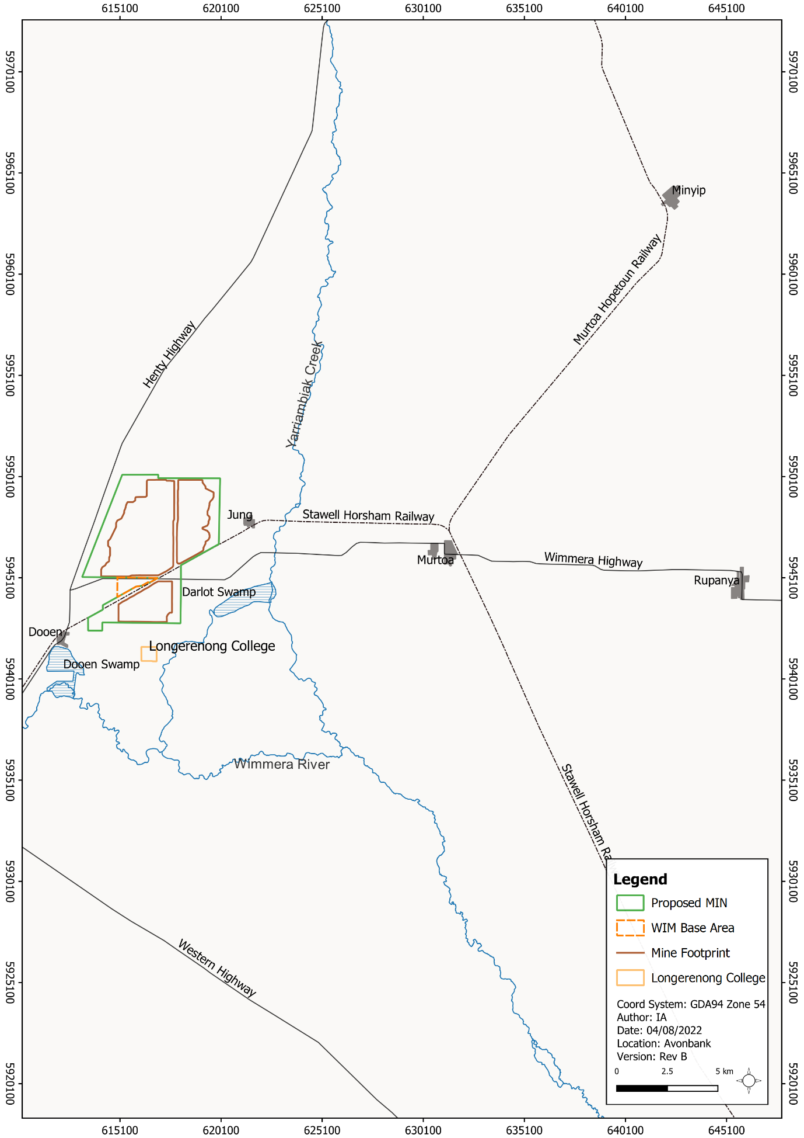
Figure 20-1: Local study area including the proposed mining licence (MIN)
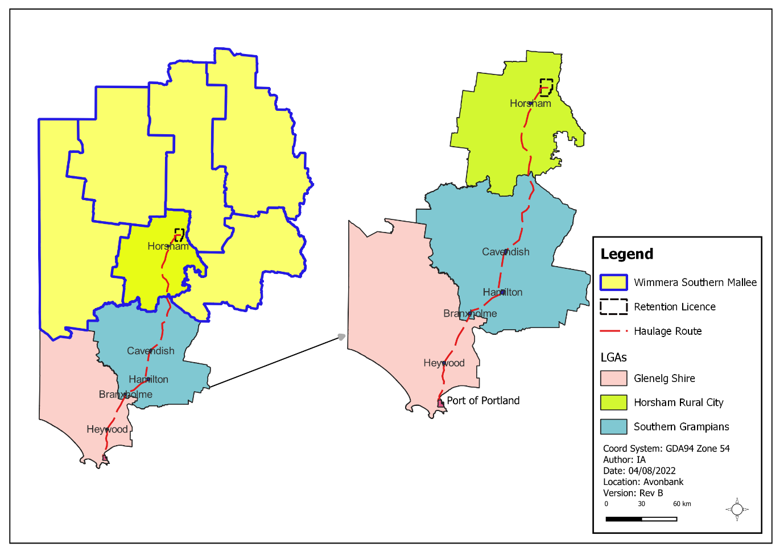
Figure 20-2: Haulage route Horsham to the Port of Portland
Figure 20-3:Wimmera Southern Mallee Region
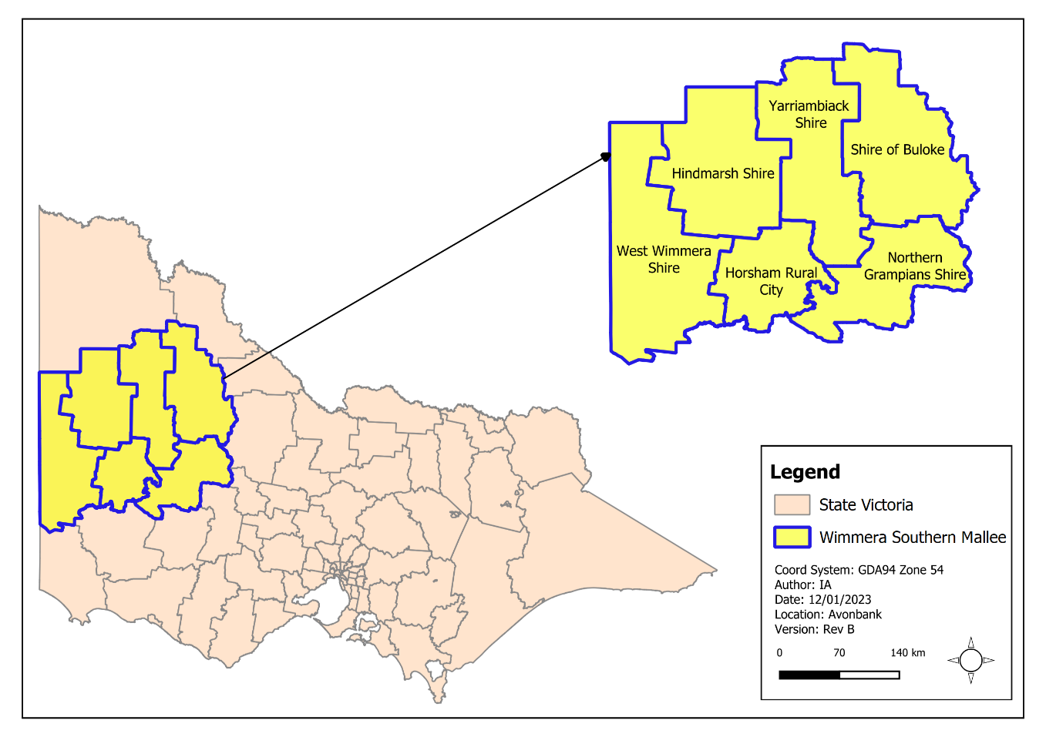

Methodology
The SIA and EIA characterised the existing conditions, identified potential impacts and assessed the residual impacts with avoidance and mitigation measures in place. The tasks undertaken are summarised below and detailed in Appendix O, Section 3, and Appendix N, Section 4.
Existing conditions:
- The Avonbank Community Reference Group (CRG) was consulted for the SIA to identify community issues and views regarding the Project:
- The CRG is comprised of residents, impacted landowners, businesses, representatives of local government, and community and sporting organisations.
- Follow-up telephone discussions were undertaken by the SIA consultant with 17 CRG members who took the opportunity to participate in conversations regarding the Project.
- Telephone discussions were conducted for the SIA with a range of stakeholders and community members, including:
- Representatives from community facilities, including local medical clinics, schools and Longerenong College.
- Representatives from Horsham community services.
- Landowners within and near the development extent.
- Information was collated from technical assessments prepared for the EES to inform existing conditions relevant to the SIA, including the Human Health Risk Assessment, Landscape and Visual Impact Assessment, Noise and Vibration Impact Assessment and Road Traffic Impact Assessment.
- Economic baselines (pre-COVID) were established for benchmarking purposes in the EIA, using an input-output model to detail the interdependent supply chain links between different industry sectors.
Potential impacts:
- Potential sensitive receptors were identified through stakeholder and community consultation and with reference to other impact assessments completed for the Project.
Residual impacts:
- Measures were identified to avoid and/or minimise impacts to sensitive receptors so far as reasonably practicable.
- The residual impacts were assessed with consideration to the magnitude of the social effects and the sensitivity of the receptors.
- Economic modelling was undertaken for the EIA to determine the total economic and employment impact to the State, regional and local economy for each Project phase.
- The cumulative effects of other projects within the region were quantitatively assessed as part of the EIA and qualitatively assessed in the SIA.
The methodology applied to the social and economic impact assessments are further detailed in Appendix O, Section 3 and Appendix N, Section 4.

Operational Context
The proposed development extent at Avonbank will total 3,546 ha comprising mining and related activities within the proposed mining licence (3,426 ha), processing within the WBA (90 ha), and a minor utilities corridor to the WBA for power and water which will extend 14 km (~30 ha).
Facilities at the Port will include a storage shed and loading facilities leased from the Port of Portland Pty Ltd (PoPL). At the Port, Heavy Mineral Concentrate (HMC) will be off-loaded directly into a purpose-built fully enclosed storage shed, with a maximum approximate storage capacity of 70,000 tonnes.
The workforce will comprise between 200–232 personnel directly employed by the Project. During operations (30 years), it is expected that the workforce will reside locally in Horsham or nearby areas. During the construction phase (8–12 months), a portion of the specialised workforce will reside outside the region and travel to site on a fly-in, fly-out or drive-in, drive-out basis.
As described in Chapter 2 (Project Description), mining activity will be conducted within discrete mining Blocks (Block A to Block D) (Figure 20-4). It is expected that rehabilitation will be completed within 4 years after the initial topsoil disturbance in each mining cell. At any given time over the life of mine, the extent of Project disturbance will be less than 400 ha and will typically (on average) be less than 300 ha as areas will be progressively mined and rehabilitated.
Works associated with secondary processing within the WBA are situated outside the proposed mining licence, within the Special Use Zone established over the Wimmera Freight Intermodal Terminal (WIFT) Precinct for industrial purposes, including the processing, storage and handling of mineral sands.
Ore processed within the WBA will be loaded for transport by road to the PoP via Henty Highway. At the Port, HMC will be temporarily stored and shipped to overseas markets for further downstream processing.
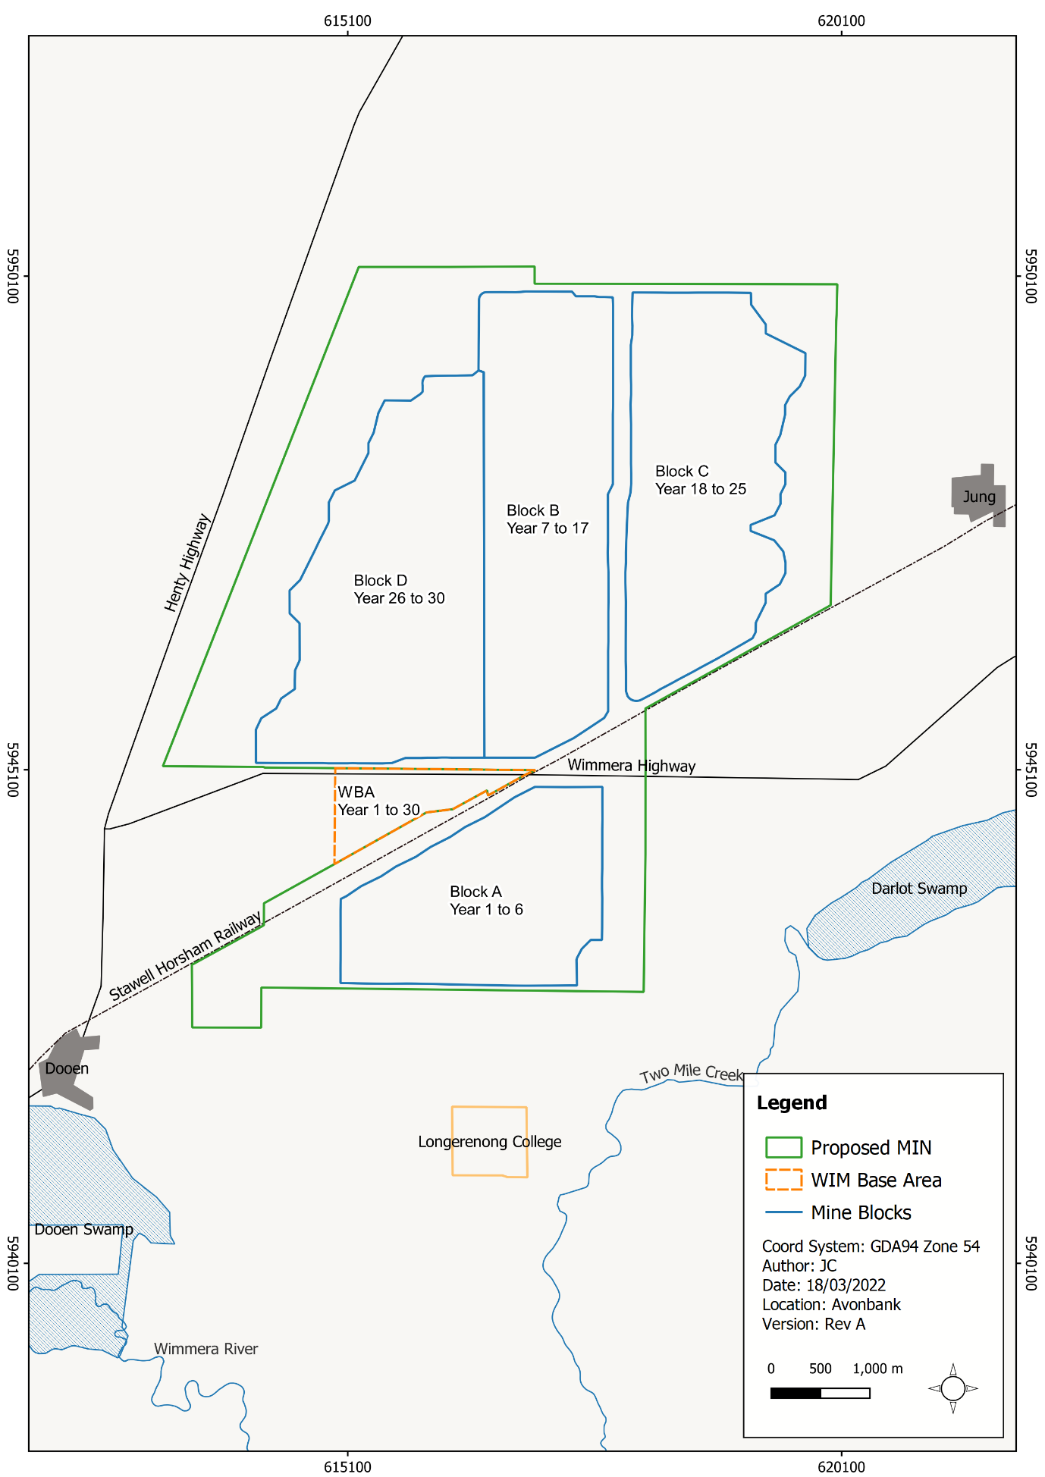
Figure 20-4: Mining Blocks and timing

Existing Conditions

Regional Context

Wimmera Southern Mallee Region
The Avonbank mining and processing facilities will be located in the Wimmera Southern Mallee (WSM) region of Western Victoria, within the Horsham Rural City (HRC) area, approximately 15 km north-east of Horsham. The WSM comprises the Local Government Areas (LGA) of Buloke Shire, Hindmarsh Shire, HRC, Northern Grampians Shire, Yarriambiack Shire, and West Wimmera Shire. The WSM is predominantly an agricultural region with a focus on broadacre cropping.

Population and Employment
The population of the WSM was estimated to be 53,515 in 2019 and has a median age of 47 years. Population decline has occurred over the past 10 years as a result of a younger demographic leaving for education and employment opportunities, combined with an aging population.
The rate of unemployment in the region varies depending on the seasonal conditions. The average annual unemployment rate for the region was 4.1% in June 2020, which is lower than the State average of 5.4%. According to the 2016 Census, the number of jobs in the WSM was 23,360. The top employing industries included agriculture, health care and retail trade, with relatively few workers in the region employed in the mining industry.
Between 2011 and 2016, industries that experienced the largest workforce contraction included information, media and telecommunications, manufacturing, and wholesale trade, whilst administrative and support services, arts and recreation services, and retail trade experienced the largest growth rate.
Employee incomes across the WSM region are similar to other agricultural regions, however, they are generally below those of metropolitan Melbourne and major regional cities.

Business
Business count data from the ABS estimates there are 6,863 businesses operating in the WSM region. These businesses are largely concentrated within the agriculture, construction and rental, hiring and real estate services industries. Between 2015 and 2019, agricultural businesses declined by 5% whilst business numbers within the rental, hiring and real estate services increased.
The highest monthly output (gross revenue) within the WSM was associated with agriculture, forestry and fishing and totalled $125.7 M. Monthly output (gross revenue) from mining within the WSM was $18.3 M.

Horsham Rural City
The HRC is the most populous LGA and largest urban centre in the WSM region. It accommodates a large and relatively diverse population of people across the age spectrum living in a wide range of circumstances. In the HRC, group households, lone persons and single-parent families form a relatively large proportion of all households, however, family households remain the dominant type.
Horsham is also the main administrative centre for the HRC, supporting residents and businesses across the region. The rural city is surrounded by smaller settlements, several of which are located close to the Project and/or are connected to Horsham via the Wimmera Highway, which bisects the proposed mining licence area. These settlements include Dooen, Jung, Murtoa, Rupanyup and Minyip.

Population and Employment
The population of the HRC was approximately 16,462 in 2016, representing 30.7% of the population of the WSM region, and has a median age of 42 years. The population has grown at a rate of 0.3% per annum since 2009 and is projected to reach 17,334 people by 2031. This minor population growth is reflective of regional farming families relocating to the urban centre towards retirement.
Concurrent with the minor population growth is a decline in the working-age population across the WSM region. This trend may be the result of younger residents from Horsham and the WSM region leaving the area, who may otherwise settle and raise families. Anecdotal feedback provided by CRG members indicated a relative lack of attractive education, training and career opportunities in the WSM region contributing to this trend.
The average annual unemployment rate for the HRC was 3.8% in June 2020, which is lower than the WSM region (4.1%) and the State average (5.4%). The rate of unemployment in the HRC has varied over the last decade between 3% and 5%, which may indicate the dependence on the agricultural industry to provide jobs, as unemployment declines when seasonal activities build.
The total estimated number of jobs supported in the HRC, according to 2016 Census data is 9,631. The highest employing industries include health care and social assistance, retail trade and construction. Industries that experienced the largest workforce contraction between 2011 and 2016 include manufacturing and transport.

Business
Business count data from the ABS estimates 2,130 businesses operate in the HRC, with 29% in the agriculture industry, followed by construction (13%), rental and hiring and real estate services (10%).
Between 2015 and 2019, large declines occurred in industries with a small number of businesses, such as public administration and safety. However, the largest loss of business occurred in agriculture, with the number of businesses declining by 9%, which may be indicative of both farm consolidation, poor seasonal conditions and the ageing workforce.

Development Extent and Immediate Surrounds
The majority of land within and near the development extent is primarily farming land held in private ownership and supports a variety of agricultural activities, including broadacre cropping. The area is populated primarily by farming families who live and work on the land, however, some landowners within the proposed mining licence area live in nearby urban centres such as Horsham.
The WBA is situated largely within the WIFT Precinct, which is an area classified as Special Use Zone under the Horsham Planning Scheme. The Special Use Zone has been established for industrial purposes, including but not limited to the processing, storage and handling of mineral sands.
There are 25 separate agricultural properties located either partly or wholly within the mining licence/WBA area and several rural dwellings located in close proximity and in the nearby townships of Dooen and Jung (Figure 20-5). The Longerenong College is an educational property that is partially contained within the proposed mining licence (Figure 20-5).
Dooen is located adjacent to the south-west corner of the proposed mining licence along the Henty Highway. The settlement currently incorporates the Dooen Hotel and a small scattered collection of around 20–30 dwellings bisected by the Henty Highway. The Dooen Hotel is located on Henty Highway and provides a focal point for the local community and surrounding district.
Jung is located approximately 1 km east of the proposed mining licence and had a population of 83 as of 2016. The settlement incorporates several local amenities, including the Jung Hall, Pepper Tree Reserve, and an operating Country Fire Association (CFA) outpost. There are no retail premises or educational or medical services in Jung, and residents rely on those provided in Horsham to the west and Murtoa to the east.
Further east and north-east are several small settlements, including Murtoa (a population of 750 people), Minyip (a population of 390 people) and Rupanyup (a population of 364 people). These settlements incorporate locally oriented retail centres and services only, and residents rely on Horsham for access to higher-order services.
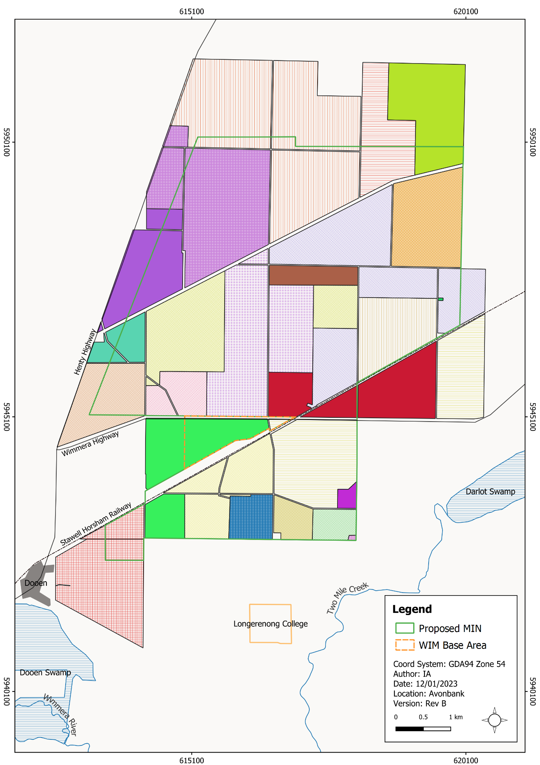
Figure 20-5: Landholdings in the proposed mining licence (MIN) and WBA (each colour represents a discreet landholding)

Community Resources

Private land and housing
A large proportion of housing located near the Avonbank mining and secondary processing facility is contained within the Horsham urban area. At the time of the last Census, there were 7,609 private dwellings in Horsham, which equates to approximately 28.5% of all dwellings in the Wimmera Region. A relatively large proportion of housing within Horsham is made available for rent compared to surrounding areas.
The rate of development of new housing in the HRC is modest and in line with population forecasts. The local rental market has experienced increased demand, largely associated with recent commercial projects in the region. The occupancy rate for the Wimmera Region is 83%, for which around 17% are rented (ABS, 2016b)
As of 2016, there were six hotels/motels (with 15 or more rooms), providing a total of 117 rooms collectively across the WSM region. The rooms were occupied around 20–30% of the time during 2015 and 2016. In addition, there are two caravan parks in Horsham offering cabin-based accommodation, which may be suitable for workers who are operating under a drive-in, drive-out work arrangement. There are also several developed private rental complexes of between 6–10 plus units.

Community facilities
There are several community facilities, services and open spaces located in Horsham which serve the local population and people living throughout the region. Horsham includes a regional-scale commercial and retail precinct, which accommodates several supermarkets, pubs, restaurants, specialty retail and services.
The supply and demand of these services and the capacity of the existing network of services to accommodate increased demand were reviewed and assessed as part of the SIA.
Most educational facilities across childcare and early learning, kindergarten, primary and secondary were observed to have capacity. The two education facilities with the largest enrollments were Horsham West Primary and Haven Primary (700 enrolled) and Horsham College (976 enrolled).
The number of general practitioners (GPs) in the HRC was determined to be approximately 16 combined full-time equivalents. The SIA determined that 17 full-time GPs would be required to support the population of Horsham, and 20 full-time GPs required to serve the needs of the HRC to be aligned with the broader rate per head of population for the State.
Historically, Horsham has had difficulty attracting and retaining GPs. This issue was of concern to some stakeholders in the context of the ongoing supply of GP services to serve the Horsham and surrounding communities.

Haulage route
Haulage traffic will travel on an approved arterial route from the WBA to Portland via Horsham, Cavendish, Hamilton, Branxholme, and Heywood. The road network has been designed to direct travel around the commercial core of Horsham, Hamilton, Branxholme, and Heywood, and in the larger settlements, residences are separated from the haulage route by service roads. In the case of Cavendish, haulage traffic will travel through the centre of the settlement passing by public open space, shops, and the Cavendish Hotel.

Community Consultation
An EES Consultation Plan (EECP) was prepared and implemented to guide community and stakeholder engagement through the Project’s feasibility, planning and EES preparation stage. The Stakeholder Engagement Report (Attachment 1) explains how the objectives of the EECP were met and describes how the community’s feedback has been addressed in the EES.
During the EES preparation period, community feedback was sought through a range of key community stakeholder meetings and site tours, community information sessions (held in Horsham, Murtoa, Jung and Dooen), video-conferencing with focus groups, community information sessions and committee meetings. One-on-one meetings were held with directly and indirectly affected landowners and families.
In general, feedback received indicates that stakeholder sentiment and views towards the Project were positive. Stakeholders expressed interest in the potential for economic benefit to the region and employment and business opportunities projected throughout the Project’s life.
The majority of concerns raised related to potential amenity impacts associated with dust and noise and the potential for land productivity impacts following rehabilitation. These concerns have been addressed in the EES and will be considered where relevant in the associated management plans prior to commencement.
While some directly impacted landholders acknowledged the benefits of the Project, for some, their preference was that mining did not occur on land within their ownership. Direct negotiations are and will be held with the subject parties, such that a suitable Land Access and Compensation Agreement can be achieved.
Further detail regarding the community engagement undertaken during the EES preparation period is provided in the Stakeholder Engagement Report (Attachment 1).

Potential Impacts

Identified Potential Impacts
Potential impacts are identified in the impact assessments with consideration to Project activities, stakeholder concerns and issues, and sensitive receptors (refer Table 20-1).
Where a source-pathway-receptor relationship was considered plausible, further investigation was undertaken to assess the residual impacts with avoidance and mitigation measures in place (refer Section 20.7).
Table 20-1: Potential impacts
Item | Potential Impacts | Phase
IP-01 | Permanent or temporary changes to land use within or adjacent to the development extent resulting in the loss of existing land use. | C, O, D
IP-02 | Mining activities and haulage traffic resulting in altered amenity (air quality, noise or road traffic) of nearby rural dwellings, settlements and community resources. | C, O, D
IP-03 | New residents associated with the Project resulting in an increased demand for community facilities and services influencing service accessibility. | C, O, D
IP-04 | New residents associated with the Project resulting in altered social dynamics within existing communities, influencing social cohesion. | C, O, D
IP-05 | New residents associated with the Project resulting in a heightened demand within the local housing market and local labour market. | C, O, D
IP-06 | The Project resulting in flow-on supply chain and consumption effects on the State, regional and local economies. | C, O, D

Sensitive Receptors
Potential sensitive receptors identified in the SIA and EIA are listed in Table 20-2. Sensitive receptors were identified in the impact assessments with consideration to the spatial extent of the Project, the associated likely effects and the outcomes from stakeholder and community engagement.
Table 20-2: Sensitive receptors
Receptor Type | Sensitive Receptors
Landholders | Landholdings and occupants of residential dwellings within the immediate vicinity of the proposed mining licence and WBA that may be subject to changes in land use.
Residents | Residents and visitors of affected settlements.
Users of public land, waters and facilities | Community using public land, waters/waterways and public facilities.
Longerenong College | Longerenong College students, staff and accommodation village.
Dooen Hall | Users of Dooen Hall.
Dwellings on the haulage route | Residents situated adjacent Henty Highway.
Community facilities and services | Users of facilities in the Horsham and services across the HRC.
Horsham community and WSM community | General public residing and working in the HRC and across the WSM region.
Housing market participants | Renters and home buyers in Horsham and surrounding settlements.

Impact Characterisation
The impact assessment summarised in Section 20.7 considers the magnitude, spatial extent and duration of the residual impacts where relevant, as described in Chapter 6 (Impact Assessment Framework). The SIA considers the effects on the sensitive receptors identified in Section 20.5.2.
The significance of the residual impacts in the SIA was assessed with consideration to the magnitude of change and sensitivity of the receptors, as summarised in Table 20-3.
The EIA considers the residual impacts quantitatively through the economic modelling described in Section 20.2.3.
Table 20-3: Assessing the significance of socioeconomic impacts
Rating | Sensitivity | Magnitude of Change
Extremely Negative/ Positive | Change is unacceptable/necessary.  Receptors have little to no capacity to cope with/without changes. | Very large change relative to baseline conditions. Duration is greater than 10 years and affects many people across a wider area (multiple LGAs).
Negative/ Positive | Change is detrimental/highly beneficial.  Receptors have limited capacity to cope with/without changes. | Large change relative to baseline conditions. Duration is between 3 to 10 years and affects many people across a wider district (such as an LGA).
Moderate Negative/ Positive | Change is undesirable/beneficial.  Receptors have some capacity to cope with/without changes. | Considerable change relative to baseline conditions. Duration is between 1 to 3 years and affects many within a local community.
Minor Negative/ Positive | Change is somewhat acceptable/desirable.  Receptors have capacity to cope with/without changes. | Noticeable change relative to baseline conditions. Duration is between 3 months to 1 year and affects discrete sections of a local community.
Negligible | Change is neither desired or resisted by social receptors.  Receptors are unaffected. | Little to no change relative to baseline conditions. Duration is less than 3 months and affects a small number of individuals.

Avoidance and Mitigation Measures
This Section outlines the measures identified to avoid and minimise residual impacts so far as reasonably practicable. It is noted that in line with the requirements of the environmental management system (EMS) described in Chapter 24 and relevant legislation, additional measures may be required during implementation to ensure risks and potential impacts have been minimised so far as reasonably practicable.
The measures communicated in the broader EES, including but not limited to Chapter 12 (Noise and Vibration), Chapter 13 (Air Quality) and Chapter 9 (Traffic and Transport), will be implemented to minimise amenity impacts and have not been repeated in this Section.

Avoidance

SE-01: Spatial extent
The development extent has been designed to avoid direct impacts on one dwelling and several historic sites that most likely have social and/or familial values (refer Chapter 10, Historic Heritage). Several patches of vegetation have been avoided along road verges and within private property (refer Chapter 21, Flora and Fauna). The mining footprint has been designed to avoid impacts to key public infrastructure, including the Horsham Stawell Railway, the Wimmera Highway and the 220 kV powerline running north-south through the development extent (refer Chapter 2, Project Description).

Minimisation

SE-02: Environmental management system and community engagement plan
It is intended that an AS/NZS ISO 14001:2016 EMS will be developed and implemented across the Project, the scope of which will cover the mine site, processing plant, road transport and activities at the PoP. The EMS will provide a consistent management approach across the Project and will be integrated with other relevant business elements.
An EMS is an auditable system of interrelated business elements established to avoid and minimise effects on the environment, fulfil compliance obligations, enhance environmental performance and maintain a process of continual improvement. The underlying concept is based on a Plan-Do-Check-Act (PDCA) principle comprising the following elements:
- Plan: establish environmental objectives and processes necessary to deliver results in accordance with the organisation’s environmental policy.
- Do: implement the processes as planned.
- Check: monitor and measure performance against the organisation’s environmental policy and environmental objectives.
- Act: take action to meet environmental objectives and to continually improve performance.
The EMS will be developed prior to the commencement of mining, following the EES assessment.
A Community Engagement Plan (CEP) will be incorporated into the EMS. The CEP provides a means by which stakeholders can provide feedback and receive responses and includes a mechanism for recording and resolving complaints. The purpose of the CEP is to develop an understanding between the Project and stakeholders, to provide an opportunity for two-way communication that allows stakeholder concerns to be addressed so far as reasonably practicable, and to facilitate beneficial Project integration with the local area and region. An overview of the community engagement strategy is provided in Chapter 5.

SE-03: Workforce Accommodation Strategy
A Workforce Accommodation Strategy will be developed in consultation with key stakeholders, including the HRC and relevant local housing organisations. The consultation will be undertaken with these groups prior to commencement to minimise adverse effects and to optimise opportunities for the community.

The Strategy will include:
- An estimate of the housing needs of the Project workforce by location.
- A schedule of housing under the control of the Project, inclusive of strategic housing purchases, rental agreements with holiday home owners and partnerships with housing developers.
- An estimate of permanent and temporary housing available on the open market by location and agreed maximum percentage be occupied by imported workers.
- An assessment of the need for mitigation strategies, including drive-in, drive-out or fly-in, fly-out worker positions.
In addition to the above, the housing requirements of the construction and operational workforce will be communicated to the market immediately following Project approval to enable the market to take advantage of the opportunities created by the Project.

SE-04: Targeted community support programs
A community development fund will be established to support community groups through an annual grant selection program. From this fund, targeted community support programs will be planned and funded over the course of the Project to reflect the needs and aspirations of the community.
The community engagement strategy (Chapter 5) recognises the following initial key areas of focus:
- Skills development and apprenticeship programs.
- Indigenous employment programs.
- Mining and rehabilitation research programs.
It is anticipated that an ongoing relationship with the Longerenong College could offer a valuable opportunity to establish student research programs aimed at optimising agricultural mine rehabilitation at Avonbank and more broadly across the mineral sands industry.
Programs will be established to encourage local small businesses to tender on goods and services contracts over the life of the Project.

SE-05: Land access and compensation agreements
Prior to the commencement of work on a mining licence, consent from the owners/occupiers of the land directly affected must be granted. This can be in the form of a written consent agreement or a registered compensation agreement. Such agreements are typically referred to as a Land Access and Compensation Agreement (LACA). Alternatively, land may be purchased prior to commencement.
As described in the Mineral Resources (Sustainable Development) Act 1990 (MRSD Act), the licensee and the owner/occupier of the land may enter into a written agreement regarding the amount or kind of compensation payable by the licensee for any loss or damage that has been or will be sustained as a direct, natural and reasonable consequence of the work plan. The agreement will typically include:
- A description of the licensee's proposed work, including the location and area.
- The anticipated date of commencement and anticipated duration of the proposed work.
- Agreed points of entry onto and exit from the land.
- The number and type of vehicles, plant and equipment involved in the proposed work.
- A description of the facilities the licensee will be provided on the land.
As described in the Work Plan Framework (Attachment 4), LACAs will be progressively sought or acquired over the life of the Project.
For access to land outside the mining licence (WBA or minor utilities corridor), the same process will be applied, such that written agreements are entered into or the land acquired prior to works commencing.

Rehabilitation

SE-06: Rehabilitation plan
A Rehabilitation Plan will be established for the Project that will address matters relating to progressive rehabilitation and closure. It will cover all work areas within the proposed mining licence and within the broader development extent and PoP.
The Rehabilitation Plan will include a schedule of progressive rehabilitation and will describe the strategy to establish a safe, stable, sustainable landform capable of supporting the proposed end land use. It is expected that land will be stabilised as soon as reasonably practicable after mining, typically within 4 years.
The Rehabilitation Plan will define the end land use with consideration to the views of the landholders and the broader community where appropriate.
A preliminary Rehabilitation Plan for the Project has been developed to meet the intent of the Scoping Requirements and is included with this EES as Attachment 3. This plan will be refined prior to commencement with consideration to the detailed operating plans, stakeholder and community feedback and the Minister’s assessment of the EES.

Residual Impacts
This Section describes the likely residual socioeconomic impacts with avoidance and mitigation measures in place. The residual impacts have been characterised as described in Section 20.5.3 and Chapter 6 (Impact Assessment Framework).

Direct Land Use Impacts
There is one potential impact (IP-01) listed in Section 20.5.1 that relates to impacts associated with the displacement of current land use and residents within the development extent.
Within the proposed mining licence, the extent of Project disturbance will be less than 400 ha and will typically (on average) be less than 300 ha as areas are progressively mined and rehabilitated. This will result in a change of land use from what is primarily broadacre farming to mining and ancillary uses. This will be a temporary land use change that is expected to extend up to 4 years within any one section of the mining footprint. Once rehabilitation is complete, the land will be returned to its pre-mining land use.
There are currently 25 landholdings (excluding Crown land tenure and managed public land) within the proposed mining licence, which are used for agricultural purposes and which may be affected by the Project (refer Chapter 8, Land Use and Planning). Some of these properties will be acquired over the course of the Project and some will remain as private landholdings. For those properties that are not acquired, loss to individual landholders will be compensated through the establishment of LACAs, which must be in place prior to mining each landholding.
Of the landholdings described above, there are six which have residential dwellings that will be affected by the Project. This includes one dwelling (R38) within the mining footprint that is likely to be removed by mining, pending ongoing discussions with the landholder. Additionally, there will be one residential receptor (R89) within 250 m of the mining footprint and a further four (R6, R33, R34, R35) within 250 m of the disturbance footprint at times over the life of mine (refer Figure 20-6). All six landholders will be displaced for periods over the life of the Project due to their proximity to the operations.
These dwellings will either be acquired, or a LACA will be put in place as described in Section 20.6.2.4. Some affected landholders may view the sale of their property or the LACA as a net positive. It is acknowledged, however, that for some landholders with a strong emotional tie to the land, this impact is not entirely mitigated through financial compensation.
Of importance to the local community is the commitment to return agricultural land to a sustainable landform capable of supporting a productive end land use. Pre-mining rehabilitation trials were undertaken at Avonbank to provide landholders confidence that this objective can be achieved. The outcomes of these trials are detailed in Chapter 15 (Soils and Landform).
On balance, with avoidance and mitigation measures in place, the residual impacts associated with displacement were assessed to be a moderate negative impact on a limited number of landholders, primarily due to the displacement of residents, as described above. The EMS and CEP set out a framework to engage landholders directly affected as well as those in the broader community to minimise this impact so far as reasonably practicable (refer Section 20.6.2.1).
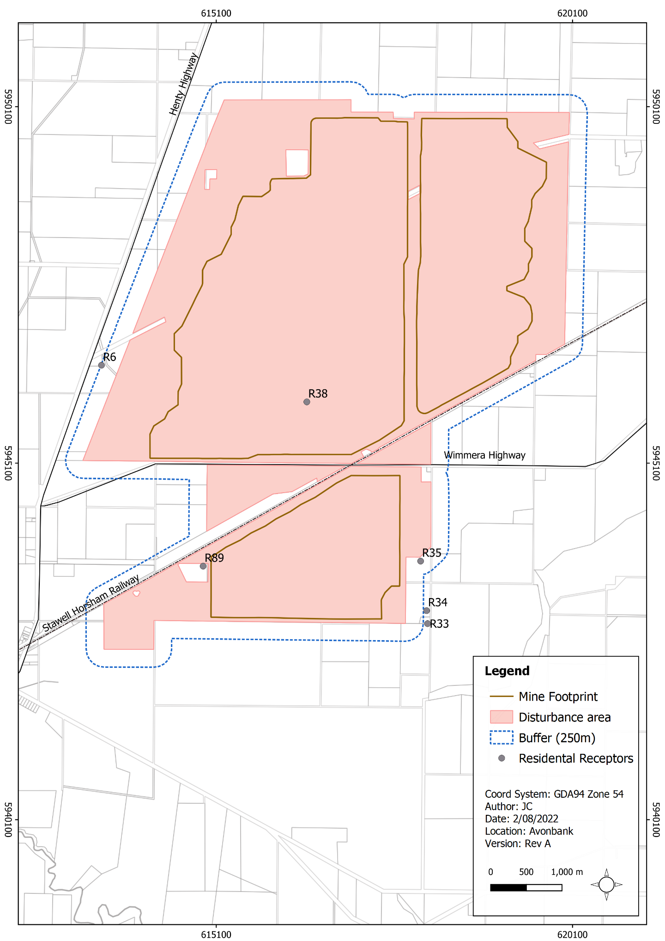
Figure 20-6: Receptors directly affected by mining

Amenity Effects
There is one potential impact (IP-02) identified in Section 20.5.1 that relates to impacts associated with the altered amenity of nearby rural dwellings, settlements and community resources. Various Project activities have the potential to affect amenity. These are described below.

Dwellings surrounding the Project
For residents located in proximity to the proposed mining licence and WBA that are not directly impacted (displaced), the presence of the Project may be perceived to detract from the area’s rural residential amenity. While impact assessments undertaken for noise, air emissions and road traffic found there to be negligible to minor impacts to landholders within the immediate vicinity of the mine, current owners/occupiers may be less satisfied with their residential amenity as a result of the Project.
The residual impacts due to the loss of actual or perceived amenity were assessed to be minor to moderate, depending on the sensitivity of the landholder and the extent to which they feel emotionally connected to the landscape. It is intended that landholder specific concerns will be managed through the EMS and associated CEP, which allows issues to be raised, investigated and resolved so far as reasonably practicable (refer Section 20.6.2.1).

Townships and settlements
Project related haulage traffic passing through townships and settlements has the potential to generate noise and accessibility concerns. Traffic and amenity impacts were assessed for Dooen and Cavendish as representative worst-case scenarios, as described in Chapter 9 (Traffic and Transport), Chapter 12 (Noise and Vibration) and Chapter 18 (Human Health Risk Assessment).
Along the haulage route, the Noise and Vibration Impact Assessment and Human Health Risk Assessment showed there would be minor impacts to dwellings adjacent Henty Highway. Predicted existing daytime and night-time road traffic noise levels exceed the WHO noise benchmarks at most roadside receptors in both Cavendish and Dooen prior to Project commencement. The increment from the Project was assessed to be minor and was not expected to lead to an increase in sleep disturbance in either Dooen or Cavendish, above that due to existing traffic (refer Chapter 18).
In addition to effects at the dwelling level, as discussed above, heavy vehicle traffic is commonly considered to detract from the amenity of urban settlements, discourage pedestrian movements and the use of outdoor areas in proximity to roads.
The Project induced increase in heavy vehicle movement is relatively small (two movements per hour) and would be set against a trend of increasing traffic on the Henty Highway. When this is considered, the Project would not fundamentally affect street level conditions in Cavendish or Dooen and would be unlikely to directly influence the lifestyle patterns of residents.
The residual impact associated with amenity loss at towns and settlements along the haulage routes was assessed to be negligible to minor. The EMS will set out a system to investigate and respond to community complaints. This will include a process to resolve issues by identifying the root cause and applying corrective measures, so far as reasonably practicable, in consultation with the complainant (refer Section 20.6.2.1).

Longerenong College
During the mining of Block A, operations will be within 1.2–3 km from the Longerenong College for a period of around 1 to 7 years prior to moving to Block B. With avoidance and mitigation measures in place, the noise levels during mining were modelled to be below the Environment Protection Authority (EPA) criteria, and the residual impacts were assessed to be negligible. There was also assessed to be a negligible risk to human health associated with mine related particulate matter and depositional dust on crops or rainwater tanks. There was assessed to be no change to the operation of the Longerenong College, and the residual social impacts were assessed to be negligible to minor.

Social Profile Impacts
There are two potential impacts (IP-03 and IP-04) in Section 20.5.1 that relate to new residents to the region increasing the demand for community services and affecting social cohesion. These effects are described below.

Demographics
The Project will generate 232 ongoing full-time jobs during the operational phase of the Project. These jobs would be relatively well paid and include skilled ‘blue collar’ and ‘white collar’ positions.
A portion of the job opportunities created by the Project are expected to be filled by existing residents of the WSM, with around 25% of the workforce expected to be people moving to the area for jobs associated with the Project.
Targeted community support programs will be developed to offer employment and training opportunities created by the Project (refer Section 20.6.2.3). The implementation of the Project will contribute to addressing one of the principal drivers of out migration of young adults from the HRC.
The Project would assist in attracting and retaining young adults in the region and in doing so, act to offset the observed trend of population ageing, contributing to the viability of community services such as schools and childcare and injecting energy and enthusiasm into social and cultural activities. This is a positive impact in the context of the recent observed ‘leakage’ of young adults from the HRC and the WSM.

Community facilities and services
The Project has the potential to increase the demand for community facilities and services in Horsham due to new residents or temporary workers residing in the area. Demand for children’s services and schools will be relatively small and is set against a trend of declining demand for services targeted at a younger demographic. This demand is considered to result in a minor positive residual impact, as it will aid the sustainability of these services in the context of a projected decline in demand.
In addition, new residents and workers to the area may increase demand for medical services in Horsham, which has historically experienced difficulties in attracting and retaining medical professionals. The projected uplift in demand would not be sufficient to fundamentally alter the current balance between supply and demand, and the residual impact was assessed to be negligible.

Social cohesion
New residents to the area that are associated with the Project have the potential to affect social cohesion within the existing community of Horsham and/or in nearby settlements. The majority of permanent employees who migrate to the WSM would take residence in Horsham (due to proximity), with a minority potentially opting to live in nearby townships, such as Murtoa.
The Project’s longer-term objective for the operational phase is for workers to reside in the local community to enable these people to become integrated with the existing community and contribute to the social and cultural life of the region. This approach is most sustainable and beneficial in terms of the health and wellbeing of the workers and their families, as it allows for a conventional work-home life and encourages workers to contribute to the area in which they are living.
Horsham accommodates a relatively large and diverse population that is growing. It is expected that this small portion of new residents associated with the Project will become integrated within the existing community and contribute to the social and cultural life of the region, resulting in a minor positive residual impact.

Community Impacts
There is one potential impact (IP-05) identified in Section 20.5.1 that relates to the heightened demand within the local labour market and housing market.

Local labour market
During operations, the Project will employ 232 workers. Based on the skills required for Project operation, it is expected that approximately 75% of this workforce will already reside in the region. For every worker employed directly by the Project, the WSM will indirectly benefit from an extra 1.5 full-time equivalent jobs due to increased supply chain demand and consumption effects.
In this context, the Project will result in a positive residual impact by providing and supporting additional jobs and employment diversity and may lower the unemployment rate in the HRC and the WSM. The indirect effects of the Project are anticipated to result in additional jobs across a range of regional industries, which would coincide with increased supply chain demand, increased consumption and increased business revenue.
The additional demand for local workers with the relevant skill sets for mining operations has the potential to adversely impact industries such as agriculture, construction and manufacturing in the short-term. However, the increased investment in the area is expected to attract additional workers, increasing the labour market pool, population, and labour force participation, which is an overall benefit to the WSM.
The Project is expected to result in a longer-term positive residual impact, as it will increase the size of the labour force by providing a diversified opportunity of jobs for the local and regional workforce. Targeted support programs will be undertaken to encourage local residents to apply for employment opportunities and skills development programs and apprenticeships for a range of critical skill sets.

Housing market
New workers to the region associated with the construction and operation of the Project will generate accommodation demand, which may affect existing housing market conditions in Horsham.
There is a substantial amount of unused capacity within the region’s temporary accommodation market, which will allow for the construction workforce to be accommodated without undue pressure being placed on this resource. As a result, the impact of the Project on the temporary housing market would be positive, creating a period of sustained increase in demand for an underutilised sector.
In relation to the permanent housing market, the additional demand for dwellings (approximately 60 dwellings) associated with the Project would be potentially significant, both in terms of the scale of rental market activity and the observed rate of development of new dwellings.
The existing market conditions may also be influenced by the influx of workers to the region in association with several other commercial projects. Anecdotal feedback indicates that the housing market in Horsham is ‘tight’, meaning increased demand associated with recent commercial projects in the region has led to spikes in rental prices.
It is expected that the imported component of the workforce will likely reside outside the WSM during the construction phase of the Project (working under a drive-in, drive-out model) and will progressively move to the region over the first 3 years of operation. To manage the effects of new residents to the region, the Project’s accommodation requirements would be signalled to the housing market as soon as practically possible, in advance of the migration of workers and their families.
By extending the period over which workers migrate to the region and providing information to the market well in advance of the projected uplift in demand, the effect on the housing market dynamics would be softened. While there is some limited potential for a short-term effect on the local housing market, this will likely be minor and have the effect of limiting choice for market participants with reduced purchasing power. However, the effect would be short-lived, and as the new residents integrate into the local community and market conditions would re-balance.
A Workforce Accommodation Strategy will be developed in consultation with key stakeholders, including Horsham Rural City Council and relevant local housing organisations. Consultation will be undertaken with these groups prior to commencement of construction to minimise adverse effects and to optimise opportunities for the community. The residual impacts relating to both the construction and operational phases of the Project were assessed to be negligible to minor.

Economic Impacts
There is one potential impact (IP-06) identified in Section 20.5.1 that relates to impacts associated with the economic effects of the Project. This is described below in the context of State and regional scale impacts.
The Project is estimated to generate a total of $5,772 million in additional Gross State Product (GSP) over the life of the Project and a gross revenue output of $335 million per annum in the WSM. The total economic loss of agricultural production due to the Project is relatively minor and is estimated to fall by $465,450 per annum.
Once flow-on supply chain and consumption effects are taken into consideration, it is estimated that for every job supported during operations, the State economy will benefit by more than three additional full-time equivalent (FTE) jobs. This is a significant positive impact for the State with respect to additional jobs that will result from the Project.
Table 20-4 below details the economic impacts the Project will have on the State and regional economy every year it is operational and are inclusive of direct, flow-on supply chain and consumption effects. The cumulative total economic effects for each Project phase are detailed in Appendix N, Table 13-1.
Table 20-4: Annual operational economic impacts on the State and regional economy
Area | Gross Revenue | Employment | Wages and Salaries | Value Added
Victoria | $512.8 million | 967 FTE jobs | $93 million | $192.4 million
WSM Region | $335 million | 588 FTE jobs | $56.7 million | $116.7 million

This represents a significant positive economic impact on the region and State. The flow-on beneficial effects for the community stemming from increased economic growth could reasonably be expected to:
- Improve public services due to higher demand and higher government tax revenue.
- Provide inter-generational employment opportunities that in turn reduces the unemployment rate and associated effects of unemployment.
- Increase demand for goods and services provided by local businesses.
- Foster regional skills development and training opportunities.
- Increase investment in new developments.
- Drive economic diversification in the region.
The development of the mining sector in the WSM region is aligned with both State and regional development policies. The State Government’s economic action plan, ‘Securing Victoria’s Economy’ (Vic Gov, 2012), aims to make Victoria a global hub of mining and mining services, while the ‘Wimmera Southern Mallee Regional Growth Plan’ (Vic Gov, 2014) specifically identifies the development of this sector, as critical to achieving the broader regional objectives.

Management Framework
An AS/NZS ISO 14001:2016 EMS will be established for the Project, as detailed in Chapter 24. The EMS will address matters relating to planning, operational control, monitoring and continuous improvement over the life of the Project. Relevant matters relating to monitoring and auditing are summarised below.

Environmental Objectives
Social and economic objectives will be established as part of the EMS to articulate the outcomes to be achieved during Project implementation. These reflect the expected and achievable outcomes based on the studies undertaken as part of this EES.
The key socioeconomic environmental objective is to optimise feasibility of the Project and enhance socioeconomic benefits for the State. Performance standards will be established to measure/assess if the environmental objectives have been achieved during operations, as further discussed in Section 20.8.2.

Monitoring and Management
The monitoring of socioeconomic effects will be undertaken through community feedback mechanisms such as periodic community surveys and the complaints handling and communications management procedure. These will be carried out throughout the duration of the Project as part of the CEP (refer Section 20.6.2.1).
Recorded feedback will be used to identify socioeconomic issues and concerns. The CEP provides a means by which stakeholders can provide feedback and receive responses and includes a mechanism for recording and resolving complaints.

Audits
Periodic internal and independent audits will be undertaken to assess the effectiveness of the EMS. An internal audit program will be maintained, which details the frequency, methods, responsibilities, and reporting requirements.
Audits will be undertaken by a suitably qualified person to assess the effectiveness of the EMS and associated management plans (including the CEP) to minimise or avoid socioeconomic impacts so far as reasonably practicable. Any non-conformity identified in the audit will be investigated and corrective actions implemented.
The outcomes of audits will be communicated to the Project Management team and records of the audit findings will be retained in the record management system. Significant findings will be reported to relevant Regulators and stakeholders where appropriate to do so.

Cumulative Impacts
The impact assessment considered the cumulative impacts of the proposed mineral sands projects within the region and State government major road projects, including:
- Donald Mineral Sands Project.
- Iluka Wimmera Project.
- WIM150 Mineral Sands Project.
- Murra Warra Windfarm.
- Wimmera Plains Energy Facility.
- Western Renewables Link.
All heavy mineral sands (HMS) projects are greater than 15 km from the Avonbank Project. The WIM150 Minerals Sands Project and the Donald Minerals Sands Project are both located in the Wimmera region and are similar in size, workforce requirements and project duration to the Avonbank Project. The WIM150 Mineral Sands Project is located 20 km from Horsham and the Donald Mineral Sands project is located 50 km from Horsham. Both projects have the potential to generate additional demand for permanent accommodation in the HRC and WSM. However, the timing of these projects is currently uncertain and the EES process for the WIM150 Mineral Sands Project has been placed on hold.
The Iluka Wimmera Mineral Sands Project is located south-west of Horsham. This project is in its pre-feasibility stage and has commenced the planning process with an EES in development. Current projections for the duration of mining activity (and associated progressive rehabilitation works) is a 20–25 year period. Preliminary economic modelling was undertaken to determine the potential cumulative economic impacts of all four minerals sand mines (inclusive of the Avonbank Project).
The preliminary modelling determined a combined total economic impact on Victoria of $750.2 million in GSP during construction and $769.9 million in GSP each operational year. The Avonbank Project contributes 25% of these cumulative totals.
There is a significant opportunity for the WSM to become a globally significant hub for mineral sands. Preliminary modelling indicates that with three additional HMS mines there would be a total of 3,867 FTE jobs for the State of Victoria and 1,766 FTE jobs for the WSM.
There is limited information available on the size, duration and current status of the Wimmera Plains Energy Facility. The Western Highway Duplication project is being undertaken in stages, with some sections completed and others in planning or construction. The project will continue to draw on the availability of construction contractors and labour for the foreseeable future. The proposed Western Renewables Link is in the planning process and is expected to create a large demand for construction labour and contractors.
These projects, in combination, will increase the size and the skills of the local workforce. However, the long-standing skills gap in regional Victoria may be exacerbated in the future due to the pipeline of major projects. While there is potential for all the projects to be active simultaneously, it is less likely that they will commence at the same time. This will allow for additional demand for permanent accommodation in Horsham to be introduced into the market progressively. The contribution of the Avonbank Project to risks associated with increased demand for housing will be managed through the proposed Workforce Accommodation Strategy.
The cumulative demand for community services and facilities associated with these projects will contribute to the viability of services currently experiencing declines, such as childcare and schools, as a large component of the workforce would potentially relocate to the region with their families. These projects have the potential to create a cumulative increased demand for medical services in the HRC and the WSM, which may exacerbate the ongoing challenge of attracting and retaining medical professionals within the region. However, it is expected that this cumulative demand would be relatively minor due to the likely staggered timing of the projects.

Conclusions
This Chapter provides an overview of the Social Impact Assessment and Economic Impact Assessment, prepared to address the EES Scoping Requirements for the Avonbank Mineral Sands Project.
The potential impacts associated with the Project activities were assessed as part of the detailed impact assessments prepared by Public Place and REMPLAN. Consideration was given to potential impacts associated with land use, access and amenity changes resulting from mining and ancillary activities and changes to the State, regional and economic profile resulting from labour market demand and direct flow-on supply chain and consumption effects.
Avoidance and mitigation measures were identified to reduce the residual impacts so far as reasonably practicable. Listed below are the key measures identified:
- Land Access and Compensation Agreements (LACA) will be negotiated with directly impacted landowners within the mining licence and WBA, or properties will be purchased.
- An EMS and CEP will be maintained such that there is a formal framework within which community issues can be resolved if they arise.
- A Workforce Accommodation Strategy will be prepared prior to commencement to minimise adverse effects and to optimise the opportunity for the community regarding the Project’s housing requirements.
- Targeted community support programs will be planned and funded over the course of the Project to reflect the needs and aspirations of the community.
Within the proposed development extent, Project disturbance will typically (on average) be less than 300 ha as areas are progressively mined and rehabilitated. There will be a temporary change of land use from broadacre farming to mining and ancillary uses as areas are progressively mined and rehabilitated. Landholders will be compensated for this temporary change in land use through the negotiation of Land Access and Compensation Agreements where relevant.
A small number of dwellings situated either within the mining footprint or in close proximity will be displaced by mining over the course of the Project. It is anticipated that several of these properties will be purchased prior to mining and for those properties that are not acquired, loss to individual landholders will be compensated through the establishment of Landholder Access and Compensation Agreements. This was assessed to be a moderate residual impact, as it can be expected that several landholders will have strong emotional ties to their properties that financial compensation may not address fully.
Environmental amenity impacts associated with air quality and noise at residences surrounding the Project (not directly impacted) and along the haulage route were assessed to be minor to negligible. There may however be some perceived loss of amenity for some individuals. This was assessed to be a minor to moderate residual social impact.
There is some limited potential for a short-term effect on the local housing market, which may limit choice for market participants with reduced purchasing power. However, the effect would be short-lived, and as new residents integrate into the local community, market conditions would re-balance. The residual impact was assessed to be a minor, relatively short-term effect.
It is projected that the uplift in demand for community services, including childcare and medical services, would not be sufficient to fundamentally alter the current balance between supply and demand, and the residual impact was assessed to be negligible.
The Project will create and sustain significant long-term employment and economic activity in the WSM region, with a gross revenue output of $335 million per annum in the WSM. The total economic impact of Avonbank operations will support 588 jobs across the WSM and 967 in Victoria (direct and indirect full-time equivalent).
The above noted minor to moderate social impacts can be managed with avoidance and mitigation measures in place. Overall, on balance, the Project is expected to result in a significant positive socioeconomic impact on the region and the State of Victoria.

Construction (C); Operations and rehabilitation (O); Decommissioning and closure (D)

