Avonbank Mineral Sands Project
Environment Effects Statement

Chapter 3 – Project Alternatives

TABLE OF CONTENTS
3 Project Alternatives 3-1
3.1 Introduction 3-1
3.2 Assessment Process 3-1
3.3 Project Alternatives 3-1
3.3.1 Mine Planning and Scheduling 3-1
3.3.2 Vegetation Removal 3-4
3.3.3 Location of the Wet Concentrator Plant 3-5
3.3.4 Ore Mining 3-6
3.3.5 Material Movement (Overburden) 3-7
3.3.6 Material Movement (Subsoils) 3-8
3.3.7 Sand Tailings Management 3-9
3.3.8 Access to WIM Base Area 3-13
3.3.9 HMC Transport 3-13
3.3.10 Power Supply 3-14
3.3.11 Power Grid Based Options 3-15
3.3.12 Water Supply 3-16
3.3.13 Water Supply Infrastructure 3-17
3.3.14 Rehabilitation and Closure 3-19
3.4 No Development Option 3-20
3.5 Conclusion 3-21

TABLES
Table 3-1: Comparison of mine scheduling options 3-2
Table 3-2: Comparison of mining layout 3-4
Table 3-3: Comparison of WCP locations 3-6
Table 3-4: Ore mining machinery comparison 3-7
Table 3-5: Overburden movement assessment 3-8
Table 3-6: Comparison of mining equipment 3-9
Table 3-7: Tailings management alternatives 3-10
Table 3-8: Access to WBA comparison 3-13
Table 3-9: Assessment of transport options 3-14
Table 3-10: Power supply options comparison 3-15
Table 3-11: Power grid supply comparison 3-16
Table 3-12: Water supply options comparison 3-17
Table 3-13: Water supply infrastructure 3-18
Table 3-14: Rehabilitation comparison assessment 3-20

FIGURES
Figure 3-1: Mining blocks and timing 3-3
Figure 3-2: Mine footprint options and vegetation avoidance in Block D 3-5
Figure 3-3: Co-disposal tailings drying at the Avonbank test pit 3-11
Figure 3-4: Centrifuge operating at the pilot plant 3-12
Figure 3-5: Geobag being trialled in the Avonbank test pit 3-12
Figure 3-6: Water supply options 3-19

Project Alternatives

Introduction
This Chapter provides an overview of the Project design alternatives for the Avonbank Mineral Sands Project (the Project). It has been prepared to address the Environment Effects Statement (EES) Scoping Requirements (DELWP, 2020), which requires that the EES describe the Project design alternatives, particularly where these offer a potential to minimise and/or avoid significant environmental effects.
The Scoping Requirements specify that the EES ‘explain the proponent’s assessment of feasible alternatives, including an explanation of how and why specific alternatives were shortlisted for evaluation within the EES. The associated Scoping Requirements are detailed in Appendix A of this EES.
This Chapter responds to the Scoping Requirements to describe how the Project design options were assessed with consideration to the overarching Project objectives. The preferred options communicated in this Chapter are further described in Chapter 2 (Project Description).

Assessment Process
The Project design described in Chapter 2 was developed and refined over the course of the EES preparation period, with consideration to the studies undertaken for the Definitive Feasibility Study (DFS), the EES impact assessments, and stakeholder feedback.
Assessments were undertaken to consider various design alternatives to address the overarching Project objectives, which are to: optimise recovery of the resource and feasibility of the Project; avoid or minimise impacts to the environment (and community) so far as reasonably practicable; and enhance the socioeconomic benefits for the State.
The design alternatives assessment involved:
- Identification of the options available to address the Project’s operational requirements.
- Assessment of the available options with consideration to the:
- Operational constraints and opportunities.
- Environmental risks and opportunities.
- Project cost implications and limitations.
- Stakeholder views and feedback.
- Selection of the preferred option that best met the Project objectives.
The alternatives summarised in this Chapter include those which could have a material effect on the Project’s overarching objectives or were listed for investigation in the Scoping Requirements. The alternatives analysis for each key Project requirement are summarised in Sections 3.3.1 to 3.3.14.

Project Alternatives
This Section describes the key Project requirements, available options to address those requirements, and the outcomes from the alternatives assessment process.

Mine Planning and Scheduling

Project requirement
A ‘moving hole’ mining method will be used to enable progressive rehabilitation over the life of the Project. The mining method will involve the direct return of tailings and overburden into the mined cell as the mining front advances. The mining footprint is divided into four Blocks (A–D), as described in Chapter 2 and shown in Figure 3-1.
The proposed mine schedule aims to minimise capital costs, operational costs and target high-grade ore with a low strip ratio during the initial stages of the Project.

Schedule starting location options and assessment
The two mining options assessed comprise:
- Target northern high-grade and low strip ratio first (Block B).
- Target southern high-grade and low strip ratio first (Block A).
The options analysis is summarised in Table 3-1.
Table 3-1: Comparison of mine scheduling options
Options Assessment
Option A – Block B start (North)
Operational constraints and opportunities:
- Water demand at start-up would be higher than the alternative due to lower predicted pit inflow from groundwater.
Environmental risks or opportunities:
- Less groundwater intercepted in the north compared to the areas associated with Block A.
Project cost implications and limitations:
- Higher start-up costs due to strip ratio (overburden to stockpile) and higher mining related costs due to depth to the top of ore (strip ratio) than the alternative.
- Higher capital cost than the alternative associated with purchasing extra booster pump stations.
Stakeholder considerations:
- Several extra landholders would be impacted during the first 3 years of mining compared to the alternative.
Option B – Block A start (South)
Operational constraints and opportunities:
- Water demand would be lower than the alternative due to higher predicted pit inflow from groundwater.
Environmental risks or opportunities:
- Ore body intersects the groundwater at a higher level and will require some dewatering.
Project cost implications and limitations:
- Lower start-up costs due to better strip ratio (overburden to stockpile) and lower mining related costs due to shallower depth to the top of ore (strip ratio).
Stakeholder considerations:
- Fewer landholders would be impacted in Block A than the alternative over the first 3 years of mining.
Targeting Block A (Option B) for the mine start-up was selected as the preferred option primarily due to the lower capital expenditure during the first 5 years of the Project and a lower number of impacted stakeholders compared to starting in Block B. The minor environmental impacts associated with groundwater interception will be realised over the life of the Project regardless of the starting location and are described in Chapter 17 (Groundwater) Sections 17.7.1 and 17.7.2.
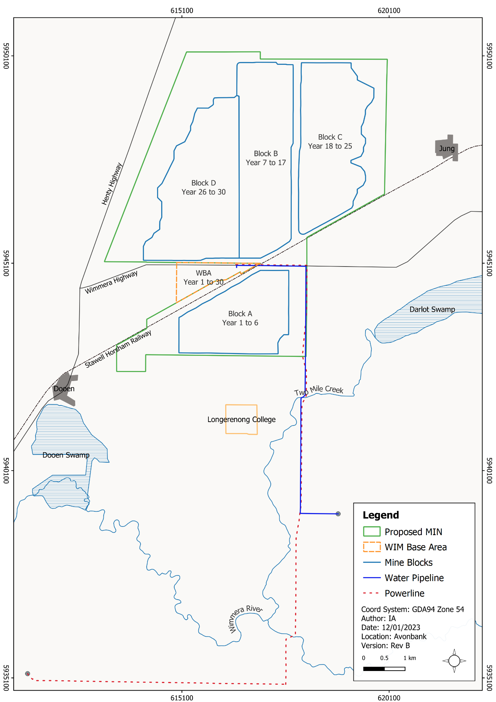
Figure 3-1: Mining blocks and timing

Vegetation Removal

Project requirement
Mining, processing and ancillary activities undertaken within the development extent will necessitate the removal of vegetation and topsoil. There is one threatened ecological community (TEC), Buloke Woodlands of the Riverina and Murray-Darling Depression (Buloke Woodlands), listed under the Environment Protection Biodiversity Act 1999 (EPBC Act), that has been surveyed within the development extent (refer Chapter 21, Flora and Fauna).

Mining layout options and assessment
Various native vegetation avoidance measures were incorporated into the Project design during the feasibility stage. The most notable of these is discussed below.
The options considered for mining Block D include:
- Mining across the entire Block D to access the entire mineral resource.
- Mining a portion of Block D and avoiding the north-west corner to preserve Buloke Woodland.
The options analysis is summarised in Table 3-2.
Table 3-2: Comparison of mining layout
Options Assessment
Option A – Mining the entire Block D
Operational constraints and opportunities:
- Full access to Block D facilitating full extraction of the ore body.
Environmental risks or opportunities:
- Removal of 30 ha in Block D in the north-west corner, resulting in the removal of 3.4 ha of Buloke Woodland.
Project cost implications and limitations:
- Cost associated with providing native vegetation offsets.
- Full access to the Block D ore body (2.3 Mt of ore), resulting in greater revenue than the alternative.
Stakeholder considerations:
- Removal of vegetation reducing biodiversity values.
- Increased economic benefit (including jobs and direct/indirect revenue) to the Wimmera Sothern Mallee (WSM).
Option B – Mining portion of Block D to avoid Buloke Woodland
Operational constraints and opportunities:
- Reduction of the mining footprint, resulting in sterilisation of 30 ha of ore in Block D, equating to a total of 6.8 Mt of ore.
Environmental risks or opportunities:
- Preservation of 3.4 ha of Buloke Woodland.
Project cost implications and limitations.
- Increased capital and operational costs on a pro-rata/area basis.
- Reduction in revenue.
Stakeholder considerations:
- Protection of biodiversity and amenity values.
- Reduced economic benefit (including jobs and direct/indirect revenue) to the WSM region.
Mining with an exclusion zone in place to protect the Buloke Woodland in Block D was selected as the preferred option (Option B) (refer Figure 3-2). The avoidance measures incorporated into the Project design required that the mining footprint be reduced and areas of the resource (ore body) sterilised. On balance, the preservation of the Buloke woodland was considered to be of net benefit with consideration to the environment and the socioeconomic effects. This exclusion zone, as well as other avoidance measures applied to the Project to minimise the extent of native vegetation removal, is further described in Chapter 21, Sections 21.6.1 and 21.7.1.
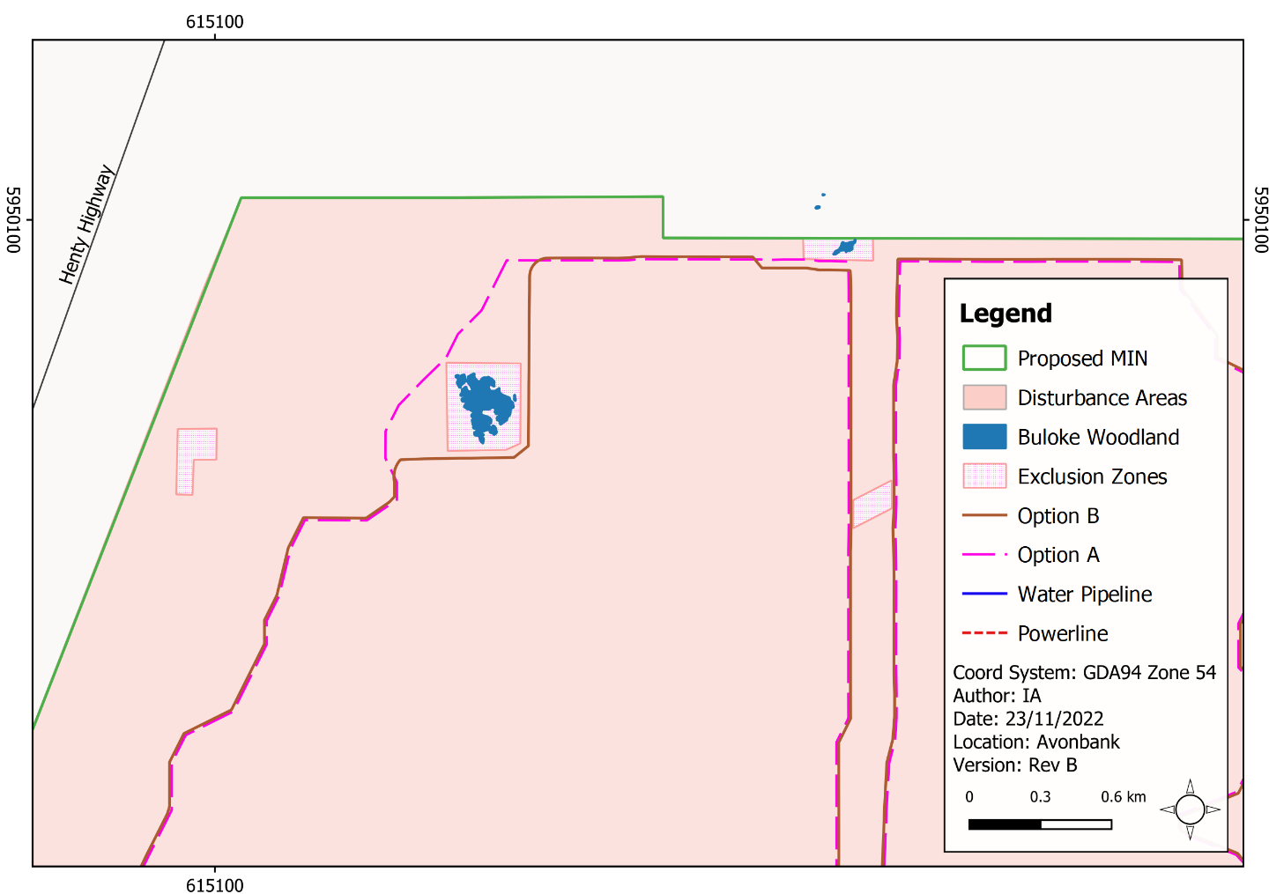
Figure 3-2: Mine footprint options and vegetation avoidance in Block D

Location of the Wet Concentrator Plant

Project requirement
Ore will be slurried at the Mining Unit Plan (MUP) and pumped to the Wet Concentrator Plant (WCP) to separate the heavy mineral sands from the non-valuable sands. Sand tails will be pumped back to the mine void to dry in tailings cells. The WCP must be situated to optimise pumping distances between the mine and the WCP. The WCP must have easy access to power and water. The WCP must also be located with access to an arterial road for the haulage of product to the Port of Portland (PoP).

WCP location options and assessment
The two options for the location of the WCP assessed comprise:
- Permanent secondary processing plant within the Wimmera Intermodal Freight Terminal (WIFT) Precinct.
- Mobile secondary processing plant, which would be relocated from the WIFT Precinct area north of Wimmera Highway midway through the Project.
The options analysis is summarised in Table 3-3.

Table 3-3: Comparison of WCP locations
Options Assessment
Option A – Permanent WCP within the WIFT Precinct
Operational constraints and opportunities:
- Closer to existing infrastructure (within the WIFT Precinct) for the life of mine than the alternative.
- Longer average pumping distance for the life of mine (largely near the centre of the resource) than the alternative.
- Will avoid sterilising/excluding part of the resource as it will be situated within an area that does not form part of the defined mine footprint.
Environmental risks or opportunities:
- Location within the WIFT Precinct avoids disturbing land zoned for farming and is consistent with planning policy for this industrial precinct.
Project cost implications and limitations:
- Reduced capital cost and Project downtime due to the fixed location of the WCP over the life of mine.
Option B – Mobile WCP
Operational constraints and opportunities:
- Shorter pumping distances as WCP is moved closer to mining operations in the north.
Environmental risks or opportunities:
- Greater overall disturbance footprint than the alternative, as the WCP is moved from one location to the next.
Project cost implications and limitations.
- Increased capital cost for WCP relocation, compared to the alternative.
- Decreased operational costs due to shorter pumping distances compared to the alternative.
- Potential sterilisation/exclusion of additional ore if the WCP is moved north to Block B.
A permanent location for the WCP (Option A) was selected as the preferred alternative primarily as it avoids downtime (up to 3 months) and capital costs associated with relocating the WCP midway through the Project. It also avoids disturbing land zoned for farming as it is within the WIFT Precinct, which is zoned as a Special Use Zone, for industrial purposes, including the processing, storage and handling of mineral sands. This preferred option is described in Chapter 2, Section 2.1.3 and Chapter 8 (Land Use and Planning), Section 8.6.1.

Ore Mining

Project requirements
The ore is hosted within the Parilla Sands Unit (the geological host unit for the Avonbank deposit). Parilla Sands within the Avonbank ore body typically comprise a fine-grained silty sand, with approximately 5% of oversize (+1 mm) material. Mining of the ore body will involve open pit mining to a nominal depth of approximately 24 m to 30 m below the ground surface, which is generally above the watertable.

Ore mining options and assessment
The two mining options assessed were:
- Dry mining using earth moving equipment in a dry mine void.
- Wet mining using a dredge in a flooded mine void.
The options analysis is summarised in Table 3-4.

Table 3-4: Ore mining machinery comparison
Options Assessment
Option A – Dry mining
Operational constraints and opportunities:
- Mobile fleet has a greater level of flexibility to implement the progressive mine and rehabilitation plan compared to dredge mining.
Environmental risks or opportunities:
- Significantly less water used compared to dredge mining (pit water levels do not have to be maintained).
Project cost implications and limitations:
- Lower capital cost and higher operational cost to run the earth moving fleet.
Stakeholder considerations:
- Mined land can be progressively rehabilitated and returned to the landholder within 4 years.
Option B – Wet/Dredge mining
Operational constraints and opportunities:
- The regional hydrogeology is not suited to dredge mining, which generally requires a higher watertable.
Environmental risks or opportunities:
- Significantly higher water use compared to dry mining (to maintain pit water levels).
Project cost implications and limitations:
- Higher capital cost and lower operating cost compared to dry mining.
Stakeholder considerations:
- Mined land would be progressively rehabilitated at a slower rate than dry mining, which would likely exceed 4 years.
Dry mining (Option A) using two D11 dozers pushing into an MUP was selected as the preferred option. This method is the most cost-effective and allows for relatively rapid rehabilitation and significantly lower water use than the dredge mining option (Option B). The dry mining option is further described in Chapter 2, Section 2.2.2.

Material Movement (Overburden)

Project requirements
Overburden must be removed to access and mine the Avonbank ore body. The overburden material comprises the upper clayey overburden derived from the Shepparton Formation and the lower non-mineralised (barren) fine sand or clayey sand of the Loxton Parilla Sands Formation. Overburden will generally be moved and directly placed to the mine void, except for the starter pits in Block A and Block B.

Overburden options and assessment
The two options assessed for movement of overburden were:
- Excavation and movement of overburden using trucks, dozers and scrapers.
- Excavation and movement of overburden using a bucket wheel excavator and conveyors.
The options analysis is summarised in Table 3-5.

Table 3-5: Overburden movement assessment
Options Assessment
Option A – Excavation and earth moving fleet
Operational constraints and opportunities:
- Mobile fleet has a greater level of flexibility to implement the progressive mine and rehabilitation plan compared to a conveyor.
Environmental risks or opportunities:
- The use of scrapers facilitates relatively accurate stripping depth.
- Safe and stable landform efficiently developed due to the compaction by vehicles during dumping.
Project cost implications and limitations:
- Lower capital cost and higher operational cost compared to conveyors.
Option B – Bucket wheel excavator and conveyors
Operational Constraints and opportunities:
- Conveyors are relatively inflexible and not suitable for the rapid movement and changes of dumping locations.
- Project scale geology is not suited to bucket wheel excavation.
Environmental risks or opportunities:
- Backfill will not be compacted during vehicle placement and may result in a greater risk of subsidence.
Project cost implications and limitations:
- Higher capital cost and lower operating cost.
Stakeholder considerations:
- Potentially higher visual impact from larger-scale plant and equipment.
The movement of overburden using an excavator and an earth moving fleet (Option A) was selected as the preferred option (refer Chapter 2, Section 2.2.2). This option was primarily selected as it offers greater flexibility with regard to the location of backfill operations compared to conveyors (Option B), which are in a fixed location.

Material Movement (Subsoils)

Project requirements
Topsoil and subsoil will be stripped and stockpiled prior to overburden removal for later use in rehabilitation. It is anticipated that the total stripping depth will be around 1 m to recover as much of the pre-existing rooting zone as practicable. The effective rooting zone will be stripped as three separate soil units, including topsoil, Subsoil A and Subsoil B.

Topsoil and subsoil options and assessment
The equipment options assessed for the movement of topsoil and subsoil were:
- Scrapers (657G scrapers) and tractor scoops to move soil material.
- Dozers, loaders and trucks to push and move soil material.
The options analysis is summarised in Table 3-6.

Table 3-6: Comparison of mining equipment
Options Assessment
Option A – Scrapers/tractor scoops
Operational constraints and opportunities:
- Designed for short-haul bulk haulage operating at speeds up to 60 km/h.
Environmental risks or opportunities:
- Reduced compaction during rehabilitation compared to dozers and large trucks.
- Allows for accurate stripping depth to target upper soil layers.
Project cost implications and limitations:
- Lower operating cost compared to dozers, loaders and trucks.
Option B – Dozers, loaders and trucks
Operational constraints and opportunities:
- More machinery is required than the alternative.
Environmental risks or opportunities:
- Dozers generate more dust and noise than the alternative.
- Stripped depths are less accurate than scrapers/tractor scoops.
Project cost implications and limitations:
- Higher operating cost compared to the alternative.
Option A (scrapers /tractor scoops) was selected as the preferred option for stripping as this equipment can target material with greater accuracy than the dozer and loader combination (Option B). Option A will also minimise compaction to the upper soil units during rehabilitation. This method is further described in Chapter 2, Section 2.2.3 and in Chapter 22 (Land Rehabilitation), Section 22.6.

Sand Tailings Management

Project requirement
Secondary processing of the ore aims to separate Heavy Mineral Concentrate (HMC) from sand tailings using gravity separation. The mined ore comprises approximately 95–97% sand tailings and between
3–5% HMC. The sand tailings comprise a sand component (>20 µm particles) and a fines component (<20 µm size particles) which must be returned to the mine void to enable progressive rehabilitation.

Secondary processing options and assessment
The four options assessed for the management of tailings were:
- Co-disposal of the fine and coarse sand tailings with flocculant to the mine void, where decant water is recovered and returned to the process water circuit.
- Centrifuge separation of sand tailings with flocculant to release and recover water. The tails solid fraction is conveyed to a stockpile where a loader and truck transfer the tailings to the pit.
- Geotextile dewatering bags (Geobags) hold the solid tailings fraction while the water seeps through the geotextile material and is returned to the process water circuit.
- Solar drying cells use the sun to evaporate water from the fines fraction of the sand tails which dry in situ and are capped with overburden.
The options analysis is summarised in Table 3-7.

Table 3-7: Tailings management alternatives
Options Assessment
Option A – Co-disposal
Operational constraints and opportunities:
- Demonstrated and reliable method applied effectively at numerous mineral sand mines.
- Relatively high-water recovery using flocculant and decant sumps.
Environmental risks or opportunities:
- Some tailings water is returned to the aquifer, partially offsetting dewatering activities.
- Results in a geotechnically stable landform that facilitates progressive rehabilitation.
- No above-ground tailing storage is required.
Project cost implications and limitations:
- Lowest start-up capital cost and lowest operational cost.
Option B – Centrifuge
Operational constraints and opportunities:
- Technology has not been proven to be effective at scale within the mineral sand industry.
- Requires significant vehicle movements to transport tailings cake to the mine void.
Environmental risks or opportunities:
- High-power requirement for centrifuge operation compared to co-disposal, solar and Geobags.
- High diesel usage for vehicle movements to transport tailings cake to the mine void.
- Occupational health and safety (OHS) risk associated with establishing a haulage circuit to cart tailings from the WIM Base Area (WBA) to the mine void.
- Increased disturbance area required for the centrifuge site.
- Greater risk of unstable landform, as the tailings cake is tipped into the pit from trucks.
- Potentially elevated noise levels due to a greater number of vehicles operating.
Project cost implications and limitations:
- Very high capital cost and high operating costs due to power usage and rehandling costs.
Stakeholder considerations:
- Haulage routes would need to be established between centrifuges and the mine void, increasing disruption to traffic on Wimmera Highway.
Option C – Geobags
Operational constraints and opportunities:
- High amount of labour required for pipework and setting up the bags.
Environmental risks or opportunities:
- OHS risks associated with bag movement while filling.
- Bags would be left in the pit and buried as a waste product.
Project cost implications and limitations.
- High capital cost and high operational costs.
Option D – Solar Drying
Operational constraints and opportunities:
- Water recovery is low compared to other options.
Environmental risks or opportunities:
- Largest disturbance area required, compared to the other options considered.
- Risk associated with slimes not sufficiently drying.
- Longer rehabilitation time frame, as fines need longer to dry than the co-disposal option.
- Lowest water recovery and higher water use compared to the other options.
Project cost implications and limitations.
- High capital cost to build drying cells and high operational cost.
Stakeholder considerations:
- Mined land would be progressively rehabilitated at a slower rate.
Co-disposal of tailings (Option A) was selected as the preferred option as it offers a demonstrated/proven means of transporting sand tailings to the mine void, recovering process water and establishing a geotechnically sound rehabilitated profile. Co-disposal is a widely utilised and well understood industry-standard tailings management technique. It is anticipated that co-disposal will result in some seepage of process water to the aquifer, however, these impacts are considered to be minor, as described in Chapter 17, Sections 17.7.1 and 17.7.2.
The centrifuge (Option B) was not considered to be a feasible option for the Project, primarily due to high energy use, high capital and operating costs and risks associated with landform stability. Geobags (Option C) were shown to have a high capital and operating cost and material safety risks. Solar drying cells (Option D) were the least preferred option due to the larger disturbance area required and the longer time to rehabilitate land.
Fieldwork undertaken as part of the Avonbank Demonstration Trial (refer Figure 3-3, Figure 3-4 and Figure 3-5) confirmed that the co-disposed tailings consolidated to form a safe and stable landform.

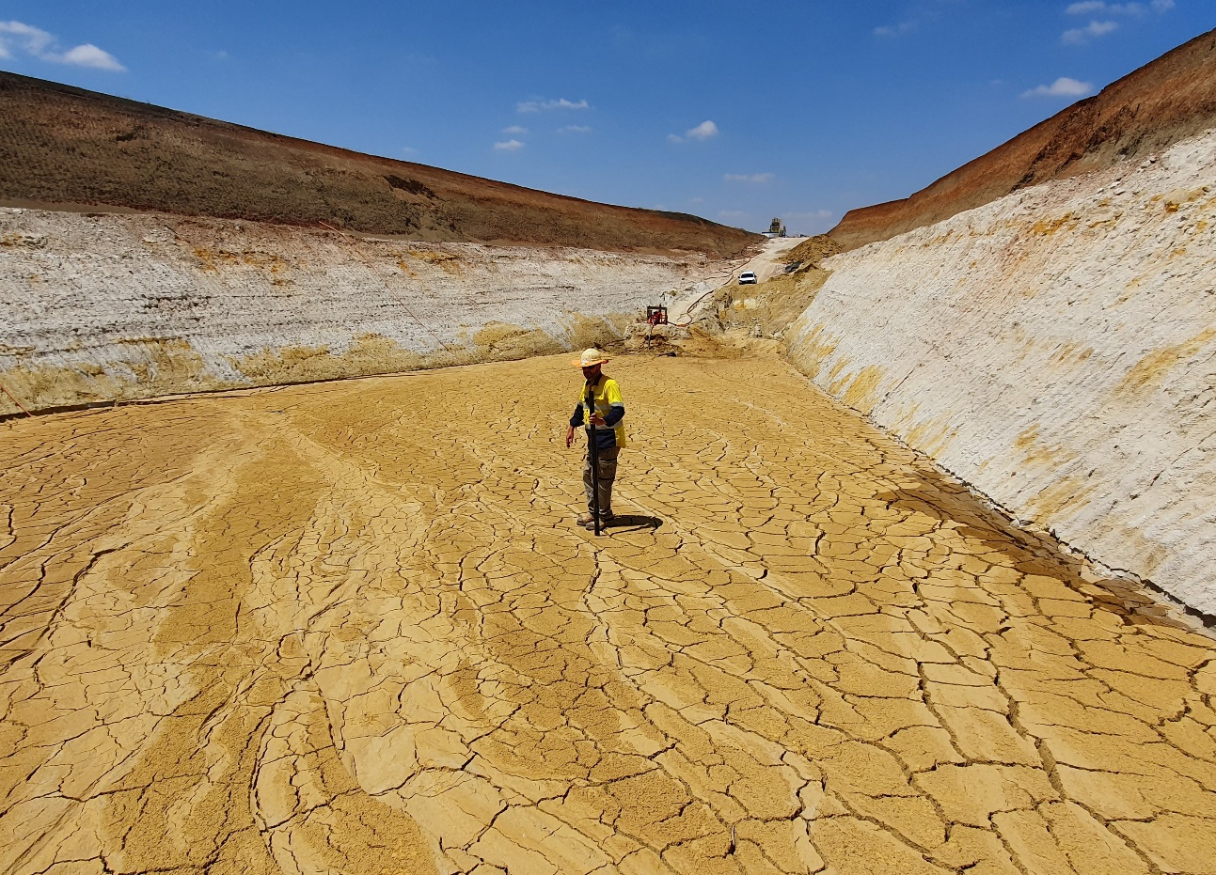
Figure 3-3: Co-disposal tailings drying at the Avonbank test pit

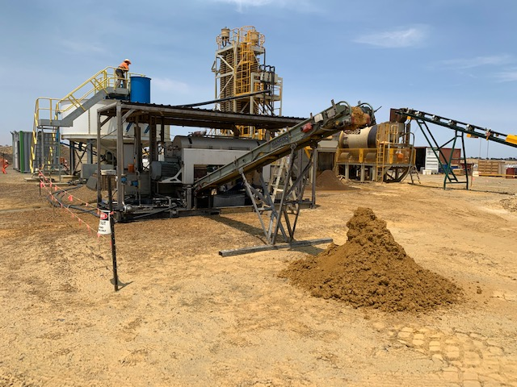
Figure 3-4: Centrifuge operating at the pilot plant

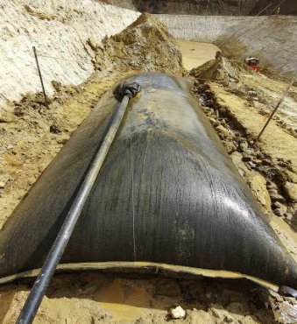
Figure 3-5: Geobag being trialled in the Avonbank test pit

Access to WIM Base Area

Project requirement
Access to the WIM Base Area is required for light vehicles and trucks transporting HMC and goods to and from the site.

Access to WBA options and assessment
The two options assessed to access the WBA were:
- Access via Freight Terminal Road, which requires a right-hand turn into the WBA.
- Access via Wimmera Highway, which requires a right-hand turn into the WBA.
The options analysis is summarised in Table 3-8.
Table 3-8: Access to WBA comparison
Options Assessment
Option A – Freight Terminal Road
Operational constraints and opportunities:
- Longer paved access is required from Freight Terminal Road to WBA.
Environmental risks or opportunities:
- Higher disturbance footprint due to the longer access road required.
Project cost implications and limitations:
- Higher capital cost relating to the longer road distance.
Stakeholder considerations:
- More stakeholders involved due to more land parcels impacted.
Option B – Wimmera Highway
Operational constraints and opportunities:
- Shortest direct route from Wimmera Highway to WBA.
Environmental risks or opportunities:
- Decreased disturbance of vegetation due to the shorter road access.
Project cost implications and limitations:
- Lower capital cost due to shorter road distance.
Stakeholder considerations:
- Fewer landholders impacted by the shorter access route.
Access to the WBA via the Wimmera Highway (Option B) was selected as the preferred option. This option is broadly consistent with discussions with Horsham Rural City Council and the WIFT Precinct plan. The proposed WBA access is described in Chapter 2, Section 2.3.2.5 and in Chapter 9 (Traffic and Transport), Section 9.6.2.4.

HMC Transport

Project requirements
The HMC product will be transported to the PoP to be temporarily stored, loaded and shipped overseas. The product storage location will be situated within a leased bunker, owned by the Port of Portland Pty Ltd. Approximately 1,430 tonnes per day of HMC will be transported from the WBA to the PoP during operations for a period of around 30 years.

Transport options and assessment
The two options assessed for the transport of HMC between the WBA and PoP were:
- Road transport using B-double articulated vehicles along an appropriately rated arterial transport route.
- Rail transport from the Dooen terminal to the PoP using the existing rail infrastructure.
The options analysis is summarised in Table 3-9.
Table 3-9: Assessment of transport options
Options Assessment
Option A – Road Transport
Operational constraints and opportunities:
- Existing arterial route is appropriately rated for freight transport using B-double articulated vehicles.
- Road transport provides greater operational flexibility to deliver HMC at the PoP at regular intervals.
Environmental risks or opportunities:
- Potential to contribute to existing traffic noise along the arterial road.
Project cost implications and limitations:
- Low capital cost and low ongoing operational costs.
Stakeholder considerations:
- Both road and rail options are likely to result in noise effects on some residents.
Option B – Rail Transport
Operational constraints and opportunities:
- Existing rail line requires upgrade on route to PoP.
- Speed and HMC payload is limited in some sections due to the condition of the main line between Maroona and Portland.
- No receival system at POP (double handling at PoP – product has to be trucked after arrival at PoP).
- Dooen Rail Terminal is not equipped for bulk loading, and a major upgrade of the terminal is required.
- Rail upgrades are unlikely to be completed prior to Project commencement.
Environmental risks or opportunities:
- Higher disturbance area required for additional rail infrastructure at the WBA.
- Potential noise issues with train load out and along the rail line.
Project cost implications and limitations:
- Very high capital cost to upgrade the rail line at Dooen to enable loading of bulk HMC, rail line and POPL receival facilities.
Stakeholder considerations:
- Both road and rail options are likely to result in noise effects on some residents.
Road transport (Option A) was selected as the only feasible option for the Project due to the operational constraints associated with the existing rail infrastructure (Option B). The high cost to upgrade the rail line was not considered to be reasonably practicable in the context of this Project. The preferred transport route via Henty Highway was assessed and detailed in Chapter 9, Section 9.6.1.

Power Supply

Project requirements
Power is required to operate the infrastructure at the WBA, as well as electric pumps and the MUP at the mine. Power will be supplied directly to the WBA and distributed to various locations around operations.

Power supply options and assessment
The two options assessed for the type of power supplied to the WBA were:
- Supply from the existing grid.
- Supply from the grid and renewables.
The options analysis is summarised in Table 3-10.
Table 3-10: Power supply options comparison
Options Assessment
Option A – Supply from the existing grid
Operational constraints and opportunities:
- Existing grid power infrastructure provides the most reliable source of power for the purpose of the mine.
Environmental risks or opportunities:
- Limited works are required to access or modify the existing power network.
Project cost implications and limitations:
- Lower capital cost and better reliability and efficiency compared to developing a renewable source.
Stakeholder considerations:
- Existing grid power infrastructure runs near the WBA, minimising additional infrastructure, visual amenity and ground disturbance impacts to landholders.
Option B – Supply from the grid and renewables
Operational constraints and opportunities:
- No renewable facility adjacent to the WBA, and new infrastructure would likely need to be constructed.
- Power supply from renewables would need to be supplemented from the grid to maintain consistent supply.
Environmental risks or opportunities:
- A new facility would have a greater disturbance footprint and have some visual amenity impacts.
Project cost implications and limitations:
- Higher Project start-up capital costs to construct renewables infrastructure.
Stakeholder considerations:
- A new facility may impact landholders due to the loss of farming land and visual amenity.
Power supplied directly from the existing power grid to the WBA (Option A) was considered the preferred option. Using renewables (Option B) at this point was not considered to be reasonably practicable due primarily to the relatively high capital cost and potential issues relating to consistency of supply. As described in Chapter 19 (Waste and Emissions), an energy efficiency program will be prepared to minimise GHG emissions. The program will be developed to investigate energy efficiency opportunities over the life of the Project, which may include further consideration of renewable energy options (refer Chapter 19, Section 19.6.2.4).

Power Grid Based Options

Project requirements
As described in Section 3.3.10, power will be supplied to the WBA via the existing power grid.

Powerline options and assessment
The three options assessed for the powerline supply to the WBA were:
- 22 kV powerline running from Horsham using existing powerline.
- 66 kV powerline from the Horsham terminal station.
- 220 kV line with a step-down transformer to 22 kV running to the WBA.
The options analysis is summarised in Table 3-11.
Table 3-11: Power grid supply comparison
Option Assessment
Option A – 22 kV powerline
Operational constraints and opportunities:
- Limited supply remaining on 22 kV lines (at capacity).
- No step-down transformer is required at WBA.
- Likely reliability issues.
Environmental risks or opportunities:
- No disturbance is required for line works or step-down transformer.
Project cost implications and limitations:
- Low capital costs and relatively high operating costs.
Stakeholder considerations:
- Possible power interruptions as loads are either at or approaching limit.
Option B – 66 kV powerline
Operational constraints and opportunities:
- Line has supply capacity sufficient to meet project power demands.
- Line does not have major reliability issues.
- Step-down required from 66 kV to 22 kV at WBA.
Environmental risks or opportunities:
- Minor clearing is required for underground disturbance along Horsham-Lubeck Road, and new poles are required along Wimmera Highway.
Project cost implications and limitations:
- Lower operating costs due to 66 kV supply.
Stakeholder considerations:
- Powercor has advised this Option would be the most suitable.
Option C – 220 kV line
Operational constraints and opportunities:
- High reliability compared to other options.
- Voltage is very high and requires significant infrastructure to step-down to 22 kV at the WBA.
Environmental risks or opportunities:
- Larger disturbance for switch yard and transformer.
Project cost implications and limitations.
- Very high capital cost and low operating costs due to the nature of the line and step-down required.
The 66 kV supply (Option B) was selected as the preferred option, primarily due to the lower capital and operational costs and with consideration to the advice provided by the power supplier regarding the feasibility of the power supply options.

Water Supply

Project requirements
A reliable water source is required for ore processing at the WCP and MUP. Conservatively, a maximum of 4.6 gigalitres (GL) of water is required during Project operations, as described in Chapter 2, Section 2.3.1. While process water will be recovered and reused to minimise water use, a top-up supply will be required over the life of mine. The water supply offtake point will be upstream of the Longerenong Pumping Station. It is intended that water for the Project will be sourced from the GWMWater Growth Water product.

Water supply options and assessment
The two options assessed for the supply of water to the Project were:
- GWMWater pipeline water supplied to meet potable and process water requirements.
- Groundwater extracted from a regional aquifer (Loxton Parilla Sands or Renmark).
The options analysis is summarised in Table 3-12.
Table 3-12: Water supply options comparison
Options Assessment
Option A – Supply from the GWMWater
Operational constraints and opportunities:
- Consistent and reliable supply to meet Project requirements.
Environmental risks or opportunities:
- Ground disturbance for 8.5 km of a new pipeline, which includes minor vegetation clearing.
Project cost implications and limitations.
- Higher operational cost compared to bore usage.
Stakeholder considerations:
- Sufficient GWMWater Growth Water available for purchase to meet the water supply requirements of the Project.
Option B – Extract groundwater from a regional aquifer
Operational constraints and opportunities:
- Less consistent and reliable supply compared to the pipeline product.
Environmental risks or opportunities:
- Disturbance footprint would be greater to allow for bore field and pipeline back to WBA.
- May have groundwater drawdown impacts associated with the use of the bore field.
Project cost implications and limitations:
- Lower operating cost compared to the pipeline supply.
Utilising the GWMWater pipeline (Option A) was selected as the preferred option, as described in Chapter 2, Section 2.3.3. This is primarily due to the high reliability and consistent supply this option offers. Groundwater extraction would exacerbate groundwater drawdown locally.

Water Supply Infrastructure

Project requirements
There will be up to 4,600 ML/year of GWMWater Wimmera-Mallee Pipeline product required for the Project’s processing activities. The product is set aside as water for new economic development (referred to as Growth Water). GWMWater confirmed that this product will be available and suitable to be used as the primary water source for the Project. A hydraulic review conducted by GWMWater concluded that the closest water off-take point that would have the required pressures to supply the design flow rate would be upstream of the Pressure Relief Valve (PRV) at the Longerenong Pumping Station.

Water supply options and assessment
The two options assessed for the supply of water to the Project were:
- Mains water pipeline aligned north–south along Drung-Jung Road (refer Figure 3-6).
- Mains water pipeline aligned east–west along Tralee Lane (refer Figure 3-6).
The options analysis is summarised in Table 3-13.

Table 3-13: Water supply infrastructure
Options Assessment
Option A – Route along Drung-Jung Road
Operational constraints and opportunities:
- Both Options A and B will supply the required flow as they are connected at the same off-take position upstream of the Longerenong Pump Station PRV.
Environmental risks or opportunities:
- Greater area of vegetation removal would be required compared to Option B.
- Would bisect one vegetated waterway that runs perpendicular to Drung-Jung Road.
Project cost implications and limitations.
- Both Options A and B are comparable.
Stakeholder considerations:
- Several more landholders would be affected by this option compared to the alternative.
Option B – Route along Tralee Lane
Operational constraints and opportunities:
- Both Options A and B will supply the required flows as they are connected at the same off-take position upstream of the Longerenong Pump Station PRV.
Environmental risks or opportunities:
- Less vegetation would be removed compared to Option B.
- Avoids one vegetated waterway on Drung-Jung Road.
Project cost implications and limitations.
- Both Options A and B are comparable.
Stakeholder considerations:
- Fewer landholders would be affected by this option compared to the alternative.
Establishing the mains water pipeline along Tralee Lane (Option B) avoids disturbing one waterway and avoids disturbing a greater area of vegetation, compared to an option along Drung-Jung Road (Option A). Option A would require the disturbance of land associated with several additional landholders. Further potential minimisation measures associated with vegetation removal are proposed in Chapter 21.
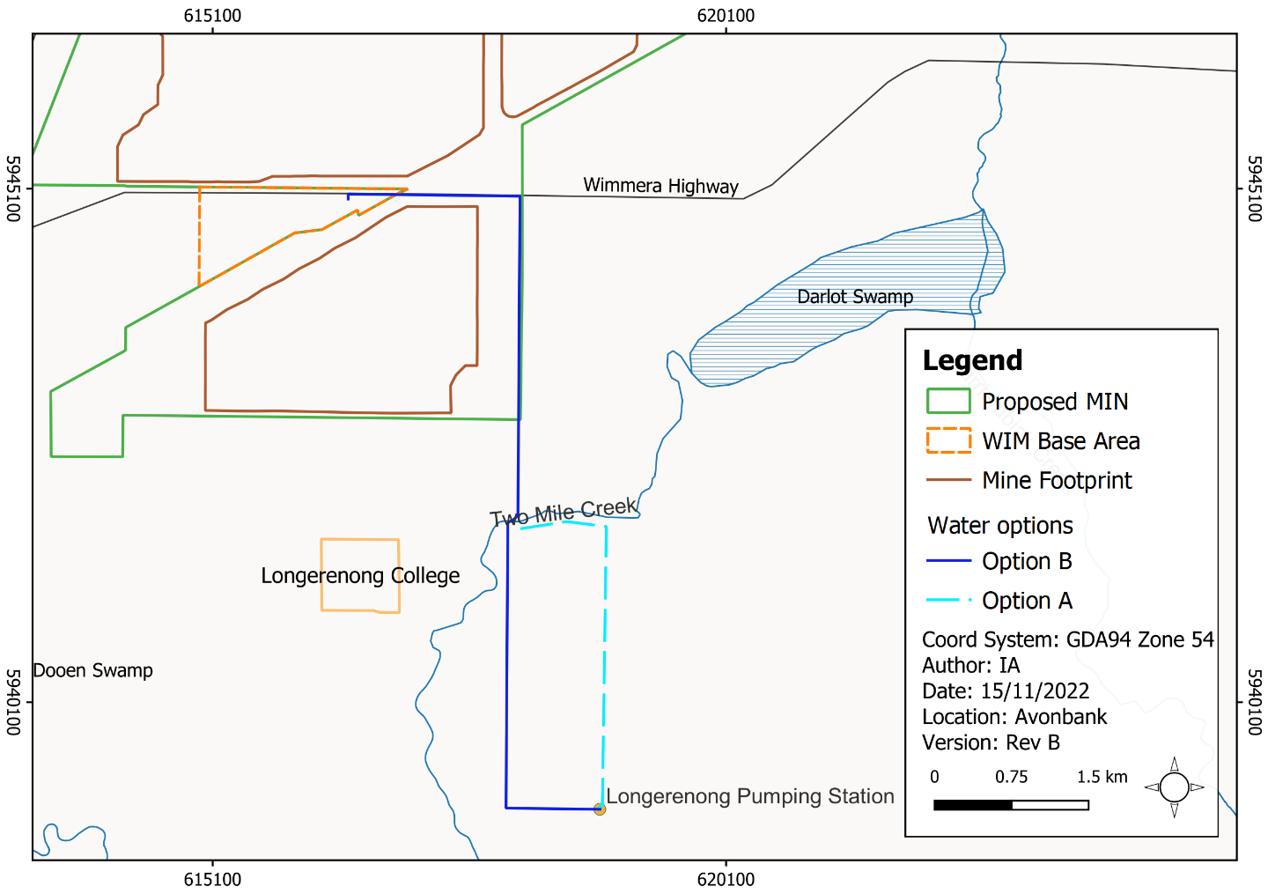
Figure 3-6: Water supply options

Rehabilitation and Closure

Project requirements
The Project must rehabilitate mine land such that it is safe, stable, sustainable, and capable of supporting the proposed end land use. The objective is to return the land to productive agriculture as soon as practicable after mining.

Rehabilitation options and assessment
The two options assessed for the rehabilitation of land were:
- Progressive rehabilitation of all mined areas.
- Leave final mine void and retain some overburden stockpiles.
The options analysis is summarised in Table 3-14.

Table 3-14: Rehabilitation comparison assessment
Options Assessment
Option A – Progressive rehabilitation of all mined areas
Environmental risks or opportunities:
- Mined land would be returned to the pre-mining use as soon as reasonably practicable after mining.
Project cost implications and limitations:
- Higher operational costs to return overburden stockpiles to void.
Stakeholder considerations:
- All land returned to pre-mining use, in line with stakeholder feedback.
Option B – Leave final mine voids and retain some overburden stockpiles
Environmental risks or opportunities
- Some mined land not returned to farming land (stockpile and void area).
Project cost implications and limitations
- Large operational cost savings, as overburden stockpiles do not have to be moved into the void.
Stakeholder considerations
- Stakeholders would prefer land is returned to its pre-mining land use as soon as reasonably practicable after mining.
The selected rehabilitation option is to progressively rehabilitate all land as soon as practicable after mining (Option A). Retaining overburden stockpiles and mine void post closure (Option B) does not align with the Project’s overarching objective to return land to its pre-existing land use, as described in Chapter 22, Section 22.5. Option B was not considered a feasible option and was not pursued through the EES planning phase.

No Development Option
The objective of the Project is to establish a world-class mining operation and concentration plant which will safely and efficiently produce a premium-quality mineral concentrate for export overseas. The Project aims to be able to supply approximately 5% of the global demand for zircon, 2–3% of the global demand for titanium, and approximately 5% of the global demand for rare earth minerals over the next 30 years.
The federal government’s 2022 Critical Minerals Strategy promotes Australia’s capacity to meet the increasing global demand for critical minerals. Zircon is a critical mineral, and by contributing to Australia’s supply of this mineral, the Project supports the government’s strategy.
Through its activities, the Project aims to create and sustain significant long-term employment and economic activity in Victoria and the WSM region. Over the 30 year Project operational life, the royalties for the State of Victoria will be approximately $180 million, there will be an increase in the Gross State Product (GSP) for Victoria of $5,772 million and a gross revenue output of $335 million per annum in the WSM.
During operation, the Project is projected to result in the creation of 967 FTE jobs per annum in Victoria and 588 FTE jobs per annum in the WSM region.
These economic benefits for the region and Victoria would not be realised if the Project did not proceed, and the 2022 Critical Minerals Strategy would not be supported.
If the Project does not proceed, potential adverse environmental and social impacts associated with the development of the Project, as assessed in this EES, will be avoided. The Project requires a temporary change of land use from broadacre farming to mining and ancillary uses as areas are progressively mined and rehabilitated. If the Project did not proceed, this land use change would not occur and the small number of residents within the mining footprint or in close proximity would not be displaced as a result of Project activities. Areas of vegetation would not be cleared, and minor adverse impacts associated with mining and transport, such as noise and air emissions would be avoided.
Approval is being sought for this Project, as it is believed the Project objectives can be achieved and that it will result in significant positive net benefit for the community.

Conclusion
The Project has considered design alternatives over the course of the EES preparation period, with consideration to the studies undertaken for the DFS, the EES impact assessments, and with consideration to stakeholder feedback.
The options considered in this Chapter have been applied to ensure that the Project is economically feasible, to enhance socioeconomic benefits to the State and to avoid or minimise impacts to the environment (and community) so far as reasonably practicable.
The options selected in this Chapter include key decisions made during the development of the Project. Each Chapter in this EES includes further measures to avoid or minimise environmental effects over the life of the Project.

