Avonbank Mineral Sands Project
Environment Effects Statement

Chapter 10 – Historic Heritage

TABLE OF CONTENTS
10 Historic Heritage 10-1
10.1 Introduction 10-1
10.2 Scope and Methods 10-1
10.2.1 Scope 10-1
10.2.2 Study Area 10-1
10.2.3 Methodology 10-3
10.3 Operational Context 10-3
10.4 Existing Conditions 10-5
10.4.1 Historical Overview 10-5
10.4.2 Heritage Sites within the Study Area 10-6
10.4.3 Heritage Sites within the Development Extent 10-8
10.5 Potential Impacts 10-11
10.5.1 Identification of Potential Impacts 10-11
10.5.2 Sensitive Receptors 10-11
10.5.3 Impact Characterisation 10-11
10.6 Avoidance and Mitigation Measures 10-12
10.6.1 Avoidance 10-12
10.6.2 Minimisation 10-12
10.6.3 Rehabilitation 10-13
10.7 Residual Impacts 10-14
10.7.1 Removal of Buildings or Structures 10-14
10.7.2 Disturbance of Potential Archaeological Sites 10-14
10.7.3 Structural Integrity and Damage 10-15
10.8 Management Framework 10-15
10.8.1 Environmental Objectives 10-15
10.8.2 Monitoring and Management 10-16
10.8.3 Audits 10-16
10.9 Cumulative Impacts 10-16
10.10 Conclusions 10-16

TABLES
Table 10-1: Potential heritage sites 10-8
Table 10-2: Potential impacts 10-11
Table 10-3: Significance of residual impacts 10-11

FIGURES
Figure 10-1: Study area 10-2
Figure 10-2: Minor utility corridor 10-4
Figure 10-3: Dooen railway station 1885 10-5
Figure 10-4: Dooen weir 10-5
Figure 10-5: Fruit orchard at Longerenong College 10-6
Figure 10-6: Locations of nearest statutory listings 10-7
Figure 10-7: Development extent and potential historic heritage sites 10-10

Historic Heritage

Introduction
This Chapter provides an overview of the historic heritage effects for the Avonbank Mineral Sands Project (the Project). It has been prepared to address the Environment Effects Statement (EES) Scoping Requirements (DELWP, 2020). This Chapter is supported by a detailed impact assessment prepared by David Bannear Historic Heritage and Archaeology Pty Ltd (DBHHA) (Appendix D).
The evaluation objective relevant to this Chapter, as defined in the Scoping Requirements, is to ‘Avoid or minimise adverse effects on Aboriginal and historical cultural heritage’ (DELWP, 2020). The associated issues and Project Scoping Requirements are detailed in Appendix A of this EES.
This Chapter describes the existing environment, the potential impacts associated with the Project and details the avoidance and mitigation measures to minimise the residual impacts so far as reasonably practicable.

Scope and Methods

Scope
The scope of this Chapter covers all potential impacts identified in the Historic Heritage Impact Assessment (HHIA) (Appendix D) and addresses the Scoping Requirements listed in Appendix A. The HHIA includes all Project activities within the development extent that may affect historic heritage items and places over the life of the Project. Matters relating to Aboriginal cultural heritage are considered in Chapter 23. Project related aspects that are well understood and considered to be relatively low risk with standard controls in place are addressed in the Aspects and Risks (Attachment 5).

Study Area
The HHIA focused on the development extent, including areas of disturbance within the proposed mining licence (MIN), WIM Base Area (WBA) and the associated minor utilities corridor, as shown in Figure 10-1. The study area extends to the broader region, including the settlements of Jung and Dooen, to provide further local historical context. Potential historic heritage sites that fall within the study area are described in Section 10.5.2.
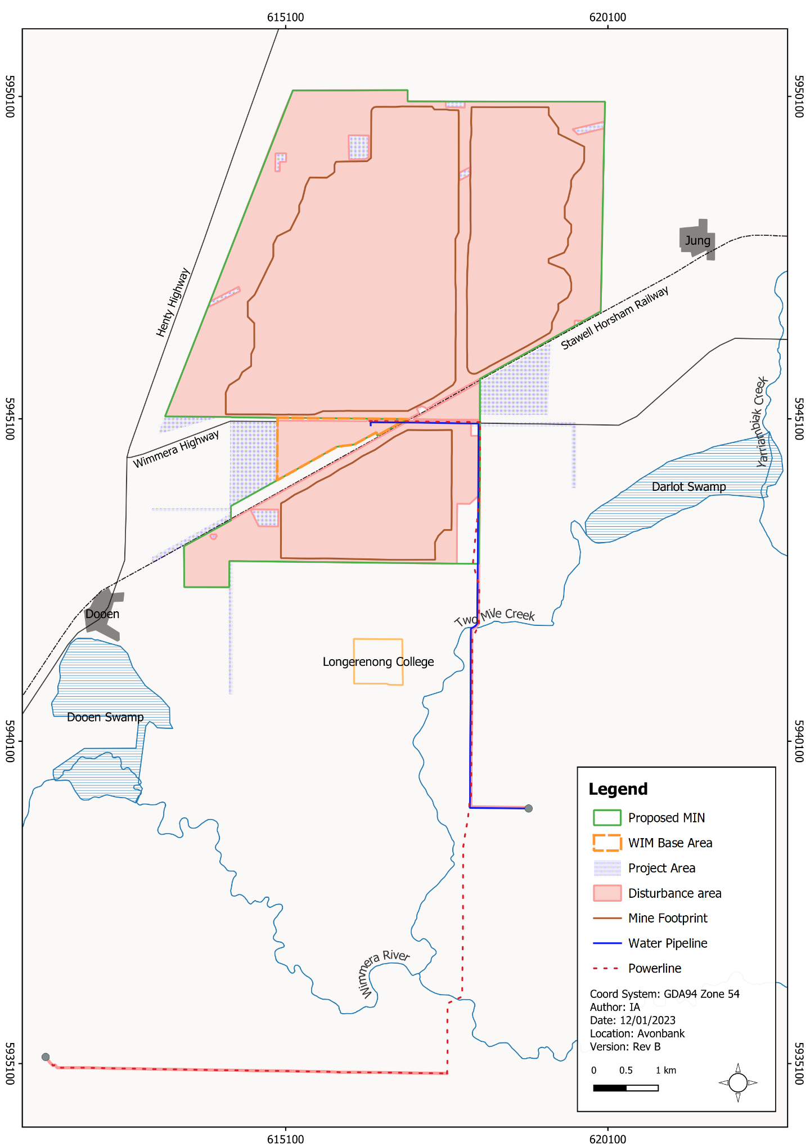
Figure 10-1: Study area

Methodology
The HHIA characterised the existing conditions, identified potential impacts and assessed the residual impacts with avoidance and mitigation measures in place. The tasks undertaken are summarised below and detailed in Appendix D, Section 2.
Existing conditions:
- A review of the Victorian Heritage Register, Victorian Heritage Inventory and Rural City of Horsham’s Heritage (historic) database was undertaken to identify and characterise any statutorily listed heritage items or places.
- A review of published reports and online databases was undertaken to identify non-statutory heritage places and potential archaeological sites.
- A review of community-based published information was undertaken regarding the heritage values within the study area.
- Two site visits were conducted (25–26 May 2021 and 4 July 2022) to identify and evaluate potential heritage sites within or adjacent to the Project area and utilities corridor.
- Aerial photography from 1946 was reviewed prior to the site visit to identify any suspected heritage sites of interest.
- The majority of site observations were made from publicly accessible local roads within the development extent.
Potential impacts:
- Potential impacts were identified with consideration to the proposed Project disturbance activities and the sites identified in or adjacent to the Project area or utilities corridor.
Residual impacts:
- Measures were identified to avoid and minimise impacts to identified sites so far as reasonably practicable.
- Exclusion zones were proposed and incorporated into the Project Description (Chapter 2).
- The significance of the residual impacts were assessed with consideration to the characteristics of each identified site.
The methodology applied to the HHIA is further detailed in Appendix D, Section 2.

Operational Context
The proposed Avonbank development extent covers 3,546 ha comprising the proposed mining licence area (3,426 ha), WIM Base Area (90 ha) and the minor utilities corridor (30 ha) (refer Figure 10-1). The total mining footprint covers an area of 2,215 ha, which will be progressively mined over the life of the Project. At any given time, the extent of Project disturbance will be less than 400 ha and will typically (on average) be less than 300 ha as areas are progressively mined and rehabilitated.
Prior to mining or the establishment of infrastructure, topsoil and subsoil will be stripped and stockpiled for use in rehabilitation. The mining method will generally involve the direct return of tailings and overburden into the mined cell as the mining front advances. Following backfill, subsoil and topsoil will be placed. The land will be returned to landholders once it has been suitably rehabilitated, as described in Chapter 22 (Land Rehabilitation).
The minor utilities corridor from the terminal stations to the WBA will include topsoil disturbance of up to 25 m along the water pipeline and 20 m for the powerline alignment along Wimmera Highway and Horsham-Lubeck Road. No ground disturbing works are expected along the established north–south section of the powerline running from Wimmera Highway to Horsham-Lubeck Road (refer Figure 10-2).
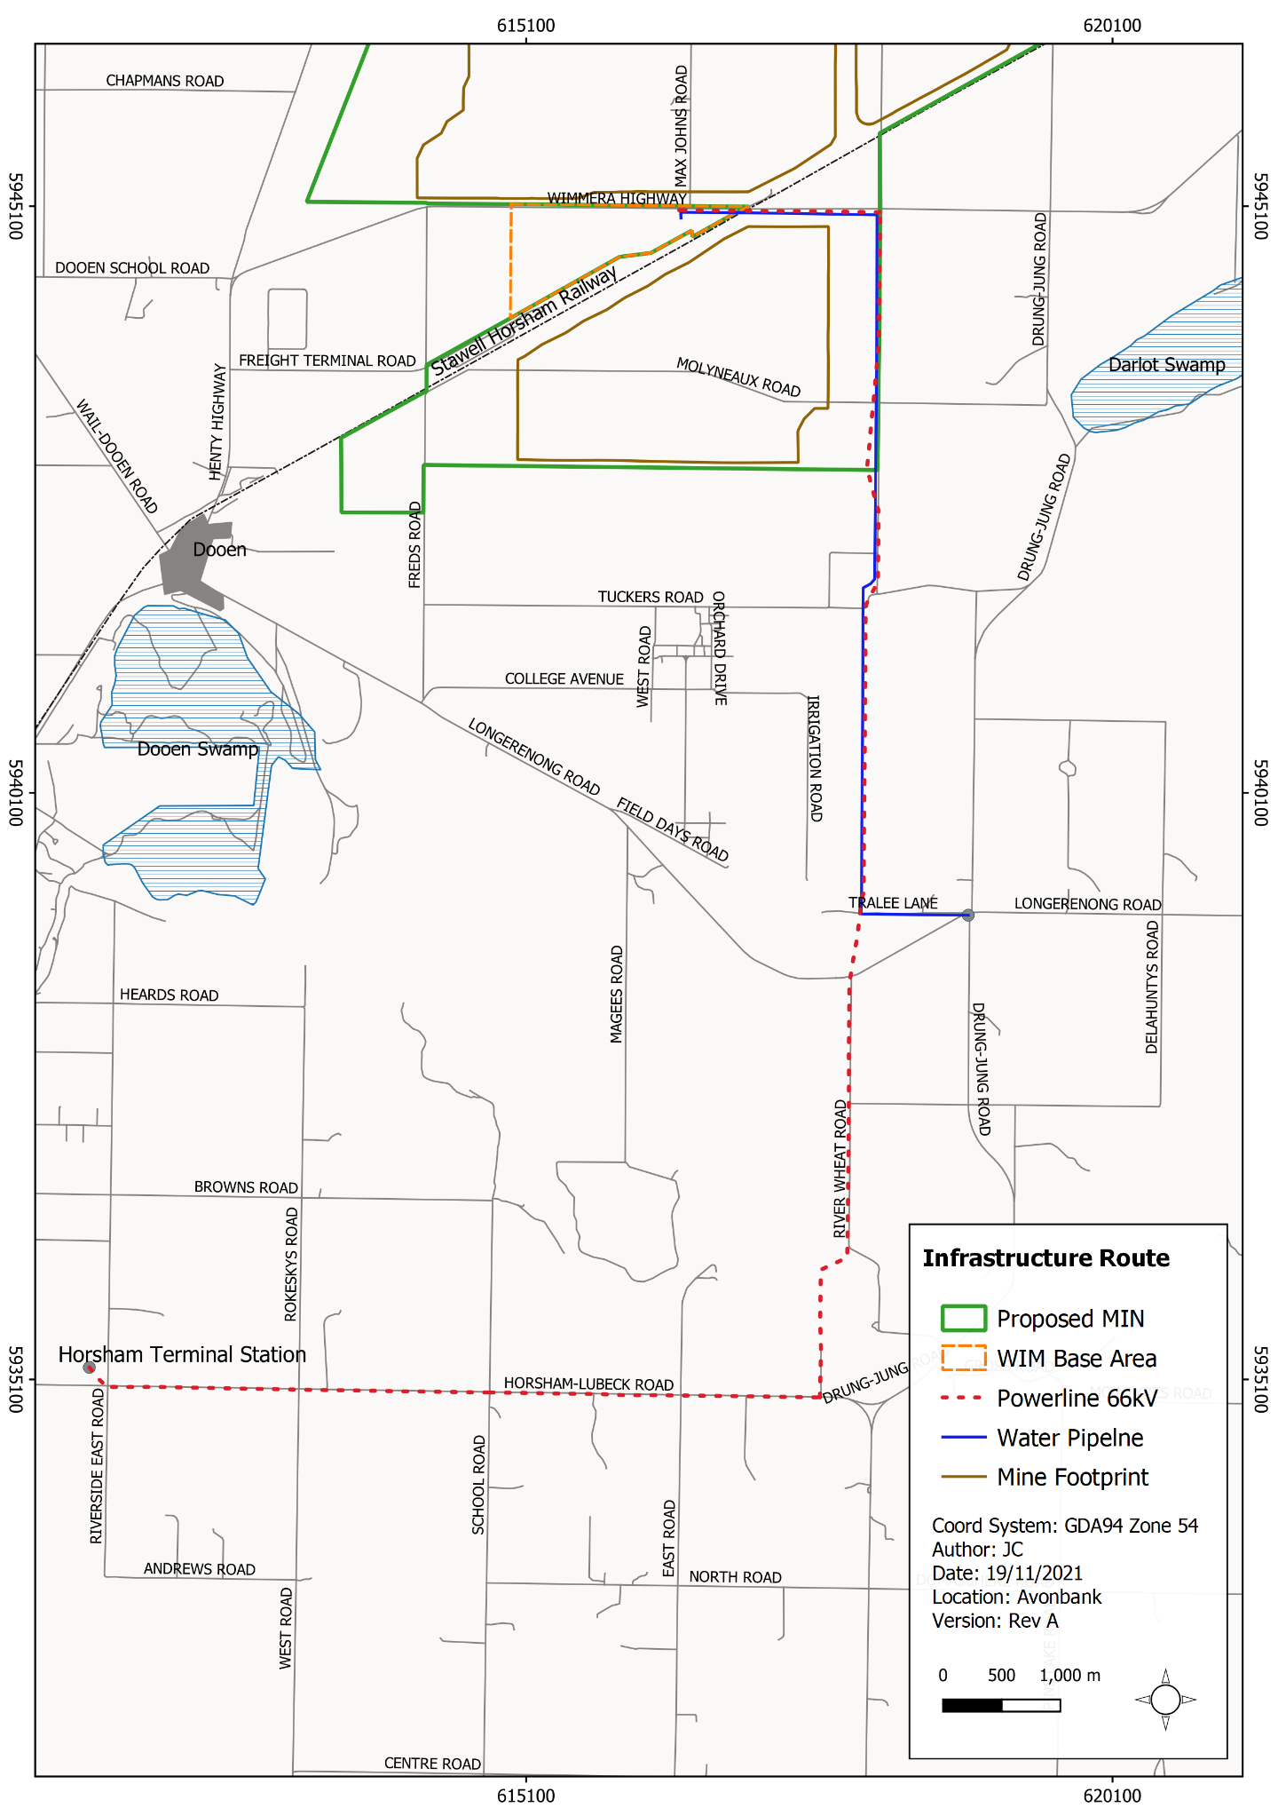
Figure 10-2: Minor utility corridor

Existing Conditions

Historical Overview
The study area historically supported pastoral activities and residential settlements, which have been dominated by grain cropping. The first pastoralist in the Dooen area was Charles Carter, who took up a pastoral run on the Wimmera River in the vicinity of present-day Horsham in 1842.
Up until the early 1870s, the only substantial buildings in the area were the North Brighton Homestead on the Wimmera River and the Dooen Hotel. The nearest railway station was at Stawell until the line was extended to Horsham in 1879, with stations at Jung and Dooen (refer Figure 10-3).
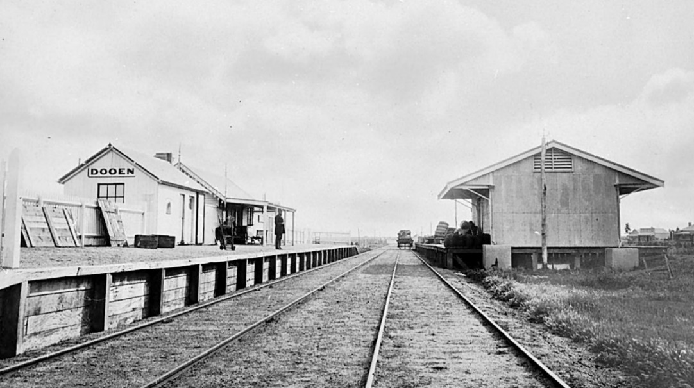
Figure 10-3: Dooen railway station 1885
Irrigation of the area around Dooen commenced in the early 1880s. The Dooen Weir was built on the Wimmera River, near the North Brighton homestead and the pump station was established to raise the level of the water so it could drain northwards to Dooen and beyond (refer Figure 10-4).
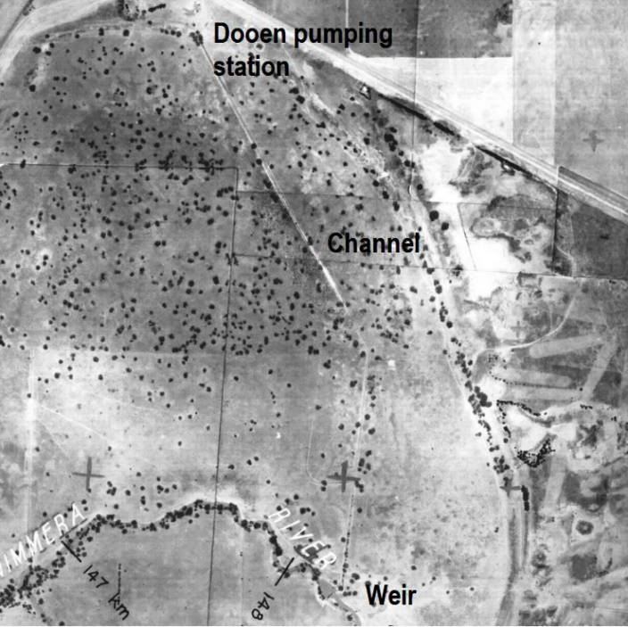
Figure 10-4: Dooen weir
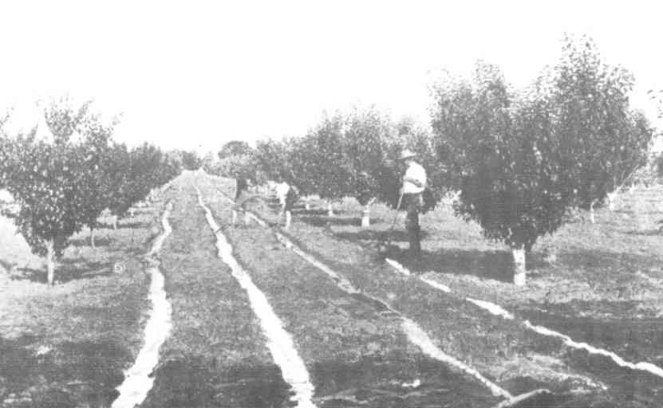
Figure 10-5: Fruit orchard at Longerenong College
The Longerenong Agricultural College and experimental farm were established in the 1880s. A channel of the Dooen water supply scheme ran near the experimental farm, from which water was supplied to the farm buildings, college grounds, plantation belts and fruit grounds (refer Figure 10-5).
The pumping station at Dooen was moved to Jung in 1921, after which the town of Dooen experienced economic and population decline. Following this, only grain growing continued within the Dooen area. In 2010 the region’s extensive open channel water supply system was replaced by the Wimmera Mallee pipeline, primarily due to the prolonged drought, which affected the viability of the open channel system.

Heritage Sites within the Study Area
This Section presents information from three different source categories, including:
- Statutory listings ─ Victorian Heritage Register, Victorian Heritage Inventory and Rural City Horsham (HRC) Heritage Overlay.
- Non-statutory listings ─ archived register of the National Estate, National Trust of Australia (Victoria) Heritage Register, and Heritage Victoria’s HERMES database.
- Community-based information ─ community consultation conducted for the ‘Horsham Heritage Study’ (Grieve and Gillet, 2012), Trove historical newspapers (National Library of Australia) online; publications of Horsham and District Historical Society; and various other online sources including historical maps and photographs at the State Library Victoria and Public Records Office Victoria.
A review of the relevant data sources found no listed heritage sites within the development extent. The nearest statutory listing on the HRC Overlay is the Dooen Hotel, which is located in Dooen, about 2.5 km south-west of the proposed mining licence. The nearest non-statutory listing is the Dooen North Brighton School Plantation, located around 1 km from the northern extent of the proposed mining licence (refer Figure 10-6).
Community consultation conducted for the 'Horsham Heritage Study’ (Grieve and Gillet, 2012) identified a range of important place types with potential heritage value, including settlers’ dwellings, farm sheds and railway sidings. There were no specific sites of interest identified within the development extent.
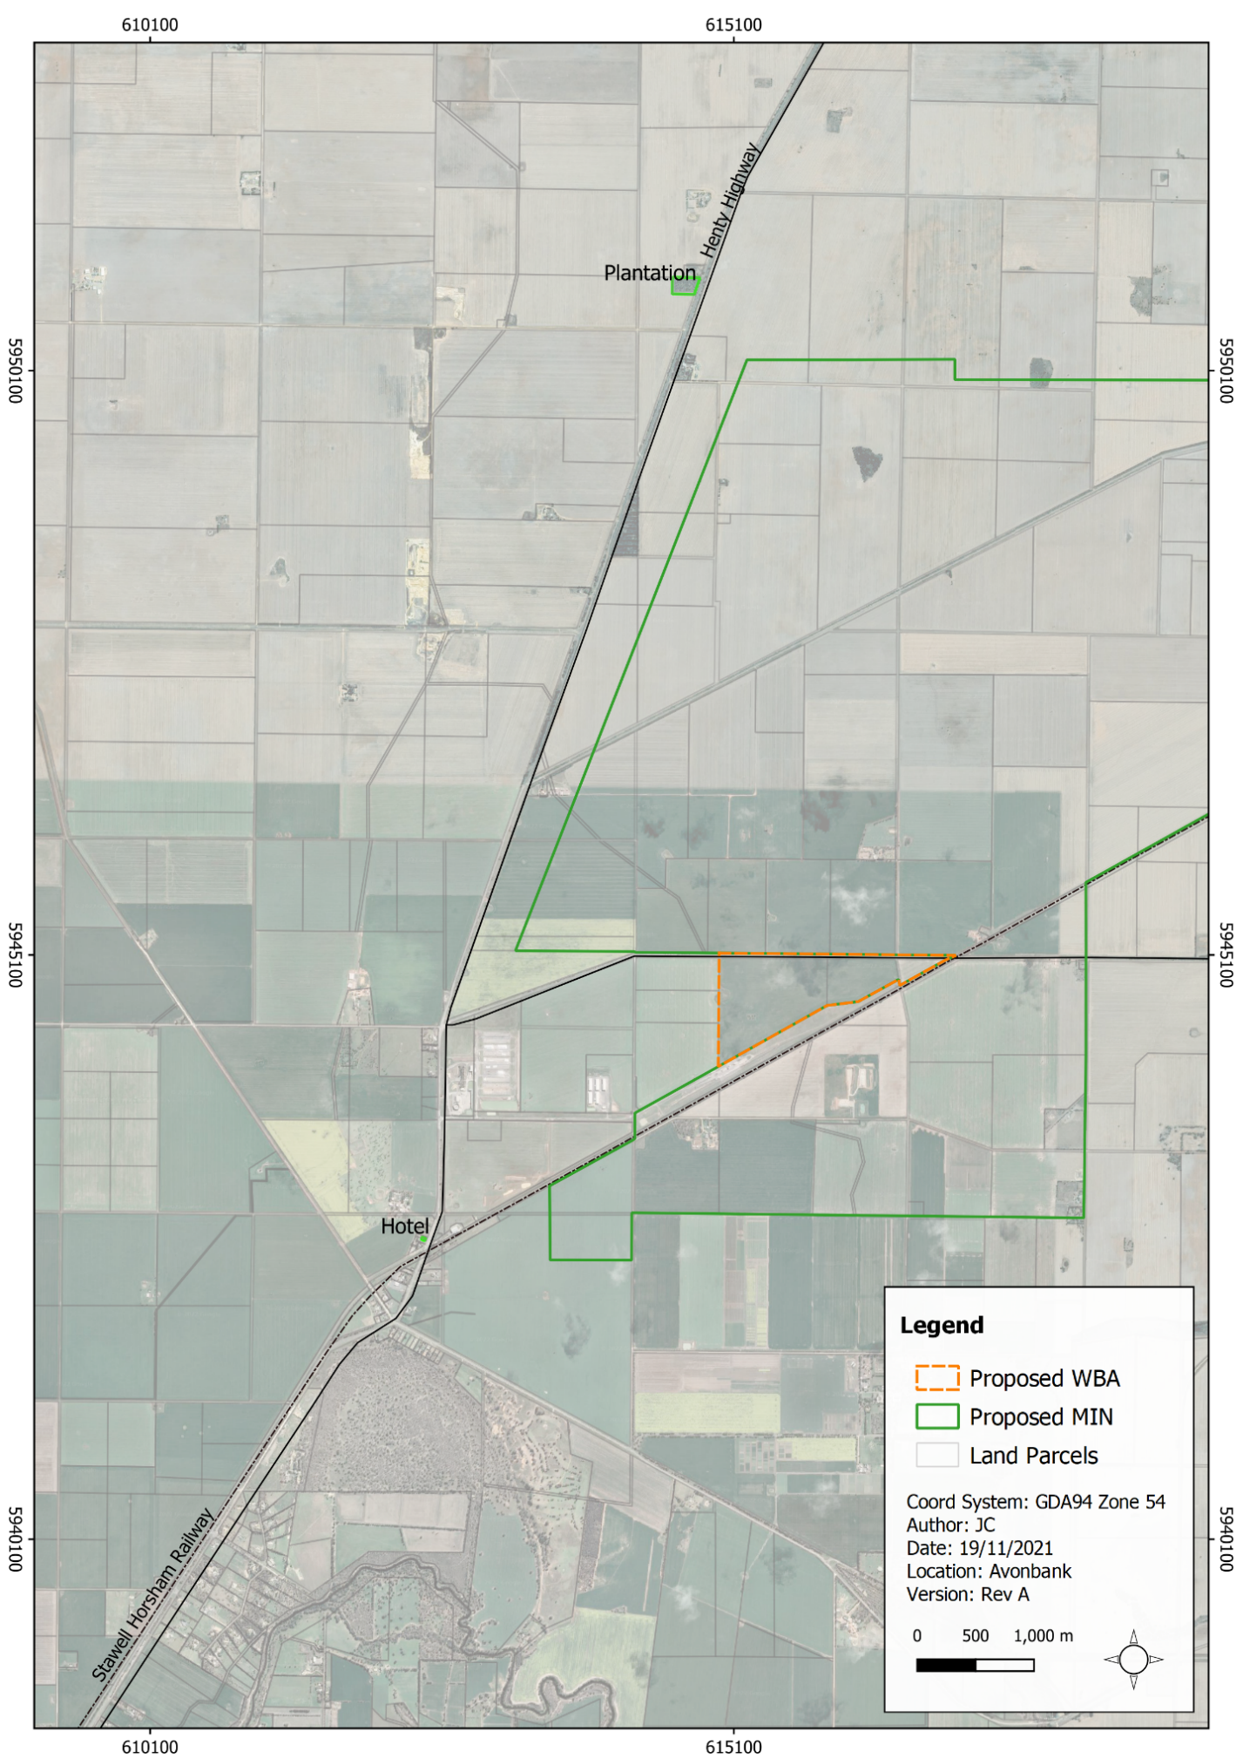
Figure 10-6: Locations of nearest statutory listings

Heritage Sites within the Development Extent
Two aerial photographs circa 1946 were reviewed prior to site inspection to identify places of interest (refer Appendix D). The review indicated that the area has remained largely unchanged over the last 70 years and comprises mainly cultivated paddocks.
The site inspection involved viewing the development extent and proposed disturbance areas from main access roads that were open to non-local traffic. The focus of the inspection was on heritage buildings, signs of building ruins, isolated exotic vegetation, sections of irrigation channels, and old dams.
The inspection identified 12 potential heritage sites as listed in Table 10-1 and shown in Figure 10-7. Of these sites, two were later confirm not to be of heritage interest (Site 4 and Site 5) and the remaining 10 were assessed as either having beneficial and/or family value or potential archaeological values.
Table 10-1: Potential heritage sites
Site | Description | Location
1 | Corrugated iron-clad storage shed with a hipped roof located near a high-voltage electricity transmission pylon. | Within the path of an infrastructure corridor.
2 | Collection of sheds close to the railway. Two small sheds are clad with weatherboard. One has a curved roof, possibly a former railway building. The other sheds are clad with corrugated iron. | Outside the mining footprint.
3 | Modern, mid-20th century onwards, brick dwelling with tiled roof. | Within the proposed mining footprint.
4 | Surface pile of scrap metal identified as dilapidated farm equipment (header) (subsequently removed from the list of potential sites). | -
5 | Windbreak for a stock dam (subsequently removed from the list of potential sites). | -
6 | Derelict dwelling. Hipped corrugated iron roof and weatherboard walls. Probably 1940s. Veranda has not survived. | Within the proposed mining licence and outside the mine footprint.
7 | Relocated dwelling that has been restumped and part of corrugated iron roof replaced with colour bond. Weatherboard-clad timber framed with a hipped roof and projecting front gable. Behind the relocated building is a weatherboard-clad timber building with a corrugated iron roof (c.1900–1920). | Within the proposed mining licence and outside the mine footprint.
8 | Likely a former homestead site with native vegetation, a pepper tree and a scatter of bricks. No above-ground structures are evident at this site, although it is possible that buried artefacts are present. The presence of an established grove of trees suggests that a homestead or other structure may once have existed at this location. | Within the proposed mining licence and outside the mine footprint
9 | Likely a former homestead site with native vegetation. No above-ground structures are evident at this site, although it is possible that buried artefacts are present. Similar to Site 8, the presence of an established grove of trees suggests that a homestead or other structure may once have existed at this location. | Outside the proposed mining licence.
10 | Former school grounds of the Fine View or Jung Jung State School No. 1745. Potential archaeological site – the school commenced in 1884 and ended in the 1920s. The timber school building was removed. School grounds are enclosed by trees on three sides (north, south and east). The trees on the western boundary are associated with a former farm (site 11). | Within the path of an infrastructure corridor.
11 | Former farm of recent origin. Historic asset – all building traces of the farm have been removed except for the corrugated iron-clad storage shed identified as Site 1. | Within the path of the infrastructure corridor.
12 | Modern concrete culvert associated with the former Dooen Main Irrigation Channel. | Within the path of the infrastructure corridor.
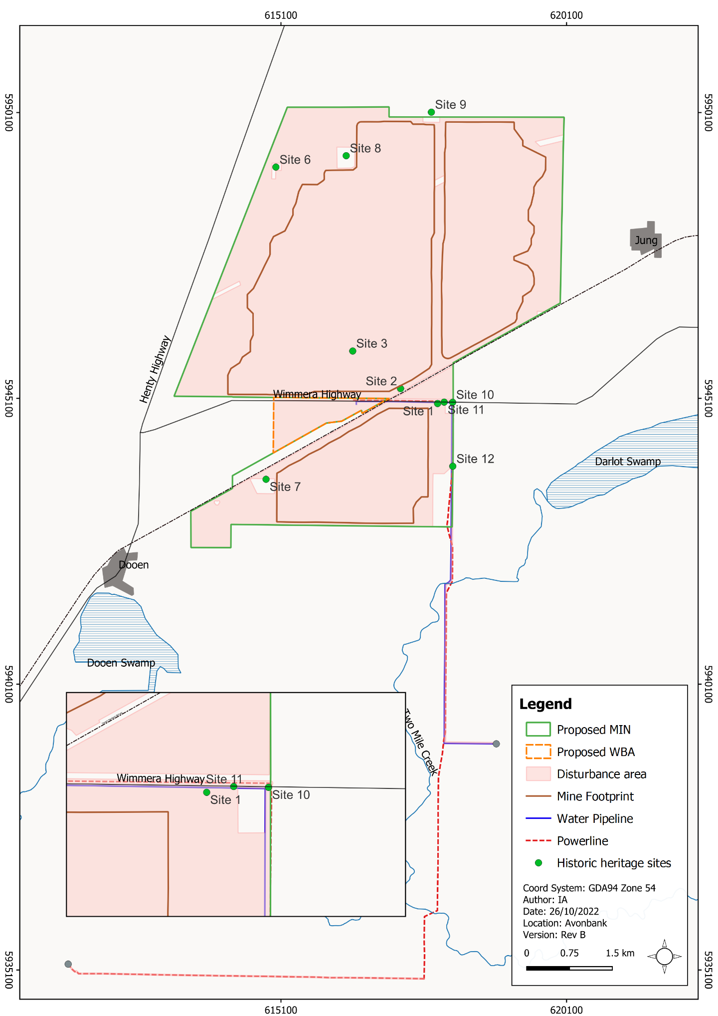
Figure 10-7: Development extent and potential historic heritage sites

Potential Impacts

Identification of Potential Impacts
Potential impacts were identified in the HHIA with consideration to the Project activities, investigation outcomes and the location of sites with potential heritage/archeological values or sites with potential familial values (refer Table 10-2).
Table 10-2: Potential impacts
Item | Potential Impacts | Phase
IP-01 | Mining, processing activities or establishment of the minor utilities corridor resulting in removal or loss of historic buildings or structures. | C, O
IP-02 | Minor utilities corridor resulting in disturbance of a potential archaeological site of interest. | C
IP-03 | Ground movement from mining activities resulting in potential impacts on the structural integrity of a building or structure. | C, O, D

Sensitive Receptors
Sites with potential heritage/archaeological value or those with potential familial value within the development extent were identified in the HHIA. These are described in Section 10.4.3 and shown in Figure 10-7. The residual impacts associated with these sites are described in Section 10.7.

Impact Characterisation
The relative significance of each residual impact was rated on a scale ranging from negligible to severe, as shown in Table 10-3. This rating scale primarily focuses on the hierarchy of consents/permissions required to conduct works that may affect a heritage site or value.
Table 10-3: Significance of residual impacts
Rating | Description
Negligible | Site remains unaffected.
Minor | Project results in works requiring Archaeological Consent from Heritage Victoria.
Moderate | Project results in works requiring a Planning Permit from the Horsham Rural City Council (HRCC).
Major | Project results in works requiring a Permit from Heritage Victoria.
Severe | Project results in complete removal of a heritage place of State or National heritage value.
The significance of each residual impact was also considered with respect to the heritage values set out by the Heritage Council of Victoria, including:
- Historical significance: Importance to the course, or pattern, of Victoria’s cultural history.
- Rarity: Possession of uncommon, rare, or endangered aspects of Victoria’s cultural history.
- Research potential: Potential to yield information that will contribute to an understanding of Victoria’s cultural history.
- Representativeness: Importance in demonstrating the principal characteristics of a class of cultural places and objects.
- Aesthetic significance: Importance in exhibiting particular aesthetic characteristics.
- Technical significance: Importance in demonstrating a high degree of creative or technical achievement at a particular period.
The assessment criteria and associated heritage values are further detailed in Section 10.7.

Avoidance and Mitigation Measures
This Section outlines the measures identified to avoid and minimise residual impacts. It is noted that in line with the requirements of the proposed environmental management system (EMS) and relevant legislation, additional measures may be required during Project implementation to ensure risks and potential impacts have been minimised so far as reasonably practicable.

Avoidance

HH-01: Exclusion zones
Exclusion zones will be established within the development extent to avoid direct impacts on identified heritage sites (Sites 2, 6, 7, 8 and 9). The exclusion zones are shown in the Project disturbance area, shown in Figure 10-7. The areas of exclusion will be recorded and communicated through site inductions/training and by physical demarcation where required. An internal topsoil disturbance approval process will be maintained that requires authorisation by a suitably trained person prior to any disturbance within the development extent.

Minimisation

HH-02: Relocation of historic structures
Relocation of the shed at Site 1 may be possible following a detailed assessment of the structure and an archaeological survey of the area. Any relocation would be conducted in line with the relevant consents under the Heritage Act 2017 and in line with the Heritage Management Plan described in Section 10.6.2.3. Over the course of the Project, if additional structures or items are discovered, opportunities for relocation will be investigated.

HH-03: Chance Finds Procedure
A Chance Finds Procedure for potential heritage or archaeological sites will be maintained to detail the steps that must be taken in the event of discovering a site of potential heritage value that requires oversight by a project archaeologist. The procedure will include contingency measures for temporarily stopping works and establishing a protection buffer around the discovery area. The Chance Finds Procedure will be prepared to include all requirements listed in the draft procedure provided in the HHIA (refer Appendix D, Appendix 1).

HH-04: Heritage management plan
A Heritage Management Plan (HMP) will be prepared prior to Project commencement. The HMP will provide a management framework to avoid and minimise impacts so far as reasonably practicable.
The plan will be reviewed and updated at an appropriate frequency as established in the overarching EMS, with consideration to the level of risk, statutory requirements, monitoring results, community complaints and in response to audit findings.
The HMP will:
- Summarise the baseline data and existing environment.
- Explain the relevant statutory requirements and context (including any relevant approvals).
- Describe the avoidance and mitigation measures to be implemented to minimise residual risks/impacts so far as reasonably practicable.
- Identify specific environmental objectives and performance standards to be achieved with avoidance and mitigation measures in place.
- Detail the monitoring and inspections to be undertaken to verify work procedures are implemented effectively.
- Describe mechanisms to determine when/if corrective actions or contingency measures are required.
- Detail a program to investigate and implement ways to improve the environmental performance of the Project over time.
- Detail appropriate review periods and/or triggers to ensure the plan remains fit for purpose.
- Establish procedures to manage:
- incidents and any non-compliance.
- stakeholder and community complaints.
- failure to comply with statutory requirements and/or performance standards.
- roles and responsibilities for implementing the plan.
- a protocol for periodic review of the plan.
In addition to the above requirements and the avoidance and mitigation measures in this Chapter, the HMP will include specific requirements to:
- Undertake field investigations were relevant in line with the ‘Guidelines for Conducting Archaeological Surveys’ (Heritage Victoria, 2020) once access is granted for each landholding and prior to the commencement of ground disturbing works.
- Complete and lodge a site card for identified historic sites within 30 days of any new discovery.
- Maintain and implement a Chance Finds Procedure as described in Section 10.6.2.2.
- Undertake archival recordings (photographs) in line with the ‘Specification for the Submission of Archival Photographic Records’ (Heritage Victoria, 2017) prior to disturbing or altering any historic sites.
- Obtain relevant consents in line with the Heritage Act 2017, including where relevant: Consent to Uncover, Consent to Disturb, or Consent to Excavate.
- Develop an internal topsoil disturbance approval process that requires authorisation by a suitably trained person prior to any disturbance.
- Develop a heritage induction and training program for site personnel so that the requirements of the HMP are understood by the relevant personnel.

Rehabilitation

HH-05: Rehabilitation plan
A Rehabilitation Plan will be established for the Project that will address matters relating to progressive rehabilitation and closure. It will cover all work areas within the proposed mining licence and within the broader development extent, and the Port of Portland.
The Rehabilitation Plan will include a schedule of progressive rehabilitation and will describe the strategy to establish a safe, stable, sustainable landform capable of supporting the proposed end land use. It is expected that land will be rehabilitated as soon as reasonably practicable after mining, typically within 4 years.
The Rehabilitation Plan will define the end land use, with consideration to the views of the landholders and the broader community, where appropriate.
A preliminary Rehabilitation Plan for the Project has been developed to meet the intent of the Scoping Requirements and is included with this EES as Attachment 3. This plan will be refined prior to commencement with consideration to the detailed operating plans, stakeholder and community feedback and the Minister’s assessment of the EES.

Residual Impacts
This Section describes the likely residual impacts with avoidance and mitigation measures in place. The residual impacts have been characterised as described in Section 10.5.3 and Chapter 6 (Impact Assessment Framework).

Removal of Buildings or Structures
There is one potential impact (IP-01) identified in Section 10.5.1 that relates to the removal of buildings or structures with potential heritage value.
There are two identified structures or buildings that will be directly impacted by Project activities, as shown in Table 10-2 and Figure 10-7. Site 3 is within the mining footprint, and Site 1 is within the minor utilities corridor. Exclusion zones have been established for four sites (Site 2, 6, 7 and 8) which will not be impacted by the Project. Site 9 is outside the mining licence and will not be impacted.
Site 3 is a mid-20th century brick and tile dwelling that is within the mining footprint and may be removed to access ore, pending further discussions with the landowner (for the purpose of this impact assessment, it has been assumed to be removed as a worst-case). The structure has been assessed as being of a common type with no inherent technical, aesthetic or historic heritage value. It has no formal standing as a heritage asset, although it most likely holds social and familial values for the current owners. The residual heritage impact associated with the removal of this dwelling is likely to be negligible. Further assessment of this site will be conducted in consultation with the landholder once access is granted, in line with the Heritage Management Plan.
The impacts relating to the displacement of residents from the dwelling at Site 3 have also been assessed separately in the Social Impact Assessment (Appendix O).
Site 1 is a corrugated iron shed that will likely be removed due to activities associated with the minor utilities corridor. The shed has no formal standing as a heritage asset, is of common type, with limited aesthetic or technical significance. The residual heritage impact associated with its removal is considered to be negligible. There may however be an opportunity to relocate the shed pending further assessment and consultation with the landholder.
Site 12 is a modern concrete culvert associated with the Dooen Main Irrigation Channel that may be partially removed due to activities associated with the minor utilities corridor. The minor utilities corridor will be subject to further detailed planning in consultation with the service provider following the EES assessment. The impact assessment ascribed no particular historical value to this site, and its removal was assessed to be a negligible residual impact. There may be an opportunity to rebuild the culvert following disturbance, if reasonably practicable to do so.
Prior to Project commencement, a Chance Finds Procedure and Heritage Management Plan will be established as described in Section 10.6. It is anticipated that site-specific management plans for the removal of Sites 1 and 3 will be established in consultation with the landholder to manage the risks and potential impacts associated with the disturbance of these sites.
The Project is expected to result in a negligible residual heritage impact as a result of the expected removal or disturbance of Site 1, Site 3 and Site 12.

Disturbance of Potential Archaeological Sites
There is one potential impact (IP-02) identified in Section 10.5.1 that relates to the disturbance of potential archaeological sites within the minor utilities corridor.
The installation of utilities (water mains and power) will result in the disturbance of a trenching area up to 25 m in width to bury pipework and establish new power poles along Wimmera Highway. These works have the potential to result in the disturbance of potential archaeological sites.
Site 10 is a former school site (1884–1920) that has had buildings and associated structures removed. Site 11 is a former farming area situated adjacent to the school site and has also had all structures removed (refer Figure 10-7). Both sites are located on private land and are of potential archaeological interest.
Once access is granted and prior to ground disturbance, both areas will be assessed in line with the statutory processes established in the Heritage Act 2017 and the HMP. If areas cannot be avoided during the detailed planning for the utilities corridor and the sites are confirmed to be of archaeological interest, then the relevant consents under the Heritage Act 2017 will be sought to uncover, disturb or excavate the areas.
Prior to Project commencement, a Chance Finds Procedure and Heritage Management Plan will be established as described in Section 10.6. It is anticipated that site-specific management plans for the disturbance of sites 10 and 11 will be established in consultation with the landholder and Heritage Victoria to manage the risks and potential opportunities associated with the disturbance of these sites.
It is likely the excavation of sites 10 and 11 will result in a minor residual impact. It is noted however that these sites represent a research opportunity that can be managed within the existing framework established in the Heritage Act 2017.

Structural Integrity and Damage
There is one potential impact (IP-03) that relates to ground movements, including vibration that may affect the structural integrity of a building or structure with potential historic heritage value. Ground movement and vibration effects may occur at some mining sites and are commonly associated with blasting activities.
There is one group of sheds (Site 2) located within the geotechnical risk zone of the mine pit. The sheds have no formal standing as a heritage asset but belong to a category of structures (railway sheds) previously identified as having social and/or associative value to the local community. The curved roof of one shed holds some aesthetic value.
Given the mining involves no blasting and the sheds will be located >20 m from the pit crest, the potential impacts associated with vibration are considered to be highly unlikely. The residual impacts associated with this site are therefore considered to be negligible and Project activities will not impact the appearance or the functionality of the structures.

Management Framework
An AS/NZS ISO 14001:2016 EMS will be established for the Project as detailed in Chapter 24. The EMS will address matters relating to planning, operational control, monitoring and continuous improvement over the life of the Project. Relevant matters relating to monitoring, auditing and corrective actions/contingencies are summarised below.

Environmental Objectives
Environmental objectives will be established as part of the EMS to articulate the outcomes to be achieved during Project implementation. These reflect the expected and achievable outcomes based on the studies undertaken as part of this EES.
The key environmental objective relating to historic heritage during Project implementation is to ensure that listed historic heritage sites will not be obscured or damaged unless otherwise approved under the Heritage Act 2017.
Performance standards will be established and incorporated into the HMP to measure and assess if the environmental objective has been achieved over the life of the Project.

Monitoring and Management
Exclusion zones will be established to protect four sites from Project related disturbance. An internal topsoil disturbance approval process will be established that requires authorisation by a suitably trained person prior to any disturbance within the development extent. Exclusion zones will be periodically inspected to ensure the protocol is complied with and no damage to heritage sites has occurred as a result of Project activities. The Chance Finds Procedure will include contingency measures to stop work if potential sites of heritage value are discovered and will require a review of the site by a suitably trained person, as described in Section 10.6.2.2.

Audits
Periodic internal and independent audits will be undertaken to assess the effectiveness of the EMS. An internal audit program will be maintained, which details the frequency, methods, responsibilities and reporting requirements.
Audits will be undertaken by a suitably qualified person to assess the effectiveness of the EMS and associated management plans (including the HMP) to minimise or avoid heritage impacts so far as reasonably practicable. Any non-conformities identified will be investigated, and corrective actions implemented.
The outcomes of audits will be communicated to the Project’s Management team and records of the audit findings will be retained in the record management system. Significant findings will be reported to relevant Regulators and stakeholders where appropriate to do so.

Cumulative Impacts
There are no listed buildings, structures, places or items within the development extent of significant heritage value. On the basis of the Project resulting in negligible to minor residual impacts, the Project is not anticipated to contribute to significant cumulative impacts on historic heritage in combination with other projects that may take place in the region.

Conclusions
This Chapter provides an overview of the Historic Heritage Impact Assessment prepared to address the EES Scoping Requirements for the Avonbank Mineral Sands Project.
The potential impacts on heritage values associated with identified sites within the development extent were assessed as part of the impact assessment.
Avoidance and mitigation measures were identified to reduce the residual impacts so far as reasonably practicable. Listed below are the key measures identified:
- Exclusion zones will be established to avoid impacts on four sites within the development extent.
- The shed at Site 1 may be relocated in consultation with the landholder if impacts are unavoidable and relocation is deemed to be practicable.
- A Heritage Management Plan will be developed, which will include relevant requirements under the Heritage Act 2017 and other means to avoid and minimise residual impacts so far as reasonably practicable.
- A Chance Finds Procedure to manage unexpected discoveries of an archaeological site, which includes a provision to stop work in the vicinity of the discovery.
Site 3 is a mid-20th century brick and tile dwelling that is within the mining footprint and will likely be removed to access the ore, depending upon access related discussions with the owner. It has no formal standing as a heritage asset, although it most likely holds social and familial values for the current owners. The residual heritage impact associated with removal of the dwelling was assessed to be negligible.
The impacts relating to the displacement of residents from the dwelling at Site 3 has been assessed separately in the Social Impact Assessment.
Site 1 is a corrugated iron shed that will likely be removed due to activities associated with the minor utilities corridor. The shed has no formal standing as a heritage asset, and the residual heritage impact associated with its removal was assessed to be negligible. There may however be an opportunity to relocate the shed pending further assessment and consultation with the landholder.
Site 12 is a modern concrete culvert associated with the Dooen Main Irrigation Channel that may be partially removed due to activities associated with the minor utilities corridor. The impact assessment ascribes no particular historic value to this site and as such was assessed to be a negligible residual impact.
Site 10 and 11 have been cleared of above-ground structures. The sites are of potential archaeological interest and warrant further investigation once access to the land is granted and prior to ground disturbing work. The excavation of these sites was assessed to result in a minor residual impact which offers a research opportunity that can be managed within the existing framework established in the Heritage Act 2017.
Given the mining involves no blasting and all sites are located >20 m from the pit crest, the potential impacts associated with vibration are highly unlikely. The residual impacts associated with ground movement and vibration are negligible.
Overall, the proposed Project activity is unlikely to result in significant heritage effects and it is anticipated that the associated impacts can be managed with avoidance and mitigation measures in place to achieve the evaluation objectives.

Construction (C); Operations and rehabilitation (O); Decommissioning and closure (D)

