Avonbank Mineral Sands Project
Environment Effects Statement

Chapter 5 – Community Engagement
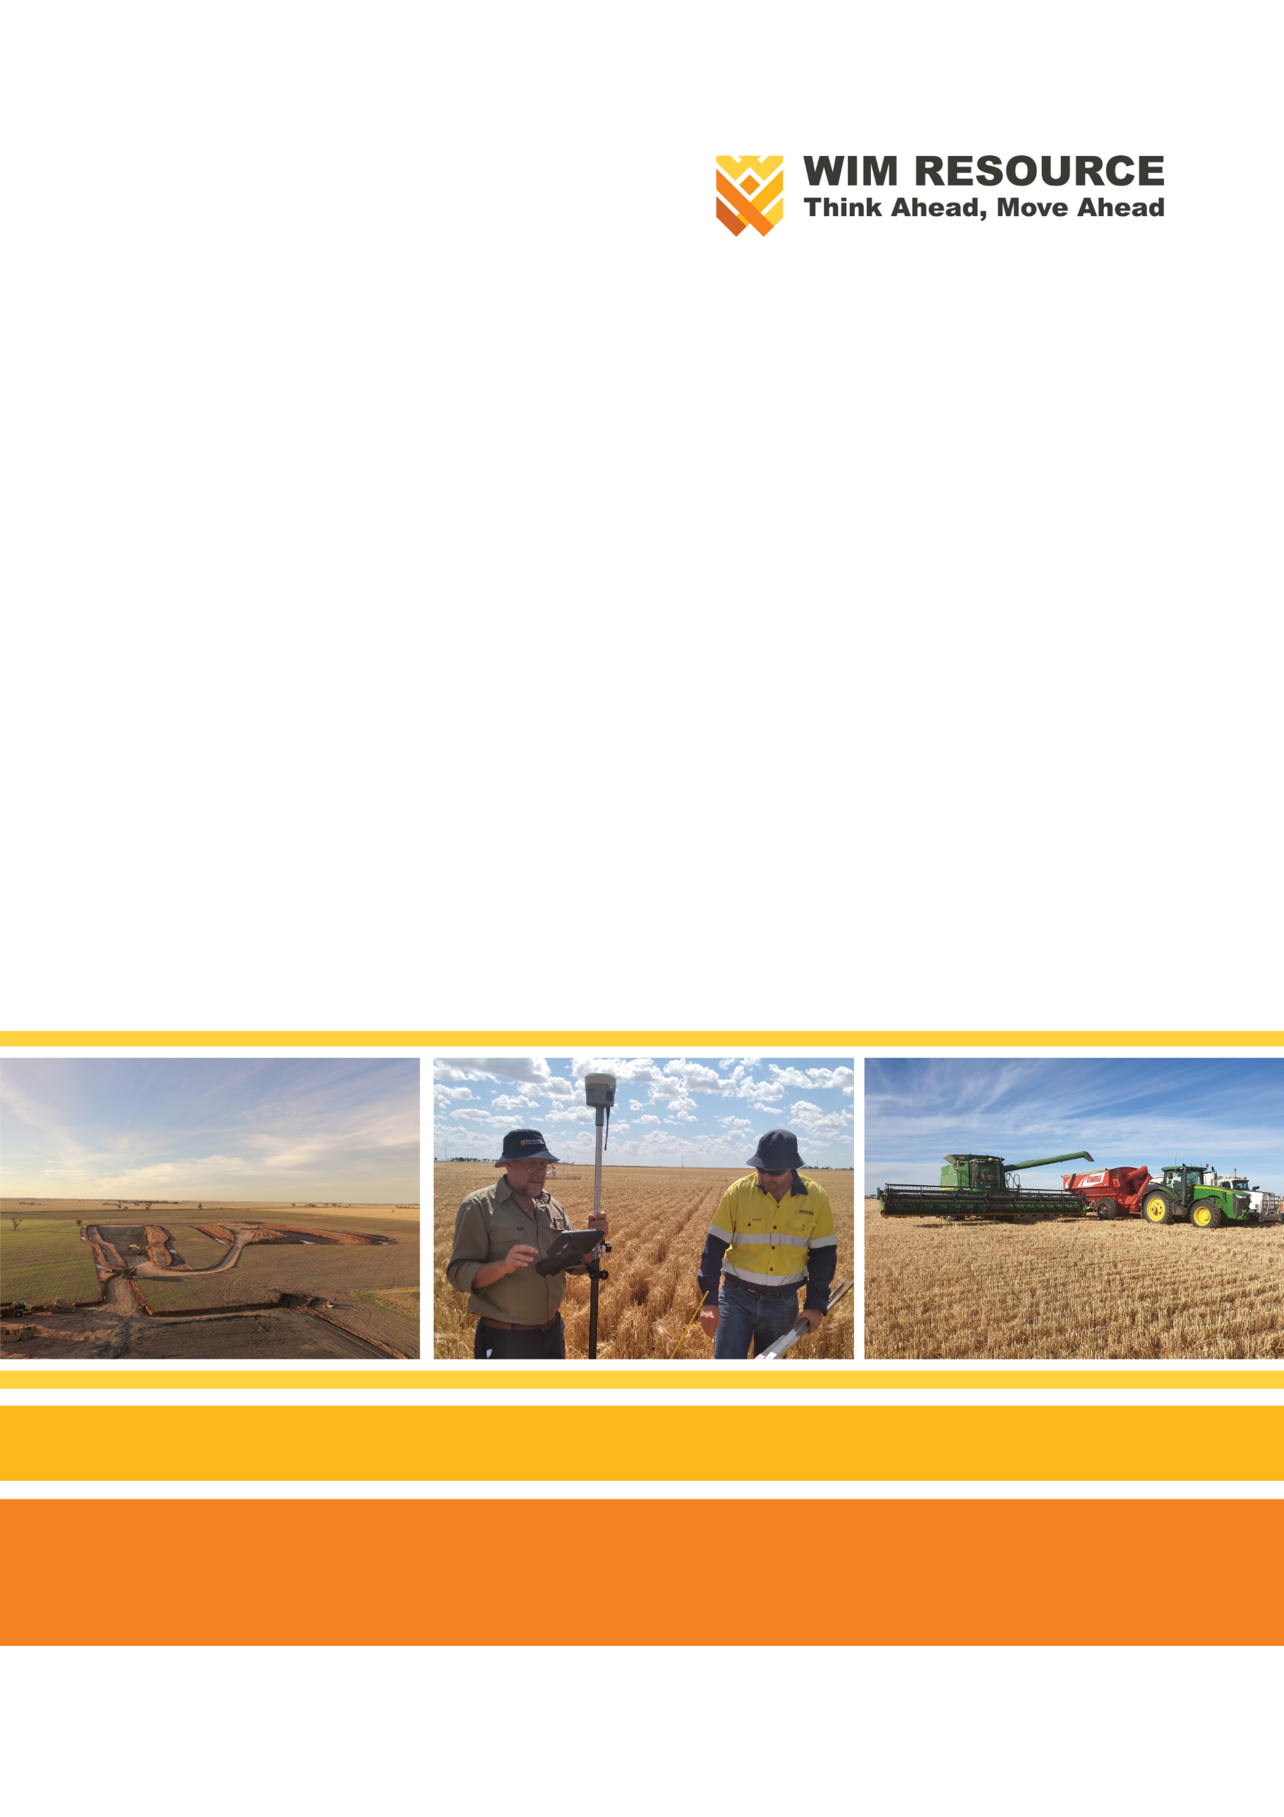

TABLE OF CONTENTS
5 Community Engagement 5-1
5.1 Introduction 5-1
5.2 Scope 5-1
5.3 Project Overview 5-1
5.3.1 Project Activities 5-1
5.3.2 Social Setting 5-6
5.3.3 Previous Consultation and Engagement 5-6
5.4 Community Stakeholders 5-7
5.5 Community Engagement Opportunities 5-8
5.6 Project Feedback 5-12
5.6.1 Contact Options 5-12
5.6.2 Complaints 5-12
5.6.3 Documentation 5-12
5.7 Community Engagement Plan 5-13

TABLES
Table 5-1: Community stakeholder groups identified for the Project 5-7
Table 5-2: Community engagement activities 5-9

FIGURES
Figure 5-1: Project location and regional surrounds 5-3
Figure 5-2: Mining blocks and timing 5-4
Figure 5-3: Development extent 5-5

Community Engagement

Introduction
This Chapter provides an overview of the community engagement strategy for the Avonbank Mineral Sands Project (the Project).
This Chapter has been prepared to address the Environment Effects Statement (EES) Scoping Requirements (DELWP, 2020) to ‘propose a program for community consultation, stakeholder engagement and communications for all stages of the project’, including the means by which local stakeholders can provide feedback and receive responses, and a mechanism for recording and resolving complaints. The Project Scoping Requirements are detailed in Appendix A of this EES.
The purpose of community engagement is to develop an understanding between the Project and stakeholders, to provide an opportunity for two-way communication that allows stakeholder concerns to be addressed so far as reasonably practical, and to facilitate beneficial Project integration with the local area and region.
This Chapter outlines the community engagement activities and processes that will be maintained over the life of the Project.

Scope
This Chapter outlines the stakeholder and community engagement strategy for the Project, to be implemented following the Minister’s assessment of the EES. It will apply to all phases of the Project, including construction, operations and closure across all Project work areas, including:
- Mining, primary processing and associated activities within the mining licence area (MIN).
- Secondary processing, ancillary infrastructure, production of Heavy Mineral Concentrate (HMC) and loading of haulage trucks at the WIM Base Area (WBA).
- Transport of HMC from the WBA to the Port of Portland (PoP).
- Temporary storage of HMC and loading at the PoP.
The stakeholder and community engagement activities undertaken during the EES preparation period are provided in Attachment 1 (Stakeholder Engagement Report) and summarised in Section 5.3.3.

Project Overview

Project Activities
The Project will involve mining the Avonbank mineral sands ore body over a period of approximately 30 years to produce an HMC product comprising mainly zircon, titanium-rich minerals and minor amounts of rare earth by-products. The Project comprises the Avonbank mine, the secondary processing facility and the storage and loading facility at the PoP.
Mining activities will be conducted on the mining licence to be secured within the granted retention licence 2014 (RL2014) (Figure 5-1). Secondary processing and product loading activities will take place within the Wimmera Intermodal Freight Terminal (WIFT) Precinct, which lies in the centre of the site. This location, outside of the proposed mining licence, is referred to as the WBA.
The proposed development extent of the Project will total 3,546 ha comprising mining and related activities within the proposed mining licence (3,426 ha) and secondary processing within the WBA (90 ha), and minor utilities corridor (~30 ha) extending from the power and water terminal stations to the WBA (refer Figure 5-3).
The mine will be an open-cut operation with primary processing to occur within the mine void and the screen/trommel located within the proposed mining licence. The total mining footprint will cover an area of 2,215 ha which will be progressively mined over the life of the Project. Mining will progress sequentially across four Mining Blocks (Block A through to Block D), as shown in Figure 5-2. At any given time, the extent of Project disturbance will be typically less than 300 ha as areas are progressively mined and rehabilitated.
Secondary processing to separate and concentrate the HMC will occur at the Wet Concentrator Plant (WCP) within the WBA to produce approximately 12.75 million tonnes of HMC over the life of mine. Mining and processing activities will operate 24 hours per day, 365 days per year, directly employing approximately 230 personnel during operations.
It is expected approximately 1,430 tonnes of HMC per day will be transported to the PoP to be temporarily stored and shipped to overseas markets for further downstream processing.
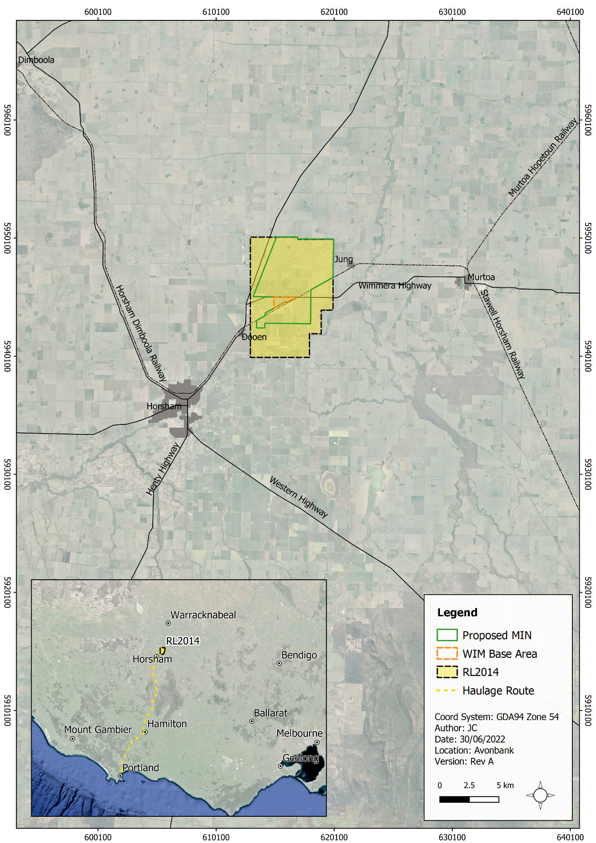
Figure 5-1: Project location and regional surrounds
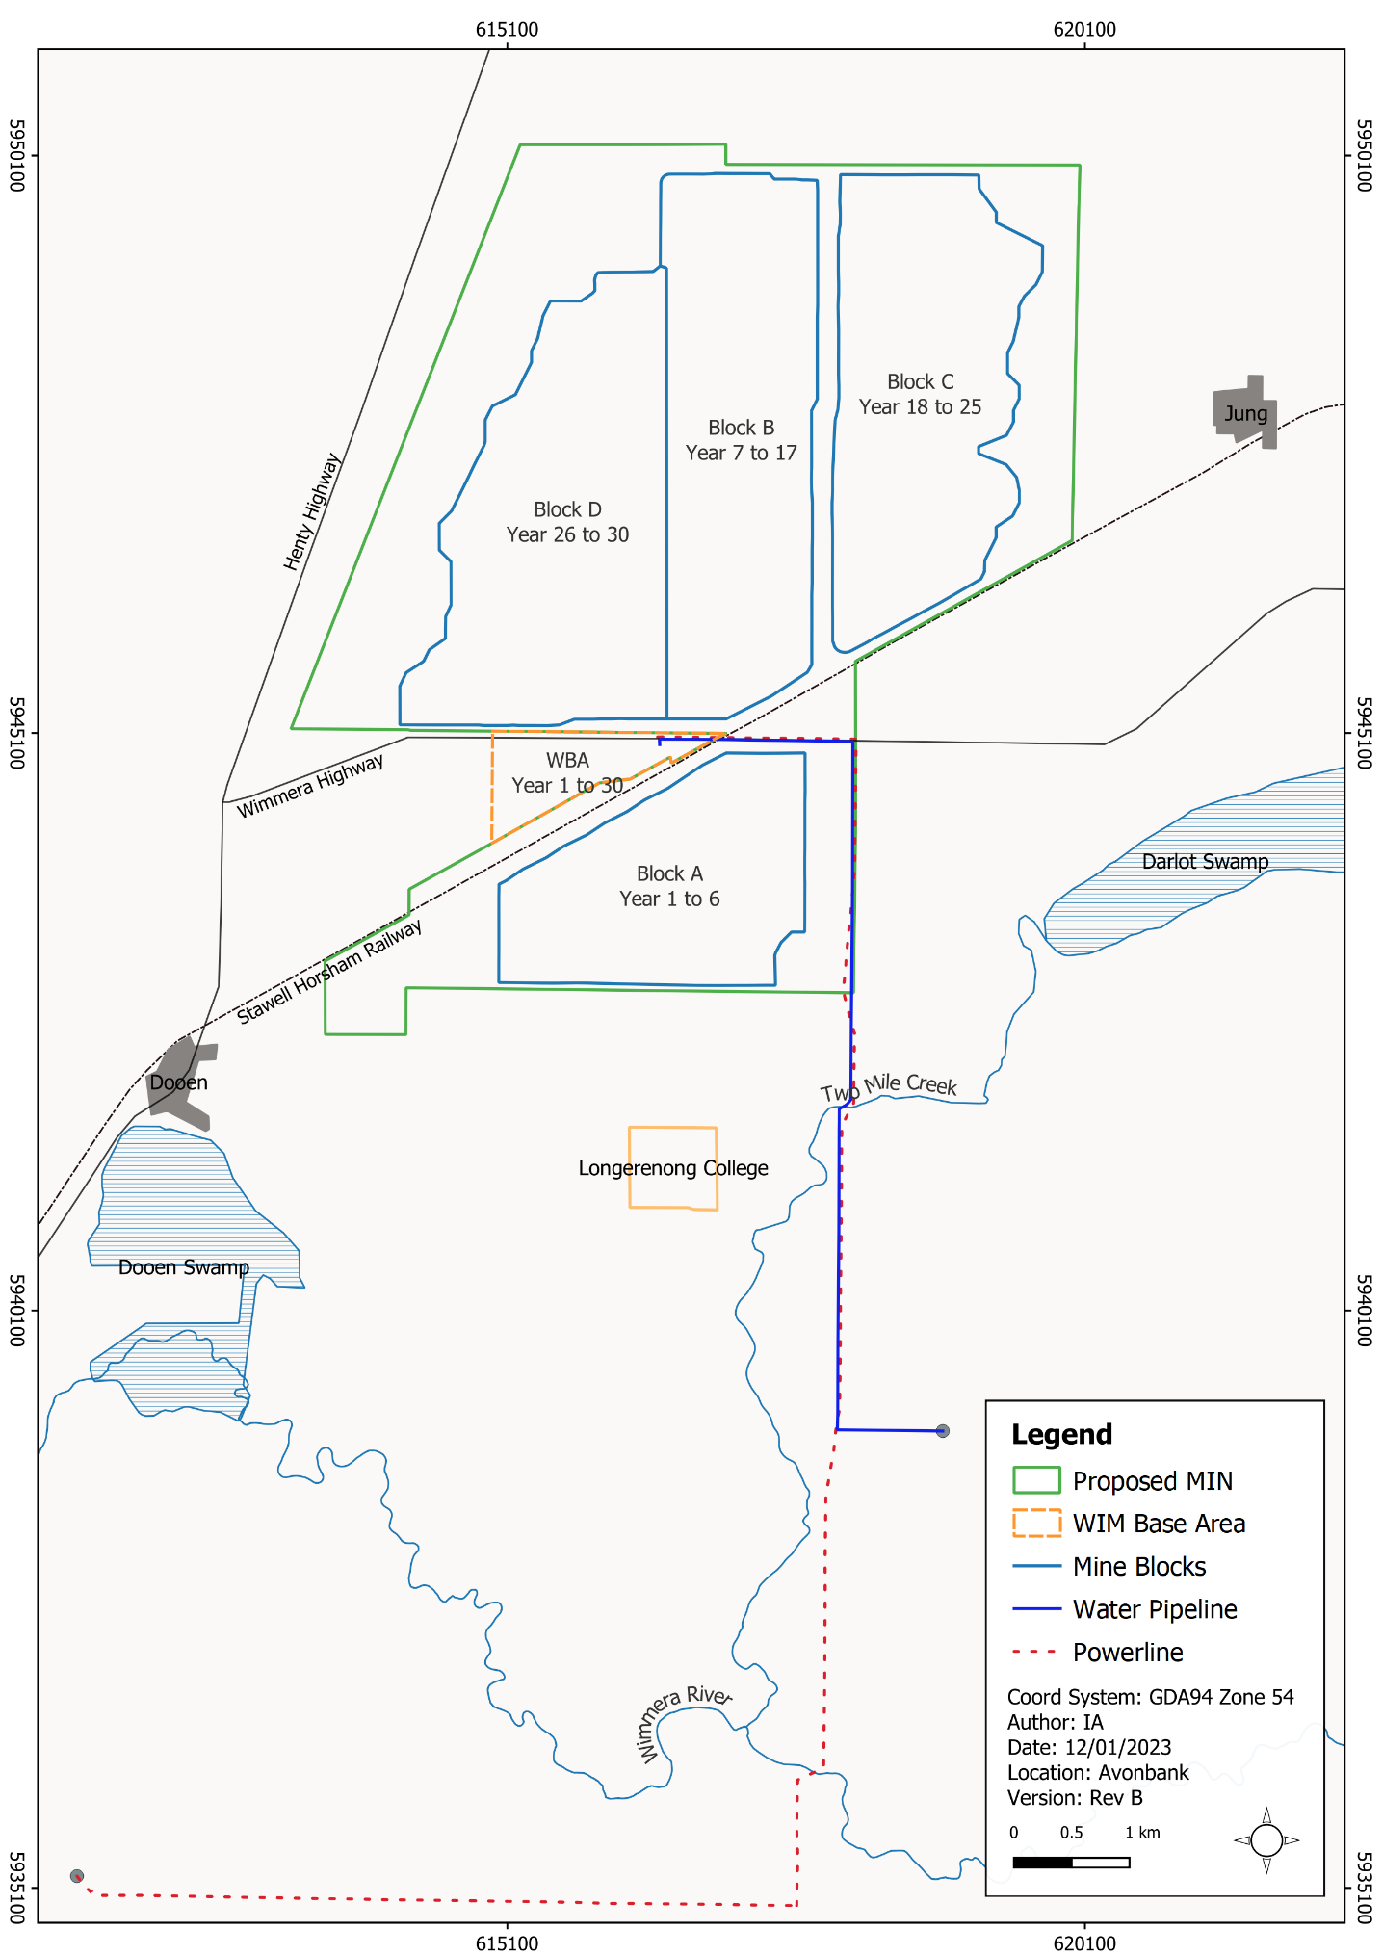
Figure 5-2: Mining blocks and timing
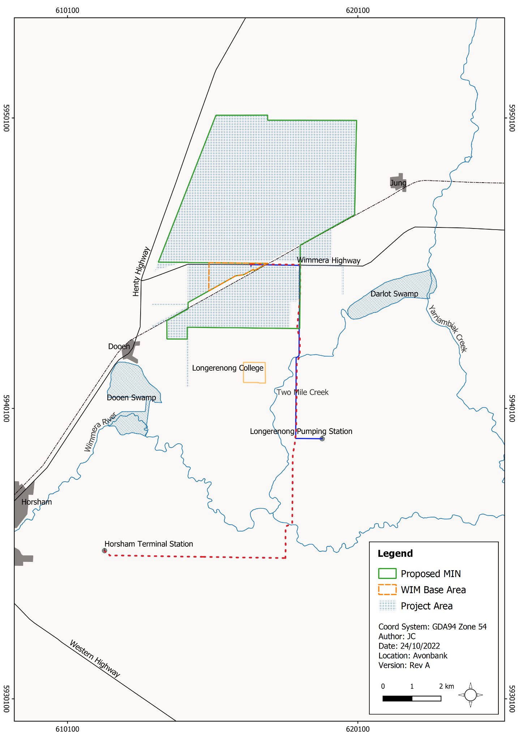
Figure 5-3: Development extent

Social Setting
The proposed mining licence and WBA are located in the Horsham Rural City local government area (LGA), approximately 15 km north-east of Horsham, in the Wimmera Southern Mallee (WSM) region. Horsham has a population of around 20,000 and is the largest urban centre in the WSM, providing retail, government, community, industrial and agribusiness services at its town centre.
The nearest settlements to the proposed mining licence and WBA are the towns of Dooen, 5 km to the south-west and Jung, approximately 1 km to the east. Dooen has an estimated population of around 40, and Jung has a population of around 80. Murtoa has a population of around 750 and is located approximately 20 km to the east (refer Figure 5-1).
The predominant land use within the development extent is broadacre farming. The area is intersected by minor public roads and the Wimmera Highway. The Stawell-Horsham railway passes through the proposed mining licence area. The minor utilities corridor passes through some road reserves and areas primarily used for broadacre farming.
The Longerenong College and associated residences are situated to the south of the mining area. The college has a student population of approximately 180 and provides on-campus accommodation for up to 107 people.
The Traditional Owners associated with the region are the Wotjobaluk, Jaadwa, Jadawadjali, Wergaia and Jupagulk peoples, represented by the Barengi Gadjin Land Council (BGLC) Aboriginal Corporation. The BGLC Aboriginal Corporation is the Registered Aboriginal Party (RAP) for the area that encompasses the development extent.
Project haulage traffic will travel on an approved arterial route to Portland via Horsham, Cavendish, Hamilton, Branxholme and Heywood. With the exception of Cavendish, the haulage traffic will travel around the various towns’ commercial centres.
The Port facilities are situated within a land use zone which provides for uses that derive direct benefit from co-establishing with a commercial trading port. The proposed land use is expected to complement the existing land use within the Port zone.

Previous Consultation and Engagement
An EES Consultation Plan (EECP) was prepared and implemented to guide community and stakeholder engagement through the Project’s feasibility, planning and EES preparation stage. The Stakeholder Engagement Report, provided as Attachment 1, explains how the objectives of the EECP were met and describes how the community’s feedback has been addressed in the EES.
During the EES preparation period, community feedback was sought through a range of key community stakeholder meetings and site tours, community information sessions (held in Horsham, Murtoa, Jung and Dooen), video-conferencing with focus groups, community information sessions and committee meetings. One-on-one meetings were held with directly and indirectly affected landowners and families, where possible.
In general, feedback indicated that stakeholder sentiment and views towards the Project were positive. Stakeholders expressed interest in the potential for economic benefit to the region and employment and business opportunities projected throughout the Project’s life.
The majority of concerns raised related to potential amenity impacts associated with dust and noise and the potential for land productivity impacts following rehabilitation. These concerns have been addressed in the EES and will be considered where relevant in the associated management plans prior to commencement.
While some directly impacted landholders acknowledged the benefits of the Project, for some, their preference was that mining did not occur on land within their ownership. Direct negotiations have been and will be held with the subject parties such that a suitable Land Access and Compensation Agreement or property purchase can be achieved.
The key expectation communicated by most landholders was that the mined land be returned to an agricultural land use as soon as possible. The progressive mine and backfill strategy communicated in this EES will ensure that disturbance is typically (on average) less than 300 ha and that mined land will be returned to a productive agricultural land use within 4 years after the initial disturbance. This has been demonstrated through the successful execution of the Avonbank Demonstration Trial and associated rehabilitation trial.
This Chapter builds on the relationships established during the EES preparation period and sets out a framework for community consultation over the life of the Project.

Community Stakeholders
The identified community encompasses groups, stakeholders or individuals that include potentially affected parties, interested community organisations and government bodies. These community stakeholders typically have a direct link (physical, social, historical, cultural, and/or political) with the Project or the area in which the Project will operate.
Community stakeholder groups identified for the Project are summarised in Table 5-1.
Table 5-1: Community stakeholder groups identified for the Project
Community Stakeholder Group | Reason for Identification
Landholders and residents with property/dwelling(s) within the proposed mining licence area and WBA | Landholders (excluding Crown land tenure and public managed land) that may be affected by the Project for periods over the life of mine.
Barengi Gadjin Land Council Aboriginal Corporation | The BGLC Aboriginal Corporation is the RAP for the Wotjobaluk, Jaadwa, Jadawadjali, Wergaia and Jupagulk peoples. The RAP represents the local Traditional Owners in the protection and management of Aboriginal cultural heritage in the region.
Longerenong College staff and students, including student residents | The Longerenong College and accommodation facilities are located adjacent to the Project’s proposed mining licence area. Part of the college land lies within the proposed mining licence area. Potential for additional study programs or collaboration.
Port of Portland | The PoP receives the Project’s end product, HMC.
Powercor | Powercor is the electricity distribution company responsible for the area encompassing the Project. Upgrade of existing transmission lines will be required for the Project.
Grampians Wimmera Mallee Water (GWMWater) | GWMWater will supply water for processing via the GWMWater pipeline.
Regional Roads Victoria | Regional Roads Victoria is the mandated authority with responsibility for coordinating regional Victoria’s transport system, including the freight route connecting the WBA to PoP.
Australian Rail Track Corporation (ARTC) | Rail was considered as an alternative during the project scoping stages and sits within the proposed mining licence area.
Freight Victoria | The Project will have transport requirements for all phases.
Horsham Rural City Council | As a significant additional business to the area, the Project will foster opportunities for community development.
Key regulators: Department of Environment, Land, Water and Planning (DELWP), Environment Protection Authority (EPA), Earth Resources Regulation (ERR). | Key regulators involved in Project approvals and regulation through all Project stages.
Local landholders, residents and businesses | Landholders, residents and businesses are located adjacent or near to the Project (including but not limited to the haulage route, power corridor and water pipeline).
Local businesses | The Project will utilise goods and services sourced from businesses proximal to the Project area.
Members of the wider community, such as residents and landowners in the areas of Dooen, Jung, Murtoa and Horsham | The Project will have socioeconomic impacts for the wider community through increased employment opportunities and demand for goods and services.
Environment groups | Environment groups have an interest in developments involving the use of natural resources.
Parliamentarians (State and Federal) | The Project provides an opportunity for economic growth through the generation of revenue and opportunities enabling socioeconomic development.
Community stakeholder identification is an ongoing process, requiring regular review and update as the Project progresses.

Community Engagement Opportunities
Throughout the Project’s life, the broader community will be able to access information on Project work activities through public information sessions, the Project website, newsletters, information sheets, advertisements and media releases.
In addition, a variety of community engagement activities will be undertaken, with the objective of sharing information and seeking feedback and promoting collaboration. Table 5-2 provides a summary of community engagement activities that have currently been defined.
As the Project progresses, engagement activities may change or be expanded. It is recognised that the regulatory environment and community stakeholder interest is fluid and dynamic. To ensure community engagement activities remain relevant and effective, community engagement plans and opportunities will be regularly reviewed and, where required, updated in line with the Project’s environmental management system.

Table 5-2: Community engagement activities
Community Stakeholder Group | Objective of the Engagement | Engagement Activity | Project Phase
Landholders and residents with property/dwelling(s) within the mining licence area and WBA. | To ensure landowners are fully informed and consulted during Project works. | There will be direct liaison (face-to-face meetings) with the owners of private properties within the mining licence area. The owners will also be informed of Project operations through targeted information sessions and, where practical, site tours. There will be collaboration with private property owners in the rehabilitation phase of the Project, facilitated through meetings and site tours. Landholder specific Land Access and Compensation Agreements will be established where required. | Ongoing/All Phases
Local landholders, residents and businesses | To ensure local landowners and residents are fully informed of Project works. | Residents and landholders in the vicinity of the Project will be informed of Project activities through the Project website and Project newsletter.  A site ‘open day’ will be held periodically at the mine, which will include site tours, information sessions and topic-specific briefing sessions.  Targeted consultation groups/committees may be formed over the life of the Project to address specific issues if they arise. | Ongoing/All Phases
BGLC Aboriginal Corporation (the RAP) | To minimise the potential impact on Aboriginal cultural heritage. | The RAP will be involved in the Project throughout each stage.  The Project will work with the RAP in a collaborative manner and the RAP will be involved in decision-making relevant to Aboriginal culture. | Ongoing/All Phases
Longerenong College administration, staff and students, including student residents | To provide practical ways that the Longerenong College community can be engaged in the Project in the mine site area. | The staff and student population of the Longerenong College will be informed of Project activities relating to the mine site. This will primarily be through targeted information sessions and, where practical, site tours.  Through all Project stages, measures to collaborate with staff members and students through meetings and surveys will be undertaken to identify areas in which the Project can support educational opportunities. This may be in the form of student scholarship programs or research grants. It is anticipated that a Memorandum of Understanding will be established with the College prior to commencement.  Rehabilitation works may be of particular interest to the College’s educational program, and there could be meaningful opportunities for students to undertake studies relating to the rehabilitation of land to promote a high-yield cropping land use. The potential for such avenues of study will be explored through consultation with College staff. | Ongoing/All Phases
Port of Portland Pty Ltd (PoPL) | To maintain communication through Project operation. | Communication between the PoPL and the Project will occur on a regular and an ‘as needs’ basis. | Operations
Regulators (DELWP, EPA, ERR) | To ensure Project regulatory compliance. | These key regulators will be involved in the Project throughout each stage and will be provided with Project information in accordance with compliance requirements. | Ongoing/All Phases  Annually and as required
Local businesses | To enhance socioeconomic opportunities for local commercial enterprises. | Local business owners will be informed of Project activities and requirements. Where possible, local businesses will be utilised to provide goods and/or services to the Project. Avenues for the involvement of local businesses in the Project will be identified and encouraged. | Ongoing/All Phases
Members of the wider community, such as residents and landowners in the areas of Dooen, Jung, Murtoa, Horsham and Cavendish | To support local communities. | The wider communities associated with the Project will be kept informed about Project activities through the Project website and Project newsletter.  A site ‘open day’ will be held periodically at the mine, which will include site tours, information sessions and topic-specific briefing sessions.  A targeted grants program will be offered periodically to support community-based activities and local community infrastructure development.  Project employment opportunities will be advertised in local newspapers. | Ongoing/All Phases
Environment groups | To facilitate clear communication on Project objectives and environmental outcomes. | Environment groups will be kept informed about Project activities through the Project website and Project newsletter.  A site ‘open day’ will be held periodically at the mine, which will include site tours, information sessions and topic-specific briefing sessions.  Targeted consultation may be undertaken to share outcomes of research projects. | Ongoing/All Phases
Horsham Rural City Council | To ensure the best socioeconomic outcomes for the Horsham Rural City Council. | A Memorandum of Understanding (MOU) has been established with the Horsham Rural City Council. The MOU provides objectives and goals for how the Project and the Council will collaborate. | Ongoing/All Phases
GWMWater | To ensure the Project’s required water supply is obtained on an annual basis for the duration of operations. | Negotiation of mutually agreeable contract terms between the Project and GWMWater. | Construction (and on Contract renewal) through the operations phase of the Project
Freight Victoria | To ensure transport requirements for all stages of the Project are met. | Communication between the Project and Freight Victoria will occur on an ‘as needs’ basis. | Ongoing/All Phases
Powercor | To ensure the Project’s required power supply is obtained on an annual basis for the duration of operations. | Negotiation of mutually agreeable contract terms will occur between the Project and Powercor. | Construction (and on Contract renewal) through the operations phase of the Project
Regional Roads Victoria | To ensure optimal (safe and efficient) movement of transport vehicles to and from PoP. | Collaboration will occur with Regional Roads Victoria through construction and operation. Regional Roads Victoria will be involved with decision-making regarding access roads, road closures and road diversions. Meetings will be held with key personnel as required. | Ongoing/All Phases
Parliamentarians (State and Federal) | To facilitate clear communication on Project objectives and outcomes. | Relevant parliamentarians will be informed of key Project milestones through Project briefings as required. | Ongoing/All Phases

Project Feedback
The Project’s AS/NZS ISO 14001:2016 environmental management system (EMS) will include a mechanism for managing and monitoring environmental and social impacts and risks associated with all Project activities (refer Chapter 24, Environmental Management). Community consultation and stakeholder engagement is an integral part of the EMS.
This Section presents an overview of the opportunities that community groups and stakeholders have to provide feedback regarding the Project. Feedback opportunities collectively cover enquires, comments, complaints and grievances.

Contact Options
Contact options established during the EES preparation phase will be maintained so that the community can provide feedback as required. Feedback can be provided by phone, email, mail, or company website. Contact details will be included in publicly available Project documentation and on the Project website.
Feedback will be documented and acknowledged as soon as practical. Where required, progress updates and/or a formal response will be provided to address the feedback received.
Community feedback will be assessed, with consideration to how the matters raised may contribute to Project decision-making. Some community feedback may not influence non-negotiable decisions or issues, however, in other cases, the feedback will be valuable and contribute to positive outcomes enabling the Project to minimise its impacts and risks, so far as reasonably practicable.

Complaints
A complaints mechanism will be established so that community issues can be resolved so far as reasonably practicable. Complaints provide an opportunity to eliminate or minimise Project related issues raised by the community and to improve environmental performance.
This mechanism is incorporated into the overarching EMS such that an incident can be raised and investigated in response to a community complaint. Outcomes of these investigations will be incorporated into decision-making processes related to the avoidance and mitigation of impacts and general improvement of environmental performance (refer Chapter 24).
The complaints or grievances will be documented in a register, and the complainants will be kept informed during the consideration of the issue and notified of any corrective actions resulting from the complaint or incident investigation.

Documentation
All engagement activities, and the outcomes of these activities, will be fully documented and an associated register will be maintained and incorporated into the overarching EMS.
A complaints/grievance register will be maintained throughout the life of the Project. Documented information will be controlled to ensure:
- it is available and suitable for use, where and when it is needed; and
- it is adequately protected (e.g., from loss of confidentiality, improper use, or loss of integrity).
For the control of documented information, the Project will ensure appropriate processes are in place for storage and preservation, including preservation of legibility, control of changes (e.g., version control), retention and disposition.

Community Engagement Plan
As a requirement under the Mineral Resources (Sustainable Development) Act 1990, a Community Engagement Plan (CEP) will be developed to document how, when and what community consultation will be undertaken. The strategy outlined in this Chapter will be incorporated into the CEP.
The CEP will align with relevant laws, regulations and guidelines, including but not limited to the following:
- The Mineral Resources (Sustainable Development) Act 1990.
- The Mineral Resources (Sustainable Development) (Mineral Industries) Regulations 2019.
- Earth Resources ‘Community Engagement Guidelines for Mining and Mineral Exploration in Victoria’ (ERR 2021).
The CEP will also be developed in accordance with the concepts developed by the International Association of Public Participation (IAP2), in which community engagement follows a systematic process to inform, consult, involve, collaborate with, and empower stakeholders about Project activities that have the potential to impact them.

Construction, operations, decommissioning

