Avonbank Mineral Sands Project
Environment Effects Statement

Chapter 11 – Landscape and Visual Amenity

TABLE OF CONTENTS
11 Landscape and Visual Amenity 11-1
11.1 Introduction 11-1
11.2 Scope and Methods 11-1
11.2.1 Scope 11-1
11.2.2 Study Area 11-1
11.2.3 Methodology 11-3
11.3 Operational Context 11-3
11.4 Existing Conditions 11-6
11.4.1 Topography 11-6
11.4.2 Vegetation 11-6
11.4.3 Land Use 11-7
11.4.4 Townships 11-8
11.4.5 Other Features 11-8
11.5 Potential Impacts 11-9
11.5.1 Identified Potential Impacts 11-9
11.5.2 Sensitive Receptors 11-9
11.5.3 Impact Characterisation 11-12
11.6 Avoidance and Mitigation Measures 11-13
11.6.1 Avoidance 11-13
11.6.2 Minimisation 11-13
11.6.3 Rehabilitation 11-16
11.7 Residual Impacts 11-16
11.7.1 Visual Impacts due to Large Plant 11-16
11.7.2 Visual Impacts due to Mining 11-17
11.7.3 Visual Impacts due to Overburden Stockpile B 11-19
11.7.4 Lighting 11-20
11.8 Management Framework 11-20
11.8.1 Environmental Objectives 11-21
11.8.2 Monitoring and Management 11-21
11.8.3 Audits 11-21
11.9 Cumulative Impacts 11-21
11.10 Conclusions 11-21

TABLES
Table 11-1: Potential impacts 11-9
Table 11-2: Sensitive receptors – Public viewpoints and private residences 11-10
Table 11-3: Landscape units and sensitivity 11-12
Table 11-4: Significance of residual impacts 11-12

FIGURES
Figure 11-1: Study area and site layout 11-2
Figure 11-2: Overburden, WBA infrastructure and mine blocks 11-5
Figure 11-3: Grampians looking south from Longerenong Road 11-6
Figure 11-4: Dooen landfill looking north-west from Henty Highway 11-6
Figure 11-5: Roadside vegetation along the Wimmera Highway east of the transmission line 11-6
Figure 11-6: Typical farming land east of Jung (left) and night-time harvesting (right). 11-7
Figure 11-7: Wimmera Intermodal Freight Terminal looking south-west from the Wimmera Highway 11-7
Figure 11-8: Grain handling and storage views from Dooen 11-8
Figure 11-9: WIFT lighting viewed from the Wimmera Highway 11-8
Figure 11-10: Murra Warra Wind Farm, transmission line and sheds looking north from Bells Road 11-9
Figure 11-11: Viewpoints for visual impact (public and private domains) 11-11
Figure 11-12: Landscape screening locations 11-15
Figure 11-13: Photomontage from Viewpoint 3 (VP3) on Wimmera Highway looking west towards the WBA and proposed screening vegetation 11-17
Figure 11-14: Photomontage showing views of the Block B overburden stockpile from the corner of Henty and Wimmera Highways, VP1, without mitigation proposed screening vegetation 11-20
Figure 11-15: Photomontage showing views of the Block B overburden stockpile from the corner of Henty and Wimmera Highways, VP1, with proposed screening vegetation 11-20

Landscape and Visual Amenity

Introduction
This Chapter provides an overview of the landscape and visual effects for the Avonbank Mineral Sands Project (the Project). It has been prepared to address the Environment Effects Statement (EES) Scoping Requirements (DELWP, 2020) and is supported by a detailed impact assessment prepared by Landform Architects Pty Ltd (Appendix F).
The key evaluation objective relevant to this Chapter, as defined in the Scoping Requirements, is to ‘Protect the health and wellbeing of the community, and minimise effects on air quality, noise, visual and social amenity’ (DELWP, 2020). The associated issues and Scoping Requirements are detailed in Appendix A of this EES.
This Chapter describes the existing landscape and visual environment, the potential impacts associated with the Project, and details the avoidance and mitigation measures to minimise the residual impacts so far as reasonably practicable.

Scope and Methods

Scope
The scope of this Chapter covers all potential impacts identified in the Landscape and Visual Impact Assessment (LVIA) (Appendix F) and addresses the relevant Scoping Requirements listed in Appendix A. The impact assessment focused on mining and mineral processing activities that may result in visual amenity impacts over the life of the Project. Project related aspects that are well understood and considered to be relatively low risk with standard controls in place are addressed in the Aspects and Risk Register (Attachment 5).

Study Area
The LVIA study area was based on a viewshed that included activities within the proposed mining licence (MIN) and WIM Base Area (WBA). The viewshed refers to the area or distance from the Project where key features may be a recognisable element in the landscape. The viewshed extended around 3.5 km to the nearest towns of Dooen and Jung, Longerenong College, and Highways where the Project is considered to be visually discernible (Figure 11-1). Sensitive receptors that fall within the study area are described in Section 11.5.2.
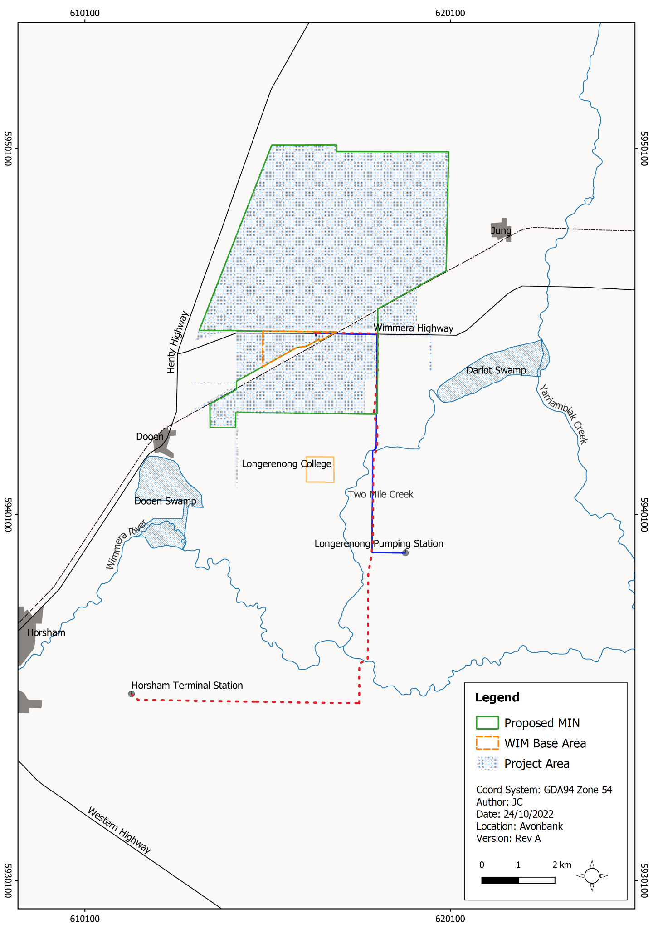
Figure 11-1: Study area and site layout

Methodology
The LVIA characterised the existing conditions, identified potential impacts and assessed the residual impacts with avoidance and mitigation measures in place. The tasks undertaken are summarised below and detailed in Appendix F, Section 3.
Existing conditions:
- The zones of visual influence surrounding the Project were established to define the study area.
- The landscape character and sensitivity to visual change were defined with consideration to landscape features, land use and applicable planning policies and guidance.
- A site visit was undertaken over several days in July 2021 to characterise the viewshed and capture photographs.
- Key public and private (residential) viewpoints were identified which may be sensitive to visual change, or significant to the local community, or representative of the landscape character types within the study area.
Potential impacts:
- The Project design elements with the potential to influence visual amenity were identified across all stages of the Project.
- Potential impacts were identified with consideration to Project visibility, distance, viewer numbers, landscape character and viewer sensitivity, and view duration.
- An assessment of the residual impacts was undertaken using a scale of effects that qualitatively defines the varying degrees of visual impacts from negligible to major.
Residual impacts:
- Measures were identified to avoid and/or minimise impacts to sensitive receptors so far as reasonably practicable.
- A series of photomontages were prepared from viewpoints that depict the Project changes and impacts from a range of distances, viewing angle and settings.
- Project design elements were considered from various viewpoints to characterise the residual impacts and to understand the effectiveness of the avoidance and mitigation measures.
- Cumulative impacts of other projects within the region were qualitatively assessed.
Key assumptions relating to the LVIA methodology are detailed in Appendix F, Section 3.

Operational Context
As described in Chapter 2 (Project Description), construction of the Wet Concentrator Plant (WCP) and preparation for the starter pit will be undertaken in year 1, followed by progressive mining in the southern areas of the mine footprint in year 2 (Block A). The WCP will be centrally located adjacent to the loading facility for the life of the Project within the WBA (refer Figure 11-2).
At the commencement of mining in Block A, overburden will be excavated and hauled approximately 1.5 km to an out-of-pit overburden stockpile located west of the mining area. The stockpile will store the first eight months of overburden and will be approximately 700 m long, 450 m wide and 30 m high. The overburden stockpile (OB-A) will remain in place for up to 8 years while areas south of the Wimmera Highway are mined (refer Figure 11-2).
Following Block A, mining operations will move to Block B, north of the Wimmera Highway in year 7. A starter pit will be established similar to that for Block A. Overburden will be hauled approximately 2 km to an out-of-pit overburden stockpile to form Stockpile Overburden B (OB-B) (refer Figure 11-2). The stockpile will be 860 m long, 500 m wide and will range from 25 m to 30 m high.
Following the completion of mining in Block B, the operation will move to Block C and then to Block D. Typically, overburden will be used to progressively backfill the mine void, along with tailings from the WCP. After the void is backfilled and tails have dried sufficiently, subsoil and topsoil will be placed.
Infrastructure within the WBA will have fixed lighting where required, to facilitate the 24-hour operation. The mining operations will have temporary lighting that will move as the mine void progresses through each Block.
All areas will be progressively rehabilitated and will be completed within 4 years after initial disturbance in each mining cell. At any given time over the life of mine, the extent of Project disturbance will be less than 400 ha and will typically (on average) be less than 300 ha as areas are progressively mined and rehabilitated.
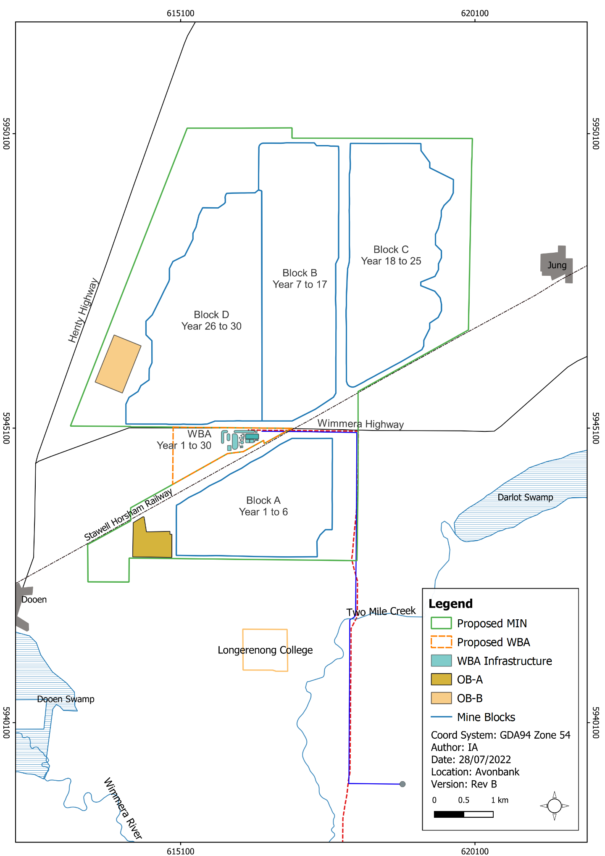
Figure 11-2: Overburden, WBA infrastructure and mine blocks

Existing Conditions

Topography
The Project is located within open, flat to gently undulating areas of the Wimmera plains. The mining area is located on land that gently falls south towards Yarriambiack Creek and Wimmera River. In clear weather, the elevated hills and topographical features of the Grampians are visible approximately 25 km to the south. Due to the distance from the Project, the Grampians are not a dominant topographical feature (Figure 11-3).
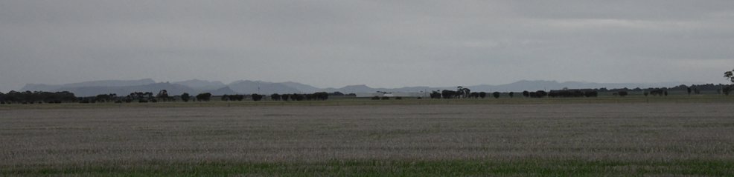
Figure 11-3: Grampians looking south from Longerenong Road
From the Henty Highway, stockpile mounds associated with the Dooen Landfill are visible in the distance to the west of the Project (Figure 11-4).
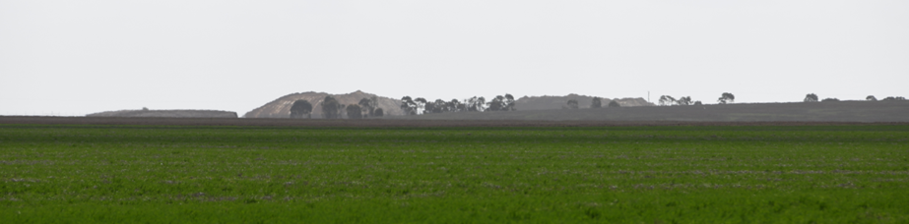
Figure 11-4: Dooen landfill looking north-west from Henty Highway

Vegetation
The majority of the study area is occupied by broadacre cropping and some low-level vegetation. Native and planted trees are largely restricted to property boundaries and road reserves. Figure 11-5 shows roadside vegetation along the Wimmera Highway near the Project.
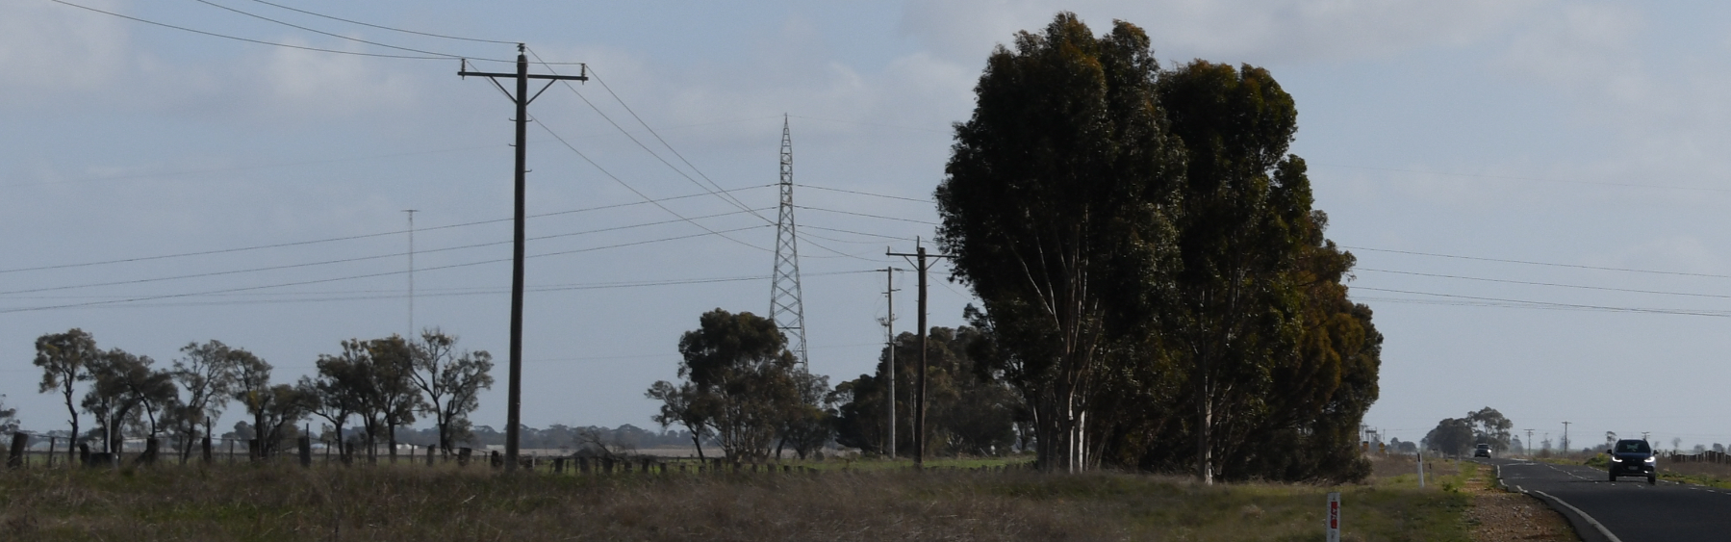
Figure 11-5: Roadside vegetation along the Wimmera Highway east of the transmission line

Land Use

Agricultural and farming land
The predominant land use within the study area is agriculture, primarily cleared land for broadacre farming. Agricultural land is subject to regular visual changes through seasonal cropping activities. Dwellings and supporting agricultural infrastructure are visible, including tarpaulin-lined grain bunkers, grain elevators, silos, sheds, windbreaks and hedgerows.
Seasonal lighting associated with plant and equipment used for larger-scale cropping and harvesting is a feature in these areas. Figure 11-6 shows farming land that is typical of the region and night-time farming operations.
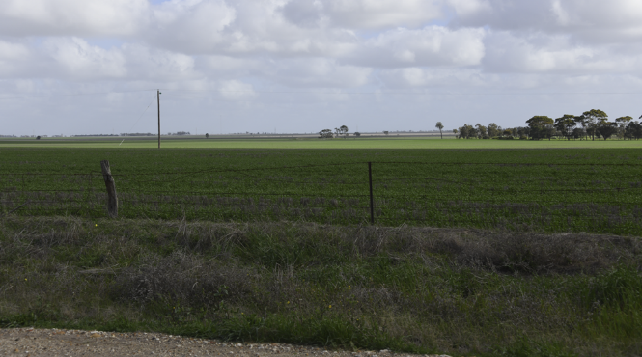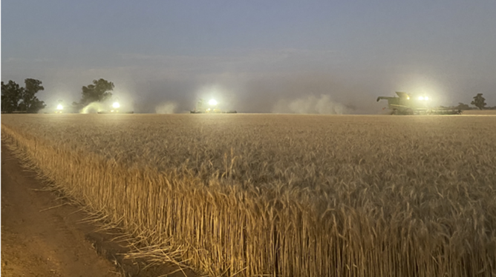
Figure 11-6: Typical farming land east of Jung (left) and night-time harvesting (right).

Wimmera Intermodal Freight Terminal
The WBA is situated largely within the Wimmera Intermodal Freight Terminal (WIFT) Precinct. The area is classified as Special Use Zone under the Horsham Planning Scheme. The Special Use Zone was established for industrial purposes, including but not limited to the processing, storage and handling of mineral sands.
Currently the WIFT Precinct accommodates shipping containers stacked to a height of around 8 m from ground level. Grain handling and storage facilities include on-ground bunkers and silos, around 30 m high, located towards the western end of the WIFT Precinct, near the Henty Highway and Dooen.
Figure 11-7, Figure 11-8 and Figure 11-9 show the operation of the WIFT Precinct during the daytime and night-time from publicly accessible viewpoints in the vicinity of the WBA.
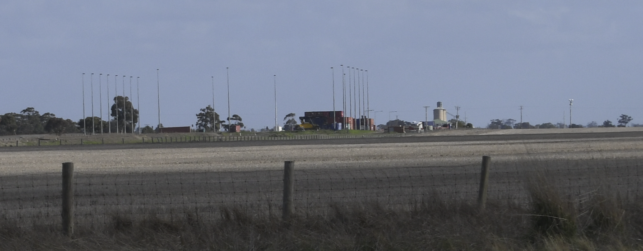
Figure 11-7: Wimmera Intermodal Freight Terminal looking south-west from the Wimmera Highway
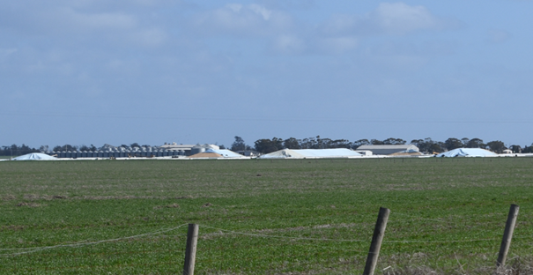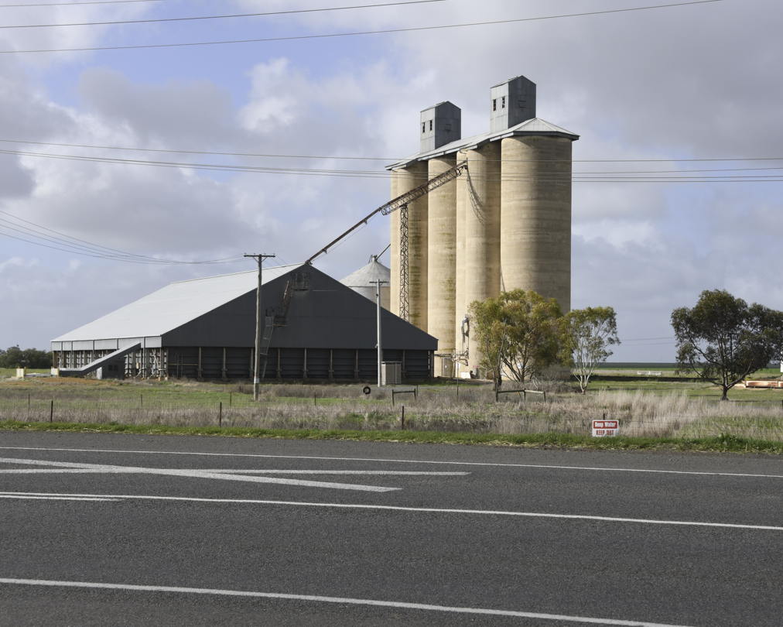
Figure 11-8: Grain handling and storage views from Dooen
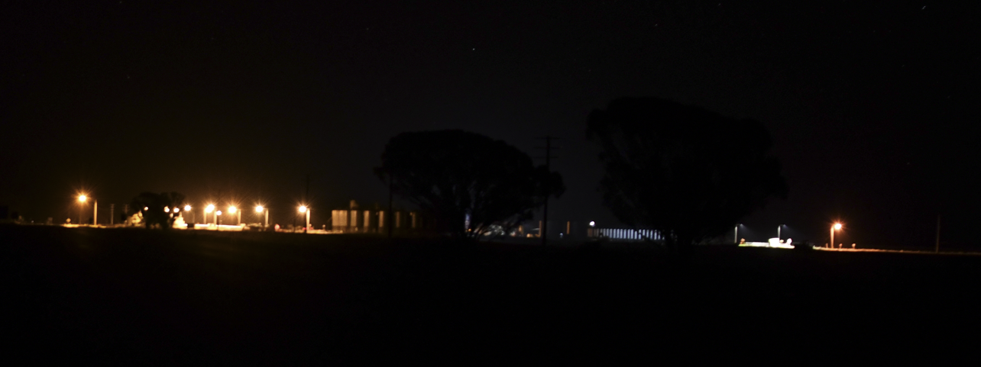
Figure 11-9: WIFT lighting viewed from the Wimmera Highway

Townships
Townships within the study area include Jung to the east and Dooen to the south-west. Jung is set back from the Wimmera Highway and freight line. The town mainly consists of dwellings on suburban scale lots, vegetation in private allotments and roadsides, and community facilities including a sports field and hall. Dooen is west of the Project area and WIFT Precinct, straddling the Henty Highway, and public locations include the Dooen Hotel north of the train line and along the western side of the Henty Highway. Lighting visible from these townships is associated with dwellings, road users, street lighting and elevated structures.

Other Features
The Murra Warra Wind Farm is located north of the Project. Key visual features of the wind farm include the wind turbines, transmission lines and substations. Other features include operations and maintenance facilities and laydown areas. A common visual feature in farming areas are large sheds for machinery and livestock. Existing wind turbines and high-voltage transmission lines are visible from the Project area and surrounds (Figure 11-10).
The 220 kV Red Cliffs to Horsham high-voltage transmission line bisects the Project area from north to south. The transmission lines form the eastern edge of Mining Block A and divides Blocks B and C.
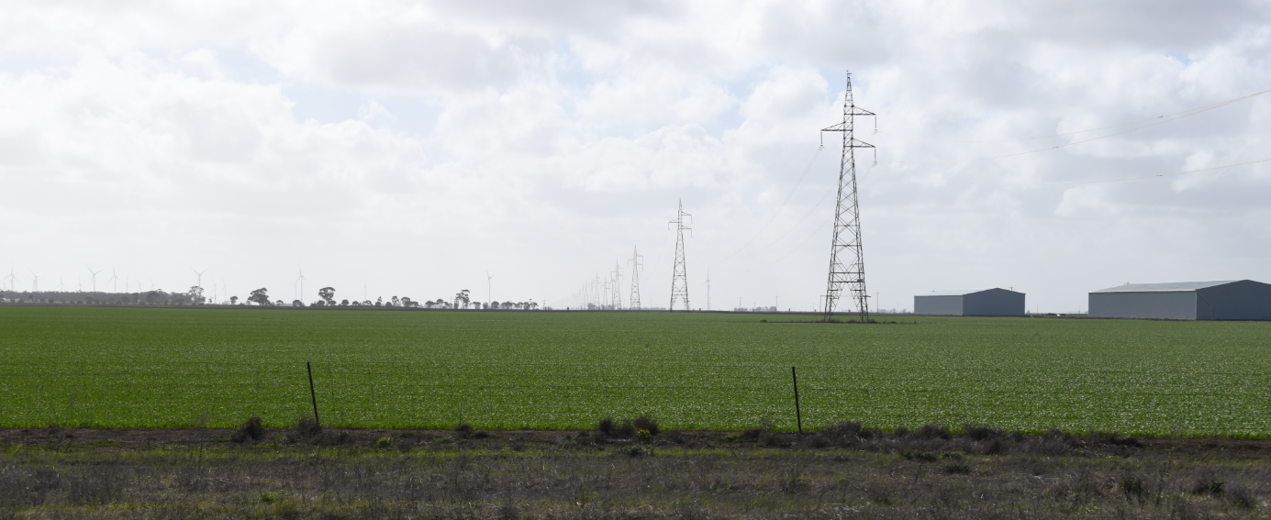
Figure 11-10: Murra Warra Wind Farm, transmission line and sheds looking north from Bells Road

Potential Impacts

Identified Potential Impacts
Potential impacts were identified in the LVIA with consideration to the Project activities, outcomes of the landscape characterisation and sensitivity assessment, and the location of sensitive receptors (refer Table 11-1). Where a plausible source-pathway-receptor relationship could be established within the viewshed, further investigation was undertaken to identify avoidance and mitigation measures and to assess the residual impacts (refer Section 11.7).
Table 11-1: Potential impacts
Item | Potential Impacts | Phase
IP-01 | Large plant in place for the life of the Project at the WBA resulting in visual amenity impacts from public or private viewpoints. | C, O
IP-02 | Mining activity at Blocks A, B, C and D resulting in visual amenity impacts from public or private viewpoints. | O
IP-03 | The placement of Block B overburden stockpile (OB-B) resulting in an impact on visual amenity from public or private viewpoints. | O
IP-04 | Lighting at the WBA or other operating locations resulting in night-time visual amenity impacts. | C, O

Sensitive Receptors
Sensitive receptors identified in the LVIA are representative viewpoints within the viewshed. A total of 18 viewpoints, comprising 12 publicly accessible viewpoints and six private viewpoints (residences), are shown in Figure 11-11.
Viewpoints from the public domain were identified as being of particular interest to the community or views that are representative of particular landscapes (refer Table 11-2). Viewpoints from the private domain were selected based on their location within the viewshed. Viewpoint selection is further discussed in Appendix F, Section 3.

Table 11-2: Sensitive receptors – Public viewpoints and private residences
Receptor Type | Sensitive Receptors
Public viewpoints | Publicly accessibly viewpoints located on Wimmera Highway (VP1, VP2, VP3, VP4, VP5), Henty Highway (VP6, VP7, VP8), Longerenong Road (VP9), Jung township (VP10), Dooen township (VP11) and the Longerenong Agricultural College (VP12). (also refer Figure 11-11).  The Project is not visible from either the Dooen swamp or Darlot swamp.
Private residences | Private residential viewpoints (R03/04, R43, R44, R37, R36, R06) located at residential dwellings within the viewshed (also refer Figure 11-11).
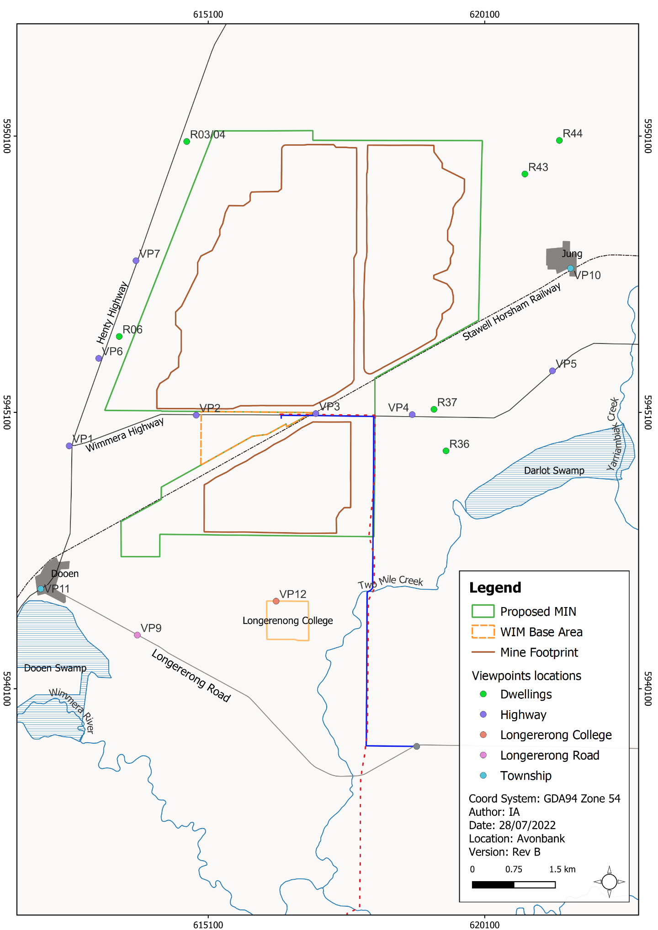
Figure 11-11: Viewpoints for visual impact (public and private domains)

Impact Characterisation
The impact assessment considered the magnitude, spatial extent and duration of the potential landscape, and visual amenity impacts and the sensitivity of the receptors. The residual impacts were characterised with regard to the visibility, distance, viewer numbers (where applicable) and landscape sensitivity. The overall visual impact was assessed as the change experienced by a viewer at a particular location.
The sensitivity to change was defined as the capacity of a given landscape unit to absorb visual change. This was qualitatively rated based on the scale of effects described in Table 11-3.
Table 11-3: Landscape units and sensitivity
Landscape Unit/Type | Sensitivity
1 – Agricultural areas | Sensitivity is low.  These areas are highly modified, are not rare and include visible infrastructure and other features. This landscape is not topographically dramatic and does not contain large bodies of water. Provisions within planning schemes may apply for the use of these areas and the potential for off-site amenity impacts.
2 – Townships | Sensitivity is moderate.  Areas within townships are moderately sensitive to further visual change due to the highly modified nature of views which include built form, roads, and urban infrastructure. Views from these areas are typically screened by buildings and vegetation within road reserves. Without such features or screening, the higher population density and a number of potential viewers of a visual change may otherwise increase the sensitivity to high.
3 – Reserves and conservation areas | Sensitivity is moderate to high.  Landscapes in these areas appear pristine and are typically not extensively modified. These areas have a high sensitivity to visual change due to their natural values, scenic qualities, and recreational pursuits. They are recognised for their recreational uses and intrinsic ecological values and often contrast visually with the surrounding farmland.
4 – Industrial | Sensitivity is low.  Industrial areas and their uses are considered as not sensitive. These areas are highly modified landscapes, although rare in terms of use and land cover, and are intensively modified areas that can contribute to off-site impacts, including noise, dust, and visual amenity.
For private viewpoints (i.e. residences), sensitivity was assessed as high on the basis that disturbances to views from a residence are considered to have a high degree of sensitivity.
Following the identification of visual impacts, avoidance and mitigation measures were identified and then applied to the residual impact assessment. The relative significance of each residual impact was rated on a scale ranging from negligible through to major, as shown in Table 11-4
Table 11-4: Significance of residual impacts
Rating | Description
Nil | The project will be screened by topography, vegetation or buildings and structures.
Negligible | Minute level of effect that is barely discernible over ordinary day-to-day effects. The assessment of a ‘Negligible’ level of visual impact is usually based on distance. That is, the Project will be at such a distance that, when visible in good weather, it would be a minute element in the view within a modified landscape or will be predominantly screened by intervening topography, vegetation or buildings and structures.
Minor | Visual impacts are those where the Project is noticeable but will not cause significant adverse impacts. The assessment of a “Minor” level of visual impact is concluded if the rating of any one or more of the four criteria (visibility, distance, viewer numbers and landscape sensitivity) is assessed as Minor. Therefore, an additional piece of infrastructure in a landscape that is highly modified and which already contains many examples of existing infrastructure may be rated as a Minor level of visual impact.
Moderate | Visual impact may occur when several of the four assessment criteria are considered as higher than ‘Minor’, or the visual effects can be mitigated/remedied from an initial rating of High. This will be moderated by the context of the existing view and the modifications within the landscape.
Major | Adverse effects that cannot be avoided, remedied or mitigated or may be in place for an extended period. The assessment of a “high adverse effect” from a publicly accessible viewpoint requires the assessment of all criteria to be high.
Further detailed description of the characterisation of impacts is described in Appendix F, Section 7.7.

Avoidance and Mitigation Measures
This Section outlines the measures identified to avoid and minimise residual impacts. It is noted that in line with the requirements of the proposed environmental management system (EMS) and relevant legislation, additional measures may be required during implementation to ensure risks and potential impacts have been minimised so far as reasonably practicable.

Avoidance

LV-01: WBA plant location
The WCP is a large facility, industrial in nature and appearance, that will be in place for the life of the Project. The WCP will be situated within the WIFT Precinct, which is a Special Use Zone established for industrial purposes, including the processing, storage and handling of mineral sands. The location of the WCP within the WIFT Precinct ensures the visual impact is commensurate with the planned land use zone.

Minimisation

LV-02: Block B stockpile (OB-B) location
The Block B Stockpile (OB-B) will be in place for a period of up to 24 years. The proposed location of the stockpile will be located in an area that is set back from the Henty and Wimmera Highways. The form of the overburden stockpile will be managed by shaping and profiling its slopes to minimise the footprint, avoid visual impacts and disturbance to the surrounding agricultural land so far as reasonably practical.

LV-03: Progressive rehabilitation.
Visual impacts associated with the Project will be minimised through the staging and sequencing of works. At any given time, the extent of Project disturbance will be less than 400 ha as areas are progressively mined and rehabilitated. The extent and duration of visual impacts associated with the active mining area from any one sensitive receptor will be minimised by progressively backfilling the mining void and rehabilitating the area, typically within 4 years.

LV-04: Landscape screening
The visual impact of Project elements that are expected to remain in place for the Project life will be minimised through landscape screening. Landscape screening will consist of planting native trees at identified locations. Once established, screening vegetation will minimise visual impacts by reducing the visibility of the WBA/WCP and OB-B stockpile from nearby receptors. Figure 11-12 shows the location of the proposed landscape screening areas.
Three locations have been identified where screening will minimise visual impacts:
- Landscape Screen 1 (LS1) to the north and east of the WBA.
- Landscape Screen 2 (LS2) along the Wimmera and Henty Highways adjacent to OB-B Stockpile.
- Landscape Screen 3 (LS3) along the Wimmera Highway north of the WBA.
Additional landscape screening may be provided during Project implementation in response to community feedback where reasonably practicable to do so.
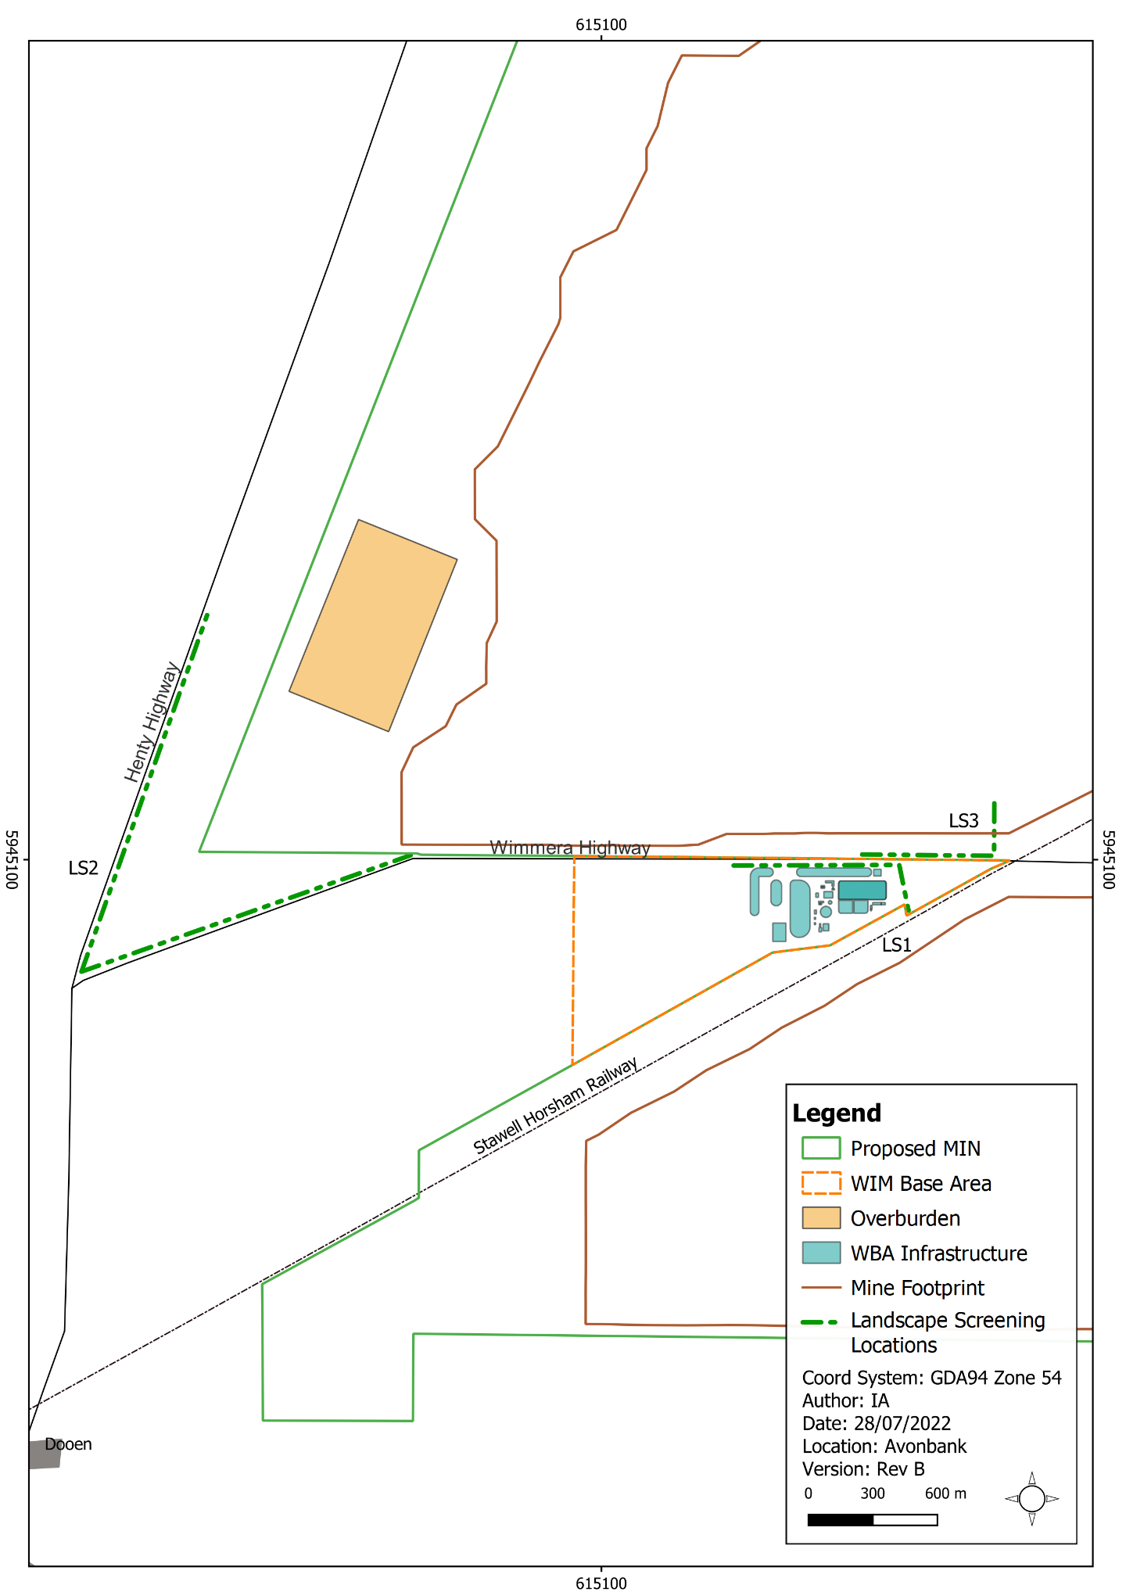
Figure 11-12: Landscape screening locations

LV-05: Lighting impacts
Lighting will be required around permanent buildings, plant, and equipment. Lighting placement will minimise off-site night-time lighting impacts so far as reasonably practicable. This will be undertaken by limiting the amount of lighting required for the Project, reducing direct visibility of light sources, reducing glare and minimising light spill. All lighting secondary to key operational and safety requirements will be designed in accordance with AS 4282 ‘Control of obtrusive effects of outdoor lighting’.

Rehabilitation

LV-06: Rehabilitation plan
A Rehabilitation Plan will be established for the Project that will address matters relating to progressive rehabilitation and closure. It will cover all work areas within the proposed mining licence and within the broader development extent.
The Rehabilitation Plan will include a schedule of progressive rehabilitation and describe the strategy to establish a safe, stable, sustainable landform capable of supporting the proposed end land use. It is expected that land will be stabilised as soon as reasonably practicable after mining, typically within 4 years.
The Rehabilitation Plan will define the end land use with consideration to the views of the landholders and the broader community where appropriate.
A preliminary Rehabilitation Plan for the Project has been developed to meet the intent of the Scoping Requirements and is included with this EES as Attachment 3. This plan will be refined and included in the work plan to reflect works within the mining licence with consideration to the detailed operating plans, stakeholder and community feedback and the Minister’s assessment of the EES.

Residual Impacts
This Section describes the likely residual impacts on sensitive receptors with avoidance and mitigation measures in place. The residual impacts have been characterised as described in Section 11.5.3 and Chapter 6 (Impact Assessment Framework).

Visual Impacts due to Large Plant
There is one potential impact (IP-01) in Section 11.5.1 that relates to impacts associated with visually prominent plant within the WBA.
Minor impacts from one public viewpoint, on the Wimmera Highway near the WBA (VP3), are expected. While the WBA will be clearly noticeable from this viewpoint, it will be situated within the WIFT Precinct, which is an area zoned for industrial land use and will therefore not appear incongruent with the surrounding area. The proposed tree screening will partially screen and filter views of the lower-level plant and equipment at the WCP from this viewpoint. Tree screening is proposed around the WBA area, as shown in Figure 11-12 and Figure 11-13.
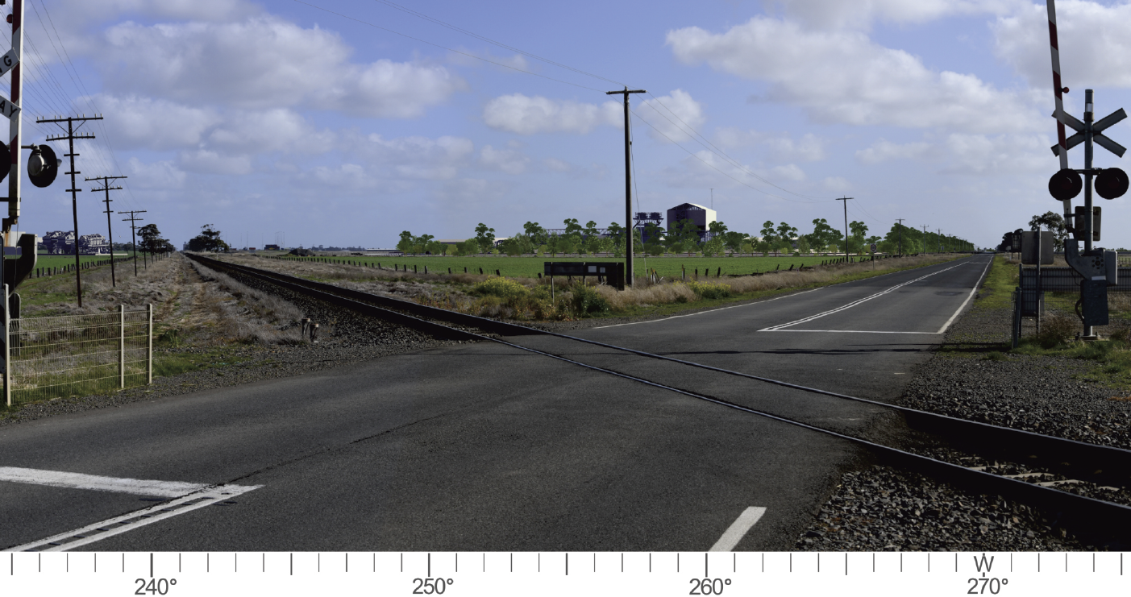
Figure 11-13: Photomontage from Viewpoint 3 (VP3) on Wimmera Highway looking west towards the WBA and proposed screening vegetation
Minor to negligible visual impacts are expected from public viewpoints on Wimmera Highway (VP4) and the Henty Highway (VP7). Viewpoint 4 is 2.3 km from the WCP and VP7 is 3.4 km from the broader WBA. These separation distances contribute to a reduced visual impact. For both viewpoints, the planting of screening vegetation will filter and screen views to the lower-level infrastructure within the WBA. The upper levels of the WCP, reaching 30 m in height, will remain visible.
Negligible visual impacts are expected from one private viewpoint on the Henty Highway and three other public viewpoints (VP1 Henty Highway/Wimmera Highway intersection, VP9 at Longerenong Road, and VP10 Jung township). The level of impacts are expected to be barely discernible over ordinary day-to-day conditions. For these viewpoints, the WCP will be noticeable, however this will be in the background of views and not a visually dominant feature.
There will be no visual impacts from the remaining six public viewpoints and three private viewpoints.

Visual Impacts due to Mining
There is one potential impact (IP-02) in Section 11.5.1 that relates to mining activity at Block A, B, C and D (refer Figure 11-2).
As the Blocks will be mined over sequential timeframes, the impacts at each sensitive receptor will vary in relation to the mining phase as follows:
- Mine Block A: Years 1-6.
- Mine Block B: Years 7-17.
- Mine Block C: Years 18-24.
- Mine Block D: Years 25-33.
The evaluation of impacts considered the implementation of the ‘moving hole’ mining and progressive rehabilitation strategy and full and final rehabilitation to minimise residual visual impacts.
The assessment determined that for all four private viewpoints (R03/04, R6, R36) assessed, there will be no material residual visual impacts during the mining of Blocks A, B, C and D. These residences were assessed to be situated amongst substantive areas of vegetation, shedding and other structures which would screen or filter views in the direction of the Project.
Visual impacts from public viewpoints are described below in Sections 11.7.2.1 to 11.7.2.4.

Block A: Years 1 to 6
Mining at Block A includes the establishment of an overburden stockpile, which will be in place for up to 8 years (refer Figure 11-2). Minor to negligible visual impacts are expected from public viewpoints at the Wimmera Highway (VP3 and VP5) and Longerenong College (VP12) during the mining of Block A. At the Wimmera Highway (VP5), mining activity will be potentially noticeable but will not dominate views. Appendix F, Figure 9-25 shows a photomontage of Block A mining operations as well as the WBA from VP3.
There are expected to be negligible visual impacts at public viewpoints at the Henty Highway/ Wimmera Highway intersection (VP1), both Wimmera Highway (VP2 and VP4), and Jung township (VP10). At the Henty Highway/Wimmera Highway intersection (VP1) and Wimmera Highway (VP2), the presence of the WBA is expected to screen views towards Block A. At the Wimmera Highway (VP2), screening vegetation for the WBA will also screen views towards Block A. At Wimmera Highway (VP4) and Jung township (VP10), mining activity will not dominate views.
There are expected to be no visual impacts from three public viewpoints along the Henty Highway (VP6, VP7, VP8) and Longerenong Road (VP9), Dooen township (VP11). From these locations, operations in Block A will be screened by existing vegetation, buildings and structures.
At the end of mine life, there will be no residual visual impacts at any sensitive receptor following full and final rehabilitation to the original landform.

Block B: Years 7 to 17
Mining at Block B includes the establishment of an overburden stockpile (OB-B) which is discussed as a separate visual impact in Section 11.7.3. The mining of Block B will have a minor to negligible visual impact at public viewpoints along the Wimmera Highway (VP2, VP3, and VP4), as well as on the Henty Highway (VP7). It is expected that there will be minor to negligible visual impacts from Wimmera Highway (VP3) as mining moves through Block B. The ‘moving hole’ mining method and progressive rehabilitation will minimise the extent and duration of impacts at this location.
There are expected to be negligible visual impacts from the public viewpoint at the Jung township (VP10). Mining in Block B will be visible at this location in clear conditions, although barely discernible due to distance, the low view angle and the generally flat topography.
Similarly, there will be negligible visual impacts at two public viewpoints at the Henty Highway intersection (VP1) and Wimmera Highway (VP5) due to the distance and resulting low visibility of mine activity. For VP1, the screening vegetation proposed for OB-B will screen any discernible Block B activity.
There will be no material residual impacts from the remaining public viewpoints as the mine activity will not be visible from these locations.
At the end of mine life, there will be no residual visual impacts at any sensitive receptor following full and final rehabilitation to the original landform.

Block C: Years 18 to 24
There are expected to be minor visual impacts from the Wimmera Highway (VP3). The landscape sensitivity from the viewpoint towards the Project is considered to be low.
The ‘moving hole’ mining method and progressive rehabilitation will minimise the extent and duration of impacts at this location. When mining is towards the northern end of Block C and furthest from the Wimmera Highway, the Project will be screened by a low topographical rise in the foreground.
There are expected to be negligible visual impacts from Wimmera Highway (VP5). Mining in Block C will be partly visible above the railway line, although distance and terrain will limit the visibility.
There was assessed to be no material visual impact from the remaining public viewpoints due to screening from the existing vegetation, topographic screening or intervening structures.
At the end of mine life, there will be no residual visual impacts at any sensitive receptor following full and final rehabilitation back to the original landform.

Block D: Years 25 to 33
There are expected to be minor visual impacts from Wimmera Highway (VP3) when mining activity is close to the road and works are visible. The landscape sensitivity from the viewpoint towards the Project is considered to be low.
The ‘moving hole’ mining method and progressive rehabilitation will minimise the extent and duration of impacts at this location. When mining is towards the northern end of Block D and furthest from the Wimmera Highway, the Project will be screened by a low topographical rise in the foreground.
There was assessed to be no material visual impact from the remaining public viewpoints due to screening from the existing vegetation, topographic screening or intervening structures.
At the end of mine life, there will be no residual visual impacts at any sensitive receptors following full and final rehabilitation to the original landform and return to agriculture.

Visual Impacts due to Overburden Stockpile B
There is one potential impact (IP-03) in Section 11.5.1 that relates to impacts associated with the overburden stockpile in Block B. Stockpile B will be established at the commencement of Block B mining and will be in place from year 7-30 of operations. The stockpile siting and profiling has been designed to avoid visual impacts so far as reasonably practicable, as described in Section 11.6.2.1.
The assessment of public views from the Henty Highway (VP7) and on Wimmera Highway (VP3) determined that Stockpile B will have a minor residual visual impact as it will be clearly visible from the road. The stockpile will be 1.1 km from the Henty Highway viewpoint location VP7 and 2.9 km from VP3. This landscape is considered to have a low sensitivity to change, and although the line of sight to the Grampians in the far distance will be impeded at VP7, it is not considered a significant view from this point. The longer distance from the Wimmera Highway viewpoint mitigates the visual impact. Views of the stockpile will also be transient (such as from passing vehicles). For these reasons, landscape mitigation using screening vegetation was not proposed for this location.
Two public viewpoints, at Henty Highway (VP8) and Jung township (VP10), were considered to have a negligible residual impact. The stockpile will be visible but over 5 km away from both viewpoints which substantially reduces the visual impact rating due to distance and topography.
There are three public viewpoints at the Henty Highway (VP6) and Wimmera Highway (VP4 and VP5) assessed to have negligible to nil residual visual impact due to the distance and resulting low visibility of mine activity.
One public viewpoint at the Henty Highway/Wimmera Highway intersection (VP1) is considered to have nil residual impact following the establishment of screening vegetation at the intersection (refer Figure 11-14 and Figure 11-15). The remaining public viewpoints at Wimmera Highway (VP2), Longerenong Road (VP9), Dooen township (VP11) and Longerenong College (VP12) are considered to have nil residual impact, as the Block B stockpile will be screened by existing vegetation, buildings and structures, as well as distance.
The private residence viewpoint at R06 is located 420 m from Stockpile B. Existing vegetation at the residence serves to filter views of the stockpile from outlooks within the residence and from private open space areas. The residual impact is considered to be negligible due to the existing vegetation. For this reason, no additional screening vegetation is proposed for this viewpoint.
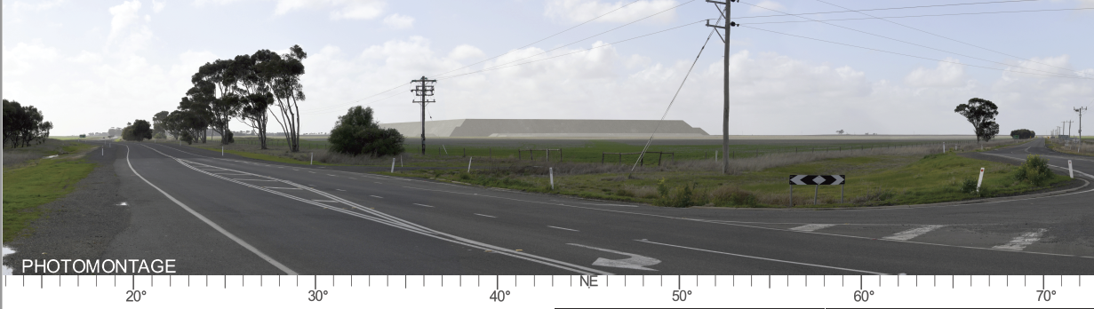
Figure 11-14: Photomontage showing views of the Block B overburden stockpile from the corner of Henty and Wimmera Highways, VP1, without mitigation proposed screening vegetation
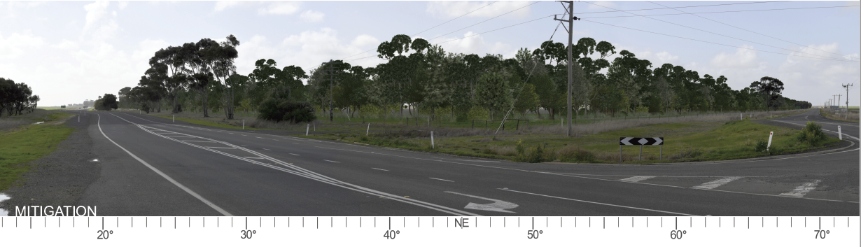
Figure 11-15: Photomontage showing views of the Block B overburden stockpile from the corner of Henty and Wimmera Highways, VP1, with proposed screening vegetation

Lighting
There is one potential impact (IP-04) in Section 11.5.1 that relates to potential impacts associated with lighting. The residences in Jung (VP10) and Dooen (VP11) are expected to experience minor to negligible residual impacts as a result of lighting. Although Project light sources will contribute to the night-time lighting environment, they are considered to have a minor to negligible impact, given existing background lighting in the study area, including the WIFT Precinct (refer Figure 11-9).
For isolated residences in rural areas, Project lighting and mining activities will be at distances of 1 km or greater from dwellings in these areas. From most residential properties assessed in farming areas, most views will be screened by vegetation or structures. For these reasons, the visual impact from dwellings in farming areas will be minor to negligible.
Security lighting is proposed for the operations and maintenance facilities and the on-site substation. Off-site impacts from this lighting will be minimised by following Australian Standard AS 4282, ‘Control of the obtrusive effects of outdoor lighting’. Relevant measures include ensuring that lighting is baffled and directed to the ground, using motion sensors to reduce the light duration, and planting perimeter vegetation to limit light spill towards sensitive receptors.

Management Framework
An AS/NZS ISO 14001:2016 EMS will be established for the Project as detailed in Chapter 24. The EMS will address matters relating to planning, operational control, monitoring and continuous improvement over the life of the Project. Relevant matters relating to visual impacts, monitoring, auditing and corrective actions/contingencies are summarised below.

Environmental Objectives
Environmental objectives will be established as part of the EMS to articulate the outcomes to be achieved during Project implementation. These will reflect the expected and achievable outcomes based on the studies undertaken as part of this EES. Performance standards will be established to measure/assess if the environmental objectives have been achieved during operations.

Monitoring and Management
Periodic visual amenity inspections will be conducted from selected viewpoints over the life of mine to qualitatively assess the effects of lighting and other matters relating to visual amenity. Inspections will also be undertaken in response to visual amenity effects raised by the community. Tree screens will be monitored in accordance with the commitments in the Rehabilitation Plan (Attachment 3).

Audits
Periodic internal and independent audits will be undertaken to assess the effectiveness of the EMS. An internal audit program will be maintained, which details the frequency, methods, responsibilities and reporting requirements.
Audits will be undertaken by a suitably qualified person to assess the effectiveness of the EMS and associated management plans (including the Rehabilitation Plan) to minimise or avoid unanticipated visual impacts so far as reasonably practicable. Any non-conformity identified in the audit will be investigated and corrective actions implemented.
The outcomes of audits will be communicated to the Project’s Management team and records of the audit findings will be retained in the record management system. Significant findings will be reported to relevant Regulators and stakeholders where appropriate to do so.

Cumulative Impacts
The LVIA considered the cumulative impacts of the proposed mineral sands projects within the region including Donald Mineral Sands, Iluka Wimmera Project and the WIM150 Mineral Sands Project (refer Chapter 7). These were assessed to determine the cumulative impact of this particular industry within the region, which is predominantly farming.
All projects are greater than 15 km from the Avonbank Project and there is expected to be no overlap between the visual impacts of these projects.
The review of cumulative impacts in Appendix F (Section 12) considered the Project’s potential to be viewed either simultaneously from a static location or sequentially as viewers travel along local roads or highways. The cumulative visual impacts from these projects were assessed to be negligible, due primarily to the distance between projects.
The Dooen Landfill was the only similar existing land use that was identified as being visible or potentially noticeable from locations assessed in the LVIA. The Dooen Landfill was noticeable but not a prominent feature in views from the Henty Highway when travelling north and on the opposing, western side of the Highway. Due to the limited visibility and relative distance to the majority of the Project areas, the cumulative visual impact of the project added to these views was considered to be negligible.

Conclusions
This Chapter provides an overview of the Landscape and Visual Impact Assessment prepared to address the EES Scoping Requirements for the Avonbank Mineral Sands Project.
The potential impacts on sensitive receptors associated with the Project activities were assessed as part of the impact assessment undertaken by Landform Architects. Consideration was given to potential impacts associated with the Project activities from a range of sensitive viewpoints.
Avoidance and mitigation measures were identified to reduce the residual impacts so far as reasonably practicable. Listed below are the key measures identified:
- Project plant will be situated in less visually prominent locations and in a planning zone designated for industrial activity (WIFT Precinct).
- Vegetation will be established to filter and screen views of the mine Block B overburden stockpile and WCP from public viewpoints along the Henty and Wimmera Highways.
- The form and placement of Mine Block B overburden stockpile will be set back from road edges and designed to minimise the footprint, avoid visual impacts and disturbance to the surrounding agricultural land.
- Project lighting at the WBA location within the WIFT Precinct will be diverted away from roads and farming areas.
The residual visual impacts from the assessed viewpoints are all considered minor to negligible. Overall, the proposed Project activity is unlikely to result in significant visual impacts and it is anticipated that the associated residual impacts can be managed with avoidance and mitigation measures in place to achieve the evaluation objective.

Construction (C); Operations and rehabilitation (O); Decommissioning and closure (D)

