Avonbank Mineral Sands Project
Environment Effects Statement

Chapter 25 – Matters of National Environmental Significance

TABLE OF CONTENTS
25 Matters of National Environmental Significance 25-1
25.1 Introduction 25-1
25.2 Matters of National Environmental Significance 25-1
25.3 Regulatory Framework 25-2
25.3.1 Radiation Act 2005 and Radiation Regulations 2017 25-2
25.3.2 Port Management Act 1995 25-3
25.3.3 Customs Act 1901 (Cth) and Customs (Prohibited Exports) Regulations 1958 25-3
25.3.4 Flora and Fauna Guarantee Act 1988 25-4
25.3.5 Wildlife Act 1975 25-4
25.3.6 Environment and Biodiversity Conservation Act 1999 25-4
25.4 Methodology 25-4
25.4.1 Scope 25-4
25.4.2 Study Area 25-5
25.4.3 Flora and Fauna Impact Assessment 25-8
25.4.4 Radiation Survey and Assessment 25-9
25.5 Assessment of Impacts – Threatened Ecological Communities 25-9
25.5.1 Buloke Woodlands of the Riverina and Murray-Darling Depression 25-12
25.6 Assessment of Impacts – Threatened Flora Species 25-18
25.7 Assessment of Impacts – Threatened Fauna Species 25-18
25.7.1 White-throated Needletail 25-18
25.8 Assessment of Impacts – Nuclear Action/Radiation 25-20
25.8.1 Potential Impacts 25-21
25.8.2 Avoidance and management measures 25-21
25.8.3 Residual Impact 25-21
25.9 Assessment of Impacts – General Environment 25-22
25.10 Conclusion 25-24

TABLES
Table 25-1: MNES and relevance to the controlled action 25-1
Table 25-2: Summary of survey effort for EPBC-listed species and ecological communities 25-8
Table 25-3: EPBC Act listed threatened ecological communities and associated ecological vegetation classes 25-10
Table 25-4: Groundwater dependent ecosystems in the vicinity of the Project 25-11
Table 25-5: Significant impact criteria and assessment for Buloke Woodlands of the Riverina and Murray-Darling Depression 25-14
Table 25-6: Threatened flora species with potential likelihood of occurrence 25-18
Table 25-7: EPBC Act-listed threatened fauna species with a moderate or greater likelihood of occurrence in the development extent 25-18
Table 25-8: Significant impact criteria and assessment for the vulnerable White-throated Needletail 25-19
Table 25-9: Summary of potential exposure pathways and annual dose rate to the Critical Group 25-22
Table 25-10: EES structure and summary table 25-22

FIGURES
Figure 25-1: Retention licence, Project area, proposed mining licence, WIM base area and utilities 25-6
Figure 25-2: Project retention licence, haulage route and the Port of Portland 25-7
Figure 25-3: Buloke Woodland threatened ecological community within the proposed mining licence 25-13
Figure 25-4: Impacted area of Buloke Woodlands within the development extent 25-17

Matters of National Environmental Significance

Introduction
This Chapter provides an overview of the potential impacts on relevant matters of national environmental significance (MNES) for the Avonbank Mineral Sands Project (the Project). Under the Environment Protection and Biodiversity Conservation Act 1999 (EPBC Act), a proposed action will require approval from the Commonwealth Environment Minister if the action is likely to have a significant impact on MNES.
The Avonbank mineral sands mine, processing plant and associated infrastructure (the proposed action) was referred to the Commonwealth under the EPBC Act (referral 2019/8586) in November 2019, due to the potential for significant impacts on threatened species and communities. In July 2020, the referral was assessed to be a controlled action, due to provisions relating to listed threatened species and communities and the protection of the environment from nuclear actions.
The Victorian Environment Effects Statement (EES) process, under the Environment Effects Act 1978 (EE Act), is accredited to assess impacts on MNES through the Bilateral Assessment Agreement between the Commonwealth and the State of Victoria. As a result, the EES Scoping Requirements (DELWP, 2020) also address the EPBC Act assessment requirements.
This Chapter has been prepared to address the EES Scoping Requirements relating to MNES and the relevant requirements under the Bilateral Assessment Agreement. It is supported by a detailed Radiation Risk Assessment prepared by DBH Radiation Solution Pty Ltd (DBH Radiation) (Appendix I), and a Flora and Fauna Impact Assessment by AECOM Australia Pty Ltd (AECOM) (Appendix P).
The Scoping Requirements (DELWP, 2020) require that the EES provide an analysis of the ‘likely residual effects and their significance, including significant residual impacts on MNES’ (DELWP, 2020). The associated issues and Scoping Requirements are detailed in Appendix A of this EES.
The controlled action was varied on the 20 January 2022 to include the minor utilities corridor (power and water) which extends from the respective terminal stations to the WIM Base Area.
This Chapter summarises the significance of the residual impacts on MNES and provides cross-references to relevant sections of the EES where these matters have been further detailed. While this Chapter focuses on the controlled provisions, it also provides an overview of the broader Project related residual environmental impacts that may be considered under the EPBC Act.

Matters of National Environmental Significance
The EPBC Act provides the regulatory framework to protect and manage MNES. There are nine MNES that include nationally and internationally important flora, fauna, ecological communities and heritage places. The MNES are listed below in Table 25-1. The relevance of each MNES to the controlled action is summarised with consideration to the referral decision (2019/8586) (as varied 20 December 2022).
Table 25-1: MNES and relevance to the controlled action
MNES | Controlled Action | Comments
World heritage properties | No | There are no world heritage properties impacted by the Project.
National heritage places | No | There are no national heritage places impacted by the Project.
Wetlands of international importance (listed under the Ramsar Convention) | No | There are no Ramsar wetlands within 100 km of the Project.
Listed threatened species and ecological communities. | Yes | Four threatened ecological communities and several threatened species could potentially be impacted by the Project. Potential impacts on threatened communities and species are described in Section 25.5.
Migratory species | No | Several bird species listed under the EPBC Act Marine and Migratory Schedules have been recorded locally.
Commonwealth marine areas | No | The controlled action is not undertaken in a commonwealth marine area.
The Great Barrier Reef Marine Park | No | The Great Barrier Reef Marine Park is not impacted by the Project.
Nuclear action | Yes | The referral decision identifies the controlled action as a nuclear action. Potential impacts as a result of naturally occurring radioactive minerals are described in Section 25.8. An overview of the broader environmental impacts are provided in Section 25.9.
A water source in relation to coal seam gas development and large coal mining development | No | The controlled action will not have a direct or indirect impact on a water source from coal seam gas or large coal mining development.

Regulatory Framework
The Victorian EES process, under the EE Act, is accredited to assess impacts on MNES through the Bilateral Assessment Agreement between the Commonwealth and the State of Victoria.
The Commonwealth Minister for the Environment and Water will consider the EES and the Victorian Minister for Planning’s assessment report to make an informed decision on the Project under the EPBC Act. The Commonwealth Minister will determine whether the Project will be approved, approved with conditions, or not approved.
Secondary approvals associated with matters considered under the EPBC Act are outlined in Chapter 4 (Regulatory Framework). Matters pertinent to the controlling provisions are summarised below in Sections 25.3.1 to 25.3.6.

Radiation Act 2005 and Radiation Regulations 2017
The Heavy Mineral Concentrate (HMC) produced at the Avonbank secondary processing facility contain low levels of Naturally Occurring Radioactive Materials (NORMs) that must be managed in line with the Victorian Radiation Act 2005 and Radiation Regulations 2017. The purpose of the Act is to protect the health and safety of persons and the environment from the harmful effects of radiation.
The Radiation Act:
- Requires a licence for conducting radiation practice.
- Prohibits use of radiation source unless licenced.
- Prohibits construction of radiation facilities in certain cases.
- Exempts certain activities or substances from the need for a licence.
The Radiation Regulations 2017, which support the Radiation Act 2005, define the levels of radioactive substances for their application and contain provisions relating to the limits on occupational and public exposures arising from mining and processing operations. For the Project, these requirements will extend to the transport of HMC and the handling of HMC at the Port of Portland (PoP). The Radiation Regulations set out the requirements for licensing, registration, emergency response, safety precautions, monitoring, disposal of radioactive materials, and other requirements for facilities handling radioactive substances.
The Radiation Regulations 2017 also prescribe the activity concentration and activity of material that emits radiation, radiation dose limits, the radiation sources that require a current certificate of compliance prior to use of the source, the date of expiry for compliance certificates issued in respect of prescribed radiation sources, and other matters required by the Radiation Act 2005.
The Project must obtain approval from the Victorian Department of Health in the form of a management licence to authorise the handling and disposal of radioactive materials. An approved radiation management plan and waste management plan are also required for the Project.
Approval of management plans is required prior to construction commencing. Additionally, Project activities must comply with the Australian Radiation Protection and Nuclear Safety Agency (ARPANSA) code of practice for mining and mineral processing in accordance with the ARPANSA ‘Guide for Radiation Protection of the Environments’ (ARPANSA, 2015a).
Within the limits of the PoP, the existing regulatory approved Radiation Management Plan (RMP) will be utilised. The RMP includes Standard Operating Procedures (SOP) for the management and handling of HMC on-site (up to and including ship loading). The SOP additionally references the PoP Safety and Environmental Management System (EMS), with supporting documents including mineral sands operations, mineral sands ship loading and competency, and the company Radiation Management Policy.

Port Management Act 1995
The requirements for temporary storage and handling of HMC at the PoP for shipment overseas are considered under the Port Management Act 1995.
Under Section 91C of the Port Management Act, the responsibility of the preparation of an Environmental Management Plan (EMP) is with the Port manager and it is incumbent on them to ensure the measures and strategies specified in the management plan provide a platform whereby the hazards and risks associated with the operation of the Port are prevented or reduced. Under S91C (2b), tenants, licensees and service providers implement the EMP.
The environmental, health and safety management issues associated with the handling and shipment of HMC will be addressed in accordance with the specific requirements of the PoP EMP and the overarching Project environmental management system. Once loaded, the responsibility for the management of the HMC for export will primarily rest with the shipping company.

Customs Act 1901 (Cth) and Customs (Prohibited Exports) Regulations 1958
The Customs Act 1901 controls the import and export of goods to and from Australia. The Act prohibits the export of certain substances, as specified in the regulations. Regulation 9 of the Customs (Prohibited Exports) Regulations 1958 prohibits the export of nuclear material.
Permission is required from the Department of Industry, Science and Resources to export nuclear material containing uranium and thorium. An application for permission to export nuclear material must be supported by the following information:
- Details about the company and its background and the export opportunity.
- Description of the material to be exported, including source and chemical composition.
- Gross weight of material to be exported.
- Uranium and thorium content of exported material.
- Details of the export arrangements, including quantity, timing and frequency.
- Commercial benefits from the export of the material (i.e., approximate value of material).
Details about the end use are also required, including ownership of the material and waste disposal arrangements. The Department of Industry, Science and Resources will consult the Australian Safeguards and Non-proliferation Office in assessing the application.

Flora and Fauna Guarantee Act 1988
The Flora and Fauna Guarantee Act 1988 provides a framework for biodiversity conservation in Victoria. It facilitates the listing of threatened species, communities of flora and fauna and potentially threatening processes.
The Project will result in the removal of native vegetation and protected flora. A permit will be required under this Act for activities that could harm listed threatened species and communities of flora and fauna within the Project area.

Wildlife Act 1975
The Wildlife Act 1975 establishes procedures for the protection and conservation of wildlife. The Act includes procedures to prohibit and regulate the conduct of activities concerning or related to wildlife.
An authorisation under s28A of this Act will be required, where fauna habitat is required to be translocated for the Project.

Environment and Biodiversity Conservation Act 1999
Threatened fauna and flora may be listed under Section 178 of the EPBC Act if it has been assessed to be extinct, extinct in the wild, critically endangered, endangered, vulnerable or conservation dependent. Once a species is listed under the EPBC Act, its recovery is promoted using conservation advice, recovery plans, and the EPBC Act’s assessment and approval provisions.
Conservation advice is developed by the Threatened Species Scientific Committee based on the best available information regarding the conservation status and threats to an ecological community at the time of listing.
Conservation advice includes the grounds on which the species is eligible for inclusion in the particular category in which it is listed, the main factors that are the causes for it being so eligible and provides guidance on what could appropriately be done to stop the decline or support the recovery of the species.
In addition to conservation advice, the Threatened Species Scientific Committee also provides the Minister with a recommendation on the need for a recovery plan for listed species. Recovery plans are comprehensive management tools that enable recovery activities for threatened species to occur within a planned and logical framework.
Listed threatened species are matters of national environmental significance (protected matters) under the EPBC Act’s assessment and approval provisions. A person must not take an action that has, will have, or is likely to have a significant impact on a listed threatened ecological community without approval from the Minister.

Methodology

Scope
The assessment of potential impacts on MNES in this Chapter considers all phases of the controlled action, including construction, operation and post-mining phases.
The controlled action includes all mining, mineral processing and related infrastructure associated with the Avonbank development extent. Activities are also broadly considered in relation to product storage and loading at the Port of Portland and shipping to overseas markets, as described in Chapter 2 (Project Description).
This Chapter includes an assessment of the potential impacts on threatened flora, fauna and threatened ecological communities. It also includes an assessment of potential impacts associated with the handling of Naturally Occurring Radioactive Minerals (NORMs).
The assessment of potential impacts has been undertaken in line with Chapter 6 (Impact Assessment Framework) to meet the intent of the ‘Ministerial Guidelines for the Assessment of Environmental Effects under the Environment Effects Act 1978’ (DSE, 2006).
The potential impacts associated with the controlled action are described with reference to the Commonwealth Guideline ‘Matters of National Environmental Significance: Significant impact guidelines 1.1, EPBC Act 1999’ (DCCEEW, 2013) (the Significant Impact Guidelines) and Appendix A (Scoping Requirements) of this EES.
An overview of the broader EES environment impact assessment is summarised in Section 25.9.

Study Area
The proposed action area referred under the EPBC Act includes the Avonbank mineral sands mine, processing plant and associated infrastructure. The referred area (Project area) was refined over the course of the EES preparation period to avoid impacts on landholders, areas of native vegetation and to realign the minor utilities (power and water) corridor as described in Chapter 2 (Project Description).
The Project development extent comprises the proposed mining licence (MIN), WIM Base Area (WBA), and the minor utilities corridor, as shown in Figure 25-1. The broader study area extending to the Port of Portland is shown in Figure 25-2.
The Flora and Fauna Impact Assessment (FFIA) assessed the direct impacts within the development extent and considered the broader ecological values within the retention licence and surrounding region (refer Figure 25-1). In doing so, the study area includes the area of direct disturbance and potential indirect impacts on flora and fauna.
The study area for the Radiation Risk Assessment (RRA) extends up to 3 km outside the proposed mining licence to receptors that may be affected by air emissions from mining and processing activities, as well as regulatory context for the management of product at the PoP and shipping to overseas markets (refer Section 25.3).
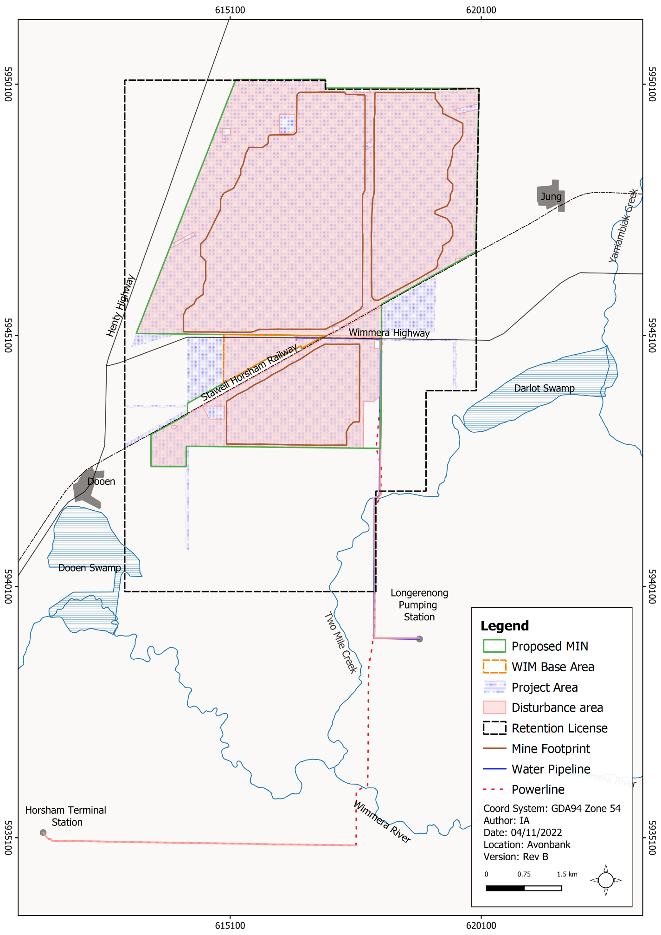
Figure 25-1: Retention licence, Project area, proposed mining licence, WIM base area and utilities
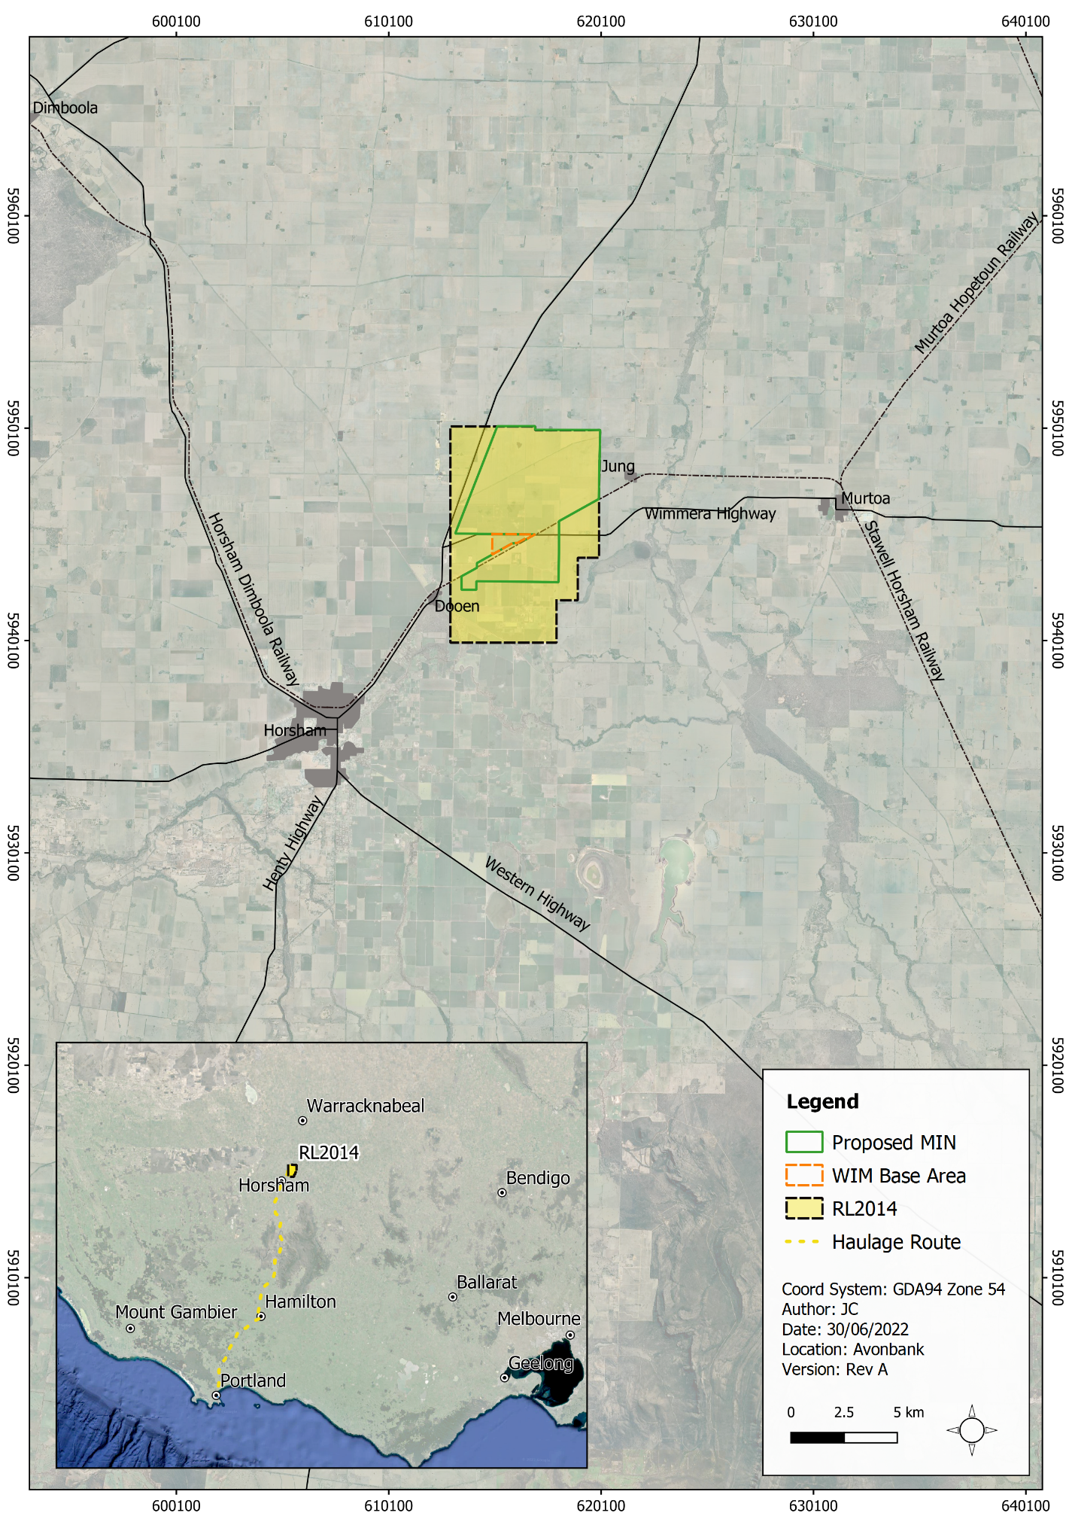
Figure 25-2: Project retention licence, haulage route and the Port of Portland

Flora and Fauna Impact Assessment

Likelihood of occurrence
A likelihood of occurrence assessment for threatened flora and fauna species was completed by Ecology Australia in 2018 and updated by AECOM in 2022 (refer Appendix P, Section 5.1.3).
The likelihood of occurrence assessment included information from the EPBC Act protected matters search tool (PMST) and from other Victorian databases. Five categories were used to assess likelihood ranging from ‘not likely’ through to ‘known’ (refer Appendix P, Table 7).
The threatened species with a moderate and high likelihood of occurrence were considered to have the potential to occur within the development extent and were subject to further investigation and targeted surveys where relevant.

Field assessment and targeted surveys
Field assessments and targeted surveys were carried out to search for threatened species, identify the presence of threatened ecological communities and assess these communities against key threshold criteria. Field assessments were carried out by Ecology Australia (EA) between:
- 19 and 23 November 2018.
- 30 March and 3 April 2020.
Additional field assessments were undertaken by AECOM to record ecological values and undertake vegetation quality assessments. These field assessments were carried out between:
- 10 and 13 January 2022 for the minor utilities corridor.
- 14 and 17 June 2022 for areas within and surrounding the proposed mining licence.
The field survey effort between 2018 to 2022 is shown in Appendix P, Figure 3. Several areas were not accessible due to access restrictions on private property. A summary of the EPBC-listed threatened species and threatened ecological communities subject to field assessment and targeted surveys are summarised in Table 25-2.
Table 25-2: Summary of survey effort for EPBC-listed species and ecological communities
Common/Scientific Name | Status | Survey date/s | Additional Information
Threatened Flora
Turnip Copperburr/ Sclerolaena napiformis | Endangered | Between 19 and 23 November 2018; and 30 March and 3 April 2020 (Ecology Australia). | Appendix P (Appendix A), Section 2.1.2, Table 2 (EA, 2020).  Appendix P, Section 5.1.6.1 (AECOM 2022).
Large-headed Fireweed/ Senecio macrocarpus | Vulnerable | Between 19 and 23 November 2018; and 30 March and 3 April 2020 (Ecology Australia). | Appendix P (Appendix A), Section 2.1.2, Table 2 (EA, 2020).  Appendix P, Section 5.1.6.1 (AECOM 2022).
Threatened Fauna
Striped Legless Lizard/ Delmar impar | Vulnerable | Nine tile grid survey established on 10 and 11 September 2018 and inspected 7 times between 3 October and 18 December 2018 (Ecology Australia). | Appendix P (Appendix A), Section 3.2.1 and Figure 2 in (EA, 2020), Section 4.1.3 in Ecology Australia (2018).  Appendix P, Section 5.1.6.2.1 in (AECOM, 2022).
Golden Sun Moth/ Synemon plana | Critically endangered | Four days between 12 November and 17 December (Ecology Australia). | Appendix P (Appendix A),, Section 3.2.2 and Figure 2 in (EA, 2020).  Appendix P, Section 5.1.6.2.2 (AECOM 2022).
Growling Grass Frog/  Litoria raniformis | Vulnerable | No targeted survey, opportunistic observations only (Ecology Australia). | Appendix P (Appendix A), Section 4.1.3 (EA, 2018).  Appendix P, Section 5.1.6.2.4 (AECOM 2022).
Migratory and marine species
White-throated Needletail/ Hirundapus caudacutus | Marine and Migratory | No targeted survey, opportunistic observations only (Ecology Australia). | Appendix P (Appendix A),  Section 4.1.2 in Ecology Australia (EA, 2018).  Appendix P, Sections 5.1.6.2.5 and 5.1.6.2.6 (AECOM 2022).
Threatened ecological communities
Buloke Woodlands of the Riverina and Murray-Darling Depression | Endangered | Between 19 and 23 November 2018; and 30 March and 3 April 2020 (Ecology Australia). | Appendix P (Appendix A),, Section 4.3.2 (EA, 2018), Section 2.1.1 (EA, 2020).  Appendix P, Section 5.1.5.3 (AECOM 2022).
Natural Grasslands of the Murray Valley Plans | Critically endangered | Between 19 and 23 November 2018; and 30 March and 3 April 2020 (Ecology Australia). | Appendix P (Appendix A),, Section 4.3.2 (EA, 2018)  Section 2.1.1 (EA, 2020).  Appendix P, Section 5.1.5.3 (AECOM 2022).
Seasons Herbaceous Wetlands (Freshwater) of the Temperate Lowland Plains | Critically endangered | Between 19 and 23 November 2018; and 30 March and 3 April 2020 (Ecology Australia). | Appendix P (Appendix A),, Section 4.3.2 (EA, 2018)  Section 2.1.1 (EA, 2020).  Appendix P, Section 5.1.5.3 (AECOM 2022).
Mallee Bird Community of the Murray Darling Depression Bioregion | Endangered | Between 19 and 23 November 2018; and 30 March and 3 April 2020 (Ecology Australia). | Appendix P, Section 5.1.5.3 (AECOM 2022).

Radiation Survey and Assessment
The background radiation levels were measured by DBH Radiation to characterise existing conditions as detailed in the Radiation Risk Assessment (RRA) provided in Appendix I. The RRA characterised ambient radon gas concentrations and radioactive content and ambient heavy metal concentrations of uranium and thorium of airborne dust.
Potential exposure pathways were developed to calculate the effective dose for both human and non-human biota. The potential effective dose rate to members of the public was assessed with consideration to the sum of a range of exposure pathways at the worst-case sensitive receptor, referred to as the Critical Group. For the purposes of this assessment, residents of the Longerenong College, south of the mining licence, were considered as the Critical Group based on their close proximity to the proposed operations.
For non-human biota, an assessment using the ERICA Tool (DSA, 2022) was used to estimate the radiological risk to wildlife. A tier 1 assessment was conducted using conservative assumptions to assess the likely risk to the most limiting reference organism. The model inputs considered the effects of depositional dust over the life of mine, using lichen and bryophytes as the most limiting reference organism.

Assessment of Impacts – Threatened Ecological Communities
Four threatened ecological communities listed under the EPBC Act were identified as having the potential to occur within the study area. These are:
- Buloke Woodlands of the Riverina and Murray-Darling Depression (listed as endangered).
- Natural Grasslands of the Murray Valley Plains (listed as critically endangered).
- Seasonal Herbaceous Wetlands (Freshwater) of the Temperate Lowland Plains (listed as critically endangered).
- Mallee Bird Community of the Murray Darling Depression Bioregion (listed as endangered).
The associations between EPBC Act listed communities and Ecological Vegetation Classes (EVC) are shown in Table 25-3 and shown in Appendix P, Appendix C, Figure 8.
Table 25-3: EPBC Act listed threatened ecological communities and associated ecological vegetation classes
EPBC Listed Community | Associated Ecological Vegetation Classes (EVC) | EVCs Surveyed within Study Area
Buloke Woodlands of the Riverina and Murray Darling Depression | Plains Savannah (EVC 826) | Surveyed within the study area.
Natural Grasslands of the Murray Valley Plains | Plains Grassland (EVC 132) and/or parts of  Plains Savannah (EVC 826)  Chenopod Grassland (EVC 829) | EVCs did not meet thresholds for a threatened ecological community.
Seasonal Herbaceous Wetlands (Freshwater) of the Temperate Lowland Plains | Plains Grassy Wetland (EVC 125)  Aquatic Grassy Wetland (EVC 306)  Plains Sedgy Wetland (EVC 647)  Ephemeral Drainage-line Grassy Wetland (EVC 678)  Gilgai Wetland (EVC 778)  Sweet Grass Wetland (EVC 920)  Herb-rich Gilgai Wetland (EVC 965) | EVCs not surveyed within the study area.
Mallee Bird Community of the Murray Darling Depression Bioregion | Major Vegetation Groups (MGV) described in the Conservation Advice (DAWE, 2021) comprise MGV 14 – Mallee woodlands and shrublands and MGV 32 – Mallee open woodlands and sparse mallee shrublands.  Mallee EVCs described in the Wimmera Bioregion include:  Sand Heathland (EVC 6)  Lowan Sands Mallee (EVC 87)  Heathy Mallee (EVC 88)  Dunefield Heathland (EVC 89)  Sandstone Ridge Shrubland (syn. Broombush Mallee) (EVC 93)  Red Swale Mallee (EVC 95)  Ridged Plains Mallee (EVC 96)  Woorinen Mallee (EVC 824)  Parilla Mallee (EVC 981) | EVCs not surveyed within the study area.
Based on an assessment against the ‘Approved Conservation Advice for Natural Grasslands of the Murray Valley Plains Ecological Community’ (DSEWPaC, 2012), it was concluded that no surveyed remnants of Plains Grassland EVC within the study area satisfied the condition thresholds for the EPBC Act listed community. Surveyed patches were in poor condition, consistent with the practice of regular cultivation along roadsides.
The Seasonal Herbaceous Wetlands (Freshwater) of the Temperate Lowland Plains were not surveyed within the retention licence area. Given the highly modified nature of the area and current and historical land use activity, it was considered unlikely that the listed threatened ecological community would be present.
The Mallee Bird Community of the Murray Darling Depression Bioregion was not surveyed within the retention licence area. The key bird species within this assemblage rely strictly on mallee vegetation. The EVCs recorded in the retention licence area do not correspond with those associated with the threatened ecological community and none of the bird species recorded during field surveys corresponded with the mallee specialist or mallee dependent species. Therefore, it is considered unlikely that the listed threatened ecological community is present.
As described in Chapter 17 (Groundwater) and Chapter 21 (Flora and Fauna), there are expected to be no material direct or indirect effects on threatened ecological communities and vegetation more broadly from groundwater mounding, drawdown or changes to groundwater quality (Chapter 17, Section 17.7.1. and Section 17.7.2, Chapter 21, Section 21.7.8). Included below in Table 25-4 are the key characteristics of each groundwater dependent ecosystem (GDE) within the broader study area.
Table 25-4: Groundwater dependent ecosystems in the vicinity of the Project
Groundwater Dependent Ecosystem | Description
Darlot Swamp | Located about 1.9 km east of the closest point of mining.  Ephemeral, shallow freshwater marsh that is normally dry. It is only filled periodically by surface water from Yarriambiack Creek during flooding, typically once every 5 years.  Darlot Swamp is not classified as a terrestrial GDE (BOM, 2017), however, it has potential terrestrial GDE features. Deep-rooted vegetation (the dominant eucalypt canopy species (Black Box) may opportunistically utilise groundwater where it is more shallow and has a possible connection with terrestrial vegetation.  Total dissolved solids in bores associated with the Darlot Swamp ranges from 7,280 to 13,000 mg/L  Losing feature. Not an aquatic GDE or baseflow dependent as groundwater depth interpreted as 5 m to 8 m.  EVCs recorded within the swamp were Black Box Lignum Woodland (EVC 663), Lignum Swamp (EVC 104) and Cane Grass Wetland (EVC 291).
Dooen Swamp | Located about 2 km south of the closest point of mining.  The swamp is a temporary deep freshwater marsh and a high-potential terrestrial GDE (BOM, 2017). The BOM potential terrestrial ecosystem type is Red Gum Swamp / Riverine Chenopod Woodland.  It is fed by the Wimmera River during flood events which typically occur once every five years. The extended dry periods in the swamp are indicative of the low potential for significant baseflow contributions from groundwater.  Total dissolved solids in bores associated with the Dooen swamp ranges from 7,000 to 8,000 mg/L.  Losing feature. Not an aquatic GDE or baseflow dependent as groundwater depth interpreted as 3 m to 6 m across the swamp.  Red Gum Swamp (EVC 292) was recorded as the dominant EVC.
Yarriambiack Creek | Located about 2.4 km from mining activity. It runs along the eastern edge of Darlot Swamp.  The potential terrestrial ecosystem type is Riparian Woodland (BOM, 2017). It is an ephemeral/ intermittent water course with surface water flows occurring about 20% of the time and is identified as a high to moderate potential terrestrial GDE (BOM, 2017).  Losing feature. Generally dry. Regional groundwater depth contours suggest 5 m to 15 m depth to groundwater.  Riparian Woodland (EVC 641) and Riverine Chenopod Woodland (EVC 103) have been mapped at Yarriambiack Creek, and its upper banks support stands of high-quality grassland vegetation.
Wimmera River | Located about 3.6 km south of the closest point of mining activity.  The potential terrestrial ecosystem type is floodplain Riparian Woodland (BOM, 2017). The river is dry about 30% of the time. Surface flows from infrequent flooding events (typically once every five years) in the river feed into Dooen Swamp and smaller tributaries. Identified as a high to moderate potential terrestrial GDE (BOM, 2017).  Generally losing feature to the south of the study area. Potential baseflow after flood events. Considered low potential aquatic GDE as dry around 30 % of the time. Areas of shallow groundwater (i.e., <5 m) are associated with the Wimmera River.  The Wimmera River supports healthy stands of Floodplain Riparian Woodland EVC on its banks.
There are several patches of Buloke Woodlands of the Riverina and Murray Darling Depression (Buloke Woodlands) within the development extent. The assessment of potential impacts on the Buloke Woodlands are described in Section 25.5.1 with reference to the National Recovery Plan for Buloke Woodland of the Riverina and Murray-Darling Depression Bioregions (Cheal et al., 2011) and the Significant Impact Guidelines.

Buloke Woodlands of the Riverina and Murray-Darling Depression

Potential impacts
The threatened ecological community of Buloke Woodlands of the Riverina and Murray-Darling Depression (Buloke Woodland) occurs over 5.22 ha within the study area, of which 5.01 ha occurs within the development extent (refer Figure 25-3). Potential direct impacts to this community include direct loss from native vegetation removal for mining, Project infrastructure and utilities. An assessment has been made against the significant impact criteria for endangered ecological communities in the Significant Impact Guidelines (refer Table 25-5).
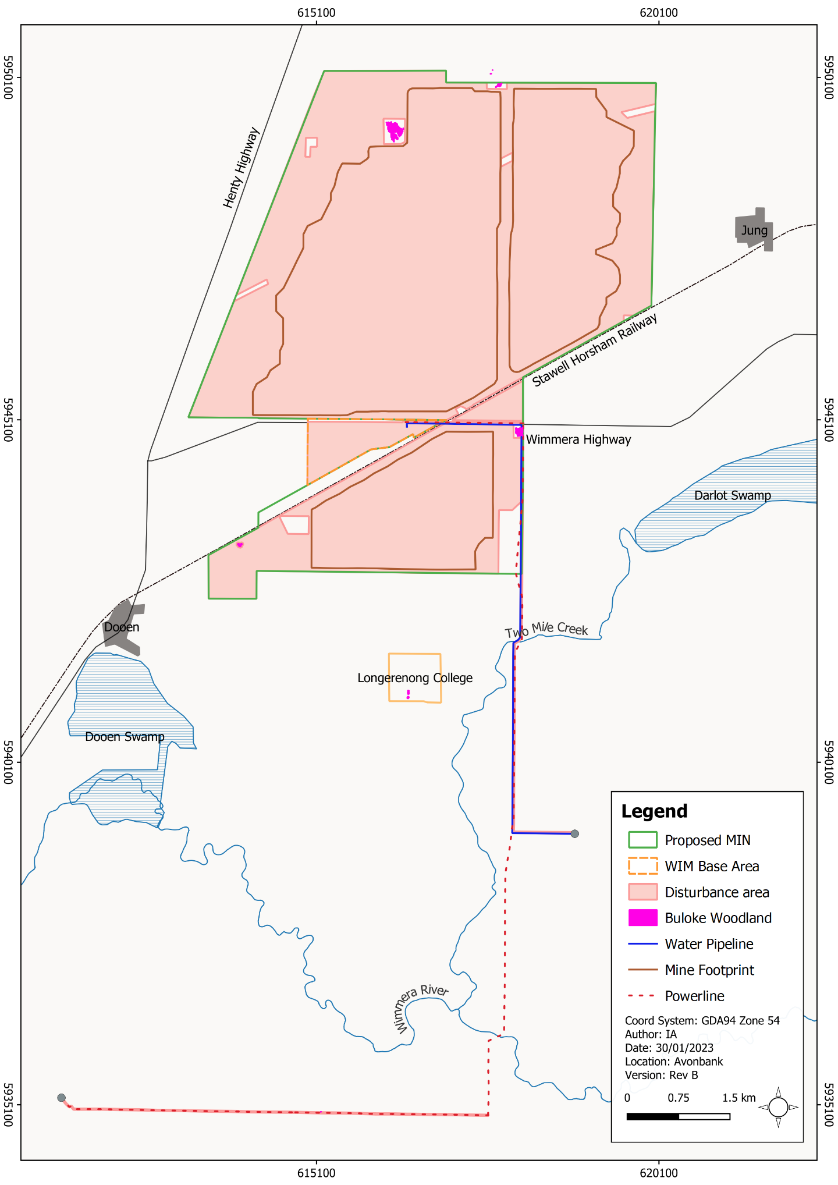
Figure 25-3: Buloke Woodland threatened ecological community within the proposed mining licence

Table 25-5: Significant impact criteria and assessment for Buloke Woodlands of the Riverina and Murray-Darling Depression
Significant Impact Criteria | Assessment of the Controlled Action
Reduce the extent of an ecological community. | Potentially  The Project proposes to remove 0.23 ha of Plains Savannah EVC, which is consistent with the description of the EPBC Act-listed ecological community, Buloke Woodlands. The Plains Savannah EVC recorded was assessed as being of low-quality and simplified composition (EA, 2020).  The National Recovery Plan for the Buloke Woodlands (Cheal et al., 2011) states that stands that are too small to support long-term viable populations of critical component species of Buloke Woodlands are less valuable than stands that support good populations of all critical component species (p.9). Size of patches is defined as large (>120 ha), medium (20–120 ha) and small (<20 ha) (Cheal et al., 2011).  Stands proposed to be removed are small (<20 ha) and range in size from 0.001 ha to 0.23 ha and are therefore of less value/priority for conservation according to the National Recovery Plan.  Nonetheless, the proposed loss will reduce the extent of the ecological community, albeit of lower value stands.
Fragment or increase fragmentation of an ecological community, for example, by clearing vegetation for roads or transmission lines. | Unlikely  Plains Savannah proposed to be impacted represents small, isolated patches that range in size from 0.001 ha to 0.23 ha. These examples of the community are typically represented by a small number of Buloke (Allocasuarina luehmannii) retained within private land that supported limited understory species and groundcover flora.  The Project will retain the largest stands of Plains Savannah representing a total of 4.78 ha, through the revised Project design to avoid the largest examples of the ecological community.  The National Recovery Plan lists the localities of important stands of the ecological community that occur on both public and private land. Two representative examples support stands of the ecological community, which are 8 ha and 18 ha respectively.  As the occurrence of the community in the development extent is already fragmented, removal of the smaller, isolated patches from within the Disturbance Area is unlikely to substantially increase fragmentation.
Adversely affect habitat critical to the survival of an ecological community. | Unlikely  The areas of Plains Savannah recorded within the Project represent small areas of low-quality vegetation that are likely to be lower on the scale of prioritisation for conservation recovery actions. Patches of Buloke Woodlands in the development extent are unlikely to be making a significant contribution to the long-term viability and survival of the ecological community.
Modify or destroy abiotic (non-living) factors (such as water, nutrients, or soil) necessary for the ecological community’s survival, including reduction of groundwater levels or substantial alteration of surface water drainage patterns. | Unlikely  The dominant canopy species of the ecological community (Buloke) is reliant on unique climatic conditions (including infrequent flooding) and local rainfall that moves through the soil profile and saturates the soil surface to provide the necessary conditions for Buloke health and regeneration (Cheal et al., 2011). Water requirements for Buloke are therefore likely to be dominated by incidental rainfall and the prevailing climatic conditions of any particular season rather than changes to surface water regimes and flooding.  Retained patches of the Plains Savannah community have been considered in terms of the effects of changes to surface water run-off. Overall, it was concluded that the apparent potential temporal changes in sub-catchment flows are not considered to have a material impact on the remnant native vegetation being avoided.
Cause a substantial change in the species composition of an occurrence of an ecological community, including causing a decline or loss of functionally important species, for example, through regular burning or flora or fauna harvesting. | Unlikely  The Project will physically remove patches of Plains Savannah but does not intend to change the species composition of retained patches through regular burning or flora or fauna harvesting.  Plains Savannah recorded supports a modified understory with limited native shrub cover and ground cover species. Weed cover within these remnants was high and the Project is unlikely to affect the species composition of the understory.  Controls to address weeds will be developed and implemented as part of the Project’s environmental management system and exclusion areas will protect retained areas from disturbance and mining activity.
Cause a substantial reduction in the quality or integrity of an occurrence of an ecological community, including, but not limited to:  - Assisting invasive species that are harmful to the listed ecological Community, to become established.  - Causing regular mobilisation of fertilisers, herbicides or other chemicals or pollutants into the ecological community, which kill or inhibit the growth of species in the ecological community. | Unlikely  Controls to address weeds and pest animals will be developed and implemented as part of the Project’s environmental management system. This will be implemented during the construction, operation and rehabilitation phases of the Project.  Provided these controls are implemented it is unlikely the Project would result in a substantial reduction in the quality or integrity of the Plains Savannah remnants that will be retained.
Interfere with the recovery of an ecological community. | Unlikely  The National Recovery Plan for the Buloke Woodlands states that stands that are too small to support long-term viable populations of critical component species of Buloke Woodlands are less valuable than stands that support good populations of all critical component species (p.9, Cheal et al. 2011). Size of patches is defined as large (>120 ha), medium (20-120 ha) and small (<20 ha).  The Plains Savannah mapped within the development extent represents examples of the community that are small and unlikely to be prioritised for conservation recovery efforts which focus on the largest and highest quality examples of the community within public and private land.

Avoidance and management measures
The Project has been designed to avoid impacts on native vegetation so far as reasonably practicable. This includes the avoidance of 4.78 ha of vegetation representative of the Buloke Woodlands of the Riverina and Murray-Darling Depression threatened ecological community, as well as 111 scattered trees (refer Chapter 21, Section 21.7). The majority of Buloke, up to 107 individuals, will be avoided and retained.
Measures to further minimise indirect impacts are detailed in Chapter 21, Section 21.6. Key management measures include the preparation and implementation of a Flora and Fauna Management Plan (refer Chapter 21, Section 21.6.2.3), Groundwater Management Plan (refer Chapter 17, Section 17.6.2.7) and Rehabilitation Plan (refer Chapter 21, Section 21.6.3.1).
As described in Chapter 21, exclusion zones will be established to will ensure that no clearing or topsoil disturbance will be permitted over the life of the Project. A 15 m tree protection buffer zone has been incorporated into each exclusion zone to minimise the risk of indirect impacts from Project activities due to root disturbance or compaction.
Offsets associated with the removal of this vegetation will be secured in accordance with the ‘Guidelines for the Removal, Destruction or Lopping of Native Vegetation’ (DELWP, 2017). The removal is unlikely to constitute a significant impact under the EPBC Act, and offsets under the EPBC Act are not expected to be required.

Residual impact
The avoidance and minimisation measures described in Section 25.5.1.2 will result in a residual impact of 0.23 ha on the Buloke Woodland threatened ecological community (refer Figure 25-4)
Whilst the Project will reduce the extent of this ecological community, the remnants proposed to be removed are of low-quality and are typically represented by a small group of Buloke with a modified understorey. These examples of the Buloke Woodland community are unlikely to represent long-term viable populations of the endangered community and are small and isolated from larger remnants within the regional landscape listed within the National Recovery Plan (Cheal et al., 2011). The Avonbank Project is therefore unlikely to have a significant impact on the threatened ecological community.
As described in Chapter 17 (Groundwater) and Chapter 21 (Flora and Fauna), there are expected to be no material indirect effects to threatened ecological communities and vegetation more broadly from groundwater mounding, drawdown or changes to groundwater quality (Chapter 17, Section 17.7.1. and Section 17.7.2 and Chapter 21, Section 21.7.8).
The proposed tailings strategy will result in low levels of groundwater drawdown and/or mounding at identified GDEs with a magnitude flux of less than around ~0.5 m. It is anticipated that the residual impacts to sensitive receptors, including GDEs and existing bores, will be negligible to minor and there will be no change to the existing environmental values. Surveyed and protected patches of Buloke Woodlands are within areas of depth to groundwater greater than around 12 m and are not expected to be groundwater dependent.
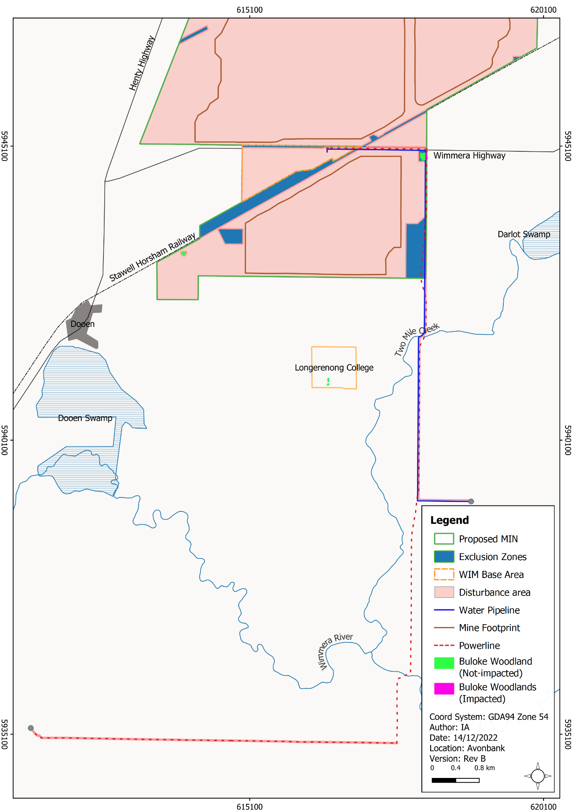
Figure 25-4: Impacted area of Buloke Woodlands within the development extent

Assessment of Impacts – Threatened Flora Species
Two EPBC Act listed flora species were identified with a moderate likelihood of occurrence in the retention licence area, including the Turnip Copperburr (Sclerolaena napiformis) (endangered) and Large-headed Fireweed (Senecio macrocarpus) (vulnerable) as presented in Table 25-6.
Table 25-6: Threatened flora species with potential likelihood of occurrence
Scientific Name | Common Name | Likelihood of Occurrence (Retention Licence) | Likelihood of Occurrence  (Minor Utilities Corridor)
Sclerolaena napiformis | Turnip Copperburr | Moderate | Moderate
Senecio macrocarpus | Large-headed Fireweed | Moderate | Low
No EPBC Act listed species were recorded within the retention licence area. This was not unexpected given the widespread practice of cultivating roadside and livestock grazing.

Assessment of Impacts – Threatened Fauna Species
There is one threatened fauna species listed under the EPBC Act that may be impacted within the development extent through the removal of woodland habitat, grassland habitat and scattered trees (refer Table 25-7 and Appendix P, Table 56). The White-throated Needletail (Hirundapus caudacutus) is a migratory marine species listed as vulnerable.
Table 25-7: EPBC Act-listed threatened fauna species with a moderate or greater likelihood of occurrence in the development extent
Scientific Name | Common Name | Conservation Status | Likelihood in the Development Extent | Habitat in the Development Extent
Hirundapus caudacutus | White-throated Needletail | Vulnerable  Migratory  Marine | High | Aerial foraging in  woodland patches and scattered trees
As described in Section 25.4.3.2, targeted surveys were conducted for the Golden Sun Moth (Synemon plana) and Striped Legless Lizard (Delma impar) during 2018 and 2020. None of these species were recorded in the targeted surveys.
There were no targeted surveys conducted for the Growling Grass Frog (Littoria raniformis) due to dry conditions, however, following site inspection, it was noted that no permanent habitat existed, and the likelihood of occurrence was subsequently revised from moderate to low.
The White-throated Needletail was considered to have a high likelihood of occurrence within the development extent, potentially for aerial foraging in woodland patches and scattered trees. Potential impacts were considered possible through the removal of woodland habitat, grassland habitat and scattered trees. The assessment of potential impacts on the White-throated Needletail are described in Section 25.7.1 (threatened vulnerable species).

White-throated Needletail

Potential impacts
The EPBC listed White-throated Needletail will be affected by the removal of woodland habitat, grassland habitat and scattered trees. This threatened species is considered likely to utilise the development extent as part of a wide-ranging foraging area whilst the species is in Australia between summer and early autumn.
The residual impacts on native vegetation will result in the loss of small discreet patches of Plains Savannah, Riverine Chenopod Woodland and Black Box Lignum woodland that the species may utilise for roosting. This will result in habitat loss for the species.
An assessment has been made against the significant impact criteria for vulnerable species in the Significant Impact Guidelines (refer Table 25-8).
Table 25-8: Significant impact criteria and assessment for the vulnerable White-throated Needletail
Significant Impact Criteria | Assessment of the Project
The action is likely to have a significant impact on a vulnerable species if there is a real chance or possibility that it will:
Lead to a long-term decrease in the size of an important population of a species. | Unlikely  An important population is defined as one that is necessary for a species’ long-term survival and recovery and may include key source populations, populations that are necessary for maintaining genetic diversity and/or populations that are near the limit of a species’ range.  An important population is not defined in the approved conservation advice. The species is described as gregarious within Australia, sometimes occurring in large flocks, but occasionally individuals are recorded. The species can also occur in mixed flocks with other aerial insectivorous species, such as Fork-tailed Swifts and Fairy Martins.  White-throated Needletail are a wide ranging and highly mobile species, therefore, an occurrence of a flock in the landscape of the site is unlikely to represent an important population.  From the Victorian Biodiversity Atlas, there are eight records for the species within 25 km of the site, the most recent being from 2008 (EA, 2018). The species is considered to have a high likelihood of regular occurrence; however, no individuals were recorded during the ecology survey program.  The species is likely to occur in the development extent and the Project may reduce habitat availability for the species. However, the loss of habitat is unlikely to lead to a long-term decrease in the size of an important population.
Reduce the area of occupancy of an important population. | Unlikely  The species is widely distributed in eastern and south-eastern Australia. In Victoria, the species is widespread along the Great Dividing Range and south of the Great Dividing Range.  The species is almost exclusively aerial, flying up to 1,000 m above the ground over wooded habitats, including forest and rainforest, however, they are also known to roost in dense woodland or forest canopies or tree hollows (Menkhorst et al., 2017).  The Project will reduce the availability of woodland habitat (including hollows) available for roosting. However, due to the wide-ranging nature of the species, the Project is unlikely to significantly reduce the area of occupancy of an important population.
Fragment an existing important population into two or more populations. | Unlikely  Due to the wide-ranging distribution of the species and largely aerial, the Project is unlikely to fragment an existing population into two or more populations.
Adversely affect habitat critical to the survival of species. | Unlikely  Habitat critical to the survival of a species is defined as areas that are necessary for activities such as foraging, breeding, roosting or dispersal, for the long-term maintenance of the species, to maintain genetic diversity or for the reintroduction of populations.  Habitat for White-throated Needletail includes forests and rainforests as well as cleared pastures, plantations, or remnant vegetation on the edge of paddocks.  Within the development extent cleared pastures and small remnants of Plains Woodland, Black Box Lignum Woodland and Riverine Chenopod Woodland vegetation represent the habitat available for the species as well as Floodplain Riparian Woodland associated with the Wimmera River riparian corridor.  A total of 0.92 ha of woodland vegetation (from three EVCs) is proposed to be impacted within the disturbance area. There is no woodland removal proposed for the Wimmera River.  White-throated Needletail are also wide ranging and highly mobile species; therefore, habitat within the development extent is unlikely to be critical to the survival of the species when in Australia during summer and early autumn.  Therefore, the Project is unlikely to adversely affect habitat critical to the survival of the species.
Disrupt the breeding cycle of an important population. | Unlikely  The species does not breed in Australia; therefore, the Project will not disrupt the breeding cycle.
Modify, destroy, remove or isolate or decrease the availability or quality of habitat to the extent that the species is likely to decline. | Unlikely  White-throated Needletail habitat that may be modified or destroyed within the development extent is 0.92 ha of woodland. Whilst the proposed clearance may reduce the availability or quality of habitat available, it is unlikely to result in a reduction to the extent that the species declines.
Result in invasive species that are harmful to vulnerable species becoming established in the vulnerable species habitat. | Unlikely  As above, controls to address weeds and pest animals will be developed and implemented as part of the Project’s environmental management system. This will be implemented during the construction, operation and rehabilitation phases of the Project.  With appropriate controls, the Project is unlikely to result in invasive species becoming established that would affect the habitat for the White-throated Needletail.
Introduce disease that may cause the species to decline. | Unlikely  There are no diseases known to affect the species.
Interfere substantially with the recovery of the species. | Unlikely  There is no adopted recovery plan for the species.

Avoidance and management measures
Impacts on the White-throated Needletail will be minimised through adjustments to the Project design so that 5.64 ha of the woodland communities and 111 scattered trees will be retained, which provide roosting habitat for White-throated Needletail (refer Chapter 21, Section 21.7). Measures to further minimise indirect impacts are detailed in Chapter 21, Section 21.6 and include the preparation and implementation of a Flora and Fauna Management Plan (refer Chapter 21, Section 21.6.2.3) and Rehabilitation Plan (refer Chapter 21, Section 21.6.3.1). It is anticipated that native rehabilitation efforts and the establishment of native tree screens will further minimise the long-term effects of the proposed vegetation removal.

Residual impact
Residual impacts to native vegetation will result in the loss of 0.92 ha of small, discreet patches of Plains Savannah, Riverine Chenopod Woodland and Black Box Lignum Woodland with limited mid-storey species and cover. In the context of the wider landscape, this loss equates to small discreet patches within a fragmented landscape rather than loss of continuous habitat or disruption to a major habitat corridor (e.g. the Wimmera River). Impacts will also result in the loss of agricultural land. Overall, the residual impacts to native vegetation and agricultural land are unlikely to affect the occurrence of White-throated Needletail throughout the region or significantly affect the availability of insects as a food source while the species is in Australia. Therefore, it is considered unlikely that the Project would result in a significant impact on the species.

Assessment of Impacts – Nuclear Action/Radiation
Project operations will produce a Heavy Mineral Concentrate (HMC) from ore. The ore and HMC contain NORMs which tend to have elevated concentrations of radioactive uranium and thorium. The radioactivity levels are expected to be approximately 1.02 Bq g⁻¹ for the ore, 0.99 Bq g⁻¹ for the material within the rougher spiral feed in the Wet Concentrator Plant, and 9.5 Bq g⁻¹ for the HMC. Based on these estimated activity concentrations, the ore and final product for the Project will be classified as prescribed radioactive material.
Radionuclide concentrations of the tailings material are expected to be less than the in situ ore at concentrations of approximately 0.53 Bq g⁻¹ (260 Bq kg⁻¹ U-238 and 270 Bq kg⁻¹ Th-232). Tailings being returned to the mine void will not be classified as radioactive waste based on its proposed radioactive content.
Ambient gamma radiation dose levels and background radionuclide concentrations in soils and surface water were characterised across the study area. The ambient gamma radiation doses were found to be consistent, averaging between 0.070 and 0.078 μGy·h⁻¹ and radionuclide activity concentrations within farming topsoils were comparable to concentrations found naturally in soils worldwide. Similarly, radionuclide activity concentrations within surface water bodies of Wimmera River and Yarriambiack Creek were within Australian Drinking Water Guidelines. Further detail regarding the baseline conditions are provided in Appendix I (Radiation Risk Assessment).

Potential Impacts
The RRA assessed several potential hazards associated with the Project (refer Appendix I). It considered exposure pathways for both human and non-human biota and assessed the residual risk with avoidance and mitigation measures in place.
The potential effective dose rate to members of the public was assessed with consideration to the sum of the exposure pathways for the Critical Group, residents of the Longerenong College.
Exposure pathways included inhalation of dust, exposure to radon gas, consumption of food and drinking water, as well as exposure during the transportation of HMC. This was considered to be a highly conservative assessment of exposure pathways. The regulatory annual dose limit for a member of the public is 1,000 μSv and the annual dose limit for an occupational worker is 20,000 μSv.
The radiological risk to non-human biota was assessed using ERICA modelling, applying conservative assumptions to assess the likely risk to the most limiting reference organisms, lichen and bryophytes. The model inputs considered the effects of depositional dust over the life of mine. The assessment on non-human biota considered the screening value of 10 µGy/h as recommended in the 'Guide for Radiation Protection of the Environments’ (ARPANSA, 2015a).

Avoidance and management measures
Radiation risks will be managed through the implementation of a Radiation Management Plan (RMP). The Plan will provide a management framework to avoid and minimise risks/impacts, so far as reasonably practicable, in line with the ‘Code of Practice and Safety Guide – Radiation Protection and Radioactive Waste Management in Mining and Mineral Processing ’(ARPANSA, 2005).
The RMP is described in Chapter 14 (Radiation), Section 14.6, and will include a description of hazards, risks and monitoring requirements for relevant sensitive receptors. The RMP will also address matters relating to occupational health and safety.
Regulatory requirements associated with the handling of products at the Port and export requirements are detailed in Section 25.3.

Residual Impact

Hazards to the general public
The RRA assessed the combined exposure pathways to the general public via an assessment of the Critical Group. As described in Section 25.8.1, residents of the Longerenong College were considered the Critical Group. The Critical Group were also conservatively assumed to have exposure pathways associated with road transport.
The calculated maximum annual doses from the combination of multiple exposure pathways from the Project, as shown in Table 25-9, is 40.1 µSv for an adult and 71 µSv for a child.

Table 25-9: Summary of potential exposure pathways and annual dose rate to the Critical Group
Exposure Pathway | Annual Dose (µSv)
 | Adult | Child (5 yo)
Airborne dust inhalation, 100 % ore, 1 µm AMAD, 50 % outdoor occupancy at residence, age-related breathing rates. | 16 | 11
Radon and thoron inhalation dose as a result of Project. | negligible | negligible
Consumption of leafy vegetables grown solely ‘Adjacent to Longerenong College’. Ore deposition at 0.2 g/m²/month, distributed evenly through the top 20 cm of soil. | 7.0 | 13
Ingestion of soils impacted by dust deposition; 10% ore fraction assumed. | 3.1 | 22
Drinking tank rainwater water impacted by run-off from a roof, 100% ore, soluble and insoluble considered. | 13 | 24
Consumption of locally grown livestock. | negligible | negligible
Inhalation and ingestion of dust during laundering of contaminated clothing. | negligible | negligible
Following truck loaded with HMC, 5 m separation distance, 1 hr/year. | 0.5 | 0.5
Resident on HMC trucking route, 24/7 occupancy, 10 m separation, 40 truck shipments per day. | 0.5 | 0.5
Total: | 40.1 µSv | 71 µSv
The assessment of each exposure pathway is further detailed in Chapter 14, Section 14.7. The residual dose rates have been conservatively assessed and are substantially below the established regulatory limit for a member of the public of 1,000 μSv.
Chapter 14 details the post-closure risks associated with the rehabilitated tailings landform would be commensurate with pre-mining conditions. The radionuclide concentrations in tailings will be less than the uranium and thorium content in the original ore. All tails will be rehabilitated with at least 3 m of overburden and soil material (refer Chapter 22, Land Rehabilitation).

Hazards to non-human biota
The ERICA modelling identified a dose rate for the reference organisms of less than the ARPANSA 10 µGy/h screening value (refer Section 25.8.1).
Even using extremely conservative criteria and applying the most sensitive reference organisms, the radiological risk on the EPBC listed species or other native flora and fauna identified in the Project area was assessed as negligible.

Assessment of Impacts – General Environment
Given that the controlled action includes provisions relating to the protection of the environment from nuclear actions, the Commonwealth Minister for the Environment and Water may consider impacts on the environment more broadly as defined in the EPBC Act (Section 528).
Table 25-10 summarises the impact assessments covered in the EES and provides a cross-reference to specific sections for more detail. This provides an overview of the residual impacts assessed in this EES (also summarised in Chapter 26)
Table 25-10: EES structure and summary table
Content, Matters Addressed | Summary of Chapter
Land Use and Planning | Presents the planning framework and current and proposed land use within which the Project will be sited, describing potential Project impacts on land use and alignment of Project activities with planning requirements. No significant residual environmental impacts were identified. Residual impacts are communicated in Chapter 8, Section 8.7.
Traffic and Transport | Presents the baseline characterisation of traffic and transport infrastructure in the Project locality. The Chapter describes potential Project impacts on traffic, transport infrastructure and elements of public safety and how these can be avoided, mitigated and managed. No significant residual environmental impacts were identified. Minor residual impacts are communicated in Chapter 9, Section 9.7.
Historic Heritage | Presents a description of existing historic heritage assets in the Project locality and describes potential Project impacts as a result of Project activities and how these can be avoided, mitigated and managed. No significant residual environmental impacts were identified. Minor residual impacts are communicated in Chapter 10, Section 10.7.
Landscape and Visual Amenity | Describes the existing visual landscape setting of the Project and the predicted impact of the Project on local and regional visual amenity, detailing proposed avoidance, mitigation and management measures. No significant residual environmental impacts were identified. Negligible to minor residual impacts are communicated in Chapter 11, Section 11.7.
Noise and Vibration | Describes the existing noise environment and provides an assessment of the potential amenity impacts of the Project from noise and vibration on surrounding sensitive receptors and proposed measures to avoid, mitigate and manage these impacts. No significant residual environmental impacts were identified. No significant residual environmental impacts were identified. Negligible to minor residual impacts are communicated in Chapter 12, Section 12.7.
Air Quality | Presents the results of the baseline characterisation of ambient air quality in the Project locality and describes the potential amenity impacts from airborne particulates generated by Project activities and proposals to avoid, mitigate and manage these impacts. No significant residual environmental impacts were identified. Negligible to minor residual impacts are communicated in Chapter 13, Section 13.7.
Radiation | Presents a description of the existing radiological setting of the Project area, including soils, dust and ground and surface waters, the predicted changes to the setting during Project operations, and measures proposed to avoid, mitigate and manage potential impacts to ensure the protection of public health. Relatively low effective dose rates and negligible residual impacts are communicated in Chapter 14, Section 14.7.
Soils and Landforms | Describes the soils and landforms potentially impacted by the Project and the management actions proposed to ensure the integrity and productivity of these soils and landforms are maintained through the construction, operations and rehabilitation phases of the Project. No significant residual environmental impacts were identified. Minor residual impacts are communicated in Chapter 15, Section 15.7.
Surface Water | Characterises the surface water catchment of the development extent and the potential hydrologic and water quality impacts of the Project on beneficial users of surface water within the catchment. The Chapter describes proposed measures to avoid, mitigate and manage potential adverse impacts. No significant residual environmental impacts were identified. Negligible to minor residual impacts are communicated in Chapter 16, Section 16.7.
Groundwater | Characterises the groundwater conditions within the area of the development extent and the potential hydrological and water quality impacts of the Project on beneficial users of groundwater, including potential groundwater dependent ecosystems (GDEs). The Chapter describes proposed measures to avoid, mitigate and manage potential adverse impacts. No significant residual environmental impacts were identified. Negligible to minor residual impacts are communicated in Chapter 17, Section 17.7.
Human Health | Describes the existing conditions and presents an assessment of predicted Project risks on human health and describes how potential risks will be avoided, minimised and managed. The residual risks to human health were assessed to be negligible, as communicated in Chapter 18, Section 18.7.
Wastes and Emissions | Identifies the wastes and emissions, including greenhouse gas emissions, that will arise from Project activities and describes how these will be avoided, minimised and managed. No significant residual environmental impacts were identified. Negligible to minor residual impacts are communicated in Chapter 19, Section 19.7.
Socioeconomic | Describes the existing socioeconomic conditions and presents an assessment of predicted Project impacts on social and economic conditions within the WSM region and Victoria and describes how these will be avoided, minimised and managed. No significant residual environmental impacts were identified. Negligible to Moderate residual impacts, as well as material beneficial effects, are communicated in Chapter 20, Section 20.7.
Flora and Fauna | Characterises the existing native vegetation, habitats, fauna and flora. The Chapter describes measures to avoid, mitigate, manage or offset potential impacts to flora and fauna (including threatened species and vegetation communities) and describes the assessed residual impacts. No significant residual environmental impacts were identified as communicated in Chapter 21.
Land Rehabilitation | Describes the rehabilitation measures proposed to return areas impacted by Project activities within the development extent to a safe, stable and productive land use. It is anticipated that the end land use objective can be achieved as communicated in Chapter 22 and Attachment 3.
Aboriginal Cultural Heritage | Presents the existing Aboriginal cultural heritage conditions and provides an assessment of potential Project impacts on tangible and intangible cultural heritage values and measures proposed to avoid, mitigate and manage potential impacts. No significant residual impacts were identified. It is anticipated that matters of Aboriginal Cultural Heritage can be managed in line with the Cultural Heritage Management Plan as described in Chapter 23.
Environmental Management | Sets out the environmental management system (EMS) to be implemented for the Project, with reference to the Australian and New Zealand Standard for Environmental Management Systems (AS/NZS ISO14001:2016). The proposed environmental management system is described in Chapter 24 and the key environmental objectives and management measures are described in Attachment 5.
The studies undertaken for the EES demonstrate that there will be no significant residual environmental impacts associated with the Project and it is expected that the Project’s EMS can be implemented and maintained to achieve the overarching Project policy commitments and regulatory requirements.
It is anticipated that the Project will result in substantial socioeconomic benefits for the WSM region and the State of Victoria in relation to long-term direct and indirect employment, State revenue and flow-on economic benefits for businesses.

Conclusion
The Avonbank Mineral Sands Project was assessed for potential impacts on MNES relating to listed threatened species and communities and the protection of the environment from nuclear actions.
Avoidance measures have reduced the removal of Buloke Woodlands of the Riverina and Murray Darling Depression to 0.23 ha. Removal of vegetation habitat for migratory bird species has been reduced to 0.92 ha and limited to small, discreet patches of Plains Savannah, Riverine Chenopod Woodland and Black Box Lignum Woodland.
The effective radiation dose to members of the public has been conservatively assessed at the most sensitive receptor location to be low. The calculated maximum annual doses from the combination of multiple exposure pathways from the Project is 40.1 µSv for an adult and 71 µSv for a child. The regulatory annual dose limit for a member of the public is 1,000 μSv and the annual dose limit for an occupational worker is 20,000 μSv.
The analysis of potential impacts on EPBC Act listed communities and species against significance impact criteria, as well as modelling of radiological risk on sensitive organisms, indicates that Project activities are unlikely to result in a significant impact on MNES. It is anticipated the Avonbank Project can be implemented in accordance with the principles of ecologically sustainable development outlined in the EPBC Act.

