Avonbank Mineral Sands Project
Environment Effects Statement

Chapter 16 – Surface Water

TABLE OF CONTENTS
16 Surface Water 16-1
16.1 Introduction 16-1
16.2 Scope and Methods 16-1
16.2.1 Scope 16-1
16.2.2 Study Area 16-1
16.2.3 Methodology 16-1
16.3 Operational Context 16-4
16.4 Existing Conditions 16-6
16.4.1 Regional Catchment and Drainage 16-6
16.4.2 Designated Waterways 16-8
16.4.3 Flooding and Local Inundation 16-8
16.4.4 Local Swamps 16-11
16.4.5 Water Quality Conditions 16-13
16.5 Potential Impacts 16-13
16.5.1 Identification of Potential Impacts 16-13
16.5.2 Sensitive Receptors 16-13
16.5.3 Impact Characterization 16-16
16.6 Avoidance and Mitigation Measures 16-16
16.6.1 Avoidance 16-17
16.6.2 Minimisation 16-17
16.6.3 Rehabilitation 16-18
16.7 Residual Impacts 16-19
16.7.1 Riverine Flooding 16-19
16.7.2 Localised Inundation 16-19
16.7.3 Reduced Surface Water Availability 16-20
16.7.4 Water Quality Impacts 16-20
16.8 Management Framework 16-21
16.8.1 Environmental Objectives 16-21
16.8.2 Monitoring and Management 16-21
16.8.3 Audits 16-22
16.9 Cumulative Impacts 16-22
16.10 Conclusions 16-22

TABLES
Table 16-1: Potential impacts 16-13
Table 16-2: Relevant sensitive receptors 16-13
Table 16-3: Significance ratings 16-16
FIGURES
Figure 16-1: Study area 16-3
Figure 16-2: Concurrent disturbance areas at year 2 and year 7 16-5
Figure 16-3: Regional catchment and drainage 16-7
Figure 16-4: Designated waterways surrounding the Project 16-9
Figure 16-5: Existing conditions – 1% AEP Flood Depth 16-10
Figure 16-6: Excavated channel in Dooen swamp 16-12
Figure 16-7: Sensitive receptors in and around the Project 16-15

Surface Water

Introduction
This Chapter provides an overview of the surface water effects for the Avonbank Mineral Sands Project (the Project). It has been prepared to address the Environment Effects Statement (EES) Scoping Requirements (DELWP, 2020) and is supported by a detailed impact assessment prepared by Water Technology Pty Ltd (Appendix K).
The key evaluation objective relevant to this Chapter, as defined in the Scoping Requirements, is to ‘Minimise effects on water resources and on existing and potential future beneficial and licensed uses of surface water, groundwater and related catchment values over the short and long-term’. The associated issues and Project Scoping Requirements are detailed in Appendix A of this EES.
This Chapter describes the existing environment, the potential impacts associated with the Project and details the proposed avoidance and mitigation measures to minimise the residual impacts so far as reasonably practicable.

Scope and Methods

Scope
The scope of this Chapter covers the potential impacts identified in the Surface Water Impact Assessment (SWIA) (Appendix K) and addresses the relevant Scoping Requirements listed in Appendix A. The impact assessment focused on mining and mineral processing activities that may result in surface water impacts over the life of the Project. Project related aspects that are well understood and considered to be relatively low risk with standard controls in place are addressed in the Project Aspects and Risk Register (Attachment 5).

Study Area
The SWIA focused on activities within the proposed mining licence (MIN) and WIM Base Area (WBA). The study area extended to the broader catchment of the Wimmera River, its tributaries and surface water sub-catchments up and downstream from the Project, as shown in Figure 16-1 and Figure 16-3. Sensitive receptors that fall within the study area are described in Section 16.5.2.

Methodology
The SWIA characterised the existing conditions, identified potential impacts and assessed the residual impacts with avoidance and mitigation measures in place. The tasks undertaken by Water Technology are summarised below and detailed in Appendix K, Section 4.
Existing conditions:
- A review of the existing literature was undertaken to establish the existing flood regime for Yarriambiack Creek and Wimmera River.
- A hydraulic model was developed to understand the surface water behaviour of localised catchments and the potential for inundation (refer Appendix K, Section 7.3).
- A Rain on Grid (RoG) modelling approach using TUFLOW was adopted for flood modelling of local storm events across the study area.
- Local catchments within and surrounding the Project were delineated using the ESRI terrain modelling software ArcHydro, based on a 2 m resolution LiDAR dataset.
- 1% Annual Exceedance Probability (AEP) rainfall depths across storm durations ranging from 2 hours to 24 hours were simulated.
- Sensitive receptors were identified with consideration to the environmental values within the study area.
Potential impacts:
- Regional catchment contribution modelling was undertaken to identify potential impacts on surface water inflows to the broader catchment (refer Appendix K, Section 7.3.5).
- An eWater Source model was developed to determine the flow and volume contribution to Dooen Swamp.
- The model results were verified to the available aerial imagery (Google Earth).
- Mine catchment contribution modelling was undertaken to assess the Project’s capacity to store and retain onsite surface water in a safe manner.
- Modelling included the consideration of climate change to hydraulic behaviours and flooding.
- Representative Concentration Pathway (RCP) projection (RCP 8.5) was utilised, which assumes little future curbing of emissions.
- Existing baseline water quality conditions were sampled during October 2020 and historic water quality observations were obtained from the DELWP database (refer Appendix K, Section 7.3.6).
- Potential impacts to sensitive receptors were characterised for all phases of the Project and worst-case assessment scenarios were developed.
Residual impacts:
- Potential avoidance and mitigation measures were identified to minimise impacts to sensitive receptors, so far as reasonably practicable, in line with the Environment Protection Authority Publication 1856 (EPA, 2020).
- Residual impacts on sensitive receptors were assessed and characterised with consideration to the magnitude and extent of potential impacts and the effectiveness of the avoidance and mitigation measures.
- A qualitative assessment of the potential cumulative impacts associated with other activities or projects throughout the region was undertaken.
Key assumptions relating to the surface water modelling are detailed in Appendix K, Section 7.3.
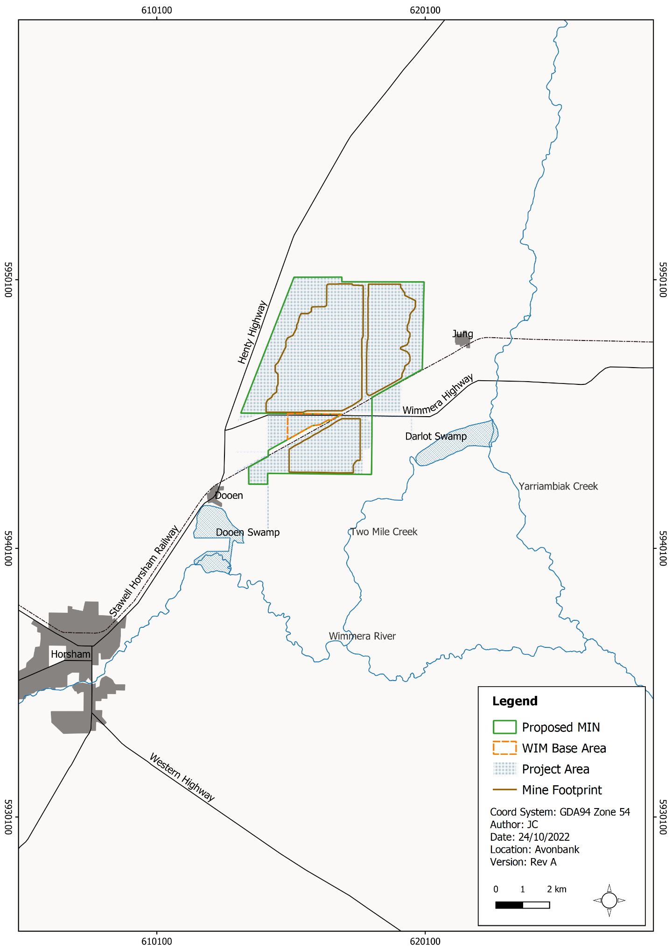
Figure 16-1: Study area

Operational Context
As described in Chapter 2, construction of the Wet Concentrator Plant (WCP) and preparation for the starter pit will be undertaken in year 1, followed by progressive mining in the southern areas of the mine footprint in year 2 (Block A). Mining operations will move to Block B north of the Wimmera Highway in year 7.
In years 2 and 7, overburden will be stockpiled to create a starter pit with sufficient room for the progressive placement of tails and overburden. Typically, overburden will be used to progressively backfill the mine void, along with tailings from the WCP. After the void is backfilled and tails have dried sufficiently, subsoil and topsoil will be placed.
It is expected that rehabilitation will be completed within 4 years after initial topsoil disturbance in each mining cell. At any given time over the life of mine, the extent of Project disturbance will be less than 400 ha and will typically (on average) be less than 300 ha as areas are progressively mined and rehabilitated.
For the purposes of the SWIA, a worst-case operational scenario was assumed that included concurrent disturbance areas at year 2 and year 7, as shown in Figure 16-2. While this scenario is not contemplated or plausible during Project implementation, it provides a highly conservative modelling assumption. The construction and mine establishment phase were considered to be adequately represented by this worst-case operational scenario.
Several rehabilitation scenarios were developed for the post-closure phase, adopting different topographic elevations of 300 mm decrease/increase and 500 mm increase compared to the final land surface elevation in mined areas. As described in Chapter 15 (Soils and Landform), the actual post-mining landform for mining will initially be 250 mm higher than the previous natural topography. This is to allow for an estimated settlement of 150 mm during the first ~5 years after placement and a further 100 mm of secondary creep over the subsequent ~25 years.
The Project will have a net water requirement of up to 4.6 GL/year. The water will be sourced from the GWMWater Wimmera Mallee Pipeline, dewatering of the mine void and rainfall. The operational water balance is shown in Appendix K, Figure 2-1.
The Project is designed with sufficient water holding capacity within the mining void and process water dams, such that there will be no discharge outside the operational areas, as further explored in this assessment. There will be a process water dam (50 ML) and two drop-out dams (10 ML each) at the WBA with a holding capacity of 70 ML (refer Chapter 2).
The SWIA design assumptions included a freshwater dam (28 ML) that was to be supplied directly with fresh pipeline water. After detailed engineering was completed for the feasibility study, the freshwater dam was removed from the design as it was deemed inefficient to double-handle the water operationally.
Removing the freshwater dam from the system does not materially affect water storage volume for rainwater run-off or the SWIA modelling, as the freshwater dam was assumed to be full, hence had zero capacity for stormwater run-off.
It is also noted that the overburden stockpile location used in the impact assessment was moved to the north-east around 600 m following completion of the modelling (refer Appendix K, Appendix B). The mining footprint was also reduced in the north-west and south-east, as shown by the pink outline and brown outline in Figure 16-2. As described in the impact assessment (Appendix K, Appendix B), this change will not materially impact the modelling outcomes or impact assessment findings.
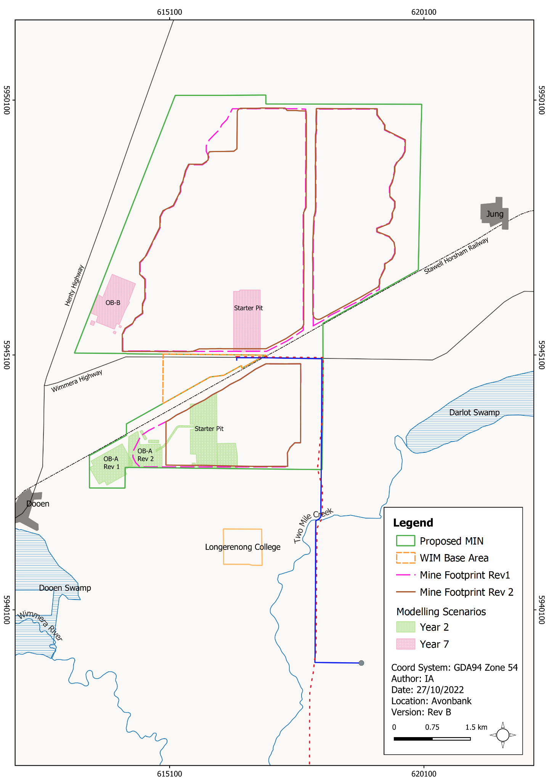
Figure 16-2: Concurrent disturbance areas at year 2 and year 7

Existing Conditions

Regional Catchment and Drainage
The proposed mining licence and WBA Area are situated within the Wimmera River catchment, located in the southwestern part of the Murray-Darling Basin. The Wimmera system contributes approximately 1.7% of the flow in the Murray-Darling Basin system.
The Wimmera River flows in a generally north-westerly direction until it reaches the Horsham area, after which it turns northward towards its terminus at Lake Albacutya (approximately 130 km to the north-northwest of Horsham). The Wimmera River and its tributaries flow intermittently in response to rainfall. Much of the river flow originates in the Grampian Ranges and surrounding areas (refer Figure 16-3).
The Wimmera River System is a large and geographically diverse system. It experiences great variability in climate, in particular rainfall, which in turn influences water regimes for creeks, rivers and wetlands. Average annual rainfall in the catchment ranges from about 1,000 mm/year in the south to 300 mm/year in the north.
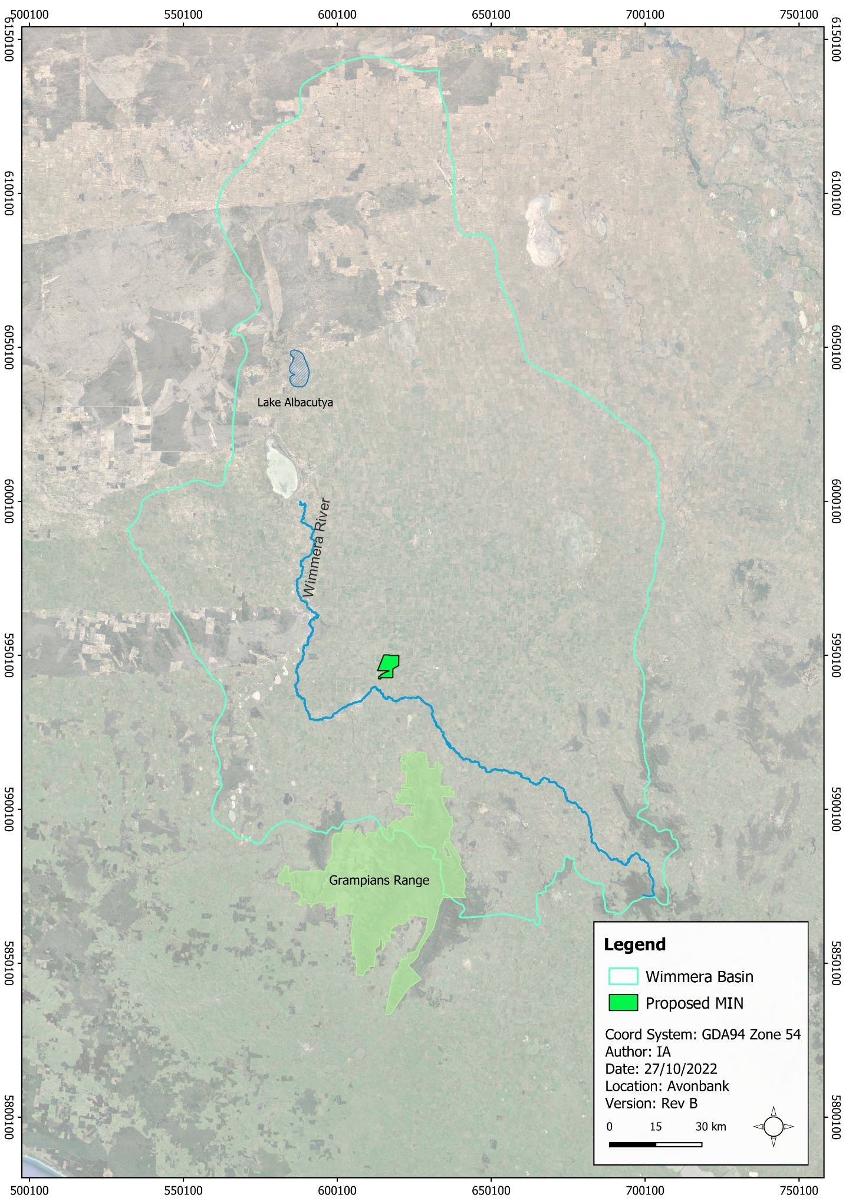
Figure 16-3: Regional catchment and drainage

Designated Waterways
The proposed mining licence area and WBA areas are relatively flat, with surface run-off tending to pool in localised depressions or flow toward Dooen Swamp. Dooen Swamp is a floodplain wetland that connects to the Wimmera River during high-flow events. There are three designated waterways within the vicinity of the Project, which are Yarriambiack Creek, Two Mile Creek and the Wimmera River. No designated waterways are situated within the proposed mining licence or WBA (Figure 16-4). Parts of Dooen Swamp are classified as a designated waterway despite it being more appropriately defined as a wetland. Yarriambiack Creek is around 3 km to the east and the Wimmera River is about 3.5 km to the south of the proposed mining licence.

Flooding and Local Inundation
Riverine hydraulic modelling was conducted as part of the Horsham and Wartook Valley Flood Investigation (Water Technology, 2019) and the Warracknabeal and Brim Flood Investigation (Water Technology, 2015). Modelling found that under current conditions, the largest river flood event modelled (1% AEP event) does not produce material external catchment overland flow into the Project area (refer Appendix K, Figure 7-5).
Local rainfall inundation modelling of the 1% AEP event was conducted as part of the impact assessment. It shows that most inundation is caused by overland flow, ponding in a series of discontinuous depressions (refer Appendix K, Figure 7-6). The maximum flood depth across the modelling area was 1.05 m adjacent to the intersection between the railway and Henty Highway. In general, inundated areas are flooded to a depth of around 0.15 m during the 1% AEP event (refer Figure 16-5).
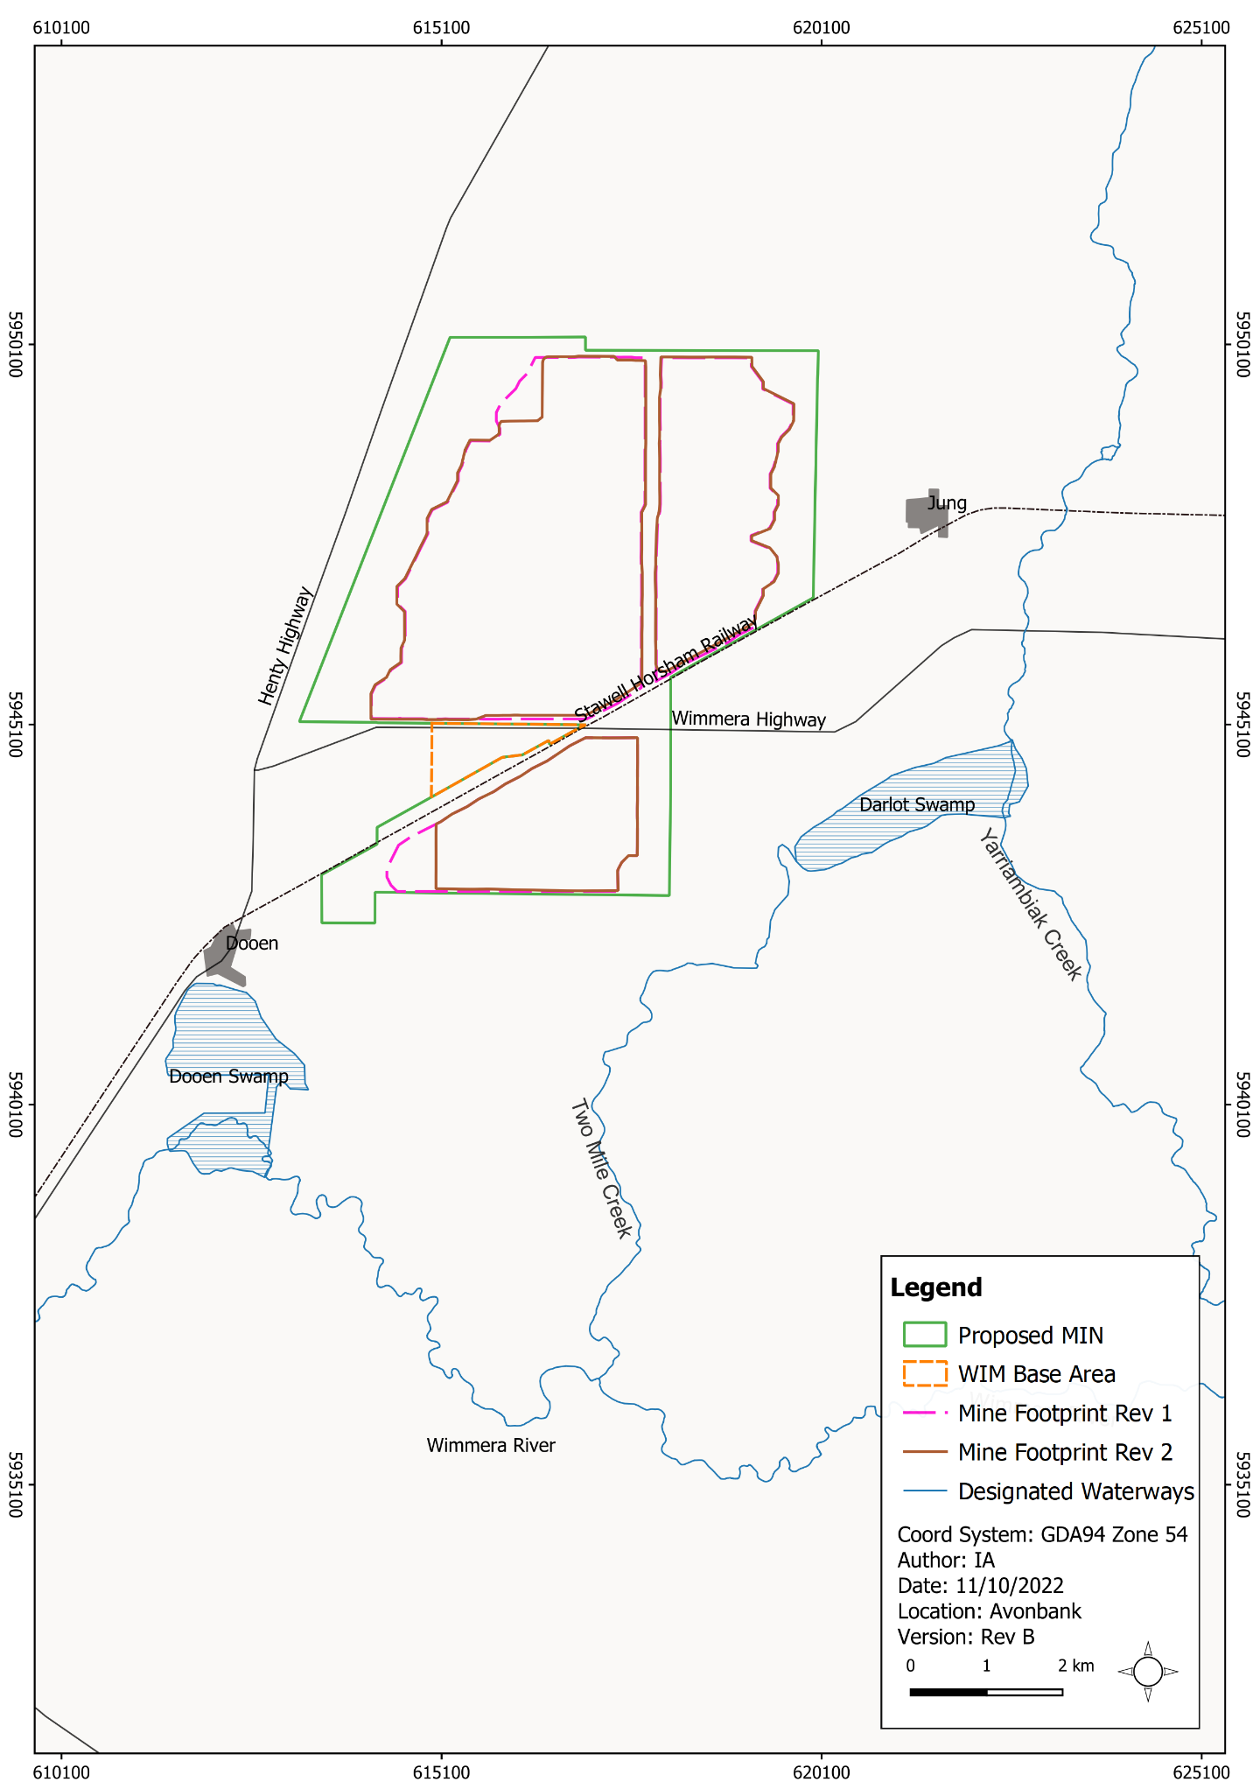
Figure 16-4: Designated waterways surrounding the Project
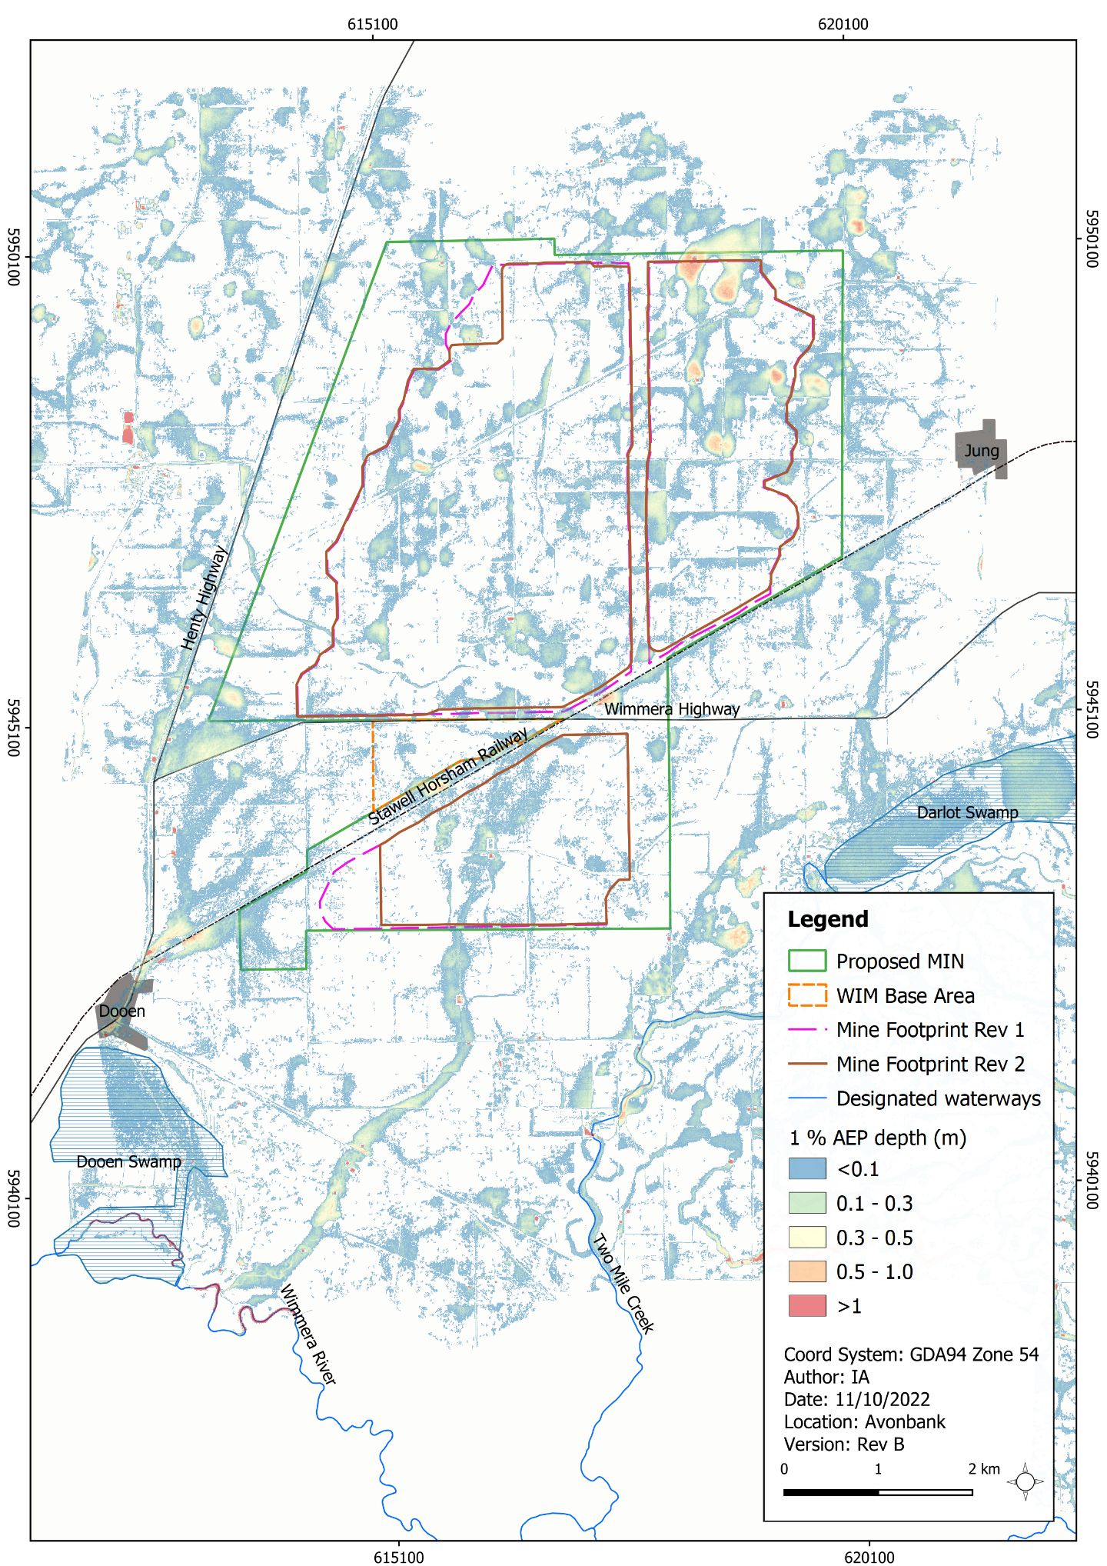
Figure 16-5: Existing conditions – 1% AEP Flood Depth

Local Swamps

Dooen swamp
Dooen Swamp is a floodplain wetland that connects to the Wimmera River during high flows. Parts of the swamp are currently used for agricultural purposes, while others remain uncultivated.
Historically, the connection between Dooen Swamp and Wimmera River was formalised by the construction of channels. These channels are understood to have been constructed to take water from the Wimmera River and transport it to the northern end of Dooen Swamp for easier water extraction for the Dooen township (Figure 16-6).
Water in these channels does not provide material surface water flow to the vegetated areas in Dooen Swamp. In general, the swamp receives small inflows from a catchment to the north, which flow into the excavated channels. There are two sources of surface water inflow into Dooen Swamp:
- Rainfall run-off from local catchments to the north of the swamp (water enters the Dooen Swamp directly through an overland flow path).
- Out-of-bank flows in the Wimmera River running into Dooen Swamp.
The Wimmera River flows from the east to the west and spills water into the swamp when the Wimmera River water level exceeds 125 m AHD. Flooding of Dooen Swamp is caused by Wimmera River inundation rather than by flow originating from the northern localised catchment. Hydrologic modelling of the Dooen Swamp wetland has concluded that the swamp would be dry 93% of the time under the climatic conditions that have occurred over the past 110 years.
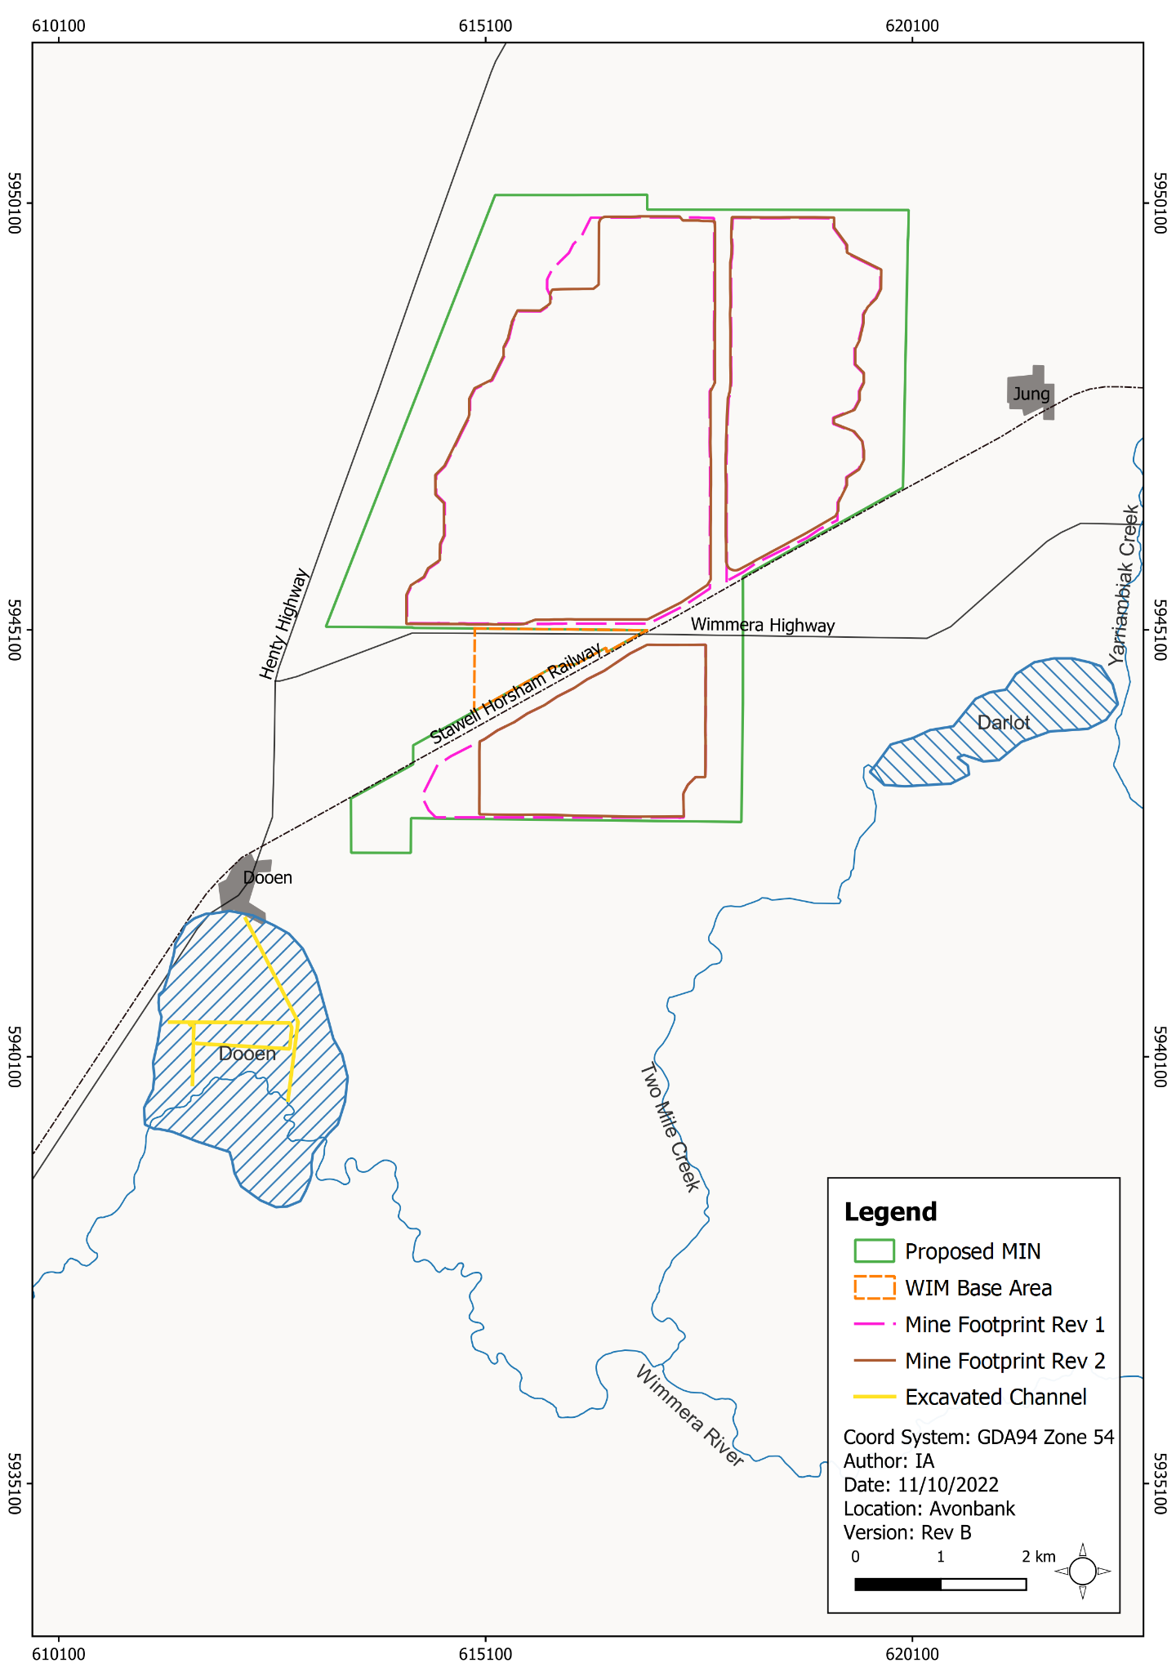
Figure 16-6: Excavated channel in Dooen swamp

Darlot swamp
Darlot Swamp is an ephemeral, shallow freshwater marsh. The swamp is normally dry and is filled during flood periods with flow from the Yarriambiack Creek, generally during floods in a 1 in 5 year frequency. No surface water flows from the proposed mining licence or WBA areas to Darlot Swamp.

Water Quality Conditions
The surface water environment relevant to the Project falls within the Murray and Western Plains segment. This segment comprises river and streams and reaches of the lowland area (which are generally below 200 m in altitude), including the Wimmera basin.
Historic water quality data for the monitoring station at the Wimmera River at Horsham (215200) was reviewed for the duration between 1990 and 2020. Although the historic records showed variations in water quality related to seasonal flows, the results showed that the quality of Wimmera River water at Horsham mostly met water quality objectives specified in the Environment Reference Standard (ERS, 2021). The relevant surface water objectives within the study area are provided in Appendix K, Section 5.2.2.

Potential Impacts

Identification of Potential Impacts
Potential impacts were identified in the impact assessment with consideration to the Project activities, preliminary modelling outcomes and the location of sensitive receptors (refer Appendix K, Table 7-2). Where a plausible source-pathway-receptor relationship could be established further investigation was undertaken to identify avoidance and mitigation measures and to assess the residual impacts. The potential impacts assessed are listed in Table 16-1.
Table 16-1: Potential impacts
Item | Potential Impacts | Phase
IP-01 | Riverine flooding within operational areas resulting in downstream impacts at sensitive receptors. | C, O, D
IP-02 | Changes to local drainage patterns resulting in flooding on private property or public infrastructure. | C, O, D
IP-03 | Changes to local drainage patterns resulting in reduced water availability at sensitive receptors. | C, O, D
IP-04 | Offsite water discharges resulting in poor quality water entering downstream environments. | C, O, D

Sensitive Receptors
Sensitive receptors were identified in the impact assessment with consideration to the conceptual surface water model and the environmental values defined in the Environment Reference Standard (ERS, 2021).
Figure 16-7 shows the location of the sensitive receptors and Table 16-2 summarises the identified receptor types and associated environmental values. The detailed assessment of relevant environmental values is provided in Appendix K, Table 7-2.
Table 16-2: Relevant sensitive receptors
Environmental Values | Sensitive Receptors
Water dependent ecosystems and species | Potential groundwater dependent ecosystems including Dooen Swamp and Wimmera River.
Human consumption after appropriate treatment | The Project is not within a declared Special Water Supply Catchment Area.
Potable water supply
Potable mineral water supply
Agriculture and irrigation | Several farm dams are in proximity to the Project (Figure 16-7). There are a total of 18 surface water licences on the Wimmera River (13 domestic and stock; and 5 irrigation) between Coughlin Park in Horsham and the Wimmera River – Yarriambiack Creek junction.
Human consumption of aquatic foods | Consumption of recreationally caught fish from the Wimmera River is common.
Water-based recreation | The Wimmera River is used for a significant number of water-based recreation activities.
Traditional Owner cultural and spiritual values | Surface water features including Dooen Swamp and Wimmera River.
Cultural and spiritual values (non-indigenous) | Surface water features including Dooen Swamp and Wimmera River.
Protection of buildings and structures | Buildings and residential dwellings and Project related infrastructure, including the WBA (Figure 16-7).
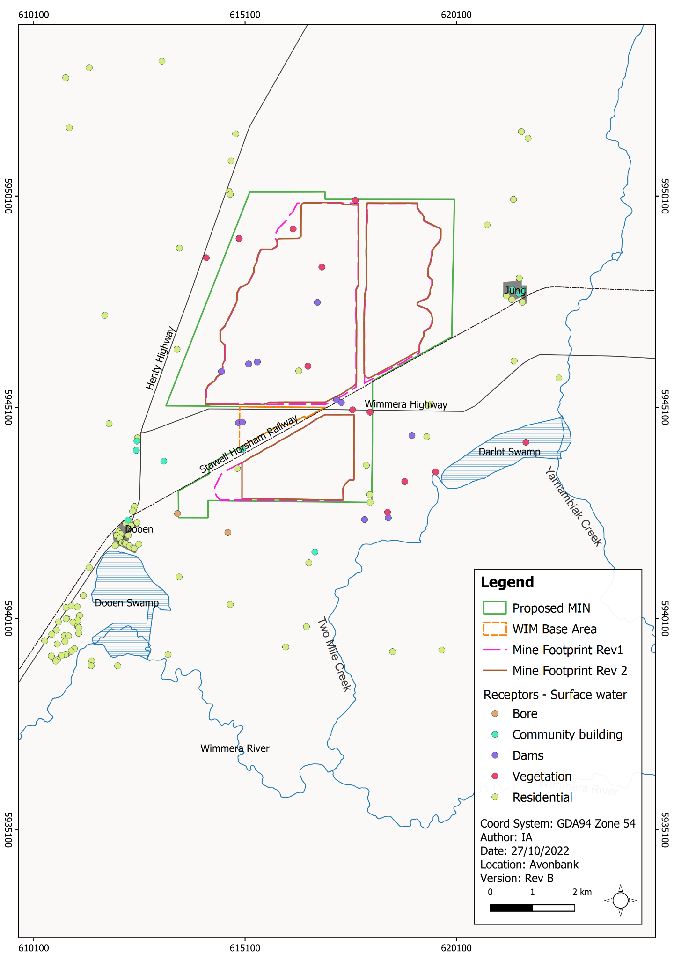
Figure 16-7: Sensitive receptors in and around the Project

Impact Characterization
The SWIA assessed the magnitude, spatial extent and duration of the predicted surface water effects as characterised in the local and regional quantitative modelling undertaken for the Project (refer Appendix K, Section 7 and Section 10). The residual impacts were characterised with regard to the ERS environmental values where relevant.
The residual impacts associated with tails water discharge to the aquifer and the potential interaction with surface water features are described in Chapter 17 (Groundwater).
In addition to the detailed characterisation of the impacts described above, the relative significance of each residual impact was summarised on a scale ranging from negligible through to severe (refer Table 16-3).
Table 16-3: Significance ratings
Rating | Description
Surface water quantity
Negligible | No material impact to peak 1% AEP water levels in areas external to the Project area.  No material reduction in catchment flow volume reporting to Dooen Swamp.
Minor | A material change to peak 1% AEP water levels outside the Project area but unlikely to cause a tangible change to environmental values or use.  A change in catchment flow volume reporting to Dooen Swamp but unlikely to cause a tangible change to environmental values or use.
Moderate | Changes to peak 1% AEP water levels outside the Project area which will cause a tangible change to environmental values or use over the short (>2 years) to medium-term (>5 years).  A change in catchment flow volume reporting to Dooen Swamp which will cause a tangible change to environmental values or use over the short (>2 years) to medium-term (>5 years).
Major | Changes to peak 1% AEP water levels outside the Project area which will cause a significant change to environmental values or use over the medium (>5 years) to long-term (>30 years).  A change in catchment flow volume reporting to Dooen Swamp which will cause a significant change to environmental values or use over the medium (>5 years) to long-term (>30 years).
Severe | Changes to peak 1% AEP water levels outside the Project area which will cause a significant change to environmental values or use over the long-term (>30 years) or be irreversible.  A change in catchment flow volume reporting to Dooen Swamp which will cause a significant change to environmental values or use over the long-term (>30 years) or be irreversible.
Surface water quality
Negligible | Quality of water exiting the site meets applicable water quality objectives or where background concentrations already exceed water quality objectives (WQO) and is no worse than upstream water quality.
Minor | Dissolved contaminant concentrations and/or turbidity in water exiting the site show a perceivable change in concentrations and meet applicable water quality objectives (assuming WQOs are also met in upstream water) and do not result in a tangible change to environmental values or use.
Moderate | Dissolved contaminant concentrations and/or turbidity in water exiting the site show an increase in upstream concentrations, which will cause a tangible change to environmental values or use over the short (>2 years) to medium-term (>5 years).
Major | Dissolved contaminant concentrations and/or turbidity in water exiting the site results in a temporary reduction of environmental values or use over the medium (>5 years) to long-term (>30 years).
Severe | Dissolved contaminant concentrations and/or turbidity in water exiting the site results in a change to environmental values or use over the long-term (>30 years) or be irreversible.

Avoidance and Mitigation Measures
This Section outlines the measures identified to avoid and minimise residual impacts. It is noted that in line with the requirements of the proposed environmental management system (EMS) and relevant legislation, additional measures may be required during implementation to ensure risks and potential impacts have been minimised so far as reasonably practicable.

Avoidance

SW-01: Solar drying cells
During the project feasibility and design phase, various tailings disposal options were considered prior to onsite trials being undertaken (refer Chapter 3). Several contemporary mineral sands operations use solar drying cells to dry the fine tailings prior to rehabilitation. This option was rejected due to the relatively high associated water use and land disturbance requirements. For this Project, fine and course tailings will be co-disposed to the in-pit tailings cells, which use less water and have a lower requirement for land disturbance. This, in turn reduces the potential operational area that needs to be managed to avoid discharge.

SW-02: Offsite water discharge
The process water storage, transfer areas and sumps will be designed with a capacity to contain a significant rainfall event of at least 1% AEP, such that there is no discharge of surface water from operational areas. It is anticipated that process water capacity will be maintained at between 350% to 500% of a 1% AEP event.

Minimisation

SW-03: Disturbance footprint
Land will be progressively rehabilitated to minimise the area disturbed on average to less than 300 ha at any point over the life of mine. This will minimise the volume of mine contact water to be managed within the operational areas.

SW-04: Mine planning and site drainage
Prior to opening new mining cells or constructing new infrastructure, an integrated mine drainage plan will be prepared by the mine planning engineer with consideration to the existing topography, detailed mine design, surrounding infrastructure and the location of sensitive receptors.
All infrastructure, including but not limited to buildings, stockpiles, sumps, pipelines and booster pumps will be located in areas to minimise the risk of ponding and adverse effects to surface water flow paths. Rehabilitation areas will be contoured to reflect the pre-mining landform and surface drainage will be re-established commensurate with undisturbed areas.
Appropriately sized sediment retention basins will be established as part of the drainage plan to capture mine contact water and prevent discharge outside operational areas. Stormwater drains will be designed and constructed to minimise the risks posed to infrastructure and sensitive receptors.
The Surface Water Management Plan (Section 16.6.2.4) will be developed and implemented to monitor water quality within operational areas and in established rehabilitation areas.

SW-05: Water use efficiency
To optimise water use from the Grampians Wimmera Mallee Pipeline, a water efficiency program will be incorporated into the Surface Water Management Plan. This program will provide a framework to investigate water use efficiency and recovery opportunities, with consideration to any new or emerging technologies over the life of mine.

SW-06: Surface Water Management Plan
A Surface Water Management Plan (SWMP) will be prepared prior to Project commencement. The SWMP will provide a management framework to avoid and minimise impacts, so far as reasonably practicable, in line with the Project EMS and relevant legislative requirements.
The SWMP will address aspects relating to Project related mine stormwater drainage, process water management and associated potential impacts and risks to sensitive receptors, including but not limited to adjacent landholders and Dooen swamp.
The SWMP will be developed in consultation with stakeholders and will be subject to approval by the relevant Authority. It will be reviewed and updated at an appropriate frequency as established in the overarching EMS, with consideration to the level of risk, statutory requirements, monitoring results, community complaints and in response to audit findings.
The SWMP will:
- Summarise the baseline data and existing environment.
- Explain the relevant statutory requirements and context (including any relevant approvals).
- Describe the avoidance and mitigation measures to be implemented to minimise residual risks/impacts so far as reasonably practicable.
- Identify specific environmental objectives and standards to be achieved with avoidance and mitigation measures in place.
- Detail the monitoring to be undertaken to verify the effectiveness of the avoidance and mitigation measures, including but not limited to surface water chemistry and water storage levels (refer Section 16.8).
- Describe mechanisms to determine when/if corrective actions and contingency measures are required (refer Section 16.8.2)
- Detail a program to investigate and implement ways to improve the environmental performance of the Project over time.
- Detail appropriate review periods and/or triggers to ensure the plan remains fit for purpose.
- Establish procedures to manage:
- incidents and any non-compliance.
- stakeholder and community complaints.
- failure to comply with statutory requirements and/or performance standards.
- roles and responsibilities for implementing the plan.
- a protocol for periodic review of the plan.
- Include a community engagement strategy which will include a complaints handling system.
In addition to the above requirements and the avoidance and mitigation measures in this Chapter, the SWMP will include specific requirements to:
- Implement mine planning procedures to ensure surface water drains and sumps are established and maintained to contain significant storm events within disturbed areas.
- Routinely inspect and monitor freeboard in process water dams and sumps.
- Reestablish pre-mining drainage patterns were appropriate to do so.
- Have procedures in place to prepare for extreme rainfall events.
- Detail the erosion control and management measures for stockpiles, internal roads and other disturbed areas.

Rehabilitation

SW-07: Rehabilitation Plan
A Rehabilitation Plan will be established for the Project that will address matters relating to progressive rehabilitation and closure. It will cover all work areas within the proposed mining licence and within the broader development extent and the Port of Portland.
The Rehabilitation Plan will include a schedule of progressive rehabilitation and will describe the strategy to establish a safe, stable, sustainable landform capable of supporting the proposed end land use. It is expected that land will be stabilised as soon as reasonably practicable after mining, typically within 4 years.
The Rehabilitation Plan will define the end land use with consideration to the views of the landholders and the broader community where appropriate. Preferential flow paths and agricultural drainage lines will be re-established to be commensurate with surrounding areas and to meet the overarching end land use objectives.
A preliminary Rehabilitation Plan for the Project has been developed to meet the intent of the Scoping Requirements and is included with this EES as Attachment 3. This plan will be refined prior to commencement with consideration to the detailed operating plans, stakeholder and community feedback and the Minister’s assessment of the EES.

Residual Impacts
This Section describes the likely residual impacts with avoidance and mitigation measures in place. The residual impacts have been characterised, as described in Section 16.5.3 and Chapter 6 (Impact Assessment Framework).

Riverine Flooding
There is one potential impact (IP-01) identified in Section 16.5.1 that relates to potential riverine flooding extending into the proposed mining licence or WBA. If flooding were to occur into operational areas, it could affect Project infrastructure and associated works.
Riverine flooding was investigated as part of the Horsham and Wartook Valley Flood Investigation (Water Technology, 2019) and the Warracknabeal and Brim Flood Investigation (Water Technology, 2015). These studies show the proposed mining licence and WBA were not impacted by riverine inundation for rainfall events up to 1% AEP. The Project will not cause changes to the associated flood behaviours and there is negligible residual impact expected. No mitigation measures are considered necessary.

Localised Inundation
There is one potential impact (IP-02) identified in Section 16.5.1 that relates to local drainage pattern changes due to Project activities. If there were significant changes to local drainage patterns, it could affect Project infrastructure and/or nearby landholders.
The potential impact of direct/localised catchment inundation within the Project area was assessed through the development of a RoG hydraulic model. The model identified existing overland flow paths, depths and velocities of water flowing within the Project area and immediate surrounds. The mine design scenarios were modelled to assess the potential for Project related impacts to surface water flow paths, inundation depths and extent. The impact of mining was modelled with respect to worst-case operational and rehabilitation/closure scenarios (refer Section 16.3).
The operational scenario included the combined area to be active during years 2 and 7. Water level results of the hydraulic modelling were compared to that of existing conditions to show the changes in water levels and inundation during a 1% AEP event. The change in water levels due to the operational scenario is shown in Appendix K, Figure 10-1.
The modelling shows minor changes to ponding water levels up to around 0.3 m which was isolated to the areas immediately surrounding the overburden stockpiles and mining pits. There was a slight reduction in flood levels in the overland flow path entering Dooen Swamp and no increases in the water levels outside the Project area. The effects to Dooen swamp are further explained in Appendix K, Section 7.3.5 and Section 10.4.
The rehabilitation and closure scenarios modelled include a decrease or increase elevation to varying degrees between 300 mm and 500 mm. The modelling results for 1% AEP inundation levels are shown in Appendix K, Figure 10-2, Figure 10-3, Figure 10-4 and Figure 10-5. In all cases, minor changes were observed in close proximity to the mine footprint ranging from 0.2 to 0.3 m.
The effect of climate change on inundation levels were assessed by comparing modelled levels for existing topographic conditions and for both operating and closure conditions. Model results are shown in Appendix K, Figure 10-8 and Figure 10-9, respectively. There was no material difference shown between the current day climatic conditions and the climate change scenario.
The Project is expected to result in negligible changes to the stormwater flow paths or ponding characteristics within and surrounding the proposed mining licence and WBA area. During a 1% AEP event, it is not expected the changes to the site inundation characteristics will materially impact sensitive receptors within or downstream from the Project area.
Mitigation measures will be implemented to limit the total area disturbed and to strategically place mine infrastructure to minimise impacts on existing surface drainage lines. It is expected that mining areas will be rehabilitated within 4 years and that pre-existing farm drainage lines will be reinstated, where appropriate to do so.

Reduced Surface Water Availability
There is one potential impact (IP-03) identified in Section 16.5.1 that relates to a potential reduction in surface water flow to Dooen Swamp and Wimmera River. A significant reduction in water flow to these swamps could affect the health of vegetation and the broader ecosystem.
The proposed total mine footprint occupies around 14.5% of the localised catchment area contributing to Dooen Swamp and about 0.18% of the Wimmera River catchment area upstream of the Horsham gauge.
The modelled scenarios described in Section 16.3 show a very small reduction of flow to the Wimmera River catchment upstream of Horsham. The modelling indicates a 0.2% reduction of flow to the contributing catchment area, which was not considered to be material.
Flooding of Dooen Swamp is primarily caused by Wimmera River inundation rather than by flow originating from the northern catchment where the Project is located. The localised catchment does not generate sufficient volume to flood Dooen Swamp. Rather, modelling indicates any water level changes are realised in the excavated channel.
Surface water modelling for existing and developed conditions indicates water level changes are barely perceptible. The maximum difference between water ponding depths within the excavated channel under existing and developed conditions was 0.16 m. The reduced flow and minor change to water levels in the channel were shown to result in a negligible change to the water availability in Dooen Swamp.
Climate change was also considered and found not to materially impact the Project’s influence on water levels in the Dooen Swamp channel.
Upon rehabilitation, stormwater run-off will be returned to pre-mining drainage lines and preferential flow paths. No change to the regional catchment contribution model will occur.
The change to water availability in Dooen Swamp is expected to result in a negligible residual impact. No specific mitigation measures are required however the disturbance area will be minimised and the SWMP will be implemented.

Water Quality Impacts
There is one potential impact (IP-04) identified in Section 16.5.1 that relates to offsite water discharge resulting in poor quality water entering downstream environments and resulting in impacts to surface water environmental values. Potential impacts on groundwater are assessed in Chapter 17.
The Project has been designed to provide sufficient storage capacity to contain significant rainfall events in excess of a 1% AEP event and up to 500% of the January 2011 flood event. All mine impacted run-off will drain to sumps to be recycled or used for operational purposes such as dust suppression.
Under the adopted climate change scenario, it was shown that adequate capacity was maintained in excess of the 1% AEP and up to 350% of the January 2011 flood event. For this reason, there are no anticipated changes to downstream water quality, as there is no plausible scenario under which impacted surface water would need to be discharged from the site.
Given the above considerations, there will be no residual water quality impacts to offsite areas or receiving waterways outside the proposed mining licence or WBA. Risks will be managed through the implementation of the SWMP.

Management Framework
An AS/NZS 14001:2016 EMS will be established for the Project, as detailed in Chapter 24. The EMS will address matters relating to planning, operational control, monitoring, and continuous improvement over the life of the Project. Relevant matters relating to monitoring, auditing and corrective actions are summarised below.

Environmental Objectives
Environmental objectives will be established as part of the EMS to articulate the outcomes to be achieved during Project implementation. These reflect the expected and achievable outcomes based on the studies undertaken as part of this EES.
The key environmental objectives are to ensure that:
- The Project will result in no material discharge of mine contact water outside of the operational areas.
- Mining and associated infrastructure will result in no significant impact on the surface drainage characteristics associated with sensitive receptors.
Performance standards will be established to measure/assess if the objectives have been achieved during operation, as further discussed below in Section 16.8.2.

Monitoring and Management
A surface water monitoring program will be incorporated into the EMS and associated SWMP to measure, analyse, and evaluate the effectiveness of the avoidance and mitigation measures and overall environmental performance. The SWMP will be developed in consultation with stakeholders and will be subject to approval by the relevant Authority.
Surface water monitoring will be undertaken over the life of the Project at sensitive receptors to confirm the avoidance and mitigation measures are effective. In line with the requirements of the EMS described in Chapter 24 and relevant legislation, additional measures may be required during implementation to ensure risks and potential impacts have been minimised so far as reasonably practicable.
Monitoring locations will be established with consideration to the source/activity, established/proposed avoidance and mitigation measures and sensitive receptors. The monitoring network will be augmented and adapted over the life of the Project to ensure the environmental impacts and risks are adequately characterised as the mine progresses.
Surface water samples and water levels will be undertaken according to a schedule approved in the SWMP (Section 16.6.2.4). The surface water sampling analytical suite will be developed by a suitably qualified person such that it is aligned with the requirements of the ERS and will fully characterise the relevant risks and impacts associated with the Project. It is expected that the monitoring schedule and analytical suite will be reviewed periodically and amended over the life of the Project to ensure it remains relevant. Material changes will be communicated and approved via the SWMP.
It is expected that the Dooen swamp will be monitored periodically during significant rainfall events. Process water dam levels will be routinely monitored to confirm freeboard levels are maintained. Process water and tails monitoring will form a part of the GWMP, as the potential impacts are more relevant to groundwater.
If actual surface water effects are observed to be trending toward levels that may exceed the performance standards, modelling, or regulatory criteria, then a root cause investigation will be undertaken, and corrective actions/contingencies identified. Depending on the severity and nature of the potential impact, it is anticipated that the mine plan may be reviewed to determine if any changes or processing variables could be adjusted to minimise the observed adverse trend.

Audits
Periodic internal and independent audits will be undertaken to assess the effectiveness of the EMS. An internal audit program will be maintained, which details the frequency, methods, responsibilities and reporting requirements.
Audits will be undertaken by a suitably qualified person to assess the effectiveness of the EMS and associated management plans (including the SWMP) to minimise or avoid surface water impacts so far as reasonably practicable. Any non-conformity identified in the audit will be investigated and corrective actions identified.
The outcomes of audits will be communicated to the Project’s Management team and records of the audit findings will be retained in the record management system. Significant findings will be reported to relevant Regulators and stakeholders where appropriate to do so.

Cumulative Impacts
The only major development known in proximity to the Avonbank Project is the Wimmera Intermodal Freight Terminal (WIFT) Precinct. The WIFT Precinct is currently being developed by Horsham Rural City Council and is at the beginning of its development, which is expected to take numerous years. In its fully developed state, the WIFT Precinct would likely contribute a higher volume of water to Dooen Swamp (given the increased impervious area) but the same peak flows as existing conditions (due to wetland and peak flow retardation infrastructure). An increased volume of run-off from the WIFT Precinct has the potential to partially offset reductions in flows from the proposed mining licence and WBA (even though this reduction has been shown to be negligible).
Other planned and proposed projects listed in Chapter 7 (Regional Setting) include mineral sands sites, road projects and windfarms within the region. None of these projects have overlapping surface water residual impacts that require consideration as part of this Chapter due to their location being some distance from the local catchment area.

Conclusions
This Chapter provides an overview of the Surface Water Impact Assessment prepared to address the EES Scoping Requirements for the Avonbank Mineral Sands Project.
The potential impacts on sensitive receptors associated with the Project activities were assessed as part of the Water Technology impact assessment. Consideration was given to potential impacts associated with riverine flooding and changes to surface water drainage and land inundation.
Avoidance and mitigation measures were identified to reduce the residual impacts so far as reasonably practicable. Listed below are the key measures identified:
- Slimes and sand tails will be co-disposed to the mining cell to avoid the construction of solar drying cells.
- Process water storage capacity will be established to contain a 1% AEP storm event.
- Progressive rehabilitation of mined areas will be undertaken to minimise the disturbed area on average to less than 300 ha at any point in time over the life of mine.
- An integrated mine planning process will be maintained to manage site drainage.
- A water efficiency program will be developed and implemented to minimise water use so far as reasonably practicable.
- A Surface Water Management Plan (SWMP) will be maintained to avoid and minimise risks/impacts so far as reasonably practicable.
It was shown that the proposed mining licence and WBA would not be impacted by riverine flooding up to a 1% AEP. The Project will not result in a change to riverine flooding behaviour.
The local inundation modelling showed minor changes to ponding water levels up to around 0.3 m which were mostly isolated to the areas immediately surrounding the overburden stockpiles and mining pits.
The mining footprint will reduce the local catchment area available to Dooen Swamp, however, the change to water availability is not expected to be material and the residual impacts were considered to be negligible.
The Project will retain and store all surface water on-site, inclusive of significant freeboard. There will be no residual water quality impacts to offsite areas or receiving waterways outside the operational areas.
Cumulative surface water impacts from the nearby WIFT Precinct are unlikely to materially add to those generated by the Avonbank Project. There is no other material interaction with other projects in the area.
The above residual impacts were all considered to be minor or negligible. Overall, the proposed Project work/activity is unlikely to result in significant surface water effects and it is anticipated that the associated impacts can be managed with avoidance and mitigation measures in place to achieve the evaluation objectives.

Construction (C); Operations and rehabilitation (O); Decommissioning and closure (D)

