Avonbank Mineral Sands Project
Environment Effects Statement

Chapter 21 – Flora and Fauna

TABLE OF CONTENTS
21 Flora and Fauna 21-1
21.1 Introduction 21-1
21.2 Scope and Methods 21-1
21.2.1 Scope 21-1
21.2.2 Study Area 21-1
21.2.3 Methodology 21-1
21.3 Operational Context 21-4
21.4 Existing Conditions 21-6
21.4.1 Development Extent and Immediate Surrounds 21-6
21.4.2 Local Region 21-13
21.5 Potential Impacts 21-15
21.5.1 Identified Potential Impacts 21-15
21.5.2 Sensitive Receptors 21-16
21.5.3 Impact Characterization 21-16
21.6 Avoidance and Mitigation Measures 21-17
21.6.1 Avoidance 21-17
21.6.2 Minimisation 21-20
21.6.3 Rehabilitation 21-22
21.6.4 Offset 21-22
21.7 Residual Impacts 21-23
21.7.1 Reduced Extent of Native Vegetation 21-23
21.7.2 Loss of Threatened Ecological Communities 21-24
21.7.3 Loss of Threatened Flora and Threatened Fauna Habitat 21-25
21.7.4 Habitat Fragmentation 21-26
21.7.5 Fauna Hazards 21-26
21.7.6 Indirect Impacts on Vegetation and Habitat 21-27
21.7.7 Threatening Processes 21-27
21.7.8 Groundwater Dependent Ecosystems 21-28
21.8 Management Framework 21-29
21.8.1 Environmental Objectives 21-29
21.8.2 Monitoring and Management 21-29
21.8.3 Audits 21-30
21.9 Cumulative Impacts 21-30
21.10 Conclusions 21-30

TABLES
Table 21-1: Summary of trees within the development extent 21-7
Table 21-2: EVCs recorded within the study area and development extent 21-7
Table 21-3: FFG Act TECs recorded in the retention licence study area and development extent 21-9
Table 21-4: FFG Act listed threatened flora recorded, or moderate or high likelihood of occurrence in the retention licence 21-10
Table 21-5: FFG Act and/or EPBC Act and fauna species likelihood of occurrence 21-11
Table 21-6: Potential groundwater dependent ecosystems and groundwater interactions 21-13
Table 21-7: Potential impacts 21-15
Table 21-8: Sensitive receptors 21-16
Table 21-9: Significance of ecological values under the EPBC Act and FFG Act 21-16
Table 21-10: Summary of residual impacts to native vegetation patches 21-23
Table 21-11: Summary of residual impacts to trees 21-24
Table 21-12: Summary of residual impacts on threatened ecological communities 21-24
Table 21-13: Residual impacts of key threatening processes 21-28

FIGURES
Figure 21-1: Study area 21-3
Figure 21-2: Development extent (MIN and WBA) 21-5
Figure 21-3: Overview of existing native vegetation patches (north) 21-8
Figure 21-4: Plains Grassland EVC – Site 5 (Habitat Zone 40) 21-9
Figure 21-5: Plains Savannah EVC HZ29 representing Buloke Woodland EPBC Act community 21-9
Figure 21-6: Exclusion zones and tree protection zones 21-19

Flora and Fauna

Introduction
This Chapter provides an overview of the flora and fauna effects for the Avonbank Mineral Sands Project (the Project). It has been prepared to address the Environment Effects Statement (EES) Scoping Requirements (DELWP, 2020) and is supported by a detailed impact assessment prepared by AECOM Australia Pty Ltd (AECOM) (Appendix P).
The key evaluation objective relevant to this Chapter, as defined in the Scoping Requirements, is to ‘Avoid, minimise or offset adverse effects of the project on biodiversity values including native vegetation, listed threatened species and communities and habitat for these species consistent with State and Commonwealth policies’ (DELWP, 2020). The associated issues and Project Scoping Requirements are detailed in Appendix A of this EES.
This Chapter describes the existing ecological characteristics of the area, the potential impacts associated with the Project and details the avoidance and mitigation measures to minimise the residual impacts and risks so far as reasonably practicable.

Scope and Methods

Scope
The scope of this Chapter covers the potential impacts identified in the Flora and Fauna Impact Assessment (FFIA) (Appendix P) and the relevant Scoping Requirements listed in Appendix A. The impact assessment focused on activities within the development extent that may directly or indirectly affect flora and fauna over the life of the Project. Project related aspects that are well understood and considered to be relatively low risk with standard controls in place are addressed in the Project Aspects and Risk Register (Attachment 5).
Matters of national environmental significance (MNES) under the Environment Protection and Biodiversity Conservation Act 1999 (EPBC Act), were assessed as part of the FFIA and are detailed in Chapter 25 (Matters of national environmental significance).

Study Area
The FFIA focused on activities within the proposed mining licence (MIN), WIM Base Area (WBA) and minor utilities corridor to the WBA. The study area extends to around 10 km from the proposed mining licence and considers the ecological values within the retention licence, covering an area of 6,550 hectares (ha) and surrounding areas outside the retention licence (off-retention licence area) (refer Figure 21-1). In doing so, the study area includes the area of direct disturbance and potential indirect impacts, including those associated with the predicted drawdown and mounding zones and potential process water migration pathways. Section 21.5.2 describes the sensitive receptors within the study area.

Methodology
The FFIA characterised the existing conditions, identified potential impacts and assessed the residual impacts with avoidance and mitigation measures in place. The tasks undertaken are summarised below and detailed in Appendix P, Sections 5 to 10.
Existing conditions:
- Information from previous site studies conducted by Ecology Australia and Okologie were collated and reviewed.
- Desktop mapping and field assessments (flora and fauna) were conducted between
2018–2020.
- Vegetation Quality Assessments, tree mapping and targeted threatened species searches were conducted in November 2018 and March–April 2020.
- Targeted fauna surveys were conducted for threatened species within the retention licence area as described in Appendix P (Section 5.1.6.2), including but not limited to:
  - Striped Legless Lizard (Delma impar) (October–December 2018).
  - Golden Sun Moth (Synemon plana) (November 2018).
  - Pale Sun Moth (Synemon selene) and Reddish Orange Sun Moth (Syemon jcaria) (February–March 2020).
- A desktop assessment and targeted field-based assessments were completed by AECOM for areas within the development extent.
- This included a field assessment for the minor utilities corridor in January 2022 and a field verification survey within the development extent in June 2022.
Potential impacts:
- The Project design elements, including the development extent were identified to define the likely direct and indirect impacts, where source-pathway-receptor linkages were considered plausible.
Residual impacts:
- Measures were identified to avoid and/or minimise impacts to sensitive receptors and biodiversity values, so far as reasonably practicable, including native vegetation, mapped wetlands and Ecological Vegetation Communities (EVCs) in the study area, with consideration to threatened ecological communities (TECs).
- An assessment of direct and indirect residual impacts, and any required offsets, were assessed with consideration to the avoidance and mitigation measures, the conservation status and biodiversity values of sensitive receptors, consistent with the relevant advisory lists (refer Appendix P, Section 2).
- Cumulative effects of other projects within the region were assessed where information was available.
Key assumptions relating to collected field data and the impact assessment are detailed in Appendix P, Section 5.4 and Section 12.1.4.

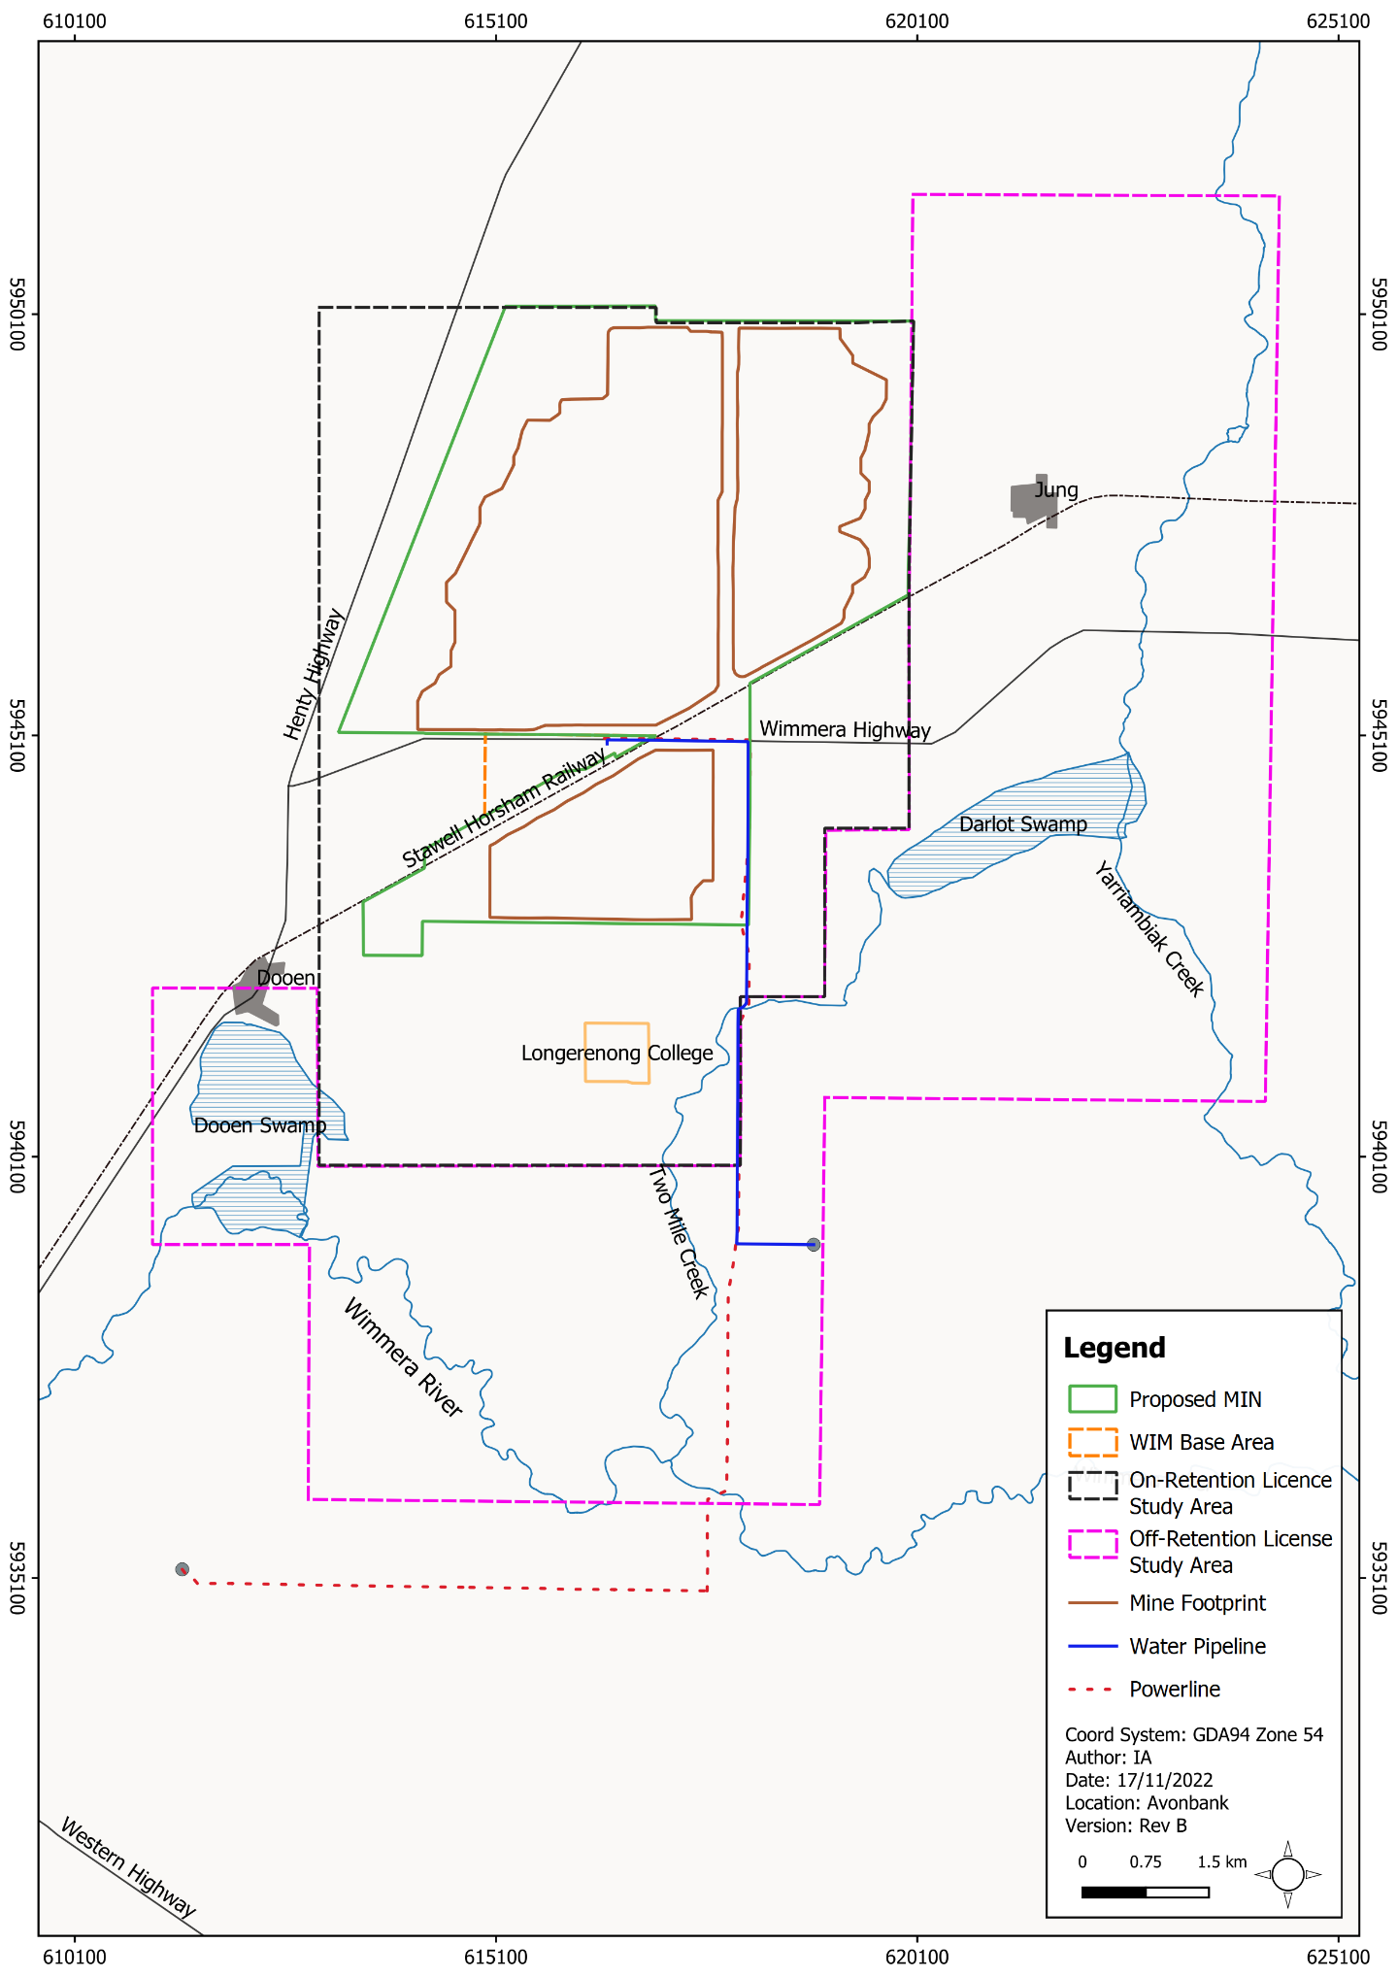
Figure 21-1: Study area

Operational Context
The proposed Avonbank development extent covers 3,546 ha, comprising the proposed mining licence area (3,426 ha), the WIM Base Area (90 ha) and the minor utilities corridor (30 ha) (refer Figure 21-2). The total mining footprint covers an area of 2,215 ha which will be progressively mined over the life of the Project. At any given time, the extent of Project disturbance will be less than 400 ha and will typically (on average) be less than 300 ha as areas are progressively mined and rehabilitated.
Ground disturbance associated with the Project will result from the use of conventional earth moving equipment such as bulldozers, scrapers, and excavators. Earth moving machinery will create deep excavations (e.g., the open-cut mining pits) or more shallow excavations to create ponds or trenches for power and water-related features. Mining will occur to nominal depths of approximately 24 m to 30 m below the ground surface and the active mining cell typically covers an area of around 2 ha. Dimensions of the mining extents are further detailed in Chapter 2 (Project Description).
Topsoil and subsoil will be stripped to depths of about 1.1 m over the mining activity area and stockpiled for progressive rehabilitation. A ‘moving hole’ mining method will be employed, which will enable progressive site rehabilitation over the life of mine. The land will be returned to landholders once it has been suitably rehabilitated, as described in Chapter 22 (Land Rehabilitation).
Power and water infrastructure within the utilities corridor will be established from the terminal stations to the WBA. This will include topsoil disturbance of up to 25 m along the water pipeline and 20 m for the powerline alignment along Wimmera Highway and Horsham-Lubeck Road. No ground disturbing works are expected along the established north-south section of the powerline, running from Wimmera Highway to Horsham-Lubeck Road.
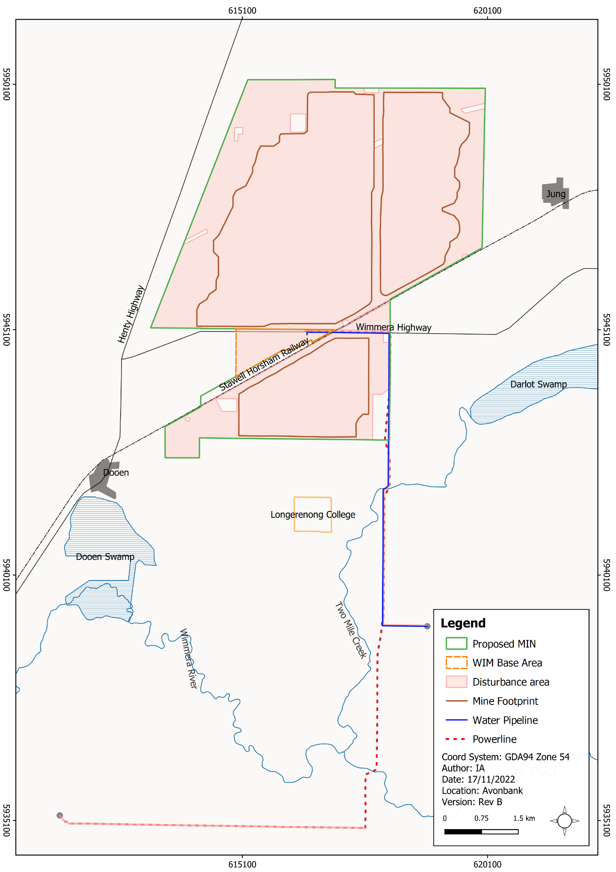
Figure 21-2: Development extent (MIN and WBA)

Existing Conditions

Development Extent and Immediate Surrounds
This Section describes the ecological values within the development extent and immediate surrounds (within the retention licence), as shown in Figure 21-2.

Native vegetation
Native vegetation identified during the Vegetation Quality Assessments (VQAs) comprised patches of native vegetation, large trees in patches and scattered trees. Identified trees are listed in Table 21-1 and patches of vegetation are provided in Table 21-2. An overview of the surveyed vegetation patches and scattered trees is provided in Figure 21-3, with the detail provided in Appendix P (Appendix C, Figure 8).
In total, 57 patches representing 82.02 ha of native vegetation were mapped. Seven Ecological Vegetation Classes (EVCs) were recorded, with six listed as ‘Endangered’ and one listed as ‘Vulnerable’ within the retention licence.
EVCs recorded within the proposed mining licence/WBA include Plains Grassland (EVC 132), Black Box Lignum Woodland (EVC 663) and Plains Savannah (EVC 826_62). There are seven EVCs within the minor utilities corridor, including but not limited to the Plains Grassland (EVC 132), Riverine Chenopod Woodland (EVC 103_62), Black Box Lignum Woodland and Floodplain Riparian Woodland (EVC 56) (refer Appendix P, Section 6.1.4.1.2).
The quality of this vegetation varies from areas of low-quality to areas of high-quality. Low-quality vegetation is where EVCs have been modified or impacted through past land use such as agriculture, while higher-quality vegetation more closely reflects the EVC bioregion benchmarks.
The highest quality vegetation within the study area was recorded within Black Box Lignum Woodland, which are dominated by scattered canopy tree species. Whilst these patches represent the highest quality areas, they typically support a highly degraded understory with low floristic diversity.
Native vegetation patches not comprising canopy species were typical of low-quality and dominated by Windmill Grass (Chloris truncate) and Wallaby Grass (Rytidosperma sp.).
The extent of EVCs recorded within the proposed mining licence and WBA area is 25.87 ha and 2.63 ha was recorded within the minor utilities corridor. Of the EVCs recorded, six EVCs have a Bioregional Conservation Status of endangered within the Wimmera bioregion.

Table 21-1: Summary of trees within the development extent
Location | Tree Category
 | Small Scattered Tree | Large Scattered Tree | Large Tree in Patches | Total
Development extent (MIN and WBA) | 34 | 79 | 48 | 161
Development extent (minor utilities corridor) | 2 | 6 | 1 | 9
Total | 36 | 85 | 49 | 170

Table 21-2: EVCs recorded within the study area and development extent
Ecological Vegetation Class | Bioregional Conservation Status | Total Extent within the On-retention Licence Study Area (ha) | EVC within Development Extent (ha)
 |  |  | MIN and WBA | Minor Utilities Corridor | Total
Black Box Lignum Woodland (663) | Endangered | 4.30 | 0.34 | 0.17 | 0.51
DELWP Mapped Wetland | N/A | 40.32 | - | 0.75 | 0.75
Floodplain Riparian Woodland (56) | Endangered | 4.45 | - | 0.33 | 0.33
Plains Grassland (132) | Endangered | 23.98 | 20.53 | 0.65 | 21.18
Plains Savannah (826_62) | Endangered | 5.22 | 5.00 | 0.01 | 5.01
Plains Woodland (803) | Endangered | 0.56 | - | - | -
Red Gum Swamp (292) | Vulnerable | 1.19 | - | 0.02 | 0.02
Riverine Chenopod Woodland (103_62) | Endangered | 2.00 | - | 0.70 | 0.70
Total |  | 82.02 | 25.87 | 2.63 | 28.50

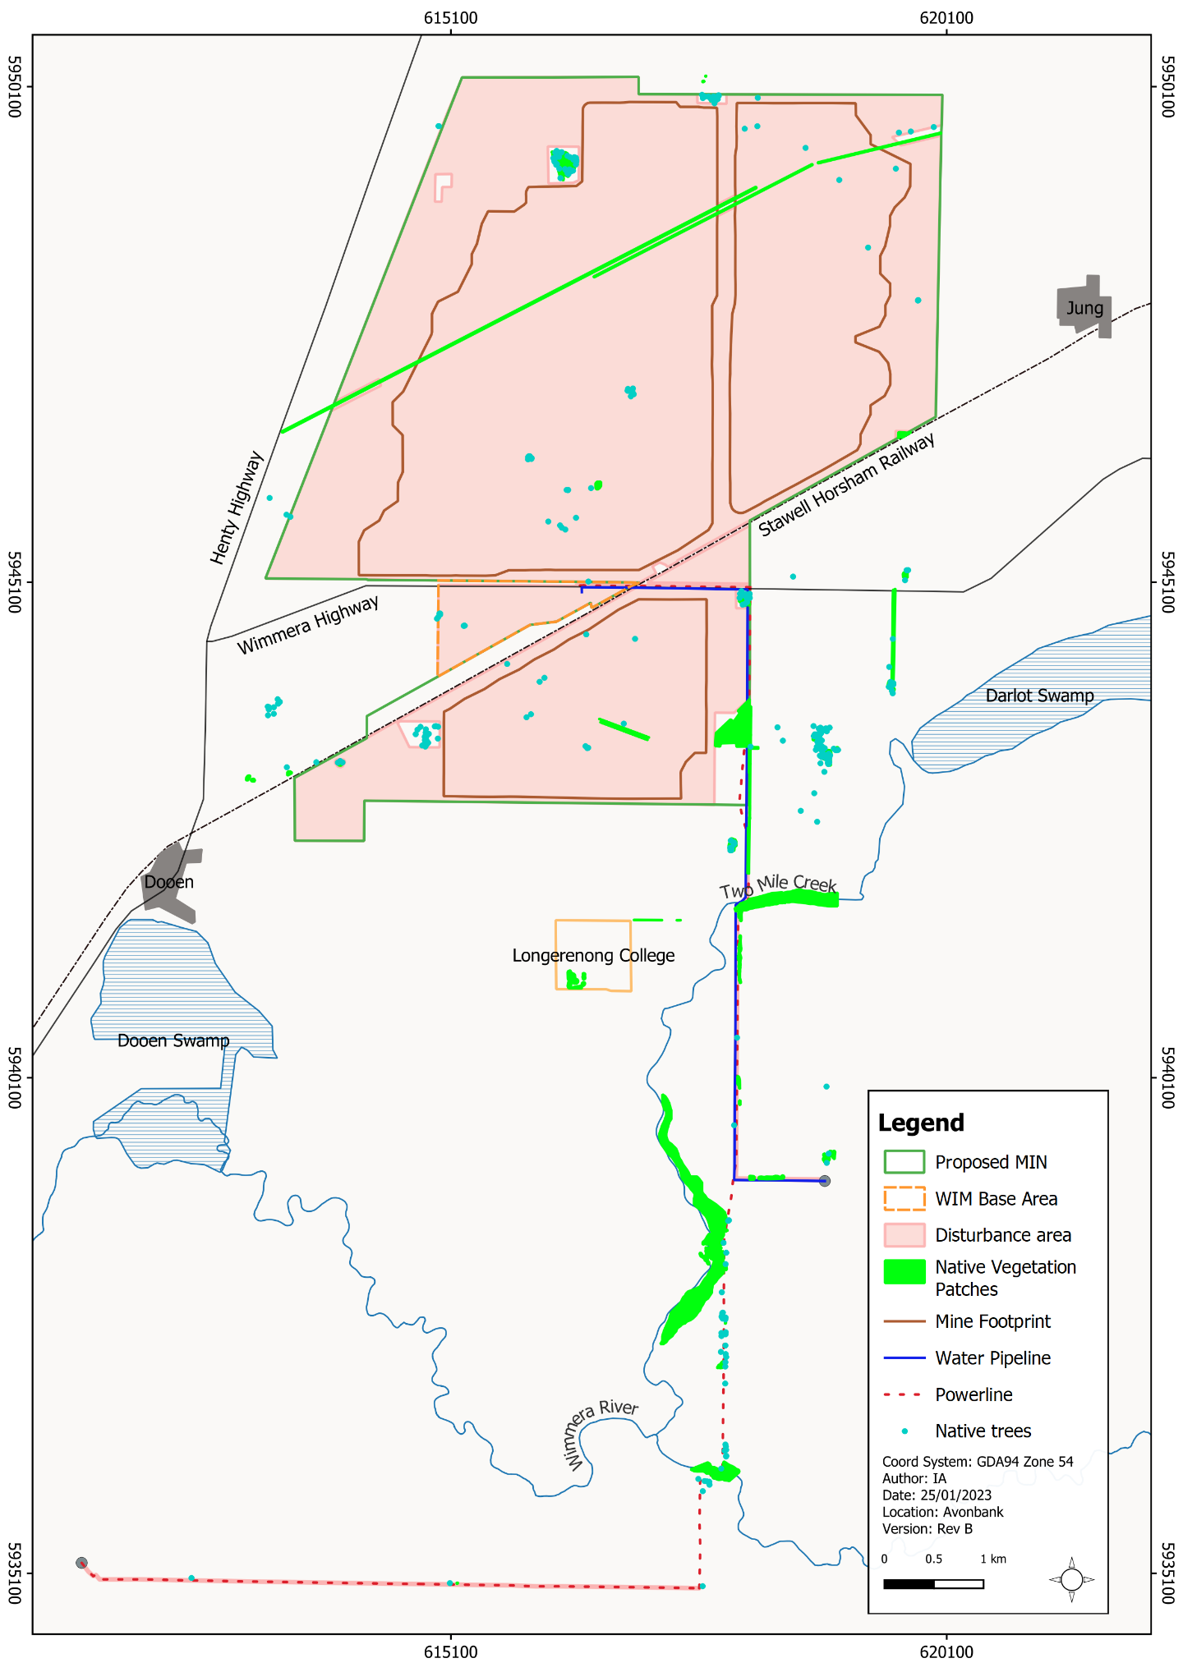
Figure 21-3: Overview of existing native vegetation patches (north)

Threatened ecological communities
Table 21-3: FFG Act TECs recorded in the retention licence study area and development extent
There were four TECs listed under the Flora and Fauna Guarantee Act 1988 (the FFG Act) recorded within the development extent. A summary of the extent of the communities recorded within the study area and within the development extent is provided in Table 21-3. The Northern Plains Grassland Community TEC (Figure 21-4) has the largest coverage within the development extent of 21.18 ha. The next largest TEC is the Semi-arid Northwest Plains Buloke Woodland Community TEC (Figure 21-5), occurring over 5.01 ha within the development extent.
FFG Act Listed TEC | Associated EVC Recorded | Total TEC extent within the On-retention Licence Study Area (ha) | TEC within Development Extent Only (ha)
 |  |  | MIN and WBA | Minor Utilities Corridor | Total
Northern Plains Grassland Community | Plains Grassland (EVC 132) | 23.98 | 20.53 | 0.65 | 21.18
Red Gum Swamp Community No. 1 | Red Gum Swamp (EVC 292) | 1.19 | - | 0.02 | 0.02
Semi-arid Northwest Plains Buloke Woodland Community | Plains Savannah (EVC 826) | 5.22 | 5.00 | 0.01 | 5.01
Victorian Temperate Woodland Bird Community (VTWBC) | Black Box Lignum Woodland (EVC 663) | 4.30 | 0.35 | 0.17 | 1.56
 | Floodplain Riparian Woodland (EVC 56) | 4.45 | - | 0.33
 | Plains Woodland (803) | 0.56 | - | -
 | Riverine Chenopod Woodland (EVC103_62) | 2.00 | - | 0.70

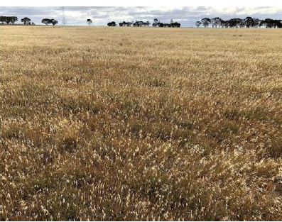  Figure 21-4: Plains Grassland EVC – Site 5 (Habitat Zone 40) | 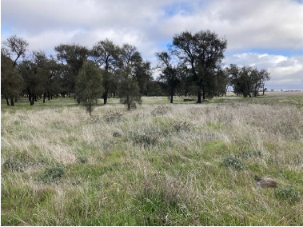  Figure 21-5: Plains Savannah EVC HZ29 representing Buloke Woodland EPBC Act community

Threatened species
State-significant flora and fauna species are those included on the FFG Act Threatened List (DELWP, 2022). Some species are also listed as threatened and/or migratory under the EPBC Act and are discussed as MNES in Chapter 25. The Sections below focus on State significance species and communities primarily.

Flora
Three flora species listed under the FFG Act occur within the development extent and retention licence. These species include Buloke (Allocasuarina luehmannii), Buloke Mistletoe (Amyema linophylla subsp. orientalis), and Weeping Myall (Acacia pendula).
Other FFG-listed threatened flora species with a moderate or high likelihood of occurrence are listed in, but were not recorded within the development extent.
Buloke is listed as Critically Endangered under the FFG Act. There are 153 recorded individuals within the development extent. This includes 148 individuals within the proposed mining licence and WBA, and five individuals within the infrastructure corridor.
Buloke Mistletoe is listed as Critically Endangered under the FFG Act. There are approximately 10 Buloke Mistletoe recorded within the development extent and its immediate surrounds. These records are predominantly associated with Buloke and adjacent scattered trees.
Weeping Myall is listed as Critically Endangered under the FFG Act. Six Weeping Myall were recorded within the development extent and its immediate surrounds. Weeping Myall was also recorded on areas of private property where the species has been planted as an amenity feature.
FFG Act listed threatened flora species with a moderate or greater likelihood within the retention licence, as determined by the desktop assessment, are listed below in Table 21-4.
Table 21-4: FFG Act listed threatened flora recorded, or moderate or high likelihood of occurrence in the retention licence
Scientific Name | Common Name | FFG Act Status | Likelihood of Occurrence within the Development Extent
 |  |  | MIN and WBA | Minor utilities corridor
Listed under FFG Act and EPBC Act
Sclerolaena napiformis | Turnip Copperburr | cr | Moderate | Moderate
Senecio macrocarpus | Large-headed Fireweed | cr | Moderate | Low
Listed under FFG Act only
Acacia pendula | Weeping Myall | cr | - | Known
Allocasuarina luehmannii | Buloke | cr | Known | Known
Amyema linophylla subsp. orientalis | Buloke Mistletoe | cr | High | High
Asperula wimmerana | Wimmera Woodruff | en | Low | Moderate
Austrostipa hemipogon | Half-bearded Spear-grass | vu | Moderate | -
Brachyscome chrysoglossa | Yellow-tongue daisy | en | Moderate | -
Callitriche umbonata | Winged Water-starwort | en | Low | Moderate
Calotis anthemoides | Cut-leaf Burr-daisy | cr | Moderate | Moderate
Duma horrida subsp. horrida | Spiny Lignum | cr | Low | Moderate
Isolepis congrua | Slender Club-sedge | en | Low | Moderate
Ptilotus erubescens | Hairy Tails | cr | Moderate | Moderate
Swainsona behriana | Southern Swainson-pea | en | Moderate | -
Key: cr = critically endangered, en = endangered, vu = vulnerable, - = no likelihood assigned
Protected flora, as a separate category to threatened flora, are native plants also protected under the FFG Act. There are two categories of protected flora: ‘restricted use protected flora’ and ‘generally protected flora’. FFG Act protected flora species that were recorded within the retention licence study area are further described in Appendix P, Section 6.1.4.3.3.

Fauna
Listed in Table 21-5 are the FFG Act and/or EPBC Act listed threatened species identified to have a moderate to high likelihood of occurrence within the retention licence study area. The likelihood was further refined for the development extent based on the type and quality of habitat available. Threatened fauna species that may be impacted in the development extent were determined to be those to have a moderate or greater likelihood of occurrence.
Table 21-5: FFG Act and/or EPBC Act and fauna species likelihood of occurrence
Scientific Name | Common Name | Status EPBC Act | Status  FFG Act | Likelihood in Retention Licence | Likelihood in Development Extent
Amphibian
Litoria raniformis | Growling Grass Frog | vu | vu | Moderate | Low
Birds
Apus pacificus | Fork-tailed Swift | mi, ma | - | High | Low
Antigone rubicunda | Brolga | - | en | Moderate | Low
Ardea alba modesta | Eastern Great Egret | - | vu | Known | Moderate
Aythya australis | Hardhead | - | vu | High | Low
Biziura lobata | Musk Duck | ma | vu | High | Low
Burhinus grallarius | Bush Stone-curlew | - | cr | Moderate | Moderate
Calidris acuminata | Sharp-tailed Sandpiper | mi, ma | - | Known | Not likely
Calidris ferruginea | Curlew Sandpiper | cr, mi, ma | cr | Moderate | Not likely
Calidris melanotos | Pectoral Sandpiper | mi, ma | - | Moderate | Not likely
Calidris ruficollis | Red-necked Stint | mi, ma | - | Moderate | Not likely
Falcon subniger | Black Falcon | - | cr | Known | Known
Gallinago hardwickii | Latham's Snipe | mi, ma | - | Moderate | Low
Geopelia cuneata | Diamond Dove | - | vu | Moderate | Moderate
Haliaeetus leucogaster | White-bellied Sea-Eagle | ma | en | Moderate | Low
Hieraaetus morphnoides | Little Eagle | - | vu | Moderate | Moderate
Hirundapus caudacutus | White-throated Needletail | vu, mi, ma | vu | High | High
Hydroprogne caspia | Caspian Tern | mi, ma | vu | Moderate | Low
Melanodryas cucullata | Hooded Robin | - | vu | Moderate | Moderate
Plegadis falcinellus | Glossy Ibis | mi, ma | - | Known | Moderate
Spatula rhynchotis | Australasian Shoveler | - | vu | High | Low
Stagonopleura guttata | Diamond Firetail | - | vu | High | High
Stictonetta naevosa | Freckled Duck | - | en | High | Low
Fish
Bidyanus bidyanus | Silver Perch | cr | en | Moderate | Moderate
Tandanus tandanus | Freshwater Catfish | - | en | High | High
Invertebrates
Synemon plana | Golden Sun Moth | cr | vu | Moderate | Low
Syemon jcaria | Reddish-orange Sun Moth |  | en | Moderate | Low
Synemon selene | Pale Sun Moth | - | en | Moderate | Low
Reptiles
Delma impar | Striped Legless Lizard | vu | en | Moderate | Low
Pogona barbata | Bearded Dragon | - | vu | High | High
Key: cr = critically endangered, en = endangered, vu = vulnerable, mi = Migratory, ma = Marine, - = no likelihood assigned
As described in Section 21.2.3 and Appendix P (Section 5.1.6.2), targeted surveys were conducted for the Golden Sun Moth (Synemon plana), Reddish Orange Sun Moth (Syemon jcaria), Pale Sun Moth (Synemon selene) and Striped Legless Lizard (Delma impar) during 2018 and 2020. None of these species were recorded in the targeted surveys.
There were no targeted surveys conducted for the Growling Grass Frog (Littoria raniformis), however, following site inspection it was noted that no permanent habitat existed, and the likelihood of occurrence was subsequently revised from moderate to low.
Woodland birds including the Hooded Robin (Melanodryas cucullate), Bush Stone-curlew (Burhinus grallarius), Diamond Dove (Geopelia cuneata) and Diamond Firetail (Stagonopleura guttata) were assessed to have a moderate to high likelihood of occurrence within the development extent. These species may use woodland patches as habitat and for foraging.
Birds of prey including the Little Eagle (Hieraaetus morphnoides) and Black Falcon (Falcon subniger) may hunt over the retention licence study area. These birds inhabit open areas, including agricultural zones and can be found along tree-lined waterbodies.
The Silver Perch (Bidyanus bidyanus) and Freshwater Catfish (Tandanus tandanus) were considered to have a moderate and high likelihood of occurrence respectively and are typically associated with the Wimmera River. The Wimmera River will not be affected by the Project activities.
Glossy Ibis (Plegadis falcinellus) and Eastern Great Egret (Ardea alba modesta) prefer shallow flowing water as their primary habitat but will also occur in dams, inundated areas, wetlands and wet grasslands.
The Bearded Dragon (Pogona barbata) habitat is variable and includes low open woodland and open paddocks. It has a high likelihood of occurrence within the development extent however, no incidental sightings were made during fieldwork conducted within the retention licence study area.
Further commentary is provided in Appendix P, Section 6.1.3.3.1 to Section 6.1.3.3.6 and Section 6.1.4.3.2.

Wetlands
Several DELWP wetlands were recorded within the retention licence area, including wetland numbers 19146, 19051 and 19053 (refer Appendix P, Section 6.1.4.1.6). Dooen and Darlot Swamps are mapped wetlands outside the retention licence and are further described in relation to groundwater dependent ecosystems (GDEs) in Section 21.4.2.1.

Matters of national environmental significance
Existing conditions relating to MNES are addressed in Chapter 25. In summary, for context within this Chapter, MNES with the potential to occur in the study area include:
- Four TECs
- Buloke Woodlands of the Riverina and Murray-Darling Depression, associated with the Plains Savannah (EVC 826) is known to occur with an extent of 5.22 ha.
- Natural Grasslands of the Murray Valley Plains, associated with the Plains Grassland (EVC 132), Plains Savannah (EVC 826) and Chenopod Grassland (EVC 829) is known to occur. However, the EVCs do not meet thresholds for classification as a TEC under the EPBC Act.
- Seasonal Herbaceous Wetlands (Freshwater) of the Temperate Lowland Plains, as a result of the occurrence of gilgai, which may indicate the presence of this community. This TEC was confirmed to be absent from the study area.
- Mallee Bird Community of the Murray Darling Depression Bioregion. EVCs recorded within the retention licence study area did not correspond with the major vegetation groups described in the Approved Conservation Advice.
- Where water is present, the study area may provide habitat for waterbirds, including some listed under Marine and Migratory Schedules of the EPBC Act, including the White-throated Needletail (Hirundapus caudacutus).
- Turnip Copperburr and Large-headed Fireweed are listed as endangered and vulnerable, respectively under the EPBC Act and were recorded with a moderate likelihood of occurrence in the retention licence.
- A number of threatened fauna species are listed with a moderate or above likelihood of occurrence within the retention licence, including the Growling Grass Frog, Striped Legless Lizard, Golden Sun Moth, as well as migratory and marine bird species.
Further detail is provided in Appendix P (Section 6.1.3.1 to Section 6.1.3.3) and Chapter 25.

Local Region
Ecological values of the local region were characterised, covering areas that occur outside the retention licence but within 10 km of the development extent. The existing conditions of vegetation, flora and fauna are described primarily in relation to Darlot Swamp, Dooen Swamp, Yarriambiack Creek and Wimmera River.

Groundwater dependent ecosystems
Groundwater dependent ecosystems can be grouped into three main categories, including subterranean, aquatic or terrestrial (refer Appendix P, Section 5.2.1). The GDE Atlas (BOM, 2017) lists the following GDEs within the study area:
- Darlot Swamp (aquatic GDE).
- Dooen Swamp (terrestrial and aquatic GDE).
- Yarriambiack Creek (terrestrial and aquatic GDE).
- Wimmera River (terrestrial and aquatic GDE).
The GDE Atlas (BOM, 2017) also lists vegetation at the Longerenong College as a potential terrestrial GDE and Two-Mile Creek as a potential aquatic GDE. Longerenong was assessed to have a low potential for groundwater dependence due to the depth to groundwater being greater than 12 m. Two Mile Creek was assessed by GHD (Chapter 17, Groundwater) to be a losing system, disconnected from the watertable and was considered unlikely to be an aquatic GDE. Table 21-6 below and Section 6.2.1 in Appendix P details the GDEs considered to have existing groundwater interactions and reliance on groundwater.
Table 21-6: Potential groundwater dependent ecosystems and groundwater interactions
Groundwater Dependent Ecosystem | Description
Darlot Swamp | Located about 1.9 km east of the closest point of mining.  Ephemeral, shallow freshwater marsh that is normally dry. It is only filled periodically by surface water from Yarriambiack Creek during flooding, typically once every 5 years.  Darlot Swamp is not classified as a terrestrial GDE (BOM, 2017), however, has potential terrestrial GDE features. Deep-rooted vegetation (the dominant eucalypt canopy species (Black Box) may opportunistically utilise groundwater where it is more shallow and has a possible connection with terrestrial vegetation.  Losing feature. Not an aquatic GDE or baseflow dependent as groundwater depth interpreted as 5 m to 8 m.
Dooen Swamp | Located about 2 km south of the closest point of mining.  The swamp is a temporary deep freshwater marsh and a high-potential terrestrial GDE (BOM, 2017). The BOM potential terrestrial ecosystem type is Red Gum Swamp/Riverine Chenopod Woodland.  It is fed by the Wimmera River during flood events which typically occur once every 5 years. The extended dry periods in the swamp are indicative of the low potential for significant baseflow contributions from groundwater.  Losing feature. Not an aquatic GDE or baseflow dependent as groundwater depth interpreted as 3 m to 6 m across the swamp.
Yarriambiack Creek | Located about 2.4 km from mining activity. It runs along the eastern edge of Darlot Swamp.  The potential terrestrial ecosystem type is Riparian woodland (BOM, 2017). It is an ephemeral/intermittent water course with surface water flows occurring about 20% of the time and is identified as a high to moderate potential terrestrial GDE (BOM, 2017).  Losing feature. Generally dry. Regional groundwater depth contours suggest 5 m to 15 m depth to groundwater.
Wimmera River | Located about 3.6 km south of the closest point of mining activity.  The potential terrestrial ecosystem type is floodplain riparian woodland (BOM, 2017). The river is dry about 30% of the time. Surface flows from infrequent flooding events (typically once every 5 years) in the river feed into Dooen Swamp and smaller tributaries. Identified as a high to moderate potential terrestrial GDE (BOM, 2017).  Generally losing feature to the south of the study area. Potential baseflow after flood events. Considered to be low potential aquatic GDE and is dry around 30% of the time.
The Groundwater Impact Assessment (Appendix L) notes that the likelihood of stygofauna occurrence across the study area is considered to be very low to low in the aquifer systems, based on the observed groundwater salinity, pH and lithology.

Native vegetation
The overall condition of native vegetation present within Darlot Swamp was moderate to very high. EVCs recorded within the swamp were Black Box Lignum Woodland (EVC 663), Lignum Swamp (EVC 104) and Cane Grass Wetland (EVC 291).
Dooen Swamp is the larger of the two swamps. Vegetation is in moderate to good condition and Red Gum Swamp (EVC 292) was recorded as the dominant EVC throughout. The Wimmera River supports healthy stands of Floodplain Riparian Woodland EVC on its banks.
At Yarriambiack Creek, DELWP native vegetation mapping identifies Riparian Woodland (EVC 641) and Riverine Chenopod Woodland (EVC 103) and its upper banks support stands of high-quality grassland vegetation.

Threatened ecological communities
No TECs matching EPBC Act-listed or FFG Act-listed communities were recorded within Darlot Swamp. It is therefore assumed that no communities of national or state conservation significance are likely to be present. Dooen Swamp supports Red Gum Swamp EVC, which is synonymous with the FFG Act listed Red Gum Swamp Community No.1.

Threatened species
Several threatened species have a moderate to high likelihood of occurrence in the local region, with some known to occur (refer Appendix P, Section 6.2.2.2.3, Table 34) as a result of previous records and targeted surveys. Threatened species are described below.

Flora
Targeted flora surveys were completed within the off-retention licence area and species were recorded incidentally during the EVC surveys or threatened fauna surveys. One flora species listed as endangered under the FFG Act was incidentally recorded within Darlot Swamp – Grassland Bindweed (Convolvulus graminetinus). Following inundation at Dooen Swamp and Darlot Swamp, there is potential for wetland-specific threatened flora to be present.

Fauna and fauna habitat
The threatened fauna species listed under the EPBC Act and/or the FFG Act that are known to occur in the off-retention licence area are listed in Appendix P, Table 34.
Threatened species surveys within the local region occurred on Darlot Swamp and Dooen Swamp, with targeted surveys conducted for the Striped Legless Lizard, Golden Sun Moth and Pale Sun Moth. Surveys for Growling Grass Frog and waterbird/migratory species could not be undertaken due to the dry conditions.
Sightings were made of the Hooded Robin (off-retention licence area) and the Black Falcon during field survey work. The Black Falcon inhabits open areas, including agricultural zones and can be found along tree-lined waterbodies, mainly in arid and semi-arid zones. The species has been recorded on numerous occasions within 20 km of the study area and within the retention licence area.
Historical records from Darlot Swamp and its surrounds, such as the Wimmera River, indicate that when water is present, Darlot Swamp may support a range of waterbirds and has the potential to support species listed under the EPBC Act or FFG Act.
The riparian corridor of the Wimmera River is also likely to support the threatened woodland birds such as the Diamond Firetail and Hooded Robin. During periods of inundation of Yarriambiack Creek, there is potential for threatened and/or migratory species to occur.
No surveys were completed for aquatic fauna, however, threatened aquatic fauna including Silver Perch and Freshwater Catfish have historical records from the Wimmera River. No Project related ground disturbing works are planned to occur along the Wimmera River.

Potential Impacts

Identified Potential Impacts
Potential impacts were identified in the FFIA with consideration to the interaction of Project activities with sensitive receptors, previous ecological assessments, and outcomes of targeted field surveys (refer Table 21-7). Where a source-pathway-receptor relationship was considered plausible, further investigation was undertaken to assess the residual impacts with avoidance and mitigation measures in place (refer Section 21.7).
Table 21-7: Potential impacts
Item | Potential Impacts | Phase
IP-01 | Native vegetation removal resulting in a reduced extent of native vegetation. | C, O
IP-02 | Native vegetation removal resulting in the loss of threatened ecological communities. | C, O
IP-03 | Native vegetation removal resulting in the loss of threatened flora and habitat for threatened fauna. | C, O
IP-04 | Native vegetation removal resulting in habitat fragmentation. | C, O
IP-05 | Project activities resulting in hazards to protected wildlife. | C, O
IP-06 | Project activities resulting in indirect impacts on vegetation and habitat. | C, O
IP-07 | Project activities initiating or exacerbating threatening processes on flora and fauna. | C, O
IP-08 | Mining ore and pit dewatering resulting in altered groundwater conditions affecting groundwater dependent ecosystems. | O, D

Sensitive Receptors
Sensitive receptors identified in the FFIA include areas of existing vegetation supporting biodiversity values and locations of listed species, their habitats and ecological communities protected under the EPBC Act, FFG Act and Wildlife Act (refer Table 21-8). Figure 21-1 in this Chapter and Figure 7 in Appendix P shows the location of the sensitive receptors with respect to the Project.
Table 21-8: Sensitive receptors
Receptor Type | Sensitive Receptors
Terrestrial ecology | Native vegetation patches and trees (Appendix P, Table 40 and Table 41).  High-quality vegetation and DELWP wetlands (Appendix P, Table 43).  Threatened ecological communities listed under the EPBC Act and/or FFG Act (Appendix P, Table 44 and Table 45).  Threatened flora and fauna species listed under the EPBC Act and/or FFG Act (Section 21.4.1).  Wildlife protected under the Wildlife Act.
Groundwater dependent ecosystems | Dooen Swamp, Darlot Swamp, Yarriambiack Creek and Wimmera River.

Impact Characterization
The impact assessment considered the magnitude, spatial extent and duration of the potential flora and fauna impacts from Project activities. This included the consideration of direct and indirect impacts, the ecological value and conservation status of the native vegetation, flora species and/or fauna species as defined under the EPBC Act and FFG Act (refer Table 21-9).
Ecological values were separated into MNES protected under the EPBC Act and State significant values listed under the FFG Act and the Planning & Environment Act 1987 (P&E Act) to guide the impact characterisation and the avoidance and mitigation measures.
Direct impacts are those that occur through direct interaction of Project activities on an ecological value, for example, the direct loss of native vegetation and habitat from vegetation removal. Indirect impacts typically include those which do not involve direct clearing/removal of standing vegetation.
The assessment of MNES under the EPBC Act’s significant impact guidelines are addressed in Chapter 25.
Table 21-9: Significance of ecological values under the EPBC Act and FFG Act
Reference | Criteria and Assessment Requirements
Environment Protection and Biodiversity Conservation Act 1999 (Cth) | The EPBC Act provides a national approach to environment and heritage protection and biodiversity conservation. It focuses on the protection of nine MNES, which include World Heritage Properties, National Heritage Places, Ramsar wetlands, nationally listed threatened species and ecological communities and listed migratory species. Native vegetation is protected under the EPBC Act where it meets the criteria for a listed TEC, provides habitat for a listed threatened species, or is a threatened or protected flora species. Actions that are likely to have a significant impact on MNES are subject to assessment and approval under the EPBC Act. Chapter 25 addresses the MNES assessment criteria under this Act in detail.
Flora and Fauna Guarantee Act 1988 (Vic) | The FFG Act provides a legal framework for enabling and promoting the conservation of Victoria’s native flora and fauna and to enable the management of potentially threatening processes. Native vegetation is protected under the FFG Act where it meets the criteria for a listed TEC, provides habitat for a listed threatened species, or is a threatened or protected flora species. Residual impacts have been assessed for TECs and threatened flora and fauna species for which a revised likelihood of moderate, high or known occurrence remains.
Bioregional Conservation Status (DELWP, 2005) | The combination of EVC and bioregion is used to determine bioregional conservation status (BCS). It is a dataset that underpins Victoria's Native Vegetation Management Framework, Regional Vegetation Plans and other biodiversity planning. BCS is a measure of the current extent and quality for each EVC when compared to its original (pre-1750) extent and condition. On this basis, a BCS of endangered, vulnerable, depleted, least concern or rare can be applied to an EVC-bioregion combination. Endangered EVCs have been selected for consideration in the impact assessment.

Avoidance and Mitigation Measures
This Section outlines the measures identified to avoid and minimise residual impacts. It is noted that in line with the requirements of the environmental management system (EMS) described in Chapter 24 (Environmental Management) and relevant legislation, additional measures may be required during implementation to ensure risks and potential impacts have been minimised so far as reasonably practicable.

Avoidance

FF-01: Exclusions zones
The ‘Guidelines for the removal, destruction or lopping of native vegetation’ (DELWP, 2017) outlines a three-step approach (avoid, minimise and offset) to achieve no net loss of biodiversity as a result of vegetation removal. In the first instance, avoidance measures must be applied to the maximum extent possible without undermining the Project objectives or intended use.
Measures to avoid native vegetation were applied iteratively during the Project development phase to avoid impacts on patches of vegetation and scattered trees, including several TECs listed under the EPBC Act and FFG Act.
Avoidance measures were applied to the fullest extent possible with consideration to the Project objectives, which are to optimise recovery of the state resource, enhance socioeconomic effects to the region and minimise effects on the environment so far as reasonably practicable.
The Project design refinements reduced the native vegetation and habitat impacts by 16.70 ha, from a total of 28.50 ha down to 11.80 ha within the development extent.
This included the avoidance of impacts to 16.14 ha of threatened ecological communities, including:
- 10.47 ha of the Northern Plains Grassland Community (FFG Act-listed).
- 4.78 ha of Semi-arid Northwest Plains Buloke Woodland Community (FFG Act-listed and EPBC Act-listed).
- 0.87 ha of Victorian Temperate Woodland Bird Community (FFG Act-listed).
- 0.2 ha of Red Gum Swamp Community (FFG Act-listed).
The residual impacts associated with vegetation removal are detailed in Sections 21.7.1 and 21.7.2.
All vegetation to be avoided will be protected from direct impacts associated with Project operations. Exclusion zones will be established to ensure that no Project related clearing or topsoil disturbance will be permitted over the life of the Project (refer Figure 21-6 and Appendix P, Figure 12).
The avoidance measures described above required the mining footprint to be reduced, resulting in the sterilisation of areas of the Avonbank mineral resource (i.e. ore body cannot be mined). Most significantly, this included the sterilisation of around 40 ha of the mine footprint in Block A (4.5 Mt of ore) and 30 ha in Block D (2.3 Mt of ore).
At this stage of the Project development, no further reduction in the mine footprint was considered to be reasonably practicable without undermining the objectives of the Project. It is however noted that over the life of the Project, there will be opportunities to refine the proposed disturbance footprint and potentially avoid additional areas of vegetation with consideration to the detailed progressive mine plans.
As recommended in the FFIA, further avoidance measures for the proposed minor utilities corridor will be investigated in consultation with the Service Providers, landholders and relevant authorities. This will occur during the detailed planning phase of the minor utilities corridor following the Minister’s assessment of the EES.

FF-02: Tree protection zones
Tree protection zones have been established around four selected scattered trees that are not otherwise protected within an exclusion zone (refer Figure 21-6). Tree protection zones will be implemented in line with Australian Standard AS 4970-2009 ‘Protection of Trees on Development Sites’ (the Standard). A 15 m buffer from trees (patches and scattered) and exposed edges will be implemented to protect trees from indirect impacts.
Activities excluded from within a tree protection zone, as detailed in the Standard, include:
- physical damage to the tree;
- machine excavation including trenching;
- parking of vehicles and plant;
- dumping of waste;
- wash down and cleaning of equipment; or
- placement of fill.
It is noted that on private properties the landholder may require activities such as cultivation, firebreaks or weed spraying to be undertaken within a tree protection zone in the course of continued management of their properties.
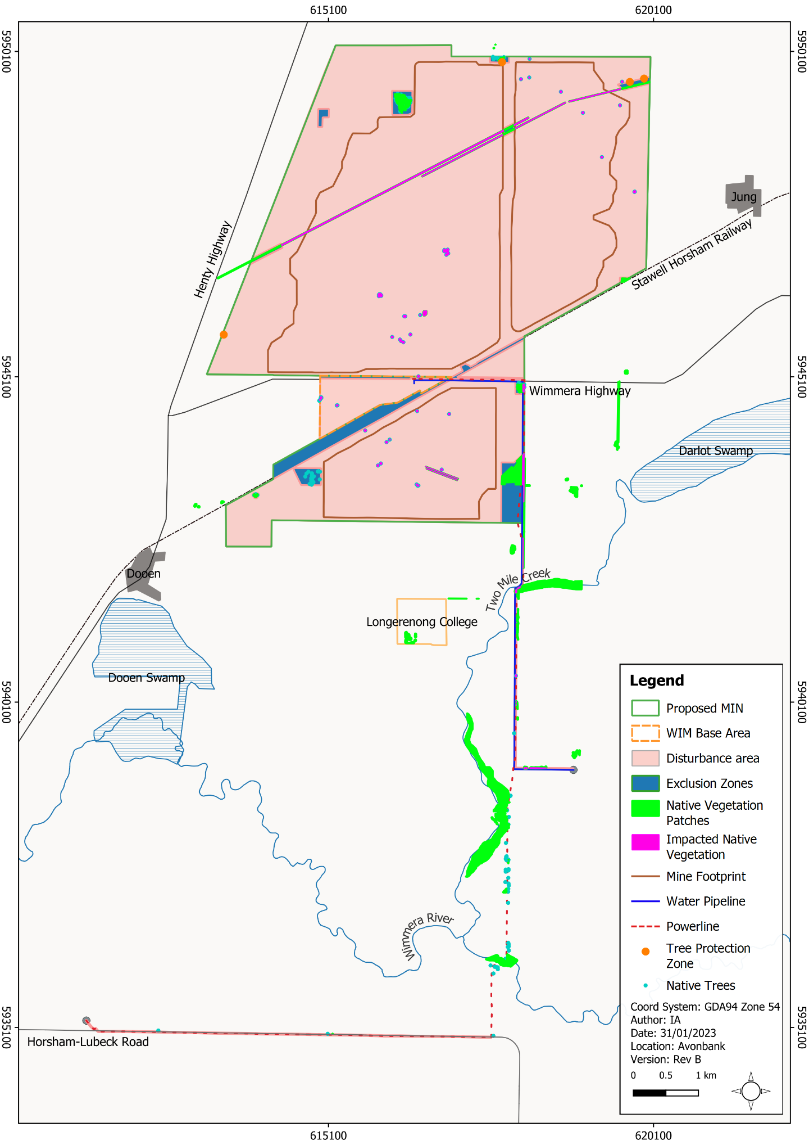
Figure 21-6: Exclusion zones and tree protection zones

FF-03: Periodic flora surveys
Periodic flora surveys will be undertaken over the life of the Project across the proposed disturbance area to characterise previously unsurveyed areas (due to land access restrictions). Given that the Project extends over 36 years, it is acknowledged that the vegetation characteristics will change over this period. The periodic surveys will capture these changes and facilitate the consideration of further avoidance and mitigation measures. It is anticipated that periodic surveys will be undertaken as agreed in the Flora and Fauna Management Plan and are likely to occur prior to the commencement of each new mining Block (B through to D). It is acknowledged that offsets may need to be adjusted over the life of the Project in response to new surveys.

Minimisation

FF-04: Construction methods
Within the development extent, there will be open mine voids, sumps, trenches and dam infrastructure which could pose a risk to native fauna due to entrapment. Fauna egress will be incorporated into the design of these features where practicable and safe to do so.
Trenching for minor utilities will be backfilled and or covered as soon as practicable. Earthen sumps and mine voids will be typically constructed such that they pose a very low risk to fauna, given the natural materials used and the gradient of the walls/batters (i.e., not vertical).
Certain activities and mining features will be fenced to exclude access by livestock and/or larger mammals. It is anticipated that activity specific fencing requirements will be assessed progressively over the life of mine, with consideration to the hazards presented and the risks posed to livestock and/or larger mammals. Existing landholder use and requirements will be considered in any such assessment of risk.

FF-05: Groundwater and surface water management plans
A Surface Water Management Plan (SWMP) (Chapter 16) and Groundwater Management Plan (GWMP) (Chapter 17) will be prepared prior to Project commencement to avoid and minimise Project related risks/impacts so far as reasonably practicable.
As described in Chapter 16, Section 16.6.2 and Chapter 17 Sections 17.6.1 and 17.6.2, various measures will be incorporated into the management plans to avoid and minimise the effects on standing vegetation and groundwater dependent ecosystems.
Each plan will include a monitoring program that will assess surface and groundwater quality, process water quality and groundwater levels in established bores. If Project related drawdown/mounding or adverse changes to groundwater quality are recorded that could propagate to areas of potential GDEs, targeted studies will be undertaken to monitor GDE health/function over time. A root cause investigation will be undertaken, and corrective actions/contingencies will be identified and implemented.

FF-06: Flora and Fauna Management Plan
A Flora and Fauna Management Plan (FFMP) will be prepared prior to Project commencement. The FFMP will provide a management framework to avoid and minimise impacts so far as reasonably practicable.
The FFMP will be reviewed and updated at an appropriate frequency as established in the overarching EMS with consideration to the level of risk, statutory requirements, monitoring results, community complaints and in response to audit findings. It will be developed in consultation with stakeholders and will be subject to approval by the Department of Environment, Land, Water and Planning.
The FFMP will:
- Summarise the baseline data and existing environment.
- Explain the relevant statutory requirements and context (including any relevant approvals).
- Describe the avoidance and mitigation measures to be implemented to minimise residual risks/impacts so far as reasonably practicable.
- Identify specific environmental objectives and performance standards to be achieved with avoidance and mitigation measures in place.
- Detail the monitoring to be undertaken to verify the effectiveness of the avoidance and mitigation measures, including but not limited to flora and fauna condition and compliance with tree protection zones and exclusions zones.
- Describe mechanisms to determine when/if corrective actions and contingency measures are required.
- Detail a program to investigate and implement ways to improve the environmental performance of the Project over time.
- Detail appropriate review periods and/or triggers to ensure the plan remains fit for purpose.
- Establish procedures to manage:
- incidents and any non-compliance.
- stakeholder and community complaints.
- failure to comply with statutory requirements and/or environmental performance standards.
- roles and responsibilities for implementing the plan.
- a protocol for periodic review of the plan.
In addition to the above requirements and the avoidance and mitigation measures in this Chapter, the FFMP will include specific requirements to:
- Undertake spring surveys along the minor utilities corridor and public roads to confirm the total numbers of protected/threatened flora individuals that will be removed by Project activities prior to commencement.
- Establish fencing or demarcate exclusions zones and tree protection zones where necessary as determined through a risk-based assessment conducted in consultation with the landholder/s.
- Develop tree removal protocols describing the timing and program for removal to avoid the breeding season of nesting birds and mammals.
- Establish and maintain tree screens (refer Chapter 11) using species that could be used as habitat by local fauna.
- Progressively rehabilitate farm dams in consultation with the landholder.
- Undertake risk-based pre-mining flora surveys as required prior to the development of each new mining Block (Blocks B-D) and revise the vegetation offsets as required.
- Identify and outline the requirements for salvaging and relocating wildlife in consultation with DELWP and Council.
- Obtain relevant permits prior to the removal of vegetation and taking of protected flora in accordance with the Horsham Planning Scheme and the FFG Act.
- Develop and implement a flora and fauna induction and training program for site personnel so that the requirements of the FFMP are understood by the relevant personnel.
- Develop a fire safety plan in consultation with the Country Fire Authority and landholders to specify requirements for operational fire safety measures, plan communication and implementation, follow-up assessment and plan review/update. The plan will include:
- Requirements to maintain firebreaks with consideration to the operational hazards and surrounding landholder activities/hazards.
- Occupational health and safety procedures relating to how Hot Works (i.e. welding etc.) are to be undertaken and hazards controlled.
- Maintenance of firefighting equipment in and around work areas to meet the general duties under the OHS Act and to minimise residual risks to the environment so far as reasonably practicable.
- Develop and maintain a risk-based weed and pathogen hygiene protocol that considers matters including but not limited to the movement of vehicles and machinery to and from operational areas (including washdown requirements) (also refer Chapter 15, Section 15.6.2.8).

Rehabilitation

FF-07: Rehabilitation plan
A Rehabilitation Plan will be established for the Project that will address matters relating to progressive rehabilitation and closure. It will cover all work areas within the proposed mining licence, the broader development extent and the Port of Portland.
The Rehabilitation Plan will include a schedule of progressive rehabilitation and will describe the strategy to establish a safe, stable, sustainable landform capable of supporting the proposed end land use. It is expected that land will be stabilised as soon as reasonably practicable after mining, typically within 4 years.
The Rehabilitation Plan will define the end land use with consideration to the views of the landholders and the broader community where appropriate. The focus of the plan, in line with community feedback to date, is on returning private land to a productive agricultural end land use.
It is proposed that rehabilitation of native vegetation is undertaken where landholders deem this appropriate and desirable. It is expected such areas would be limited to where native vegetation existed prior to mining. One such opportunity may exist along Greenhills Road, where road verges may be rehabilitated following road reinstatement with a Plains Grassland vegetation type.
Where areas of native vegetation are to be rehabilitated, a landholder specific rehabilitation plan would be developed to meet these objectives. It is expected that topsoil would be stored separately and returned following mining. Alternatively, topsoil stripped from these areas could be directly returned to an area of rehabilitation in a commensurate location to facilitate the regeneration of the retained seed bank. Targeted seeding and planting programs would also be planned within these areas.
It is expected that there will be opportunities to enhance the habitat values of protected stands of vegetation where this is deemed appropriate by a suitably qualified ecologist and in consultation with the Landholder. This may include implementing weed control measures, additional planting of native understorey species and additional canopy species to enhance the habitat value of the sites.
Felled trees may be utilised as habitat logs in exclusion zones where practicable to do so and in agreement with the landholder. Similarly, some targeted translocation of significant species (flora or fauna) may be possible in some instances in consultation with DELWP.
A preliminary Rehabilitation Plan for the Project has been developed to meet the intent of the Scoping Requirements and is included with this EES as Attachment 3. This plan will be refined prior to commencement with consideration to the detailed operating plans, stakeholder and community feedback and the Minister’s assessment of the EES.

Offset

FF-08: Native vegetation offsets
The Project will result in unavoidable residual impacts on native vegetation with avoidance and mitigation measures in place. Offsets will be required to compensate for residual impacts on native vegetation, threatened species and habitat for threatened species.
The offset requirements have been calculated based on the extent of proposed vegetation removal as communicated in the FFIA (Appendix P, Appendix H). The offset is based on the removal of 14.77 ha of vegetation and 45 large trees. A total of 2.650 General Habitat Units and 45 large trees will be offset within the Wimmera Catchment Management Authority (WCMA) or the Horsham Rural City area. Section 11.0 of Appendix P provides further detail.

Residual Impacts
This Section describes the likely residual impacts on flora and fauna with avoidance and mitigation measures in place. The residual impacts have been characterised as described in Section 21.5.3.

Reduced Extent of Native Vegetation
There is one potential impact (IP-01) identified in Section 21.5.1 that relates to the removal of native vegetation.
The removal of native vegetation and habitat within the development extent will be unavoidable as a result of Project activities. The Project design has retained and avoided impacts to several locations of Plains Savannah EVC and Scattered Trees (Buloke) as well as areas of Plains Grassland EVC (refer Section 21.6.1).
The Project design refinements have reduced the native vegetation and habitat impacts by 16.70 ha, from a total of 28.50 ha down to 11.80 ha within the development extent (refer Table 21-10). In addition, 111 trees will be avoided and retained through exclusion zones and refinements of the minor utilities corridor. There will be 59 trees removed which include 43 large scattered trees, 14 small scattered trees and 2 large trees in patches (refer Table 21-11).
Of the 11.80 ha of native vegetation impacted, 11.63 ha is considered to represent endangered EVCs and 0.52 ha is considered high-quality vegetation. The Project will avoid 16.11 ha of the endangered EVC and 0.92 ha of the high-quality vegetation by implementing exclusion zones and refining the disturbance area of the minor utilities corridor.
Further refinements to the minor utilities corridor in consultation with the Service Providers, as described in Section 21.6.1.1, may result in further minor avoidance or minimisation measures.
Table 21-10: Summary of residual impacts to native vegetation patches
EVC | Potential Impact Extent within the Development Extent (ha) | Residual Impacts (ha)
 |  | MIN and WBA | Minor Utilities Corridor | Total
Black Box Lignum Woodland (663) | 0.51 | 0.35 | - | 0.35
DELWP Mapped Wetland (19053) | 0.75 | - | 0.17 | 0.17
Floodplain Riparian Woodland (56) | 0.33 | - | - | -
Plains Grassland (132) | 21.18 | 9.56 | 1.15 | 10.71
Plains Savannah (826) | 5.01 | - | 0.23 | 0.23
Red Gum Swamp (292) | 0.02 | - | - | -
Riverine Chenopod Woodland (103_62) | 0.70 | - | 0.34 | 0.34
Total | 28.50 | 9.91 | 1.89 | 11.80

Table 21-11: Summary of residual impacts to trees
Tree Type | Potential Trees Impacted within the Development Extent (ha) | Residual Impacts (ha)
 |  | MIN and WBA Utility | Minor Utilities Corridor | Total
Small Scattered Tree | 36 | 14 | - | 14
Large Scattered Tree | 85 | 42 | 1 | 43
Large Tree in a Patch | 49 | 0 | 2 | 2
Total | 170 | 56 | 3 | 59
The unavoidable residual impacts on native vegetation will require offsets to compensate for the loss of native vegetation in accordance with the P&E Act and the ‘Guidelines for the removal, destruction or lopping of native vegetation’ (DELWP, 2017). Offset requirements are outlined in Section 21.6.4.1.

Loss of Threatened Ecological Communities
There is one potential impact (IP-02) identified in Section 21.5.1 that relates to the removal of native vegetation resulting in direct impacts on three threatened ecological communities listed under the FFG Act and one threatened ecological community listed under the EPBC Act (Table 21-12).
The removal of 11.80 ha of native vegetation described in Section 21.7.1 will include the unavoidable reduction of 11.63 ha of threatened ecological communities (Table 21-12). The Northern Plains Grassland Community TEC will experience the largest reduction in the extent of 10.71 ha from its total area of 21.18 ha in the development extent. Impact on the Red Gum Swamp Community No. 1 TEC will be avoided.
The Project design has avoided impacts to 16.14 ha of threatened ecological communities (refer Appendix P, Table 55). After implementing avoidance and minimisation measures, the residual impacts on TECs are:
- 10.71 ha of the Northern Plains Grassland Community (FFG Act-listed).
- 0.23 ha of Semi-arid Northwest Plains Buloke Woodland Community (FFG Act-listed and EPBC Act-listed).
- 0.69 ha of Victorian Temperate Woodland Bird Community (FFG Act-listed).
Prior to the removal of native vegetation, a ‘permit to take protected flora’ will be required to remove any flora species listed under the descriptions of the three TECs. This is also relevant to the threatened flora species described in Section 21.7.3.1.
The assessment of residual impacts on the EPBC-listed Buloke Woodland is further discussed in Chapter 25 (matters of national environmental significance).
Table 21-12: Summary of residual impacts on threatened ecological communities
Threatened Ecological Community (TEC) |  | Potential Impact within the Development Extent (ha) | Residual Impacts (ha)
FFG Act - Listed | EPBC Act - Listed |  | MIN and WBA | Minor Utilities Corridor | Total
Northern Plains Grassland Community | - | 21.18 | 9.56 | 1.15 | 10.71
Red Gum Swamp Community No. 1 | - | 0.02 | - | - | -
Semi-arid Northwest Plains Buloke Woodland Community | Buloke Woodland of the Riverina and Murray-Darling Depression Bioregions | 5.01 | - | 0.23 | 0.23
Victorian Temperate Woodland Bird Community (VTWBC) | - | 1.56 | 0.35 | 0.34 | 0.69
Total |  | 27.77 | 9.91 | 1.72 | 11.63

Loss of Threatened Flora and Threatened Fauna Habitat
There is one potential impact (IP-03) identified in Section 21.5.1 that relates to the removal of native vegetation resulting in the loss of threatened flora and habitat for threatened fauna.

Threatened flora
Three threatened flora species listed as critically endangered under the FFG Act were identified in the FFIA with the potential to be impacted. Following the assessment of known records of individuals and interactions with Project activities, the removal of 11.80 ha of native vegetation will result in a direct impact on two flora species. These species are Buloke (Allocasuarina leuhmannii) and Weeping Myall (Acacia pendula). No direct impacts are anticipated to the 10 individuals of Buloke Mistletoe (Amyema linophylla subsp. orientalis) occurring within the development extent.
A total of 46 individuals of Buloke will be impacted from approximately 153 individuals identified within the development extent. The majority of Buloke, up to 107 individuals, will be avoided and retained.
A total of five out of six individuals of Weeping Myall occurring within the development extent will be impacted by the Project. One Weeping Myall has been retained through Project design refinements.
A ‘permit to take protected flora’ will be required to remove species protected under the FFG Act from areas of public land (roadsides). This includes listed threatened species, protected flora, and flora listed above. A spring survey will be undertaken prior to commencement to confirm the total number of individuals that will be removed from the relevant vegetation communities in areas within the minor utilities corridor.

Threatened fauna
There are two species listed under the EPBC Act and nine species listed under the FFG Act that may be impacted by the Project, primarily through the removal of woodland habitat, grassland habitat and scattered trees (refer Appendix P, Table 56).
The Project has retained the largest woodland blocks within the development extent to reduce habitat loss. The residual impacts on native vegetation will result in the loss of small, discreet patches of Plains Savannah, Riverine Chenopod Woodland and Black Box Lignum Woodland with limited mid-storey species and cover.
In the context of the wider landscape, this loss equates to small discreet patches within a fragmented landscape rather than loss of continuous habitat or disruption to a major habitat corridor.
The removal of 0.92 ha of woodland vegetation and 59 scattered trees will result in a reduction of habitat for woodland bird species, including the Bush Stone-curlew, Diamond Dove, Hooded Robin and Diamond Firetail. The removal of this vegetation will also reduce available habitat for birds of prey, including the Black Falcon and Little Eagle.
The Glossy Ibis and Eastern Great Egret prefer shallow flowing water as primary habitat but will also occur in dams and inundated areas. The Project activities are unlikely to influence the hydrological cycles of the closest swamps, which offer the best habitat in the surrounding landscape. Farm dams that are removed temporarily due to mining will be reinstated as described in Section 21.6.3.1, and pending discussion with relevant landowners regarding the end land use.
The Bearded Dragon habitat is broad, varied and includes woodlands, open paddocks and roadsides. The removal of woodlands, grasslands and open paddocks will reduce the habitat for this species. The habitat requirements are however broad and are not considered to be restricted.
An assessment of the impacts to the White-throated Needletail is provided in Chapter 25 (MNES). This assessment found that there are unlikely to be significant residual impacts on these species associated with direct or indirect Project activities.
The magnitude of residual impacts to the above listed fauna was assessed to be limited to a small number of individuals of these species noting the loss of habitat is localised and in an already fragmented landscape.
The adoption of measures to avoid impacts on woodland and grassland habitat will mitigate impacts on threatened fauna. Minimisation measures in Section 21.6.2 will mitigate residual impacts. Rehabilitation efforts relating to native vegetation and farm dams will further minimise the longer-term effects of the Project.

Habitat Fragmentation
There is one potential impact (IP-04) identified in Section 21.5.1 that relates to the removal of native vegetation resulting in the fragmentation of habitat.
The development extent and immediate surrounds are characterised by agricultural activity, where the landscape has been largely cleared of vegetation. This has resulted in a fragmented landscape with patches of remnant native vegetation and scattered trees. Fragmentation of habitat increases the distance between patches and limits the availability of trees as ‘stepping-stones’ through the landscape.
Removal of these features have the potential to introduce new gaps or widen existing gaps in vegetation cover that could affect woodland birds and other fauna. The removal of woodland vegetation has been limited to 0.92 ha and 59 scattered trees.
The avoidance measures outlined in Section 21.6.1 will minimise the extent of further incremental fragmentation resulting from Project activities. Native rehabilitation efforts and the proposed tree screens will minimise the longer-term effects of the Project (refer Section 21.6.3.1).

Fauna Hazards
There is one potential impact (IP-05) identified in Section 21.5.1 that relates to the presence of fauna hazards as a result of Project activities.
The construction and operation of the Project will introduce hazards to fauna that have the potential to lead to displacement, entanglement, entrapment, injury or death of wildlife. Displacement can result from changes to noise, lighting and vibration in areas of retained habitat. Hazards can occur from habitat removal, creating open trenches during construction, the presence of fencing and movement of vehicles.
Construction and mining works may also unintentionally disturb and displace fauna occupying retained habitat within and adjacent to the development extent. Fauna most at risk of displacement, injury or death are those which are more sedentary or fauna that breed and shelter in hollows that are less likely to move away from the construction work.
Nesting birds may also be displaced by construction works and vehicle movement in proximity to nests. A tree removal protocol will be developed to describe the inspection requirements prior to removal to spot nests and apply some restrictions regarding the timing of removal to avoid breeding season for nesting birds and mammals wherever practicable to do so.
Minimisation of fauna hazards and reducing the potential for displacement, entanglement, entrapment, injury or death of wildlife will be managed during construction as described in Section 21.6.2.1 and implementation of an FFMP (Section 21.6.2.3). Key measures that will reduce residual impacts on protected wildlife will include pre-clearing surveys, salvaging and translocating wildlife (in consultation with DELWP), and implementing vehicle restrictions and exclusion zones for retained habitats.
The effect of radiation on wildlife has been considered in the Radiation Impact Assessment by DBH Radiation (Appendix I) and Chapter 14. Modelling was undertaken to identify a dose rate on sensitive reference organisms (lichen and bryophytes) against a screening value of 10 µGy/h recommended in the ‘Guide for Radiation Protection of the Environments’ (ARPANSA, 2015a).
DBH Radiation concluded that using extremely conservative criteria and application of the most sensitive reference organisms, the radiological risk will be negligible. Management measures are outlined in the Radiation Management Plan (Chapter 14, Section 14.6.2.6) and will result in a negligible residual exposure risk to native flora and fauna.

Indirect Impacts on Vegetation and Habitat
There is one potential impact (IP-06) identified in Section 21.5.1 that relates to indirect impacts on vegetation and habitat from Project activities.
Implementation of the Project may indirectly affect vegetation and habitat adjacent operational areas. This could occur as a result of:
- Inappropriate placement of construction stockpiles resulting in the smothering of native vegetation.
- Soil compaction or excavation resulting in structural root damage and vegetation loss.
- Dust generated during construction settling on and impacting the health of vegetation.
- Introduction or spread of weeds from soil disturbance activities resulting in a decline in the quality of retained native vegetation and habitat.
- Surface water run-off carrying pollution and sediment into waterways or areas subject to seasonal flooding.
- Changed hydrology to retained patches of woodland.
Tree protection zones will be established around selected scattered trees and patches that are not otherwise protected within an exclusion zone, as described in Section 21.6.1. Implementation of measures outlined in the FFMP, the GWMP and SWMP will avoid and minimise indirect impacts to retained vegetation within and adjacent to the development extent so far as reasonably practicable.

Threatening Processes
There is one potential impact (IP-07) identified in Section 21.5.1 that relates to the initiation or exacerbation of listed flora and fauna threatening processes.
This Section summarises the listed threatening processes under the FFG Act, which may also include similar threatening processes listed under the EPBC Act. It also summarises the listed threatening processes that may be initiated or exacerbated by Project activities. Further information is provided in Appendix P, Sections 8.7 and 10.7.
The key threatening processes of land clearing and habitat fragmentation are discussed in Sections 21.7.1 to Section 21.7.3. Other potential threatening processes relevant to the Project are identified and assessed in Table 21-13.

Table 21-13: Residual impacts of key threatening processes
Threatening Process | Residual Impact Description
Introduction and spread of weeds and pathogens.  Invasion of environmental weeds | Weeds can compete and displace native flora, which alters vegetation communities and reduces habitat suitability for native fauna. The Project is unlikely to contribute to this threatening process. Control of weeds will form part of the FFMP and it is not expected the Project will encourage the invasion of environmental weeds into native vegetation.
Predation of feral animals (feral cats and red fox) | Introduced predators such as foxes and feral cats directly threaten native fauna via predation. The Red Fox and feral cat were not recorded; however, they are a common pest animal in agricultural settings. The current land use (agriculture) and future land use (mining/extractive industry) are unlikely to further exacerbate this threatening process.
Competition and reduced biodiversity of native vegetation by rabbits | Introduced species such as rabbits can cause indirect impacts through land degradation with the potential to result in significant impacts on native vegetation and fauna habitat. The current land use (agriculture) and future land use (mining/extractive industry) are unlikely to further exacerbate this threatening process.
Infection of amphibians with chytrid fungus | Chytridiomycos is an infectious disease affecting the normal function of the skin leading to mortality. The Project is unlikely to exacerbate this threatening process.
Alteration to natural flow regimes and increase in sediment input of rivers and streams | Alteration to natural flow regimes can result in a reduction of habitat, a change in the frequency and duration of flooding events and riparian zone degradation. The Project activities are unlikely to result in the alteration of natural flow regimes or result in the sedimentation of rivers and streams.  The Surface Water Impact Assessment provided as Appendix K indicates the Project area does not contribute significant surface water to downstream waterbodies such as Dooen Swamp or the Wimmera River, as well as no surface water flows to Darlot Swamp. The Project will adopt on-site water storage to store all run-off from disturbed areas so that no run-off is discharged off-site. Surface water monitoring will be undertaken for the Project to manage potential water quality impacts.
Loss of coarse woody debris | The presence of woody debris is an important component of the structure of woodlands and helps determine the habitat value for a wide range of fauna. Loss of woody debris from native woodlands is likely to occur during vegetation clearing. Some of this may be retained were practicable, as explained in Section 21.6.3.1.
The Project’s contribution to key threatening processes will be minimised through the FFMP, described in Section 21.6.2.3.

Groundwater Dependent Ecosystems
There is one potential impact (IP-08) identified in Section 21.5.1 that relates to mining and pit dewatering resulting in altered groundwater conditions affecting GDEs. These GDEs include Dooen Swamp (terrestrial and aquatic), Darlot Swamp (aquatic), Yarriambiack Creek (terrestrial and aquatic) and the Wimmera River (terrestrial and aquatic). Vegetation at the Longerenong College is not expected to be groundwater dependent as the depth to groundwater is >12 m, as described in Section 21.4.2.1.
Groundwater level flux, in proximity to a GDE, has the potential to impact the health and function of aquatic GDEs that depend on groundwater baseflows and/or terrestrial GDEs that may intermittently rely on groundwater to maintain health. The groundwater modelling and the associated flux contours (drawdown and mounding) are shown with relevant context in Chapter 17 (Figure 17-6 and Figure 17-7).
Dooen Swamp, Darlot Swamp, Yarriambiack Creek and the Wimmera River are all located outside the predicted area of groundwater drawdown, therefore, no residual impact is predicted for these potential GDEs. The vegetation at Longerenong college is not expected to be groundwater dependent based on the depth to groundwater (>12 m) and there are expected to be no residual impacts associated with drawdown.
Groundwater mounding will be limited to 0.1-0.5 m at Darlot Swamp, 0.1–0.15 m at Dooen Swamp and 0.1 m at Yarriambiack Creek. The rate of water level change due to mounding will be gradual at rates of less than around 0.05 m per annum. The rate and magnitude of mounding was assessed to be minor, and there is anticipated to be no residual predicted impact on GDEs.
Numerical modelling conducted by GHD (Chapter 17) indicates that a small mounding of <0.5 m in the fringing area to the south and south-east is not expected to reverse the natural direction of groundwater flow towards the north-west, which will limit the transport of solutes in this direction. Upgradient of the mine footprint (i.e., to the south and south-east), any process water migration is likely to occur only marginally beyond the mine footprint. As such, there was assessed to be no residual impacts to GDEs resulting from changes in groundwater salinity.
A GWMP will be developed prior to mining that will include commitments to monitor groundwater levels, to verify and update the groundwater model over the life of mine and to undertake targeted GDE monitoring as required. It is expected that residual impacts have been reduced so far as reasonably practicable based on the proposed dewatering and tailings placement schedule described in Chapter 17.

Management Framework
An AS/NZS 14001:2016 EMS will be established for the Project, as detailed in Chapter 24. The EMS will address matters relating to planning, operational control, monitoring and continuous improvement over the life of the Project. Relevant matters relating to monitoring, auditing and corrective actions/contingencies are summarised below.

Environmental Objectives
Environmental objectives will be established as part of the EMS to articulate the outcomes to be achieved during Project implementation. These reflect the expected and achievable outcomes based on the studies undertaken as part of this EES.
The key environmental objectives relevant to the Project during implementation are listed below:
- Areas of vegetation listed as exclusions zones will be protected from direct impact for the life of the Project.
- Weed populations will be no greater in areas affected by the Project compared to surrounding reference sites.
- Groundwater drawdown and/or mounding will result in no material impact on the health and function of potential GDEs.
Performance standards will be established to measure/assess if the environmental objectives have been achieved during operations, as further discussed in Section 21.8.2.

Monitoring and Management
A groundwater monitoring program will be incorporated into the EMS to measure, analyse and evaluate the effectiveness of the avoidance and mitigation measures and overall environmental performance. Monitoring will be undertaken over the life of the Project at sensitive receptors to confirm the measures have minimised residual impacts so far as reasonably practicable.
If process water, groundwater chemistry or groundwater flux is recorded trending toward modelled levels/performance standards, a root cause investigation will be undertaken, and corrective actions/contingencies identified and implemented.
Depending on the severity and nature of the trend, it is anticipated that the mine plan would be reviewed to determine if any changes (including tailings schedule) or processing variables could be adjusted to minimise the observed trend and avoid impacts (refer Chapter 17).
If Project related drawdown/mounding or adverse changes to groundwater quality are recorded in monitoring bores that could propagate to areas of potential GDEs, targeted studies and monitoring will be undertaken to monitor impacts on health/function.
A weed monitoring program will be implemented to identify and record the introduction and/or spread of weeds within the development extent. Monitoring will be used to measure the effectiveness of weed hygiene protocols and to identify areas requiring weed treatment. Rehabilitation monitoring will be undertaken as described in Attachment 3 (Rehabilitation Plan) of this EES.

Audits
Periodic internal and independent audits will be undertaken to assess the effectiveness of the EMS. An internal audit program will be maintained, which details the frequency, methods, responsibilities and reporting requirements.
Audits will be undertaken by a suitably qualified person to assess the effectiveness of EMS and associated management plans (including the FFMP) to minimise or avoid flora and fauna impacts so far as reasonably practicable. Any non-conformity identified in the audit will be investigated and corrective actions implemented.
The outcomes of audits will be communicated to the Project’s Management team and records of the audit findings will be retained in the record management system. Significant findings will be reported to relevant Regulators and stakeholders where appropriate to do so.

Cumulative Impacts
The FFIA considered the cumulative impacts of the proposed mineral sands projects within the region, including Donald Mineral Sands, Wimmera Mineral Sands Project and the WIM150 Mineral Sands Project. All projects are greater than 15 km from the Avonbank Project and there is expected to be no spatial overlap between disturbance areas or the groundwater effects of these projects. No significant groundwater interfering activities were identified within the predicted extent of groundwater impact.
Cumulative impacts considered for the FFIA relate to the loss of native vegetation, reduction in the extent of TECs, impacts on threatened flora and fauna, habitat fragmentation, and loss of hollow-bearing trees. Information for surrounding projects was reviewed to identify proposed impacts. The review indicates a paucity of available public data relating to the direct and indirect impacts on flora and fauna for these other projects. As a result, this limited the capacity for a quantitative assessment of cumulative impacts.
Table 60 in Appendix P provides the potential impact of the Mineral Sands projects within the area and the Murra Murra Wind Farm Project. A cumulative impact of approximately 57.38 ha was considered likely, excluding the Wimmera Mineral Sands Project. As discussed in Table 60 (Appendix P), without the impact data from the Wimmera Mineral Sands Project and the certainty of each project proceeding, it is difficult to ascertain exactly how much loss will occur and what the significance of this loss means in the context of habitat loss, fragmentation and impacts to connectivity.
It is however noted that the magnitude of vegetation removal associated with the Avonbank Project is relatively low for a mining Project of its size. The total area of threatened ecological communities to be removed under the EPBC Act is 0.23 ha, with 11.63 ha to be removed under the FFG Act.

Conclusions
This Chapter provides an overview of the Flora and Fauna Impact Assessment prepared to address the EES Scoping Requirements for the Avonbank Mineral Sands Project.
The potential impacts associated with the Project activities were assessed as part of the AECOM impact assessment. Consideration was given to potential impacts on ecological values resulting from Project activities.
Avoidance and mitigation measures were identified to minimise the residual impacts so far as reasonably practicable. Listed below are the key measures identified:
- Exclusion zones and tree protection zones will be implemented to avoid impacts on native vegetation.
- Periodic flora surveys will be undertaken to identify previously unsurveyed flora within the proposed disturbance area.
- Refinement of the minor utilities corridor will be undertaken in consultation with Service Providers and landholders to avoid further areas of vegetation where practicable.
- Fauna egress will be incorporated into the design of dams, sumps and pits where practicable and safe to do so.
- Targeted areas of rehabilitation comprising native species will be undertaken where appropriate in consultation with landholders.
- The FFMP, SWMP and GWMP will be implemented to avoid and minimise indirect risks/impacts so far as reasonably practicable.
Substantial avoidance measures have been defined to avoid impacts on areas of ecological value. This has enabled the Avonbank Project to reduce direct impacts on native vegetation by 16.70 ha and reduce tree loss by 111 trees.
The removal of 11.80 ha of native vegetation and 59 trees within the development extent will be unavoidable. This vegetation comprises some areas of threatened ecological communities, habitat for threatened fauna and threatened flora listed under the FFG Act and EPBC Act.
The total area of threatened ecological communities to be removed under the EPBC Act is 0.23 ha, with 11.63 ha to be removed under the FFG Act.
No residual impacts on GDEs are expected due to the groundwater flux or migration of process water. Indirect impacts as a result of changes to surface water flows are unlikely to affect inflow to the Dooen Swamp and potential temporal changes in sub-catchment flows are not considered to have a significant impact on remnant native vegetation.
Other potential indirect impacts and contributions to threatening processes will be minimised through the FFMP.
Rehabilitation of areas of native vegetation, planting of native tree screens and the re-establishment of dams after mining will minimise the long-term effects of the Project.
Vegetation offsets will total 2.650 General Habitat Units and 45 large trees. The offsets are required to compensate for the residual impacts on native vegetation, threatened species and habitat for threatened species. The offsets will apply to the Wimmera CMA or the Horsham Rural City Council.
Overall, the proposed Project activity will result in some residual impacts on flora and fauna that can be managed with avoidance and mitigation measures in place to achieve the evaluation objectives.

Construction (C); Operations and rehabilitation (O); Decommissioning and closure (D)

