Avonbank Mineral Sands Project
Environment Effects Statement

Chapter 12 – Noise and Vibration

TABLE OF CONTENTS
12 Noise and Vibration 12-1
12.1 Introduction 12-1
12.2 Scope and Methods 12-1
12.2.1 Scope 12-1
12.2.2 Study Area 12-1
12.2.3 Methodology 12-1
12.3 Operational Context 12-4
12.4 Existing Conditions 12-7
12.4.1 Baseline Monitoring 12-7
12.4.2 Unattended Noise Monitoring Results 12-9
12.4.3 Baseline Noise Conditions 12-9
12.4.4 Traffic Conditions 12-10
12.5 Potential Impacts 12-10
12.5.1 Identified Potential Impacts 12-10
12.5.2 Sensitive Receptors 12-11
12.5.3 Impact Characterisation 12-13
12.6 Avoidance and Mitigation Measures 12-14
12.6.1 Avoidance 12-14
12.6.2 Minimisation 12-15
12.7 Residual Impacts 12-16
12.7.1 Construction Noise 12-17
12.7.2 Operational Noise 12-19
12.7.3 Road Traffic Noise 12-24
12.7.4 Vibration 12-29
12.8 Management Framework 12-30
12.8.1 Environmental Objectives 12-30
12.8.2 Monitoring and Management 12-30
12.8.3 Audits 12-31
12.9 Cumulative Impacts 12-31
12.10 Conclusions 12-32

TABLES
Table 12-1: Modelled scenarios 12-5
Table 12-2: Ambient and background noise summary 12-9
Table 12-3: Total vehicle movement and percent heavy vehicles (HV) – 15 hr and 9 hr 12-10
Table 12-4: Total vehicle movement and percent heavy vehicles (HV) – 18 hr 12-10
Table 12-5: Potential Impacts 12-11
Table 12-6: Sensitive receptors 12-11
Table 12-7: Assessment criteria 12-13
Table 12-8: Significance ratings 12-13
Table 12-9: Noise levels LAeq, 30 minute 12-18
Table 12-10: Operational criteria/ thresholds 12-19
Table 12-11: Road traffic noise criteria (DECCW, 2011) 12-24
Table 12-12: Noise levels existing and future 12-26

FIGURES
Figure 12-1: Study area 12-3
Figure 12-2: Study area haulage route 12-4
Figure 12-3: Modelled scenarios 12-6
Figure 12-4: Noise monitoring locations 12-8
Figure 12-5: Sensitive receptor types 12-12
Figure 12-6: Mining - year 2 (OP02) 12-21
Figure 12-7: Mining – year 22 (OP2) 12-22
Figure 12-8: Mining - year 26 (OP04) 12-23
Figure 12-9: Traffic noise contours at Dooen 12-27
Figure 12-10: Traffic noise contours at Cavendish 12-28

Noise and Vibration

Introduction
This Chapter provides an overview of the noise and vibration effects associated with the Avonbank Mineral Sands Project (the Project). It has been prepared to address the Environment Effects Statement (EES) Scoping Requirements (DELWP, 2020) and is supported by a detailed impact assessment prepared by Environmental Resources Management Australia Pty Ltd (ERM) (Appendix G).
The key evaluation objective, relevant to this Chapter, as defined in the Scoping Requirements is to ‘Protect the health and wellbeing of the community and minimise effects on amenity’ in relation to noise and vibration impacts. The associated issues and Project Scoping Requirements are detailed in Appendix A of this EES.
This Chapter describes the existing environment, the potential impacts associated with the Project and details the proposed avoidance and mitigation measures to minimise the residual impacts so far as reasonably practicable.

Scope and Methods

Scope
The scope of this Chapter covers the potential impacts identified in the Noise and Vibration Impact Assessment (NVIA) (Appendix G) and addresses the relevant Scoping Requirements listed in Appendix A. The impact assessment focused on mining and mineral processing activities that may result in noise and vibration impacts over the life of the Project and considered the Heavy Mineral Concentrate (HMC) haulage route to the Port of Portland (PoP). Project related aspects that are well understood and considered to be relatively low risk with standard controls in place are addressed in the Aspects and Risk Register (Attachment 5).

Study Area
The NVIA focused on activities within the proposed mining licence area (MIN), WIM Base Area (WBA) and extended to areas that may be impacted by noise and vibration impacts for representative worst-case scenarios. The study area extended around 4 km from the proposed mining licence, as shown in Figure 12-1. The impact assessment also considered representative areas along the haulage route to the Port of Portland, as shown in Figure 12-2. Sensitive receptors that fall within the study area are described in Section 12.5.2.

Methodology
The NVIA characterised the existing conditions, identified potential impacts and assessed the residual impacts with avoidance and mitigation measures in place. The tasks undertaken are summarised below and detailed in Appendix G, Section 2 and Section 5.
Existing conditions:
- A review was undertaken with consideration to the aerial photography, zoning information and cadastral data to identify sensitive receptors within the study area.
- Baseline ambient (average) and background (quiet, steady state) noise levels were monitored at six representative locations during 2020.
- The traffic impact assessment was reviewed to understand key road traffic movements during all phases of the Project.
Potential impacts:
- Significant noise and vibration emissions from equipment and activities associated with all phases of the Project were considered.
- Potential risks and impacts to sensitive receptors were characterised, and worst-case assessment scenarios were developed.
Residual impacts:
- Potential measures were identified to avoid and/or minimise impacts to sensitive receptors, so far as reasonably practicable, in line with the Environment Protection Authority Publication 1856 (EPA, 2021).
- Preliminary 3D modelling was undertaken to assess the effectiveness of various avoidance and mitigation measures.
- Project specific 3D noise modelling was undertaken to predict Project construction and operational noise levels, including road traffic, for each assessment scenario with avoidance and mitigation measures in place (refer Appendix G, Table 5-1).
- Predicted noise levels were compared to established criteria to assess the magnitude and extent of any residual impacts.
- Residual noise impacts on sensitive receptors were assessed and characterised.
- A qualitative assessment of the potential cumulative impacts associated with other activities or projects throughout the region was undertaken.
Key assumptions relating to the noise modelling are detailed in Appendix G, Section 5.
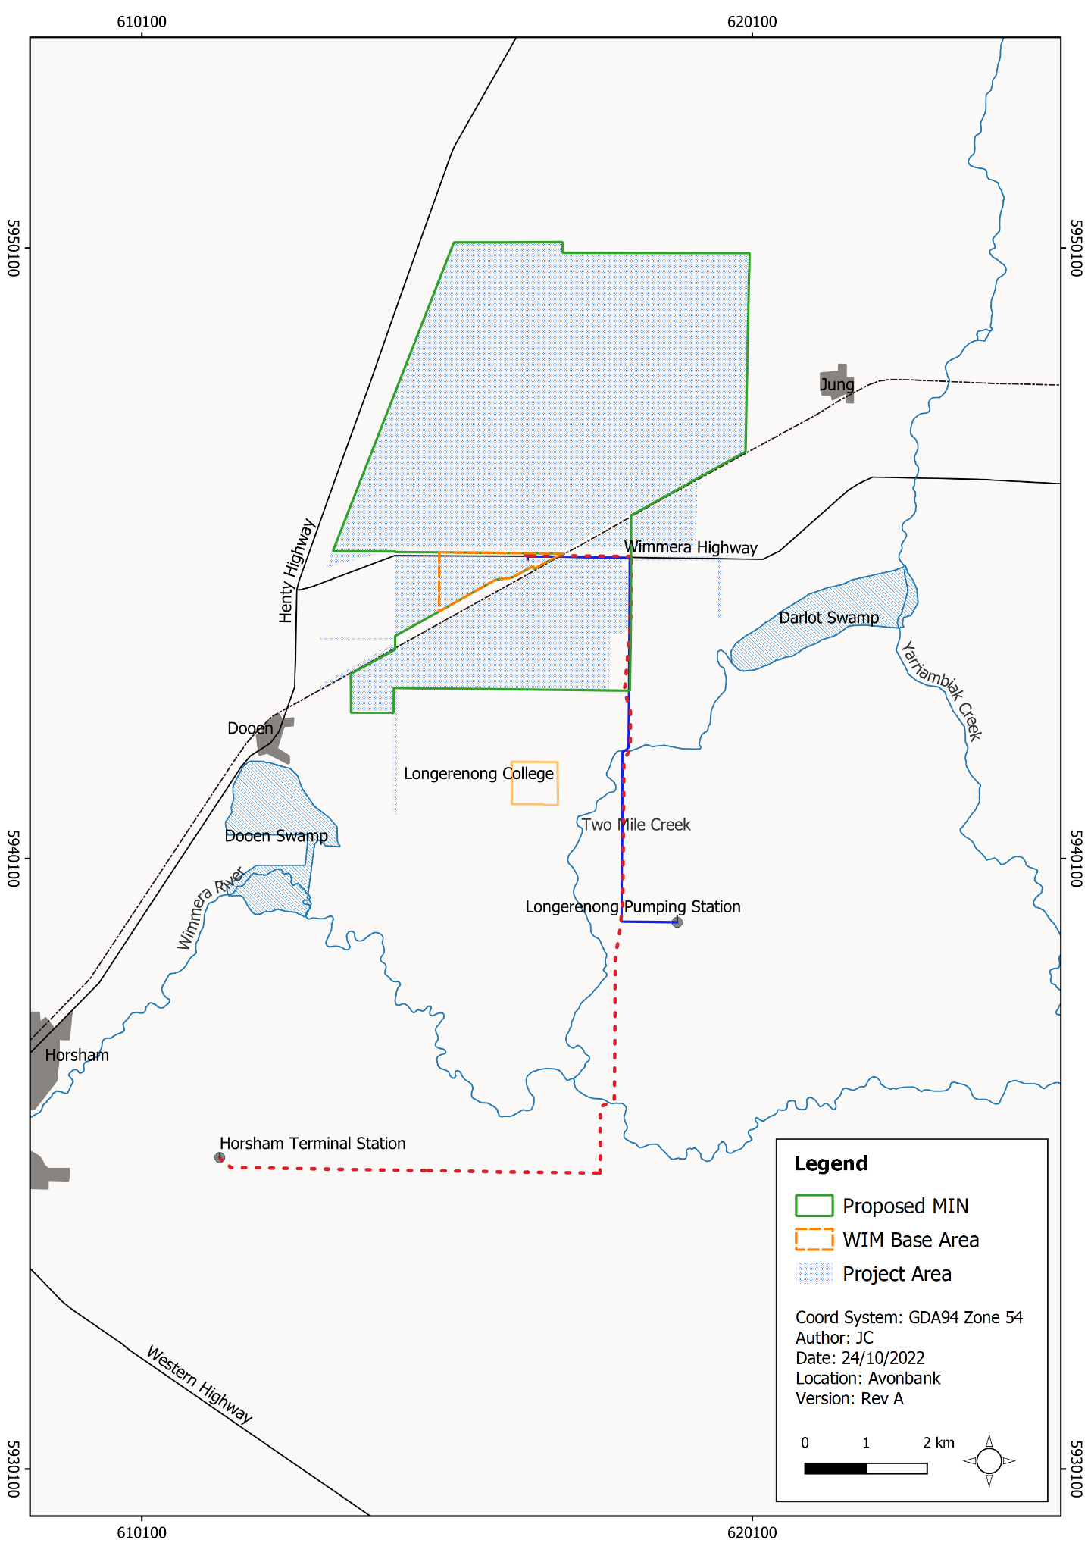
Figure 12-1: Study area
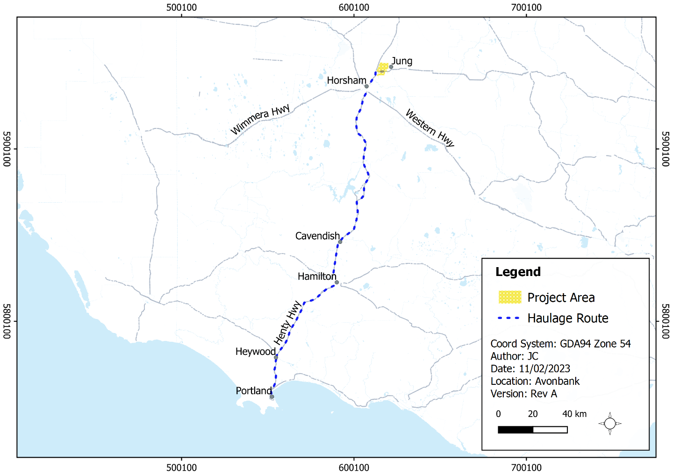
Figure 12-2: Study area haulage route

Operational Context
As described in Chapter 2 (Project Description), construction of the Wet Concentrator Plant (WCP) and preparation of a starter pit will be undertaken in year 1. In year 2, overburden will be stockpiled outside the mining footprint and the starter pit will be mined to create sufficient room for the progressive placement of tails and overburden.
Mining will commence in Block A for around 6 years and then move north of Wimmera Highway to progress sequentially through Blocks B to Block D between year 7 to 30 (refer Figure 12-3). It is expected that rehabilitation will be complete within each mining cell around 4 years after initial topsoil disturbance.
For the purposes of the NVIA, representative operational and construction scenarios were developed to characterise the worse-case noise emissions over the life of the Project (refer Figure 12-3).
There were two construction scenarios developed which include site preparation for the WCP (CON01) and WCP construction and fit-out (CON03). A third scenario (CON02) was modelled to represent noise emissions associated with constructing noise bunds south of the WCP and Block A. This is considered to be an operational activity that occurs concurrently with the construction of the WCP for a period of 6 to 8 months. This concurrent construction activity is represented by modelling scenario CON02/CON03.
There were four operational scenarios modelled (OP01–OP04), which included progressive mining and rehabilitation through years 1, 2, 22 and 26 (refer Figure 12-3). The haulage route scenario includes the haulage of HMC from the Project area to the Port of Portland with representative receptors selected at Cavendish and Dooen.
The scenarios are summarised below in Table 12-1. Further detail is provided in Appendix G, Section 5.3.
Table 12-1: Modelled scenarios
Scenario | Activities / Equipment
Earthworks and site preparation of the Wet Concentrator Plant (WCP) at year 1 (CON01) | Activities: Stripping topsoil/subsoil, placing fill, stockpiling, excavation of dams, dust control.  Equipment: Scrapers, roller, excavators, water truck, graders, loaders, light vehicles, trucks.
Earthworks and site preparation at the starter pit at year 1 (CON02) | Activities: Scrapers stripping topsoil/subsoil, placing fill, stockpiling, overburden excavation, dust control.  Equipment: Dozer, excavator, haul truck, grader, water truck, scrapers.
WCP construction and fit-out at year 1 (CON03) | Activities: Construction and fit-out of the WCP.  Equipment: Gensets, cranes, telehandler, excavators, rattle guns, loaders, trucks, elevated platforms, light vehicles, air compressors.
WCP construction and fit-out and site preparation for the Starter Pit at year 1 (CON02/03) | Combined CON02 and CON03 represent activities that will occur concurrently.
Mining at the southern starter pit at year 1 (OP01) | Activities: Excavating starter pit and stockpiling overburden.  Equipment: Dozer, excavator, haul truck, grader, water truck, scrapers.
Mining at the southern starter pit at year 2 (OP02) | Activities: Mining to depth of pit and operation of WCP, overburden/subsoil removal and placement.  Equipment: Dozers, excavators, haul trucks, graders, WCP, screen/trommel, mining unit plants, water carts, trucks, scrapers.
Mining at the north-east pit at year 22 (OP03) | Activities: Mining to depth of pit and operation of WCP, overburden/subsoil removal and placement.  Equipment: Dozers, excavators, haul trucks, graders, WCP, screen/trommel, mining unit plants, water carts, trucks, scrapers.
Mining at the north-west pit at year 26 (OP04) | Activities: Mining to depth of pit and operation of WCP overburden/subsoil removal and placement.  Equipment: Dozers, excavators, haul trucks, graders, WCP, screen trommel, mining unit plants, water carts, trucks, scrapers.
Haulage of product on the public road network | Activities: Haulage to the Port of Portland through Dooen and Cavendish.  Equipment: Haul trucks.
It is noted in the NVIA that the overburden stockpile location for Block A (OB-A Rev 1) was relocated to an area around 600 m to the north-east (OB-A Rev 2) following completion of the first iteration of the modelling (refer Figure 12-3). The modelling was rerun for relevant modelling scenarios to capture this change. The original stockpile location is shown in several figures in this Chapter for which the move was not considered relevant and was therefore not remodelled (refer Appendix G, Appendix A).
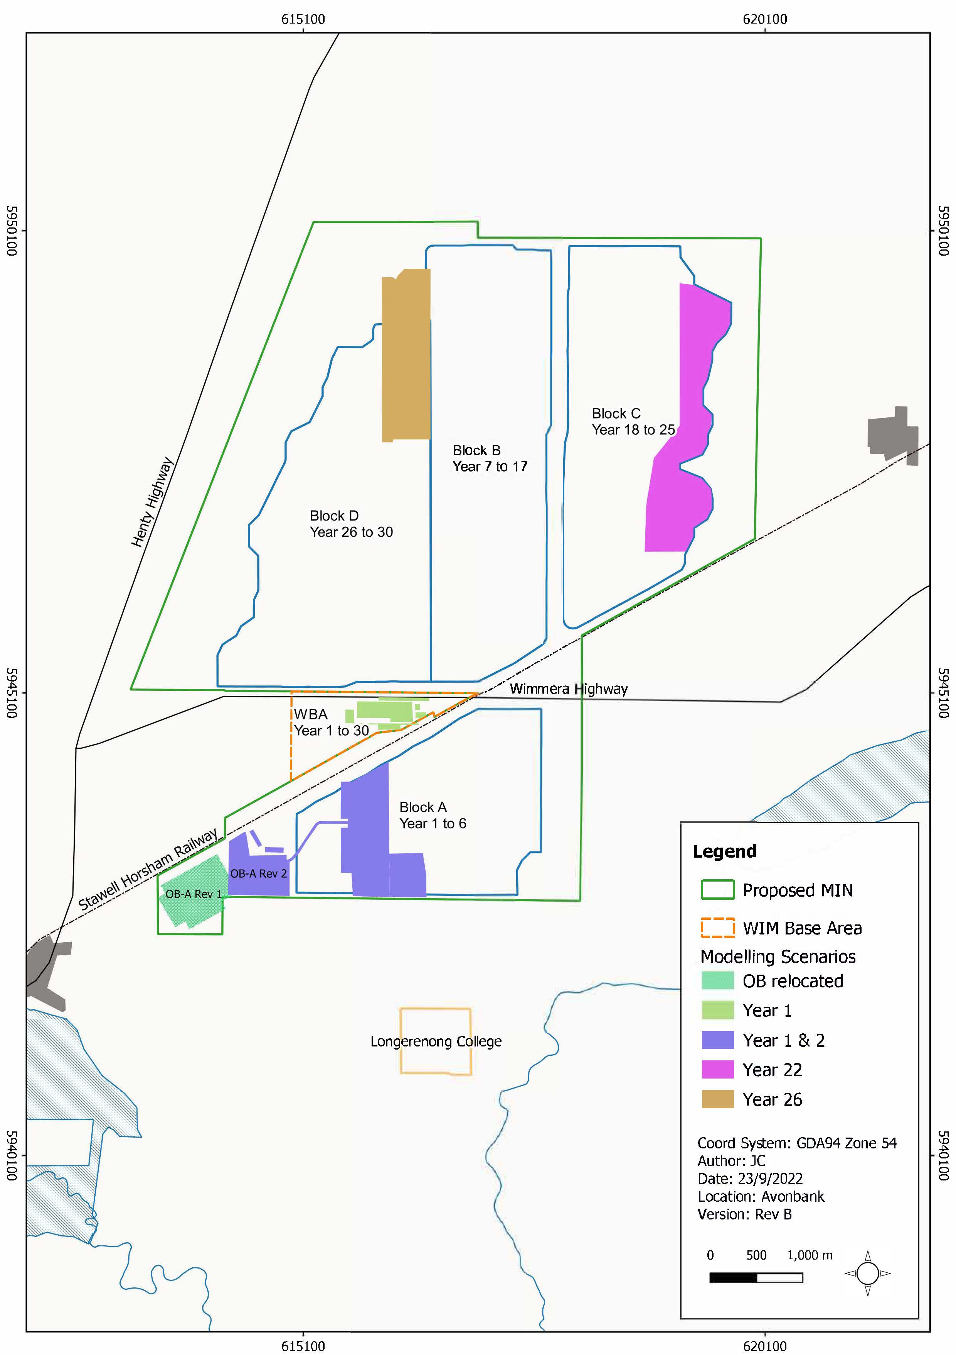
Figure 12-3: Modelled scenarios

Existing Conditions

Baseline Monitoring
Baseline noise monitoring was undertaken at six locations, as shown in Figure 12-4. These locations were selected to capture noise levels representative of existing conditions at noise sensitive receptors within and around the Project area. The data captured was used to quantify existing noise levels for all potentially impacted sensitive receptors. The impact assessment identified a total of 46 separate receptors for the construction and mining noise modelling at various distances from Project emission sources, as discussed in Section 12.5.2 of this Chapter.
Two rounds of monitoring were conducted to understand the variation between seasons due to weather conditions and types of agricultural activities undertaken. The first round of monitoring was undertaken during February/March 2020, and the second round of monitoring was undertaken during May/June 2020. The May/June monitoring event captured a period of increased agricultural activity associated with crop sowing. Weather conditions during this period were also colder, with a temperature inversion potential, which promotes the transmission of noise across longer distances.
Unlike noise, vibration dissipates rapidly with distance such that impacts, even from significant vibration generating sources, are not commonly experienced beyond a distance of 100 m. This statement is consistent when considering either human comfort/annoyance impacts or structural/cosmetic damage impacts.
Based on the equipment and activities identified for the Project’s construction and operation, potential sources of vibration are limited and blasting (a common form of vibration generation) will not form part of the Project design. Given the ≥100 m distance offset to the closest sensitive receptors or buildings to the Project, it was concluded that vibration impacts would be minimal if any at all. Given the limited potential for any vibration impacts to occur, no baseline vibration monitoring was conducted.
The Environment Protection Authority (EPA) were consulted regarding the methodology prior to monitoring commencing. Noise measurements were undertaken with consideration to the Noise Protocol (EPA, 2021a) and other relevant technical standards as detailed in Appendix G.
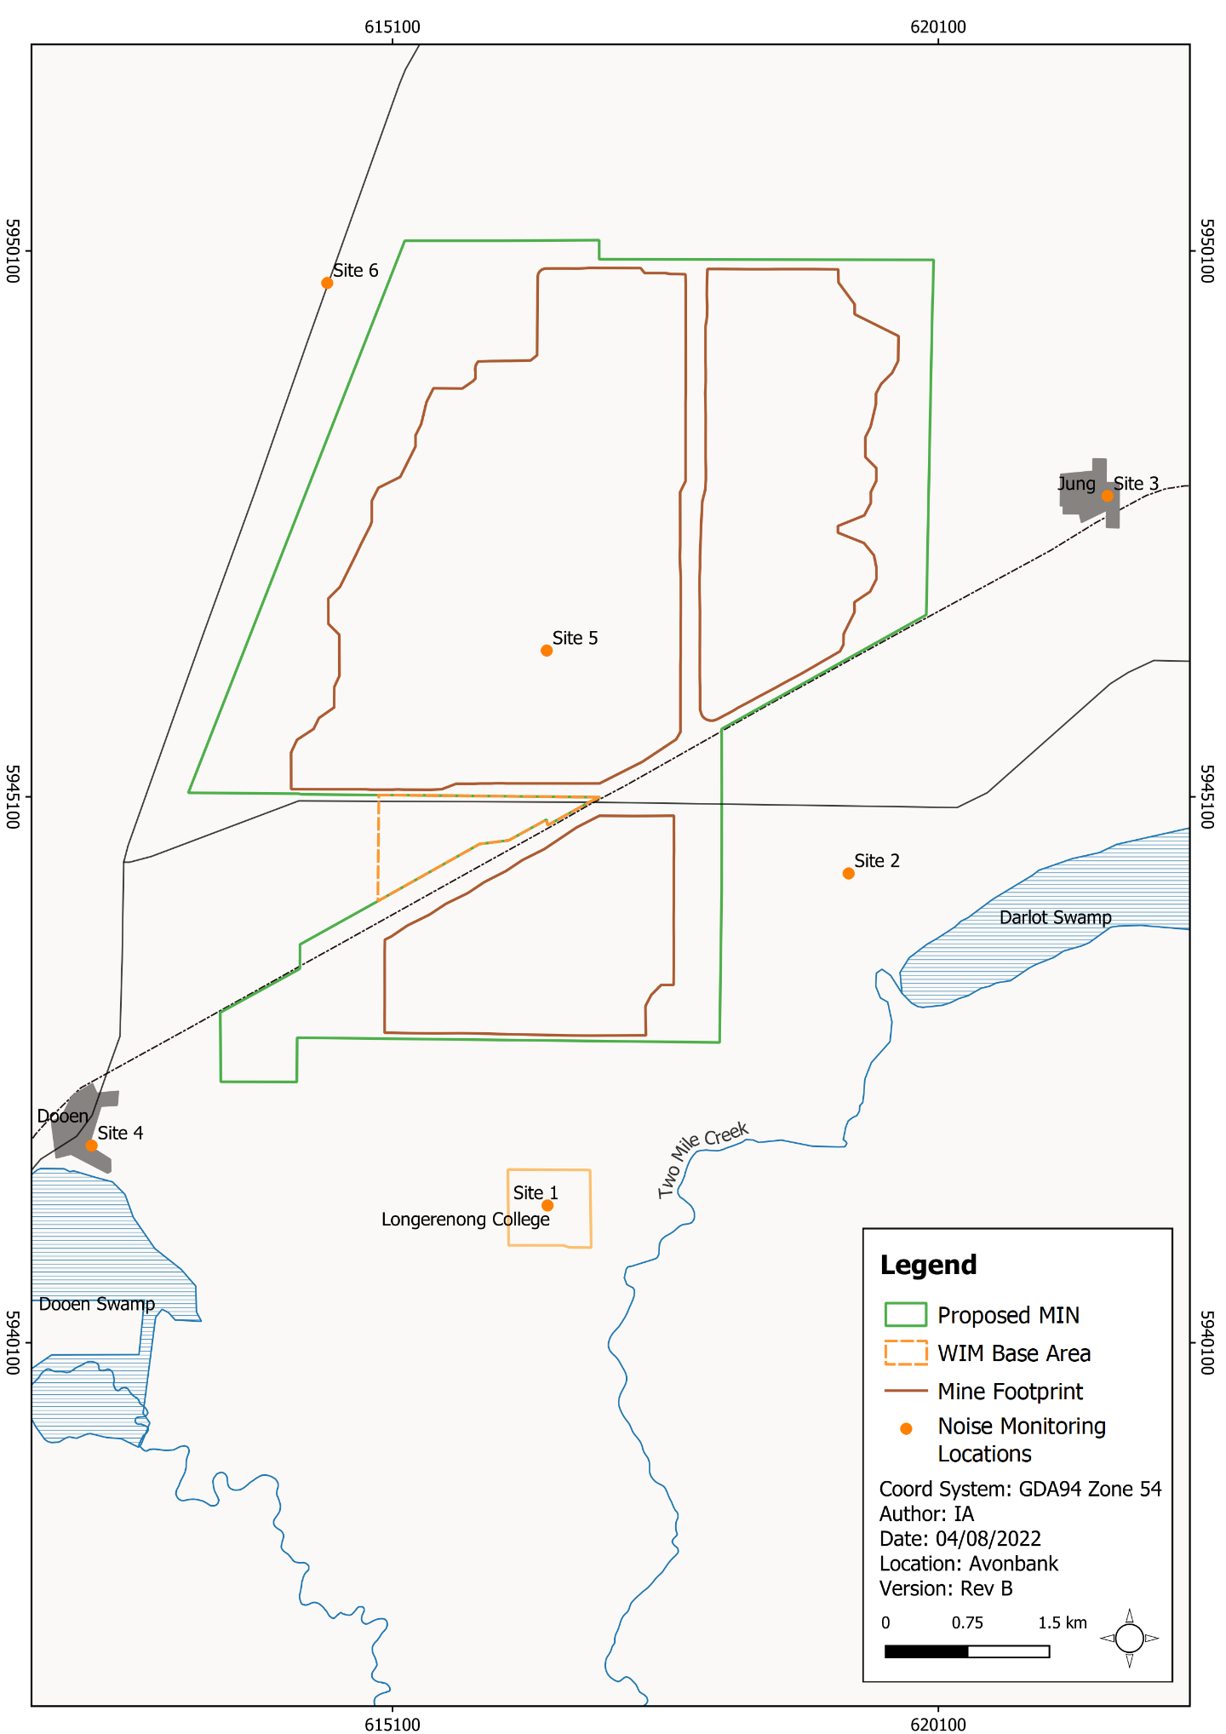
Figure 12-4: Noise monitoring locations

Unattended Noise Monitoring Results
A summary of the measured existing ambient (LAeq) and background (LA90) noise levels at each monitoring site across all assessment periods (day, evening and night) for both rounds of monitoring is presented in Table 12-2. Ambient noise levels are represented by the LAeq parameter, whilst background noise levels are represented by the LA90 noise parameter, both in decibels (dBA).
Table 12-2: Ambient and background noise summary
Feb-Mar | Site 1 |  | Site 2 |  | Site 3 |  | Site 4 |  | Site 5 |  | Site 6
 | LA90 | LAeq | LA90 | LAeq | LA90 | LAeq | LA90 | LAeq | LA90 | LAeq | LA90 | LAeq
Day | 31 | 62 | 26 | 40 | 29 | 53 | 37 | 53 | 26 | 48 | 32 | 59
Eve | 30 | 47 | 25 | 35 | 28 | 42 | 28 | 50 | 28 | 41 | 26 | 54
Night | 23 | 27 | 20 | 32 | 23 | 48 | 21 | 44 | 21 | 38 | 24 | 51
May-Jun | Site 1 |  | Site 2 |  | Site 3 |  | Site 4 |  | Site 5 |  | Site 6
 | LA90 | LAeq | LA90 | LAeq | LA90 | LAeq | LA90 | LAeq | LA90 | LAeq | LA90 | LAeq
Day | 28 | 48 | 24 | 44 | 31 | 50 | 37 | 53 | 28 | 48 | 29 | 59
Eve | 25 | 37 | 20 | 38 | 23 | 47 | 29 | 50 | 22 | 40 | 26 | 56
Night | 22 | 34 | 19 | 38 | 20 | 44 | 27 | 47 | 21 | 38 | 22 | 49

Baseline Noise Conditions
Baseline noise monitoring indicated a quiet noise environment typical of rural areas with negligible human activity. In general, the lowest ambient and background noise levels were recorded during the night period, and the highest levels were recorded during the day.
The first round of monitoring (February/March) recorded background LA90 noise levels between 26 and 37 dBA for the day period, 25 and 30 dBA for the evening and 20 and 24 dBA for the night period. Ambient LAeq noise levels ranged between 40 and 62 dBA for the day period, 35 and 54 dBA for the evening and then 27 and 51 dBA for the night period.
The second round of monitoring (May/June) recorded background LA90 noise levels between 24 and 37 dBA for the day period, 20 and 29 dBA for the evening and then 19 and 27 dBA for the night period. Ambient Leq noise levels ranged between 44 and 59 dBA for the day period, 37 and 56 dBA for the evening and then 34 and 49 dBA for the night period.
Background LA90 noise levels were slightly lower at most locations in the second round, except for Site 3 and Site 5 during the day and Site 4 during the evening and night (refer Figure 12-4). Site 5 was influenced by existing emissions from the Wimmera Intermodal Freight Terminal (WIFT) Precinct. Despite this, levels at Site 5 were considered to be representative of a quiet noise environment (especially at night).
The second monitoring round occurred during a period of increased agricultural activity associated with crop sowing and potential noise-enhancing weather conditions that can promote the transmission of noise across longer distances. Noise-enhancing meteorological conditions have the potential to increase noise levels at receptors influenced by the effects of wind and temperature inversions. Winds blowing between the source and the receptor and temperature inversions can increase noise levels by approximately 1 and 7 dBA depending on the distance of the receptor from the source and condition.
Despite this, the monitoring data does not suggest any significant influence of the increased agricultural activities or noise-enhancing conditions. Noise levels measured during the May/June monitoring (when increased agricultural activity and temperature inversion conditions were likely) were slightly lower than levels measured during February/March.
A meteorological analysis identified that source-to-receptor noise-enhancing winds (2–3 m/s) occur less than 30% of the year and temperature inversion conditions occur for ~15% of the year (refer Appendix G, Section 5.1.1). It is noted that combined wind and temperature inversion noise-enhancing conditions occur only 1% of the year and hence are not a prevailing/assessable condition.
A comparison against the Environment Reference Standard (ERS) objectives showed that existing ambient noise levels exceeded the Category IV objectives, which are 40 dBA for the day/evening and 35 dBA for the night, at the majority of receptors. On average, levels exceeded by 13 dBA during the day, 8 dBA during the evening and 10 dBA during the night.

Traffic Conditions
A Project traffic assessment was undertaken for the preferred haulage route at the townships of Cavendish and Dooen as a part of the Road Traffic Impact Assessment (Appendix C). A summary of the existing traffic flows through these townships are presented in Table 12-3 and Table 12-4 for time periods relevant to the established criteria (refer Section 12.5.3)
Table 12-3: Total vehicle movement and percent heavy vehicles (HV) – 15 hr and 9 hr
Location | Weekday |  | Weekend
 | Day (15-hour) | Night (9-hour) | Day (15-hour) | Night (9-hour)
Dooen – Wimmera Highway | 1349 vehicles  (HV 13.2%) | 87 vehicles  (HV 13.2%) | 1004 vehicles  (HV 13.2%) | 84 vehicles  (HV 13.2%)
Dooen – Henty Highway | 3493 vehicles  (HV 11.8%) | 219 vehicles  (HV 11.8%) | 2272 vehicles  (HV 11.8%) | 209 vehicles  (HV 11.8%)
Cavendish – Riley Street | 719 vehicles  (HV 23%) | 48 vehicles  (HV 23%) | 491 vehicles  (HV 23%) | 32 vehicles  (HV 23%)
Cavendish – Henty Highway | 957 vehicles  (HV 15%) | 64 vehicles  (HV 15%) | 749 vehicles  (HV 15%) | 49 vehicles  (HV 15%)
Table 12-4: Total vehicle movement and percent heavy vehicles (HV) – 18 hr
Location | Weekday |  | Weekend
 | Day/Night 6am to 10pm (18-hour) |  | Day/Night 6am to 10pm (18-hour)
 | Volume | HV% | Volume | HV%
Dooen – Wimmera Highway | 1415 | 13.2 | 1061 | 13.2
Dooen – Henty Hwy | 3659 | 11.8 | 2409 | 11.8
Cavendish – Riley Street | 751 | 23 | 507 | 23
Cavendish – Henty Highway | 1006 | 15 | 831 | 15

Potential Impacts

Identified Potential Impacts
Potential impacts were identified in the NVIA with consideration to the Project activities, preliminary modelling outcomes, stakeholder concerns and the issues identified in the referral document and Scoping Requirements. Where a source-pathway-receptor relationship was considered plausible, further investigation was undertaken to assess the residual impacts with avoidance and mitigation measures in place (refer Section 12.7). The potential impacts assessed are listed in Table 12-5 below.
Table 12-5: Potential Impacts
Item | Potential Impacts | Phase
IP-01 | Construction and site preparation resulting in short-term/temporary noise emissions that impact local residents and/or environmental receptors (refer scenarios CON01 and CON03). | C, D
IP-02 | Operational mining activity and associated works resulting in noise emissions that impact local residents and/or environmental receptors (refer scenarios OP01-OP04). | O
IP-03 | Road traffic noise emissions resulting in impacts to local residents. | C, O, D
IP-04 | Vibration effects resulting in impact local residents and/or environmental receptors | C, O, D

Sensitive Receptors
The impact assessment identified 46 sensitive receptors within the study area surrounding the proposed mining licence and WBA (refer Figure 12-5). These receptors are representative of the closest and/or potentially most affected ‘noise sensitive areas’ as defined in the Environment Protection Regulations 2021 or ‘environmental value’ as defined in the Environment Reference Standard.
The receptors were identified based on observations made during the baseline noise study, aerial photography, zoning information and the anticipated noise emissions from the Project. The receptors were verified during the preliminary noise modelling to ensure the worst-case emissions were assessed for each scenario.
Table 12-6 summarises the types of sensitive receptors assessed in the impact assessment, and Figure 12-5 shows their location within and surrounding the Project.
Representative sensitive receptors for each road traffic segment assessed in the towns of Dooen and Cavendish are shown in Figure 12-9 and Figure 12-10 respectively. A full list of receptors and associated baseline monitoring locations is provided in Appendix G, Table 6.1.
Table 12-6: Sensitive receptors
Receptor Type | Sensitive Receptor
Residential dwellings (Project area and surrounds) (EP Regs 2021 - Noise sensitive area) | Isolated residential dwellings within and surrounding the Project area and representative dwellings within built up areas in the townships of Dooen and Jung. Environmental values include sleep during the night, domestic and recreational activities and normal conversation.
Residential dwellings (haulage route) (EP Regs 2021 - Noise sensitive area) | Representative dwellings in the townships of Dooen and Cavendish adjacent the HMC haulage route. Environmental values include sleep during the night, domestic and recreational activities and normal conversation.
Educational facilities and community venues (EP Regs 2021 - Noise sensitive area) | Environmental values include domestic and recreational activities, learning and development and normal conversation.
Industrial and Commercial (ERS – Environmental Value) | Located to the west of the Project area surrounding Dooen and adjacent Henty Highway (WIFT Precinct). Environmental values include industrial and commercial activities, an active public realm and normal conversation.
Natural areas (ERS – Environment Value) | Darlot swamp and Dooen swamps to the south of the Project area. Environmental values include human tranquility and enjoyment of the outdoors in natural areas (Category V – ERS Environmental Value).
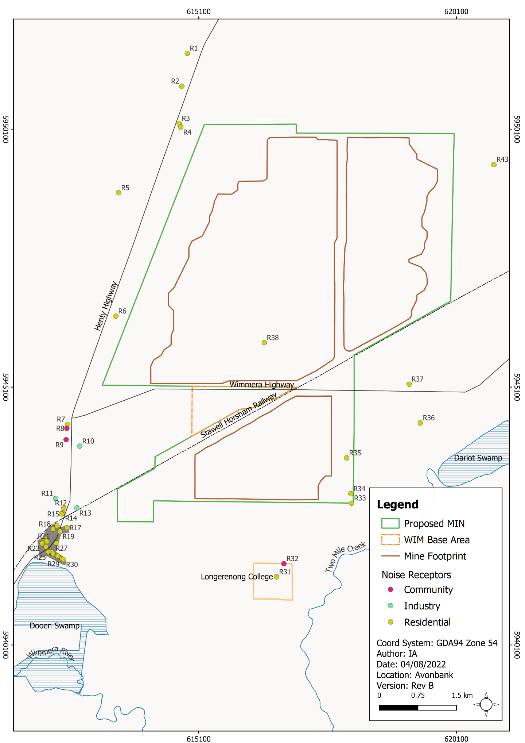
Figure 12-5: Sensitive receptor types

Impact Characterisation
The NVIA considered the magnitude, spatial extent and duration of the noise emissions and the sensitivity of the receptor. The residual impacts were characterised with regard to the relevant reference material listed in Table 12-7.
Table 12-7: Assessment criteria
Reference | Commentary
Civil Construction, Building and Demolition guide (Publication 1834, EPA, November 2020) | Provides guidance to the civil construction, building and demolition industries to eliminate or reduce the risk of harm to human health and the environment through good environmental practice. This publication requires the proponent to minimise noise and vibration at all times, consistent with the Environment Protection Act 2017, General Environmental Duty. Applied to construction noise emissions (Section 12.7.1).
Noise Limit and Assessment Protocol for the Control of Noise from Commercial, Industrial and Trade Premises and Entertainment Venues (Publication 1826.4, EPA, March 2021a) | Describes the methodology to determine unreasonable noise under the Environment Protection Regulations 2021. Provides noise criteria/limits for industry and earth resources which are used to assess if an impact is considered to be unreasonable. Applied to operational noise emissions (Section 12.7.2).
VicRoads Traffic Noise Reduction Policy, 2005 (VicRoads, 2005) | Details noise criteria for new or upgraded roads. The criteria provided are intended to inform the design of roads and give regard to the balance of factors a road operator/ manager must give regard to when considering noise mitigation measures. Not directly relevant to this impact assessment but has been provided for context (Section 12.7.3).
NSW Road Noise Policy (DECCW, 2011) | Provides assessment criteria for road traffic noise for new traffic generating developments. In the absence of relevant Victorian guidelines, these criteria have been applied to the traffic impact assessment (refer Section 12.7.3).
Environment Reference Standard (ERS), (May 2021) | Sets out the environmental values, indicators and objectives relevant to ambient sound based on land use category. The objectives for each land use category are typical ambient sound level values and were used in the impact assessment to provide context for the residual impacts. As stated in the ERS, the objectives are “neither noise limits nor noise design criteria”. In situations where pre-existing levels are above the quantified ERS objectives for ambient sound, the approach is to prevent additional risk to the environmental values by implementing appropriate avoidance and mitigation measures.
In addition to the detailed characterisation of the impacts described above, the relative significance of the residual impacts were summarised on a scale ranging from negligible through to severe (refer Table 12-8). These impact ratings are applied for the operational phases of the Project.
Table 12-8: Significance ratings
Rating | Description
Negligible | Where noise levels are predicted below project noise limits, no impacts are anticipated. Nuisance and unacceptable level of noise amenity, harm to human health and the environment should not occur. Complaints highly unlikely.
Minor | Exceedances of project noise limits of ≤2 dBA are generally imperceptible in practice. Nuisance, or an unacceptable level of noise amenity could occur but would be unlikely. Complaints unlikely.
Moderate | Exceedances of project noise limits of >2 dBA and <5 dBA are perceptible.  Nuisance, or an unacceptable level of noise amenity would be anticipated. Harm to human health and the environment could occur. Complaints could be received.
Major | Exceedances of project noise limits of around 5 to 7 dBA are clearly perceptible.  Major nuisance, or an unacceptable level of noise amenity would occur. Harm to human health and the environment could occur. Complaints highly likely.
Severe | Exceedances of project noise limits of >7 dBA are clearly perceptible and considered to be severe. Severe nuisance, or an unacceptable level of noise amenity would occur. Harm to human health and the environment would occur. Complaints highly likely.

Avoidance and Mitigation Measures
This Section outlines the measures identified to avoid and minimise residual impacts. It is noted that in line with the requirements of the environmental management system (EMS) and relevant legislation, additional measures may be required during implementation to ensure risks and potential impacts have been minimised so far as reasonably practicable.

Avoidance

NV-01: Fleet type
The proposed mining fleet was analysed during the preliminary 3D noise modelling to optimise the size/type of vehicles with respect to overall noise emissions. Two haul truck sizes were assessed, including the CAT793 and the smaller CAT785. The smaller sized haul truck required a greater number of in-pit circuits to achieve the same throughput and ultimately resulted in greater noise emissions. For this reason, the in-pit haulage fleet will comprise CAT793 vehicles to minimise the number of circuits and reduce noise emissions.

NV-02: Haulage route
A road haulage options assessment was undertaken to determine the most appropriate route from the Project area to the Port of Portland (refer Chapter 9, Traffic and Transport). Of the four routes assessed, the preferred haulage route was identified to have:
- lowest percentage increase in traffic from existing conditions; and
- highest standard of road (Classification A or B).
The preferred option has the lowest percentage increase in traffic from existing conditions, and therefore the change in noise emissions are likely to be less than the other routes. The preferred route also comprises the highest standard of road and therefore, noise emissions from the contact of tyres with the road surface are likely to be less.
This is considered to be an avoidance measure as lower order roads (Classification C) are avoided in the preferred route option.

NV-03: High noise level activities
High noise generating construction activities associated with the Project will be limited to the EPA recommended normal working hours to avoid unreasonable impacts when people are more sensitive to noise (i.e., night-time). While construction activities outside recommended normal working hours are expected to occur, noise emissions will be monitored and proactively managed to avoid high noise level generating activities during the night, whenever practicable to do so, in line with Environment Protection Authority Publication 1834 (EPA, 2021b) (refer Section 12.6.2.3).
Publication 1834 affirms the expectation that construction works will be managed to occur during normal working hours. However, provision is made for works outside normal working hours under circumstances of low noise, managed impact or unavoidable works. For ‘low noise’ works, these relate to inherently quiet or unobtrusive activities, and approval needs to be sought to conduct them. For ‘managed-impact’ and ‘unavoidable’ works, Publication 1834 requires a Noise and Vibration Management Plan to be prepared and approval sought (refer Section 12.6.2.3).
It is expected that approval may be sought for various managed-impact works during the construction period. A community engagement strategy and complaints handling system will be established to ensure noise emissions are avoided and minimised so far as reasonably practicable during the construction phase.

Minimisation

NV-04: Earthen bunds and stockpiles
Earthen bunds and stockpiles will be strategically located to abate noise emissions and mitigate impacts to sensitive receptors. Various configurations and dimensions of bunds/stockpiles were considered during the Project design phase to achieve maximum protection of sensitive receptors.
Indicative stockpiles and bunds for the construction phase are shown in Appendix G, Section 5.3 and are predicted to provide a substantial level of noise reduction. The effectiveness of each bund and stockpile will vary depending on the scenario assessed. An average reduction of between 3 dBA and 10 dBA is expected.
Noise bunds will be designed to minimise the risk of noise emissions at sensitive receptors so far as reasonably practicable. During operations, the location and configuration of bunds could potentially be adapted and augmented to respond to the results of monitoring and stakeholder feedback (refer Section 12.6.2.3).

NV-05: Noise abatement on equipment
Vehicles and equipment will be fitted with noise abatement kits to reduce noise emissions wherever practicable to do so. This will minimise emissions from key source contributors, including but not limited to scrapers, large excavators (600 t), haul trucks, dozers (D11) and water carts. Sound power level reductions of up to 7 dBA are expected for machinery and vehicles with noise abatement kits installed.

NV-06: Noise and Vibration Management Plan
A Noise and Vibration Management Plan (NVMP) will be prepared prior to Project commencement. The NVMP will provide a management framework to avoid and minimise risks/impacts, so far as reasonably practicable, in line with the Project EMS and relevant legislative requirements.
The NVMP will address the management of any works outside recommended normal working hours (during construction) in accordance with EPA publication 1834 and will also address the operational phase of the Project, including road traffic haulage to the Port of Portland.
The NVMP will be developed in consultation with stakeholders and will be subject to approval by the relevant Authority. Initially, the NVMP will address matters relating to worksite construction and as the Project progresses it will be reviewed and updated to address subsequent Project phases.
The NVMP will be reviewed and updated at an appropriate frequency as established in the overarching EMS with consideration to the level of risk, statutory requirements, monitoring results, community complaints and in response to audit findings.
The NVMP will:
- Summarise the baseline data and existing environment.
- Explain the relevant statutory requirements and context (including any relevant approvals).
- Detail a framework for the approval of construction works outside normal working hours as detailed in EPA publication 1834.
- Describe the avoidance and mitigation measures to be implemented to minimise noise emissions so far as reasonably practicable.
- Identify specific environmental objectives and performance standards to be achieved with avoidance and mitigation measures in place.
- Detail the monitoring to be undertaken to verify the modelling and the effectiveness of the avoidance and mitigation measures.
- Describe mechanisms to determine when/if corrective actions and contingency measures are required (refer Section 12.8).
- Detail a program to investigate and implement ways to improve the environmental performance of the Project over time.
- Detail appropriate review periods and/or triggers to ensure the plan remains fit for purpose.
- Establish procedures to manage:
- incidents and any non-compliance;
- stakeholder and community complaints;
- failure to comply with statutory requirements and/or performance standards;
- roles and responsibilities for implementing the plan; and
- a protocol for periodic review of the plan.
- Include a community engagement strategy which will include a complaints handling system.
In addition to the above requirements, the NVMP will include the avoidance and mitigation measures detailed in this Chapter and will include good management practices to:
- Plan vehicle movements to avoid manoeuvres and idling near sensitive receptors.
- Restrict areas where mobile plant can operate, so that it is away from sensitive receptors.
- Use quieter equipment or methods and maintain equipment.
- Define procedures for the selection of equipment for each phase/stage of works in order to minimise noise emissions.
- Connect to the electricity grid as early as possible to avoid the use of diesel generators.
- Enable preparatory work to occur off-site or within shielded areas where there is low potential for impacting receptors.
- Restrict areas where mobile plant can operate so that it is away from receptors that may be affected by noise.
- Consider maximum/impulsive noise level events, especially at night, as they have the potential to generate sleep disturbance or awakening impacts.
- Educate drivers to use driving practices that minimise noise.
- Use electrical equipment rather than equipment driven by a diesel generator.
- Use effective alternatives to ‘beeper’ alarms (e.g. broadband alarms, proximity sensors).

NV-07: Traffic Management Plan
A Traffic Management Plan (TMP) will be developed prior to Project commencement, as described in Chapter 9. The TMP will provide a management framework and specific requirements relating to traffic movement to and from the Project area to mitigate potential impacts. The TMP will be updated periodically and will apply to all phases of the Project including construction, operations, and decommissioning.
Initially, the TMP will address matters relating to worksite construction traffic and as the Project progresses it will be reviewed and updated to address subsequent Project phases. The TMP will be prepared to minimise and manage potential traffic related impacts so far as reasonably practicable (refer Chapter 9, Traffic and Transport).

Residual Impacts
This Section describes the likely residual impacts with avoidance and mitigation measures in place. The residual impacts have been characterised, as described in Section 12.5.3 and Chapter 6 (Impact Assessment Framework).

Construction Noise
There is one potential impact (IP-01) identified in Section 12.5.1 that relates to noise impacts from construction and site preparation activities. Section 12.3 describes the scenarios modelled, which relate primarily to the construction and fit-out of the WCP.
Construction activities will be completed within the first 2 years of the Project. It is expected that earthworks and site preparation for the WCP (CON01) will take less than 4 months to complete and the construction and fit-out of the WCP will take around 12 months (CON03).
The modelled noise scenarios assumed all plant, equipment and machinery operating concurrently and considered both standard and noise-enhancing meteorological conditions. Table 12-9 shows the noise emissions for the modelled scenarios at each residential receptor.
The highest noise levels (LAeq, 30mins) were predicted during site preparation of the WCP (CON01) at residential receptors (R34 to R38). At these receptors, during standard meteorological conditions, noise levels ranged between 30 dBA and 41 dBA and between 36 dBA and 46 dBA during noise-enhancing meteorological conditions.
As a point of reference, the baseline ambient noise conditions (LAeq) associated with receptors sites R34 to R38 ranged between 36 dBA and 38 dBA during the night and between 37 dBA and 41 dBA during the evening and between 42 dBA and 48 dBA during the daytime. The baseline ambient and background noise levels are included in Appendix G, Table 6-1 and provided in Section 12.4.2.
Scenario CON02/CON03 includes components that will occur concurrently and involve the construction of noise bunds (CON02) and site fit-out for the WCP (CON03). The bund building associated with (CON02) is considered to be an operational component that will be undertaken during daytime hours, or will otherwise comply with the operational noise criteria in the Noise Protocol (EPA, 2021a).
During CON02/CON03, noise levels were modelled to be 38 dBA during noise-enhancing conditions at the Longerenong College residences (R31), up to 27 dBA at Darlot Swamp and up to 35 dBA at Dooen Swamp. Following construction of these bunds, it is anticipated that the noise levels will be lower, as further described in the operational scenarios (refer Section 12.7.2).
The EPA publication 1834 recognises some noise from construction activities is inevitable and focuses on minimising construction noise so far as reasonably practicable rather than achieving numeric noise levels. A Noise and Vibration Management Plan (NVMP) detailing the avoidance and mitigation measures as described in Section 12.6.2.3 will be developed and implemented prior to commencement.
The avoidance and mitigation measures described in Section 12.6, are expected to effectively minimise the impacts so far as reasonably practicable, and residual impacts relating to construction are considered to be minor, given the temporary and intermittent nature of the proposed activities. It is anticipated that high noise activities will be undertaken during the daytime hours to avoid impacts during the night as describe in Section 12.6.1.3.
The NVMP will include measures to respond to community complaints, investigate incidents and respond accordingly with corrective actions where appropriate (refer Section 12.6.2.3). This may include modifying certain types of activities during night periods in response to community complaints/monitoring results or modifying bund/stockpile layout.
The potential health risks associated with noise emissions are further explored in the Human Health Risk Assessment (Chapter 18).

Table 12-9: Noise levels LAeq, 30 minute
ID | CON01 |  | CON02 |  | CON03 |  | CON02 and CON03 (~6 Month Overlap)
 | Standard | Noise-enhancing | Standard | Noise-enhancing | Standard | Noise-enhancing | Standard | Noise-enhancing
R01 | <20 | <20 | <20 | 20 | <20 | <20 | <20 | 23
R02 | <20 | 21 | <20 | 21 | <20 | 20 | <20 | 24
R03 | <20 | 23 | <20 | 23 | <20 | 22 | <20 | 25
R04 | <20 | 23 | <20 | 23 | <20 | 22 | <20 | 26
R05 | <20 | 25 | <20 | 26 | <20 | 24 | 21 | 28
R06 | 28 | 34 | 28 | 34 | 26 | 31 | 30 | 36
R07 | 24 | 30 | 34 | 39 | 24 | 30 | 34 | 40
R08 | 24 | 30 | 34 | 40 | 24 | 30 | 34 | 40
R12 | <20 | 25 | 34 | 39 | 21 | 28 | 34 | 39
R14 | <20 | 26 | 33 | 39 | 21 | 27 | 33 | 39
R15 | <20 | 26 | 33 | 38 | 20 | 27 | 33 | 39
R16 | <20 | 25 | 32 | 38 | <20 | 26 | 32 | 38
R17 | <20 | 25 | 33 | 38 | 20 | 27 | 33 | 39
R18 | <20 | 24 | 31 | 37 | <20 | 26 | 31 | 37
R19 | <20 | 25 | 32 | 38 | <20 | 26 | 32 | 38
R20 | <20 | 23 | 30 | 36 | <20 | 25 | 30 | 36
R21 | <20 | 23 | 30 | 36 | <20 | 25 | 30 | 36
R22 | <20 | 24 | 31 | 37 | <20 | 23 | 31 | 37
R23 | <20 | 23 | 29 | 35 | <20 | 25 | 30 | 36
R24 | <20 | 23 | 30 | 36 | <20 | 25 | 30 | 36
R25 | <20 | 23 | 30 | 36 | <20 | 22 | 30 | 36
R26 | <20 | 23 | 30 | 36 | <20 | 22 | 30 | 36
R27 | <20 | 23 | 30 | 36 | <20 | 22 | 30 | 36
R28 | <20 | 22 | 30 | 36 | <20 | 22 | 31 | 36
R29 | <20 | 22 | 31 | 37 | <20 | 22 | 31 | 37
R30 | <20 | 22 | 31 | 37 | <20 | 22 | 31 | 37
R31 | 24 | 30 | 32 | 38 | 23 | 30 | 33 | 38
R33 | 30 | 36 | 28 | 33 | 27 | 33 | 30 | 36
R34 | 34 | 40 | 30 | 35 | 29 | 34 | 32 | 38
R35 | 38 | 43 | 31 | 36 | 35 | 41 | 37 | 42
R36 | 32 | 38 | 23 | 30 | 31 | 37 | 32 | 38
R37 | 33 | 39 | 22 | 28 | 32 | 38 | 33 | 38
R38 | 41 | 46 | 30 | 35 | 38 | 42 | 38 | 43
R39 | <20 | 22 | <20 | <20 | <20 | 22 | <20 | 23
R40 | <20 | 23 | <20 | <20 | <20 | 22 | <20 | 23
R41 | <20 | 25 | <20 | <20 | <20 | 22 | <20 | 23
R42 | <20 | 22 | <20 | <20 | <20 | 21 | <20 | 22
R43 | <20 | 24 | <20 | <20 | <20 | 20 | <20 | 22
R44 | <20 | 21 | <20 | <20 | <20 | <20 | <20 | <20
R45 | <20 | <20 | <20 | <20 | <20 | <20 | <20 | <20
R46 | <20 | <20 | <20 | <20 | <20 | <20 | <20 | <20

Operational Noise
There is one potential impact (IP-02) identified in Section 12.5.1 that relates to noise impacts from mine operations and ancillary activities. Noise levels were modelled to include the WCP operating and mining activities during years 1, 2, 22 and 26, as described in Section 12.3. The modelling predicted daytime, evening and night-time (LAeq, 30 minute) noise levels for both standard meteorological conditions and noise-enhancing meteorological conditions.
Mining activity will occur progressively through each Block (Block A – Block D), as described in Section 12.3. The duration from initial mining to final rehabilitation for each mining cell (~20ha) will be between 1.5 and 4 years. It can be expected that noise emissions will be loudest when operations are closest to each receptor and will become lower as mining operations move progressively through each mining Block.
Noise-enhancing conditions occur around 1% of the year and are not a prevailing condition. Noise levels that would occur most of the time are represented by standard meteorological conditions. Emissions predicted for noise-enhancing conditions are provided in this Chapter to provide a conservative assessment of the residual impacts.
The modelling results are discussed below with respect to the Noise Protocol (EPA, 2021a) criteria/thresholds shown in Table 12-10. These operational noise limits (i.e., recommended maximum noise levels) have been determined via the processes outlined in the Noise Protocol for earth resources activities. Noise limits for industrial/commercial receptor types do not apply under the Noise Protocol and hence screening thresholds have been adopted for this assessment. Further information is provided in Appendix G, Section 7.2.
Table 12-10: Operational criteria/ thresholds
Receptor Type | Operational Criteria/Thresholds  LAeq (30 minute) (dBA)
 | Day | Evening | Night
Residential (EP Regs 2021 – EP Regulations noise limits) | 46 | 41 | 36
Educational (EP Regs 2021 – EP Regulations noise limits) | 46 | 41 | 36
Commercial/Industrial (Screening threshold based on the procedures for noise limits of the Noise Protocol) | 51 | 46 | 41
Predicted noise levels for the proposed operational scenarios (OP01 to OP04) were modelled to be below the criteria outlined in Table 12-10 for all identified receptors. This statement is consistent for both standard and noise-enhancing meteorological conditions (refer Appendix G, Table 10-2). Figure 12-6 to Figure 12-8 below show the noise modelling output for scenarios OP02, OP03 and OP04 during noise-enhancing conditions.
The highest predicted noise levels for the proposed scenarios were at the Longerenong College (R32), with 36 dBA predicted for south pit mining operations (OP02 – year 2) during noise-enhancing meteorological conditions. During standard meteorological conditions, noise levels were reduced to 31 dBA for the OP02 scenario at this receptor.
The highest predicted noise level for the proposed operations at a residential receptor was at the Longerenong College residences (R31). Noise levels were modelled to be 35 dBA for south pit mining operations (OP02 – year 2), during noise-enhancing meteorological conditions, which is 1 dBA below the most stringent night-time noise criteria. During standard meteorological conditions noise levels were reduced to 29 dBA for the OP02 scenario at this receptor.
As a point of reference, the baseline ambient noise conditions (LAeq) associated with receptors sites for Longerenong College (R31 and R32) were 32 dBA during the night, 44 dBA during the evening and 59 dBA during the day. The baseline ambient and background noise levels are included in Appendix G, Table 6-1 and provided in Section 12.4.2.
The highest noise level at a natural area sensitive receptor was 32 dBA at Darlot Swamp (represented conservatively by R33 and R36). It is not expected the environmental values associated with the natural area will be materially impacted by mining operations, as described in Appendix G, Section 10.1.3.1.

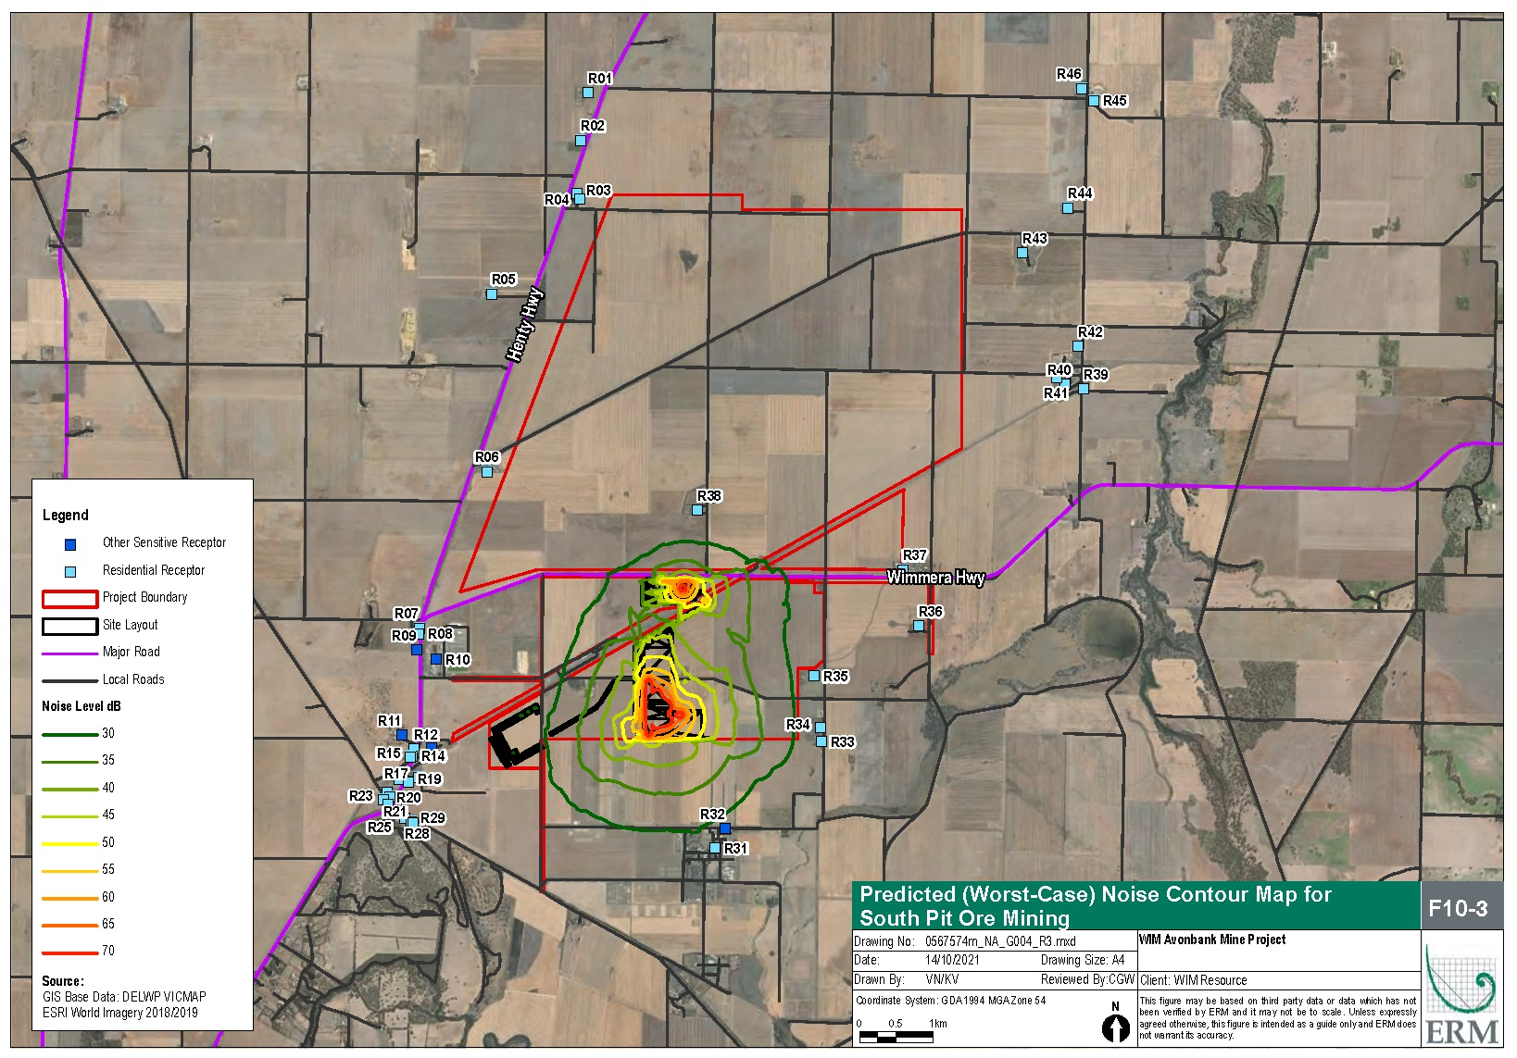
Figure 12-6: Mining – year 2 (OP02)
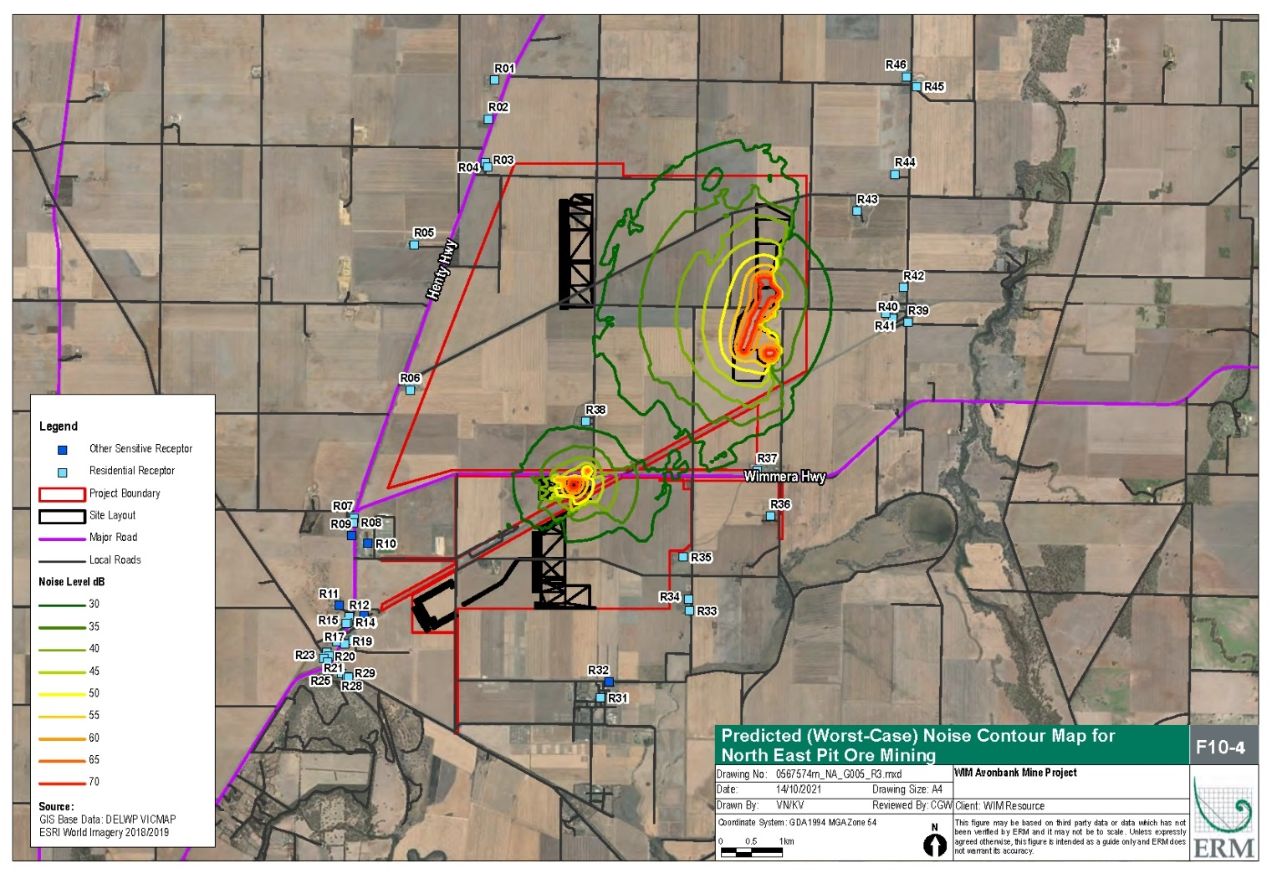
Figure 12-7: Mining – year 22 (OP2)
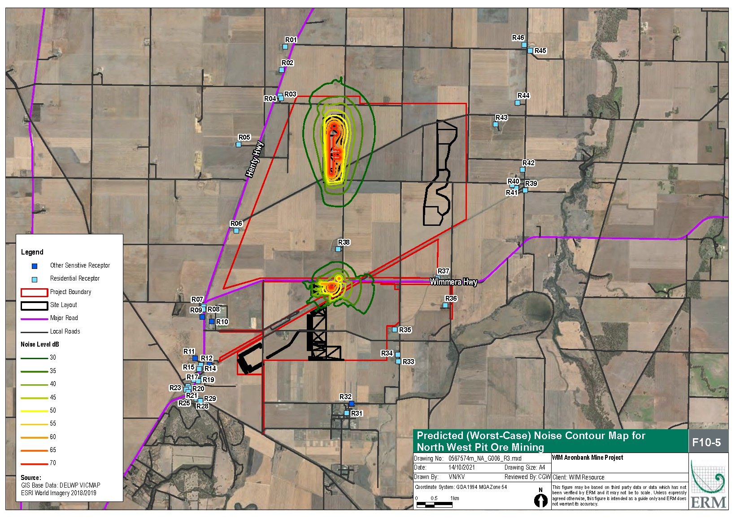
Figure 12-8: Mining – year 26 (OP04)

The residual impacts were modelled to be below the relevant criteria for the operational scenarios and were assessed to be negligible. It is expected the progressive construction of earthen bunds and stockpiles over the life of mine will be an effective measure that can be augmented to respond to community feedback and monitoring results. The avoidance and mitigation measures described in Section 12.6 are expected to effectively minimise the impacts so far as reasonably practicable.

Road Traffic Noise
There is one potential impact (IP-03) listed in Section 12.5.1 that relates to increased road traffic and associated noise effects. Noise levels associated with road traffic were modelled for construction and operational scenarios as described in Section 12.3.
Haulage of HMC to and from Avonbank to the Port of Portland as modelled in the NVIA will involve 27 B-double articulated vehicles per day, which equates to 54 vehicle movements (i.e. arrival trip and departure trip). Based on an even distribution of Project trucks over a 24-hour period, it is expected that the Project would generate the following vehicle movements:
- Daytime 15-hour (7 am to 10 pm) – ~33.75 truck movements (i.e. ~17 inbound movements and ~17 outbound movements).
- Night-time 9-hour (10 pm to 7 am) – ~20.25 truck movements (i.e. ~10 inbound movements and ~10 outbound movements).
The noise modelling was conducted for the daytime LAeq (15 hour) noise levels and night LAeq (9 hour) noise levels for existing traffic and future traffic scenarios. The results were compared with the road traffic noise criteria from the Road Noise Policy (DECCW, 2011), as explained in Section 12.5.3 and shown below in Table 12-11.
Table 12-11: Road traffic noise criteria (DECCW, 2011)
Assessment Classification | Daytime | Night
Road traffic noise criteria for existing residences affected by additional traffic on existing sub-arterial roads generated by land use developments. | LAeq(15-hour)₎  ≤ 60 dBA (external) | LAeq(9-hour)  ≤ 55 dBA (external)
The modelling shows that during construction, the Project does not generate a substantial increase in vehicles compared to the existing vehicle flows on the road network (refer Appendix G, Section 5.3.2). The anticipated difference in noise during peak construction is <0.5 dBA for the closest and/or potentially most affected receptors. Differences in noise levels of less than approximately 2 dBA are generally imperceptible in practice. Hence construction road traffic noise impacts are considered to be negligible.
Operational road traffic noise was modelled leaving the Project area and passing through the closest township of Dooen and Cavendish which were identified as the most sensitive towns along the route, due to the existing low levels of traffic.
Based on the findings of the modelling, noise levels at Cavendish receptors were below the assessment criteria for daytime and night-time, however, noise levels at night were increased by up to 5 dBA (due to Project activities), which is considered to be a clearly perceptible change (refer Table 12-12). Noise levels at Dooen exceed criteria at several receptors prior to and during Project implementation. At these receptors, the change in noise levels due to the Project of <2 dBA are unlikely to be perceptible.
The increased noise levels at Cavendish, while perceptible will be limited to around two trucks per hour, with noise levels considered to be commensurate with other heavy haulage vehicles using the arterial road. Effects will be limited to those receptors closest to the road and the noise levels will be below the assessment criteria (refer Table 12-11). The potential health risk associated with this residual impact is further examined in Chapter 18 (Human Health Risk Assessment).
Predicted existing and future road traffic noise levels were above the ERS Category IV 10pm to 6am night objectives (35 dBA) and 6am to 10pm day/evening objectives (40 dBA) at all but one receptor location, D01 in the township of Dooen. As represented by these findings, the introduction of Project haulage traffic does not vary the number of locations at which predicted values exceed the ERS Category IV objectives for either the day/evening and night periods.
The avoidance and mitigation measures described in Section 12.6 are expected to effectively minimise the residual impacts so far as reasonably practicable. The road route is considered appropriate as described in Section 12.6.1.2, and both the NVMP and TMP will include measures to respond to community complaints, investigate incidents and respond accordingly with corrective actions where appropriate. It is expected that a key corrective action with regard to traffic noise will relate to driver behaviour to avoid sudden acceleration/deceleration and restrict the use of engine brakes to ensure it is used only when justified for safety reasons.
Consideration was given to reducing the speed of trucks through the townships of Dooen and Cavendish to further reduce truck noise associated with the Project, however, that option was not considered to be reasonably practicable. Slowing trucks could have unintended consequences relating to road safety if the trucks are travelling at a speed that is not commensurate with the broader traffic flow. The Department of Transport is responsible for setting speed limits in line with the ‘Speed Zone Policy’ (DoT, 2021).
The residual impacts relating to road traffic for the Project, with consideration to the existing traffic noise and change of noise levels are considered to be minor. While the noise emissions in Cavendish were below the relevant noise criteria, they will be clearly perceptible, and as such further assessment of road traffic noise is provided in the Human Health Risk Assessment (refer Chapter 18).

Table 12-12: Noise levels existing and future
ID | Description | Weekdays |  |  |  |  |  | Weekends
 |  | Existing Traffic |  | Future Traffic |  | Change in Noise |  | Existing Traffic |  | Future Traffic |  | Change in Noise
 |  | Day LAeq,15hr | Night LAeq,9hr | Day LAeq,15hr | Night LAeq,9hr | Day LAeq,15hr | Night LAeq,9hr | Day LAeq,15hr | Night LAeq,9hr | Day LAeq,15hr | Night LAeq,9hr | Day LAeq,15hr | Night LAeq,9hr
C01 | Representative Cavendish Residential Receptors | 49.8 | 40.2 | 50.4 | 44.2 | 0.6 | 4.0 | 48.2 | 38.5 | 48.3 | 42.7 | 0.1 | 4.2
C02 |  | 52.9 | 43.4 | 53.5 | 47.3 | 0.6 | 3.9 | 51.3 | 41.6 | 51.6 | 46.0 | 0.3 | 4.4
C03 |  | 56.2 | 46.6 | 56.8 | 50.6 | 0.6 | 4.0 | 54.5 | 44.9 | 55.4 | 49.8 | 0.9 | 4.9
C04 |  | 47.9 | 38.3 | 48.5 | 42.4 | 0.6 | 4.1 | 46.3 | 36.7 | 47.1 | 41.6 | 0.8 | 4.9
C05 |  | 56.0 | 46.5 | 56.6 | 50.5 | 0.6 | 4.0 | 54.4 | 44.8 | 55.4 | 49.8 | 1.0 | 5.0
C06 |  | 51.1 | 41.5 | 51.7 | 45.5 | 0.6 | 4.0 | 49.4 | 39.8 | 50.4 | 44.8 | 1.0 | 5.0
C07 |  | 58.8 | 49.2 | 59.4 | 52.8 | 0.6 | 3.6 | 57.6 | 48.0 | 58.4 | 52.4 | 0.8 | 4.4
C08 |  | 58.3 | 48.8 | 58.9 | 52.4 | 0.6 | 3.6 | 57.2 | 47.6 | 58.0 | 51.9 | 0.8 | 4.3
C09 |  | 58.8 | 49.2 | 59.4 | 52.8 | 0.6 | 3.6 | 57.7 | 48.1 | 58.4 | 52.3 | 0.7 | 4.2
C10 |  | 54.6 | 45.0 | 55.2 | 48.7 | 0.6 | 3.7 | 53.5 | 43.9 | 54.2 | 48.1 | 0.7 | 4.2
D01 | Representative Dooen Residential Receptors | 37.5 | 27.8 | 38.0 | 31.2 | 0.5 | 3.4 | 36.2 | 27.7 | 36.9 | 31.2 | 0.7 | 3.5
D02 |  | 63.6 | 53.8 | 63.8 | 55.3 | 0.2 | 1.5 | 61.8 | 53.6 | 62.0 | 55.2 | 0.2 | 1.6
D03 |  | 59.9 | 50.1 | 60.1 | 51.7 | 0.2 | 1.6 | 58.1 | 49.9 | 58.3 | 51.6 | 0.2 | 1.7
D04 |  | 61.3 | 51.4 | 61.5 | 53.0 | 0.2 | 1.6 | 59.4 | 51.2 | 59.7 | 53.0 | 0.3 | 1.8
D05 |  | 58.8 | 49.0 | 59.1 | 50.6 | 0.3 | 1.6 | 57.0 | 48.8 | 57.2 | 50.5 | 0.2 | 1.7
D06 |  | 52.5 | 42.7 | 52.8 | 44.4 | 0.3 | 1.7 | 50.7 | 42.5 | 50.9 | 44.3 | 0.2 | 1.8
D07 |  | 57.5 | 47.6 | 57.7 | 49.3 | 0.2 | 1.7 | 55.6 | 47.4 | 55.9 | 49.2 | 0.3 | 1.8
D08 |  | 55.1 | 45.3 | 55.4 | 47.1 | 0.3 | 1.8 | 53.3 | 45.1 | 53.6 | 47.0 | 0.3 | 1.9
D09 |  | 57.9 | 48.1 | 58.2 | 49.7 | 0.3 | 1.6 | 56.1 | 47.9 | 56.3 | 49.6 | 0.2 | 1.7
D10 |  | 58.5 | 48.7 | 58.8 | 50.3 | 0.3 | 1.6 | 56.7 | 48.5 | 56.9 | 50.2 | 0.2 | 1.7
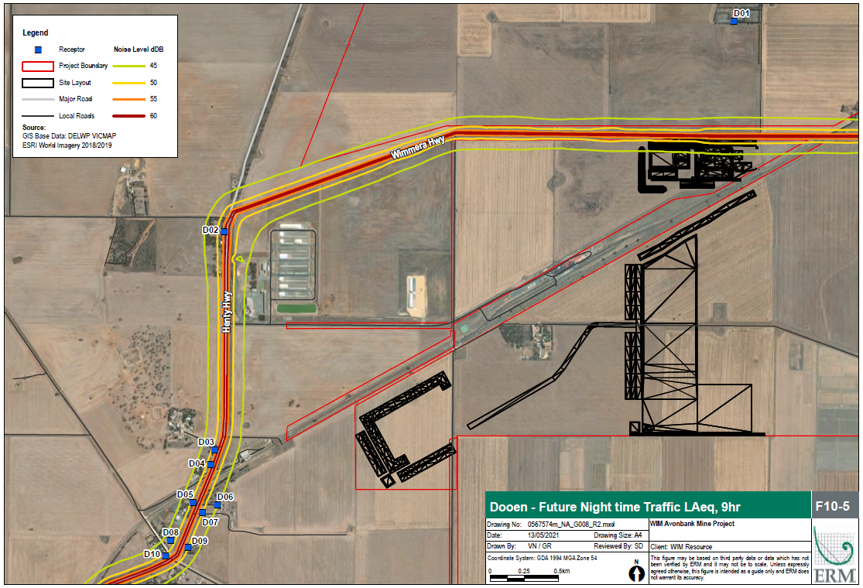
Figure 12-9: Traffic noise contours at Dooen
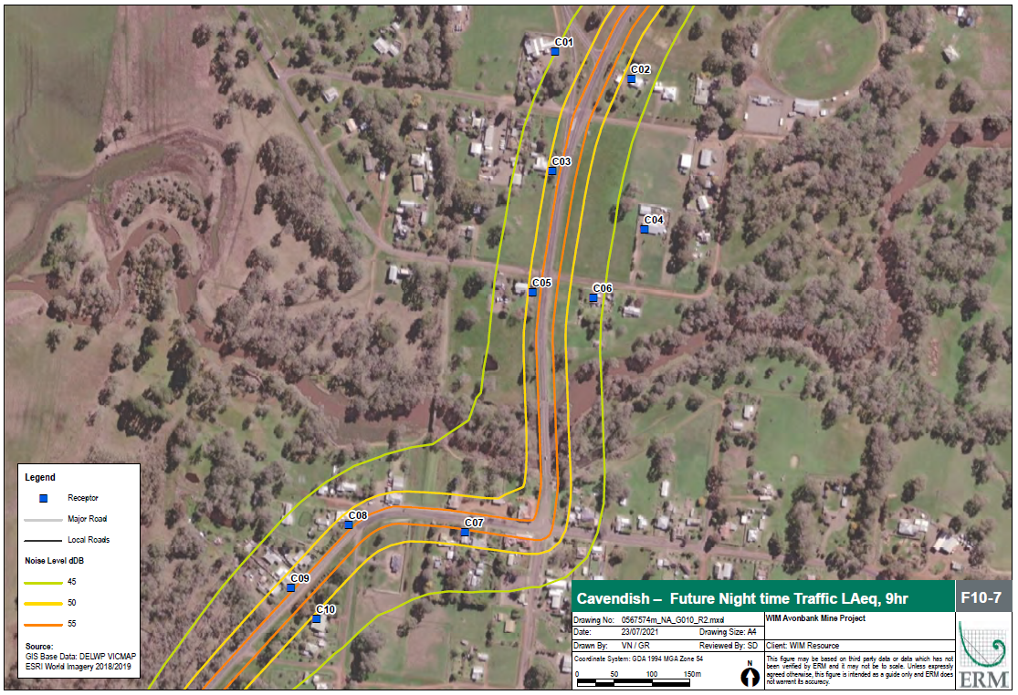
Figure 12-10: Traffic noise contours at Cavendish

Vibration
There is one potential impact (IP-04) listed in Section 12.5.1 that relates to vibration impacts associated with all phases of the Project, including traffic. The residual impacts are described in the sections below.

Project area
Vibration impacts are expected to dissipate rapidly with distance from the source, such that even from significant vibration generating sources, impacts are not expected beyond a distance of around 100 m. This applies when considering either human comfort/annoyance impacts or structural/cosmetic damage impacts.
Based on the equipment and activities identified for the Project’s construction and operational phases, potential sources of vibration are limited. Given the limited vibration sources combined with the greater than 100 m distance offset to the closest sensitive receptors, impacts are expected to be negligible, if any at all. As such, no specific vibration mitigation measures are proposed.

Traffic related
For trucks with rubber wheels travelling on smooth road surfaces, vibration levels are likely to be well below the established thresholds. Traffic induced vibration may occur when a heavy vehicle, such as a truck strikes an irregularity in a road surface, such as a cattle grate or speed hump. This may result in an impact load which can cause vibrations that travels through the ground.
Vibrations from Project haulage vehicles may be perceptible at select receptors for very short periods of time. These events would be consistent with other vehicles already accessing the public road network.
Given that the preferred and assessed haulage route for the Project is classified as arterial/sub-arterial and is approved for the use of B-double articulated vehicles, it is not anticipated that the Project related trucks would introduce any vibration events greater than those already encountered. With the implementation of a TMP, vibration impacts are expected to be negligible, if any at all.

Management Framework
An AS/NZS ISO14001:2016 EMS will be established for the Project as detailed in Chapter 24. The EMS will address matters relating to planning, operational control, monitoring and continuous improvement over the life of the Project. Relevant matters relating to noise monitoring, auditing and corrective actions are summarised below.

Environmental Objectives
Environmental objectives will be established as part of the EMS that articulate the outcomes to be achieved during Project implementation. These will reflect the expected and achievable outcomes based on the studies undertaken as part of this EES.
The key environmental objectives are to ensure that:
- Noise emissions from operational areas will result in no persistent unreasonable noise at sensitive receptors.
- Noise emissions from haulage vehicles will result in no material change to the environmental values or existing use of land adjacent the haulage route.
Performance standards will be established to measure/assess if the objectives have been achieved during operation, as further discussed below in Section 12.8.2.

Monitoring and Management
A noise monitoring program will be incorporated into the EMS and associated NVMP to measure, analyse and evaluate the effectiveness of the avoidance and mitigation measures and overall environmental performance. The NVMP will be developed in consultation with stakeholders and will be subject to approval by the relevant Authority.
Noise level measurements will be undertaken over the life of the Project at sensitive receptors to confirm the avoidance and mitigation measures are effective. In line with the requirements of the EMS described in Chapter 24 and relevant legislation, additional measures may be required during implementation to ensure risks and potential impacts have been minimised so far as reasonably practicable.
Monitoring locations will be established by a suitably qualified person with consideration to the source/activity, established/proposed avoidance and mitigation measures and sensitive receptors. Operator attenuated noise measurements (LAeq, 30 minute) will be taken by a suitably experienced person using a calibrated sound level metre. During operator attenuated noise measurements field sheets will be completed to document relevant observations and recorded noise parameters, as well as the meteorological conditions at the time. Worst-case Project noise levels will be established in the absence of any influential extraneous sources.
If Project noise levels are recorded above the predicted/modelled noise levels, performance standards or established regulatory criteria (refer Appendix G, Section 7), a root cause investigation will be undertaken and corrective actions identified and implemented where appropriate. Similarly, if community noise complaints are made, these will be investigated in the same manner.
Contingencies and corrective actions that may be applied in response to a root cause investigation may include:
- New noise bunds or stockpiles may be established, or existing bunds may be augmented and optimised to abate noise emissions and mitigate impacts to sensitive receptors.
- Certain construction activities may be rescheduled to occur during normal working hours or activities may be re-examined to determine ways to minimise noise levels.
- Driver or machine operator behaviour may be adapted in response to incidents or community complaints to reduce noise levels in the vicinity of sensitive receptors (i.e., avoid sudden acceleration/deceleration, restrict the use of engine brakes).
- Noise abatement devices may be reviewed to determine if new or more effective devices have been developed and are appropriate.
The noise monitoring requirements will be established in the NVMP and will be subject to approval by the relevant Authority prior to commencement.

Audits
Periodic internal and independent audits will be undertaken to assess the effectiveness of the EMS. An internal audit program will be maintained, which details the frequency, methods, responsibilities and reporting requirements.
Audits will be undertaken by a suitably qualified person to assess the effectiveness of the EMS and associated management plans (including the NVMP and the TMP) to minimise or avoid noise impacts so far as reasonably practicable. Any non-conformity identified in the audit will be investigated and corrective actions identified.
The outcomes of audits will be communicated to the Project Management team and records of the audit findings will be retained in the record management system. Significant findings will be reported to relevant Regulators and stakeholders where appropriate to do so.

Cumulative Impacts
The impact assessment identified and considered the following projects with regard to potential cumulative noise and vibration impacts:
- Western Highway Duplication project.
- Western Renewable Links project.
- Wimmera Mineral Sands project.
- WIM150 Mineral Sands project.
- Donald Minerals Sands project.
- Murra Warra Wind Farm project.
- Wimmera Plains Energy Facility.
These projects were selected as they may interact with the Project and have the potential to contribute to cumulative impacts. Further details regarding these projects are provided in Chapter 7 (Regional Setting).
Despite multiple projects operating and proposed in the region, cumulative construction noise and construction traffic impacts will be temporary and likely to be restricted to the initial phases of each project. It is expected that each project will have an approved construction noise management plan that will include an adaptive management strategy to minimise cumulative impacts so far as reasonably practicable with consideration to surrounding projects.
The distance between Avonbank to those projects listed above (with the exception of Wimmera Plains Energy Facility) are greater than 3 km from the Project (Chapter 7). Over this distance, noise emissions are unlikely to materially impact receptors considered in the noise impact assessment.
The Wimmera Plains Energy Facility situated adjacent the northern boundary is not expected to generate noise emissions during operations that would add to those of the Avonbank Project, such that it would risk non-compliance with applicable criteria or generate any additional impacts to those described in this Chapter.
The Wimmera Plains Energy Facility’s potential construction (including road traffic requirements) may interact with that of the Project, however, given the large spatial area of both projects and the distribution of receptors, acute cumulative impacts are unlikely to occur. Road traffic impacts could be easily managed via consultation between the Project and the wind farm proponent, with a view of minimising vehicle usage interactions and cumulative road traffic impacts, if possible. Managing the occurrence of daily deliveries and vehicle arrivals can be problematic, but efforts would be made with a view to targeting larger vehicle haulage requirements (e.g. delivery of turbines to the wind farm site) and peak Project haulage periods.

Conclusions
This Chapter provides an overview of the Noise and Vibration Impact Assessment prepared to address the EES Scoping Requirements for the Avonbank Mineral Sands Project.
The potential impacts associated with the Project activities were assessed as part of the ERM impact assessment. Consideration was given to potential impacts associated with noise and vibration emissions during all phases of the Project, as well as emissions associated with the HMC haulage route.
Avoidance and mitigation measures were identified to reduce the residual impacts so far as reasonably practicable. Listed below are the key measures identified:
- The proposed transport route comprises arterial roads, which are gazetted to cater for the types of traffic generated by the Project, and as such, impacts to lower order local roads will be avoided.
- Equipment fleet size will be optimised to reduce the number of circuits associated with the mining operations.
- Earth bunds/stockpiles will be established to abate noise emissions and mitigate impacts to sensitive receptors.
- Noise abatement kits will be fitted on earth moving equipment and vehicles where practicable to do so.
- A Noise and Vibration Management Plan (NVMP) will be established and implemented to manage and mitigate impacts associated with Project construction, operations and decommissioning.
- A Traffic Management Plan (TMP) will be established to manage and mitigate impacts associated with all phases of the Project.
Noise emissions associated with construction and establishment activities are expected to be experienced at sensitive receptors intermittently during the first 2 years of Project establishment. With avoidance and mitigation measures in place, residual impacts are expected to be minor.
Operational activities over the life of mine are expected to result in noise emissions that are below the assessment criteria at all sensitive receptors, and with avoidance and mitigation measures in place, residual impacts are expected to be negligible.
Road traffic noise emissions are likely to result in a perceptible noise level change at some sensitive receptors in Cavendish, however, the magnitude is below the selected assessment criteria. The magnitude of noise emissions at Dooen exceeds the selected criteria prior to and after Project implementation, however the resulting change is unlikely to be perceptible. The residual impact from road traffic is expected to be minor.
Vibration impacts are expected to be negligible for all activities and phases of the Project.
The above residual impacts are all considered to be minor or negligible. Overall, the proposed Project work/activity is unlikely to result in significant noise and vibration environmental effects and the associated impacts can be managed with avoidance and mitigation measures in place to achieve the evaluation objectives.

L_{Aeq} – The average noise level. Defined as the equivalent sound level that has the same sound energy as the actual fluctuating sound measured over a specified period of time.
L_{A90} - The noise level exceeded for 90 per cent of the sample period. This noise level is described as the average minimum background sound level (in the absence of the source under consideration), or simply the background level.
‘lower density or sparse populations with settlements that include smaller hamlets, villages and small towns that are generally unsuited for further expansion. Land uses include primary industry and farming’.
Construction (C); Operations and rehabilitation (O); Decommissioning and closure (D)
CON02 is an operation scenario that will occur concurrently with CON03. Activities associated with CON02 will need to comply with the Noise Protocol (EPA 2022a)
Day: 07:00 – 18:00 Monday – Friday, 07:00 – 13:00 Saturdays
Evening: 18:00 – 22:00 all days 13:00 – 18:00 Saturdays 07:00 – 18:00 Sundays and public holidays
Night: 22:00 – 07:00
54 daily movements were conservatively assumed however the maximum number of movements is 52 as described in Chapter 2
Day: 0700 – 2200
Evening: 2200 – 0700

