Avonbank Mineral Sands Project
Environment Effects Statement

Chapter 7 – Regional Setting

TABLE OF CONTENTS
7 Regional Setting 7-1
7.1 Introduction 7-1
7.2 Avonbank Regional Setting 7-1
7.2.1 Climatic Setting 7-2
7.2.2 Geology and Landscape 7-2
7.2.3 Surface Water 7-3
7.2.4 Biodiversity 7-6
7.2.5 Aboriginal Cultural Heritage 7-7
7.2.6 Heritage Sites 7-8
7.2.7 Governmental Areas and Services 7-8
7.2.8 Land Use 7-9
7.2.9 Transport, Services and Utilities 7-10
7.3 Project Haulage Route 7-10
7.4 Port of Portland 7-11
7.5 Other Projects in the Region 7-11
7.5.1 Wimmera Mineral Sands Project 7-12
7.5.2 WIM150 Mineral Sands Project 7-12
7.5.3 Donald Minerals Sands Project 7-12
7.5.4 Murra Warra Wind Farm Project 7-13
7.5.5 Wimmera Plains Energy Facility 7-13
7.5.6 Western Renewable Links Project 7-13
7.5.7 Western Highway Duplication project 7-13

TABLES
Table 7-1: WSM LGA population 7-8

FIGURES
Figure 7-1: Retention licence, haulage route and the surrounding region 7-1
Figure 7-2: Wimmera Southern Mallee region 7-2
Figure 7-3: Geomorphic units within the Wimmera Catchment Management Area (WCMA) 7-3
Figure 7-4: Wimmera River and other major waterways 7-4
Figure 7-5: Waterways in the vicinity of the proposed mining licence 7-5
Figure 7-6: Bioregions within the WCMA area and Wimmera catchment. 7-6
Figure 7-7: National parks and state forests 7-7
Figure 7-8: Haulage route to PoP 7-11
Figure 7-9: Other projects in the region 7-12

Regional Setting

Introduction
This Chapter provides an overview of the regional setting for the Avonbank Mineral Sands Project (the Project). It has been prepared to address the Environment Effects Statement (EES) Scoping Requirements (DELWP, 2020) to provide context for the Project through a description of the existing environment, geography and land use.
This Chapter describes the regional setting within which the Project will operate, including the mining and processing area (refer Section 7.2), the haulage route (refer Section 7.3) and the Port of Portland (PoP) (refer Section 7.4). The key focus of this Chapter relates to the region encompassing the Avonbank retention licence, as this is where the majority of the Project’s activities will take place.

Avonbank Regional Setting
The Avonbank retention licence (RL2014) is located in the Wimmera Southern Mallee (WSM) region, approximately 5 km north-east of the township of Dooen and 15 km north-east of the City of Horsham. The WSM region covers approximately 30,000 km² and includes six local government areas (LGAs), these being Horsham Rural City (HRC), Hindmarsh Shire, Northern Grampians Shire, West Wimmera Shire, Yarriambiack Shire and part of the Shire of Buloke (refer Figure 7-1 and Figure 7-2).

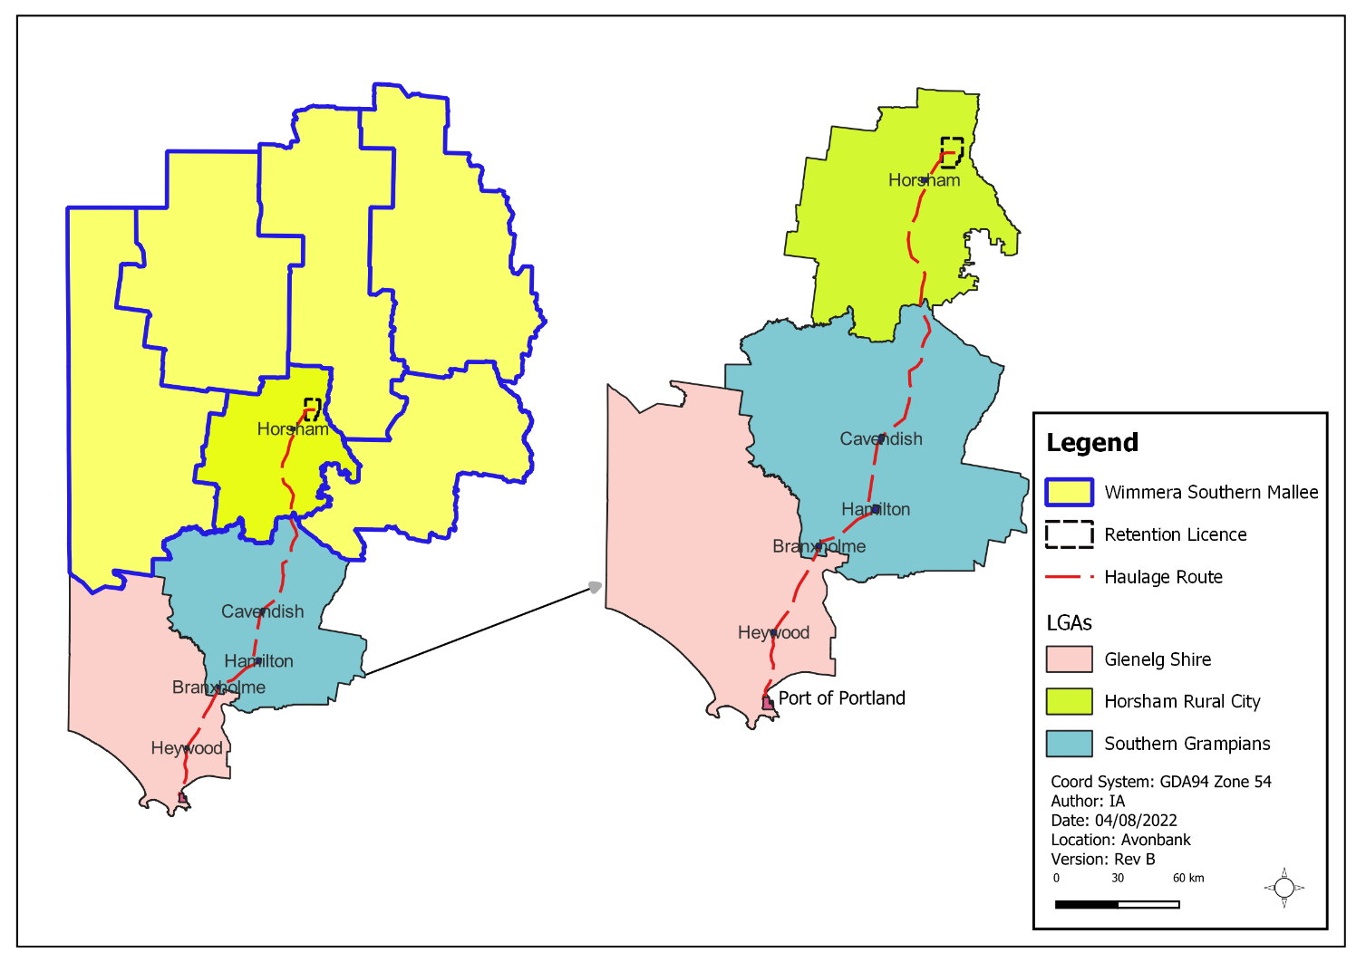
Figure 7-1: Retention licence, haulage route and the surrounding region
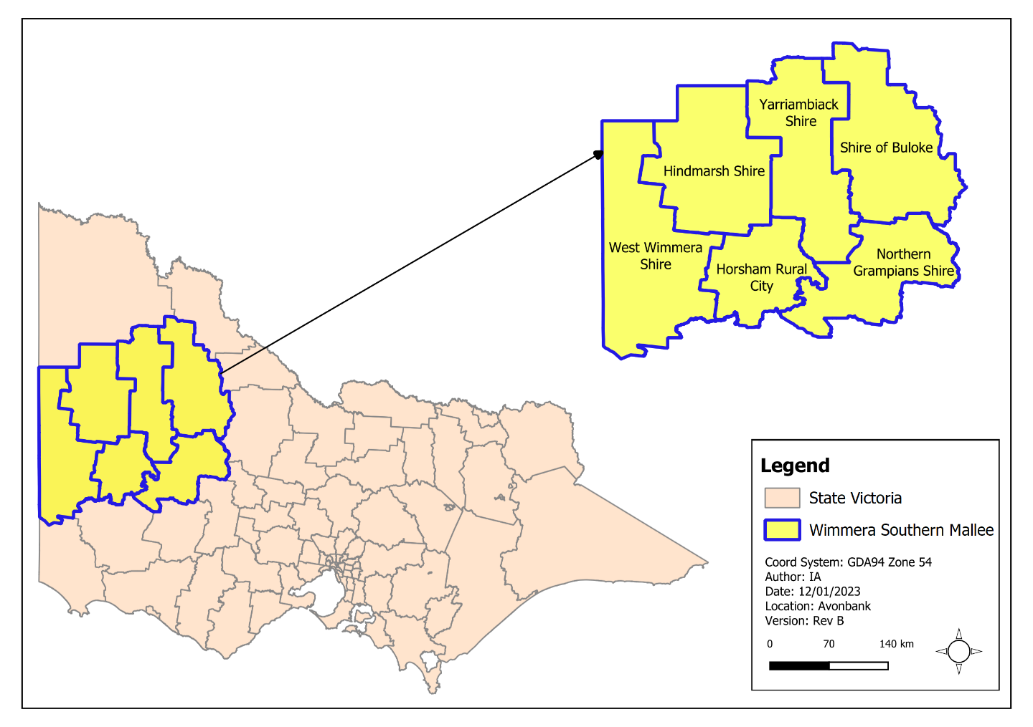
Figure 7-2: Wimmera Southern Mallee region

Climatic Setting
The WSM has a temperate climate with warm, dry summers and cool, wet winters. Mean annual temperatures across the region range from a minimum of 8.2°C (winter) to a maximum of 21.5°C (summer), with severe frosts often occurring during winter and early spring. Mean annual rainfall is 448 mm, with about 60% of the annual rainfall occurring during the winter months.

Geology and Landscape
The WSM region is divided into three main geomorphological units:
- Western Uplands, which extend westwards from the Kilmore Gap to the Glenelg River.
- Northern Riverine Plains, an extensive and predominantly alluvial landscape lying to the north of the Western Uplands.
- North Western Dunefield and Plains, which in areas to the north of the Wimmera Highway, consists of clay plains with subdued ridges.
The retention licence is located on the North Western Dunefield and Plains landscape, which is characterised by a very low elevation variation and comprises clay plains with subdued ridges (refer Figure 7-3).
During the Tertiary period, a series of marine transgressions occupied much of the lower Murray Basin. Over time, a thick layer of marine sediments (the Renmark Group and the Geera Clay) accumulated over the pre-Tertiary basement rock.
As the sea levels receded, a series of north–south trending strandline sand ridges were deposited. The stranded ridges and intervening swales or troughs were then lateralised. These ridges and associated troughs continue to influence catchment behaviour and local watercourses, including the Wimmera River and Yarriambiack Creek, which are approximately aligned with the troughs.
Alluvial and aeolian deposition occurred during the Pleistocene (around 12,000 years ago). The predominantly clayey sediments of the extensive alluvial Shepparton Formation accumulated between the stranded ridges.
During the mid to late Pleistocene, a series of arid phases led to the development of dune fields, the Parilla Sand and lacustrine deposits in swales between the stranded ridges. The Avonbank resource lies within the Parrilla Sand geological unit.
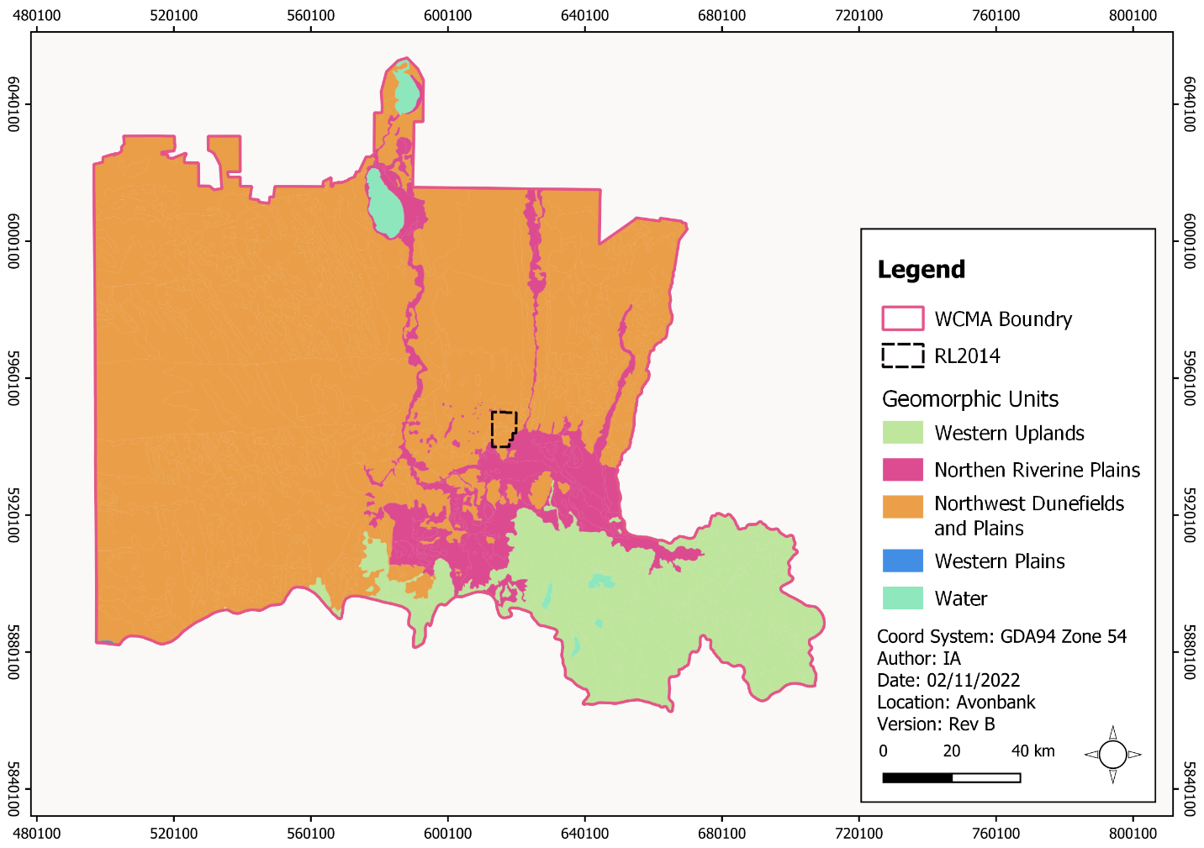
Figure 7-3: Geomorphic units within the Wimmera Catchment Management Area (WCMA)

Surface Water
The retention licence lies within the Wimmera River catchment in the Wimmera Catchment Management Area (refer Figure 7-4). The Wimmera River catchment is located in the south-western part of the Murray-Darling Basin. The Wimmera River System contributes approximately 1.7% of the flow to the Murray-Darling Basin system (WCMA, 2022).
The Wimmera River System is large and geographically diverse. It experiences great variability in climate, in particular rainfall, which in turn influences water regimes for creeks, rivers and wetlands. Average annual rainfall in the catchment ranges from about 1,000 mm/year in the south to 300 mm/year in the north.
The Wimmera River is around 3 km south of the proposed mining licence at its closest point. It generally flows in a north-westerly direction until it reaches the Horsham area, after which it turns northward towards its terminus at Lake Albacutya (approximately 130 km to the north north-west of Horsham). The Wimmera River and its tributaries flow intermittently in response to rainfall. Much of the river flow originates in the Grampian Ranges and surrounding areas.
The Yarriambiack Creek is located around 3 km to the east of the proposed mining licence. The Yarriambiack Creek is a distributary of the Wimmera River, flowing almost due north from its source near Longerenong. There are several wetlands along Yarriambiack Creek, including Darlot Swamp, located to the south-east of the proposed mining licence (refer Figure 7-5).
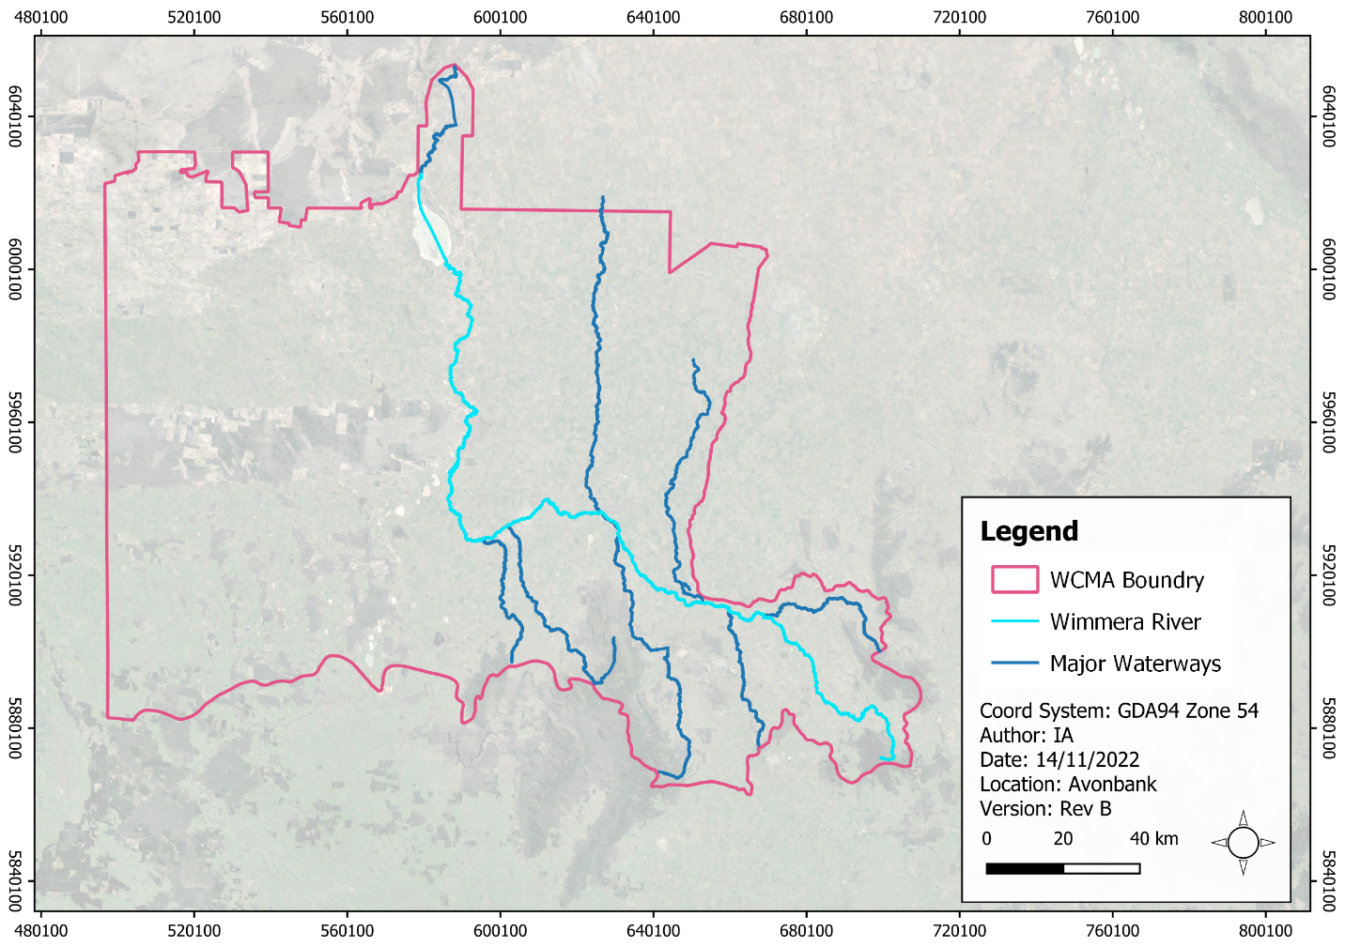
Figure 7-4: Wimmera River and other major waterways
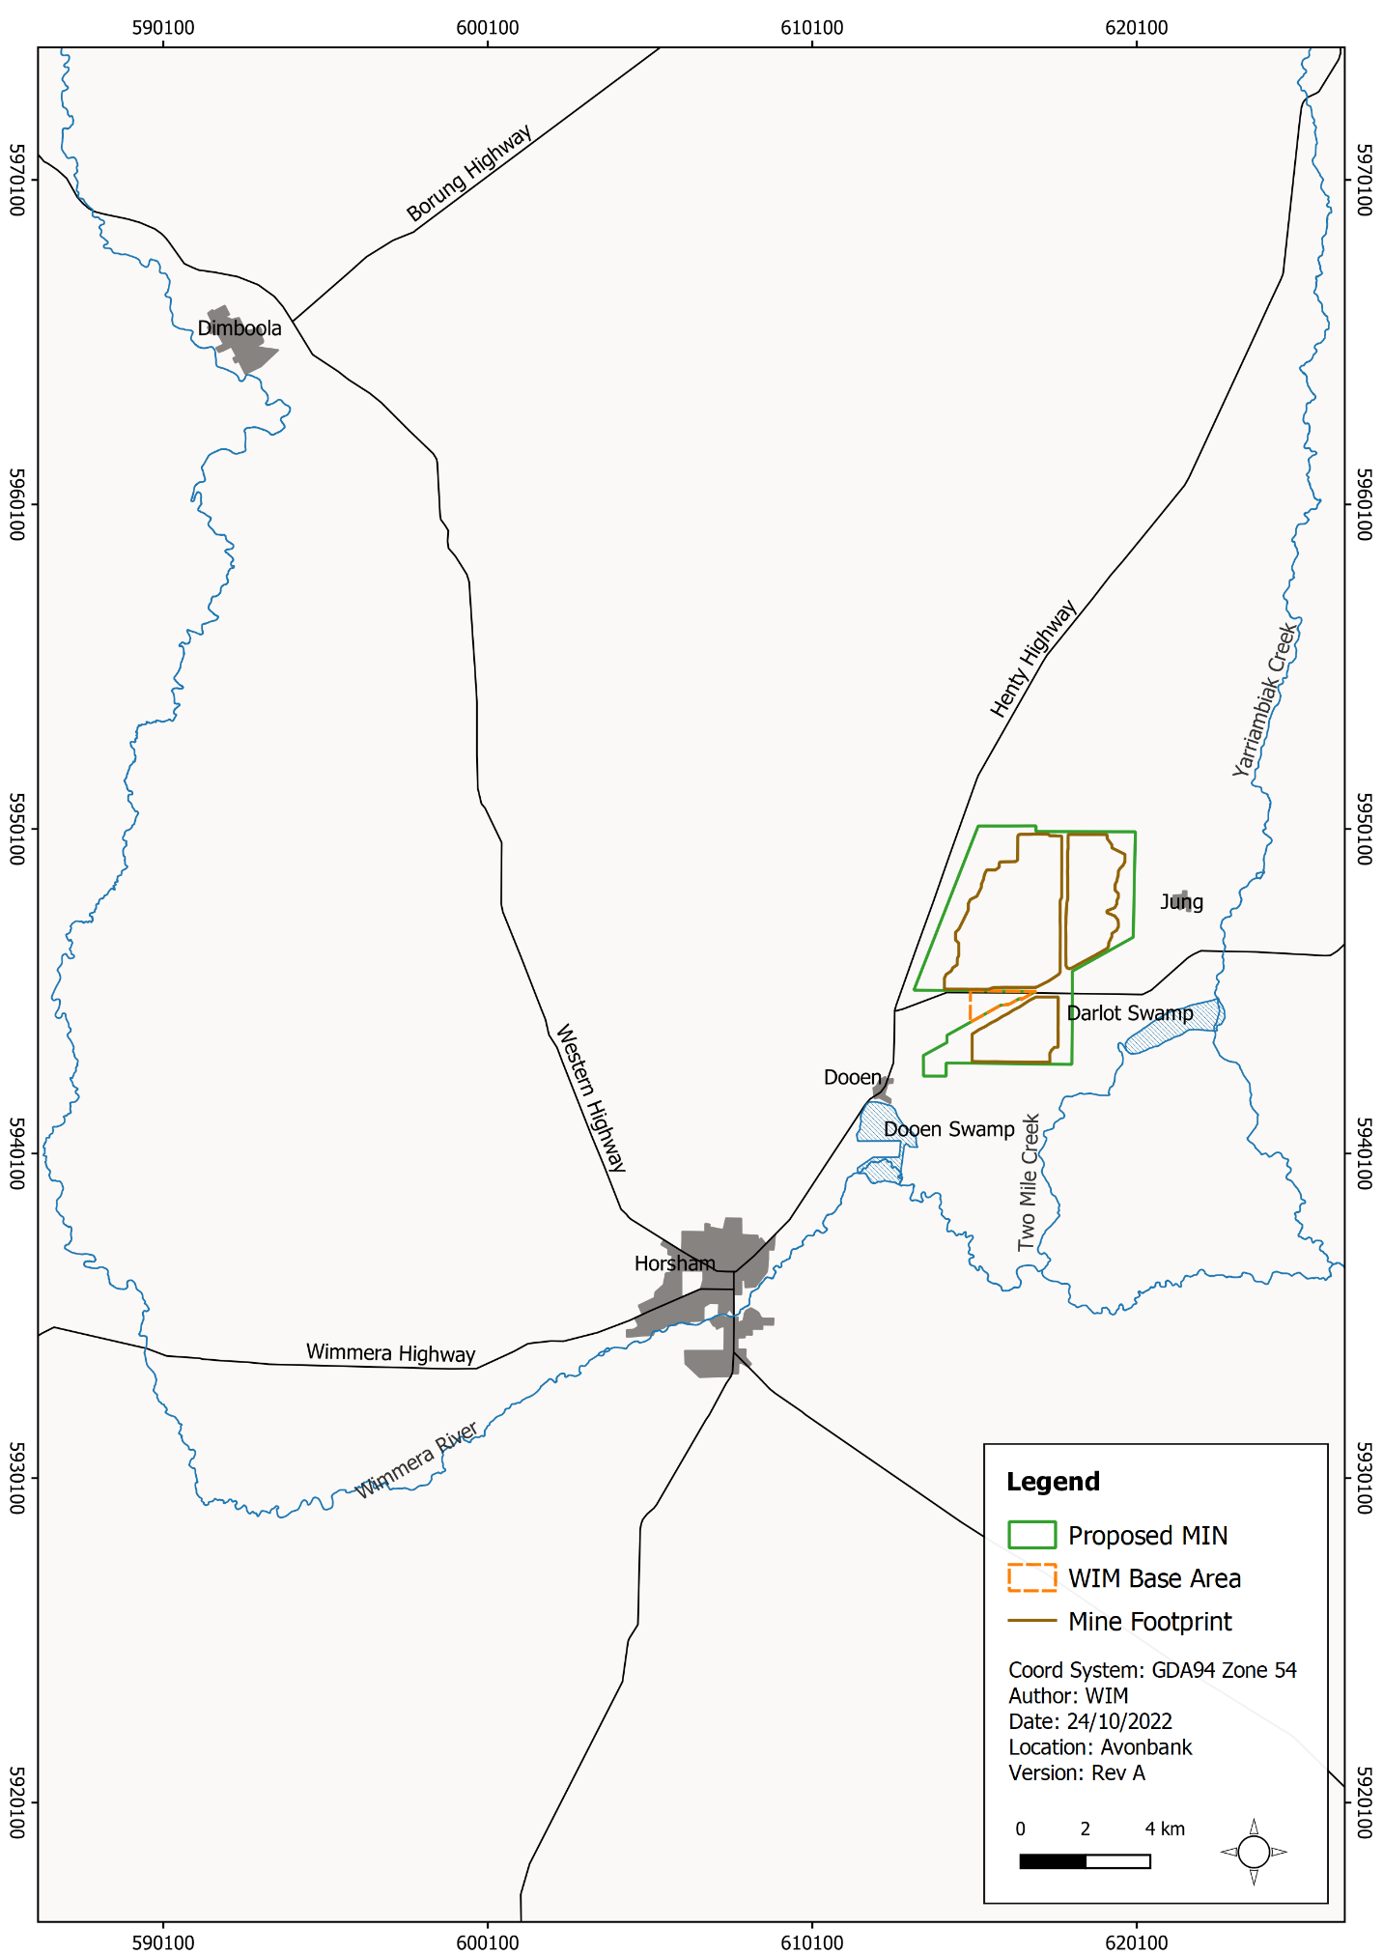
Figure 7-5: Waterways in the vicinity of the proposed mining licence

Biodiversity
Victorian biogeographic regions (bioregions) reflect the ecological characteristics across the State. The bioregions provide a framework for recognising and responding to biodiversity values. The development extent is situated within the Wimmera bioregion (refer Figure 7-6).
The Wimmera bioregion is characterised by flat to gently undulating plains in the east, with black and grey cracking clay soils (vertosols). Plains Woodland, Plains Grassy Woodland, Plains Grassland, Red Gum Wetland and Grassy Woodland are the dominant ecosystems. The western part is typified by ancient stranded beach ridges interspersed with clay plains (where there is a mixture of swamps, lakes, lagoons and lunettes in the south) with cracking clay soils and red texture contrast soils (vertosols and sodosols).
The Wimmera region in the vicinity of the development extent has been extensively cleared for broadacre agricultural cropping. Tree cover is mostly contained in National Parks and on public land in isolated areas broken up by cleared land (refer Figure 7-7).
Figure 7-6: Bioregions within the WCMA area and Wimmera catchment.
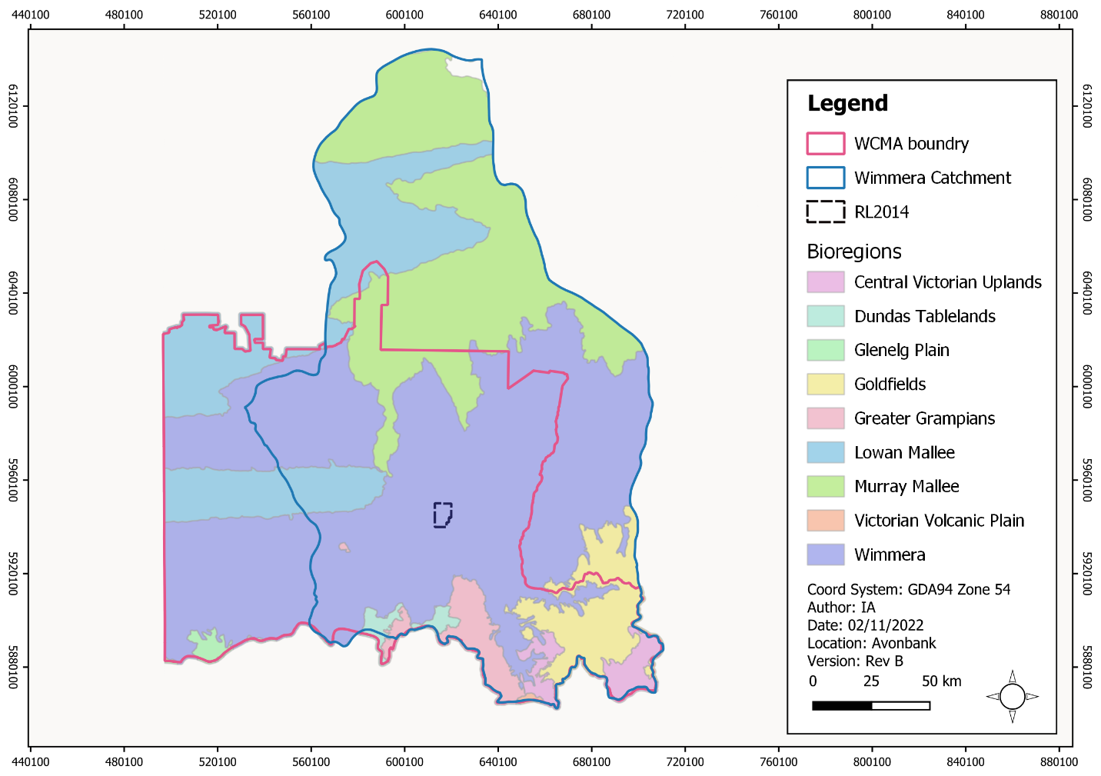

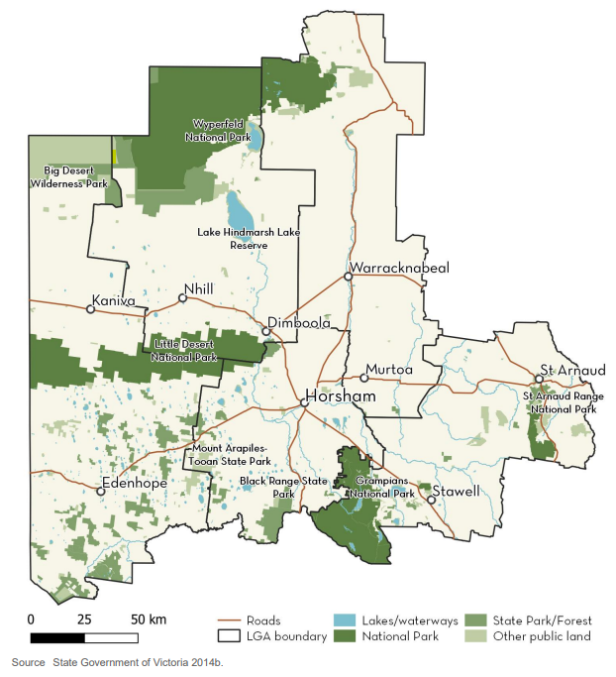
Figure 7-7: National parks and state forests

Aboriginal Cultural Heritage
The Wotjobaluk, Jaadwa, Jadawadjali, Wergaia and Jupagalk peoples are the recognised original inhabitants of the area of western Victoria and are part of the region’s contemporary Aboriginal community.
The Wotjobaluk, Jaadwa, Jadawadjali, Wergaia and Jupagalk peoples have non-exclusive native title rights over some Crown reserves along the banks of the Wimmera River. They are represented by a body corporate, the Barengi Gadjin Land Council (BGLC) Aboriginal Corporation, which is a Registered Aboriginal Party (RAP) within the State of Victoria.
The region primarily comprises land that has been extensively modified since the 1840s. Past disturbance by agriculture is likely to have removed some Aboriginal cultural heritage sites had they previously occurred.
Areas of surface water in the otherwise drier Wimmera region generally hold important intangible Aboriginal cultural value. Such areas include the Dooen Swamp and Darlot Swamp, approximately 1 km to the south-west and 1 km to the east of the development extent, respectively.
Aboriginal cultural heritage is important to the Wimmera region’s identity and contributes to the economy by providing heritage tourism experiences.

Heritage Sites
The WSM region holds numerous heritage sites, mostly within its main settlements, centred around early exploration, pastoral expansion and the establishment of infrastructure. The WSM is recognised as having a strong farming heritage.
Horsham has a significant collection of interwar structures from the 1920s and 1930s that reflect the development of the City. On the Victorian Heritage Register, 92 heritage places and items were identified in Horsham.
The historic heritage in the region is greatly valued and protected, forming the urban character of the townships and encouraging tourism.

Governmental Areas and Services
The WSM has a population of approximately 50,000 people, of which around a quarter are employed in the agricultural sector. In 2014, the ‘Wimmera Southern Mallee Growth Plan’ (WSMRGP) was launched with a vision to increase primary production and diversify the region’s economy with industry, mining, tourism, and education by 2041 (Vic Gov, 2014). The plan also describes the importance of the preservation and maintenance of the region’s environmental, community, economic and cultural assets.
The Project aims to seek goods and services from the region. This includes the provision of goods, commercial services, emergency services, equipment and human resources to meet the workforce needs. The populations associated with the LGAs located in the WSM are summarised Table 7-1.
Table 7-1: WSM LGA population
Shire | Population (Year)
Yarriambiack | 6,600 (2018)
Hindmarsh | 5,700 (2022)
Buloke | 6,350 (2021)
West Wimmera | 3,500 (2022)
Northern Grampians | 11,470 (2021)
Southern Grampians | 16,100 (2018)
Horsham Rural City | 20,369 (2021)
The retention licence is located in the HRC, which is administered by the Horsham Rural City Council (HRCC). This LGA is 4,265 km² in area, with the majority of the population residing in the City of Horsham.
The City of Horsham is the main urban centre for the HRC and is the closest larger urban centre to the development extent. It is located at the junction of the Western Highway, Wimmera Highway and Henty Highway, 15 km to the south-west of the development extent.
Horsham serves as a district centre, representing Wimmera's main business and employment centre and provides health, retail, government, community, industrial and agribusiness services at its town centre.
The regional city is supported by key social infrastructure, including the Wimmera Base Hospital, four medical clinics, government centres, educational facilities (five kindergartens, four primary schools, three secondary schools and the Federation University), recreational facilities and places of worship. The Horsham urban centre also includes a regional-scale commercial and retail precinct, which accommodates several supermarkets, pubs and restaurants and specialty retail and services.
The highest employing industries include health care and social assistance, retail trade and construction. The local economy is largely reliant on the agricultural sector.
Horsham is on the Melbourne-Adelaide railway line. Rail transport includes both passenger rail and freight rail. Interstate freight trains regularly travel through Horsham to the Wimmera Intermodal Freight Terminal (WIFT) Precinct in Dooen. Public transport services for the WSM are supported by the V/Line service, which services regional Victoria. V/Line includes a train service into Ararat and connecting coach services to Horsham and onward to Nhill.
The Horsham Airport is located to the north of the city and hosts a variety of private aviation companies as well as a depot for the Royal Flying Doctor Service.
Smaller settlements located in the HRC in the area of the development extent are the towns of Dooen, 5 km to the north-east and Jung, approximately 1 km to the east. Dooen has an estimated population of around 40, and Jung has a population of around 80.
Dooen is a small settlement comprising the Dooen Hotel, Dooen Hall and a scattered collection of dwellings bisected by the Henty Highway. Jung incorporates several local amenities, including the Jung Hall, Pepper Tree Reserve (a small open space with a children’s playground), a Country Fire Authority (CFA) station and the Jung Recreation Reserve. There are no retail premises, educational or medical services in Jung.
Victoria is divided into nine fire districts, and the HRC falls within the Wimmera Fire District. The Fire Danger Period (FDP) typically starts in late spring to early summer and is declared by the CFA. Once declared, the FDP stays in place until fire danger reduces sufficiently, typically by mid-autumn. Total Fire Bans are declared on days when fires are likely to spread rapidly and be difficult to control. Emergency fire services in the area of the development extent include CFA stations located in Horsham, Dooen and Murtoa.
Emergency medical facilities are provided through the Wimmera Base Hospital in Horsham.

Land Use
The area encompassing the development extent mostly comprises privately owned property used primarily for dryland, broadacre continuous cropping.
Commercial and industrial land uses in the area primarily relate to transport services, such as freight and logistics. The WIFT Precinct is located adjacent to the development extent. A Special Use Zone is established over the WIFT Precinct for industrial purposes, including the processing, storage and handling of mineral sands. The WIFT Precinct is well connected to Melbourne, Portland and Adelaide via road and three separate rail corridors suitable to carry freight.
The Longerenong College and associated residences are situated to the south of the development extent. The college has a student population of approximately 180 and provides on-campus accommodation for up to 107 people. Part of the college grounds lie within the development extent, however, this area does not contain any major infrastructure.
The Wimmera Events Centre is located to the south of Longerenong College. The events centre is a privately owned purpose-built events facility comprising two large-scale pavilions, many smaller pavilions, meeting rooms, facilities for on-site camping, catering areas, numerous sheds and outbuildings. The facility is used to hold major events throughout the year and numerous other gatherings on a small to medium scale.
Natural assets within the HRC and its surroundings provide a strong base for tourism. Horsham is located within a 30 minute drive to either the Mount Arapiles-Tooan State Park to the west or the Wartook Valley and the Grampians (Gariwerd) National Park to the south-east. The WSMRGP has included a strategic direction for the development of complementary infrastructure to improve regional attractions.
Waterways in the region are widely used for tourism and recreational activities, including fishing, swimming, canoeing, water skiing and birdwatching.
Mining and extractive industries continue to be a major industry in the WSM, with the Stawell Gold Mine and numerous quarries located across the region. Other planned mineral sands, energy and infrastructure development projects with the potential to interact with the Project are outlined in Section 7.5.

Transport, Services and Utilities
The main transport corridor in the WSM is the Western Highway, which connects Horsham to the major city centres of Melbourne and Adelaide. The Henty Highway is a key arterial route, providing north–south connectivity through the WSM region and access to PoP for the import and export of bulk commodities, such as fertilisers, grain and mineral sands. Transport infrastructure in the region is also supported by the Melbourne to Adelaide railway that follows the east-west alignment of the Western Highway.
Power to the WSM region is primarily supplied by Powercor, an electricity distribution company that operates throughout western Victoria and the western suburbs of Melbourne. Powercor owns and maintains power lines, substations and streetlights.
Water and wastewater services for most of north-western Victoria, larger settlements including Horsham and the area encompassing the development extent are provided by Grampians Wimmera Mallee Water (GWMWater), a government-owned statutory corporation.
GWMWater is responsible for the provision of stock and irrigation water supplies in rural areas, including services provided through the Wimmera-Mallee Pipeline. Water supplies for urban usage in the WSM region are supplied by surface water from both within and outside the region.
Reticulated gas supplies within the WSM are currently provided by SP AusNet in Horsham and the immediate surrounding residential areas.
Town centres in the WSM are serviced with NBN telecommunications. Mobile telecommunication services vary in reliability, particularly in the more sparsely settled areas.

Project Haulage Route
The HMC product will be transported by road from the WBA to the PoP via the Henty Highway (refer Figure 7-8). Haulage traffic will travel via Horsham, Cavendish, Hamilton, Branxholme and Heywood, passing through the HRC, Southern Grampians and Glenelg Shires.
The Southern Grampians Shire is in south-west Victoria. It has a population of approximately 16,100 people, with Hamilton being the regional hub. Agriculture is the largest employment sector in the Shire. The Glenelg Shire is in the southwestern corner of Victoria. It has a population of approximately 19,600 people, with Portland being the major urban centre. The Shire's economy is based on service industries, timber production, grazing and manufacturing.
The arterial transport route to the PoP has been and continues to be, widely used to transport agricultural products and mineral sands. The land use surrounding the transport route is predominantly rural land used for agriculture. The rural cities of Horsham and Hamilton serve as commercial and retail centres, however, the road network bypasses the commercial core of these cities, as well as Branxholme and Heywood.
Cavendish is a small town located in the Southern Grampians shire with a population of 454. Haulage traffic will travel through the centre of the town, passing by public open space, shops and the Cavendish Hotel.

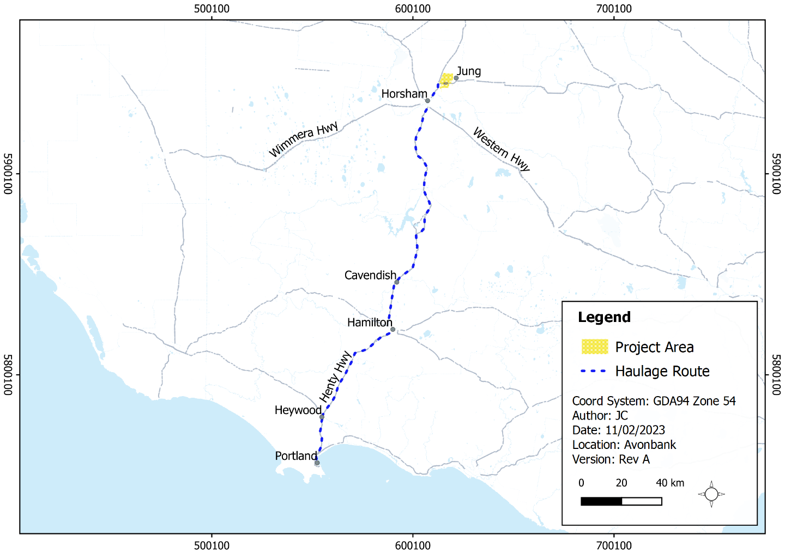
Figure 7-8: Haulage route to PoP

Port of Portland
Portland, within Glenelg Shire, is located on the far south-west coast of Victoria. One of Portland's major industries is the Alcoa aluminium smelter. Portland has a population of approximately 10,000 people. It is a main regional centre that supports the fishing industry and is well connected with rail links, and the PoP for overseas shipping.
The PoP is a commercial deep-water port located in the City of Portland, specialising in the export of bulk commodity products, including mineral sands, forestry products, livestock, grain, and fertiliser. The PoP imports and exports goods to international markets in China, Japan, Korea, Indonesia and Taiwan, as well as other Australian regions.
The PoP is zoned ‘Port Zone (PZ)’, a Special Purpose Zone under the Glenelg Planning Scheme. The zoning provides for PoP’s ongoing use and development consistent with a designated port development strategy. A residential precinct is located on higher ground adjacent to the Port’s southern boundary.

Other Projects in the Region
This Section describes other activities or projects known in the vicinity of the development extent that may interact with the Project. Some of these have approval and financial support in place and are underway, while others are yet to receive approval or funding and are at an early stage of development. These projects have been considered relevant as part of the cumulative impact assessments for each of the EES technical studies. The projects are summarised below and depicted in Figure 7-9.
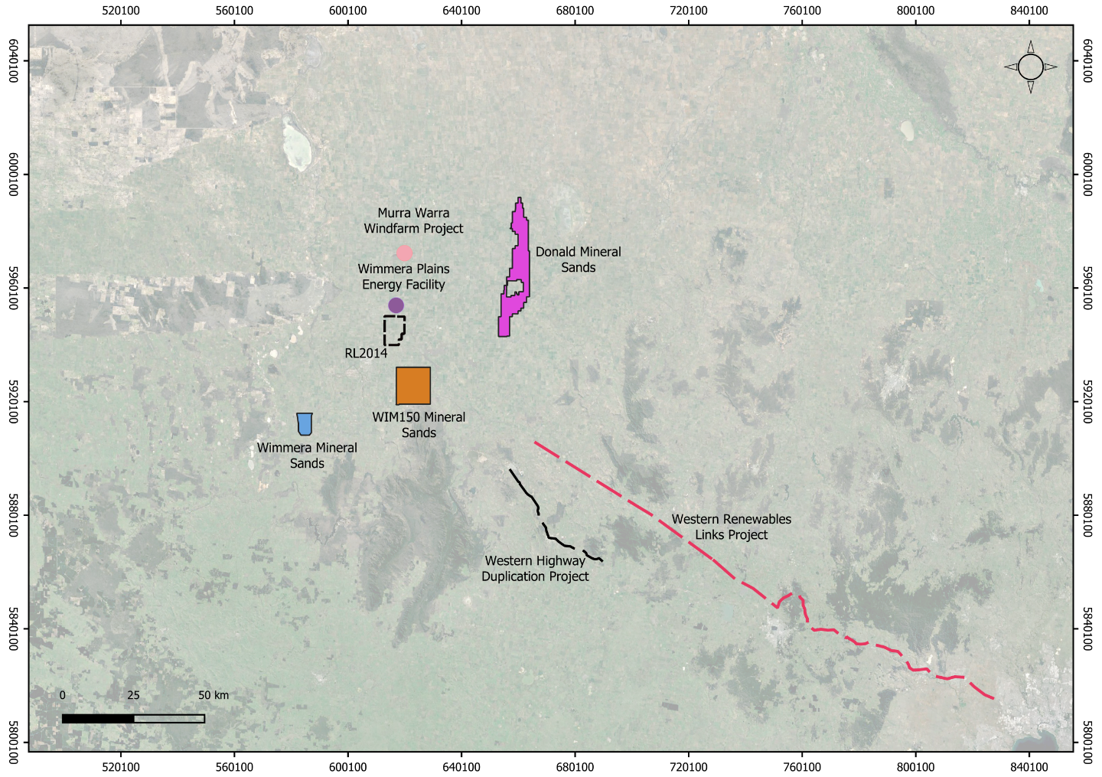
Figure 7-9: Other projects in the region

Wimmera Mineral Sands Project
Iluka Resources Limited (Iluka) is an Australian-owned, ASX-listed international mineral sands company involved in exploration, mining and processing. Iluka is in the pre-feasibility phase for the Wimmera Mineral Sands project, located approximately 25 km south-west of Horsham. The company is currently undertaking technical studies regarding the project’s commercial viability and has commenced the EES process. Current projections for the duration of mining activity (and associated progressive rehabilitation works) is a 20–25 year period. This project is approximately 42 km south of the development extent.

WIM150 Mineral Sands Project
This is a joint venture project being managed by Murray Zircon. Located in the Wimmera, 20 km south-east of Horsham, the proposed project will see the development of the 12,850 ha WIM150 minerals sands deposit. The proponent has formally advised the DELWP to place the EES process on hold while a review of the project occurs prior to recommencing the EES process. This project is approximately 15 km south-east of the development extent.

Donald Minerals Sands Project
The Donald Minerals Sands project is being developed by Astron Limited. It is situated approximately 50 km north-east of Horsham. The EES process is complete, and the project was assessed in November 2008. A draft work plan is in the process of being prepared. This project is approximately 30 km north-east of the Avonbank retention licence.

Murra Warra Wind Farm Project
This wind farm is located in north-western Victoria, 25 km north of Horsham, between the Henty Highway and the Blue Ribbon Road. It is being developed in two stages, with Stage 1 (61 wind turbines – total maximum capacity of 225.7 MW) now operational. Stage 2 is under construction and will consist of an additional 38 wind turbines. The Murra Warra Wind Farm is located approximately 13 km north of the development extent.

Wimmera Plains Energy Facility
Proposed by BayWa r.e., the Wimmera Plains Energy Facility is located 10 km north-east of Horsham on land to the east and west of the Henty Highway. The wind farm, encompassing the formerly proposed Jung Renewable Energy Project, comprises over 50 wind turbines for an output of between 291 MW and 416 MW, with a connection to western Victoria’s 220 kV electricity network.

Western Renewable Links Project
This project was announced in 2019 and is in its early stages of planning. This is a new 190 km west transmission line. Starting in Bulgana in Victoria’s west, the project will connect to Sydenham in Melbourne’s north-west via a new terminal station. This will support utility servicing infrastructure to urban settlements across the region and minimise the load on the existing network and minimise transmission losses, especially in dispersed towns. This project is approximately 82 km south-east of the retention licence.

Western Highway Duplication project
This Victorian State Government Project is approximately 63 km south-west of the development extent, between Ballarat and Stawell. Parts of the project have been completed, and others are in various stages of planning and construction. This project aims to improve the capacity and efficiency of the transport network with the anticipated increase in freight tasks for grain or other products.

