Avonbank Mineral Sands Project
Environment Effects Statement

Executive Summary

TABLE OF CONTENTS
Executive Summary 1
1 Introduction 1
2 The Project 1
2.1.1 Overview 1
2.1.2 Rationale 3
2.1.3 Project Activities 3
2.1.4 Construction 3
2.1.5 Operations 4
2.1.6 Rehabilitation/Closure 6
2.1.7 Project Alternatives 8
3 Existing Environment 8
3.1 Noise, Air Quality and Greenhouse Gases 8
3.2 Geology and Soils 8
3.3 Surface Water and Groundwater 9
3.4 Flora and Fauna 9
3.5 Social Setting, Health and Heritage 10
3.6 Economic Setting 11
4 The EES 11
4.1 Why an EES is Required for the Project 11
4.2 The Structure of the EES 13
4.3 The Evaluation Objectives for the EES 13
4.4 Key Project Approval Requirements 14
4.5 Impact Assessment Methodology 14
4.6 Impact Assessment Findings 15
4.6.1 Land Use and Planning Impacts 15
4.6.2 Traffic and Transport Impacts 16
4.6.3 Historic Heritage Impacts 16
4.6.4 Landscape and Visual Amenity Impacts 17
4.6.5 Noise and Vibration Impacts 18
4.6.6 Air Quality Impacts 18
4.6.7 Radiation Risks 19
4.6.8 Soils and Landform Impacts 20
4.6.9 Surface Water Impacts 20
4.6.10 Groundwater Impacts 21
4.6.11 Human Health Risks 22
4.6.12 Waste and Emissions Impacts 22
4.6.13 Socioeconomic Impacts 23
4.6.14 Flora and Fauna Impacts 24
4.6.15 Aboriginal Cultural Heritage Impacts 25
4.6.16 Impact to Matters of National Environmental Significance 25
4.7 Environmental Management 26
4.8 Community Consultation 27
4.8.1 Background 27
4.8.2 Post EES Approval Consultation 28
4.9 EES Conclusions 28
4.10 Next Steps 29

TABLES
Table 1: Annual Project operational economic impacts 3
Table 2: EES structure 13
Table 3: Evaluation objectives 14

FIGURES
Figure 1: Project location 2
Figure 2: Development extent 5
Figure 3: Project overview 6
Figure 4: Mining at Avonbank (Demonstration Trial 2019) 7
Figure 5: Completed rehabilitation at Avonbank (Demonstration Trial 2021) 7
Figure 6: Impact assessment framework 15

Executive Summary

Introduction
This Executive Summary provides an overview of the Environment Effects Statement (EES) for the Avonbank Mineral Sands Project (the Project). The Executive Summary outlines the Project description, the setting in which the Project is proposed, provides a summary of the environmental assessments undertaken and describes the significance of the Project related residual impacts.
The Project will be owned and operated by WIM Resource Pty Ltd (WIM) and will involve mining the Avonbank ore body to produce a premium quality mineral sands product comprising mainly zircon, titanium-rich mineral concentrate and minor amounts of rare earth products.
On 17 August 2019, the Victorian Minister for Planning determined an EES was required for the Project under the provisions of the Environment Effects Act 1978 (EE Act). The Project was also determined to require assessment under the Commonwealth’s Environment Protection and Biodiversity Conservation Act 1999 (EPBC Act).
The EES is comprised of a main report supported by technical studies and supporting information provided as appendices and attachments.

The Project

Overview
The Project comprises the mining and processing of mineral sands to produce a Heavy Mineral Concentrate (HMC), road haulage of HMC to the Port of Portland (PoP), and the temporary storage of HMC at the PoP prior to loading and shipping overseas. The Project will produce approximately 12.75 million tonnes (Mt) of HMC over the operational life of mine.
The HMC product consists of zircon, titanium-rich mineral concentrate and minor amounts of rare earth products.
Zircon is used in the production of ceramics and other applications such as catalytic fuel converters and in water and air purification. Titanium minerals (ilmenite, leucoxene and rutile) are principal components for pigment production used in products such as protective house/car paints, paper, plastics, ink, rubber, textiles, cosmetics, sunscreens, leather and ceramics. Rare earth minerals are critical components for various applications, in particular electric vehicles and wind turbines.
Mining and processing activities will operate 24 hours a day, 365 days per year. The life of the Project (construction, operation and rehabilitation/closure) is expected to be 36 years, with the operational period of the Project being 30 years.
The Project location, including the granted retention licence and proposed mining licence (MIN) areas, are shown in Figure 1.
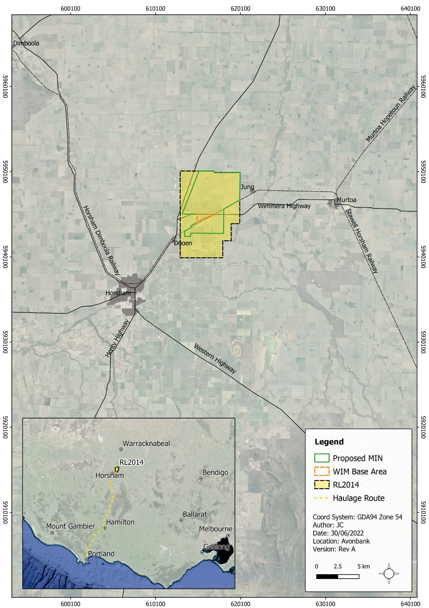
Figure 1: Project location

Rationale
The objective of the Project is to establish a world-class mining operation and concentration plant which will safely and efficiently produce a premium-quality mineral concentrate for export overseas.
The Project aims to supply approximately 5% of the global demand for zircon, 2% to 3% of the global demand for titanium, and approximately 5% of the global demand for rare earth minerals over the next 30 years. In doing so, the Project is in line with the federal government’s 2022 ‘Critical Minerals Strategy’ (DISR, 2022) to promote Australia’s capacity to meet the increasing global demand for critical minerals such as zircon.
Through its activities, the Project aims to create and sustain significant long-term employment and economic activity in Victoria and the Wimmera Southern Mallee (WSM), the region in which the Project is located. The economic impact the Project will have for every year it is operational (inclusive of direct, flow-on supply chain and consumption effects) is presented in Table 1.
Table 1: Annual Project operational economic impacts
Impact | Victoria | WSM Region
Gross revenue | $512.8 million | $335 million
Employment | 967 FTE jobs | 588 FTE jobs
Wages and salaries | $93 million | $56.7 million
Value added | $192.4 million | $116.7 million
Over the 30 year Project operational life, the royalties for the State of Victoria will be approximately $180 million, there will be an increase in the Gross State Product (GSP) for Victoria of $5,772 million, and a gross revenue output of $335 million per annum in the WSM. During operation, the Project will support 588 jobs across the WSM and 967 in Victoria (direct and indirect full-time equivalent).
These economic benefits for the WSM region and Victoria would not be realised if the Project did not proceed and the Commonwealth’s 2022 Critical Minerals Strategy would not be supported.

Project Activities
Mining and related activities will occur within the proposed mining licence (3,426 ha) to be secured within the granted retention licence 2014 (RL2014) and secondary processing in an adjacent area, referred to as the WIM Base Area (WBA) (90 ha). Minor utilities, including power and water infrastructure, will extend to the WBA from the respective terminal stations. The utilities infrastructure corridor will be located within areas of road reserve and private properties.
The WBA is primarily located within the Special Use Zone established over the existing Wimmera Intermodal Freight Terminal (WIFT) Precinct zoned for industrial purposes, including the processing, storage and handling of mineral sands.

Construction
Construction works will be required in the WBA during the first 12 months of the Project.
Site access from the Wimmera Highway and temporary construction services (site offices, site ablutions and lay-down areas) will be established. Earthworks will include clearing, stripping of topsoil layers, and bulk filling to the design level. The Wet Concentrator Plant (WCP) and ancillary infrastructure will be constructed within the WBA.
Minor utility works will involve the construction of water mains to the WBA and an upgrade of existing powerlines.

Operations
The resource development potential of the Avonbank deposit comprises a global mineral resource estimate of 490 Mt of ore. The Project will produce approximately 12.75 Mt of HMC over the operational life of mine.
Mining will be undertaken over a 30 year period. The mining licence area will be divided into four Blocks (A-D), which will be mined sequentially. The total mining footprint will cover an area of 2,215 ha. The development extent is shown in Figure 2 and an overview of Project operations is provided in Figure 3.
Mining will involve open pit mining to a depth of approximately 24 m to 30 m below the ground surface. A ‘moving hole’ mining method will be used where tailings and overburden will be directly returned into the mined cell as the mining front advances. This will enable progressive rehabilitation of mined areas, such that at any given time Project disturbance will average less than 300 ha, with a maximum disturbance area of 400 ha.
Topsoil and subsoil horizons will be stripped and stockpiled adjacent to the ore mining cell. Overburden will be excavated and directly returned to a previously completed ore mining cell.
Primary processing of the mined ore will take place within the mine void, where the ore will be prepared and pumped to the WCP via an above-ground slurry pipeline.
Secondary processing to separate and concentrate the HMC will occur at the WCP. Valuable heavy minerals will be separated from the slurry at the WCP and the resultant HMC product stockpiled ready for transport. Sand tailings from the WCP will be thickened and dosed with a polymer flocculant to promote water recovery prior to return to the mine void.
At the WBA, the HMC will be loaded by front-end loader into B-double articulated vehicles (trucks) and transported to the PoP via the Henty Highway (26 return trips per day). The HMC product will be unloaded from the B-double trucks into a bunker/storage shed at the PoP. It is expected that every 2 to 3 weeks a ship will be loaded with HMC for transport overseas. The HMC will be transferred directly from the storage shed to the ship’s bulk hold using a closed circuit bulk loading system.
Water for the Project processes will be supplied by Grampians Wimmera Mallee Water (GWMWater) via an extension of the Wimmera-Mallee Pipeline.
The main waste streams resulting from Project activities will include sand tailings, excavated regolith (overburden, subsoil and topsoil), waste hydrocarbons from vehicle and equipment maintenance, generation of sewage from ablutions, stormwater run-off, greenhouse gas (GHG) emissions and other general municipal waste.
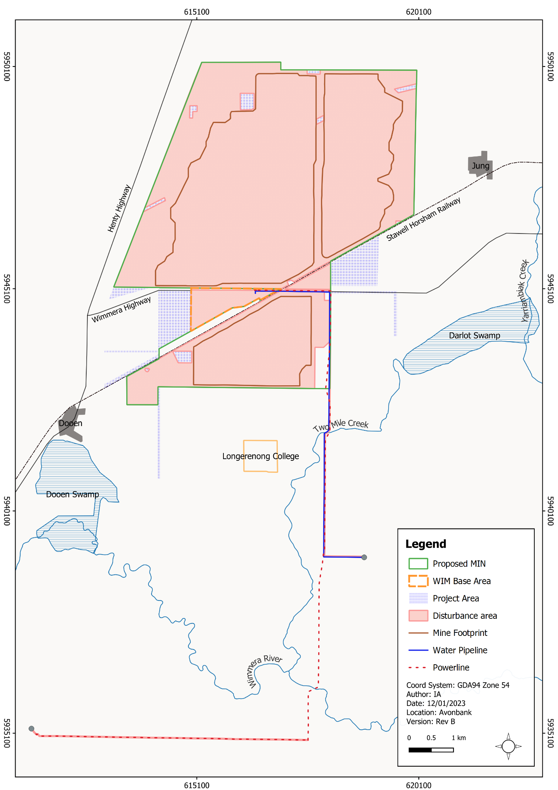
Figure 2: Development extent
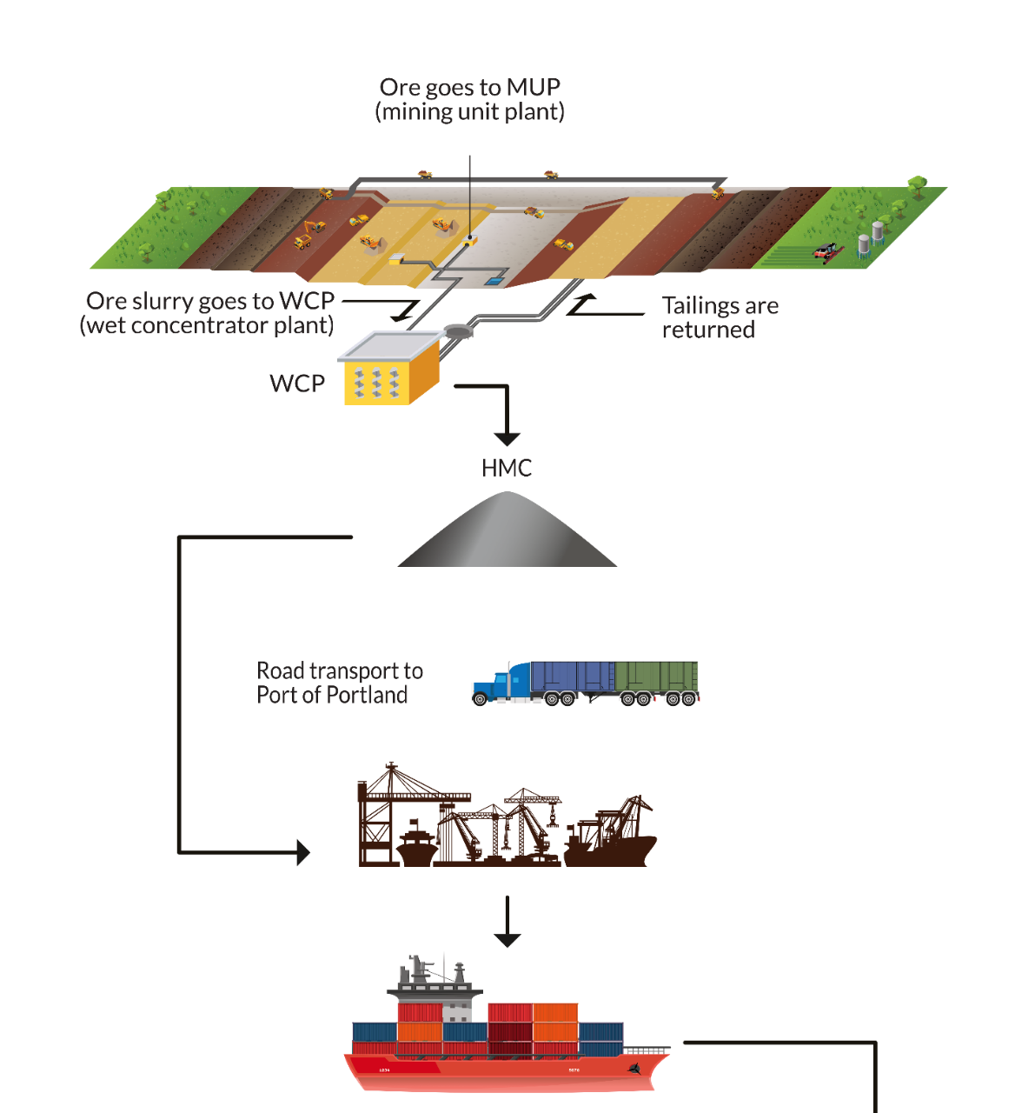
Figure 3: Project overview

Rehabilitation/Closure
Rehabilitation of mined areas will be completed within 4 years after initial disturbance of each mining cell. The overarching rehabilitation strategy is to recover as much of the effective rooting zone as practicable and to separate the upper soil horizons from the lower more hostile units. The rehabilitated landform will be stable, sustainable and commensurate with the agreed end land use.
Sand tailings will be deposited into the mined cell to a depth of approximately 3 m from the surface. After drying, the tailings will be covered with overburden, subsoil and finally topsoil. The topsoil will be seeded with a broadacre agricultural crop.
There will be no stockpiles or voids left upon completion of mining. Rehabilitation will be considered complete when all rehabilitation objectives/criteria are met. The final landform will be commensurate with the surrounding areas and the pre-mining landscape.
During 2019–2022, the Avonbank Demonstration Trial was successfully undertaken to test the feasibility of mining, processing and rehabilitation within the development extent (refer Figures 4 and 5).
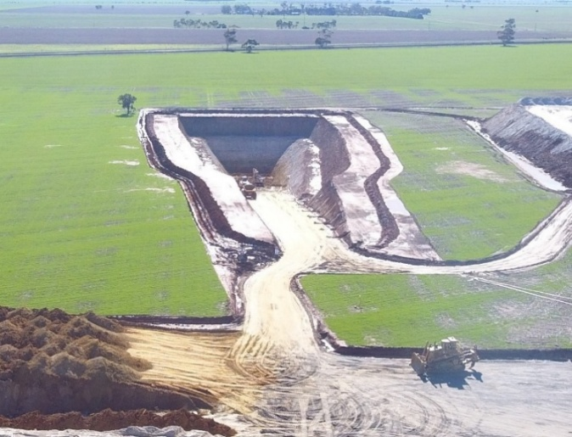
Figure 4: Mining at Avonbank (Demonstration Trial 2019)

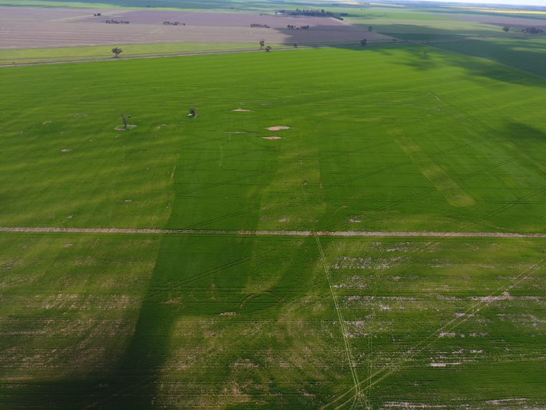
Figure 5: Completed rehabilitation at Avonbank (Demonstration Trial 2021)

Project Alternatives
The Project design was developed and refined over the course of the EES preparation period, with consideration to the feasibility studies, technical impact assessment studies and stakeholder feedback.
Project design alternatives were assessed with consideration to the operational constraints and opportunities, environmental impacts, risks or opportunities, stakeholder feedback and cost implications and limitations. The key Project design considerations are outlined below and detailed in Chapter 3.
Mining of the Avonbank ore body will involve open pit mining. Two methods of mining were considered: dry mining and wet mining. Dry mining was the preferred option as it provides increased flexibility, requires less water and allows for relatively rapid land rehabilitation.
The HMC product will be transported to the PoP for overseas shipment. Both road transport and rail transport were considered for product haulage. The existing rail infrastructure was however not suitable for the purpose, due to operational constraints that required upgrades to the rail line and loading facilities.
Project activities will necessitate the removal of vegetation and topsoil within the development extent. Measures were developed to avoid 4.78 ha of EPBC Act listed Buloke Woodlands of the Riverina and Murray Darling Depression by reducing the mining footprint and sterilising sections of the ore body. The total area of this threatened ecological community to be removed was reduced to 0.23 ha.

Existing Environment
The development extent is located in the Horsham Rural City (HRC) municipality, over which the Horsham Planning Scheme (HPS) applies. The predominant land use within the development extent is broadacre farming, intersected by public minor roads and the Wimmera Highway.

Noise, Air Quality and Greenhouse Gases
The majority of the development extent is located in a quiet noise environment typical of rural areas.
Background air quality monitoring indicated the levels of particulate matter (PM), respirable crystalline silica (RCS) and heavy metal content in the development extent are within applicable criteria, with the exception of episodic PM₁₀ measurements. The criterion for PM₁₀ (24-hour average) was exceeded on five occasions over a 12-month period of monitoring, with the results indicative of windblown dust, harvesting or sowing of seed for grain crops.
The existing conditions for GHG provide a base case against which emissions from the Project can be compared. The Climate Change Act 2017 drives the State to achieve net-zero emissions by 2050. Victoria’s total GHG emissions for 2019 was 91.3 Mt CO₂^{-e}, representing a reduction of 25% from 2005 levels.

Geology and Soils
The Project area lies within the Parilla Sands geological unit. There are two dominant soil types associated with the area: sodosols (soils with strong texture contrast between A and B horizons) and vertosols (clay soils with shrink-swell properties exhibiting strong cracking when dry).
The materials below the A and B horizons that sit above the ore are commonly referred to as overburden. There are two main types of overburden: upper clayey overburden (Shepparton Formation) and lower non-mineralised (barren) fine sand or clayey sand (Loxton Parilla Sands Formation). The mineralised parts of the Loxton Parilla Sands Formation represent the ore body targeted by mining.
Geera Clay lies beneath the Loxton Parilla Sands. Geera Clay is considered a Potential Acid Sulfate Soil (PASS) risk and will not be disturbed during mining.
There are no priority Environment Protection Authority (EPA) contaminated sites recorded within the development extent.

Surface Water and Groundwater
The Project is situated within the Wimmera River catchment, located in the southwestern part of the Murray-Darling Basin.
There are three designated waterways within the vicinity of the development extent: the Yarriambiack Creek, Two Mile Creek and the Wimmera River. Parts of Dooen Swamp are classified as a designated waterway, despite it being more appropriately defined as a wetland.
Riverine hydraulic and inundation modelling found that under current conditions, the largest river flood event modelled, a 1% annual exceedance probability (AEP) event, does not produce material external catchment overland flow into the development extent area. The modelling also found that most local rainfall inundation is caused by overland flow with inundated areas, in general, flooded to a depth of around 0.15 m during the 1% AEP event.
The hydrogeology of the study area comprises discrete hydrostratigraphic units, with the depth to groundwater ranging from around 5 m to 10 m in the south to more than 30 m in the north-west corner. Areas of shallow groundwater (less than 5 m) are associated with the Wimmera River, Dooen Swamp and Two Mile Creek.
Potential groundwater dependent ecosystems (GDEs) in the area include the Two Mile Creek, Wimmera River, Yarriambiack Creek, Darlot Swamp and Dooen Swamp.
Records indicate 42 private bores are located within approximately 5 km of the proposed mine area, 2 of which are listed as stock and domestic bores. The other bores are listed for groundwater investigation and observation.

Flora and Fauna
The development extent is within the Wimmera Bioregion. A large portion of this area is dominated by exotic species with limited remnant vegetation. Native and planted trees are largely restricted to property boundaries and road reserves.
Four threatened ecological communities (TECs) are represented in the development extent, with Northern Plains Grassland Community having the largest coverage (21.18 ha). The remaining TECs (Semi-arid Northwest Plains Buloke Woodland Community, Victorian Temperate Woodland Bird Community, and Red Gum Swamp Community No. 1) range in area from 0.02 ha to 5.01 ha.
Four TECs listed under the Environment Protection and Biodiversity Conservation Act 1999 (EPBC Act) were identified as having the potential to occur within the area: Seasonal Herbaceous Wetlands (Freshwater) of the Temperate Lowland Plains, Natural Grasslands of the Murray Valley Plains, Buloke Woodlands of the Riverina and Murray Darling Depression (Buloke Woodlands) and Mallee Bird Community of the Murray Darling Depression Bioregion.
The Seasonal Herbaceous Wetlands (Freshwater) of the Temperate Lowland Plains were confirmed to be absent from the development extent and there was no evidence to satisfy the condition thresholds for the Natural Grasslands of the Murray Valley Plains community in the development extent. The EVCs recorded within the study area did not correspond with the major vegetation groups described for the Mallee Bird Community of the Murray Darling Depression Bioregion.
Seven ecological vegetation classes (EVCs) were identified within the development extent with a combined total area of 28.50 ha, these being: Plains Grassland, Plains Savannah, Black Box Lignum Woodland, DELWP Mapped Wetland, Red Gum Swamp, Floodplain Riparian Woodland and Riverine Chenopod Woodland.
Flora species listed as Critically Endangered (Flora and Fauna Guarantee Act 1988 (FFG Act)) identified within the development extent and immediate surrounds were: 153 Buloke (Allocasuarina luehmannii), 10 Buloke Mistletoe (Amyema linophylla subsp. orientalis) and 6 Weeping Myall (Acacia pendula). No EPBC Act listed flora species have been recorded within the development extent and its immediate surrounds.
Large trees in patches and scattered Buloke trees at the north-western portion of the development extent are known to support Wedge-tailed Eagle (Aquila audax) nests. Large trees provide nesting, shelter and foraging habitat for microbats and log piles and fallen timber provide nesting, shelter, foraging and breeding habitat for reptiles. There was considered to be a moderate to high likelihood of occurrence of 19 fauna species in the development extent that are listed under the EPBC Act and FFG Act or under the FFG Act only.

Social Setting, Health and Heritage
The proposed mining licence and WBA are located in the HRC, approximately 15 km north-east of Horsham. Horsham has a population of around 20,000 and is the largest urban centre in the WSM region, providing retail, government, community, industrial and agribusiness services at its town centre.
The nearest settlements to the proposed mining licence and WBA are the towns of Dooen, 5 km to the south-west and Jung, approximately 1 km to the east. Dooen has an estimated population of 40, and Jung has a population of around 80. Murtoa, population of around 750, is located approximately 20 km to the east.
Project haulage traffic will use the Henty Highway to transport HMC product to the PoP via Horsham, Cavendish, Hamilton, Branxholme, and Heywood.
The Port facilities area is situated within a land use zone that provides for uses that derive direct benefit from co-establishing with a commercial trading port. The proposed land use complements the existing land use within the Port zone.
The age of the population in Horsham, Cavendish and Dooen is higher than the Victorian average. For Dooen, this is driven by a larger percentage of the population in the 15–64 year age group compared to the Victorian average. For Cavendish and Horsham, there is a much higher percentage of people greater than 65 years of age. By comparison, the population of Jung is younger than that of the other towns and the Victorian average.
The baseline health profile of people in the HRC, which includes the towns of Dooen and Jung, is better than the Victorian average. The rates of admissions for respiratory and cardiovascular disease and asthma are lower than those for Victoria as a whole.
The predominant land use within the development extent is broadacre farming, intersected by public minor roads and the Wimmera Highway. The Stawell-Horsham Railway passes through the proposed mining licence area. The minor utilities corridor passes through areas used predominantly for broadacre farming and some road reserves.
There are 25 landholdings located either partly or wholly within the proposed mining licence/WBA. There are several rural dwellings located in close proximity to the development extent as well as dwellings in the nearby townships of Dooen and Jung. The Longerenong College is an educational property that is partially located within the proposed mining licence. There is no educational infrastructure located within the development extent.
Traditional Owners associated with the region are the Wotjobaluk, Jaadwa, Jadawadjali, Wergaia and Jupagulk peoples, represented by the Barengi Gadjin Land Council (BGLC) Aboriginal Corporation. The BGLC Aboriginal Corporation is the Registered Aboriginal Party (RAP) for the area that encompasses the development extent. No previously registered Aboriginal Places are listed on the Victorian Aboriginal Heritage Register (accessed 20 June 2022) for the development extent, nor are any referenced in literature for the area.
No historic heritage sites are formally registered within the development extent. The nearest statutory listed site is the Dooen Hotel, located approximately 2.5 km to the south-west and the nearest non-statutory listing is the Dooen North Brighton School Plantation, located approximately 1 km north of the development extent.

Economic Setting
The WSM is predominantly an agricultural region with a focus on broadacre cropping. Horsham is the main administrative centre for the HRC, supporting residents and businesses across the region. Smaller settlements in the region include Dooen, Jung, Murtoa, Rupanyup and Minyip.
In 2016, the population of HRC was approximately 16,462, representing 30.7% of the population of the WSM region. The population has grown at a rate of 0.3% per annum since 2009 and is projected to reach 17,334 people by 2031.
The average annual unemployment rate for the HRC was 3.8% in June 2020, lower than the WSM region (4.1%) and the State average (5.4%). The highest employing industries include health care and social assistance, retail trade and construction.
Business count data from the Australian Bureau of Statistics estimates 2,130 businesses operate in the HRC, with 29% in the agriculture industry, followed by construction (13%) and real estate services (10%). Between 2015 and 2019, large declines occurred in industries with a small number of businesses, such as public administration and safety. However, the largest loss of business occurred in agriculture, with the number of businesses declining by 9%, which may be indicative of farm consolidation, poor seasonal conditions, and the ageing workforce.
The Henty Highway and the Wimmera Highway are key arterial roads within the WSM. The Henty Highway forms part of the region’s high-productivity freight network and provides north-south connectivity and access to the PoP for the import and export of bulk commodities.

The EES

Why an EES is Required for the Project
Where a proposed development has the potential to have a significant impact on environmental, socioeconomic and cultural values, an EES is required under the provisions of the EE Act. On 17 August 2019, the former Victorian Minister for Planning decided an EES was required for the Project.
The Commonwealth’s EPBC Act protects certain MNES and requires the assessment and approval of proposed actions likely to have a significant impact on MNES. On 3 July 2020, the Commonwealth Minister for the Environment determined the Project was a controlled action (that is, there are significant potential impacts to MNES) on the basis the Project has the potential to impact listed threatened species and communities and protection of the environment from nuclear actions.
To proceed the Project must therefore be assessed and approved under the EPBC Act. The Commonwealth has accredited the Victorian EES assessment process for this purpose.
The purpose of the EES is to describe the Project and assess its potential effects on the environment, including measures to avoid, minimise, rehabilitate or offset the effects. The EES assesses the key environmental effects the Minister determined needed to be addressed in the document, these being:
- Effects on the land use of the site and surrounding areas, including the implications for agricultural productivity.
- Effects on land stability, erosion and soil productivity associated with the construction and operation of the Project, including progressive rehabilitation works.
- Effects of Project construction and operation on air quality, noise and visual amenity of nearby sensitive receptors (particularly residences).
- Effects on surface water environments, including local waterways and the broader catchment, as well as groundwater (hydrology, quality, uses and dependent ecosystems).
- Solid and liquid waste that might be generated by the Project during construction and operation.
- Both positive and adverse socioeconomic effects, at local and regional scales, potentially generated by the Project, including increased traffic movement and indirect effects of the project construction workforce on the capacity of local community infrastructure.
- Effects on biodiversity and ecological values within and in the vicinity of the site and associated with adjacent road reserves and Crown land, including native vegetation, listed threatened ecological communities and species of flora and fauna, and other habitat values.
- Effects on Aboriginal and non-Aboriginal cultural heritage values.
The EES Scoping Requirements, issued in August 2020, detail the specific matters to be investigated within the EES and the evaluation objectives against which the Project will be assessed by the Minister for Planning.
The Scoping Requirements are included in the EES as Appendix A (Scoping Requirements).

The Structure of the EES
A summary of the EES structure is provided in Table 2.
Table 2: EES structure
Summary Brochure
Executive Summary

Main EES report
Chapter 1 | Introduction | Chapter 15 | Soils and landforms
Chapter 2 | Project Description | Chapter 16 | Surface Water
Chapter 3 | Project Alternatives | Chapter 17 | Groundwater
Chapter 4 | Regulatory Framework | Chapter 18 | Human Health
Chapter 5 | Community Engagement | Chapter 19 | Wastes and Emissions
Chapter 6 | Impact Assessment Framework | Chapter 20 | Socioeconomics
Chapter 7 | Regional Setting | Chapter 21 | Flora and Fauna
Chapter 8 | Land Use and Planning | Chapter 22 | Land Rehabilitation
Chapter 9 | Traffic and Transport | Chapter 23 | Aboriginal Cultural Heritage
Chapter 10 | Historic Heritage | Chapter 24 | Environmental Management
Chapter 11 | Landscape and Visual Amenity | Chapter 25 | Matters of National Environmental Significance
Chapter 12 | Noise and Vibration | Chapter 26 | Summary and Conclusions
Chapter 13 | Air Quality | Chapter 27 | Glossary, Abbreviations and Acronyms
Chapter 14 | Radiation
References
Appendices and Attachments
Appendix A | Scoping Requirements | Appendix L | Groundwater Impact Assessment
Appendix B | Land Use and Planning Impact Assessment | Appendix M | Human Health Risk Assessment
Appendix C | Road Traffic Impact Assessment | Appendix N | Economic Impact Assessment
Appendix D | Historic Heritage Impact Assessment | Appendix O | Social Impact Assessment
Appendix E | Cultural Heritage Management Plan Summary | Appendix P | Flora and Fauna Impact Assessment
Appendix F | Landscape and Visual Amenity Impact Assessment | Appendix Q | Waste and Emissions Impact Assessment
Appendix G | Noise and Vibration Impact Assessment | Attachment 1 | Stakeholder Engagement Report
Appendix H | Air Quality Impact Assessment | Attachment 2 | Draft Planning Scheme Amendment
Appendix I | Radiation Risk Assessment | Attachment 3 | Rehabilitation Plan
Appendix J | Soils and Landform Impact Assessment | Attachment 4 | Work Plan Framework
Appendix K | Surface Water Impact Assessment | Attachment 5 | Aspects and Risks

The Evaluation Objectives for the EES
The EES Scoping Requirements detail the evaluation objectives against which the Project will be assessed by the Minister for Planning (refer Table 3). These objectives provide a framework for an integrated assessment of the environmental effects and overall implications of the Project.
Table 3: Evaluation objectives
Environmental Value | Evaluation Objective
Resource development | Achieve the best use of available mineral sands resources in an economically and environmentally sustainable way.
Social, land use and infrastructure | Minimise adverse social, land use and infrastructure effects.
Amenity and environmental quality | Protect the health and wellbeing of the community, and minimise effects on air quality, noise, visual and social amenity.
Cultural heritage | Avoid or minimise adverse effects on Aboriginal and historical cultural heritage.
Biodiversity and habitats | Avoid, minimise or offset adverse effects of the project on biodiversity values, including native vegetation, listed threatened species and communities and habitat for these species consistent with State and Commonwealth policies.
Catchment values | Minimise effects on water resources and on existing and potential future beneficial and licensed uses of surface water, groundwater and related catchment values over the short and long-term.
The Project’s achievement of the evaluation objectives is determined through an assessment of the residual impacts that may result due to Project activities following the application of avoidance and mitigation measures.

Key Project Approval Requirements
The final EES, public submissions and the Victorian Minister for Planning’s assessment report will inform the Minister for the Environment and Water’s decision on the Project under the EPBC Act.
If the Project is deemed acceptable, all required statutory approvals must be sought prior to Project commencement. Under Victorian legislation, the key Project approvals required are:
- An approved work plan and mining licence under the Mineral Resources (Sustainable Development) Act 1990 (MRSD Act).
- An approved Cultural Heritage Management Plan (CHMP) under the Aboriginal Heritage Act 2006.
- A planning scheme amendment with the Horsham Rural City Council (HRCC) under the Planning and Environment Act 1987 for a Specific Controls Overlay (SCO) to cover the same extent as the WBA.
- Relevant Environment Protection Authority (EPA) permission requirements under the Environment Protection Regulations 2021.

Impact Assessment Methodology
The EES identifies and assesses the residual impacts that may result due to Project activities following the application of avoidance and mitigation measures.
The significance of each residual impact is determined through consideration of the magnitude, spatial extent and duration of the impact, the likely effectiveness of avoidance or mitigation measures, statutory benchmarks (where relevant), the level of uncertainty associated with the impact assessment, and the interrelationship between different impacts, where they exist.
The impact assessment framework is shown in Figure 6.
Project Definition and Alternatives
Existing Conditions
Identification of Potential Impacts
Avoidance and Mitigation Measures
Impacts Avoided or Minimised
Residual Impact Assessment and Performance Objectives
Amend Project Description
Stakeholder Engagement
No
Yes
Figure 6: Impact assessment framework

Impact Assessment Findings

Land Use and Planning Impacts
The potential land use and planning impacts were assessed with consideration to the existing and proposed land uses, the potential agglomeration effects, and the alignment with existing planning policies.
Within the proposed mining licence, the extent of Project disturbance will on average be less than 300 ha at any one point in time, with a maximum disturbance of 400 ha. This will result in a change of land use from what is primarily broadacre cropping to mining, processing and ancillary uses. This will be a temporary land use change that is expected to extend up to 4 years within any one section of the mining footprint.
Land Access and Compensation Agreements (LACAs) will be negotiated with landholders or landholdings will be purchased, prior to the commencement of mining. After mining, land will be rehabilitated to establish a post-mining landform commensurate with the agreed end land use.
There are 25 landholdings (excluding Crown land tenure and managed public land) that will be directly affected by the Project. Some of these properties will be acquired over the course of the Project and some will be retained as third-party private landholdings. For those properties not acquired, loss to individual landholders will be compensated through LACAs.
The secondary processing facilities are primarily situated within a Special Use Zone which has been established for industrial purposes, including the processing, storage and handling of mineral sands. The intended land use is considered to be commensurate with this purpose.
There is anticipated to be only a temporary loss of land use (less than 3 months) associated with the installation and development of the minor utilities (power and water). There will be no change to the land use associated with the establishment and use of facilities at the PoP.
Industrial or commercial developments may be attracted to the area as a result of the Project. It is expected that the potential agglomeration effects that may be caused by the Project can be managed through the existing Planning Policy Framework and Municipal Planning Strategy.
There are three other proposed mineral sands projects within the region (~50 km). The cumulative impact of agricultural land temporarily removed from agricultural production is relatively minor in a regional context.
In summary, the proposed Project is unlikely to result in significant environmental effects relating to land use and planning and it is anticipated that the associated impacts can be managed with avoidance and mitigation measures in place to achieve the evaluation objective.

Traffic and Transport Impacts
The potential road traffic impacts were assessed with consideration to the transport of HMC to the PoP, and activities within the development extent including road closures associated with mining operations.
The road traffic impact assessment findings indicate Project traffic will result in no change to the Level of Service (LOS) across all arterial roads during construction and operation and the projected traffic volumes would have no material impact on road users. During rehabilitation/closure, all roads will operate with a stable uncongested flow.
Haulage trucks for the transport of HMC will rely on arterial roads which are of a suitable standard (at least gazetted B‐double) for the proposed vehicle types. The road traffic impact assessment concluded there are expected to be no material impacts that would compromise the function or safety of these roads. Arterial roads relied upon for HMC transport are declared main roads managed by the Department of Transport (DoT).
Mining operations will require the temporary closure and diversion of existing local roads, resulting in longer travel distances (up to ~5 km) for some road users. The establishment of local road diversions will allow access to all properties and maintain continuity of the local road network. There will be progressive rehabilitation and reinstatement of local roads over the life of the Project.
Roadworks to construct the Wimmera Highway/WBA intersection will result in lane closures and cause temporary delays for road users. These works are expected to last for up to 3 months at the beginning of the Project during site establishment.
A Traffic Management Plan (TMP) will be implemented to manage Project related traffic movements and mitigate specific short and long-term traffic impacts. A Green Travel Plan will be established to encourage sustainable travel and to minimise Project related traffic.
In summary, the residual impacts relating to traffic volume, adequacy of road infrastructure and road closures were assessed to be minor or negligible. The proposed Project activity is unlikely to result in significant environmental effects, and it is anticipated that the residual impacts can be managed with avoidance and mitigation measures in place to achieve the evaluation objective.

Historic Heritage Impacts
The potential historic heritage impacts were assessed with consideration to the loss or damage of heritage buildings or structures and archeological sites.
There are no historic heritage sites listed under the Victorian Heritage Register or Victorian Heritage Inventory located within the development extent. The historic heritage study identified and assessed 10 sites of heritage interest, primarily comprising sheds and former dwellings.
Exclusion zones will be established to avoid direct impacts to five sites (sheds, a derelict dwelling, a relocated homestead and two former homestead sites).
An occupied mid-20th century dwelling will likely be removed to access the ore, pending further discussions with the landholder. It has no formal standing as a heritage asset, although it most likely holds social and familial value for the current owners. The residual heritage impact associated with removal of the dwelling was assessed to be negligible, should this occur.
A corrugated iron shed is likely to be removed due to activities associated with the minor utilities corridor to the WBA. The shed has no formal standing as a heritage asset, and the residual heritage impact associated with its removal was assessed to be negligible. There may however be an opportunity to relocate the shed pending further assessment and consultation with the landholder.
A modern concrete culvert associated with the Dooen Main Irrigation Channel may be partially removed due to activities associated with the utilities corridor. The impact assessment ascribes no particular historic value to this site and as such, was assessed to be a negligible residual impact.
Two sites (a former school ground and former farm) that have been cleared of above-ground structures are of potential archaeological interest. These sites warrant further investigation once access to the land is granted and prior to ground disturbing work. The excavation of these sites is likely to result in a minor residual impact which offers a research opportunity that can be managed within the existing framework established in the Heritage Act 2017.
A Heritage Management Plan (HMP) will be prepared prior to Project commencement to provide a management framework to avoid and minimise impacts to historic heritage so far as reasonably practicable. The HMP will include a Chance Finds Procedure to minimise the impacts to unexpected discoveries.
In summary, the residual impacts relating to historic heritage are likely to be minor. The proposed Project activity is unlikely to result in significant environmental effects, and it is anticipated that the residual impacts can be managed with avoidance and mitigation measures in place to achieve the evaluation objective.

Landscape and Visual Amenity Impacts
The potential visual amenity impacts were assessed from 12 public viewpoints (located on roadways, at Jung/Dooen townships and Longerenong College) and seven private viewpoints (residences). The potential impact at these viewpoints pertained to visual amenity impacts relating to the WBA, mining activity, overburden stockpiles and lighting.
There will be negligible to minor residual impacts associated with visually prominent plant within the WBA at several public viewpoints on the Wimmera Highway and the Henty Highway. The WBA will be primarily situated within the WIFT Precinct, which is an area zoned for industrial land use and therefore will not appear incongruent with the surrounding area. The planting of vegetation will filter and screen views of the lower-level infrastructure within the WBA.
The residual visual impacts at four private viewpoints (residences) within the viewshed of the mining Blocks was assessed to be negligible. The residual visual impacts identified relating to public viewpoints were also assessed to be negligible, with the exception of minor residual impacts at two public viewpoints due to the overburden stockpile established at the commencement of mining in Block B. To reduce visual impacts, the overburden stockpile footprint will be minimised, will be set back from road edges and tree screens will be established.
Project light sources will contribute to the night-time lighting environment. Where practical, lighting at the WBA will be diverted away from roads and farming areas. Project related light emissions were considered to have a minor to negligible impact on the residents in Jung and Dooen given existing and other background lighting in the area, including the WIFT Precinct and township lighting. The visual impact on dwellings in farming areas was assessed to be minor to negligible.
The cumulative impact was assessed with consideration to other activities in proximity to the Project that may contribute to visual impacts. The Dooen Landfill is the only similar use that was identified as being visible or potentially noticeable from the assessed viewpoints, although it is not a prominent feature in views from Henty Highway. The limited visibility of this activity and its relative distance to the Project (2 km west) was considered to result in a negligible cumulative visual impact.
In summary, the residual visual amenity impacts were assessed to be negligible or minor. The proposed Project activity is unlikely to result in significant environmental effects, and it is anticipated that the residual impacts can be managed with avoidance and mitigation measures in place to achieve the evaluation objective.

Noise and Vibration Impacts
The potential noise and vibration impacts were assessed with consideration to Project related activities associated with construction and site establishment, operational activities and HMC haulage to the PoP.
Noise generated as a result of Project activities will be reduced through the optimisation of equipment, fleet size and noise minimisation measures such as the establishment of earth bunds to abate noise emissions and the use of noise abatement kits on equipment and vehicles. A Noise and Vibration Management Plan (NVMP) and a TMP will be implemented to provide a framework for the management of residual impacts and risks.
Noise emissions associated with construction and site establishment activities are expected to be experienced at sensitive receptors intermittently during the first 2 years of the Project. High noise generating activities will be restricted to daytime hours to minimise impacts during the night. The residual impacts with avoidance and mitigation measures in place were assessed to be minor.
Noise emissions associated with operational activities (mining and processing) over the life of mine were assessed to be below the assessment criteria at all sensitive receptors. With avoidance and mitigation measures in place, residual impacts were assessed to be negligible.
Road traffic noise emissions were assessed to result in a perceptible noise level change at some sensitive receptors in Cavendish, however, the magnitude was below the relevant assessment criteria. The magnitude of noise emissions at Dooen exceeded the selected criteria prior to and after Project implementation, however the resulting change is unlikely to be perceptible. The residual impact from road traffic was assessed to be minor.
Based on the equipment and activities identified for the Project, potential sources of vibration are limited. Vibration impacts are expected to dissipate rapidly with distance from the source, such impacts are not expected beyond a distance of around 100 m. Given the limited vibration sources the impacts were assessed to be negligible, if any at all, for all activities and phases of the Project.
In summary, the residual impacts relating to noise and vibration were assessed to be negligible or minor. The proposed Project activity is unlikely to result in significant environmental effects and it is anticipated that the associated residual impacts can be managed with avoidance and mitigation measures in place to achieve the evaluation objective.

Air Quality Impacts
The potential air quality impacts were assessed with consideration to Project related dust emissions including particulate matter, respirable crystalline silica, heavy metals and depositional dust during all phases of the Project.
Mining cells are expected to be disturbed and a potential source of Project related dust for a period of 1.5 to 4 years from initial disturbance through to mining and rehabilitation. The progressive mining and rehabilitation strategy minimises the area of active mining and means the worst-case impacts at each sensitive receptor will be temporary.
Topsoil stripping and placement will be avoided during extreme weather conditions to reduce Project related dust generation, gravel and low silt content material will be used for internal haulage routes. Air emissions will be avoided at the PoP as the storage and loading of HMC will be via a closed system.
In the WBA, the HMC will be stockpiled wet, and sprinklers will be established to maintain moisture content and minimise surface creep during extremely dry conditions.
An Air Quality Management Plan (AQMP) will be established to provide a framework for the management of residual impacts and risks. The AQMP will apply an adaptive management strategy to ensure avoidance and mitigation measures can be applied in response to forecast weather conditions, monitoring results and community complaints to minimise residual impacts so far as reasonably practicable.
It is expected that measures to minimise the area disturbed over the life of the Project, in combination with an adaptive management strategy, that includes watering roads and disturbed areas, will minimise residual impacts. A mechanism for community feedback or complaints will be established through the Community Engagement Plan (CEP).
Modelling demonstrated the residual impacts associated with all phases of the Project were below the Air Pollution Assessment Criteria (APAC) for all indicators except for the 24-hour average PM₁₀ cumulative concentration, which was exceeded due to elevated background conditions on several days for each scenario during the 2018–2019 modelling period. The Project contribution in these instances was very low.
In summary, the residual air quality impacts were all assessed to be minor or negligible. Overall, the proposed Project activities are unlikely to result in significant air quality environmental effects and the associated impacts can be managed with avoidance and mitigation measures in place to achieved the evaluation objective.

Radiation Risks
The Project related radiation risks were assessed with consideration to the ore mining and mineral processing activities, and the transport of HMC to the PoP.
Project operations will produce HMC from the mined ore which will contain Naturally Occurring Radioactive Materials (NORMs) with elevated concentrations of radioactive uranium and thorium. Based on the expected levels, the ore and final product for the Project will be classified as a prescribed radioactive material.
The radionuclide concentration of the tailings material are expected to be less than the in situ ore. Tailings being returned to the mine void will not be classified as radioactive waste based on the expected radioactive content.
Exposure pathways considered in the impact assessment included inhalation of dust, exposure to radon gas, consumption of food and drinking water, as well as exposure during the transportation of HMC. This was considered to be a highly conservative assessment of exposure pathways.
The calculated maximum annual doses from the combination of multiple exposure pathways from the Project were 40 microsievert (µSv) for an adult and 71 µSv for a child. Both doses are substantially below the Victorian regulatory limit for a member of the public of 1,000 µSv and the annual dose limit for an occupational worker of 20,000 μSv.
A Radiation Management Plan (RMP) will be implemented to provide a framework for the management of risks associated with radiation. The RMP requires Victorian Department of Health approval prior to the commencement of mining activities.
Based on the processes proposed for the Project, the potential for seepage of radionuclides from the rehabilitated site into the existing groundwater system or surface waters will be low and commensurate with the pre-mining conditions.
The post-mining surface gamma radiation dose rates and radon emanation rates are expected to be comparable to the current natural pre-mining conditions.
Sprinklers will be established as a contingency to maintain moisture content across the HMC stockpile and to minimise surface creep outside the stockpile area. The HMC haulage trucks will be fully contained and the storage and loading of HMC at the PoP will be via a closed system.
Predicted radiation doses to non-human biota from resuspended particulates settling on soils were substantially below the screening value of 10 micrograys per hour (µGy/h). The radiological risks to non-human biota were assessed to be negligible.
A cumulative assessment considered other projects (current and proposed) in the local and regional area. This concluded that none of the projects would result in a cumulative risk, either because they are too distant for the zones of impact to overlap or because emissions would not occur concurrently.
The proposed Project activities are unlikely to result in significant environmental effects, and it is anticipated that the associated risks can be managed with avoidance and mitigation measures in place to achieve the evaluation objective.

Soils and Landform Impacts
The potential soil and landform impacts were assessed with consideration to changes that may occur to the soil profile capability and productivity, landform stability and Potential Acid Sulfate Soils (PASS).
A rehabilitation strategy was developed and successfully implemented as part of the Avonbank Demonstration Trial. This trial showed that mined areas could be rehabilitated and returned to an end land use with an agricultural productivity commensurate with surrounding areas.
The trial showed there to be minor amounts of landform settlement following rehabilitation and that the soil erosion potential following rehabilitation was comparable to unmined areas. There were considered to be no material residual risks or management requirements beyond those commensurate with the surrounding land use following the completion of rehabilitation.
The impact assessment and associated studies noted there were expected to be minor changes to the chemical and physical properties of the rehabilitated soil profiles compared to unmined areas. The soil capability and productivity were however expected to be commensurate with surrounding unmined areas.
The total depth of ore excavation will allow a minimum 1.5 m buffer above the Geera Clay, such that PASS material will not be disturbed during mining. With this avoidance measure in place, the residual impact of exposing/oxidising PASS material was assessed to be negligible.
Implementation of the rehabilitation strategy outlined in the Rehabilitation Plan and the Rehabilitation Operations Management Plan will ensure adequate planning operational controls and monitoring requirements are established to ensure the rehabilitation objectives can be met.
In summary, the residual impacts relating to soils and landform were assessed to be minor or negligible. The proposed Project is unlikely to result in significant environmental effects, and it is anticipated that associated impacts can be managed with avoidance and mitigation measures in place to achieve the rehabilitation objective.

Surface Water Impacts
The potential surface water impacts were assessed with consideration to changes that could occur to surface water drainage and land inundation due to activities within the Project area.
Riverine hydraulic and inundation modelling found that the proposed development extent was not impacted by riverine flooding up to a 1% AEP and as such the risk of flooding was assessed as negligible, and the proposed Project activities in the area will not result in changes to riverine flood behaviour.
Process water storage and transfer areas will be designed with a capacity to contain a significant rainfall event of at least a 1% AEP and as such, there will be no discharge of contact water from operational areas.
Local inundation modelling showed minor changes to ponding water levels up to around 0.3 m which would mostly be isolated to the areas immediately surrounding the overburden stockpiles and mining pits. The mining footprint will reduce the local catchment area available to Dooen Swamp, however, the progressive rehabilitation of mined areas will minimise the disturbance area. The change to water availability was not expected to be material and the residual impacts were assessed as negligible.
A Surface Water Management Plan (SWMP) will be implemented to reduce the residual impacts resulting from Project activities on sensitive receptors so far as reasonably practicable. The SWMP will include a site drainage strategy and water efficiency optimisation measures.
The Project will retain and store all surface water on-site. The surface water assessment concluded there would be no residual water quality impacts to offsite areas or receiving waterways outside the operational areas.
Cumulative surface water impacts from the nearby WIFT Precinct were considered unlikely to materially add to those generated by the Project and there is no other material interaction with other projects (current and proposed) in the area.
In summary, the residual impacts relating to surface water were all assessed to be minor or negligible. Overall, the proposed Project activities are unlikely to result in significant surface water effects and it is anticipated that the associated impacts can be managed with avoidance and mitigation measures in place to achieve the evaluation objective.

Groundwater Impacts
The potential groundwater impacts were assessed with consideration to the proposed tailing strategy, ore mining activities and the management of contaminated sites.
Tailings management will include the recovery and re-use of approximately 62% of process water from tailings using flocculants and decant sumps. The proposed tailings strategy will result in low levels of groundwater drawdown and/or mounding at identified sensitive receptors (less than ~0.5m). It is anticipated that the residual impacts to sensitive receptors, including GDEs and existing bores will be negligible to minor and there will be no change to the existing environmental values.
Groundwater within the vicinity of the mine will become less saline due to the use of fresh pipeline water in the process. There is expected to be no change to the environmental values associated with GDEs, and existing bore users, due to the discharge of tailings water.
The PASS material (Geera Clay) below the base of ore will be avoided during mining activities and residual impacts are likely to be minor. There is expected to be no change to the environmental values associated with mining of the ore body above the Geera Clay.
A contaminated site investigation will be undertaken prior to mining in accordance with the National Environment Protection Measures (NEPM) and storage and management of chemicals will be in line with relevant guidelines and industry best practice. Residual impacts associated with the mobilisation of existing contaminated sites, chemical spills and changes to soil salinity were assessed to be negligible with the avoidance and mitigation measures in place.
A Groundwater Management Plan (GWMP) and PASS Management Plan will be implemented to avoid and mitigate residual impacts and risks so far as reasonably practicable.
In summary, the residual impacts relating to groundwater were all assessed to be minor or negligible. Overall, the proposed Project activities are unlikely to result in significant groundwater effects, and it is anticipated that the associated impacts can be managed with avoidance and mitigation measures in place to achieve the evaluation objective.

Human Health Risks
The potential human health hazards were assessed in relation to the inhalation of airborne particles resulting from mining activities and truck movements, consumption of deposited dust (on crops and in water from rainwater tanks), noise and exposure to changes in water quality (groundwater and surface water).
The avoidance and mitigation measures identified in the assessment studies for air quality, noise and vibration, traffic and transport, soils and landform, groundwater and surface water are applicable to minimising potential risks to human health.
The Project contribution to air emissions were assessed to be low and the residual human health risk associated with the inhalation of PM₁₀, PM_{2.5}, RCS and metals were assessed to be negligible. The predicted level of metals deposited on crops were well below maximum residue levels for the safe consumption of food and was also assessed to pose a negligible risk.
The human health risk assessment assumed that residential properties have rainwater tanks that may be used for drinking water, and accordingly an assessment of metal deposition and potential impacts on water quality was undertaken. All metals were well below the relevant Australian Drinking Water Guidelines (ADWG) benchmarks and were assessed to pose a negligible risk.
Predicted existing daytime and night-time road traffic noise levels were determined to exceed the World Health Organisation (WHO) benchmarks at most receptors in both Cavendish and Dooen prior to Project commencement. There was one additional receptor predicted to be affected due to the Project, above those already affected due to the existing traffic noise and the associated residual risks were assessed to be minor.
There were some perceptible increases in noise from the Project during construction at some receptors; however, these were assessed to pose a negligible risk to human health.
Based on the findings of the groundwater and surface water investigations, the residual risk to human health was considered to be negligible.
In summary, the residual risks to human health were all assessed to be minor to negligible. Overall, the proposed Project is unlikely to result in significant risks to human health and it is anticipated that the associated risks can be managed with avoidance and mitigation measures in place.

Waste and Emissions Impacts
The potential waste and emissions impacts were assessed with consideration to changes that may occur due to tailings placement, stormwater contamination, GHG emissions, hydrocarbon spills and the uncontrolled disturbance of existing contaminated sites.
Process water will be recovered and reused to minimise discharge to the aquifer. Process water storage, transfer areas and sumps will be designed with a capacity to contain a significant rainfall event of at least a 1% AEP. There will be no discharge of contact surface water from operational areas.
The proposed tailings strategy was assessed to result in a minor or negligible impact on groundwater quality, and no change was expected to the existing environmental values.
Potentially contaminated materials and sites will be assessed in accordance with the NEPM prior to mining. Hydrocarbons and other chemicals will be stored and managed in line with relevant guidelines and industry best practice. Residual impacts associated with the uncontrolled disturbance of contaminated sites, chemical spills and stormwater run-off were assessed to be minor or negligible.
A Waste Management Plan (WMP) will be maintained over the life of the Project to provide a management framework to avoid and minimise risks/impacts so far as reasonably practicable. The WMP will address aspects relating to Project related waste, emissions and associated potential impacts on sensitive receptors.
An energy efficiency program will be established to minimise GHG emissions over the life of the Project. Increased GHG emissions due to construction and operational activities, including energy consumption, were considered to result in a minor residual impact.
The residual impacts relating to waste generation and GHG emissions were all assessed to be minor or negligible. Overall, the impact assessment concluded the proposed Project activities were unlikely to result in significant effects as a result of waste generation or emissions. It is anticipated that the associated impacts can be managed with avoidance and mitigation measures in place to achieve the evaluation objectives.

Socioeconomic Impacts
The potential socioeconomic impacts were assessed with consideration to changes that may occur to land use, land access and amenity, impacts to community facilities as well as changes to the State and regional economic profile.
Within the proposed development extent Project disturbance will typically (on average) be less than 300 ha as areas are progressively mined and rehabilitated, with a maximum disturbance area of 400 ha. There will be a temporary change of land use from broadacre farming to mining and ancillary uses as areas are progressively mined and rehabilitated. Landholders will be compensated for this temporary change in land use through the negotiation of LACAs where relevant.
A small number of dwellings situated either within the mining footprint or in close proximity will be displaced by mining over the course of the Project. It is anticipated that several of these properties will be purchased prior to mining and for those properties not acquired, loss to individual landholders will be compensated through the establishment of LACAs. This was assessed to be a moderate residual impact as it was expected that several landholders would have strong emotional ties to their properties that financial compensation may not address fully.
For residents located in proximity to the proposed mining licence and WBA that are not directly impacted (displaced), the presence of the Project may be perceived to detract from the area’s rural residential amenity. While impact assessments undertaken for noise, air emissions and road traffic found there to be negligible to minor impacts to landholders within the immediate vicinity of the mine, current owners/occupiers may be less satisfied with their residential amenity as a result of the Project. The residual impacts due to the loss of actual or perceived amenity were assessed to be minor to moderate, depending on the sensitivity of the landholder and the extent to which they feel emotionally connected to the landscape.
The Project has the potential to increase the demand for community facilities and services in Horsham due to new residents or temporary workers residing in the area. Demand for children’s services and schools will be relatively small and is set against a trend of declining demand for services targeted at a younger demographic. This demand is considered to result in a minor positive residual impact, as it will aid the sustainability of these services in the context of a projected decline in demand.
It was projected that the uplift in demand for medical services would not be sufficient to fundamentally alter the current balance between supply and demand and the residual impact was assessed to be negligible during the construction period and minor during operations.
Over the 30 year Project operational life, the royalties for the State of Victoria will be approximately $180 million, there will be an increase in the GSP for Victoria of $5,772 million, and a gross revenue output of $335 million per annum in the WSM, inclusive of flow-on supply chain and consumption expenditure. The Project will create and sustain significant long-term employment with operations projected to support 588 jobs across the WSM and 967 in Victoria (direct and FTE).
A CEP will be implemented throughout the Project’s life such that stakeholder feedback can be received, considered and responded to. The CEP will include measures through which the Project can make a practical contribution to the local community, such as by the provision of scholarships or funding for community programs.
The Project will create and sustain significant long-term employment and economic activity in the WSM and the State of Victoria. It is anticipated that the minor to moderate adverse social impacts identified can be managed with avoidance and mitigation measures in place to achieve the evaluation objective.

Flora and Fauna Impacts
The potential flora and fauna impacts were assessed with consideration to the removal of native vegetation, threatened ecological communities (TECs), threatened flora and habitat for threatened fauna, habitat fragmentation and impacts to groundwater dependent ecosystems.
A large portion of the development extent is dominated by exotic species with limited remnant vegetation. Native flora identified in the development extent and surrounding area during field survey work comprised patches of native vegetation, large trees in patches and scattered trees.
Four TECs listed under the FFG Act are represented in the development extent with Northern Plains Grassland Community having the largest coverage (21.18 ha). The remaining TECs (Semi-arid Northwest Plains Buloke Woodland Community, Victorian Temperate Woodland Bird Community (VTWBC), and Red Gum Swamp Community No. 1) range in area from 0.02 ha to 5.01 ha.
Buloke Woodlands is a TEC listed under the EPBC Act that is known to occur within the development extent (5.01 ha). Other TECs under the EPBC Act were assessed as being absent from the development extent or not present at thresholds for classification as a TEC.
Five endangered ecological vegetation classes were identified within the development extent with a combined total area of 27.73 ha, these being: Plains Grassland, Plains Savannah, Black Box Lignum Woodland, Floodplain Riparian Woodland and Riverine Chenopod Woodland.
No EPBC Act listed flora species have been recorded within the development extent and its immediate surrounds. Flora species listed as Critically Endangered (FFG Act) identified within the development extent and immediate surrounds were: 153 Buloke (Allocasuarina luehmannii), 10 Buloke Mistletoe (Amyema linophylla subsp. orientalis) and 6 Weeping Myall (Acacia pendula).
In summary, there was considered to be a moderate or higher likelihood of occurrence of 12 fauna species in the development extent that are listed under the EPBC Act and FFG Act, or under the EPBC Act or FFG Act only.
The potential biodiversity impacts as a result of Project activities assessed included those associated with the removal of native vegetation, in particular TECs, and the impact on significant flora and fauna species.
Project design refinements avoided impacts to 16.70 ha of native vegetation and habitat within the development extent. Through exclusion zones, the largest stands of Plains Savannah representing a total of 4.78 ha and 111 scattered trees have been avoided. Plains Savannah is associated with the Buloke Woodlands TEC and the exclusion zone protects the largest examples of the ecological community in the development extent.
The removal of 11.80 ha of native vegetation and 59 trees within the development extent will be unavoidable. The total area of TECs to be removed under the EPBC Act is 0.23 ha (Buloke Woodlands). The total area of TECs to be removed under the FFG Act is 11.63 ha, comprising Northern Plains Grassland (10.71 ha), Buloke Woodlands (0.23 ha) and VTWBC (0.69 ha).
Vegetation offsets will total 2.650 General Habitat Units (a measure of native vegetation extent and condition) and 45 large trees. The offsets are required to compensate for the residual impacts on native vegetation, threatened species and habitat for threatened species. The offsets will be sourced from areas under the jurisdiction of the Wimmera Catchment Management Authority or the HRCC.
Following site inspection, it was noted that no permanent habitat existed for the Growling Grass Frog (Litoria raniformis) and the likelihood of its occurrence within the development extent was assessed to be low. Similarly, the likelihood of the Striped Legless Lizard (Delma impar) and Golden Sun Moth (Synemon plana) being present in the development extent was assessed as low.
The White-throated Needletail (Hirundapus caudacutus), listed as vulnerable under the EPBC Act, was considered to have a high likelihood of occurrence between summer and early autumn. The White-throated Needletail may utilise Plains Savannah, Riverine Chenopod Woodland and Black Box Lignum Woodland for foraging.
No residual impacts on GDEs were expected due to the groundwater flux or migration of process water.
A Flora and Fauna Management Plan (FFMP) will provide a framework through which impacts on ecological communities, flora and fauna will be avoided or minimised. Other relevant Project management plans include the land Rehabilitation Plan, SWMP and GWMP.
In summary, the impact assessment concluded that the proposed Project activity would result in some residual impacts on flora and fauna that can be managed with avoidance and mitigation measures in place. The avoidance measures have reduced impacts to EPBC Act listed species so far as reasonably practicable.

Aboriginal Cultural Heritage Management
Matters relating to Aboriginal cultural heritage were assessed, and a Cultural Heritage Management Plan was developed in consultation with the Barengi Gadjin Land Council Aboriginal Corporation (BGLCAC).
The WSM region has been extensively modified since the 1840s. No previously registered Aboriginal Places are listed on the Victorian Aboriginal Heritage Register (accessed 20 June 2022) for the proposed activity area, nor are any referenced in literature for the area.
No evidence of Aboriginal artefacts were observed during the site walk-over assessment and the subsurface assessment. The Aboriginal community representatives involved in the assessment identified the proposed activity area as a place that Aboriginal people had occupied in the past, however, the Traditional Owners were unaware of any specific Aboriginal cultural heritage places within this area.
Overall, assessment works concluded that the proposed Project activities are unlikely to result in significant Aboriginal cultural heritage impacts. Landforms that may contain archaeological material were not identified within the activity area and assessment work concluded archaeological material was not present on the surface nor likely buried beneath the soil.
Contingency measures, including a Chance Finds Procedure, will be implemented through the CHMP during all phases of the Project.

Impact to Matters of National Environmental Significance
The Project’s mine, processing plant and associated infrastructure (the proposed action) were referred to the Commonwealth under the EPBC Act (referral 2019/8586). Under the EPBC Act, a proposed action requires approval from the Commonwealth Minister for the Environment and Water if the action is likely to have a significant impact on one or more of the nine specified MNES. In July 2020, the referral was assessed to be a controlled action due to provisions relating to two MNES, these being listed threatened species and communities and nuclear action.
This Section summarises the significance of the Project related residual impacts to the MNES and provides an overview of the broader residual environmental impacts that may be considered under the EPBC Act.

Threatened species and communities
Project works will necessitate the removal of vegetation, potentially resulting in the direct loss of TECs and threatened species habitat if present within the development extent. The flora and fauna investigation identified four TECs listed under the EPBC Act that could potentially be impacted by the Project, these being Buloke Woodlands, Natural Grasslands of the Murray Valley Plains, Seasonal Herbaceous Wetlands (Freshwater) of the Temperate Lowland Plains, and Mallee Bird Community of the Murray Darling Depression Bioregion.
Survey works identified 5.01 ha of Buloke Woodlands within the development extent. Following the application of avoidance measures, the Project proposes to remove 0.23 ha of the 5.01 ha of Buloke Woodlands. Based on the quality of the remnants proposed to be removed, the area impacted and the existing fragmentation, the impact assessment concluded the removal was unlikely to have a significant impact on the TEC.
The flora and fauna assessment determined that the other three TECs listed under the EPBC Act were absent from the development extent or not present at thresholds for classification as a TEC.
Two EPBC Act listed flora species were identified with a moderate likelihood of occurrence in the retention licence area, these being the Turnip Copperburr (Sclerolaena napiformis) and Large-headed Fireweed (Senecio macrocarpus). These species were not recorded during survey works.
One threatened fauna species listed under the EPBC Act, the White-throated Needletail (Hirundapus caudacutus), may be impacted within the development extent through the removal of 0.92 ha of small, discreet patches of Plains Savannah, Riverine Chenopod Woodland and Black Box Lignum Woodland. The flora and fauna impact assessment concluded that residual impacts to native vegetation and agricultural land were unlikely to result in a significant impact on this migratory species.
Three threatened fauna species listed under the EPBC Act were investigated including the Golden Sun Moth (Synemon plana), Striped Legless Lizard (Delma impar) and the Growling Grass Frog (Litoria raniformis). Targeted surveys were undertaken for the Golden Sun Moth and Striped Legless Lizard and were not recorded within the study area. It was noted there was no permanent habitat for the Growling Grass Frog and the likelihood of its occurrence within the development extent was assessed to be low.

Nuclear action
Project operations will produce HMC from ore. The ore and HMC contain NORMs which tend to have elevated concentrations of radioactive uranium and thorium. Based on estimated radioactivity levels, the ore and HMC will be classified as a prescribed radioactive material.
Based on its proposed radioactive content, tailings being returned to the mine void will not be classified as radioactive waste.
The radiation risk assessment considered exposure pathways including inhalation of dust, exposure to radon gas, and consumption of food and drinking water, for both human and non-human biota.
The effective radiation dose to members of the public was conservatively assessed at the most sensitive receptor location to be low. The calculated maximum annual doses from the combination of multiple exposure pathways from the Project was 40.1 µSv for an adult and 71 µSv for a child, below the regulatory annual dose limit for a member of the public of 1,000 μSv and the annual dose limit to an occupational worker of 20,000 μSv.
Predictions of radiation doses to non-human biota from resuspended particulates settling on soils were substantially below the screening value of 10 µGy/h.
In summary, the residual radiation doses predicted by the radiation risk assessment are not expected to result in a significant environmental effect.

Environmental Management
An overview of the environmental management framework for the Project is presented in Chapter 24 (Environment Management) of the EES, reflecting the requirements set out in the AS/NZS ISO 14001:2016 Standard ‘Environmental management systems – Requirements with guidance for use’.
The environmental management system (EMS) will communicate how the Project will achieve its predicted environmental outcomes, meet statutory requirements and maintain stakeholder relations. The EMS covers all Project work areas including the operational mining area, processing plant, road transport and activities at the PoP.
The EMS will provide a consistent management approach across the Project and will be integrated with other relevant business elements. The EMS will document management plans which will incorporate the avoidance and mitigation measures/controls and monitoring commitments described in the EES. Project compliance with the EMS will be assessed through both internal and external audits.
The Project Management team will be responsible for the establishment of an environmental policy that is compatible with the strategic direction and context of the organisation. The environmental policy will include commitments to comply with regulatory requirements, avoid or minimise adverse environmental impacts, protect sites of cultural heritage, conserve resources and minimise waste, progressively rehabilitate disturbed areas, respond quickly and effectively to stakeholder concerns and communicate openly with employees, the community and regulators.
The organisation will maintain a set of environmental objectives that aim to fulfil the commitments in the environmental policy and performance standards will be developed and maintained to provide a measurable benchmark against which an associated environmental objective can be assessed. The performance standards will be specific, measurable, achievable, realistic and time-bound. Each performance standard will have an associated monitoring, inspection or auditing program.
A register of environmental aspects and risks will be maintained to identify the Project related activities, conditions and products that can interact with the environment.
The organisation will implement and maintain procedures and processes to prepare for and respond to potential emergency situations. The procedures and plans will aim to prevent or mitigate adverse environmental impacts from emergency situations. They will define training requirements and response actions appropriate to the magnitude of the emergency and the potential environmental impact, including a periodic testing regime for the planned response actions, where practicable. Periodic review of the procedures and processes will be undertaken, particularly after the occurrence of an emergency situation.
Given the 36-year life of the Project, it is recognised that opportunities for continual improvement through innovation and technological advancement will be available. A process of continual improvement will be established to enhance environmental performance over the life of the Project. This will be primarily achieved through the successful implementation of the EMS.

Community Consultation
Community consultation has been and will continue to be undertaken with stakeholders, including potentially affected parties, interested community organisations and government bodies. These stakeholders typically have a direct link (physical, social, historical, cultural, and/or political) with the Project or the area in which the Project will operate.

Background
An EES Consultation Plan (EECP) was prepared and implemented to guide community/stakeholder engagement through the Project’s feasibility, planning and EES preparation stage.
The community has been informed about the Project using a variety of methods, including open days, fact sheets, newsletters, media notices/articles, advertisements in local newspapers, digital media, the company website and webinars.
Further information sharing and an understanding of community attitudes and expectations were developed through activities such as key stakeholder meetings and site tours, community information sessions (held in Horsham, Murtoa, Jung and Dooen) and video-conferencing with focus groups. One-on-one meetings were held with directly and indirectly affected landowners and families.

Post EES Approval Consultation
A CEP will be developed prior to Project commencement to document how, when and what community consultation will be undertaken over the life of the Project. The CEP will align with relevant laws, regulations and guidelines. The CEP will include a complaints mechanism so that community issues can be resolved so far as reasonably practicable.
Information on the Project, throughout all stages, will be available through newsletters, the Project website and the Project office located in Horsham. Community engagement activities that are ongoing include one-on-one stakeholder meetings, working groups and representation at community events. The Project aims to contribute to the development and vibrancy of nearby communities through grants, sponsorships and scholarships.
As the Project progresses, engagement activities may change or be expanded. It is recognised that the regulatory environment and stakeholder interest are fluid and dynamic. To ensure community engagement activities remain relevant and effective, community engagement plans and opportunities will be regularly reviewed and, where required, updated.

EES Conclusions
The evaluation objectives communicated in the Scoping Requirements provide a framework for an integrated assessment of the environmental effects and overall implications of the Project.
The studies undertaken for the EES demonstrate that the evaluation objectives can be met and that there will be no significant residual environmental impacts associated with the Project. It is expected that the Project’s environmental management system can be implemented and maintained to achieve the overarching Project policy commitments and the relevant regulatory requirements.
It is anticipated that the Project will result in substantial socioeconomic benefits for the WSM region and the State of Victoria in relation to long-term direct and indirect employment, State revenue and flow-on economic benefits for businesses.
The analysis of potential impacts on EPBC Act listed communities and species against established significance criteria, as well as the modelling of radiological risks, indicates that Project activities are unlikely to result in a significant impact on MNES. It is anticipated the Project can be implemented in accordance with the principles of ecologically sustainable development outlined in the EPBC Act.

Next Steps
The Avonbank Mineral Sands Project EES will be on public exhibition for 30 business days. During this time members of the public can view the EES and make written submissions concerning the Project.
The EES (Main report, Appendices (A–Q) and Attachments, including a draft Planning Scheme Amendment) can be viewed and downloaded from the Project website www.avonbankproject.com.au.
Hard copies of the EES can be viewed at the Project office in Horsham, the Horsham Rural City Council office, Horsham Public Library and the State Library of Victoria. The addresses of these locations are as follows:

WIM Project Office Horsham Rural City Council
81 Hamilton Street Civic Centre, 18 Roberts Avenue
Horsham VIC 3400 Horsham VIC 3402

Horsham Public Library State Library of Victoria
Mibus Centre, 28 McLachlan Street 328 Swanston Street
Horsham VIC 3400 Melbourne VIC 3000

To obtain a hard copy of the EES Summary Report, a request can be made via the Project website or a copy collected from the Project office located at 81 Hamilton Street.
More information on how to make a submission, the submission process and public hearings can be found on the Engage Victoria website or by contacting Planning Panels Victoria by email or on 136 186.
Online submissions are preferred and can be lodged via the Victorian Government’s engagement website. Hard copy submissions must be accompanied by a coversheet obtained from Planning Panels Victoria. To request a coversheet please call DELWP Customer Service Centre on 136 186. Each written submission must have a separate coversheet.
Following the public exhibition/submission period of the EES, it is expected that the Minister for Planning will appoint an inquiry under the EE Act to consider and report on the environmental effects of the Project. The Minister for Planning may also appoint an advisory committee under the Planning and Environment Act 1987 to consider the draft Planning Scheme Amendment. No decisions can be made on the Project until the Minister for Planning has provided their assessment of the EES.
The Minister will consider all relevant information relating to the Avonbank Mineral Sands Project, including the EES documents, public submissions, the proponent's response and the inquiry report. The Minister will then provide an assessment of the Project’s environmental effects.
The Minister’s assessment may conclude that the Project:
- Will have an acceptable level of environmental effects.
- Will not have an acceptable level of environmental effects.
- Would need major modifications and/or further investigations to establish that acceptable outcomes would be achieved.
The Minister's assessment will also be provided to the Commonwealth Minister for the Environment and Water. The Commonwealth Minister will then consider the final EES document and the Victorian Minister for Planning’s assessment report to make an informed decision on the Project under the EPBC Act.
A decision under the EPBC Act is anticipated to be made within 40 business days from the submission of final documentation to the Commonwealth Minister for the Environment and Water, although there may be some delay if additional information is requested regarding specific aspects of the Project. Based on the assessment report, the Commonwealth Minister formalises the decision, determining whether the Project will be approved, approved with conditions or not approved.
If it is concluded that the Project would have an acceptable level of environmental effects, all required statutory approvals must be sought prior to Project commencement.

