Avonbank Mineral Sands Project
Environment Effects Statement

Chapter 14 – Radiation

TABLE OF CONTENTS
14 Radiation 14-1
14.1 Introduction 14-1
14.2 Scope and Methods 14-1
14.2.1 Scope 14-1
14.2.2 Study Area 14-1
14.2.3 Risk Assessment 14-1
14.3 Operational Context 14-4
14.4 Existing Conditions 14-4
14.4.1 Terrestrial Radiation 14-4
14.4.2 Radionuclide Content of Surface Soils 14-4
14.4.3 Radionuclides in Crops 14-5
14.4.4 Radioactivity Content of Surface Water 14-5
14.4.5 Radionuclides in Groundwater 14-6
14.4.6 Airborne Dust Concentrations 14-6
14.5 Potential Hazards 14-8
14.5.1 Potential Exposure Pathways 14-8
14.5.2 Sensitive Receptors 14-8
14.5.3 Risk Characterisation 14-9
14.6 Avoidance and Mitigation Measures 14-10
14.6.1 Avoidance 14-10
14.6.2 Minimisation 14-10
14.6.3 Rehabilitation 14-12
14.7 Residual Risks 14-13
14.7.1 Exposure Pathways to the Critical Group 14-13
14.7.2 Exposure to Members of the Public, the Non-critical Group 14-17
14.7.3 Exposure Risks at the Port of Portland 14-17
14.7.4 Post-rehabilitation Exposure Risks 14-18
14.7.5 Exposure Risk to Non-human Biota 14-18
14.7.6 Non-existent Exposure Pathways 14-18
14.8 Management Framework 14-19
14.8.1 Environmental Objectives 14-19
14.8.2 Monitoring and Management 14-19
14.8.3 Audits 14-19
14.9 Cumulative Risks 14-20
14.10 Conclusions 14-20
TABLES
Table 14-1: Ambient gamma radiation survey results (January 2019) 14-4
Table 14-2: Radionuclide content of surface soil and farming land (January 2019) 14-5
Table 14-3: Radionuclide content in crops 14-5
Table 14-4: Radioactivity in surface water 14-5
Table 14-5: Potential exposure pathways 14-8
Table 14-6: Summary of potential exposure pathways and annual dose rate to the Critical Group 14-13
Table 14-7: Estimated adult annual radiation doses from consumption of crops grown in the farming soils 14-15

FIGURES
Figure 14-1: Study area 14-3
Figure 14-2: Passive dust deposition locations 14-7
Figure 14-3: Critical group 14-9

Radiation

Introduction
This Chapter provides an overview of the radiation risks for the Avonbank Mineral Sands Project (the Project). It has been prepared to address the Environment Effects Statement (EES) Scoping Requirements (DELWP, 2020) and is supported by a detailed assessment prepared by DBH Radiation Solution Pty Ltd (DBH Radiation) (Appendix I).
The key evaluation objective relevant to this Chapter, defined in the Scoping Requirements, is to ‘Protect the health and wellbeing of the community, and minimise effects on air quality, noise, visual and social amenity’ (DELWP, 2020). The associated issues and Project Scoping Requirements are detailed in Appendix A of this EES.
This Chapter describes the existing conditions, potential radiation hazards associated with the Project and details the measures to avoid and minimise the residual risks so far as reasonably practicable.

Scope and Methods

Scope
The scope of this Chapter covers the potential hazards identified in the Radiation Risk Assessment (RRA) (Appendix I) and addresses the Scoping Requirements listed in Appendix A. The risk assessment focused on the mining and mineral processing activities that may affect background radiation levels over the life of the Project. It included consideration of the Heavy Mineral Concentrate (HMC) haulage route and the storage and loading facilities at the Port of Portland. Project related aspects that are well understood and considered to be relatively low risk with standard controls in place are addressed in the Aspects and Risk Register (Attachment 5).

Study Area
The RRA focused on activities within the proposed mining licence (MIN) and WIM Base Area (WBA), as shown in Figure 14-1. The study area extends up to 3 km outside of the Project area to receptors that may be affected by air emissions from mining and ancillary activities. The risk assessment also considers the HMC haulage route and storage and loading facilities at the Port of Portland. The study area was considered to be the worst-case plausible extent of potential hazards prior to undertaking the risk assessment. Sensitive receptors that fall within the study area are described in Section 14.5.2.

Risk Assessment
The RRA characterised the existing conditions, identified the potential radiation hazards and assessed the residual risks to the general public and non-human biota from radiation exposure. The tasks undertaken are summarised below and detailed in Appendix I (refer Section 4).
Existing conditions:
- Background radiation levels and ambient dose rates were characterised to identify natural levels of radioactivity in surface soils, surface waters and groundwater, as follows:
- Ambient radon gas was monitored at 22 outdoor representative locations using passive radon monitors.
- A combination of fixed dose rate and spot dose measurements were undertaken over the survey area (refer Appendix I, Appendix B).
- Representative soil samples were collected to characterise the existing radionuclide content at depths varying between 5 cm for surface soil, 20 cm for topsoil and root depths for vegetable crops and grain.
- Representative surface water samples were collected from four surface water locations during the summer and winter months to identify seasonal variations (refer Appendix I, Appendix E).
- Representative groundwater samples were collected from bores within the study area, down-gradient of the groundwater flow direction and outside of the mining footprint (refer Appendix I, Appendix F).
- Airborne parameters, including ambient radon gas concentrations and radioactive content of dust were characterised as follows:
- High-volume airborne dust and dust deposition sampling was undertaken over a 12-month period to assess alpha emitting radionuclides (refer Appendix I, Table 10).
- Ambient heavy metal concentrations of uranium and thorium from PM₁₀ samples were characterised from high-volume airborne dust sampling over a 12-month period (refer Appendix I, Table 11).
Potential Hazards:
- The Project design elements including the mining and processing of ore and the site rehabilitation were documented to define the key variables relevant to the detailed radiation modelling.
- Potential sensitive receptors were identified with consideration to the plausible effects relating to the risks associated with exposure to radiation.
- Key potential hazards and exposure pathways were identified where source-pathway-receptor linkages were considered plausible.
Residual risks:
- Measures were identified to avoid and/or minimise risks to sensitive receptors so far as reasonably practicable.
- A detailed calculation of potential radiation doses were undertaken, consistent with internationally recognised radiation protection documentation, including the International Commission of Radiological Protection (ICRP) and the Australian Radiation Protection and Nuclear Safety Agency (ARPANSA) (refer Appendix I). This included:
- Developing exposure scenarios with consideration to the proposed site activities and likely sources.
- Identifying the mechanisms by which the radionuclides move within the environment and which organisms may be at risk.
- Calculating potential annual doses based upon the duration of source release/exposure and predicting the biological risk/outcomes as a result of the exposure.
- Modelling outputs/risk assessment outcomes were considered with respect to receptors to characterise the residual risks and to understand the effectiveness of the avoidance and mitigation measures.
- Cumulative effects of other projects within the region were qualitatively assessed.
Key assumptions relating to the RRA are detailed in Appendix I, Section 4 and Section 11.
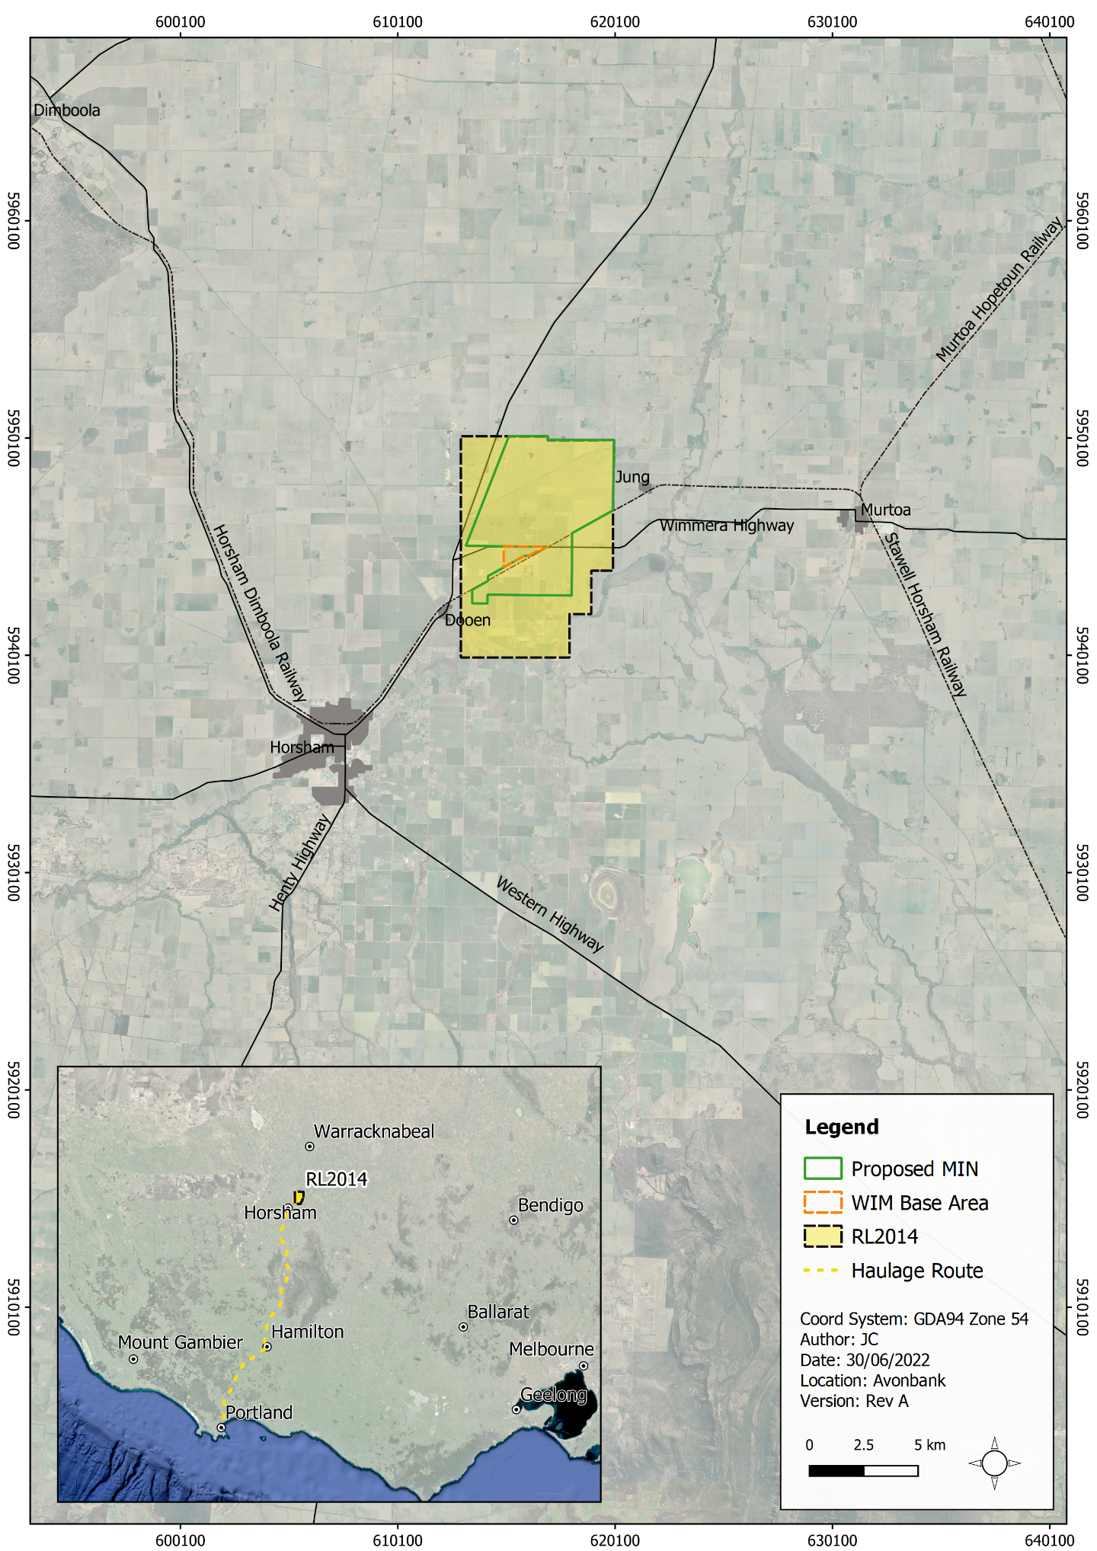
Figure 14-1: Study area

Operational Context
Conventional dry mining techniques will be used to mine the ore, which will be fed into a mining unit plant (MUP) in the pit and mixed with water to form a slurry, from which the heavy minerals (around 5% of the ore) will be separated from sand and clay tailings in the Wet Concentrator Plant (WCP) using conventional wet separation techniques.
The ore and HMC contain Naturally Occurring Radioactive Materials (NORMs) which tend to have elevated concentrations of radioactive uranium and thorium. Appendix I, Section 8.3 provides detail of the radioactivity levels for the ore, the material through the WCP and the HMC product. In summary, the radioactivity levels are expected to be approximately 1.02 Bq g⁻¹ for the ore, 0.99 Bq g⁻¹ for the material within the rougher spiral feed in the WCP, and 9.5 Bq g⁻¹ for the HMC.
Based on the estimated activity concentrations, the ore and final product for the Project will be classified as prescribed radioactive material. The HMC will be transported to the Port of Portland in enclosed
B-double articulated vehicles (trucks). Infrastructure at the Port to manage HMC storage will be fully enclosed. This will ensure containment and will prevent the airborne suspension of HMC.
Sand tailings will be pumped back to the mining cells for consolidation and subsequent rehabilitation. Tailings will be rehabilitated with at least 3 metres of overburden, subsoils, and topsoils.
Radionuclide concentrations of the tailings are expected to be considerably less than that of the in situ ore. Preliminary data indicates that the tailings will have an activity concentration of approximately 0.53 Bq g⁻¹ (260 Bq kg⁻¹ U-238 and 270 Bq kg⁻¹ Th-232).
Tailings being returned to the mine void will not be a radioactive waste, based on its proposed radioactive content. There are no radioactive waste streams produced, however an exception will be any discrete radiation sources such as density gauges that may be used in the processing plant which will require legal offsite disposal once the devices are decommissioned.

Existing Conditions

Terrestrial Radiation
The background external gamma radiation levels within the study area were measured using fixed dose rate measurements and 'spot' dose measurements. Measurements were taken at a distance less than 1 km apart within the retention licence and approximately 2 km in surrounding areas (refer Appendix I, Appendix C). The external gamma radiation dose rates are summarised in Table 14-1 For comparison, the average external dose rate for terrestrial radiation in Australia is approximately 0.09 μGy h⁻¹ (UNSCEAR, 2000). Measured dose rates for the Project are consistent with this value.
Table 14-1: Ambient gamma radiation survey results (January 2019)
Survey Area | Grid Size | No. of Survey Locations | Absorbed Dose Rate Free-in-air (μGy h-1)
Pilot Plant (Avonbank demonstration trial) | 0.1 km | 28 | 0.070 ± 0.008
Retention licence area | 1 km | 70 | 0.078 ± 0.009
Outside retention licence | 2 km | 26 | 0.076 ± 0.010

Radionuclide Content of Surface Soils
Soil samples were collected within and around the Project area to measure the background radionuclide content (refer Appendix I, Appendix D). The radioactive concentration of uranium-238 in surface soil and farming lands across the Project area is shown in Table 14-2. For comparison, the range of concentrations of uranium-238 and thorium-232 in soil worldwide is 16 to 110 Bq kg⁻¹ and 17 to 60 Bq kg⁻¹, respectively (UNSCEAR, 2000). The analysis of topsoil samples collected from within and around the Project area were shown to be comparable to concentrations found naturally in soils worldwide.
Table 14-2: Radionuclide content of surface soil and farming land (January 2019)
 | Radionuclide Activity (becquerel per kilogram dry weight)
 | Surface Soil | Farming Land
Uranium (U-238 series | 10 to 72 Bq kg⁻¹ | 10 to 31 Bq kg⁻¹
Thorium (Th-232) series | 20 to 63 Bq kg⁻¹ | 33 to 44 Bq kg⁻¹

Radionuclides in Crops
Vegetation will directly uptake radionuclides from the soil if present in elevated concentrations. The estimated uptake of radionuclides was assessed for cereals/grains and leafy vegetables using established soil-to-plant transfer factors. The results of this assessment are provided in Table 14-3. Due to the variability in soil-to-plant uptake factors, a comparison of the data with international examples is not possible. This data has however been used in the estimated dose assessment provided in Section 14.7.1.3.
Table 14-3: Radionuclide content in crops
Soil Sample Location/ID | Plant Group | Key Radionuclide Activity in Crops (becquerel per kilogram)
 |  | U-238 | Ra-226 | Pb-210 | Ra-228
North of Greenhills Road | Cereals/grain | 0.131 | 0.370 | 0.350 | 0.777
South of Greenhills Road | Cereals/grain | 0.143 | 0.405 | 0.486 | 0.792
Wimmera Intermodal Freight Terminal (WIFT) Precinct | Cereals/grain | 0.134 | 0.380 | 0.350 | 0.713
Adjacent Longerenong College | Leafy vegetables | 0.437 | 1.99 | 2.41 | 3.85

Radioactivity Content of Surface Water
Eight water samples were collected from four surface water bodies identified within the study area. Samples were collected during the summer and winter months and analysed for gross alpha and beta radioactivity and radionuclide content. The results are summarised in Table 14-4 and the sampling locations are shown in Appendix I (refer Appendix E).
As outlined by the ‘Australian Drinking Water Guidelines’ (ADWG), Ra-226 and Ra-228 activity concentrations should be determined if gross alpha radioactivity exceeds 0.5 Bq L⁻¹ or the gross beta radioactivity (with K-40 contributions subtracted) exceeds 0.5 Bq L⁻¹ (ADWG, 2011). None of the surface water samples demonstrated gross alpha or beta activities in exceedance of 0.5 Bq L⁻¹.
Table 14-4: Radioactivity in surface water
Sample Location | Sample Month |  |  | Radionuclide Concentration (Bq L⁻¹)  (becquerel per kilogram)
 |  | Gross alpha | Gross beta | U-238  (as Th-234) | Ra-226 | Pb-210 | Ra-228 | Th-228
Yarriambiack Creek | Jan-19 | NR | NR | <0.17 | <0.039 | <0.13 | <0.11 | <0.035
 | Jul-20 | 0.046 | 0.061 | <0.16 | <0.027 | <0.14 | <0.079 | <0.027
Misery Creek Dam | Jan-19 | Nr | NR | <0.11 | <0.039 | <0.12 | <0.13 | <0.026
 | Jul-20 | 0.043 | <0.07 | <0.16 | <0.045 | <0.15 | <0.086 | <0.031
Grosses Bridge | Jan-19 | NR | NR | <0.15 | <0.041 | <0.14 | <0.16 | <0.026
 | Jul-20 | 0.147 | 0.124 | <0.14 | <0.041 | <0.16 | <0.11 | <0.31
Wimmera River | Jan-19 | NR | NR | <0.14 | 0.021 | <0.13 | <0.086 | <0.026
 | Jul-20 | 0.043 | 0.042 | <0.16 | <0.042 | <0.15 | <0.14 | <0.032
Note: Less than (<) values indicate the limit of detection for each radionuclide for the measurement system.

Radionuclides in Groundwater
Ambient groundwater samples were collected from bores located within and external to the mine footprint (refer Appendix I, Appendix F). Samples were analysed for gross alpha and beta radioactivity, in addition to analysis of key radionuclides. Several samples were shown to have gross alpha and beta radioactivity concentrations in excess of the ADWG guidance value (0.5 Bq L⁻¹) (ADWG, 2011). This is interpreted to be the result of groundwater contact with the ore body and was not unexpected. The majority of Ra-226 and Ra-228 concentrations were within the range of concentrations outlined in the ‘The Radioactive Content of Some Australian Drinking Waters’ (ARPANSA, 2008). Appendix I, Section 7.5 provide further detail on the groundwater monitoring and associated results.

Airborne Dust Concentrations

Airborne concentrations of gross alpha and beta activity
The most significant radionuclides contributing to an individual’s radiation dose are those that emit alpha radiation. High-volume PM₁₀ air-borne dust sampling was conducted in March 2020 to determine dust concentrations over a 12-month period. Dust concentrations ranged from 5-30 μg m⁻³. The highest dust concentrations were identified during the summer months (December and January) and the lowest concentrations were associated with the winter months. No apparent correlation of alpha and beta radioactivity concentrations with total dust concentrations were determined for the monitoring period.

Dust deposition
Dust deposition was measured within the study area over a 12-month period to quantify the background concentration of Ra-226 and Pb-210 (refer Figure 14-2). The results indicated that dust deposition levels were influenced by the amount of surrounding vegetation and the condition and use of the surrounding land (i.e., recently sowed or tilled for crops).
The recorded baseline levels are presented in Appendix I, Table 12. The highest dust deposition loading was obtained from a sampler located within Block A, which recorded levels of 24.4 g during March 2020 to February 2021 sampling period. The specific radionuclide concentrations from this dust sampling period at this sampling location were U-238 below 30 Bq mg⁻¹, Th-232 at 25 Bq mg⁻¹, Ra-226 at 10.3 Bq mg⁻¹ and Pb-210 at 86 Bq mg⁻¹.
Depositional dust that falls on rooftops can affect rainwater tank quality. Baseline water quality samples were collected at three rainwater tanks surrounding the Project area, as detailed in Appendix I, Table 13. Samples were analysed for individual radionuclide content, including the key radionuclides Ra-226 and
Ra-228.
The majority of the concentrations reported are less than the limit of detection for the laboratory analysis technique. The ADWG (ADWG, 2011) states that Ra-226 and Ra-228 activity concentrations should be determined if the gross alpha radioactivity exceeds 0.5 Bq L⁻¹ or the gross beta radioactivity (with K-40 contributions subtracted) exceed 0.5 Bq L⁻¹. None of the tank rainwater samples demonstrated gross alpha or beta activities that exceed 0.5 Bq L⁻¹.
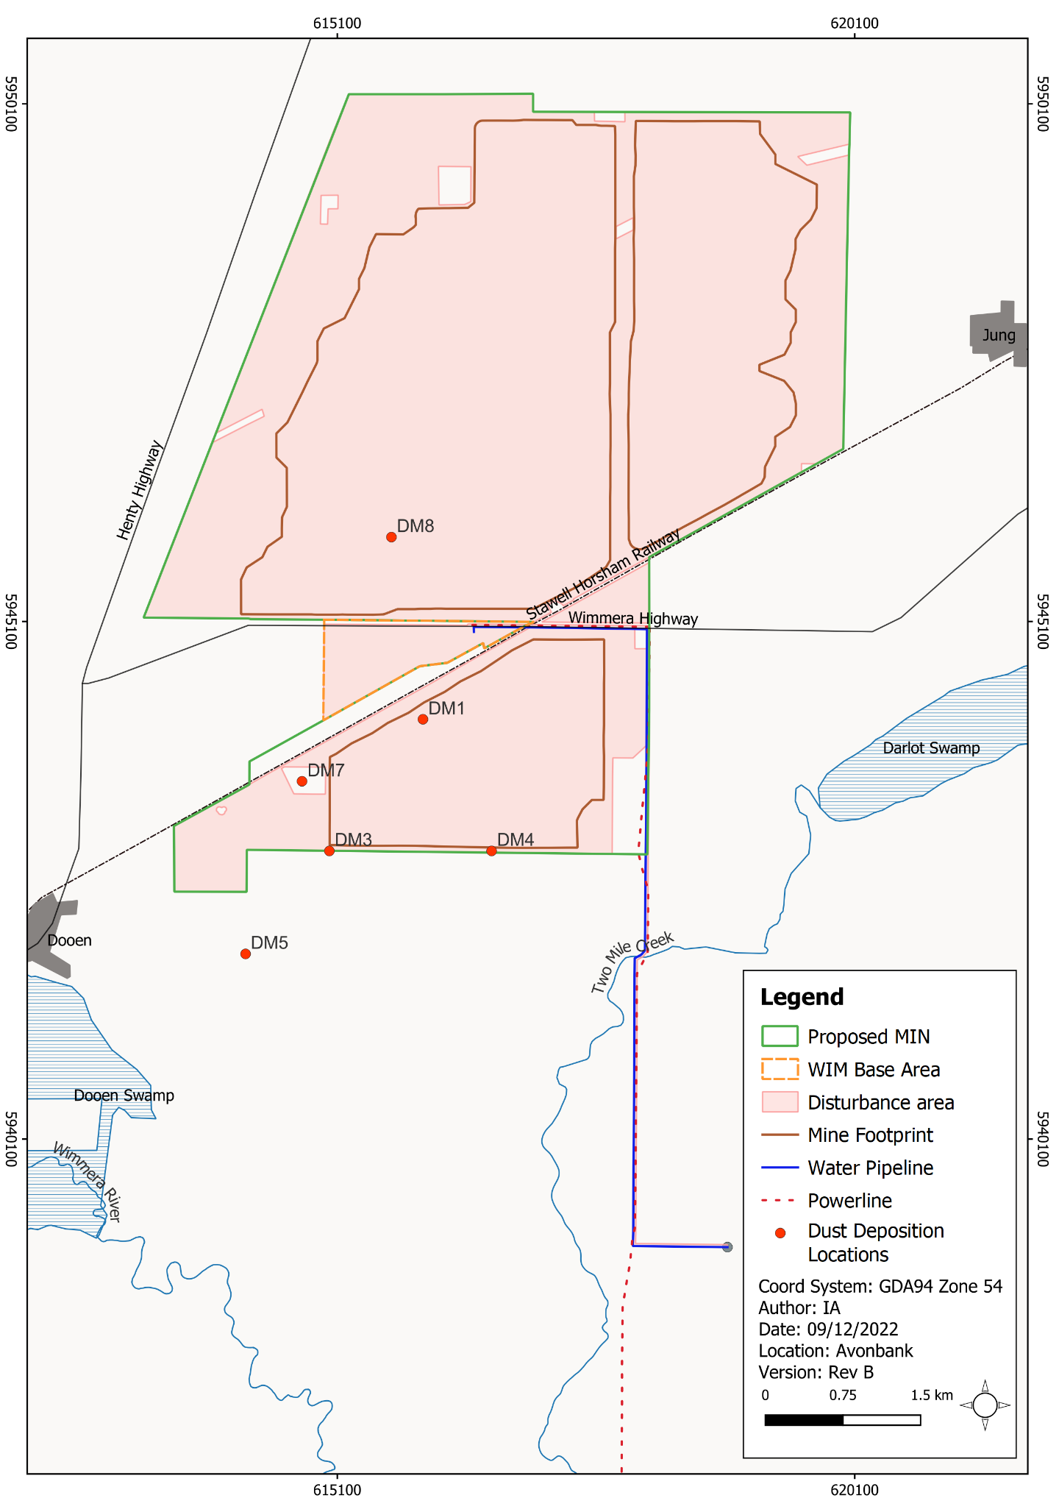
Figure 14-2: Passive dust deposition locations

Ambient radon concentrations
Radon concentrations were sampled at 22 locations (refer Appendix I, Appendix H) using passive radon monitors from January 2019 to January 2021, with monitors left in place for a minimum period of 3 months for each rotation.
The outdoor monitoring results indicate measurable Rn-222 (radon) average concentrations in the range of <15 Bq m⁻³ to 54 Bq m⁻³. Measurable Rn-220 (thoron) concentrations are in the range of <20 Bq m⁻³ to 133 Bq m⁻³. No seasonal trends were determined over the 2-year sampling period.
Concentrations of Rn-220 and Rn-222 demonstrate similar variability to concentrations recorded worldwide, as reported by United Nations Scientific Committee on the Effects of Atomic Radiation (UNSCEAR, 2000). Additional comparison against the Australian Radiation Protection and Nuclear Safety Agency, ‘Guide for Radiation Protection in Existing Exposure Situations’ (ARPANSA, 2017) indicates the monitoring results are an order of magnitude below the defined action level for radon concentrations in existing workplaces of 1,000 Bq m⁻³.

Potential Hazards

Potential Exposure Pathways
Potential hazards are identified in the RRA with consideration to the proposed Project activities, the baseline studies, stakeholder concerns and the issues identified in the referral document and scoping requirements.
The RRA considered a range of potential exposure pathways associated with the Project and assessed the risks with respect to the general public and non-human biota (refer Table 14-5).
The RRA grouped exposure pathways to assess the estimated dose rates to the general public by defining a Critical Group. The Critical Group are those members of the public that are living in close proximity to the proposed operations and as such would have the highest potential dose rates.
The Non-Critical Group are those members of the public situated at any distance further from the operations, relative to the Critical Group (i.e. will have lower dose rates).
The detailed assessment of exposure pathways and dose rates is provided in Section 14.7.
Table 14-5: Potential exposure pathways
Item | Exposure Pathways | Project Phase
IP-01 | Potential exposure pathways to the general public (Critical Group) resulting in an elevated annual radiation dose. | O
IP-02 | Potential exposure pathways to the general public (Non-Critical group) resulting in an elevated annual radiation dose. | O
IP-03 | Potential exposure pathways to members of the public from activities at the Port of Portland resulting in an elevated annual radiation dose. | O
IP-04 | Exposure pathways from the post-mining areas and rehabilitated landform resulting in an elevated annual radiation dose. | O, D
IP-05 | Radiological impact on non-human biota from resuspended radioactive particulate settling in soils. | O

Sensitive Receptors
For the RRA, potential sensitive receptors included members of the general public and non-human biota.
As described in Section 14.5.1, the general public were represented by the Critical Group. The ‘Code of Practice and Safety Guide – Radiation Protection and Radioactive Waste Management in Mining and Mineral Processing’ (ARPANSA, 2005) recommends assessing the effective dose to a Critical Group of individuals most likely to be impacted by the Project.
For this assessment, residents of the Longerenong College, south of the Project were assessed as the Critical Group based on their close proximity to the proposed operations. The location of the Critical Group receptors (R31 and R32) are shown in Figure 14-3. The Non-Critical group represent those members of the general public that are situated at any distance further from the operations relative to the Critical Group (not defined by a specific location).
The exposure risk to non-human biota was assessed with consideration to the average exposure rate for the most sensitive organisms, as described in Section 14.7.5.
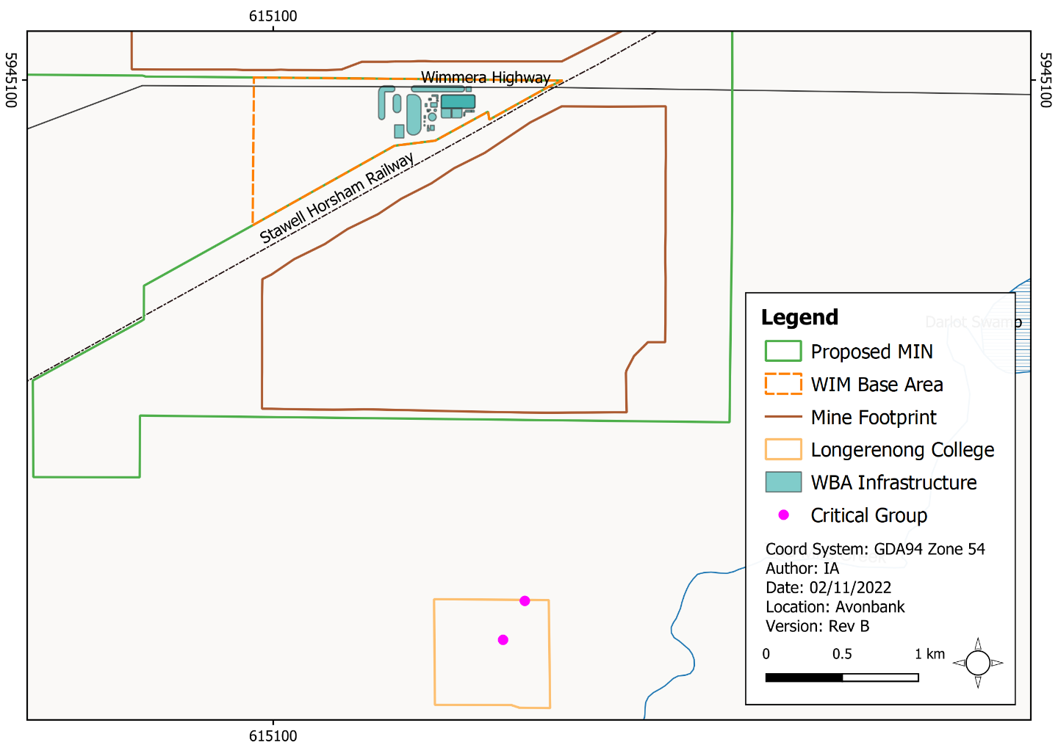
Figure 14-3: Critical group

Risk Characterisation
The potential for a noticeable health effect is related directly to the total exposure that is received. For biological systems, this is quantified in terms of dose in units of microsieverts (µSv). The greater the µSv received, the greater the ‘risk’ of an effect.
The risk of an effect is the result of the sum of all exposure pathways to an individual. Thus, whilst individual exposure components are addressed, they cannot be considered in isolation as only the sum of assessed exposure pathways is of importance in determining the risk.
There are regulatory upper dose limits that apply to occupational workers and members of the public. The limit for a member of the public is set at 1,000 µSv per year. This is set conservatively low and considerably less than the allowable annual dose limit to an occupational worker (20,000 µSv) in the interest of keeping doses as low as reasonably achievable.
In relation to the RRA, individual exposure components were assessed and summed to enable a total annual dose received to be estimated, allowing direct comparison with the regulatory limits. The majority of projected doses calculated and used for the assessment are considered upper ‘worst-case’ annual doses rather than realistic potential dose outcomes.
Hazards to the environment, including those to non-human biota, have been discussed in relation to a screening value of 10 µGy/h as recommended in the ‘Guide for Radiation Protection of the Environments’ (ARPANSA, 2015a).
While the avoidance and mitigation measures have been included, where relevant in the associated modelling for air quality, the dose assessment assumptions in the RRA are highly conservative to ensure worst-case conditions are presented. The avoidance and mitigation measures presented in this Chapter are considered to be good practice and will reduce the residual risks so far as reasonably practicable.

Avoidance and Mitigation Measures
This Section outlines the measures identified to avoid and minimise residual risks so far as reasonably practicable, in line with the requirements of the proposed environmental management system (EMS) and relevant legislation.

Avoidance

RD-01: Site security
Site security and signage will be provided to restrict unauthorised access by members of the public to the operational areas. This will prevent the general public from coming into direct contact with bulk quantities of HMC.

RD-02: Use of sealed vehicles for the transport of HMC on public roads
Transport of HMC from the WBA to the Port of Portland will be undertaken on sealed roads in covered B-double articulated vehicles. This will prevent the resuspension of HMC into the air and deposition along the haulage route.

Minimisation

RD-03: Road surface material
Roads for light and heavy vehicles will be constructed with appropriate materials comprising low silt content to minimise dust emissions. It is expected gravels mined from the Karoonda sandstone geological unit will be preferentially used as it is less susceptible to surface erosion due to the relatively large particle or aggregate size. Permanent and semi-permanent roads will be topped with gravel excavated during mining to optimise road conditions and minimise surface erosion and dust so far as reasonably practicable.
Sealing roads with bitumen was not considered feasible as internal Project haulage routes and light vehicle roads will progressively move over the life of mine. Haulage routes will typically change on a monthly basis depending on the location of stockpiles and the operational area. Sealing roads around the HMC stockpile circuit was not considered feasible due to geotechnical issues associated with the swelling characteristics of the underlying clay material.

RD-04: Dust suppression
Road watering will be undertaken on light vehicle roads and heavy vehicle routes to keep the surface moist and to minimise wheel generated dust. It will be undertaken as required in areas that have been disturbed and not yet stabilised.
Road watering will be scheduled such that the rate is commensurate with the ambient conditions and can be adapted to provide a preventative response to forecast weather events. This is a highly effective mitigation measure that is standard practice across the mining industry to minimise dust emissions.
It is expected that during the summer months, there will be at least two water trucks to service all at-risk areas. The water trucks will be able to complete a load of water every 50 minutes. Water trucks may be dosed with polymer stabilising agents to improve the efficiency of the program during high-risk periods.

RD-05: HMC stockpile management
Heavy Mineral Concentrate will be stockpiled wet when pumped from the WCP. The HMC stockpile will retain moisture and will be loaded to the haulage trucks moist with around 4-6% water content.
In some circumstances during extreme conditions, the surface may dry and be subject to some surface creep. Sprinklers will be established as a contingency to maintain moisture content across the stockpile and minimise surface creep. A sediment fence will be established around the stockpile area to prevent HMC surface creep outside the stockpile domain.

RD-06: Controls at the site
Vehicle washdown facilities will be provided within the WBA to ensure vehicles and equipment can be washed down as required. Periodic audits will be conducted to ensure compliance with this requirement. Procedural controls and/or Personal Protective Equipment (PPE) may be used to minimise concentrate leaving site on worker’s clothing where appropriate.

RD-07: Emergency and clean-up procedures
Emergency response procedures and processes will be maintained to prepare for and respond to potential emergency situations. This will include suitable emergency and clean-up procedures in the unlikely event of a spill. This is further discussed in Section 24.7.2 of Chapter 24 (Environmental Management).

RD-08: Radiation Management Plan
A Radiation Management Plan (RMP) will be prepared prior to Project commencement. The RMP will provide a management framework to avoid and minimise risks so far as reasonably practicable in line with the ‘Code of Practice on Radiation Protection and Radioactive Waste Management in Mining and Mineral Processing’ (ARPANSA, 2005).
The RMP will address aspects relating to radiation exposures to workers and members of the public, a statutory requirement under the Radiation Act 2005 (Radiation Act). The RMP will also address matters associated with risks to the environment and the management of any ancillary wastes.
The RMP will be reviewed and updated at an appropriate frequency as established in the overarching EMS, with consideration to the level of risk, statutory requirements, monitoring results, community complaints and in response to audit findings. It will be developed in consultation with stakeholders and will be subject to approval by the relevant Authority.
The RMP will:
- Summarise the baseline data and existing environment and be updated as additional baseline data is obtained.
- Explain the relevant statutory requirements and context (including any relevant approvals).
- Describe the avoidance and mitigation measures to be implemented to minimise residual risks so far as reasonably practicable.
- Identify specific environmental objectives and performance standards to be achieved with avoidance and mitigation measures in place.
- Detail the monitoring and inspections to be undertaken to verify the effectiveness of the avoidance and mitigation measures.
- Establish performance standards relating to radiation exposure associated with specific receptors.
- Describe mechanisms to determine when/if corrective actions and contingency measures are required.
- Detail a program to investigate and implement ways to improve the environmental performance of the Project over time consistent with currently available technology.
- Detail appropriate review periods and/or triggers to ensure the plan remains fit for purpose.
- Establish procedures to manage:
- Incidents and any non-compliance.
- Stakeholder and community complaints.
- Failure to comply with statutory requirements and/or environmental performance standards.
- Roles and responsibilities for implementing the RMP.
- A protocol for periodic review of the RMP.
- Include a community engagement strategy which will include a complaints handling system.
In addition to the above requirements and the avoidance and mitigation measures outlined in this Chapter, the RMP will include specific requirements to:
- Identify all significant exposure sources and pathways, including plans of the mine and processing plant, descriptions of the equipment to be used in mining and processing, the processes involved and estimates of the radionuclide content of various process streams, and identification of those groups of workers or members of the public most at risk.
- Prevent and minimise low-level radiation exposure to workers and detail the worker dose assessment methodologies for internal and external exposure pathways in accordance with the ‘Monitoring, Assessing and Recording Occupational Radiation Doses in Mining and Mineral Processing ’(ARPANSA, 2011).
- Report to the Victorian Department of Health, and company management, detailing results of personal dosimetry, area and dust monitoring, incident reports and other operational issues, and worker dose records.
- Describe the waste generated and the facilities and procedures involved in the handling, treatment, storage and disposal of radioactive waste (i.e., any process gauges or discrete radiation source that may be used in the process plant, which will require legal off-site disposal in accordance with requirements under the Radiation Act).
- Describe the hazards risks and monitoring requirements for relevant sensitive receptors identifying the reference organisms selected for the assessment and the rationale for selection.

Rehabilitation

RD-09: Progressive rehabilitation
Prior to Project commencement, a Rehabilitation Plan will be established that will address matters relating to progressive rehabilitation. It will cover all work areas and domains with a focus on those higher risk areas in the proposed mining licence and WBA.
The Rehabilitation Plan will describe the work to be undertaken to ensure the rehabilitated landform will be safe, stable, sustainable, and capable of supporting the proposed end land use. It will describe the Project’s rehabilitation strategy including those commitments included in this Chapter of the EES. The Rehabilitation Plan will define the end land use with consideration to the views of the landholders and the broader community where appropriate.
The Rehabilitation Plan will establish objectives and performance standards/criteria to measure and quantify when the objectives have been met and the rehabilitation is considered to be complete. A schedule for progressive rehabilitation will be included along with the rehabilitation milestones for the life of mine.
Relevant post-closure risks associated with the completed rehabilitation will be identified and assessed to determine: the type, likelihood and consequence of the risks; the activities required to manage those risks; the associated projected costs; and any other matter that may be relevant to risks arising from the rehabilitated land.
A preliminary Rehabilitation Plan for the Project has been developed to meet the intent of the Scoping Requirements and is included with this EES as Attachment 3. This plan will be refined prior to commencement with consideration to the detailed operating plans, stakeholder and community feedback and the Minister’s assessment of the EES.
A rehabilitation bond will be assessed and lodged prior to the commencement of mining, in line with the Mineral Resources (Sustainable Development) Act 1990 (MRSD Act) and the ‘Earth Resource Regulation Guidelines for Rehabilitation Bonds – Mineral, Exploration, Mine and Quarries’ (ERR, 2022). It is anticipated that the bond will be periodically assessed prior to the commencement of each mine development stage and will consider the progressive rehabilitation undertaken at that point in time.

RD-10: Management of non-economic radioactive product
The radionuclide concentrations in tailings disposed of in the mine pit from the processing of the mineral sand ore will be less than the uranium and thorium content in the original ore. All tailings areas will be rehabilitated with at least 3 m of overburden, subsoil and topsoil such that the external exposure rates are comparable to unmined areas.

Residual Risks
This Section describes the likely residual risks with avoidance and mitigation measures in place. The residual risks were characterised as described in Section 14.5.3 and Chapter 6 (Impact Assessment Framework). It is noted the air quality modelling used in this assessment includes all avoidance and mitigation measures as communicated in Chapter 13 and Section 14.6. Further assumptions regarding the use of the air quality modelling dataset and assessment of radiation risks are provided in Appendix I, Section 11.

Exposure Pathways to the Critical Group
There is one potential hazard (IP-01) listed in Section 14.5.1 that relates to the exposure pathways assessed for the Critical Group. As described in Section 14.5, the residents of the Longerenong College, south of the development extent, were assessed as the Critical Group
The exposure pathways and estimated dose rates are summarised in Table 14-6 and further described in Sections 14.7.1.1 to 14.7.1.10.
The calculated maximum annual doses from all assessed exposure pathways are shown in Table 14-6. The total maximum annual dose was assessed to be 40.1 µSv for an adult and 71 µSv for a child. These doses are below the Victorian regulatory annual exposure limit for a member of the public of 1,000 µSv.
Table 14-6: Summary of potential exposure pathways and annual dose rate to the Critical Group
Exposure Pathways to the Critical Group | Annual Dose (µSv)
 | Adult | Child (5 yo)
Airborne dust inhalation (refer Section 14.7.1.1) | 16 | 11
Radon and thoron inhalation (refer Section 14.7.1.2) | negligible | negligible
Consumption of leafy vegetables grown (refer Section 14.7.1.3) | 7.0ª | 13ª
Ingestion of soils impacted by dust deposition (refer Section 14.7.1.4) | 3.1 | 22
Drinking tank rainwater water impacted by run-off from a roof (refer Section 14.7.1.5) | 13 | 24
Consumption of locally grown livestock (refer Section 14.7.1.6) | negligible | negligible
Inhalation and ingestion of dust during laundering of contaminated clothing (refer Section 14.7.1.7) | negligible | negligible
Following truck loaded with HMC (refer Section 14.7.1.8) | 0.5 | 0.5
Resident on HMC trucking route (refer Section 14.7.1.9) | 0.5 | 0.5
Spill of HMC on the haulage route (refer 14.7.1.10) | negligible | negligible
Total: | 40.1 µSv | 71 µSv

Inhalation of airborne radioactive dust during operation
There is one potential exposure pathway to the Critical Group that relates to the inhalation of resuspended airborne radioactive dust, resulting in an elevated annual radiation dose.
The annual dose to a member of the public can be estimated as a result of inhalation of dust from the Project. This assessment considered the dust modelling outcomes in the air quality study (Appendix H). The air quality study identified the potential receptors from which the average annual dust concentrations and the exposure risk from radiation were assessed.
Several assumptions were considered for the dose assessment of an adult and child. In situations where a parameter could be considered subjective, a conservative ‘worst-case’ value was used. Assumptions included particle size, dust concentration, resuspension levels, dose coefficient, breathing rate and hours of exposure in a year.
Based on these conservative assumptions, the maximum annual effective dose to an adult as a result of inhalation of Project related dust was 16 µSv. For a 5-year-old child, a dose of 11 µSv was calculated (refer Table 14-6).

Exposure to radon and thoron gas
There is one potential exposure pathway to the Critical Group that relates to exposure to radon and thoron gas, resulting in an elevated annual radiation dose. These inert radioactive gases are released from minerals containing uranium and thorium and their inhalation at significantly high concentrations can lead to radiation doses to lung tissue.
Radon emanation coefficients for heavy minerals have been reported to be, on average, an order of magnitude below that of rock and soil. Additionally, emanation rates are inversely proportional to the grain size and are inhibited in the presence of soils with high moisture content. The emanation rate for thoron is expected to be even more diminished due to its short half-life.
Further dilution and atmospheric dispersion of any radon or thoron released will mean that off-site concentrations in the air will not be discernible from ambient levels due to the release of natural radon from the surface soils in the area. Therefore, it is likely that in an open pit during mining, radon and thoron concentrations will be close to ambient levels and this exposure pathway will not be of significance.
Based on the characteristics of the Avonbank ore and produced concentrate, the potential exposure pathway to a member of the public as a result of radon and thoron gas emanation was assessed to be negligible.

Consumption of vegetables or crops grown in impacted soils
There is one potential exposure pathway to the Critical Group that relates to the consumption of crops and vegetables with elevated radionuclides. Elevated radionuclides in crops and vegetables could result from resuspended dust settling in soils and subsequent uptake in root systems.
The calculated doses are provided in Table 14-7. The average annual deposition dust rates were modelled for representative operational scenarios (including year 7 and year 33). Radionuclide uptake from the dust to the plant was calculated using recognised models for terrestrial and freshwater environments (IAEA, 2010).
The annual doses calculated were only marginally greater than the calculated baseline doses. The additional Project related dose to an adult as a result of the consumption of leafy vegetables was calculated to be 7 µSv and 13 µSv for a child (refer Table 14-6). For comparison, the world average annual radiation dose as a result of the ingestion of any radioactive material varies from 0.2–1.0 mSv (ARPANSA, 2015).
Table 14-7: Estimated adult annual radiation doses from consumption of crops grown in the farming soils
Soil Sample Location | Vegetable Type | Annual Dose Baseline (mSv) | Annual Dose  Year 7 (mSv) | Annual Dose  Year 33 (mSv)
North Greenhills Road | Cereals/grain | 0.0726 | 0.0730 | 0.0746
South Greenhills Road | Cereals/grain | 0.0814 | 0.0818 | 0.0834
Proposed WIFT Precinct | Cereals/grain | 0.0692 | 0.0697 | 0.0713
Adjacent Longerenong College | Leafy vegetables | 0.2356 | 0.2371 | 0.2426

Consumption of contaminated soils
There is one potential exposure pathway to the Critical Group that relates to the inadvertent ingestion of settled radioactive dust/soil on materials or food. Several assumptions were considered to calculate the dose assessment, including soil consumption volumes and the radioactive content of the soil. The maximum annual effective dose to a Critical Group member of the public as a result of ingestion of soils and settled dust was 3.1 µSv for an adult and 22 µSv for a child (refer Table 14-6).

Consumption of personal tank rainwater
There is one potential exposure pathway to the Critical Group that relates to the drinking of tank rainwater affected by resuspended dust settling on roofs and washing into tanks.
This assessment considered the soluble and insoluble portions once the dust enters the tank. Soluble portions are of most interest from a drinking water perspective. The minerals from the Project are naturally highly insoluble, particularly the radium content by-product of uranium and thorium decay series.
The leachability factor for the Avonbank ore in rainwater can be inferred from the impact of the ore on groundwater radioactivity levels. The impact of the deposited dust on the soluble radioactive component will be less than that of the buried ore body in groundwater. This is due to a shorter contact time and the soluble radioactive component being less than that of the in situ ore body.
The dust collected in rainwater tanks is not expected to contribute to the existing soluble radioactive component and is unlikely to be identifiable from any naturally occurring variability. For this assessment, a worst-case dose was calculated with the maximum annual dose for an adult of 13 µSv and 24 µSv for a child (refer Table 14-6).

Consumption of locally grown livestock
There is one potential exposure pathway to the Critical Group that relates to the consumption of livestock grazing on local crops containing an elevated radionuclide content resulting in an elevated annual radiation dose to an individual.
The human consumption of grazing farm animals and related produce is seen as an inconsequential exposure pathway relative to other pathways assessed. This was based on the low radioactive content of the dust and the estimated doses to a member of the public as a result of crop consumption directly already being of inconsequential value (refer Section 14.7.1.3). Additionally, land within the development extent is not typically used for the support of livestock and is predominantly for the farming of crops.
The consumption of locally produced livestock was assessed to be a negligible exposure pathway and was not considered further.

Dust inhalation and ingestion generated from HMC and ore
There is one potential exposure pathway to the Critical Group that relates to exposure from inhalation and ingestion of dust originating from ore, HMC and intermediate products transferred by workers leaving site.
The assessment considered the risk to the person responsible for the regular handling of potentially contaminated work clothing for the purposes of laundering. There is the potential for the inhalation of dried ore or HMC dust that has accumulated on clothing or the direct ingestion of soils from poor hygiene practices.
Prolonged exposure to resuspended airborne dust has been considered in Section 14.7.1.1. Prolonged daily ingestion of radioactive particulate was considered in Section 14.7.1.4. Both scenarios considered continuous exposure at elevated airborne concentrations to ore material over a calendar year. Laundering operations and other periods of exposure to family members of workers would be of considerably less duration, and subsequently, the potential dose would be considerably less.
The exposure pathway due to dust inhalation and ingestion from HMC and ore transferred off-site on clothing was considered to be negligible and was not considered further.

Gamma radiation exposure during transport of HMC – resident
There is one potential exposure pathway to the Critical Group that relates to external gamma radiation exposure due to trucks travelling on the haulage route. While this is an unlikely exposure pathway for the Critical Group, as they are not located on the haulage route, it was included to ensure the upper worst-case scenario was assessed. The assessment included highly conservative assumptions regarding exposure time, average separation distance and number of trucks per day. The estimated maximum dose was assessed to be less than 0.5 µSv per year (refer Table 14-6).

Gamma radiation exposure during transport of HMC – passenger
There is one potential exposure pathway to the Critical Group that relates to external gamma radiation exposure to vehicle occupants on roadways shared by trucks on the haulage route.
The assessment considered an individual in a passenger vehicle following 25 m behind an HMC loaded truck. The assessment concluded that the gamma radiation dose rates in the passenger vehicle would be indiscernible from natural background levels.
A worst-case scenario was calculated by reducing the separation distance from 25 m to 5 m to represent a scenario in a busy rural township with traffic lights and multiple occurrences totalling 1 hour per year. Even with separation distances reduced, the estimated maximum dose was assessed to be less than 0.5 µSv per year (refer Table 14-6).

Exposure during transport of HMC – major road accident
There is one potential exposure pathway to the Critical Group that relates to a member of the public being exposed during a major road accident involving a truck spill of bulk concentrate on a roadway.
A traffic incident could result in the spill of a significant quantity of HMC. Under this scenario, a member of the public could be near the spill and/or the bulk shipment. Assumptions have considered an average separation distance and that the concentrate is dry and uncovered for the entire exposure period, providing a worst-case scenario.
The exposure would be considered a ‘one-off ‘exposure and not a regular annual dose component for a member of the public. The estimated maximum dose for the member of the public, using the conservative assumptions, would be less than 13 µSv from a single exposure (refer Table 14-6).
Should such an incident occur, it would be managed through the Project’s emergency response plans. Avoidance and mitigation measures implemented in an emergency scenario would be similar to those adopted for the handling of the product on-site, including containment, separation from personnel, and PPE. Consequently, doses were considered to be negligible.

Exposure to Members of the Public, the Non-critical Group
There is one potential hazard (IP-02) listed in Section 14.5.1 that relates to exposure pathways to members of the public that are not part of the Critical Group (referred to as the Non-Critical Group). The Non-Critical Group assessment is based on an adult male and the dose received by a 5-year-old child from communities living further from the Project than the Critical Group.
This assessment concluded that other members of the public, irrespective of the location of residence, workplace or schooling in relation to the distance from Project operations would receive a radiation dose most likely less than, but no more than 40.1 µSv per year for an adult and 71 µSv for a child, as a result of the operations. The calculated maximum annual doses are considerably less than the dose limit applicable for a member of the public of 1,000 µSv per annum.

Exposure Risks at the Port of Portland
There is one potential hazard (IP-03) listed in Section 14.5.1 that relates to the exposure pathways to members of the public from the Port of Portland. An assessment of the storage and movement of HMC at the Port of Portland identified four potential exposure pathways. These were:
- Inhalation of airborne dust arising from resuspended HMC.
- Consumption of contaminated soils arising from settled dust, impacting local produce, personal tank rainwater or local livestock.
- Exposure to radon gas migrating from the Port facilities.
- Seepage to groundwater or surface waters.
Operations at the Port of Portland are considered essentially a closed operation which will comprise the following activities:
- HMC will arrive at the Port of Portland in B-double articulated vehicles fitted with hydraulic lids.
- HMC will be unloaded inside an enclosed purpose built shed, where it will be stored.
- Mobile equipment will load HMC into a hopper that feeds into a sealed conveyor system and into a ship loader.
- The HMC will be fed into the hold of an awaiting cargo vessel and the hold is sealed prior to departure.
The potential for the resuspension of HMC is eliminated by the closed facility. The potential exposure pathway to a member of the public as a result of inhalation of radioactive dust, radon gas or from consuming locally grown livestock and collected tank rainwater was assessed to be negligible.
Based on the proposed shed design and concrete floor, there was considered to be no potential for seepage of HMC whilst in storage and subsequently no risk to the local environment from this pathway.

Post-rehabilitation Exposure Risks
There is one potential hazard (IP-04) listed in Section 14.5.1 that relates to exposure pathways associated with the disposal of tailings and the post-rehabilitated landform. Four exposure pathways were considered:
- External gamma radiation exposure at the surface of the rehabilitated landform after the return of tailings to the mine void resulting in an elevated annual radiation dose.
- Exposure to airborne radon/thoron gas emanating from the rehabilitated landform after the return of tailings to the mine void resulting in an elevated annual radiation dose.
- Radionuclide seepage from buried tailings in the mine void resulting in elevated radioactive concentrations in groundwater.
- Radionuclide seepage from buried tailings in the mine void resulting in elevated radioactive concentrations in surface water bodies.
Given the HMC is separated and removed from the tails component, the radionuclide concentrations in tailings will be less than the uranium and thorium content in the original ore. As such, it was determined that the gamma radiation levels arising from the disposed material are likely to be less than that associated with the undisturbed mineral resource. Furthermore, all tailings will be rehabilitated with at least 3 m of overburden and soil material.
The external exposure from the rehabilitated tailings landform could be comparable to the current natural pre-mining conditions. The exposure risk to members of the public was assessed to be a negligible residual risk.

Exposure Risk to Non-human Biota
There is one potential hazard (IP-05) listed in Section 14.5.1 that relates to the radiological impact on non-human biota from resuspended radioactive particulates settling on soils.
This scenario considered the exposure to biota and terrestrial ecosystems in the Project area in year 33 of the Project’s operational life. This assessment made assumptions on the dust deposition rate and adopted reference organisms of lichen and bryophytes. The rationale for selecting these reference organisms is described in Appendix I, Section 14.1.
A screening value of 10 µGy/h was used for this reference group, as recommended in the ‘Guide for Radiation Protection of the Environments’ (ARPANSA, 2015a).
The modelling identified a dose rate for the reference organisms of less than the 10 µGy/h screening value. Even using extremely conservative criteria and applying the most sensitive reference organisms, the radiological risk on the native flora and fauna identified in the Project area was assessed to be negligible.

Non-existent Exposure Pathways
Five potential exposure pathways were found to be ‘non-existent’ to members of the public as no complete source to receptor pathway was identified. These pathways are:
- External gamma radiation exposure from ore, HMC and tailings to a member of the public being on-site resulting in an elevated annual radiation dose.
- Drinking Wimmera Mallee Pipeline water supply resulting in an elevated annual radiation dose.
- Inhalation of airborne HMC dust by a resident living adjacent to the haulage route resulting in an elevated annual radiation dose.
- Inhalation of airborne HMC dust to vehicle occupants on roadways shared by trucks on the haulage route resulting in an elevated annual radiation dose.
- Impact on the environment resulting from deposition of resuspended HMC product from trucks on the haulage route.
No detailed residual risk assessment was considered necessary for these pathways.

Management Framework
An AS/NZS ISO 14001:2016 EMS will be established for the Project, as detailed in Chapter 24. The EMS will address matters relating to planning, risk management, operational control, monitoring and continuous improvement over the life of the Project. Relevant matters relating to monitoring and auditing are summarised below.

Environmental Objectives
Environmental objectives will be established as part of the EMS to articulate the outcomes to be achieved during Project implementation. These reflect the expected and achievable outcomes based on the studies undertaken as part of this EES.
The key environmental objective relevant to the Project in relation to radiation is that the production, management and movement of HMC will result in no exceedance of regulatory limits to the general public or environment.
Performance standards will be established to measure/assess if the environmental objective has been achieved during operations, as further discussed in Section 14.8.2.

Monitoring and Management
A radiation monitoring program will be incorporated into the RMP to measure, analyse and evaluate the effectiveness of the avoidance and mitigation measures and overall environmental performance. Monitoring will be undertaken over the life of the Project at sensitive receptors to confirm the avoidance and mitigation measures have minimised residual risks so far as reasonably practicable.
The radiation monitoring program will demonstrate compliance with regulatory standards, dose estimation and effectiveness of engineering controls. Various monitoring techniques will be undertaken for personal dose monitoring (workers), area monitoring, dust sampling and surface contamination monitoring. The monitoring will be designed and carried out by suitably qualified personnel.
Although the tailings are not classified as radioactive waste and are assessed as having a lower level of risk than the in situ ore, this waste stream will be monitored in accordance with the ‘Code of Practice and Safety Guide – Radiation Protection and Radioactive Waste Management in Mining and Mineral Processing' (ARPANSA, 2005). The monitoring program will be incorporated into the overarching RMP.

Audits
Periodic internal and independent audits will be undertaken to assess the effectiveness of the EMS. An internal audit program will be maintained, which details the frequency, methods, responsibilities and reporting requirements.
Audits will be undertaken by a suitably qualified person to assess the effectiveness of the EMS and associated management plans (including the RMP) to minimise or avoid radiation risks so far as reasonably practicable. Any non-conformity identified in the audit will be investigated and corrective actions implemented.
The outcomes of audits will be communicated to the Project’s Management team and records of the audit findings will be retained in the record management system. Significant findings will be reported to relevant regulators and stakeholders where appropriate to do so.

Cumulative Risks
The RRA considered the cumulative risks of the proposed mineral sands projects within the region including Donald Mineral Sands, the Iluka Wimmera Project and the WIM150 Mineral Sands Project.
These projects were identified to have the potential to contribute to cumulative risks from a radiological aspect due to the production of HMC. The projects either have approvals, financial support in place and are underway or are still at an early stage of development.
All projects are greater than 15 km from the Avonbank Project and there is expected to be no overlap of air quality effects. Despite multiple projects operating and proposed in the region, it is considered that none of the projects listed above would result in any cumulative risks associated with elevated radiation dose levels.

Conclusions
This Chapter provides an overview of the Radiation Risk Assessment prepared to address the EES Scoping Requirements for the Avonbank Mineral Sands Project.
The potential risks to sensitive receptors associated with Project activities were assessed as part of the DBH Radiation risk assessment. Consideration was given to potential risks associated with radiation dose levels resulting from mining activities, transportation and rehabilitation.
Avoidance and mitigation measures were identified during the risk assessment to reduce the residual risks so far as reasonably practicable. Key avoidance and mitigation measures identified in response to these potential risks are listed below:
- Site security measures and signage will be applied to restrict unauthorised access by members of the public to operational areas.
- HMC will be stockpiled wet, and sprinklers will be established to maintain moisture content and minimise surface creep during extremely dry conditions.
- HMC haulage trucks will be fully contained.
- Storage and loading facilities at the Port of Portland will be enclosed.
- Washdown facilities will be established at the WBA to clean vehicles and equipment as required prior to leaving site.
- An RMP will be established to provide a framework for the management of radiation related risks.
- Suitable emergency and clean-up procedures will be established in the unlikely event of a spill.
Predicted annual doses of radiation from exposure pathways from the Project during operations are expected to be a maximum potential dose of 40.1 µSv for an adult and a maximum potential dose of 71 µSv for a child. Both doses are substantially below the Victorian regulatory limit for a member of the public of 1,000 µSv.
Based on the processes proposed for the Project, the potential for seepage of radionuclides from the rehabilitated site into the existing groundwater system or surface waters are expected to be commensurate with the pre-mining conditions.
The radionuclide concentrations in tailings disposed into the mine pit from the processing of the mineral sand ore will be less than the uranium and thorium content in the original ore. Furthermore, all tailings will be rehabilitated with at least 3 m of overburden and soil material. The residual risk was assessed to be negligible.
Radiation doses to non-human biota from resuspended particulates and settling on soils were substantially below the screening value of 10 µGy/h. The radiological risk to non-human biota was assessed to be negligible.
A cumulative assessment considered other projects in the local and regional areas. This concluded that none of the projects would result in a cumulative risk, either because they are too distant for the zones of impact to overlap or because emissions would not occur concurrently.
An RMP to manage the risks associated with radiation and waste management will be prepared and must be approved by the Victorian Department of Health prior to commencement.
Overall, the proposed Project work/activity is unlikely to result in significant radiation doses to members of the public or non-human biota and it is anticipated that the associated risks can be managed with avoidance and mitigation measures in place to achieve the evaluation objectives.

Operations and rehabilitation (O); Decommissioning and closure (D)

