Avonbank Mineral Sands Project
Environment Effects Statement

Chapter 15 – Soils and Landform

TABLE OF CONTENTS
15 Soils and Landform 15-1
15.1 Introduction 15-1
15.2 Scope and Methods 15-1
15.2.1 Scope 15-1
15.2.2 Study Area 15-1
15.2.3 Methodology 15-1
15.3 Operational Context 15-4
15.3.1 Mining and Rehabilitation 15-4
15.3.2 Avonbank Demonstration Trial 15-4
15.4 Existing Conditions 15-7
15.4.1 Regional Landforms and Geology 15-7
15.4.2 Regional Soil Mapping 15-8
15.4.3 Soil Mapping Units 15-10
15.4.4 In situ Regolith 15-13
15.4.5 Potential Acid Sulfate Soils 15-14
15.4.6 Contaminated Sites 15-14
15.4.7 Land Use 15-14
15.5 Potential Impacts 15-15
15.5.1 Identified Potential Impacts 15-15
15.5.2 Sensitive Receptors 15-15
15.5.3 Impact Characterization 15-15
15.6 Avoidance and Mitigation Measures 15-16
15.6.1 Avoidance 15-16
15.6.2 Minimisation 15-16
15.6.3 Rehabilitation 15-20
15.7 Residual Impacts 15-21
15.7.1 Soil Profile Capability and Productivity 15-21
15.7.2 Landform Stability 15-25
15.7.3 Surface Erosion 15-26
15.7.4 Existing Contaminated Sites 15-26
15.7.5 Contamination from Project Activities 15-27
15.7.6 Potential Acid Sulfate Soils 15-27
15.8 Management Framework 15-27
15.8.1 Environmental Objectives 15-28
15.8.2 Monitoring and Management 15-28
15.8.3 Audits 15-28
15.9 Cumulative Impacts 15-29
15.10 Conclusions 15-29

TABLES
Table 15-1: Regional soil mapping types 15-8
Table 15-2: Soil characteristics within the Project area 15-12
Table 15-3: Potential impacts 15-15
Table 15-4: Sensitive receptors 15-15
Table 15-5: Benchmark criteria 15-15
Table 15-6: Significance of residual impacts 15-16

FIGURES
Figure 15-1: Study area 15-3
Figure 15-2: Avonbank Demonstration Trial showing mining pit, stockpiles, and plant 15-6
Figure 15-3: Avonbank Demonstration Trial rehabilitation August 2021 15-6
Figure 15-4: Regional soil mapping (source data: DJPR 2018) 15-9
Figure 15-5: Test pits within Project area showing typical vertosol profile 15-10
Figure 15-6: Test pits within Project area showing typical sodosol profile 15-11
Figure 15-7: Avonbank Demonstration Trial mining showing regolith profile 15-13
Figure 15-8: Median exchangeable sodium percentage by soil horizon (pre-mining and post-mining 2021) 15-23
Figure 15-9: Median boron concentration by horizon (pre-mining and post-mining 2021) 15-23

Soils and Landform

Introduction
This Chapter provides an overview of the soils and landform effects for the Avonbank Mineral Sands Project (the Project). It has been prepared to address the Environment Effects Statement (EES) Scoping Requirements (DELWP, 2020) and is supported by a detailed impact assessment prepared by EMM Consulting Pty Ltd (EMM) (Appendix J).
The evaluation objective defined in the Scoping Requirements is to ‘Minimise adverse social, land use and infrastructure effects’ (DELWP, 2020). The associated issues and Project Scoping Requirements are detailed in Appendix A of this EES.
This Chapter describes the existing environment, the potential impacts associated with the Project and details the avoidance and mitigation measures to minimise the residual impacts so far as reasonably practicable.

Scope and Methods

Scope
The scope of this Chapter covers all potential impacts identified in the Soils and Landform Impact Assessment (SLIA) (Appendix J) and addresses the Scoping Requirements listed in Appendix A. The impact assessment focused on mining and mineral processing activities that may impact soils or landform over the life of the Project. Project related aspects that are well understood and considered to be relatively low risk with standard controls in place are addressed in the Aspects and Risk Register (Attachment 5).

Study Area
The SLIA focused on activities within the proposed mining licence (MIN) and WIM Base Area (WBA) and extended up to 3 km from the proposed mining licence to receptors that may be affected by Project activities (refer Figure 15-1). This was considered to be the worst-case plausible extent of potential impacts prior to undertaking the impact assessment. Sensitive receptors that fall within the study area are described in Section 15.5.2.

Methodology
The SLIA characterised the existing conditions, potential impacts and assessed the residual impacts with avoidance and mitigation measures in place. The tasks undertaken are summarised below and detailed in Appendix J, Section 4.
Existing conditions:
- Baseline soil conditions were surveyed within the Project area on a grid spacing of 500 m to characterise soils in areas where land access had been approved by landowners (Tonkin, 2020):
- Test pit/auger holes were established to depths ranging from 1.5 m to 2 m and 146 samples from 32 locations were sampled across the Project area.
- A pre-mining soils assessment for the Avonbank Demonstration Trial was undertaken in January 2019 by South East Soil and Water (SESW, 2019):
- 23 inspection pits (to ~2.0 m) were established, and the soil profiles were characterised for areas covering the trial.
- Comprehensive soil testing was carried out on 70 samples from 12 of the 23 inspection pits.
- Air core drilling was undertaken between 2013 to 2019 to characterise the geology and to define the mineral resource within the Project area:
- Drilling was undertaken at an intensity of around 1 drill hole for every 4 ha within the mine footprint.
- Geological observations were taken every 1 m down the drill hole to characterise and record the lithological characteristics and mineralogy.
- A geological model was developed using assay results and the drill hole logging observations.
- Potential Acid Sulfate Soils were characterised by the University of Adelaide (UoA, 2020):
- The geological model was used as the basis to select representative sample locations/depths for each identified lithological unit.
- 242 soil, overburden and ore body samples were collected, and 35 samples were selected to represent the main lithological units for which full acid-base accounting by Chromium Reducible Sulfur was conducted.
Potential impacts:
- Potential sensitive receptors within the study area were identified.
- Key potential impacts were identified where source-pathway-receptor linkages were considered plausible.
Residual impacts:
- The Avonbank Demonstration Trial was planned and implemented to assess the effectiveness of the proposed rehabilitation strategy (refer Section 15.3.2).
- A post-mining soils assessment of the demonstration trial was undertaken soon after topsoil placement in April 2021 and following harvest in May 2022 by South East Soil and Water (SESW, 2022):
- 19 inspection pits (to ~1.2 m) were established and the soil profiles were characterised over areas covering the mining, overburden and infrastructure areas.
- Comprehensive soil testing was carried out on 62 samples from the 19 inspection pits.
- Crop monitoring was conducted by South East Soil and Water during the 2021 growing season in August, September and October within mined areas and unmined areas (SESW, 2022):
- Monitoring included key agronomic indicators including but not limited to crop canopy percentage, plant counts, tiller counts, weed counts, drainage conditions and hand penetrometer measurements.
- Yield potential and a yield range assessment was conducted using the annual rainfall, 90th percentile and 10th percentile rainfall:
- Visual assessment of the effective rooting zone depth and calculated Plant Available Water were used to support available water and yield calculations.
- Erosion studies were undertaken by Landloch to predict erosion rates for both mine and unmined areas within the demonstration trial using the Revised Universal Soil Loss Equation (Landloch, 2021).
- A geotechnical assessment was undertaken by Geoanalytica to evaluate the different rates of settlement between the tailings and overburden backfill cells with consideration to material characteristics and findings from the demonstration trial (Geoanalytica, 2020).
- Potential avoidance and mitigation measures were identified to minimise impacts to sensitive receptors so far as reasonably practicable.
- Residual impacts were assessed and characterised with consideration to the magnitude, duration and extent of residual impacts and the effectiveness of the avoidance and mitigation measures.
- A qualitative assessment of the cumulative impacts associated with other projects in the region was undertaken.
The methodology used for the SLIA is further detailed in Appendix J, Section 4.
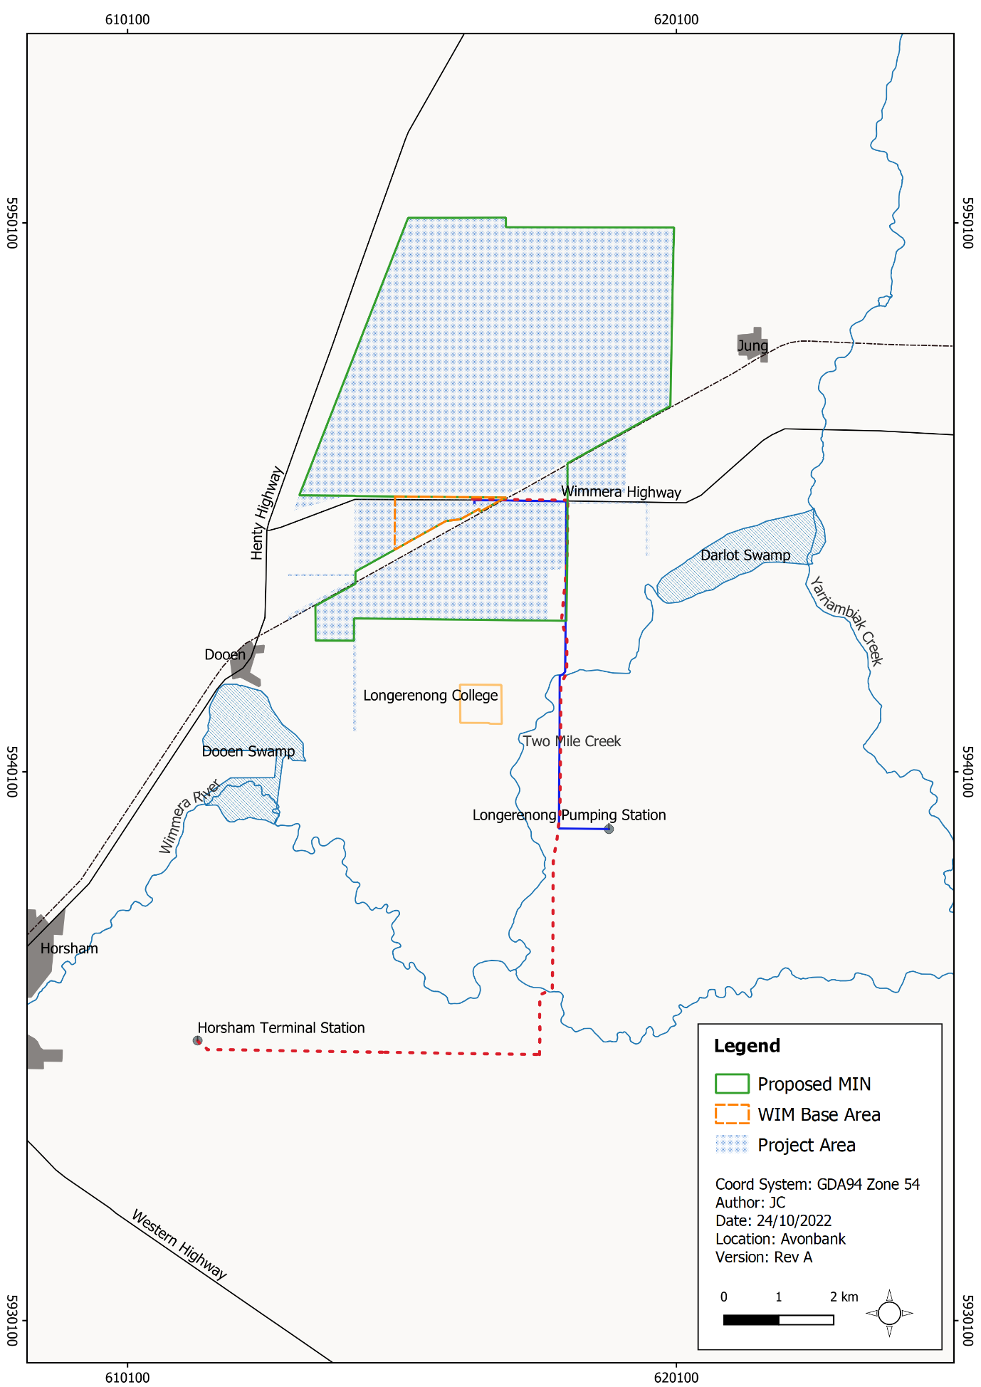
Figure 15-1: Study area

Operational Context

Mining and Rehabilitation
As described in Chapter 2, construction of the Wet Concentrator Plant (WCP) and preparation for the starter pit will be undertaken in year 1, followed by progressive mining in the southern areas of the mine footprint in year 2. Mining operations will move to Block B north of the Wimmera Highway in year 7.
In years 2 and year 7, overburden will be stockpiled to create a starter pit with sufficient room for the progressive placement of tails and overburden. Typically, overburden will be used to progressively backfill the mine void, along with tailings from the WCP.
The topsoil and subsoil growing medium will be stripped and temporarily stockpiled to maintain the integrity of the upper soil units for use in rehabilitation. Soil units will be stripped separately to a nominal depth dependent on the site soil characteristics and will be stockpiled, like-on-like soil units, to ensure that mixing is minimised (i.e., subsoil will be placed directly onto subsoil).
Sand tailings will be returned to the mining void via a pipeline from the WCP. Once the tailings are dry, such that they are safe, stable and have sufficient strength to support machinery movement, overburden will be placed. Subsoil and topsoil will then be placed to a total depth of around 1 m.
Areas of overburden direct return (where there are no tailings) will be rehabilitated rapidly, with subsoil and topsoil placement subject to appropriate weather conditions, to avoid compaction in wet conditions and erosion in windy conditions.
Subsoil units will be ripped and ameliorated with gypsum as required prior to the placement of topsoil. Land will then be sown and cropped in consultation with the landholders. Land will be handed back to the landholders once it is considered to be safe, stable, sustainable and the rehabilitation objectives have been met.
At the end of mining, all overburden stockpiles will be returned to the mining void. No mining void will remain once rehabilitation has been completed and no permanent stockpiles will remain upon Project completion.
It is expected that rehabilitation will be completed within 4 years after initial topsoil disturbance in each mining cell. At any given time over the life of mine, the extent of Project disturbance will be less than 400 ha and will typically (on average) be less than 300 ha as areas are progressively mined and rehabilitated.

Avonbank Demonstration Trial
This Section describes the Avonbank Demonstration Trial which was undertaken in 2019–2022 to test the feasibility of mining, processing and rehabilitation within the Project area. A description of how the trial was undertaken is provided below.
Pre-mine soil surveys were undertaken by South East Soil and Water (SESW, 2019) to characterise the soil profiles and to inform the rehabilitation strategy with the aim of returning the rehabilitation area to a land use commensurate with the surrounding areas. The overarching rehabilitation strategy was to recover as much of the effective rooting zone as practicable and to separate the upper soil horizons from the lower more hostile units.
Following the soil surveys and development of the rehabilitation strategy, the topsoil and subsoils were stripped from operational areas during January and February of 2019. Three separate stockpiles were established for topsoil, upper and lower subsoil units (Subsoil A and Subsoil B) and a fourth stockpile was established for excavated overburden (refer Figure 15-2). The stripping depths below ground level (BGL) were:
- Topsoil from 0–12 cm;
- Subsoil A from 12–60 cm;
- Subsoil B from 60–110 cm; and
- Overburden >110 cm.
Following removal and stockpiling of the upper soil profile and overburden, ore excavation commenced with material trucked to the pilot plant for processing. Ore was excavated from between 119–126 mAHD (~13-20 mBGL), totalling around 5,000 bank cubic meters (bcm) of ore.
The total depth of excavation in the test pit was to 119 mAHD (~20 mBGL) which is around 5 m above the potentially acid-forming material identified in the geological model as the Geera Clay. This material remained in situ and was therefore not disturbed or exposed to oxidation processes.
The excavated ore was processed in the pilot plant to separate the Heavy Mineral Concentrate from the coarse and fine sand tailings. This process involved washing and screening ore in a scrubber/trommel and de-sliming the sands through the desliming cyclones to remove the fines. The ore was separated over gravity separation spirals to produce concentrate and coarse sand tails streams. Coarse sand tails and fine tails were co-disposed back to the mining pit cell using flocculant and recovered water was reused in the process.
In-pit tails were left to consolidate for 9 months. Geotechnical testing undertaken between March 2020 and December 2020 demonstrated that tails had consolidated sufficiently under its own weight. Following tails consolidation, overburden placement commenced at 124 mAHD (~15 mBGL).
Rocky overburden and residual low-grade ore were placed on top the tails, followed by overburden from the Shepperton Formation. Overburden was placed using scrapers and dozers which resulted in compaction under tyre pressure to around 200 kPa. The final overburden level was surveyed at around 137.5–137.9 mAHD (~1.1 mBGL.)
This was followed by the placement of subsoil in two separate cuts:
- Subsoil B was placed over the overburden to a thickness of ~50 cm, spread with 10 t/ha gypsum and deep ripped to 30 cm.
- Subsoil A was placed over the Subsoil B to a thickness of 50 cm, spread with 10 t/ha gypsum and deep ripped to 30 cm.
Topsoil was then placed to a thickness of ~10–20 cm, ameliorated with 6 t/ha of gypsum and disc ploughed. The final landform was designed to sit 10–15 cm above the surrounding land elevation to account for subsidence expected over the coming years.
Post-rehabilitation monitoring was conducted by SESW immediately after topsoil placement, during the growing season and following crop harvest (refer Attachment 3). The site showed no material evidence of ground movement or erosion and the estimated crop yield monitored through the growing season was higher in the rehabilitated site than the unmined areas (refer Figure 15-3). Monitoring showed that the rehabilitation strategy had been implemented as planned and confirmed the outcome was suitable for broadacre agriculture as intended.
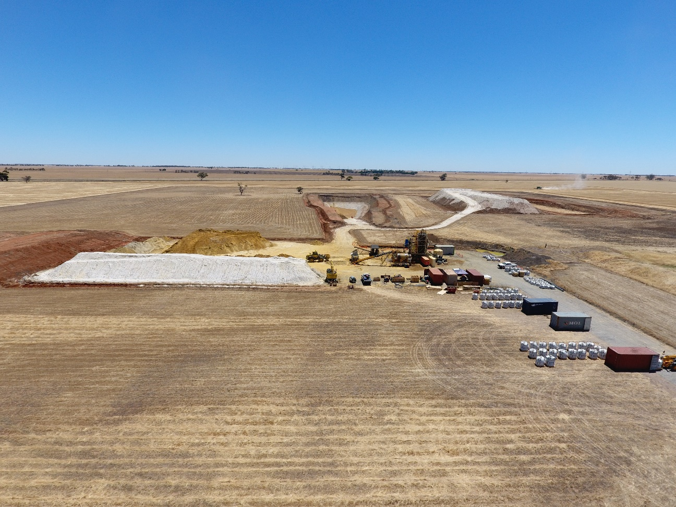
Figure 15-2: Avonbank Demonstration Trial showing mining pit, stockpiles, and plant
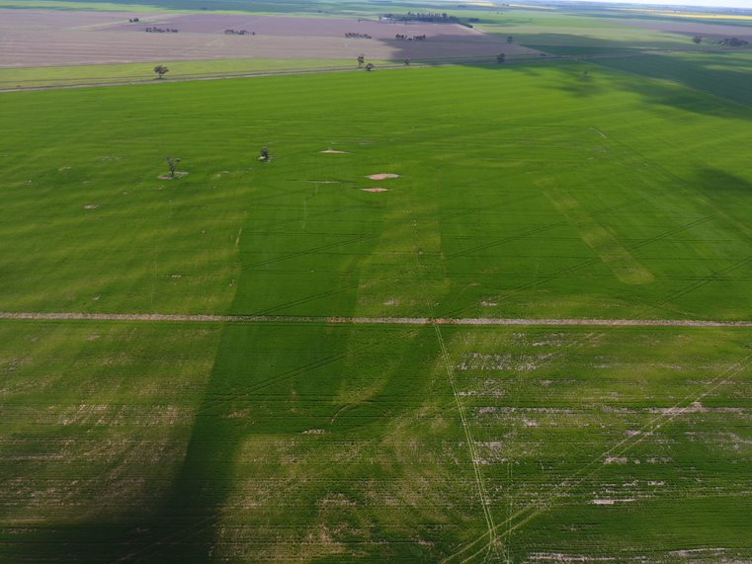
Figure 15-3: Avonbank Demonstration Trial rehabilitation August 2021

Existing Conditions

Regional Landforms and Geology

Geomorphology
The proposed mining licence lies within the Wimmera Catchment Management Area. The Wimmera region is divided into three main geomorphological units according to Robinson et al. (2005):
- Western Uplands, which extend westwards from the Kilmore Gap to the Glenelg River;
- Northern Riverine Plains, an extensive and predominantly alluvial landscape lying to the north of the Western Uplands; and
- North Western Dunefield and Plains, which in areas to the north of the Wimmera Highway consists of clay plains with subdued ridges.
The mine is situated within the North Western Dunefield landscape unit which is characterised by a very low variation in elevation.

Geology
The ore body lies within the Parilla Sand geological unit, as mapped by the Geological Survey of Victoria (1:250,000 map series). During the Tertiary period (65 to 2.6 million years ago), a series of marine transgressions occupied much of the lower Murray Basin. Over time, a thick layer of marine sediments (the Renmark Group and the Geera Clay) accumulated over the pre-tertiary basement rock.
As the sea levels receded, a series of north–south trending strandline sand ridges were deposited. The stranded ridges and intervening swales or troughs were then lateralised. These ridges and associated troughs continue to influence catchment behaviour and local watercourses, including the Wimmera River and Yarriambiack Creek, which are approximately aligned with the troughs.
Alluvial and aeolian deposition occurred during the Pleistocene (around 12,000 years ago). The predominantly clayey sediments of the extensive alluvial Shepparton Formation accumulated between the stranded ridges.
During the mid to late Pleistocene, a series of arid phases led to the development of dune fields, the Parilla Sands and lacustrine deposits in swales between the stranded ridges. The self-mulching clay soils in the Project area are essentially end products of late-Pleistocene to Holocene aeolian redistribution of sediments from inter-ridge corridors.

Regional Soil Mapping
The two dominant soil types associated with the Project area, as defined in the regional mapping (1:100,000), are grey vertosols (VEAD) and brown sodosols (SOAB). The typical characteristics for each soil type are summarised in Table 15-1. Figure 15-4 shows the soil types as characterised by the Victorian Soil Type Mapping (DJPR, 2018).
Table 15-1: Regional soil mapping types
Soil Type | ASC Description | Agricultural Potential
Sodosols (SO) | Soils with strong texture contrast between A and sodic B horizons which are not strongly acidic.  Soils other than Hydrosols with:  - with a clear or abrupt textural B horizon in which the major part of the upper 0.2 m of the B2 horizon (or the major part of the entire B2 horizon if it is less than 0.2 m thick) is sodic and not strongly acid; and  - soils with strongly sub-plastic upper B2 horizons are excluded. | Typically have very low agricultural potential with high sodicity, leading to high erodibility, poor structure and low permeability.  Subsoils are often dispersive and prone to gully and tunnel erosion.  Often hard-setting when dry and prone to crust formation.  Low to moderate chemical fertility and can be associated with soil salinity.
Vertosols (VE) | Clay soils with shrink-swell properties that exhibit strong cracking when dry and at depth have slickensides and/or lenticular structural aggregates.  Soils which have all the following:  - a clay field texture of 35% or more clay throughout the solum except for thin, surface crusty horizons 0.03 m or less thick.  - when dry, open cracks occur at some time in most years. These are at least 5 mm wide and extend upward to the surface or to the base of any plough layer, self-mulching horizon, or thin, surface crusty horizon; and  - slickensides and/or lenticular peds occur at some depth in the solum. | Generally high agricultural potential.  High chemical fertility and water holding capacity but require significant amounts of rain before water is available to plants.  Gypsum and/or lime may be required to improve the structure.  Heavy plastic clays can be difficult to respread and cultivate, especially when wet.  Shrink-swell phenomena creates foundation problems for buildings and infrastructure.

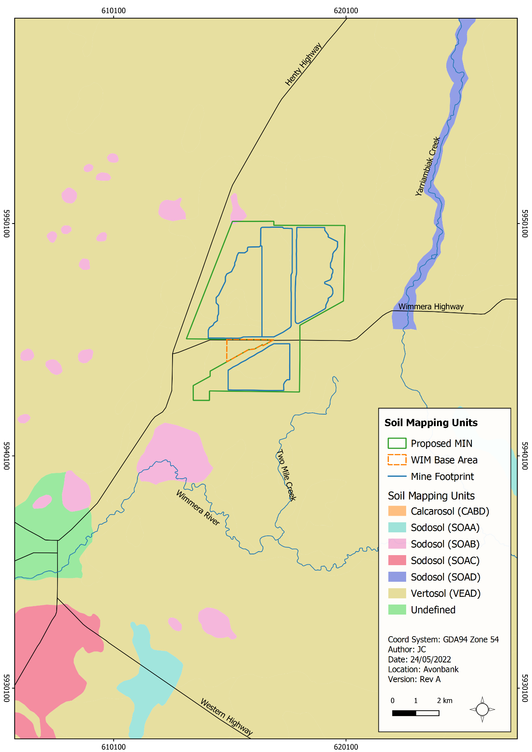
Figure 15-4: Regional soil mapping (source data: DJPR 2018)

Soil Mapping Units
Consistent with the regional scale mapping, the soil types present within the Project area, as described by Tonkin Consulting (Tonkin, 2020) and South East Soil and Water (SESW, 2022), can be grouped into two soil mapping units dominated by vertosols and sodosols.

Vertosols
Vertosols (grey/brown clay) occupy up to 70% of the Project area and consist of cracking calcareous brown clay soils intermingled with grey clays.
The most common soil type within this soil association comprises grey to grey-brown, medium to light self-mulching clays (Figure 15-5). The surface horizons are typically friable or semi-friable and up to 25 cm in thickness.
There is usually a clear delineation between topsoil and subsoil layers. The subsoils (B horizons) mostly comprise mottled heavy clays of various colours (often brown to red-brown blocky clays). Infilling of surface soils into cracks in lower soil horizons is evident.
Vertosols generally have high agricultural potential because of their high chemical fertility and high water-holding capacity, but they may suffer from poor drainage unless their structure is improved through the addition of gypsum.
The vertosol soils generally have moderately to highly sodic and saline subsoils, but the average subsoil sodicity and salinity is not as pronounced as in the subsoils of the sodosols.
Notwithstanding the high sodicity and sodium concentration in the deeper soil layers, the vertosols are considered to be among the most productive of the Wimmera wheatland soils.
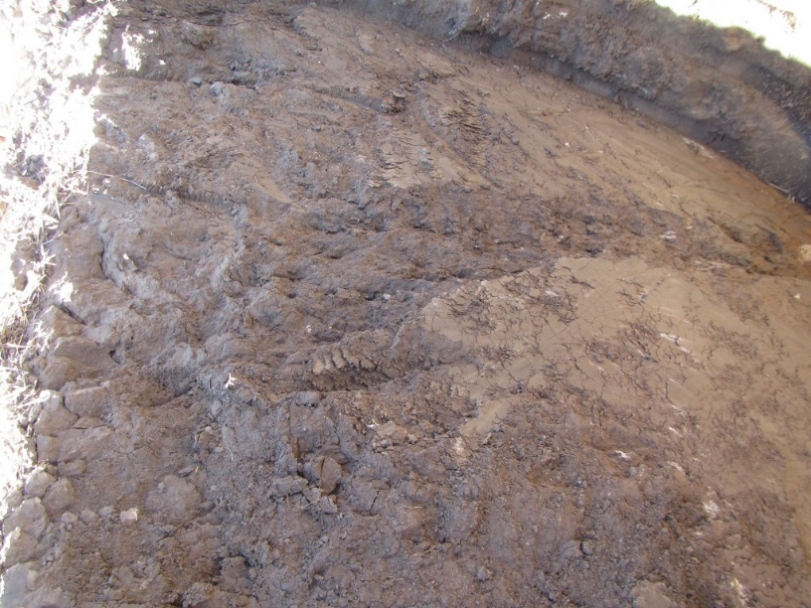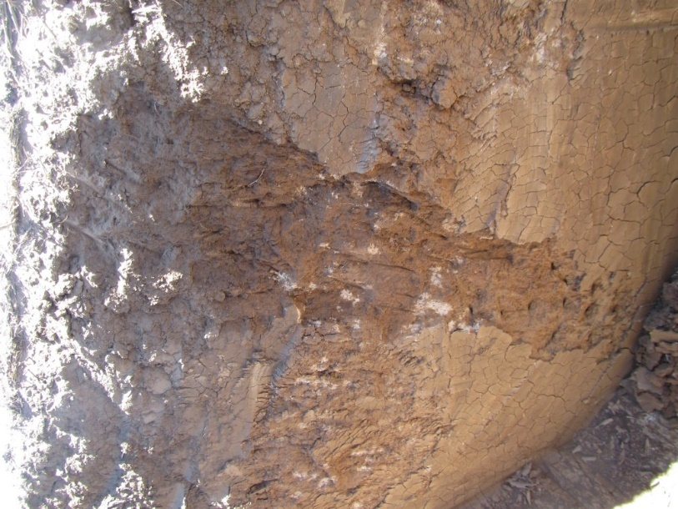
Figure 15-5: Test pits within Project area showing typical vertosol profile

Sodosols
Sodosols (calcareous red-brown earth) occur over approximately 30% of the Project area. During field surveys this type of soil was more commonly observed on low rises.
These are duplex soils with a strongly sodic and saline subsoil and a pronounced texture contrast between topsoils and subsoil horizons (Figure 15-6). The topsoil typically has a sandy clay loam or sandy loam texture and a thickness of up to 20 cm.
Surface soils in this group may be hard-setting, which can hinder plant growth. Subsoils consist of red-brown to reddish-brown medium or heavy clay. At about 50 cm the subsoil changes gradually into slightly mottled colours.
Carbonates occur at depth in the subsoil. Despite their typically low agricultural potential and notwithstanding the high sodium concentration in the deeper soil layers, the sodosols are still considered to be productive agricultural soils.
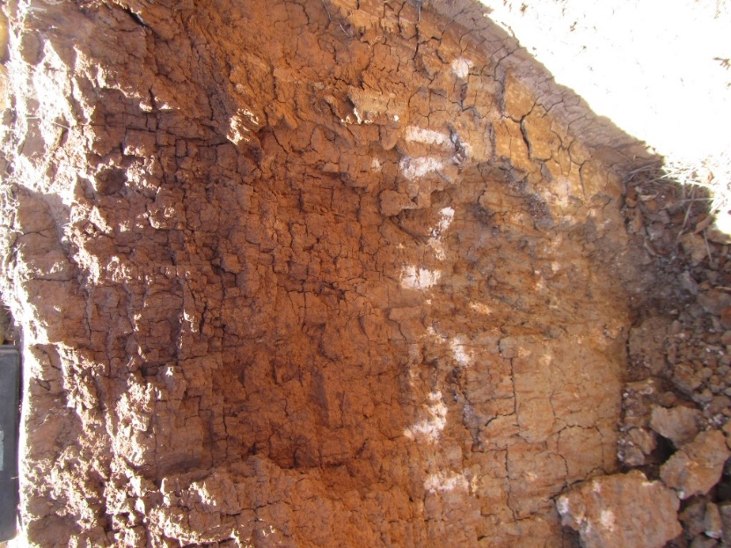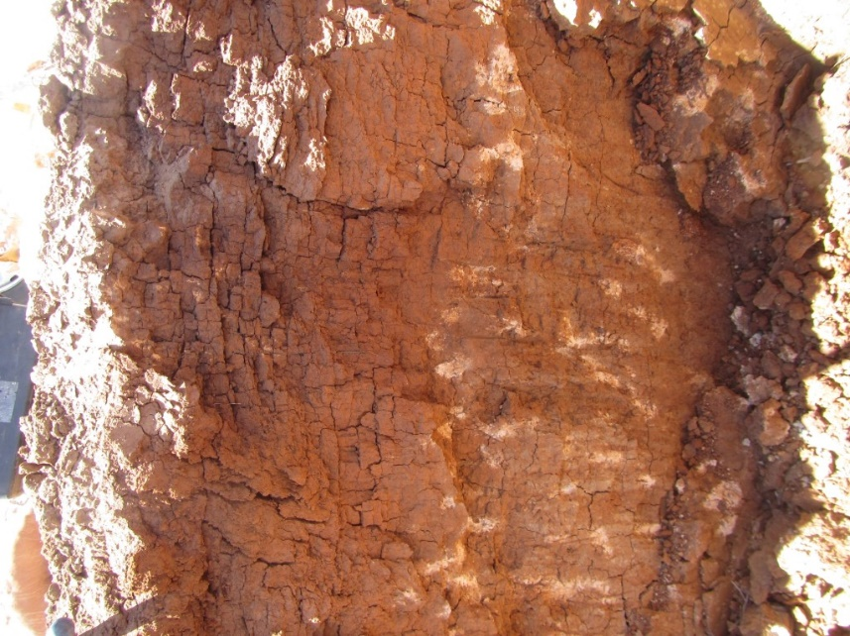
Figure 15-6: Test pits within Project area showing typical sodosol profile

Soil characteristics
The key characteristic of the main soil types within the Project area are summarised in Table 15-2. The primary differences relate to the texture trend observed throughout the profile colour of the subsoil and the depth of the effective rooting zone.

Table 15-2: Soil characteristics within the Project area
Soil Characteristic or Constraint | Sodosols | Vertosols
A horizon topsoil texture | Sandy Clay Loam | Light Clay
A horizon structure | Weak sub angular-blocky, tending massive or structureless where thin hard pan exists from 7–14 cm | Weak sub angular-blocky to crumb structure, typical of self-mulching clay topsoils
A2 horizon hard pan | Yes | No
Dominant B horizon texture | Medium and heavy clay | Medium and heavy clay
B horizon structure | Moderate angular blocky | Weak to moderate angular blocky, tending strong angular-blocky with depth
Depth to a violent reaction to 1N°HCl | 67 cm | 81 cm
Average effective root zone depth | 87 cm | 110 cm
Estimated plant available water at 1500°kPa | 129 mm | 141 mm
Average EC – A1 horizons | 0.9 dS/m | 1.1 dS/m
Average EC – B1 horizons | 1.7 dS/m | 0.9 dS/m
Average EC– B2 horizons | 5.2 dS/m | 1.4 dS/m
Average EC – B3 horizons | 8.7 dS/m | 3.4 dS/m
Average ESP – A1 horizons | 7.7% | 1.7%
Average ESP – B1 horizons | 29.1% | 10.7%
Average ESP – B2 horizons | 26.9% | 16.5%
Average ESP – B3 horizons | 26.4% | 26.3%
The two soil types have broadly similar chemical characteristics in the topsoil, with limitations typically encountered at slightly shallower depths in the sodosols compared to the vertosols. The two soil types have an effective rooting zone averaging around 90 cm, with the vertosol soils typically extending slightly deeper than the sodosols.
Both soil types show pronounced changes with depth, becoming increasingly alkaline, saline and sodic in the B2 and deeper horizons.
Sodosols have predominantly sodic topsoils and vertosols typically have non-sodic topsoils. The sodosols are strongly sodic throughout the subsoils with exchangeable sodium percentage (ESP) generally between 20–30%. The vertosols tend to be non-sodic in the B1 horizon, becoming sodic in the B2 horizon and strongly sodic from the B3 horizon onwards (17–23% ESP).
Both soil types are commonly saline (electrical conductivity above 4 dS/m) throughout the B2–B5 subsoils, generally below 40 cm depth.
The pH of both soil types are predominantly within the range suitable for plant growth in the upper profile. Subsoils show increasing alkalinity with depth, becoming very strongly alkaline (pH >9.0) at depth, typically 70 cm below ground level.
Trace element concentrations in both topsoils and subsoils are typically low, although boron concentrations increase markedly with depth and are commonly present at levels that can be hostile to moderately sensitive crops in the B2 and deeper soil horizons.
Total heavy metal concentrations are consistently below health-based investigation levels specified in the ‘National Environment Protection Measure (Assessment of Site Contamination) 1999’ (NEPM) (NEPC, 1999) (refer Appendix J, Table 6.9).
The primary chemical limitations present across the Project area for both soil types were determined to be sodicity, alkalinity, salinity and boron.

In situ Regolith
The regolith materials below the A and B horizons that sit above the ore are commonly referred to as overburden. Within the Project area, this typically occurs from around 1 m through to around 14 m.
There are two main types of overburden within the Project area:
- Upper clayey overburden derived from the Shepparton Formation; and
- Lower non-mineralised (barren) fine sand or clayey sand, known as the Loxton Parilla Sands Formation.
The mineralised parts of the Loxton Parilla Sands Formation represent the ore body targeted by mining (refer Figure 15-7). A comparatively thin layer (1 m to 2 m in thickness) of ferruginised and/or silicified sand, known as the Karoonda Surface, separates the Shepparton Formation from the underlying Loxton Parilla Sands.
The Geera Clay lies beneath the Loxton Parilla Sands. The target maximum mining depth lies approximately 2 m above the uppermost part of the Geera Clay stratum. A conceptual geological model is contained in the Groundwater Impact Assessment, Appendix L of this EES.
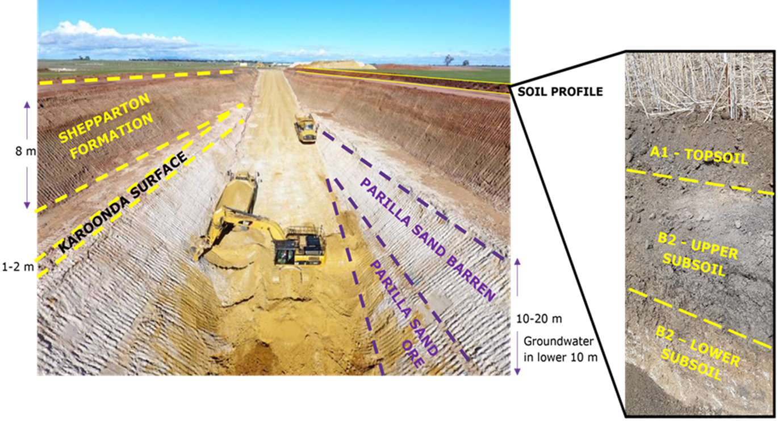
Figure 15-7: Avonbank Demonstration Trial mining showing regolith profile
The geochemical properties of the overburden are broadly similar to the soils in the lower B horizons. The pH of the mixed overburden consisting of the Karoonda Surface, Shepparton Formation and non-mineralised Loxton Parilla Sands Formation is neutral to alkaline.
The salinity of the Shepparton Formation and mixed overburden is moderately to highly saline. Salinity in the ore body and non-mineralised sandy overburden is moderate. The median exchangeable sodium percentage value in the overburden was 40%. Soils with an exchangeable sodium percentage value above 15% are classified as highly sodic and prone to dispersion.
Total heavy metal concentrations generally lie well below health-based investigation levels specified in the NEPM (refer Appendix J, Table 6.12).
Dissolved metals are consistently below the upper concentrations specified for leachable metals in Category D industrial waste, which is the lowest hazard level category defined by EPA for industrial wastes (refer Appendix J, Table 6.12).

Potential Acid Sulfate Soils
Based on a review of the ‘National Acid Sulfate Atlas’ (ASRIS, 2013), the potential for acid sulfate soils within the surficial soils of the Project area was considered to be low. The lower subsurface geological units including the Geera Clay were considered to be a Potential Acid Sulfate Soil (PASS) risk. A field investigation was undertaken to characterise this risk.
Targeted field sampling was completed to characterise the Chromium Reducible Sulfur percentage within and below the materials to be mined. This investigation showed that materials from the Shepparton Formation and Loxton Parilla Sands Formation within the Project area are unlikely to present a PASS hazard. The Geera Clay was considered to represent a high PASS hazard, however, it sits below the ore body and will not be disturbed during mining.

Contaminated Sites
There are no priority EPA contaminated sites recorded within the development extent. Several priority sites are situated in the surrounding areas, as described in Chapter 17 (Groundwater). The land use within the Project area is primarily farming, with one dwelling, farm sheds, silos, sealed and unsealed roads and farm dams situated within the proposed disturbance area. Areas of contamination may be associated with these sources, including but not limited to hydrocarbons, asbestos and pesticides/herbicides.

Land Use

Land capability
A land capability assessment was undertaken in line with the ‘Guidelines for Land capability Assessment in Victoria’ (Agriculture Victoria, 1981). The Project area was categorised as a Capability Class 4 for intensive cropping for both soil types due to their poor drainage. The classification indicates that the capability is low and the limitations and hazards to the land are such that it is marginal for the use specified. Despite this classification, it should be noted that vertosols are typically seen as one of the most productive soil types as their cracking or self-mulching nature reduces the limitations associated with clay topsoils, such as poor water infiltration or potential hard setting. The impact assessment has conservatively assumed all land within the Project area is highly productive.

Potential yield
The yield potential for wheat and canola was assessed under various rainfall and soil moisture scenarios by SESW (SESW, 2019). A visual assessment of the effective rooting depth calculated Plant Available Water and other agronomic factors were used to calculate the yield potential. The calculated yield potential for the Project area was:
- Low rainfall or drought conditions: 0–2.0 t/Ha.
- Average rainfall year: 1.5–4.0 t/Ha.
- Above average rainfall year: 2.0–5.0 t/Ha.
Yield estimates were also conducted for the rehabilitation and undisturbed sites, as communicated in Section 15.3.2.

Potential Impacts

Identified Potential Impacts
Potential impacts were identified in the SLIA with consideration to the proposed Project activities, the baseline studies, stakeholder concerns and the issues identified in the referral document and Scoping Requirements (refer Table 15-3). Where a source-pathway-receptor relationship was considered plausible, further investigation was undertaken to assess the residual impacts with avoidance and mitigation measures in place (refer Section 15.7).
Table 15-3: Potential impacts
Item | Potential Impacts | Phase
IP-01 | Mining and movement of soil materials resulting in adverse effects on soil profile capability and agricultural productivity. | C, O, D
IP-02 | Backfilling of mine voids with tails and/or overburden resulting in geotechnical instability of the final landform. | C, O, D
IP-03 | Mining and movement of soil material resulting in increased rates of erosion from operational areas and from rehabilitation. | C, O, D
IP-04 | Stripping and excavation of the soil profile resulting in disturbance to existing contaminated land and impacts to surrounding soil resources. | C, O
IP-05 | Disturbance of Potential Acid Sulfate Soils resulting in oxidation of reactive materials and acidification of soil resources. | C, O
IP-06 | Mine operations resulting in the release of contaminants and impacts to soil resources and other sensitive receptors. | C, O, D

Sensitive Receptors
Potential sensitive receptors identified in the SLIA are listed in Table 15-4 and shown in Figure 15-1. These receptors are situated within the worst-case plausible extent of identified potential impacts.
Table 15-4: Sensitive receptors
Receptor Type | Sensitive Receptors
Land | Land within and adjoining the proposed mining licence and WBA.  Associated ERS values include land dependent ecosystems (modified and highly modified), human health, building, aesthetics and production of food.
Wetlands and waterways | Dooen Swamp, Darlot Swamp, Two Mile Creek and Wimmera River.  Associated ERS environmental values include water dependent ecosystems and species, water-based recreation (Wimmera River), traditional owner values, human consumption of aquatic foods (fish) and surface water licences on the Wimmera River.

Impact Characterization
The impact assessments summarised in Section 15.7 considered the magnitude, spatial extent and duration of the residual impacts as described in Chapter 6. In assessing the residual impacts, consideration was given to available benchmarks (Table 15-5) and direct comparisons between the mined and pre-mine or unmined lands as part of the Avonbank Demonstration Trial.
Table 15-5: Benchmark criteria
Reference | Commentary
Waste disposal categories – characteristics and threshold (Publication 1828.2, 2021) (EPA, 2021d) | The publication lists criteria against which certain wastes are intended to be assessed to determine which waste disposal category applies. Where soil contains known or is reasonably expected to contain contaminants exceeding the upper limits for fill material in Table 3 of EPA Publication 1828.2, these will be classified as contaminated soils. These benchmarks have been applied in Section 15.4.4 and in Appendix J Table 6.12.
National Environment Protection (Assessment of Site Contamination) Measure 1999 (NEPM) (NEPC, 1999) | The NEPM provides a national risk-based framework for the assessment of site contamination in Australia. The NEPM ensures there is adequate protection of human health and the environment. The most stringent level of health-based soil contamination in the NEPM are the HIL-A investigation levels which are typically applied to residential properties with gardens and/or accessible soils. These have been applied in Section 15.4.4, Section 15.4.3.3 and in Appendix J Table 6.9 and 6.12. Chapter 18 investigates matters relating to Human Health risk further.
In addition to the detailed characterisation of the impacts described above, the relative significance of each likely residual impact was summarised on a scale ranging from negligible through to severe (refer Table 15-6).
Table 15-6: Significance of residual impacts
Rating | Description
Negligible | No detectable impact on identified receptor/s, use or value.
Minor | Impact on identified receptor/s within natural variability and/or no tangible change to environmental values or use.
Moderate | Impacts on identified receptor/s with a tangible change to environmental values or use. Impacts extend outside the Project area and may persist over the medium to long-term.
Major | Impacts on identified receptor/s with a significant change to environmental values or use. Impacts extend locally or regionally and may persist over the medium to long-term. Receptors of State significance permanently impacted.
Severe | Impacts on identified receptor/s with a significant change to environmental values or use. Impacts may extend locally, regionally or State-wide and may persist over the long-term or be irreversible.

Avoidance and Mitigation Measures
This Section outlines the measures identified to avoid and minimise residual impacts. It is noted that in line with the requirements of the proposed environmental management system (EMS) and relevant legislation, additional measures may be required during Project implementation to ensure risks and potential impacts have been minimised so far as reasonably practicable.

Avoidance

SL-01: Geera Clay Formation
Exploration drilling and analysis of the Avonbank deposit identified that the ore body sits above the Geera Clay geological unit, which was shown to be a PASS. It was determined that this formation will be avoided during all mining, excavation and dewatering activities with a buffer of at least 1.5 m to avoid exposing and oxidising the Geera Clay. Mining and sump excavation will be undertaken with survey control to ensure the buffer is maintained. An overarching PASS Management Plan is described in Chapter 17 (Groundwater).

Minimisation

SL-02: Soil resource management
A pre-mine soil survey will be undertaken by a suitably qualified person for each landholding once land access is granted and prior to stripping topsoil. The surveys will be conducted at an appropriate intensity to characterise the materials that will be stripped and stockpiled for later placement in the reconstructed soil profile. Field characteristics will be logged, and representative samples submitted for laboratory analysis, including but not limited to sodicity, salinity and pH.
The overarching rehabilitation strategy is to strip and stockpile the upper soil horizons separately from the lower soil horizons, which tend to be more hostile to plant root growth (refer Section 15.3). The Rehabilitation Plan included as Attachment 3 of this EES explains that a soil unit refers to the soil horizon/s that will be stripped and stockpiled together. Attachment 3, Section 9 describes the anticipated stripping depths and the associated horizons that comprise those soil units.
It is anticipated that the stripping depth will total 1.1 m to recover as much of the pre-existing rooting zone as reasonably practicable. The effective rooting zone will be stripped as three separate soil units, including topsoil, Subsoil A and Subsoil B. Lower soil horizons will be stripped or excavated as overburden and either stockpiled or placed directly back to the mined void. It is anticipated that the depth of each soil unit will be adjusted as required across the landholding to ensure appropriate differentiation of upper and lower subsoil units.
The pre-mine survey will identify the key stripping depths for each soil unit based on factors including but not limited to soil texture, sodicity, salinity, and alkalinity. This information will be used to develop specific rehabilitation plans for each landholding (groups of land parcels) that detail matters relating to stripping depths for each soil unit, stockpile locations, amelioration requirements during rehabilitation and intended placement locations.
Stripping operations will be controlled via a combination of survey control for each soil unit and field observations. The depth of each soil unit will be either marked by survey pegs or by GPS control in the relevant rehabilitation machinery. Operations will be supervised to verify the stripping depths as per survey controls and to verify various field indicators (such as soil colour or texture). Adjustments will be made, if required, to the planned stripping depth by a suitably trained field supervisor to ensure soil units are appropriately stripped and stockpiled.

SL-03: Soil stockpile management
Stockpile areas will be pre-stripped to preserve the soil resource and to ensure stockpiles are placed on the same underlying soil unit. An inventory of soil stockpiles will be kept which identify the stockpile footprint, surveyed volume, key characteristics, amelioration requirements and intended placement location.
Topsoil and subsoil stockpiles will be seeded and stabilised with vegetation to minimise wind erosion where practicable to do so. It is anticipated chemical stabilisers such as polymers or hydromulch may be used as a contingency if required.
Overburden will be directly returned to the mine void except for the stockpiles associated with starter pits for Block A and Block B. The overburden material has been shown to crust, as observed during the rehabilitation trial, making wind erosion a negligible risk. Surface water run-off and surface erosion will be actively managed given the dispersive nature of the materials.
Drainage of each stockpile location will be designed and incorporated into the overarching progressive mine and rehabilitation planning system to ensure no mine contact water is discharged from the operational areas. Suitable erosion and sediment controls, such as sediment detention ponds, will be established at the toe of each overburden stockpile to capture run-off water. Water from sumps will be returned to the process water circuit or used for operational purposes.

SL-04: Soil amelioration
The subsoil and topsoil units will be ameliorated to mitigate the issues relating to sodicity described in Section 15.4.3. Gypsum requirement tests will be undertaken prior to topsoil/subsoil placement to determine the amelioration requirements for each soil unit or stockpile. Based on the rehabilitation trial, it is expected that around 5–10 t/ha of gypsum may be required on each subsoil unit. Gypsum will be spread following topsoil and subsoil placement and then ripped or disc ploughed to the depth of each soil unit. Gypsum will then mobilise through the profile with each subsequent rainfall event.
Fertilisers will be spread onto topsoil areas after placement at rates commensurate with surrounding unmined areas. This is expected to offset the anticipated loss of topsoil fertility due to stockpiling.

SL-05: Soil profile ripping and compaction management
The stripping, stockpiling and placement of topsoil and subsoil materials will be undertaken during dry soil conditions, wherever practicable to do so, to minimise compaction. Topsoil heights will be limited to 2 m and subsoil heights will be limited to 6 m, which will minimise compaction within the stockpile. The height of the stockpiles takes into consideration the relative import of each subsoil unit and the overarching objective to minimise the disturbance footprint so far as practicable.
It is anticipated that machinery with low bearing pressure will be used to minimise topsoil and subsoil compaction. Each soil unit will be ripped as required to alleviate compaction within the rooting zone. It is expected ripping will be undertaken to the depth extent of each soil unit to avoid mixing hostile materials into the upper soil profile.

SL-06: Contaminated land
Prior to mining each land parcel, a contaminated site investigation will be undertaken in accordance with the NEPM. The investigation will be undertaken at the earliest opportunity once the relevant consent to access land parcels has been granted by the landholder and prior to the commencement of ground disturbing works.
The NEPM outlines a staged approach to the investigation and assessment of existing contamination that proceed in stages, in proportion to the risks of environmental harm. The initial desktop review provided in this EES will be expanded upon and will involve:
- Site inspections and landholder interviews to identify areas of potential contamination.
- Preliminary sampling of soil, groundwater and surface water in areas of suspected contamination.
- Preparation of a conceptual model relevant to each suspected contaminated site.
This will facilitate the completion of a preliminary site investigation for the relevant landholdings. As detailed in Section 2 of the NEPM, further work may be required pending the outcomes of the site investigation, which may involve a detailed site investigation. If areas of contamination are confirmed, a remediation plan will be developed to address all relevant requirements of the NEPM.
Any management plan in the first instance will determine whether it is possible to avoid disturbing pre-existing contaminated land. Where disturbance cannot be avoided, it will describe options to mitigate or remediate environmental harm from existing contamination.

SL-07: Site drainage and erosion
Prior to opening new mining cells or constructing new infrastructure, an integrated mine drainage plan will be prepared by the mine planning engineer with consideration to the existing topography, detailed mine design and surrounding infrastructure.
All infrastructure including but not limited to buildings, stockpiles, sumps, pipelines and booster pumps will be located in areas to minimise the risk of ponding and adverse effects to surface water flow paths. Rehabilitation areas will be contoured to reflect the pre-mining landform and surface drainage will be re-established commensurate with undisturbed areas.
Appropriately sized sediment retention basins will be established as part of the drainage plan to capture mine contact water and prevent discharge outside operational areas. Stormwater drains will be designed and constructed to minimise the risks posed to infrastructure and sensitive receptors.
The Surface Water Management Plan will be developed and implemented to monitor water quality within operational areas and in established rehabilitation areas. Contingency measures will be in place to ensure any stormwater run-off meets approved performance standards. The surface water management framework is detailed in Chapter 16 (Surface Water).

SL-08: Chemical management
Chemicals will be stored and managed in line with relevant guidelines, material data safety sheets and industry best practice. A dangerous goods register with emergency response procedures will be developed to effectively manage chemical spills. A Waste Management Plan will be developed and incorporated into the overarching AS/NZS ISO 14001:2016 EMS to manage these risks (refer Section 15.8).

SL-09: Weeds and pathogens
A management protocol will be established to minimise the risk of weeds or pathogens proliferating or spreading as a result of the Projects activities. Matters relating to biosecurity will be incorporated into the Flora and Fauna Management Plan (FFMP) to detail the identified pathogen, weed and pest management measures. The FFMP is detailed in Chapter 21 and will include requirements pertinent to weed and pest management to:
- access to rehabilitation areas will be restricted or minimised where possible;
- vehicles and machinery will be restricted to formed roads and tracks to the maximum practicable extent;
- risk-based vehicle/machinery hygiene protocols will be implemented when crossing between landholdings and when entering or leaving the operational areas;
- movement of topsoil between landholdings will be avoided or minimised so far as reasonably practicable;
- topsoil stockpiles will be managed to minimise the occurrence and proliferation of weeds;
- risk-based hygiene controls will be implemented for any imported rehabilitation materials to minimise biosecurity risks; and
- weeds and pests will be monitored across site.
The FFMP will be updated periodically and will apply to all phases of the Project, including construction, operations, and decommissioning (refer Chapter 21).

SL-10 Rehabilitation Operations Management Plan
A Rehabilitation Operations Management Plan (ROMP) will be prepared prior to Project commencement. The ROMP will provide a management framework to avoid and minimise impacts so far as reasonably practicable.
The ROMP will address matters relating to operational control and in doing so will facilitate the successful implementation of the approved Rehabilitation Plan. The plan will detail processes relating to planning, works implementation, monitoring and reporting. It will provide a roadmap to the detailed rehabilitation related work procedures that must be maintained and implemented.
The plan will be reviewed and updated at an appropriate frequency as established in the overarching EMS, with consideration to the level of risk, statutory requirements, monitoring results, community complaints and in response to audit findings.
The ROMP will:
- Summarise the baseline data and existing environment.
- Explain the relevant statutory requirements and context (including any relevant approvals).
- Detail planning and operational requirements associated with the successful implementation of the Rehabilitation Plan (Attachment 3).
- Describe the avoidance and mitigation measures to be implemented to minimise residual risks/impacts so far as reasonably practicable.
- Identify specific environmental objectives and performance standards to be achieved with avoidance and mitigation measures in place.
- Detail the monitoring and inspections to be undertaken to verify work procedures are implemented effectively (refer Section 15.8).
- Describe mechanisms to determine when/if corrective actions and contingency measures are required (refer Section 15.8.2)
- Detail a program to investigate and implement ways to improve the environmental performance of the Project over time.
- Detail appropriate review periods and/or triggers to ensure the plan remains fit for purpose.
- Establish procedures to manage:
- incidents and any non-compliance.
- stakeholder and community complaints.
- failure to comply with statutory requirements and/or performance standards.
- roles and responsibilities for implementing the plan.
- a protocol for periodic review of the plan.
- Include a community engagement strategy which will include a complaints handling system.
In addition to the above requirements and the avoidance and mitigation measures in this EES, the ROMP will include specific requirements to:
- Detail a protocol for pre-mine soil surveys and contaminated sites investigations for each landholding.
- Detail the design specifications relevant to backfill operations for overburden and sand tailings.
- Describe the procedural requirements for the development of an integrated planning process that will inform the Rehabilitation Plan and the landholder specific plans (which may form a part of the Land Access and Compensation Agreements (LACA)).
- Describe procedural requirements relating to the scheduling of activities with consideration to ground and weather conditions such that environmental risks are minimised.
- Include work instructions relevant to the successful implementation of the Rehabilitation Plan.
- Maintain fire management measures, including but not limited to the establishment of fire breaks and access to a water source.

Rehabilitation

SL-11 Rehabilitation Plan
Prior to Project commencement, a Rehabilitation Plan will be established that will address matters relating to progressive rehabilitation. It will cover all work areas and domains with a focus on those higher risk areas in the proposed mining licence and WBA.
The Rehabilitation Plan will describe the work to be undertaken to ensure the rehabilitated landform will be safe, stable, sustainable, and be capable of supporting the proposed end land use. It will describe the Project’s rehabilitation strategy, including those commitments included in this Chapter of the EES. The Rehabilitation Plan will define the end land use with consideration to the views of the landholders and the broader community where appropriate.
The Rehabilitation Plan will establish objectives and performance standards/criteria to measure and quantify when the objectives have been met and the rehabilitation is considered to be complete. A schedule for progressive rehabilitation will be included along with the rehabilitation milestones for the life of mine.
Relevant post-closure risks associated with the completed rehabilitation will be identified and assessed to determine: the type, likelihood and consequence of the risks; the activities required to manage those risks; the associated projected costs; and any other matter that may be relevant to risks arising from the rehabilitated land.
A preliminary Rehabilitation Plan for the Project has been developed to meet the intent of the Scoping Requirements and is included with this EES as Attachment 3. This plan will be refined prior to commencement with consideration to the detailed operating plans, stakeholder and community feedback and the Minister’s assessment of the EES.
A rehabilitation bond will be assessed and lodged prior to the commencement of mining, in line with the MRSD Act and the ERR ‘Guidelines for Rehabilitation Bonds – Mineral, Exploration, Mine and Quarries’ (ERR, 2022). It is anticipated that the bond will be periodically assessed prior to the commencement of each mine development stage and will consider the progressive rehabilitation undertaken at that point in time.

SL-12: Agricultural baseline assessment
A detailed agricultural baseline assessment will be completed prior to mining within each landholding. The outcomes of the assessment will inform the setting of appropriate performance standards and rehabilitation criteria. The assessments may be used to form the basis of the Land Access and Compensation Agreements performance target, where appropriate.

Residual Impacts
This Section describes the likely residual impacts with avoidance and mitigation measures in place. The residual impacts were characterised as described in Section 15.5.3 and Chapter 6 (Impact Assessment Framework).

Soil Profile Capability and Productivity
There is one potential impact (IP-01) identified in Section 15.5.1 that relates to potential adverse impacts on the post-mining soil profile capability and agricultural productivity. This impact may eventuate from a range of contributing factors, including:
- Mixing of soil profile horizons such that hostile materials are placed within the effective rooting zone of the reconstructed profile.
- Soil compaction within the effective rooting zone of the reconstructed soil profile.
- Loss of fertility in the topsoil due to stockpiling.
- Introduction or proliferation of weeds and/or pathogens.
The Avonbank rehabilitation strategy has been developed to optimise the post-mining soil profile capability in order to achieve the rehabilitation objective.
The rehabilitation strategy comprises the following key components:
- Subsoil horizons and topsoil will be stripped and stockpiled separately to preserve the growth medium within the effective rooting zone, so far as reasonably practicable.
- Mining voids will be backfilled with sand tailings and overburden directly after mining, typically within 4 years after topsoil is stripped.
- During rehabilitation, subsoil and topsoil material will be placed to reflect the pre-mining soil horizons and in doing so, minimise the risk of incorporating hostile materials into the effective rooting zone.
- Subsoil units will be ripped and treated with gypsum as required prior to the placement of topsoil, to ameliorate dispersive materials.
The Avonbank Demonstration Trial, as described in Section 15.3.2, tested the effectiveness of the proposed rehabilitation strategy. The residual impacts associated with each of the above listed contributing factors are described in the sections below.

Separation and placement of soil units
The two dominant soil types recorded within the Project area were the sodosols (calcareous red-brown earth) and vertosols (grey/brown clay), as detailed in Section 15.4.3. Both soil types were characterised by increasing levels of salinity, sodicity, alkalinity, and boron with depth below ground level. Adverse conditions were typically encountered deeper in the profile for the vertosols compared to the sodosols. The two soil types have an effective rooting zone averaging around 90 cm, with the vertosol rooting zone extending slightly deeper than the sodosols.
As described in Section 15.7.1, the rehabilitation strategy aims to strip, stockpile and replace soils from within the effective rooting zone and to separate the upper soil horizons from the lower more hostile horizons. The rehabilitated soil profile will be reconstructed to reflect the pre-mining conditions. The Avonbank Demonstration Trial was undertaken to test if this could be undertaken successfully within the proposed mining footprint (refer Section 15.3.2).
The trial involved stripping topsoil and subsoil in four separate cuts including topsoil (0–12 cm), Subsoil A (12–60 cm), Subsoil B (60–110 cm) and overburden (>110 cm). The test pit was mined, with sand tailings and overburden used to backfill the void to around 1 m from the surrounding ground level. The stockpiled soils were spread once the tailings were dry and overburden placed. A crop of barley was sown, soon after topsoil placement.
Soil sampling was conducted after topsoil placement to compare the conditions of the trial site and the unmined areas. The effective rooting zone recorded in rehabilitated areas averaged around 90 cm compared to the pre-mining average of 91 cm. South East Soil and Water concluded that the effective rooting zones pre and post-mining were similar, albeit with some loss likely due to compaction.
A comparison of the chemical conditions of the post-mining compared to the unmined areas is described in Appendix J, Section 9.1.2. Figure 15-8 and Figure 15-9 show the median exchangeable sodium percentage and median boron concentration respectively, along with the benchmarks for agricultural crops.
Similar trends of increasing exchangeable sodium percentage and boron with depth are observed in both the pre-mining and post-mining soil profiles. The SESW post mine soil assessment (SESW, 2022) concluded that the pre-mining soil conditions had not been significantly altered.

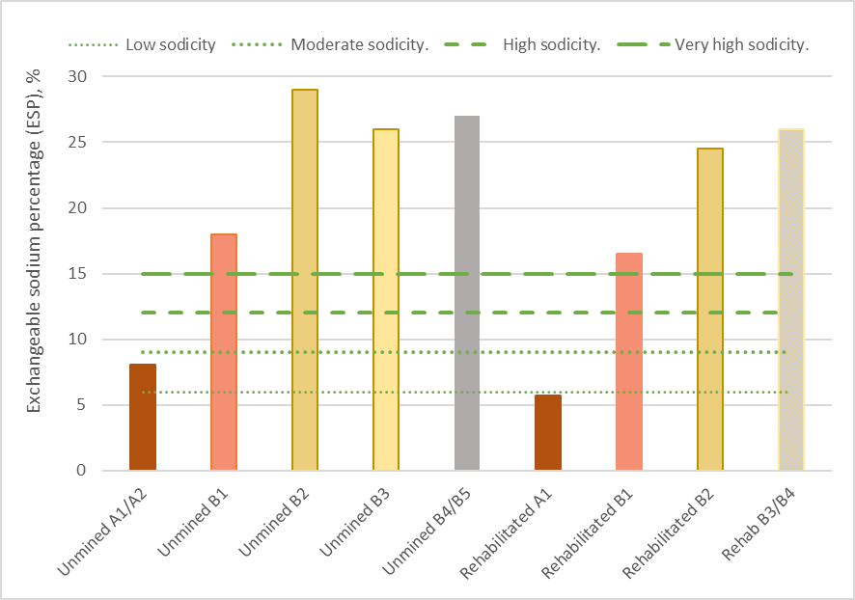
Figure 15-8: Median exchangeable sodium percentage by soil horizon (pre-mining and post-mining 2021)

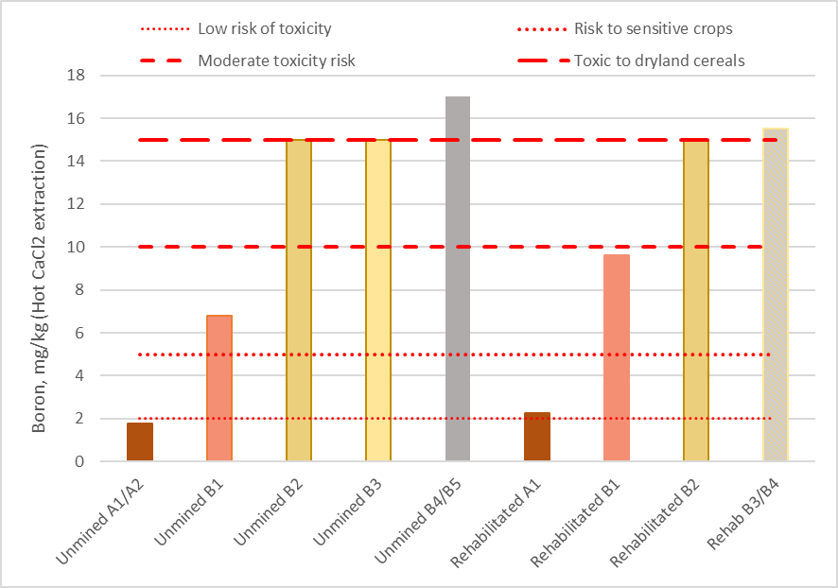
Figure 15-9: Median boron concentration by horizon (pre-mining and post-mining 2021)
The demonstration trial has shown that the rehabilitation strategy can be successfully implemented to preserve the effective rooting zone and separate the upper soil profile from the lower, more hostile soil profile units.
The trial resulted in minor changes to the soil profile conditions after rehabilitation and the estimated crop yield was shown to be commensurate with unmined areas. It is expected that the environmental objectives described in Section 15.8 can be achieved. Any residual impacts were assessed to be minor and within the range of natural variability observed in surrounding unmined areas.

Loss of soil fertility
Stockpiling topsoil can result in the formation of anaerobic conditions, which can reduce soil pH and alter nutrient availability. It is likely that mechanical handling of soils and increased aeration during soil handling will result in some short-term reduction in organic carbon levels and soil fertility.
Organic carbon was tested in all horizons for both pre- and post-mining assessments. In the A horizon, topsoil levels in the pre-mining assessment were slightly low to deficient averaging 1.10%. Levels in the post-mining assessment were also deficient, averaging 0.95%. This reduction is considered minor and may be due to stockpiling activities. Levels within the clay subsoils were all low and show negligible change.
Nitrogen levels were very low to deficient within all samples in both pre and post-mining assessments. Colwell Phosphorus levels average 31 mg/kg respectively within A₁ and A₂ horizons in the pre-mining assessment. Levels in the post-mining assessment average 23 mg/kg. Although levels show a slight decline, the change is considered minimal.
Rehabilitation areas will be fertilised, to optimise crop yields commensurate with surrounding unmined areas. It is anticipated that the soil organic matter will increase after the first crop is sown, as plant roots and stubble incorporate into the topsoil and upper subsurface soil unit. The residual impacts on soil fertility with mitigation measures in place were assessed to be minor and unlikely to adversely affect crop yield.

Soil compaction
Topsoil and subsoils within the Project area generally have a high clay content, show some propensity to slake and/or disperse and may be prone to mechanical compaction, especially when wet. Excessive compaction can impact crop yield if the plant root vertical growth is affected.
The placement of subsoil and topsoil into backfilled areas requires machinery to track over areas multiple times, which can cause excessive mechanical compaction. The demonstration trial involved ripping subsoil units after placement to alleviate compaction, as described in Section 15.3.2.
Monitoring within the trial shows that the topsoil and Subsoil A were not compacted within the mining areas. Some compaction was evident in Subsoil B layers and in the overburden soil units, however, this does not appear to have affected crop yield.
During operations, machinery with a relatively low bearing pressure (i.e., carry graders or tractor scoops) will be used to minimise compaction and subsoil units will be ripped after placement (refer Section 15.6.2.4). It is anticipated that residual impacts associated with mechanical compaction of rehabilitated areas will be minor and minimised so far as reasonably practicable, in line with industry leading practice.

Introduction of weed or pathogens
Monitoring undertaken within the demonstration trial indicate weeds are common within the mined area and unmined areas. The risk of spreading weeds and pathogens will be managed in line with existing farming practices across the region. Herbicides and pesticides will be periodically used as required within operational areas, rehabilitation areas, stockpiles and in undisturbed areas. A risk-based management protocol will be implemented to ensure the risk of spreading weeds or pathogens is as low as reasonably practicable (refer 15.6.2.8). The residual impacts associated with the spread or proliferation of weeds or pathogens were assessed to be minor and manageable with standard farming practices in place.

Landform Stability
There is one potential impact (IP-02) in Section 15.5.1 that relates to the potential for geotechnical instability associated with the final landform. Geotechnical instability, such as slumping and differential settlement, can affect the capability of the final end land use.
The mining void will be directly backfilled with tails and overburden to optimise the rate of progressive rehabilitation and to achieve a safe, stable and sustainable landform. Approximately 60% of the completed ore mining cells will be backfilled with overburden only, then completed by covering with subsoil and topsoil. The other 40% of the completed ore mining cells will be partly backfilled with tailings, then covered with overburden, subsoil and topsoil once the tailings have consolidated sufficiently.
Sand tailings will be pumped to the mining void from the WCP. Once tailings are dry, such that they are safe, stable and have sufficient strength to support machinery movement, overburden will be placed. Subsoil and topsoil will then be placed to a total depth of around 1.1 m. Areas of overburden direct return (where there are no tailings) will be rehabilitated rapidly, with subsoil and topsoil placement to occur as soon as reasonably practicable.
The post-mining predicted settlement and consolidation of the sand tails and overburden were assessed by Geoanalytica (Geoanalytica, 2021). This assessment considers the characteristics of the materials mined and direct observations from the demonstration trial. Chapter 17 addresses matters relating to tails management with respect to groundwater management.
The geotechnical assessment explains that tails consolidation can be categorised into three separate components:
- primary settlement/consolidation of the tailings due to ‘self-weight’ during and after tailings deposition as the tailings are dewatered, drained and dried;
- primary settlement/consolidation under load from the backfilled overburden, which will further reduce the void ratio within the tailings; and
- time-dependent secondary creep settlement/consolidation of the tailings.
Geoanalytica anticipates that the final surface of the tailings areas will settle to a maximum of 100 mm in the first year following topsoil placement, reducing to 15 mm per year for the second to fifth years, 10 mm per annum from the fifth to tenth year and then less than 5 mm per year from the tenth year onwards. This results in an estimated maximum settlement of 250 mm over a period of 30 years, with half of the settlement occurring in the first 5 years.
It is expected that once the tails dry and are trafficable, overburden will be placed to facilitate settlement and consolidation prior to subsoil placement. Subsoil and topsoil will be placed around 12 months after overburden placement. The final landform immediately following topsoil placement will be domed by up to 250 mm over the mining Block to account for time dependent secondary settlement.
Around 60% of the mining cells will be directly backfilled entirely with overburden (no tailings will be placed). Geoanalytica estimates that the surface over these cells may undergo limited and uniform settlement not exceeding 50 mm over a duration of up to 30 years after completion of backfill placement (less than 2 mm per year).
With the implementation of the Project design described in Chapter 2 and the rehabilitation commitments in this Chapter and Attachment 3, the residual impacts associated with settlement and consolidation were assessed to be minor. The implementation of the ROMP will ensure adequate planning, operational controls and monitoring requirements are established. It is expected based on the modelling conducted the impacts have been minimised so far as reasonably practicable and that the rehabilitation objectives can be achieved.

Surface Erosion
There is one potential impact (IP-03) in Section 15.5.1 that relates to the potential for excessive surface erosion from the rehabilitated soil profile, which could result in the loss of topsoil resources. If a complete source-pathway-receptor linkage could be established, adjacent sensitive receptors may be affected including neighbouring land parcels and wetlands/GDE’s via surface water drainage.
The Project design detailed in Chapter 2 and the surface water modelling conducted in Chapter 16 explains there will be no discharge from operational areas and stormwater drainage will be retained for re-use in the process water circuit. Rehabilitation areas will be contoured to reflect the pre-mining landform and surface drainage will be re-established commensurate with undisturbed areas.
Predicted soil loss calculations were conducted by Landloch to assess the relative annualise loss from rehabilitated areas and unmined areas using the Revised Universal Soil Loss Equation (RUSLE) (refer Section 15.2.3). The RUSLE calculation considered the site-specific dispersive characteristic of topsoil collected from the demonstration trial and adjacent undisturbed areas.
The soil erosion potential for the period after rehabilitation is complete and the crop established was between 1.18–1.87 t/ha/year. The modelled rates of soil erosion were all lower than the tolerable soil loss rate of 4.5 t/ha/year that is recommended for shallow agricultural soils. The post-rehabilitation monitoring conducted by SESW recorded no significant surface erosion features.
The risk of tunnel erosion is considered to be low, as the topography is relatively flat, with limited landform features to concentrate flow or pond water. This limits the potential for down-gradient subsurface flows to mobilise soil particles and cause tunnel erosion.
It is anticipated that the rehabilitation strategy and site drainage plan will result in surface soil erosion rates commensurate with surrounding unmined areas (refer Section 15.6.2). The residual impacts will be managed in line with standard farming practices and are expected to be minor, resulting in no material change to the pre-mining land use.

Existing Contaminated Sites
There is one potential impact (IP-04) listed in Section 15.5.1, which relates to the uncontrolled disturbance of contaminated sites associated with the pre-mining land-use. If a source-pathway-receptor connection can be established, this could result in the contamination of adjacent soil resources and other sensitive receptors. Potential impacts on groundwater are addressed in Chapter 17.
Areas of contaminated land associated with the existing land use may be present within the Project area. Given the current and historical agricultural land use, the potential for contamination is considered to be relatively low.
As described in Section 15.4.6, there are various sources of contamination within the disturbance footprint including one dwelling, farm sheds, silos, sealed and unsealed roads and farm dams. It is plausible that areas of contamination, including but not limited to hydrocarbons, sewage, asbestos and pesticides/ herbicides could be associated with these potential sources.
As described in Section 15.6.2.5, a contaminated sites investigation will be undertaken in accordance with the NEPM prior to mining for each landholding. This will facilitate the completion of a preliminary site investigation (PSI) for the relevant landholdings.
As required by the NEPM, further work may be required pending the outcomes of the PSI, which could involve detailed site investigations. If areas of contamination are confirmed, a remediation plan will be developed to address all relevant requirements of the NEPM.
It is anticipated that the Project will be able to manage contaminated land in line with industry standard practice and the NEPM. The progressive and high-precision nature of the stripping activities will minimise the risk of impacting an unexpected contaminated site in an uncontrolled manner. The likely residual impacts relating to pollution events associated with the disturbance of contaminated sites are expected to be minor, assuming the NEPM is implemented as described in Section 15.6.2.5.

Contamination from Project Activities
There is one potential impact (IP-06) listed in Section 15.5.1 which relates to the contamination of soil resources due to discharge or release from the mining operations. If a source-pathway-receptor connection is established this could result in the contamination of adjacent soil resources. Potential impacts on groundwater are addressed in Chapter 17.
A range of hydrocarbons, including around 160,000 L of diesel, oils and hydraulic fluids will be stored on-site for the mining fleet, ancillary machinery and vehicles. Smaller amounts of other chemicals, including flocculants will be stored on-site as described in Chapter 19 (Waste and Emissions).
All chemicals will be stored and managed in line with the associated material safety data sheets. A Waste Management Plan will be developed and implemented to manage the impacts and risks associated with these chemicals (refer Section 15.6.2.7). It is considered that with standard industry controls in place, that the residual impacts will be minor and the associated risks will be as low as reasonably practical, in line with industry standard practice.
Other potential sources of contamination identified in the SLIA include seepage and or drainage from saline overburden stockpiles. The overburden will be directly returned to the mining void after excavation. As described in Section 15.3, the starter pits in Block A and Block B will require the establishment of two long-term overburden stockpiles.
Materials will be stockpiled on like material (overburden on overburden) to avoid mixing different types of materials (refer Section 15.6.2.2). Surface water will be drained and recovered into the process water circuit, where it will be mixed with large volumes of fresh pipeline water and returned to the mine void (refer Section 15.6.2.6). The water quality discharged to the mine void is explained in Chapter 17 (Groundwater).
Implementation of the ROMP will ensure adequate planning, operational controls and monitoring requirements are established to manage the residual impacts and risks. It is expected based on the modelling conducted, the impacts have been minimised so far as reasonably practicable and that the rehabilitation objectives can be met.

Potential Acid Sulfate Soils
There is one potential impact (IP-05) listed in Section 15.5.1 that relates to the disturbance and oxidisation of PASS, resulting in the formation of acid and impacts on soil and groundwater resources. Potential impacts associated with groundwater are addressed in Chapter 17 (Groundwater).
As described in Section 15.4.5, the soils within the Project area represent a low risk except for the Geera Clay geological unit, which could pose a risk if disturbed by mining. As described in Chapter 2, the Project has been designed to avoid the Geera Clay such that it will not be disturbed with a buffer of at least 1.5 m (refer Section 15.6.1.1).
A PASS sampling program and associated PASS Management Plan will be developed and implemented as described in Chapter 17 and is not further described in this Chapter. The residual impacts were assessed to be negligible with the avoidance measure in place.

Management Framework
An AS/NZS ISO 14001:2016 EMS will be established for the Project, as detailed in Chapter 24. The EMS will address matters relating to planning, operational control, monitoring, and continuous improvement over the life of the Project. Relevant matters relating to monitoring, auditing and corrective actions are summarised below.

Environmental Objectives
Environmental objectives will be established as part of the EMS to articulate the outcomes that must be achieved during Project implementation. These will reflect the expected and achievable outcomes based on the studies undertaken as part of this EES.
The key environmental objectives are to ensure:
- The rehabilitated landform will be safe, stable, sustainable, and capable of supporting the proposed end land use.
- Agricultural productivity and soil profile capability of the rehabilitated landform will be commensurate with surrounding unmined areas.
Environmental objectives are elaborated upon in Attachment 3 (Rehabilitation Plan). Performance standards will be established to measure/assess if the environmental objectives have been achieved during operations as further discussed below.

Monitoring and Management
A monitoring program will be incorporated into the EMS and associated management plans to measure, analyse, and evaluate the effectiveness of the avoidance and mitigation measures and overall environmental performance. The relevant management plans will be developed in consultation with stakeholders and will be subject to approval by the relevant Authority.
The monitoring program will be undertaken over the life of the Project at sensitive receptors to confirm the avoidance and mitigation measures are effective. In line with the requirements of the EMS described in Chapter 24 and relevant legislation, additional measures may be required during implementation to ensure risks and potential impacts have been minimised so far as reasonably practicable.
The Rehabilitation Plan included as Attachment 3 outlines the environmental objectives and performance standards (completion criteria) relevant to land rehabilitation and closure. Associated monitoring programs are identified in the Plan and will be further developed prior to mining.
The monitoring program will be implemented to assess rehabilitation trends and outcomes against the environmental objectives and performance standards. Key performance standards will include criteria associated with the estimated crop yield, abundance of weeds, material settlement/consolidation, surface stability and physical/chemical soil characteristics, as described further in Attachment 3.
The Rehabilitation Operations Management Plan will detail the environmental objectives and performance standards relating to planning and operational controls for rehabilitation activities. The associated monitoring program will include requirements for pre-mine and post-mine soil and crop surveys, field control during stripping and stockpiling activities, contaminated land assessments and drainage controls.
If monitoring against the performance standards show adverse trends or non-conformities, then immediate actions will be taken where relevant to correct the issue or a root cause investigation will be undertaken, and corrective actions/contingencies identified and implemented. Matters relating to post-closure rehabilitation objectives, risks and contingencies are further described in the Rehabilitation Plan (refer Attachment 3).
Management and monitoring requirements relating to surface water and PASS management are described in the surface water and groundwater Chapters respectively.

Audits
Periodic internal and independent audits will be undertaken to assess the effectiveness of the EMS. An internal audit program will be maintained, which details the frequency, methods, responsibilities and reporting requirements.
Audits will be undertaken by a suitably qualified person to assess the effectiveness of the EMS and associated management plans (including the Rehabilitation Plan and ROMP) to minimise or avoid impacts so far as reasonably practicable. Any non-conformity identified in the audit will be investigated and corrective actions identified.
The outcomes of audits will be communicated to the Project’s Management team and records of the audit findings will be retained in the record management system. Significant findings will be reported to relevant Regulators and stakeholders where appropriate to do so.

Cumulative Impacts
Proposed mineral sands projects within the region include Donald Mineral Sands, Iluka Wimmera Project and the WIM150 Mineral Sands Project (refer Chapter 7, Regional Setting). All projects are greater than 15 km from the Avonbank Project and there is expected to be no overlap between the soils and landform impacts associated with these projects. Assuming the environmental objectives can be achieved, there will be no material potential cumulative impact from the proposed projects.

Conclusions
This Chapter provides an overview of the Soils and Landform Impact Assessment prepared to address the EES Scoping Requirements for the Avonbank Mineral Sands Project.
The potential impacts associated with the Project activities were assessed as part of the EMM impact assessment. Consideration was given to potential impacts associated with the rehabilitated soil profile capability and productivity, landform stability, surface erosion, contaminated lands and potential acid sulfate soils.
Avoidance and mitigation measures were identified to reduce the residual impacts so far as reasonably practicable. Listed below are the key measures identified:
- PASS material (Geera Clay) will be avoided during all mining, excavation and dewatering activities with a buffer of at least 1.5 m to avoid exposing/oxidising PASS.
- A pre-mine soil survey protocol will be maintained to characterise soils prior to stripping and to inform landholder specific stripping, stockpiling and rehabilitation plans.
- The effective rooting zone will be stripped and stockpiled to ensure the upper soil horizons are stockpiled separately from the lower soil horizons.
- A Rehabilitation Plan and ROMP will be maintained to avoid and minimise planning and operational risks/impacts.
- An integrated mining and drainage plan will be maintained over the life of the Project.
- Rehabilitation machinery with low bearing pressure will be used and subsurface soil units will be ripped as required.
- Potentially contaminated sites will be assessed and managed in accordance with the NEPM prior to mining.
- Hydrocarbons and other chemicals will be managed in line with industry leading practice and the material safety datasheets.
- A risk-based weed management protocol will be implemented to minimise the risk of spreading weeds or pathogens.
- The agricultural productivity of landholdings will be assessed prior to mining to inform the relevant performance standards for each landholding.
The impact assessment and associated studies note that there are expected to be minor changes to the chemical and physical properties of the rehabilitated soil profiles compared to unmined areas. The soil capability and productivity are however expected to be commensurate with surrounding non-mined areas.
With the implementation of the Project design described in Chapter 2 and the rehabilitation commitments in this Chapter, the residual impacts associated with settlement and consolidation were assessed to be minor. The soil erosion potential following rehabilitation is expected to be commensurate with unmined areas.
A risk-based management protocol will be implemented to ensure the risk of spreading weeds or pathogens is as low as reasonably practicable. The residual impacts are likely to be minor and manageable with standard farming practices in place.
Implementation of the ROMP will ensure adequate planning, operational controls and monitoring requirements are established to manage the residual impacts and risks associated with rehabilitation and soil management.
The Project has been designed to avoid the Geera Clay such that it will not be disturbed during mining with a buffer of at least 1.5 m. The residual impact with the avoidance measure in place was assessed to be negligible.
The above residual impacts are all considered to be minor or negligible. Overall, the proposed Project is unlikely to result in significant environmental effects and it is anticipated that the associated impacts can be managed with avoidance and mitigation measures in place to achieve the EES evaluation objectives.

per Isbell (2016)
per Gray and Murphy (2002)
EC’ is electrical conductivity. ‘ESP’ is exchangeable sodium percentage.
Construction (C); Operations and rehabilitation (O); Decommissioning and closure (D)

