Avonbank Mineral Sands Project
Environment Effects Statement

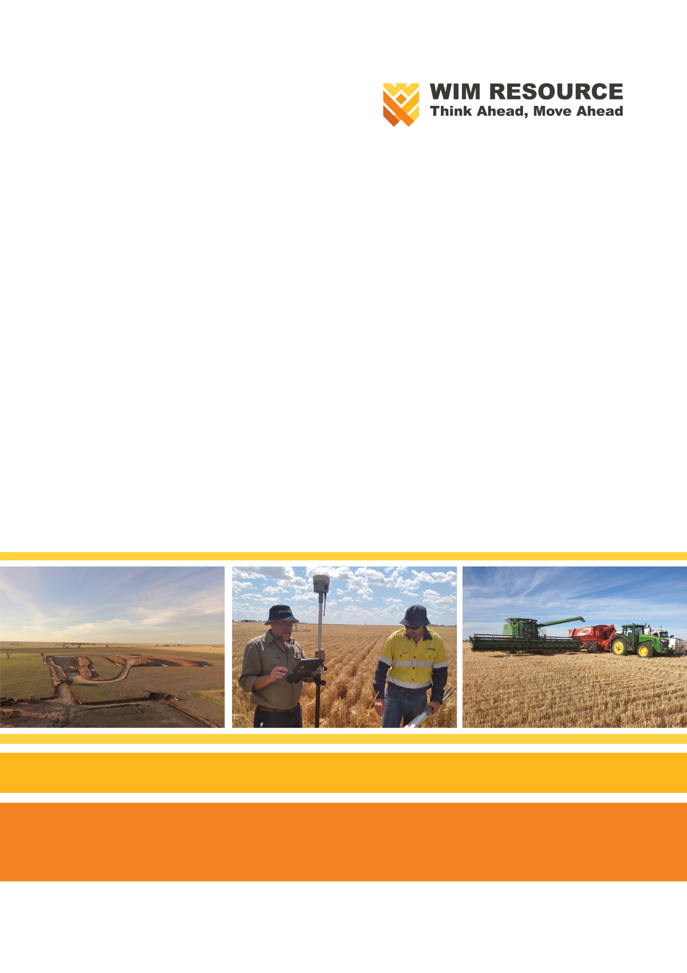
Chapter 27 – Glossary, Abbreviations and Acronyms

TABLE OF CONTENTS
27 Glossary, Abbreviations and Acronyms 27-1
27.1 Glossary 27-1
27.2 Acronyms and Abbreviations 27-5

TABLES
Table 27-1: Definitions 27-1
Table 27-2: Acronyms and abbreviations 27-5

Glossary, Abbreviations and Acronyms

Glossary
Definitions of specific terms used in the Environment Effects Statement are provided in Table 27-1.
Table 27-1: Definitions
Term | Definition
Annual exceedance probability | The probability that a given rainfall total accumulated over a given duration will be exceeded in any one year.
Aquifer | A formation of rock or sediment that is saturated with water and sufficiently permeable to transit quantities of water to wells and springs.
Avonbank Demonstration Trial | A pilot mining, processing and rehabilitation trial was undertaken at Avonbank between 2019–2022. A 'test pit' was excavated and a 'pilot plant' was established. A 'rehabilitation trial' was undertaken as part of the Avonbank Demonstration Trial.
Background conditions | The conditions present in an area prior to the commencement of a specific activity.
B-double truck | A truck and trailer combination consisting of a prime mover coupled with two trailers.
Biodiversity | The variety of all life forms, plants, animals, fungi, protists (including algae) and bacteria, their encoded genes, and the ecosystems of which they form a part.
Co-disposal | Mixing of two materials (coarse sand and fine tailings) for disposal.
Community stakeholder | Community stakeholders encompass groups, stakeholders or individuals that include potentially affected parties, interested community organisations and government bodies. Community stakeholders typically have a direct link (physical, social, historical, cultural, and/or political) with the Project or the area in which the Project will operate. Refer also to Stakeholder.
Compliance obligations | The legal requirements that an organisation has to comply with and other requirements that an organisation has to or chooses to comply with.
Contingency | Refer to corrective action.
Continual improvement | An ongoing effort to improve environmental performance.
Control | A control is any measure or action that modifies or regulates risk. Controls include any policy, procedure, practice, process, technology, technique, method or device that modifies or regulates risk.
Corrective action | An action to eliminate the cause of a non-conformity to prevent recurrence.
Cultural Heritage Management Plan | A three-tiered framework for the assessment of Aboriginal cultural heritage. A CHMP describes the existing environment by identifying existing or potential Aboriginal places, describes how proposed works can avoid or minimise impacts, and establishes management conditions and contingency measures to guide the proposed works which must be followed.
Cumulative impact | Cumulative impacts are the successive, incremental and combined direct and indirect impacts of project development. They arise from compounding additional activities of a project or other non-related projects. As with indirect impacts, cumulative impacts may be separated from the project in location or time.
Cyclone | Mining equipment that removes fines from the ore. The process comprises a cylindrical upper section and lower conical sections down which tailings fall and rotate, with coarser material being separated by the resulting centrifugal forces.
Development extent | An area that comprises the proposed mining licence area (MIN), the WIM Base Area (WBA) and the power/water minor utilities corridor from the terminal stations to the WBA. It excludes the product transport route from the WBA to Portland and the Port of Portland.
Dewatering | Process of pumping or draining water from an excavation, mine void, aquifer or other material.
Direct impact | Impacts that are linked to Project aspects where there is an immediate cause and effect relationship.
Disturbance/ disturbed area | Areas where topsoil has been stripped (removed with machinery) as a result of Project activities.
Ecological Vegetation Class (EVC) | A vegetation classification is described through a combination of its floristic composition, life form and ecological characteristics, and its association with particular environmental attributes. EVCs may include one or more floristic community that occurs across a biogeographic range and has similar habitat and ecological processes operating.
Effect | Any change that a project or activity may cause in the environment that is an outcome, result or consequence to the environment bought about by some force, project or action.
Effective dose (radiation) | A measure of dose that takes into account both the type of radiation involved and the radiological sensitivities of the organs and tissues irradiated. The measurement unit is the sievert.
Environment | The environment comprises the physical, biological, heritage, cultural, social, health, safety and economic aspects of human surroundings, including the wider ecological and physical systems within which humans live.
Environmental aspect or aspect | Project related activities, conditions, infrastructure or products that can interact with the environment that the organisation has control or influence over.
Environmental condition | The state or characteristic of the environment as determined at a certain point in time.
Environmental management system (EMS) | A set of interrelated or interacting elements of an organisation to establish environmental policies and objectives and processes to achieve those objectives.
Environmental objective | An outcome to be achieved that is consistent with the EMS environmental policy and compliance obligations. Performance standards are established to measure or assess if the objective has been achieved.
Environmental performance | The performance related to the management of environmental aspects.
Environmental policy | The intentions and direction of an organisation related to environmental performance committed to by management.
Environmental value | Environmental value in the Environment Protection Act 2017 means a use, an attribute or a function of the environment.
Exclusion zones | Exclusion zones within the development extent aim to protect certain features, including vegetation and heritage sites. No clearing or topsoil disturbing activities can be undertaken within these areas.
Flocculant | A chemical added to slurried ore during processing to remove excess water and to produce thickened fine tailings.
Gangue minerals | Commercially worthless material surrounding or closely mixed with a wanted mineral in an ore deposit.
General Environmental Duty | A person or organisation engaging in an activity that may give rise to risk of harm to human health or the environment from pollution or waste must minimise those risks so far as reasonably practicable.
Gravity separation | Gravity concentration process using water and spirals to separate the heavy target minerals from the lighter minerals
Groundwater | Any water contained in or occurring in a geological structure or formation or an artificial landfill below the land surface.
Haul trucks | Heavy vehicles used for the transportation of materials.
Heavy Mineral Concentrate | Material containing mineral sands, including zircon, rutile, ilmenite, leucoxene, and rare-earth bearing minerals.
Ilmenite | Titanium-iron oxide mineral with the chemical symbol of FeTiO₃; a form of titanium dioxide (TiO₂) principally used to produce pigments and used in commercial applications such as paints, plastics, toothpaste, sunscreen and white paper industries.
Impact | A change to the environment, whether adverse or beneficial, wholly or partially resulting from the Project's environmental aspects.
Indicator | The measurable representation of the condition or status of operations, management or conditions.
Indirect impact | Those impacts that are linked to Project aspects and may occur at different locations and at different times. There may not be an immediate cause and effect relationship.
Inherent risk | A deviation from an expected outcome that has a level of uncertainty, which can be characterised in terms of consequence and likelihood. Assumes key project design avoidance and engineering controls are in place.
Interested party | A person or organisation that can affect or be affected by or perceive itself to be affected by a decision or activity.
L_{A90} | L_{A90} represents the noise level exceeded for 90% of a measurement period.
L_{Aeq} | A-weighted, equivalent continuous sound level that is the constant noise level that would result in the same total sound energy being produced over a given period.
L_{den} | Noise assessment indicator that represents the sound pressure level corrected according to the period of the day. L stands for ‘level‘, d for ’day‘, e for ’evening‘, and n for ’night‘.
Leucoxene | Form of titanium dioxide (TiO₂) is principally used to produce pigments.
Listing Advice Statements | A listing advice statement is a notifiable instrument that sets out the grounds that a species, community, or process is eligible to be included in, transferred within, or omitted from a list.
Matters of national environmental significance | Nine matters of national environmental significance (MNES) are defined in the Environment Protection and Biodiversity Conservation Act 1999 (EPBC Act). The listed MNES in the EPBC Act include threatened species and communities, environments of national and global importance and nuclear actions.
Mine-contact water | Water that has been in contact with the active mining area or disturbed area, such as process water or stormwater run-off from within the operational areas.
Mining footprint | Represents the area that will be mined for ore over the life of mine.
Mining licence | The spatial extent of the proposed mining licence and the scope of works to be included in the mining licence. The scope of the mining licence will include all mining, primary processing and works incidental to mining within an area covered by the mining licence to be granted under the Mineral Resources (Sustainable Development) Act 1990.
Mining unit plant | A primary processing mobile plant approximately 10 metres wide by 10 metres long and 5 metres high that is located where the ore is mixed with water to form a slurry which is pumped to the Wet Concentrator Plant.
Mitigation measures | A hierarchy of measures to minimise, rehabilitate or offset Project related adverse impacts. Controls apply a similar hierarchy, and in this EES refers to those measures applied in the Project risk assessment and associated environmental management system.
Monitoring | To supervise, continually check and/or critically observe to determine the status of a system, a process or an activity. Monitoring is undertaken to assess whether or not required or expected performance standards are being achieved.
Moving hole (mining method) | Mining method enabling progressive rehabilitation over the life of the Project. The mining method involves the direct return of tailings and overburden into mined cells as the mining front advances.
Naturally Occurring Radioactive Material | Naturally Occurring Radioactive Material (NORM) is the term used to describe materials containing radionuclides that exist in the natural environment.
Non-conformity | Non-fulfilment of a requirement. Non-conformity relates to requirements in the AS/NZS ISO14001:2016 standard, the environmental management system, and requirements that an organisation establishes for itself.
Offsets | Offsets compensate for biodiversity losses as a result of impacts on native vegetation or habitat for threatened species or communities. A native vegetation offset consists of a site that protects existing patches of native vegetation and large trees and could involve planting new native vegetation.
Operational area | Areas within the development extent where topsoil has been disturbed and not yet rehabilitated.
Performance standard | A benchmark level against which a particular EMS environmental objective can be assessed.
Process | A set of interrelated or interacting activities which transforms inputs into outputs
Process water dam | Dam constructed to receive and store water from the process water circuit for re-use.
Project area | The area at Avonbank which comprise the mine and processing facilities, as shown in Chapter 2. This area formed the basis for most impact assessment studies. It was later refined as the project was further developed and avoidance measures were developed.
Project implementation | Putting the Project plan into effect and covering all phases of the Project.
Protected matters search tool | The Protected Matters Search Tool (PMST) is a Department of Climate Change, Energy, Environment and Water interactive website that can be used to generate a report which provides guidance on MNES or other matters protected by the EPBC Act in a selected area of Australia.
Rare earth mineral | Group of minerals with atomic numbers ranging from 57 to 71, including monazite and xenotime that are rare to find in economic concentrations and used in magnets and electronic components; a by-product of HMC production having applications including mobile phone technology, medical applications, temperature magnets used in windfarms, and electric vehicle batteries.
Rehabilitation | The return of a disturbed area to a safe, stable and sustainable end land use. The rehabilitation is considered to be complete once the rehabilitation objectives have been achieved.
Residual impact | Used within the EES impact assessments to refer to change to the environment, whether adverse or beneficial, wholly resulting from the Projects activities with avoidance and mitigation measures in place.
Residual risk | A deviation from an expected outcome that has a level of uncertainty, which can be characterised in terms of consequence and likelihood. Assumes all controls are in place.
Risk | A risk represents a deviation from an expected outcome that has a level of uncertainty that can be characterised in terms of consequence and likelihood. Risk is often expressed in terms of a combination of the consequences of an event or environmental aspect and the associated likelihood of occurrence.
Risk assessment | An assessment of the level of risk associated with identified potential hazards relating to environmental aspects. The risk assessment is based on consideration of the consequence of the hazard occurring and the likelihood of the occurrence, using a risk matrix to then categorise the risk as low, medium, high or extreme.
Sand tailings | Non-economic sands produced when separating mineral sands from the ore in the wet concentrator plant.
Sensitive receptor | An environmental or social asset, entity, condition, attribute, value or function that may be reasonably expected to be impacted by changes resulting from the Project activities. It includes the physical, biological, heritage, cultural, social, health, safety and economic aspects of human surroundings, including the wider ecological and physical systems within which humans live.
Significance | An attribute describing the importance of an impact.
Site | A term commonly used to refer to the area in which an activity is occurring or building/infrastructure is situated.
Soil horizon | One of the series of distinct layers found in a vertical cross-section of any well-developed soil, grouped primarily into O, A, B, and C horizons.
Soil unit | Soil defined by common characteristics observed vertically and horizontally. Terminology commonly used in mine and rehabilitation planning.
Source-Pathway-Receptors | Any change to the environment which results in a complete linkage between the Project related source activity or condition and a sensitive receptor.
Spirals | Wet separation equipment used for gravity separation.
Stakeholder | Person or group affected by or concerned with an issue.
Study area | The spatial extent of the study which encompasses source activities and plausible pathways to sensitive receptors.
Subsoil | Soil layers below the topsoil, often denoted as the B horizon, within the soil profile that lies immediately below the topsoil, or A horizon.
Technical Reference Group (TRG) | Group of officials convened by the Department of Environment, Land, Water and Planning (DELWP) to provide guidance over the assessment process for the Project.
Topsoil | The uppermost soil horizon containing organic matter removed and retained for mine void rehabilitation.
Waste | Waste includes solid, liquid, gaseous or radioactive matter that is deposited, discharged, emitted or disposed of into the environment, including greenhouse gases, in a manner that alters the environment.
Wet Concentrator Plant | Processing facility where the target mineral sands to are separated to produce a Heavy Mineral Concentrate (HMC).
WIM Base Area (WBA) | WBA includes the secondary processing plant and ancillary infrastructure.
Work plan | A work plan must be approved under the Mineral Resources (Sustainable Development) Act 1990 prior to work commencing on a mining licence. The work plan details the mining activities, associated risks and includes a risk management plan, community engagement plan and rehabilitation plan.
Zircon | A heavy mineral is used in industry, including for ceramics applications such as tiles, bathroom fixtures and tableware and high-tech applications such as joint replacements, for abrasion resistance and solid oxide fuel cells.

Acronyms and Abbreviations
Abbreviations and acronyms used in the Environment Effects Statement are expanded in Table 27-2.
Table 27-2: Acronyms and abbreviations
Acronym/Abbreviations | Definition
AADT | Average Annual Daily Traffic
ABS | Australian Bureau of Statistics
ADWG | Australian Drinking Water Guidelines
AEP | Annual Exceedance Probability
AHD | Australian Height Datum
ANCOLD | Australian National Committee on Large Dams
APAC | Air Pollution Assessment Criteria
AQAC | Air Quality Assessment Criteria
AQIA | Air Quality Impact Assessment
AQMP | Air Quality Management Plan
ARPANSA | Australian Radiation Protection and Nuclear Safety Agency
ARTC | Australian Rail Track Corporation
BCM | Bank Cubic Metre
BGL | Below ground level
BGLC | Barengi Gadjin Land Council
BOM | Bureau of Meteorology
CEP | Community Engagement Plan
CFA | Country Fire Authority
COPC | Chemicals of Potential Concern
CRG | Community Reference Group
CRS | Chromium Reducible Sulfur
CHMP | Cultural Heritage Management Plan
dBA | Decibels
DBHHA | David Bannear Historic Heritage and Archaeology
DCCEEW | Department of Climate Change, Energy, the Environment and Water
DELWP | Department of Environment, Land, Water and Planning
DFS | Definitive Feasibility Study
DMS | Donald Mineral Sands
DoT | Department of Transport
EE Act | Environment Effects Act 1978
EES | Environment Effects Statement
EESCP | EES Consultation Plan
EIA | Economic Impact Assessment
EMM | EMM Consulting Pty Ltd
EMP | Environmental Management Plan
EMS | Environmental Management System
EPA | Environment Protection Authority
EP Act | Environment Protection Act 2017
EPBC Act | Environment Protection and Biodiversity Conservation Act 1999
EP Regs | Environment Protection Regulations 2021
ERM | Environmental Resources Management
ERS | Environment Reference Standard 2021
EVC | Ecological Vegetation Class
FFG Act | Flora and Fauna Guarantee Act 1988
FFMP | Flora and fauna management plan
FTE | Full-Time Equivalent
GDE | Groundwater Dependent Ecosystem
GDES | Groundwater dependent ecosystems and species
GED | General Environmental Duty
GHG | Greenhous Gas
GL | Gigalitre
GSP | Gross State Product
GTP | Green Travel Plan
GWIA | Groundwater Impact Assessment
GWMP | Groundwater Management Plan
GWMWater | Grampians Wimmera Mallee Water
ha | Hectare
HHIA | Historic Heritage Impact Assessment
HHRA | Human Health Risk Assessment
HMC | Heavy Mineral Concentrate
HML | Heavy Mass Load
HMP | Heritage Management Plan
HMS | Heavy Mineral Sands
HOTS | Horsham Terminal Station
HPS | Horsham Planning Scheme
HRC | Horsham Rural City
HRCC | Horsham Rural City Council
HV | High Voltage
HVAS | High-Volume Air Sampler
IARC | International Agency for Research into Cancer
ICRP | International Commission of Radiological Protection
IBRA | Interim Biogeographic Regionalisation for Australia
ILCR | Incremental Lifetime Cancer Risk
ILUA | Indigenous Land Use Agreement
JORC | Joint Ore Reserves Committee
LACA | Land Access and Compensation Agreement
LGA | Local Government Area
LOS | Level of Service
LPIA | Land Use and Planning Impact Assessment
LPS | Loxton Parilla Sands
LV | Low Voltage
LVIA | Landscape and Visual Impact Assessment
M | Million
MIN | Mining Licence
MNES | Matters Of National Environmental Significance
MOU | Memorandum of Understanding
MPS | Municipal Planning Strategy
MRLs | Maximum Residue Levels
MRSD Act | Mineral Resources (Sustainable Development) Act 1990
MRSDMI Regs | Mineral Resources (Sustainable Development) (Mineral Industries) Regulations 2019
MSP | Mineral Separation Plant
MUP | Mining Unit Plant
NHMRC | National Health and Medical Research Council
NEPM | National Environment Protection Measures
NORM | Naturally Occurring Radioactive Mineral
NVMP | Noise and Vibration Management Plan
OB | Overburden
OHS | Occupational Health and Safety
OSOM | Oversize Overmass
P&E Act | Planning and Environment Act 1987
PASS | Potentially Acid Sulfate Soil
PASSMP | Potentially Acid Sulfate Soil Management Plan
PCRZ | Public Conservation and Recreation Zone
PEM | Protocol for Environmental Management
PFAS | Perfluoroalkyl and Polyfluoroalkyl Substances
PHN | Public Health Network
PM | Particulate Matter
PoP | Port of Portland
PoPL | Port of Portland Pty Ltd
PPE | Personal Protective Equipment
PPF | Planning Policy Framework
PRV | Pressure Relief Valve
PSI | Preliminary Site Investigation
PWD | Process water dam
PZ | Port Zone
QA | Quaternary Aquifer
RAP | Registered Aboriginal Party
RCP | Representative Concentration Pathway
RCS | Respirable Crystalline Silica
RL | Retention Licence
RMP | Radiation Management Plan
RoG | Rain on Grid
ROM | Run of Mine
ROMP | Rehabilitation Operations Management Plan
RTIA | Road Traffic Impact Assessment
RRA | Radiation Risk Assessment
RRP | Rehabilitation Research Plan
RUSLE | Revised Universal Soil Loss Equation
SCO | Specific Controls Overlay
SEIFA | Socioeconomic indexes for areas
SESW | South East Soil and Water
SG | Specific Gravity
SIA | Social Impact Assessment
SLIA | Soils and Landform Impact Assessment
SOP | Standard Operating Procedures
SUZ | Special Use Zone
SWMP | Surface Water Management Plan
t | Tonnes
TDS | Total Dissolved Solids
TEC | Threatened Ecological Community
THM | Total Heavy Mineral
TMP | Traffic Management Plan
tpa | Tonnes per annum
TRG | Technical Reference Group
TSF | Tailing Storage Facility
T and T | Tonkin and Taylor Pty Ltd
UoA | University of Adelaide
VAF | Victorian Aquifer Framework
VHM | Valuable Heavy Mineral
Vpd | Vehicles per day
VTWBC | Victorian Temperate Woodland Bird Community
WBA | WIM Base Area
WCMA | Wimmera Catchment Management Authority
WCP | Wet Concentrator Plant
WHO | World Health Organisation
WIFT | Wimmera Intermodal Freight Terminal
WIM | WIM Resource Pty Ltd
WMIS | Water Measurement Information System
WMP | Waste Management Plan
WSM | Wimmera Southern Mallee
WSMRGP | Wimmera Southern Mallee Regional Growth Plan
µGy/h | Micrograys per hour
µSv | Microsieverts

