Avonbank Mineral Sands Project
Environment Effects Statement

Chapter 17 – Groundwater

TABLE OF CONTENTS
17 Groundwater 17-1
17.1 Introduction 17-1
17.2 Scope and Methods 17-1
17.2.1 Scope 17-1
17.2.2 Study Area 17-1
17.2.3 Methodology 17-1
17.3 Operational Context 17-4
17.4 Existing Conditions 17-6
17.4.1 Hydrostratigraphic Units 17-6
17.4.2 Groundwater Bores 17-6
17.4.3 Groundwater Levels and Flow Direction 17-8
17.4.4 Water Quality 17-8
17.4.5 Hydrology 17-9
17.4.6 Groundwater Dependent Ecosystems 17-10
17.4.7 Potential Sources of Contamination 17-10
17.5 Potential Impacts 17-13
17.5.1 Identified Potential Impacts 17-13
17.5.2 Sensitive Receptors 17-13
17.5.3 Impact Characterization 17-14
17.6 Avoidance and Mitigation Measures 17-15
17.6.1 Avoidance 17-15
17.6.2 Minimisation 17-15
17.6.3 Rehabilitation 17-19
17.7 Residual Impacts 17-19
17.7.1 Groundwater Drawdown and Mounding Impacts 17-19
17.7.2 Groundwater Quality Impacts 17-26
17.8 Management Framework 17-31
17.8.1 Environmental Objectives 17-32
17.8.2 Monitoring and Management 17-32
17.8.3 Audits 17-33
17.9 Cumulative Impacts 17-34
17.10 Conclusions 17-34

TABLES
Table 17-1: Potential impacts 17-13
Table 17-2: Sensitive receptors 17-13
Table 17-3: Environmental values, indicators and objectives 17-14
Table 17-4: Significance rating 17-15
Table 17-5: Drawdown effects on potential GDEs 17-21
Table 17-6: Mounding effects on potential GDEs 17-24

FIGURES
Figure 17-1: Study area extent 17-3
Figure 17-2: Indicative disturbance at year 2 17-5
Figure 17-3: Groundwater bores in the immediate vicinity of the mine 17-7
Figure 17-4: Potential terrestrial GDEs (depth to groundwater in metres) 17-11
Figure 17-5: Potential aquatic GDEs (depth to groundwater in metres) 17-12
Figure 17-6: Predicted cumulative maximum drawdown and depth to groundwater (metres) 17-22
Figure 17-7: Predicted cumulative maximum mounding and depth to groundwater (metres) 17-25
Figure 17-8: Bore users 17-29

Groundwater

Introduction
This Chapter provides an overview of the groundwater effects for the Avonbank Mineral Sands Project (the Project). It has been prepared to address the Environment Effects Statement (EES) Scoping Requirements (DELWP, 2020) and is supported by a detailed impact assessment prepared by GHD Group Pty Ltd (GHD) (Appendix L).
The key evaluation objective relevant to this Chapter, as defined in the Scoping Requirements, is to ‘Minimise effects on water resources and on existing and potential future beneficial and licensed uses of surface water, groundwater and related catchment values over the short and long-term’ (DELWP, 2020). The associated issues and Project Scoping Requirements are detailed in Appendix A of this EES.
This Chapter describes the existing groundwater environment, the groundwater effects associated with the Project and details the avoidance and mitigation measures to minimise the residual impacts so far as reasonably practicable.

Scope and Methods

Scope
The scope of this Chapter covers the potential impacts identified in the Groundwater Impact Assessment (GWIA) (Appendix L) and the relevant Scoping Requirements listed in Appendix A. The impact assessment focused on the mining and mineral processing activities that may affect groundwater resources over the life of the Project. Project related aspects that are well understood and considered to be relatively low risk with standard controls in place are addressed in the Project Aspects and Risk Register (Attachment 5).

Study Area
The GWIA focused on activities within the mining footprint, associated areas within the predicted drawdown and mounding zones and potential process water migration pathways. The study area extends to Wimmera River in the north-west, west and south and to Yarriambiack creek in the east, as shown in Figure 17-1. Sensitive receptors that fall within the study area are described in Section 17.5.2.

Methodology
The GWIA characterised the existing conditions, identified potential impacts and assessed the residual impacts with avoidance and mitigation measures in place. The tasks undertaken are summarised below and detailed in Appendix L, Section 3 and Section 7.
Existing conditions:
- Key hydrostratigraphic units (aquifers and aquitards) were characterised with consideration to the site mineral exploration bore logs and the Victorian Aquifer Framework (VAF).
- The site groundwater monitoring bore network comprising 30 bores was monitored between 2018 and 2021 to characterise the hydrogeological properties, groundwater levels (flow directions) and groundwater quality.
- Groundwater samples were analysed for anions/cations, heavy metals, radionuclides and nutrients (refer Appendix L, Table 6.7).
- Background water quality and existing environmental values within the study area were determined.
- Mined materials were sampled from representative locations and analysed to characterise the chemical and physical characteristics.
- Existing bore users listed within DELWP’s Water Measurement Information System database were identified within the study area.
- A hydrogeological conceptual model was developed to characterise the relevant groundwater aquifers across the study area (Appendix L, Section 6.8).
- Likely groundwater and surface water interactions were assessed, and the associated groundwater dependent ecosystems were broadly characterised with consideration to the GDE Atlas (Appendix L, Section 6.4) and Project groundwater monitoring (refer Appendix L, Section 6.6.1).
- Hydrological studies were undertaken as part of the Avonbank Demonstration Trial to characterise various hydrogeological conditions during mining operations (refer Appendix L, Section 6.5.3).
Potential impacts:
- The Project design elements including the water balance and tailings plan were documented to define the key variables relevant to the detailed groundwater modelling.
- Potential sensitive receptors were identified with consideration to the plausible effects relating to mining and backfill.
- Key potential impacts were identified where source-pathway-receptor linkages were considered plausible.
Residual impacts:
- Mitigation measures were identified to avoid and/or minimise impacts to sensitive receptors so far as reasonably practicable.
- Detailed numerical groundwater modelling was undertaken within a domain extending up to 23 km from the mine, consistent with the ‘Australian Groundwater Modelling Guidelines’ (NWC, 2012) (refer Appendix L, Section 7.2.1). This included:
- Predictive modelling of the progressive mine dewatering and tailings placement, simulated on quarterly increments to quantify changes to groundwater flux over time.
- Assessment of model uncertainty by undertaking a non-linear uncertainty analysis based on the Null-Space Monte Carlo methodology.
- Modelling groundwater flow paths across potentially contaminated sites (and between aquifers).
- Modelling outputs were considered with respect to receptors to characterise the residual impacts and to understand the effectiveness of the avoidance and mitigation measures.
- Effects of climate change were assessed based on DEWLP’s ‘Guidelines for Assessing the Impact of Climate Change on Water Availability in Victoria’ (DELWP, 2020a).
- Cumulative effects of other projects within the region were qualitatively assessed.
Key assumptions relating to the groundwater modelling and impact assessment are detailed in Appendix L, Sections 5 to 7.
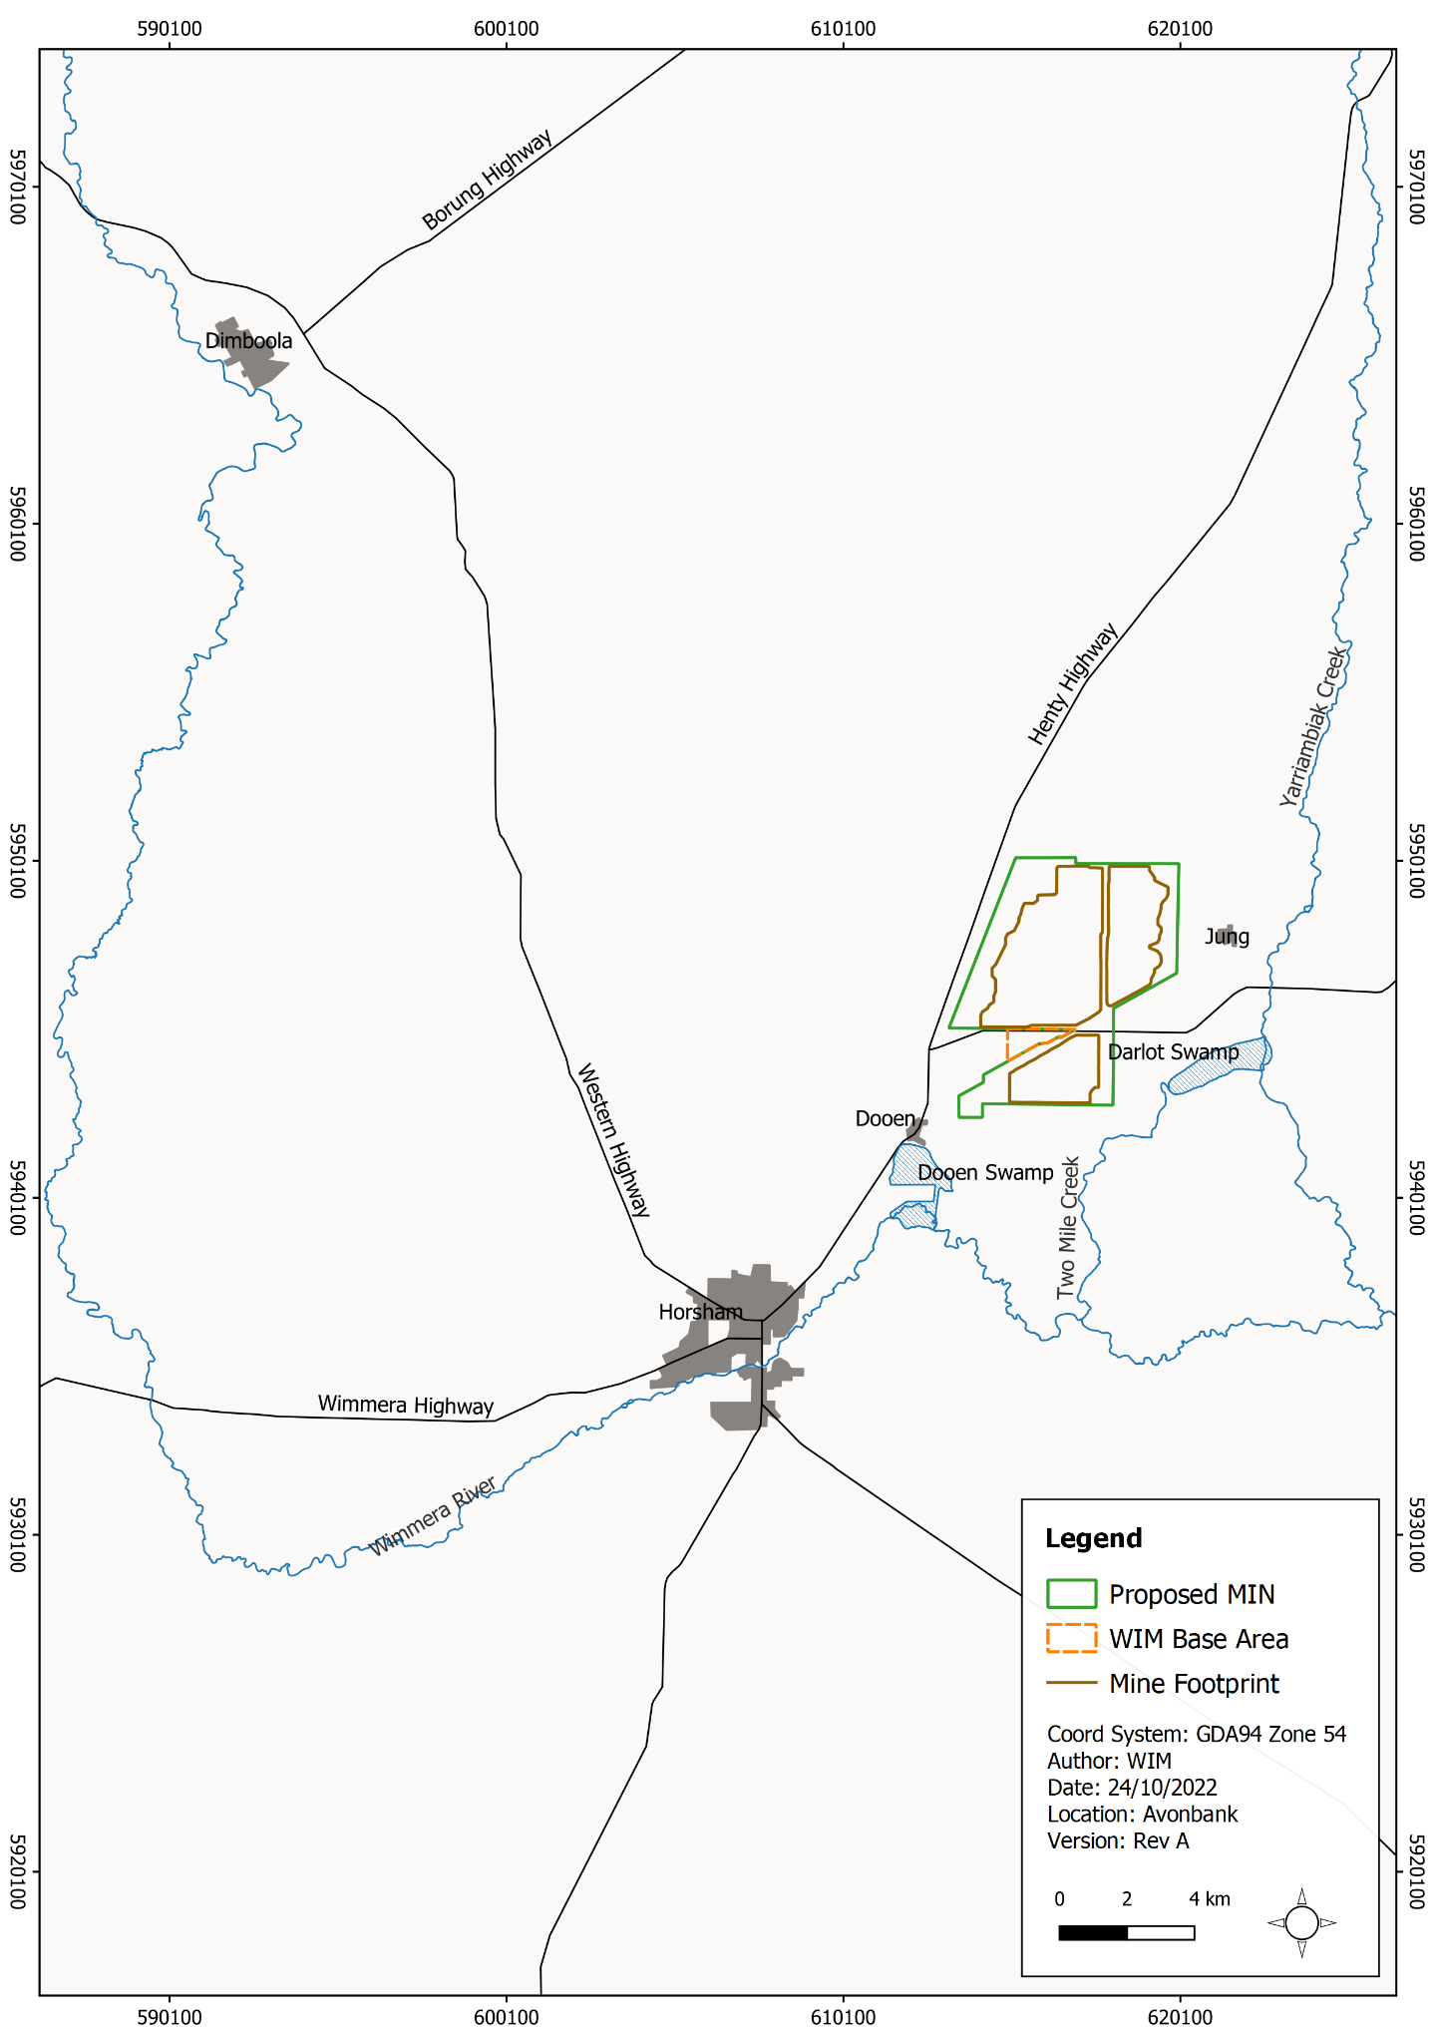
Figure 17-1: Study area extent

Operational Context
Conventional dry mining techniques will be used to mine the ore, which will be fed into a mining unit plant (MUP) and mixed with water to form a slurry, from which the heavy minerals (around 5% of the ore) will be separated from sand and clay tailings in the Wet Concentrator Plant (WCP) using conventional wet separation techniques.
The mining cells will be stripped of topsoil, subsoil and overburden while the non-valuable component of the ore (tailings, accounting for around 95% of the mined material) and overburden will be disposed directly behind the mining cell and rehabilitated. An indicative mine layout at year 2 is shown in Figure 17-2.
Dewatering will be required in parts of the mine where the base of the ore is located below the watertable. The water collected in sumps and in-pit toe drains will be pumped into the process water circuit and used to top up the water supply.
The production of tailings will commence around 6 to 8 months after the start of mining. Once processed, tailings will be dosed with a flocculant, deposited, and left to settle and drain for 6 to 12 months before a layer of overburden, subsoil and topsoil will be placed, and the cell will be rehabilitated. It is expected that rehabilitation will be complete within 4 years after initial topsoil disturbance at each mining cell.
Recovery of water from the tailings will be maximised to allow efficient re-use of water, facilitate drying and strengthening of the deposited tails and to enable rapid rehabilitation. The initial (preliminary) recovery of water will take place following the separation of the heavy minerals at the WCP, where the fine tailings stream will be dosed with a polymer flocculant to promote water recovery.
The recovery of water will also take place subsequently within the mining cells (secondary recovery), as a flocculant will be added to the tailings stream exiting the pipe head, which will facilitate the clumping of tailings at the point of deposition and will promote separation from water. The water separated from the deposited tailings will flow down the tails beach to a decant sump, where it will be recycled to the process water circuit.
The supply of freshwater for mine processing will be sourced from rainfall run-off and the GWMWater Wimmera Pipeline and will be supplemented by water recovered from the tailings. It is estimated that around 62% (5,757 ML/y) of tailings water will be recovered through the use of flocculant and decant sump pumps.
Of the remaining 38% (3,528 ML/y), around a quarter of the water is estimated to remain entrained in the tailings pore space (882 ML/y) while the rest (2,646 ML/y) would seep out of the tailings. As the tailings will be deposited in close proximity to the mining cells, around two-thirds of the water seeping out of the tailings may be intercepted and recovered in the pit (1,764 ML/y) while the rest will be lost to the groundwater system (900 ML/y).
The volume of tailings water returned to the pit during operations and rehabilitation is estimated to be around 25.4 (ML) per day on average. This means around 2.5 to 7.5 ML could seep into the groundwater system each day.
The Avonbank Demonstration Trial was undertaken from 2019 through 2021 to assess the feasibility of mining, processing, tailings and rehabilitation. Aspects monitored and studies relevant to the GWIA include the monitoring of process water quality, adjacent groundwater quality and levels, and water supply and use (water balance).
It is noted that there was a minor reduction to the mining footprint (~70 ha) following completion of the modelling and the GWIA (refer Appendix L, Appendix U). The groundwater modelling was re-run to assess if the change had any material effect on the GWIA findings. The residual impacts remained largely unchanged and an Addendum was prepared to describe the outcomes of the updated modelling. The updated groundwater contours and findings have been incorporated into this Chapter.
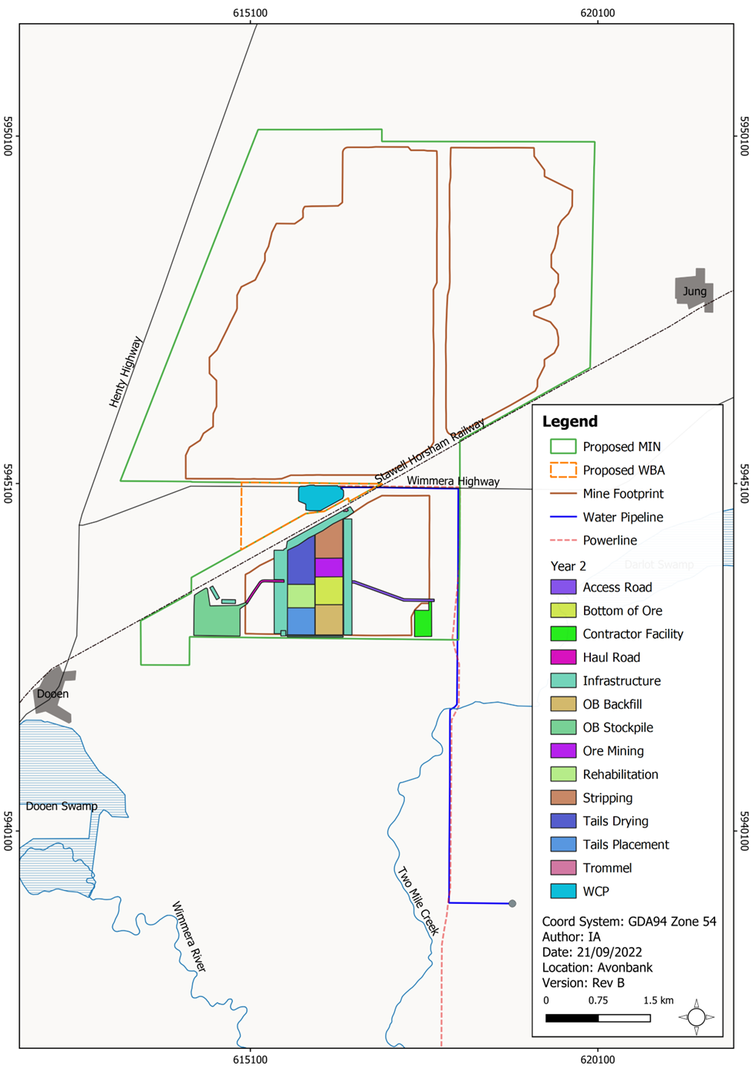
Figure 17-2: Indicative disturbance at year 2

Existing Conditions

Hydrostratigraphic Units
The hydrogeology within the study area was characterised using exploration mineral bore hole data and records from the Victorian Aquifer Framework (VAF). Materials with similar hydrogeological properties were identified as discrete hydrostratigraphic units, which included (from youngest to oldest).
- Quaternary aquifer (QA) – less than 10 m thick aquifer associated with the existing drainage lines and consists of silty clays, sands and gravels (absent within the mine footprint).
- Shepparton Formation aquifer – typically dry (unsaturated) and 8 to 10 m thick across the mine footprint, comprising sands, gravels and clays (becomes saturated regionally, to the south of Wimmera River).
- Loxton Parilla Sands (LPS) aquifer – forms a watertable where groundwater is first intersected beneath the mine footprint, with a thickness of 20 to 30 m. It comprises sands, silts and sandstones.
- Bookpurnong Formation and Geera Clay aquitard – present across the mine footprint with a thickness of 35 to 40 m, comprising predominantly of low hydraulic conductivity clays with minor silts and sands.
- Renmark Group aquifer – forms a major confined aquifer at depths of typically 70 to 80 m, comprising sands, gravels and clays with a thickness of up to 45 m. It is underlain by the low hydraulic conductivity basement, which forms the effective hydraulic base of the regional groundwater system.
Further detail for each hydrostratigraphic unit is provided in Appendix L, Section 6.8.

Groundwater Bores
A network of 30 groundwater monitoring bores were established across the study area during 2018 and 2019. These are shown in Figure 17-3 and are labelled as BH01 to BH06, GW01 to GW24 and INV01 to INV03. The hydrostratigraphic unit associated with each bore (i.e., screen depth) is provided in Appendix L, Section 6.2.1.
A search of the Water Measurement Information System (WMIS) database indicated 42 private bores located within 5 km of the mine. The majority of these are listed for groundwater investigation and observation, with only two ‘stock and domestic’ bores (68431 and 117043), as shown in Appendix L, Figure 6-1.
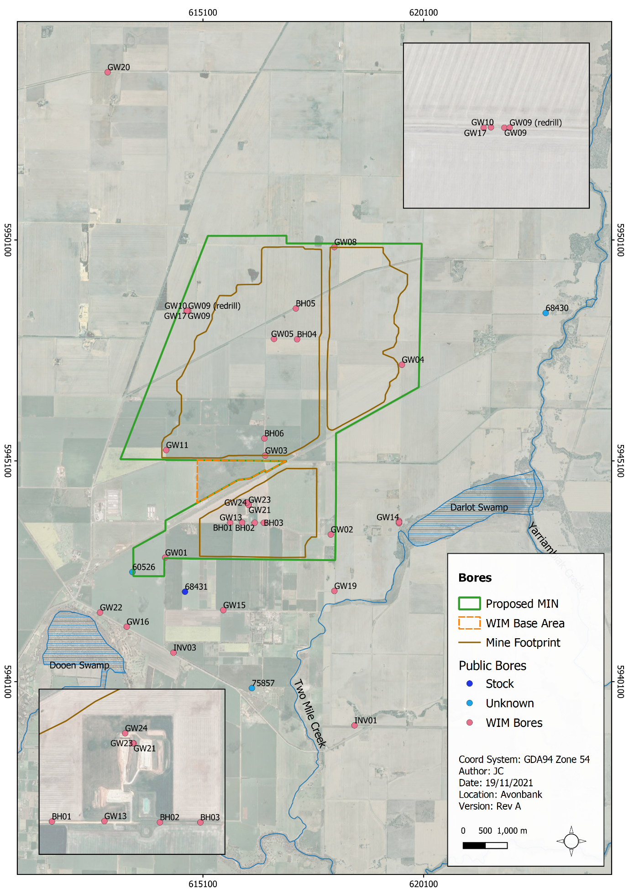
Figure 17-3: Groundwater bores in the immediate vicinity of the mine

Groundwater Levels and Flow Direction

Watertable aquifer
Bores located in the Loxton Parilla Sands aquifer showed little seasonal variability due to limited rainfall derived local diffuse recharge. Bores located close to the Wimmera River showed more seasonal variability, due to the effects of stream leakage and periodic flooding.
Groundwater in the Loxton Parilla Sands aquifer was shown to flow across the study area from south-east to north-west. The hydraulic gradient calculated across the study area is 0.0018, which means the groundwater level typically decreases by 1.8 m for every 1 km distance in the direction of groundwater flow.

Confined aquifer (Renmark Group)
Bores in the Renmark Group aquifer generally showed little seasonal variability as it is confined by the thick Bookpuronong/Geera Clay aquitard. The exception is near the Wimmera River due to the influence of stream leakage and flooding.
Groundwater in the Renmark Group aquifer was shown to flow across the study area from south-east to north-west, similar to the overlying Loxton Parilla Sands aquifer. The hydraulic gradient calculated across the study area is 0.0026 to 0.0028, which means the groundwater level typically decreases by 2.6 to 2.8 m for every 1 km distance in the direction of groundwater flow.

Inter-aquifer connection
The data currently available indicates that the groundwater level in the Loxton Parilla Sands aquifer is higher than that in the Renmark Group aquifer across the study area, with differences of typically 2 m to 6 m. This means there is a downward vertical hydraulic gradient, with connectivity limited by the thick, low hydraulic conductivity Bookpuronong/Geera Clay aquitard. To the south of the study area, towards the Grampians, the groundwater level in the Renmark Group aquifer becomes higher than that in the Loxton Parilla Sands aquifer, indicating an upward vertical hydraulic gradient (possibly due to recharge, as the Renmark Group aquifer becomes shallower).

Ore body saturation
The ore body is hosted within the Loxton Parilla Sands aquifer and is located, on average, between approximately 15 m (top of ore) and 30 m (base of ore) below ground. The ore body has the largest saturated thickness in parts of the southern pit, where it penetrates the watertable by around 7 m. In the other pits to the north, the ore body is around 0.6 to 2 m below the watertable on average. In many locations, the ore body is above the watertable, indicating little to no requirement for dewatering of the pits during mining. Further detail on groundwater levels and flow regimes are provided in Appendix L, Section 6.3.4.

Water Quality
Groundwater quality monitoring was undertaken across the WIM bore network between 2018 and 2020. Details associated with each monitoring event, including the schedule of analysis is provided in Appendix L, Section 6.6.1. This Section provides a description of the observed groundwater quality against the relevant environmental values and associated objectives as described in the Environment Reference Standard (ERS, 2021).
Within the Loxton Parilla Sands aquifer, the recorded salinities ranged from 6,360 mg/L to 13,000 mg/L Total Dissolved Solids (TDS). In the Renmark Group aquifer salinities ranged from 4,056 mg/L to 16,000 mg/L TDS. For the Loxton Parilla Sands aquifer, the environmental values associated with Segment E were adopted (7,101–10,000 mg/L) and for the Renmark Group aquifer, Segment D was adopted (5,401–7,100 mg/L).
The environmental values relevant to Segments D and E, as stated in the ERS include:
- Water-dependent ecosystems and species (Segment D and E).
- Agriculture and irrigation (stock watering) (Segment D and E).
- Industrial and commercial (Segment D).
- Water-based recreation (primary contact recreation) (Segment D and E).
- Traditional Owner cultural values (Segment D and E).
- Buildings and structures (Segment D and E).
- Geothermal properties (Segment D and E).
The water quality description below provides a high-level overview of the recorded background conditions, with reference to the environmental objectives detailed in the ERS. For the purposes of this summary, the background groundwater quality is compared to the adopted objectives associated with the protection of groundwater dependent ecosystems and species (GDES) and stock water use.
The adopted GDES objectives are the most stringent benchmarks described in this Chapter. These objectives apply to water quality at the point of groundwater discharge to a surface water body. For the purposes of this high-level description, it has been applied to all monitoring bores as a point of reference. Further explanation of the relevant criteria associated with each environmental objective is provided in Appendix L, Section 6.6.3.2.
Quantifiable concentrations of dissolved aluminium, chromium, copper, nickel, selenium, silver and zinc were detected in bores within the study area, with the mean ambient background concentration exceeding the GDES objective (albeit established at a low confidence level), except for chromium concentrations which were similar to the GDES objective. All mean ambient concentrations were below the adopted environmental value objective for protection of stock water supply and recreational use.
Quantifiable concentrations of arsenic were reported from 10 bores in the study area. While arsenic concentrations exceeded the GDES objective in several bores, the mean ambient arsenic concentration was below the GDES objective. One bore recorded nitrogen and phosphorus levels greater than the GDES objective.
Hexavalent chromium was detected at a number of bores across the study area, with some of the measured concentrations exceeding the GDES objective. Given the hydrogeochemical environment within the study area is unlikely to be conducive to the formation of hexavalent chromium, the measured concentrations where considered to be either due to laboratory method reliability issues or resulting from anthropogenic activities that form hexavalent chromium. This is further discussed in Section 17.7.2.1 of this Chapter.

Hydrology
The general hydrology within the proposed mining licence area and WIM Base Area is largely cleared and devoid of any defined water courses. Within the broader study area, the main hydrological features include:
- Wimmera River, which is located approximately 3.6 km south of the mine footprint. The river is ephemeral at Horsham with flow occurring around 70% of the time.
- Yarriambiack Creek, located approximately 3.6 km to the east of the mine footprint. It flows generally north and drains into Lake Coorong, north-east of Hopetown.
- Two Mile Creek, located approximately 1.2 km south of the mine footprint. Two Mile Creek is an ephemeral waterway that forms an overland flow path which channels flow from Yarriambiack Creek to Wimmera River via Darlot Swamp during high rainfall periods.
- Darlot Swamp, located approximately 1.9 km east of the mine footprint, adjacent Yarriambiack Creek. This swamp is described as an ephemeral, shallow freshwater marsh (BOM, 2020) fed by Yarriambiack Creek during flood events.
- Dooen Swamp, located around 2 km south-west of the mine footprint. This swamp is described as a temporary, deep freshwater marsh and is fed by the Wimmera River during flood events.

Groundwater Dependent Ecosystems
The depth to groundwater across the study area ranges from around 5 m to 10 m in the south to more than 30 m in the north-west corner. Areas of shallow groundwater (i.e., <5 m) are associated with the Wimmera River (to the south of the mine footprint), Dooen Swamp and along Two Mile Creek (south-west of the mine footprint).
The areas where the depth to watertable is shallow (<6 m) broadly align with the areas of potential GDEs identified in the BOM GDE Atlas (BOM, 2017). Figure 17-4 and Figure 17-5 show the areas of potential terrestrial and aquatic GDEs respectively, based on the GDE Atlas spatial dataset.
The potential GDEs and the nature of interaction between the surface water and groundwater systems at each of the key hydrological features are described in Appendix L, Section 6.4 and are further explored in Chapter 21 (Flora and Fauna).
A desktop assessment relating to the likelihood of Stygofauna within the study area was undertaken. The likelihood of stygofauna occurrence across the study area was considered to be very low to low in the aquifer systems based on the observed groundwater salinity, pH and lithology (Appendix L, Appendix K).

Potential Sources of Contamination
There are two potential sources of contamination within 2 km of the Project, which include the Dooen Landfill and the Country Fire Authority (CFA) training site, as described in Appendix L, Section 4.5. In addition, the farming land use in the general region has the potential to introduce contaminants into the aquifer, such as nitrates from fertilisers and animal faeces, as well as pesticides/herbicides.
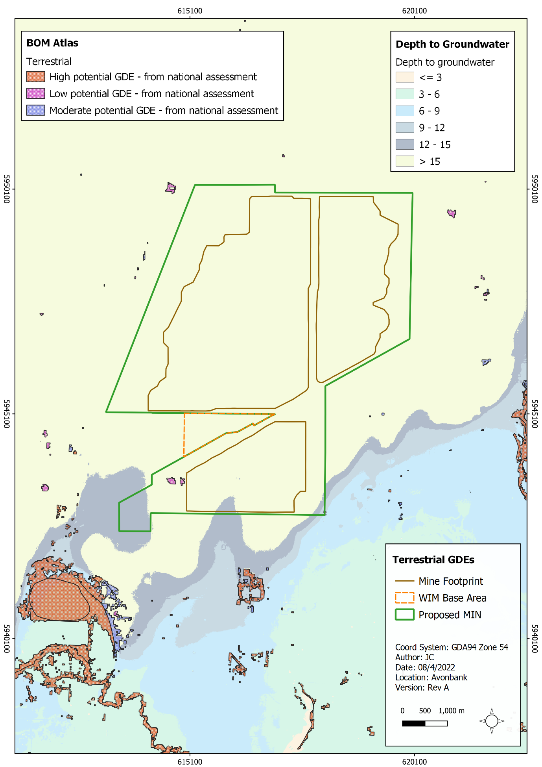
Figure 17-4: Potential terrestrial GDEs (depth to groundwater in metres)
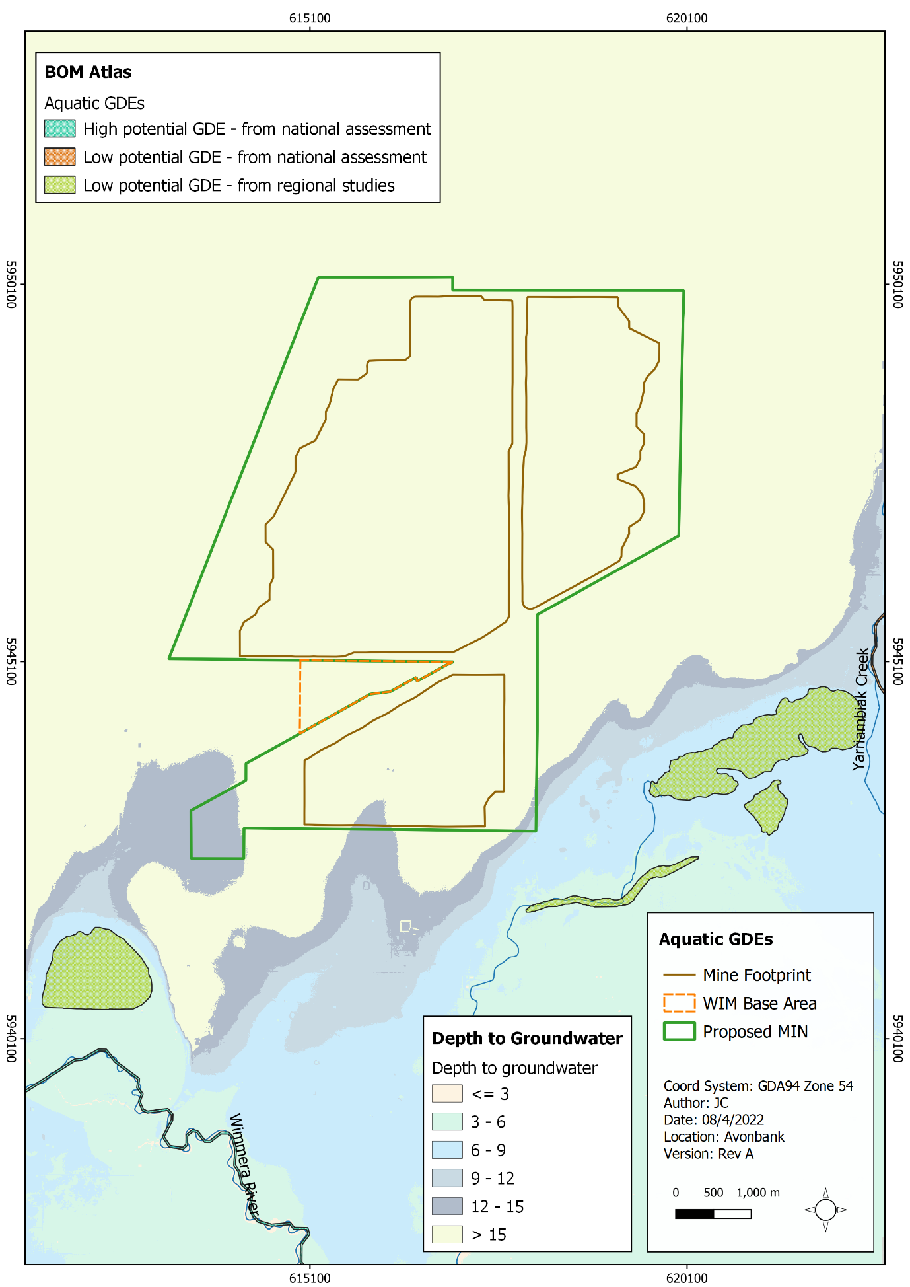
Figure 17-5: Potential aquatic GDEs (depth to groundwater in metres)

Potential Impacts

Identified Potential Impacts
Potential impacts were identified in the GWIA with consideration to the Project activities, preliminary modelling outcomes, stakeholder concerns and the issues identified in the referral document and Scoping Requirements (refer Table 17-1). Where a source-pathway-receptor relationship was considered plausible, further investigation was undertaken to assess the residual impacts with avoidance and mitigation measures in place (refer Section 17.7).
Table 17-1: Potential impacts
Item | Potential Impacts | Phase
IP-01 | Mining ore and pit dewatering resulting in groundwater drawdown and impacts to sensitive receptors. | O, D
IP-02 | Tails placement resulting in groundwater mounding and impacts to sensitive receptors. | O, D
IP-03 | Mining ore and pit dewatering resulting in land subsidence. | O, D
IP-04 | Mining ore and pit dewatering resulting in the activation of potential acid-forming materials and related impacts to the groundwater aquifer. | O, D
IP-05 | Placement of tails resulting in changes to the hydrochemistry of the groundwater aquifer and impacts to sensitive receptors. | O, D
IP-06 | Tails water mounding within and adjacent mining cells resulting in saturation and salinisation of the upper soil profile. | O, D
IP-07 | Mobilisation of existing potentially contaminated groundwater areas. | O, D
IP-08 | Spills and leaks from storage areas affecting the groundwater aquifer. | C, O, D

Sensitive Receptors
Potential sensitive receptors identified in the GWIA are listed in Table 17-2. Sensitive receptors were identified in the impact assessment with consideration to the preliminary conceptual groundwater/surface water model and the environmental values defined in the Environment Reference Standard (ERS, 2021).
Figure 17-3, Figure 17-4 and Figure 17-5 show the sensitive receptors, and Table 17-2 summarises the identified receptor types and associated environmental values. The detailed assessment of relevant environmental values is provided in Appendix L, Table 2.2 and Table 6.10.
Table 17-2: Sensitive receptors
Environmental Values | Sensitive Receptors
Water-dependent ecosystems and species (surface water) | Potential groundwater dependent ecosystems including Two Mile Creek, Wimmera River, Yarriambiack Creek, Darlot Swamp and Dooen Swamp.
Agriculture and irrigation (stock watering) | Livestock drinking water sourced from groundwater bores within the study area that are identified and classified as (domestic/stock or unknown) as well as more broadly across the entire LPS aquifer.
Industry and commercial use | LPS aquifer across the study area (no specific point location).
Water-based recreation  (Primary contact recreation) | Assumed to be water-based recreational use at baseflow receiving surface water features down-gradient of the Project.
Traditional owner cultural values | All potential GDEs and surface water features.
Buildings and structures | LPS aquifer across the study area (no specific point location).
Geothermal properties | Not relevant to this impact assessment as water <20 degrees.

Impact Characterization
The impact assessment summarised in Section 17.7 considers the magnitude, spatial extent, and duration of the residual impacts where relevant, as described in Chapter 6 (Impact Assessment Framework).
The residual impacts were characterised with regard to the ERS environmental values included in Table 17-3 below. The ERS defines the environmental values to be achieved or maintained throughout Victoria. Environmental objectives are benchmarks for specific indicators that can be used to assess whether an environmental value has been maintained and to identify and assess the risks to the environment from pollution and waste.
The ERS explains that an environmental value may not apply to groundwater if the background water quality level exceeds the relevant objective. In these instances, the background water quality becomes the objective for a specific indicator. The impact assessment notes various instances where the background water quality may exceed the groundwater objective.
Further context regarding the ERS environmental values, indicators and objectives are provided below in Table 17-3 and Appendix L (Section 6.6.3.2, Table 6.10).
Table 17-3: Environmental values, indicators and objectives
Environmental Values | Groundwater Indicators and Objectives
Water-dependent ecosystems and species (ERS, 2021) | The ERS lists the environmental values to be protected for each segment of the water environment. In accordance with Figure 1 of Division 3, the Wimmera River, Yarriambiack Creek and other waterbodies are included in the “Murray and Western Plains” Segment.  The level of ecosystem protection for the Segment is generally 95% for sightly to moderately modified aquatic ecosystems. The indicators for surface waters are specified in Division 3 of Part 5 of the ERS. The ERS specifies environmental objectives for a number of parameters including nutrients, and references ANZG for various indicators.
Agriculture and irrigation (stock watering) (ANZECC and ARMCANZ, 2000) | ANZECC investigation levels for Primary Industries (Chapter 4.3 Livestock drinking water quality).
Industrial and commercial  (ANZECC and ARMCANZ, 2000) | ANZECC do not provide specific guidance for industrial water use because industrial water requirements are so varied and sources of water for industry have other coincidental environmental values that tend to drive the management of the resource. However, given that many industrial processes require low-salinity water, the environmental values for commercial and industrial processes would be limited.
Water-based recreation (primary contact recreation)  (NHMRC, 2008) | NHMRC Guidelines for Managing Risks in Recreational Water refers to the ADWG 2011, and as such, the criteria in that document have been adopted for the purposes of this report. The ERS states that the environmental quality indicators and objectives for the environmental value of water-based recreation should be applied consistent with the risk-based approach recommended by the NHMRC’s 2008 guidelines.
Traditional Owner values  (ERS, 2021) | Water quality that protects the cultural values of Traditional Owners may include traditional aquaculture, fishing, harvesting, cultivation of freshwater and marine foods, fish, grasses, medicines, and filtration of water holes, and that allows cultural, spiritual and ceremonial practices to continue.
Cultural and spiritual values  (ERS, 2021) | Water quality allows cultural, spiritual and ceremonial practices to continue. In the absence of defined criteria, it has been assumed that the groundwater quality must be protected to maintain aquatic ecosystems and GDEs.
Buildings and structures  (Standards Australia, 2009) | Introduced contaminants shall not cause groundwater to be corrosive to structures or building materials (pH, sulfate, redox potential, salinity or any chemical or waste that may impact structural integrity). Investigation levels are not specified, and reference has been made to AS2159: 2009 ‘Piling – Design and installation’.
Geothermal | Not relevant to the Project (groundwater is less than 20°C).
In addition to the detailed characterisation of the impacts described above, the relative significance of each residual impact was summarised on a scale ranging from negligible through to severe (refer Table 17-4).
Table 17-4: Significance rating
Rating | Description
Negligible | Changes to groundwater levels, flows or quality have no detectable impact.
Minor | Changes to groundwater levels, flows or quality within the range of natural variation and does not result in loss of one or more environmental values.
Moderate | Changes to groundwater levels, flows or quality results in temporary and reversible loss of one or more environmental values.
Major | Changes to groundwater levels, flows or quality results in permanent loss of one or more environmental values in a local area.
Severe | Changes to groundwater levels, flows or quality results in permanent loss of one or more environmental values over a widespread area.

Avoidance and Mitigation Measures
This Section outlines the measures identified to avoid and minimise residual impacts. It is noted that in line with the requirements of the environmental management system (EMS) described in Chapter 24 and relevant legislation, additional measures may be required during implementation to ensure risks and potential impacts have been minimised so far as reasonably practicable.

Avoidance

GW-01: Geera Clay Formation
Exploration drilling and analysis of the Avonbank deposit identified that the ore body sits above the Bookpurnong Formation/Geera Clay, which was shown to be a Potentially Acid Sulphate Soil (PASS). It was determined that this Formation would be avoided during all mining, excavation, and dewatering activities with a buffer of at least 1.5 m to avoid exposing and oxidising the Geera Clay. Mining and sump excavation will be undertaken with survey control to ensure the buffer is maintained. An overarching PASS Management Plan is described in Section 17.6.2.8.

Minimisation

GW-02: Tailings strategy
The fine tailings produced at the desliming cyclone will be dosed with a polymer flocculant to promote water recovery. A large diameter thickener and a flocculant dosing system will be used in the primary stage of dewatering to allow the fines to be thickened.
Fines will report to the thickener underflow and will be combined with sand tailings and pumped back to the mine void. Clean water overflow from the thickener will be transferred to a process water dam or recirculated to the WCP.
The use of flocculants will be optimised to ensure maximum clean water recovery whilst minimising the amount used, so far as reasonably practicable. The flocculants will be used in the process at very low concentrations in line with standard practice within the mineral sands industry.
Secondary dewatering will occur at the mine void tails discharge outlet. This will involve adding further polymer flocculant to the slurry exiting the pipe head. The clean water will separate from the tailings beach and will report to a decant sump. The recovered water will be recycled to the process water circuit. This process results in water recovery of around 62% and will effectively maximise water recovery, so far as reasonably practicable.
It is expected that up to 10% of the tailings water will infiltrate to the groundwater aquifer and not be recovered in the process. This water will contribute to offsetting the predicted drawdown.

GW-03: Tails placement
Sand tails will be placed in the mine void to a depth greater than 3 m from the final rehabilitated ground surface and surrounding natural ground. All sand tailings cells will be capped with at least 3 m of overburden, subsoil and topsoil material. This will provide sufficient rooting depth for the intended agricultural land use and will minimise the risk of groundwater mounding in the surrounding upper soil profile.

GW-04: Groundwater bore network
Process water and groundwater monitoring will be undertaken in line with the Groundwater Management Plan (GWMP) (Section 17.6.2.7). The bore network (locations and sampling schedule) will be adapted over the life of mine in response to observed Project related drawdown/mounding effects and any changes to water chemistry, with consideration to identified sensitive receptors.
An annual groundwater monitoring review will be undertaken by a suitably qualified person to assess the outcomes against the groundwater modelling and background water quality. Recommendations will be made as required to adapt the monitoring schedule and/or bore network so that the effects on sensitive receptors can be adequately characterised as the mine progresses. Matters relating to the proposed monitoring schedule are further described in Section 17.8.2.1.

GW-05: Groundwater dependent ecosystem studies
If Project related drawdown/mounding or adverse changes to groundwater quality are recorded that could propagate to areas of potential GDEs, targeted studies will be undertaken to monitor GDE health/function over time. The proposed type of monitoring is further explored in Chapter 21 (Flora and Fauna).
As described in the GWMP framework (refer Section 17.6.2.7), environmental performance standards will be established, against which groundwater monitoring results will be regularly reviewed. Performance standards will be established for bores situated in between the source and the identified GDE receptors. Commencement of targeted GDE health monitoring will be triggered if the performance standards are exceeded. Matters relating to the GDE monitoring are further described in Section 17.8.2.1.

GW-06: Contaminated sites investigations
Prior to mining each land parcel, a contaminated site investigation will be undertaken in accordance with the National Environment Protection (Assessment of Site Contamination) Measure 1999 (NEPM) (NEPC, 1999). The investigation will be undertaken at the earliest opportunity once the relevant consent to access land parcels have been granted by the landholder.
The NEPM outlines a staged approach to the investigation and assessment of existing contamination that proceeds in stages, in proportion to the risks of environmental harm. The initial desktop review provided in this EES will be expanded upon and will involve:
- Site inspections and landholder interviews to identify areas of potential contamination.
- Preliminary sampling of soil, groundwater and surface water in areas of suspected contamination.
- Preparation of a conceptual model relevant to each suspected contaminated site.
This will facilitate the completion of a preliminary site investigation for the relevant landholdings. As detailed in Section 2 of the NEPM, further work may be required pending the outcomes of the site investigations, which may involve a detailed site investigation. If areas of contamination are confirmed, a remediation plan will be developed to address all relevant requirements of the NEPM.
Any management plan in the first instance will determine whether it is possible to avoid disturbing pre-existing contaminated land. Where disturbance cannot be avoided, it will describe options to mitigate or remediate environmental harm from existing contamination.
Consultation with the landholders responsible for known or suspected contaminated sites listed, including the Dooen Landfill and Country Fire Authority site will continue over the life of mine to ensure there are no material Project related effects at these sites.

GW-07: Chemical storage and management
Chemicals will be stored and managed in line with relevant guidelines, material data safety sheets and industry best practice. A dangerous goods register with emergency response procedures will be developed to effectively manage chemical spills. A Waste Management Plan will be developed and incorporated into the overarching AS/NZS ISO 14001:2016 EMS to manage these risks.

GW-08: Groundwater Management Plan
A Groundwater Management Plan (GWMP) will be prepared prior to Project commencement which will provide a management framework to avoid and minimise risks/impacts from the Project, so far as reasonably practicable, in line with the Project EMS and relevant legislative requirements.
The GWMP will address aspects relating to Project related groundwater drawdown/mounding, changes to the groundwater chemistry and associated potential impacts to sensitive receptors, including but not limited to bore users and GDEs.
The GWMP will be reviewed and updated at an appropriate frequency as established in the overarching EMS, with consideration to the level of risk, statutory requirements, monitoring results, community complaints and in response to audit findings. It will be developed in consultation with stakeholders and will be subject to approval by the relevant Authority.
The GWMP will:
- Summarise the baseline data and existing environment.
- Explain the relevant statutory requirements and context (including any relevant approvals).
- Describe the avoidance and mitigation measures to be implemented to minimise residual risks/impacts so far as reasonably practicable.
- Identify specific environmental objectives and performance standards to be achieved with avoidance and mitigation measures in place.
- Detail monitoring to be undertaken to verify the effectiveness of the avoidance and mitigation measures including but not limited to groundwater levels and chemistry (refer Section 17.8.2.1).
- Establish performance standards relating to groundwater flux and changes to hydrochemistry for bores associated with specific receptors.
- Establish a GDE monitoring protocol to be implemented if certain groundwater flux performance standards are exceeded.
- Describe mechanisms to determine when/if corrective actions and contingency measures are required (refer Section 17.8.2.1)
- Detail a program to investigate and implement ways to improve the environmental performance of the Project over time.
- Detail appropriate review periods and/or triggers to ensure the plan remains fit for purpose.
- Establish procedures to manage:
- incidents and any non-compliance.
- stakeholder and community complaints.
- failure to comply with statutory requirements and/or environmental performance standards.
- roles and responsibilities for implementing the plan.
- a protocol for periodic review of the plan.
- Include a community engagement strategy which will include a complaints handling system.
In addition to the above requirements and the avoidance and mitigation measures in this Chapter, the GWMP will include specific requirements to:
- Review the groundwater bore network annually to ensure the spatial extent and monitoring frequency is adequate to characterise the risks at identified sensitive receptors.
- Implement a water quality monitoring program that is commensurate with the risks associated with mining and water use/discharge.
- Submit an annual groundwater report to the relevant regulatory authority that summarises groundwater monitoring data against relevant environmental objectives.
- Maintain a Project water balance to forecast water use and to verify actual use over the life of mine.
- Undertake a periodic survey of groundwater bore users over the life of mine, to maintain a current record of users that may be affected by Project activities.
- Maintain groundwater quality monitoring equipment to ensure it is appropriately calibrated and associated records maintained.

GW-9: PASS Management Plan
A Potential Acid Sulphate Soil Management Plan (PASSMP) will be prepared prior to Project commencement which will provide a management framework to avoid and minimise risks/impacts so far as reasonably practicable in line with the Environmental Protection Act 2017.
The PASSMP will address aspects relating to Project related PASS risks with the objective of avoiding the high-risk lithological unit (Geera Clay).
The PASSMP will be reviewed and updated at an appropriate frequency as established in the overarching EMS, with consideration to the level of risk, statutory requirements, monitoring results, community complaints and in response to audit findings. It will be developed in consultation with stakeholders and will be subject to approval by the relevant Authority.
The PASSMP will:
- Summarise the baseline data and existing environment primarily through the Avonbank geological model.
- Include a protocol for sampling PASS as part of the progressive resource drilling program to verify and further characterise the geological model.
- Explain the relevant statutory requirements and context (including any relevant approvals).
- Describe the measures to avoid PASS material during mining and to minimise residual risks so far as reasonably practicable.
- Identify specific environmental objectives and performance standards to be achieved with avoidance and mitigation measures in place.
- Detail the monitoring and inspection to be undertaken to verify the effectiveness of the avoidance and mitigation measures (refer Section 17.8).
- Establish performance standards relating to changes in process water chemistry and bores associated with specific receptors.
- Describe mechanisms to determine when/if corrective actions and contingency measures are required (refer Section 17.8.2.1).
- Detail a program to investigate and implement ways to improve the environmental performance of the Project over time.
- Detail appropriate review periods and/or triggers to ensure the plan remains fit for purpose.
- Establish procedures to manage:
- incidents and any non-compliance.
- stakeholder and community complaints.
- failure to comply with statutory requirements and/or environmental performance standards.
- roles and responsibilities for implementing the plan.
- a protocol for periodic review of the plan.
- Include a community engagement strategy, which will include a complaints handling system.
In addition to the above requirements and the avoidance and mitigation measures in this Chapter, the PASSMP will include specific requirements to:
- Ensure GPS survey control is used to limit the excavation at the bottom of the ore body such that there is a buffer of at least 1.5 m to the Geera Clay lithological unit.
- Conduct routine in-pit inspections within the lower ore body above the Geera Clay to verify Potential Acid Sulfate Soil (PASS) materials are not excavated or dewatered.
- Monitor the pH of decant sumps and conduct PASS field testing in-pit during mining.
- Maintain a geological model and incorporate new drilling or sampling results as required.

GW-10: Waste Management Plan
A Waste Management Plan (WMP) will be developed prior to Project commencement, as described in Chapter 19 (Wastes and Emissions). The WMP will provide a management framework for the management of hydrocarbons and chemicals. The WMP will be updated periodically and will apply to all phases of the Project, including construction, operations, and decommissioning.

Rehabilitation

GW-11: Rehabilitation Plan
A Rehabilitation Plan will be established for the Project that will address matters relating to progressive rehabilitation and closure. It will cover all work areas within the proposed mining licence and within the broader development extent and the Port of Portland.
The Rehabilitation Plan will include a schedule of progressive rehabilitation and will describe the strategy to establish a safe, stable, sustainable landform capable of supporting the proposed end land use. It is expected that land will be stabilised as soon as reasonably practicable after mining, typically within 4 years.
The Rehabilitation Plan will define the end land use with consideration to the views of the landholders and the broader community where appropriate.
A preliminary Rehabilitation Plan for the Project has been developed to meet the intent of the Scoping Requirements and is included with this EES as Attachment 3. This plan will be refined prior to commencement with consideration to the detailed operating plans, stakeholder and community feedback and the Minister’s assessment of the EES.

Residual Impacts
This Section describes the likely residual impacts with avoidance and mitigation measures in place. The residual impacts have been characterised, as described in Section 17.5.3 and Chapter 6 (Impact Assessment Framework).

Groundwater Drawdown and Mounding Impacts
Groundwater modelling was undertaken to quantify the magnitude, spatial extent, rate and duration of drawdown and mounding effects caused by dewatering and tailings deposition. The associated residual impacts on sensitive receptors are described below in Sections 17.7.1.1 and 17.7.1.4.
Commentary in the following sections refers to the predicted groundwater flux contours from the GHD groundwater modelling. Uncertainty analysis is provided in Appendix L, Section 7.2.2, which provides commentary on the upper and lower bounds of model uncertainty.
The effects of climate change are unlikely to make a material difference to the assessment of Project induced effects, as detailed in Appendix L, Section 7.3.13.

Groundwater drawdown
There is one potential impact (IP-01) listed in Section 17.5.1 that relates to groundwater drawdown due to dewatering of the pit during mining. Mine voids will be dewatered at the base of the pit (16 m – 25 m BGL) to access ore, resulting in localised drawdown within the Loxton Parilla Sands aquifer.
The mine plan will involve pumping tails to the mined void and rehabilitating areas within 4 years after disturbance. A proportion of the return water entrained in the tails will infiltrate to the aquifer to mitigate drawdown effects caused by dewatering of the mine void.
The predicted maximum cumulative drawdown over the life of mine is shown in Figure 17-6. The drawdown will be realised as a localised temporary reduction in groundwater levels followed by subsequent recharge due to tails placement. The groundwater flux over time is shown in Appendix L, Figure 7.1.
Groundwater drawdown effects as they relate to sensitive receptors, including GDEs and bore users are described below in Sections 17.7.1.2 to 17.7.1.3. Other environmental values listed in Section 17.5.3 will be either maintained through the protection of these two environmental values or are not applicable to drawdown impacts and are not discussed further in the following Sections.

Groundwater dependent ecosystems
Groundwater drawdown has the potential to adversely impact the health and function of aquatic GDEs that depend on groundwater baseflow and/or terrestrial GDEs that source some or all of their water requirements from the aquifer.
Terrestrial GDEs must derive a portion of their annual water requirements from the watertable or capillary fringe to be considered at risk of groundwater drawdown impacts. Terrestrial GDEs tend to be associated with a shallow watertable. The underlying assumption is that the closer the proximity of a plant’s rooting zone to groundwater, the greater the potential dependency.
The Victorian ‘Ministerial Guidelines for Groundwater Licensing and the Protection of High Value Groundwater Dependent Ecosystems’ indicates that at watertable depths of greater than 6m BGL, terrestrial vegetation is unlikely to be groundwater dependent.
Surface water features must have access to groundwater baseflow to be at risk of drawdown related impacts. Features where the watertable is lower than the bed are considered to be disconnected and will not be affected by groundwater drawdown. Appendix L, Section 6.4 describes the types of surface water – groundwater interactions within the study area.
An assessment of the residual impacts was undertaken with consideration to the depth to groundwater and the magnitude and rate of drawdown. A summary of the findings from the GWIA are provided below in Table 17-5, and Figure 17-6 shows the predicted maximum cumulative drawdown contour (0.1 m) over the life of mine and the potential GDEs as listed in the Bureau of Metrology, GDE Atlas (BOM, 2017).

Table 17-5: Drawdown effects on potential GDEs
Potential GDE | Depth to Groundwater (m) | Drawdown Magnitude (m) | Drawdown Rate (m p/annum) | Likely Effects
Darlot swamp | 5–8 | 0 | 0 | No appreciable drawdown expected.  Losing system not dependant on baseflow.
Longerenong College | 12 | 0.1 | 0.02 | Low potential for groundwater dependence due to depth to groundwater. Negligible magnitude and rate.
Wimmera River | Varies | 0 | 0 | No appreciable drawdown expected.
Two Mile Creek | 4–5 | 0.1 | 0.01 | Small magnitude and rate of change relative to the depth to groundwater.  Losing system not dependant on baseflow.
Yarriambiak Creek | 5–10 | 0 | 0 | No appreciable drawdown expected.
The expected maximum drawdown at sensitive receptors is considered to be very low and will be experienced gradually at a rate of around 0.01 to 0.02 m/annum. The residual impacts to both aquatic and terrestrial GDEs will be negligible to minor, and there is expected to be no change to the environmental values at the identified sensitive receptors.
The GWMP will include commitments to monitor groundwater levels, to verify and update the groundwater model over the life of mine and to undertake targeted GDE monitoring as required (refer Section 17.6.2.4). It is expected that residual impacts have been reduced to as low as reasonably practicable based on the proposed dewatering and tails placement schedule.
As described in Section 17.8, the environmental objective associated with this aspect during Project implementation is to have no material impact on the health and function of GDEs, due to groundwater drawdown. Management and monitoring measures are described in Section 17.8.
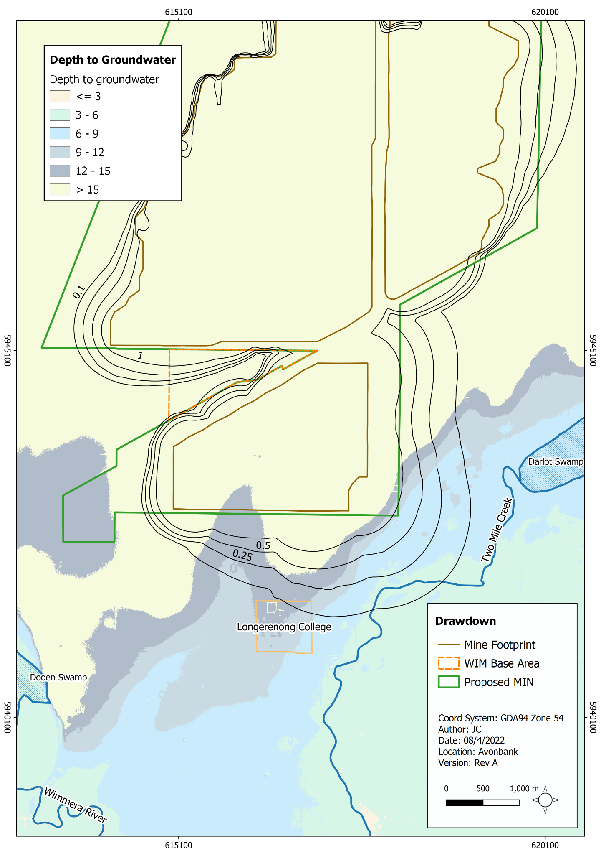
Figure 17-6: Predicted cumulative maximum drawdown and depth to groundwater (metres)

Bore users
The potential for groundwater drawdown to impact the yield from extraction bores depends primarily on the ‘available drawdown’ (the height of groundwater above the pump intake) and the extraction rate.
The number of groundwater users within the study area is limited due to the relatively high background groundwater salinity, however, there are two bores with use registered within 2 km of the mine footprint (60526 and 68431) (refer Figure 17-3). For the purposes of this study, these bores are assumed to be actively used for stock watering purposes.
As described in Appendix L, Section 7.3.1, there are expected to be no drawdown impacts at these bores. A bore audit will however be conducted periodically over the life of mine to record current bore users and establish a baseline against which effects can be assessed.
The GWMP will include commitments to monitor groundwater levels and to verify and update the groundwater model over the life of mine. The impact of groundwater drawdown on bore users is considered negligible, however, contingency actions are further detailed in Section 17.8.2.1.

Groundwater mounding
There is one potential impact (IP-02) listed in Section 17.5.1 that relates to groundwater mounding associated with the discharge of water to the in-pit tailings cells. These include potential impacts on vegetation/groundwater dependent ecosystems and surrounding groundwater bore users. Other environmental values listed in Section 17.5.1 will be either maintained through the protection of these two values or not applicable to mounding impacts (absence of source-pathway-receptor linkage) and are not discussed further in the following sections.
Fine and coarse tailings will be deposited into in-pit tailings cells at a depth of no closer than 3 m to the final rehabilitation surface and surrounding undisturbed landform. Entrained process water is expected to drain rapidly through the upper tails profile.
Around 62% of the process water discharged with the tails will be recovered and around 10% will infiltrate into the groundwater aquifer (refer Section 17.3). The infiltration will result in a groundwater pressure response which is expected to cause groundwater levels to rise some distance from the discharge point. The expected mounding contours are shown in Appendix L, Figure 7.1.
Impacts associated with groundwater mounding are described in the Sections below.

Vegetation and groundwater dependent ecosystems
Changes to groundwater levels may impact vegetation if the effective rooting zone becomes saturated and available oxygen is limited to the extent that plants become stressed. Potential impacts may also occur due to changes in the groundwater hydrochemistry, as described in Section 17.7.2.
Figure 17-7 shows the predicted maximum cumulative mounding over the life of mine and the groundwater dependent ecosystems as listed in the Bureau of Metrology, GDE Atlas (BOM, 2017). The mounding will be related to the accumulation of tails water close to the pit and will be increasingly associated with a pressure response with distance from the pit.
Predicted mounding effects including depth to groundwater and rate of mounding are described below in Table 17-6.

Table 17-6: Mounding effects on potential GDEs
Potential GDE | Depth to Groundwater (m) | Mounding Magnitude (m) | Mounding Rate (m p/a) | Likely effects
Darlot swamp | 5–8 | 0.1–0.5 | 0.05 | Small magnitude and rate of change relative to the depth of groundwater. Swamp remains disconnected from the watertable and no changes to surface water – groundwater interactions.
Dooen Swamp | 5.5–7 | 0.1–0.15 | 0.01 | Small magnitude and rate of change relative to the depth of groundwater. Swamp remains disconnected from the watertable and no changes to surface water – groundwater interactions.
Longerenong College | 12 | 0.25–0.5 | 0.05 | Small magnitude and rate of change relative to depth to groundwater. Vegetation unlikely to be groundwater dependent due to depth of groundwater.
Wimmera River | Variable | 0 | 0 | Located outside potential mounding zone.
Two Mile Creek | 4–5 | 0.25–0.5 | 0.05 | Small magnitude and rate of change relative to the depth to groundwater. Creek remains disconnected from watertable and no changes to surface water – groundwater interactions.
Yarriambiak Creek | 5–10 | 0.1 | 0.01 | Small magnitude and rate of change relative to the depth to groundwater.
The magnitude and rate of groundwater mounding at sensitive receptors is low and not expected to materially saturate the effective rooting zone (which may also adapt by developing adventitious roots as the watertable moves vertically). The watertable will remain disconnected from surface water, resulting in no changes to the nature of surface water – groundwater interactions and dynamics of hydrological processes that maintain the natural wetting and drying cycles.
The residual impacts of mounding on terrestrial groundwater dependent ecosystems and vegetation are expected to be minor. The mounding is expected to be within the normal seasonal range and impacts on the health and function of GDEs are considered to be very unlikely. This is further explored in Chapter 21 (Flora and Fauna).
Aquatic ecosystems are unlikely to be impacted by mounding as the surface water features within the predicted extent of mounding are conceptualised to be losing features. The magnitude of mounding is expected to remain below the invert of the identified waterways and swamps.
The GWMP will include commitments to monitor groundwater levels, to verify and update the groundwater model over the life of mine and to undertake targeted GDE monitoring as required (refer Section 17.6.2.4). It is expected that residual impacts have been reduced so far as reasonably practicable based on the proposed dewatering and tails placement schedule.
The EMS environmental objective associated with this aspect is to have no material impact on the health and function of GDEs due to groundwater mounding. Management and monitoring measures are described in Section 17.8.
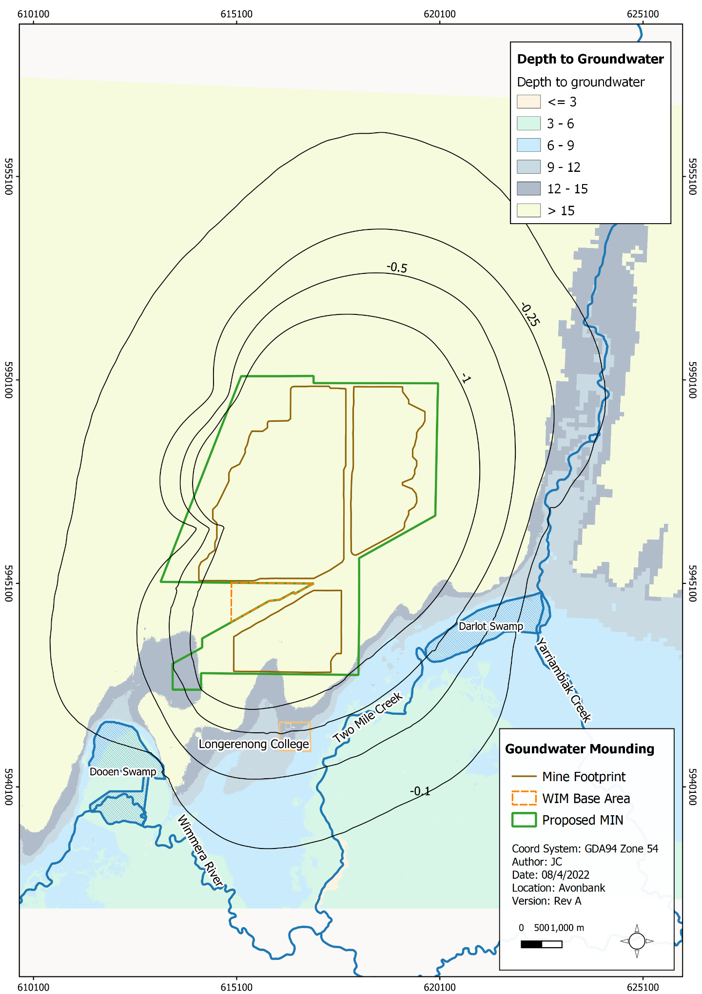
Figure 17-7: Predicted cumulative maximum mounding and depth to groundwater (metres)

Bore users
There are four registered groundwater bores (68431, 60526, 75857 and 68430) located within the predicted spatial extent of maximum groundwater mounding. The location of these bores is shown in Figure 17-3.
The mounding at these bores will occur gradually due to the slow groundwater pressure response following tailings placement. Mounding at bore 68431 will be <1 m at bore 60526. Mounding at the remaining bores is <0.1 m.
The residual impact of the predicted maximum mounding of the watertable was assessed with respect to potential change to the available drawdown. At bore 68431, the change in the height of water above the pump increased by around 12% and was assessed to be a minor change, unlikely to have a material impact on the operation of the bore. For bore 60525, the change in the height of water above the pump increased by around 4% and was assessed to be a negligible change.
A bore audit will be conducted prior to the commencement of mining and periodically over the life of mine to record current users and to establish a baseline against which effects can be assessed. The GWMP will include commitments to monitor groundwater levels and to verify and update the groundwater model over the life of mine. The impact of groundwater mounding on bore users was assessed to be minor to negligible, however contingency actions are further detailed in Section 17.8.2.1.

Subsidence
There is one potential impact (IP-03) listed in Section 17.5.1 that relates to land subsidence caused by aquifer dewatering.
Land subsidence can be triggered by the consolidation of sediments due to the lowering of the watertable, during dewatering of the mine and/or loss of cementation or mobilisation of sediments, due to the seepage of groundwater as a function of high groundwater velocity.
Land and Marine Geological Services (LMGS, 2021) undertook a subsidence assessment which found that the geological conditions of the study area were not conducive to settlement caused by dewatering and drawdown (refer Appendix L, Section 7). This is due to the strength, cementation characteristics and absence of soluble carbonate materials within the aquifer, coupled with the low flow (seepage) velocity and self‐filtering capacity through these materials.
The geological formations are not compressible and there is a low potential for the mobilisation of fines to result in settlement. Detectable changes to the land surface are not expected to arise due to dewatering and the residual impact of subsidence was assessed to be negligible. No specific mitigation measures are required.

Groundwater Quality Impacts
An assessment was undertaken to evaluate the potential groundwater quality effects associated with the mining activities. The following assessment relates specifically to the Loxton Parilla Sands aquifer. The Renmark aquifer was not considered to be materially affected by the Project due to the overlaying aquitard and is not further discussed in this Section.

Process water quality and migration
There is one potential impact (IP-05) listed in Section 17.5.1 that relates to changes to the hydrochemistry of the aquifer due to process water discharged to the in-pit tailings cells.
As described in Section 17.3, sand tailings and process water will be discharged to the tails cells, with around 10% expected to infiltrate into the aquifer. The process water will comprise primarily of water supplied via the Wimmera Mallee Pipeline, with smaller amounts of groundwater extracted during dewatering and ore removal.
Monitoring of the Avonbank Demonstration Trial showed that the salinity of the tailings water is expected to be around 2,400 mg/L TDS, which is considerably fresher than the background groundwater quality. Salinity of the process water will vary during operations and is expected to remain considerably less saline than the ambient background conditions, which range between 7,000 and 10,000 mg/L TDS.
Process water was monitored during the trial at several locations during tails deposition. Several metals exceeded the adopted objective for GDES and were below the objective for stock water use, including aluminium, chromium, hexavalent chromium, copper and zinc. These metals reflect those that also exceed the GDES in the ambient background conditions. This is not unexpected given the process water comprises partially of extracted groundwater.
Several bores adjacent to the pit (within 5 to 15 m) were monitored prior to, during and after the trial. These bores showed a pressure response in relation to the dewatering and tailings activities, however, the salinity levels remained relatively consistent, indicating limited if any migration of tails water to these bores. As per the ambient background, levels of aluminium, copper, hexavalent chromium, nickel and zinc exceeded the GDES, and were below the stock water objectives.
With consideration to the above listed exceedances in the baseline and test pit trials, the Chemicals of Potential Concern (COPC) for this study were determined to be aluminium, chromium, copper, nickel, selenium, zinc and hexavalent chromium. Polyacrylamide was also considered to be a COPC for the purposes of this study due to its presence in the flocculant used in the process.
The primary migration pathway considered relevant to the transport of COPCs was determined to be down hydraulic gradient to the north-west. Process water is expected to migrate slowly away from the pit to the north-west at a rate of around 100–300 m over 62 years. It is expected that process water will mix with the groundwater over time, increasing salinity levels toward the natural background levels.
Numerical modelling indicates that a small mounding of <0.5 m in the fringing area to the south and south-east is not expected to reverse the natural direction of groundwater flow towards the north-west, which will limit the transport of solutes in this direction. Upgradient of the mine footprint (i.e., to the south and south-east), any process water migration is likely to occur only marginally beyond the mine footprint.
It is anticipated that a permit (A18 permit) issued under the Environment Protection Act 2017 (EP Act) will be required to discharge process water to the aquifer. The permit is likely to define the discharge rate to the aquifer and the water quality objectives. Further detail is provided in Chapter 4 (Regulatory Framework).
The following sections describe the predicted likely effects on environmental values and sensitive receptors associated with the protection of GDEs and bore users. Other environmental values listed in Section 17.5.3 will be maintained through the protection of these two values and are not discussed further in detail in the following Sections.

Vegetation/terrestrial groundwater dependent ecosystems
The nearest point of potential groundwater discharge, where the GDES objectives may apply, is the Wimmera River down hydraulic gradient of the mine footprint (~20 km to the north-west).
Process water migration down hydraulic gradient is not expected to result in detectable concentrations of metals above the natural background at this location. It is expected that the considerable transport distance and slow groundwater flow velocity will facilitate sufficient attenuation through advection and dispersion processes. The residual impact on the aquatic ecosystems at the Wimmera River is considered negligible.
The migration of process water to the south and east is considered unlikely, given that they are situated up hydraulic gradient from the mining area. Prevalent groundwater flow direction is expected to remain towards the mine footprint and any changes to groundwater quality surrounding the mine will be further limited due to the slow particle movement and the mixing/dilution of process water with groundwater.
There are expected to be no detectable impacts to aquatic ecosystems of the Wimmera River up hydraulic gradient of the mine footprint (to the south), as the prevailing groundwater flow direction is predicted to remain to the north-northwest, towards the mine footprint. It should be noted that the naturally occurring background concentrations of some metals already exceed the adopted criteria for the GDES.
The GWMP will include commitments to monitor groundwater levels, to verify and update the groundwater model over the life of mine and to undertake targeted GDE monitoring as required (refer Section 17.6.2.4). It is expected that residual impacts are as low as reasonably practicable based on the proposed mine design.
As described in Section 17.8, the environmental objective associated with this aspect during Project implementation is to protect environmental values associated with GDEs. Management and monitoring measures are described in Section 17.8.

Bore users
The two closest existing potential groundwater bore users (bore 68431 and 60526) are located more than 600 m from the southern mining pit and slightly up hydraulic gradient (Figure 17-3 and Figure 17-8). Other existing potential groundwater users (68430 and 75857) are located more than 1,500 m from the pit boundary. Particle tracking suggests that migration of metals away from the tails cells will occur slowly at a rate of 100–300 m over the 62-year simulation period.
While groundwater extraction for stock watering purposes within the study area is currently limited, there remains the potential for new bores to intersect the affected area in the future, resulting in a possible complete transport linkage (during and/or after mining). Existing data from the test trial indicated process water remains within the stock water guideline, however there is a potential for hydrogeochemical conditions to become more conducive to the formation and solubility of hexavalent chromium.
A review of the background soil chromium concentration and the leach fraction derived from the leachability tests indicated there were insufficient amounts of chromium to generate dissolved concentrations above the stock water criteria. Flocculants/polyacrylamides were considered unlikely to pose a risk to the stock water environmental value, as they are predicted to be present in low concentrations and will have limited mobility.
There is expected to be no change to the environmental value associated with stock water bore use and the residual impacts are considered to be minor. The GWMP will include commitments to monitor process water and groundwater quality. Periodic bore audits will be undertaken to record users within the predicted drawdown/mounding zone for each mining Block. While the residual impacts are expected to be minor, contingency measures are further detailed in Section 17.8.
The environmental objective associated with this aspect during Project implementation is to protect environmental values associated with stock water use. Management and monitoring measures are described in Section 17.8.
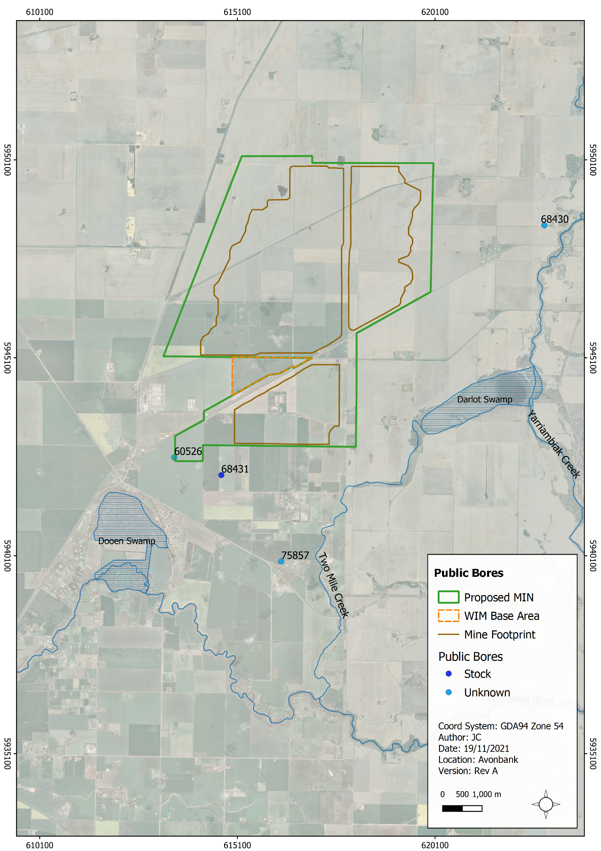
Figure 17-8: Bore users

Potential acid sulfate soils
There is one potential impact (IP-04) listed in Section 17.5.1 that relates to the activation of Potentially Acid Sulfate Soils during mining.
Potentially Acid Sulfate Soils (PASS) are naturally occurring soils which contain iron sulfides that can oxidise when exposed to form Actual Acid Sulfate Soils (AASS). Potential Acid sulfate soils are typically characterised by a Chromium Reducible Sulfur (CRS) content of over 0.03% S (medium texture sandy loams to light clays) (DER, 2015).
Potential acid sulfate soils tend to be widespread in coastal regions and are also locally associated with freshwater wetlands and saline, sulfate-rich groundwater in some agricultural areas. A review of the Australian Soil Resource Information System (ASRIS) identified a low probability of PASS across the study area, except at Dooen Swamp and Darlot Swamp. There is expected to be no measurable groundwater drawdown within either of these swamps.
A preliminary PASS investigation undertaken by the University of Adelaide (UoA, 2019) showed that samples taken in the Shepparton and Loxton Parilla Sand formations were less than CRS 0.03%S and not classified as PASS. One sample in the Geera Clay had a CRS greater than 0.03%S (refer Appendix L, Appendix R). University of Adelaide concluded that a PASS hazard is unlikely in the Shepperton Formation and Loxton Parilla Sands, but highly likely in the Geera Clay.
A PASS Management Plan will be developed prior to mining that includes a range of commitments to minimise the risks associated with PASS. Most importantly the Geera Clay will be avoided during mining and will not be dewatered, to prevent oxidation and activation of PASS.
The geological model will be maintained to clearly identify the Geera Clay as a lithological unit such that it can be avoided. Adequate sampling and field control will be conducted over the life of mine to ensure this can be achieved. The residual impacts relating to the activation of PASS were assessed to be minor, with avoidance and mitigation measures in place.
As described in Section 17.8, the environmental objective associated with this aspect during Project implementation is to avoid disturbance of the Geera Clay and protect groundwater environmental values. Management and monitoring measures are described in Section 17.8.

Changes to soil salinity
There is one potential impact (IP-06) listed in Section 17.5.1 that relates to the saturation of the upper soil profile adjacent tailing cells, causing changes to soil salinity. If returned tailings are placed close to the ground surface, the entrained process water may interact with the soil profile leading to soil saturation and changes to soil salinity within the rooting zone of adjacent agricultural land.
To avoid this scenario, tailings will be placed no closer than 3 m below the rehabilitated and natural ground surface, which is largely below the agricultural crop rooting zone. Monitoring during the pilot trial suggests water will drain rapidly from tails after placement, and the saturated soil profile will be around 2 m below the tails surface. The pore pressure in the tailings will dissipate over the ensuing 6 months as the tailings drain and settle. This means that the tailings water level (saturated soil profile) will generally remain greater than 5 m below the surrounding ground surface (natural and rehabilitation). The residual impact of water mounding adjacent the pit is expected to be negligible with avoidance and mitigation measures in place.

Contaminated sites
There is one potential impact (IP-07) listed in Section 17.5.1 that relates to the mobilisation of contaminants associated with current and past land uses.
Drawdown and mounding resulting from mine dewatering and tailings placement have the potential to modify the natural groundwater flow paths. There is a risk that this could mobilise existing potentially contaminated groundwater towards sensitive receptors such as bores, GDEs and receiving environments.
A review of publicly available information identified the CFA training ground (the EPA priority site) adjacent to Longerenong College and Dooen Landfill near the predicted area of mining influence. Monitoring at the CFA site indicates that perfluoroalkyl and polyfluoroalkyl substances (PFAS) concentrations are below the limit of reporting for all samples from seven bores. No water quality data was available for the Dooen landfill.
Given the potential risks at both sites, particle tracking was undertaken to assess the effects of drawdown and mounding on the rate and direction of movement of water particles from the site (refer Appendix L, Section 7.2.2.3).
Particle tracking for the CFA site indicates that there is the potential for the flow paths from the site to be slightly deflected (to the south, in the direction of mounding). However, this would not be expected to change the overall flow direction (to the north-west). The particle movement was between 120–240 m over 62 years.
The Dooen landfill is located hydraulically downgradient of the mine, with predicted mounding in the order of 0.1–0.25 m. As per the CFA site, particle tracking indicates the potential for very slight deflection of flow paths (to the north-west, in the direction of mounding) with no material difference expected in the rate and direction of movement of solutes.
The modelling suggests that the flow changes are unlikely to be material due to the distance from the mine and small magnitude of drawdown and mounding predicted at both of these locations.
For this reason, any detectable changes to the distribution of existing contaminated groundwater from these sites would be expected to be limited and unlikely to result in a loss of relevant environmental value.
Prior to mining each land parcel, a contaminated site investigation will be undertaken in accordance with the NEPM to identify any areas of potential contamination associated with the historical use of the land. If areas of contamination are confirmed, a remediation plan will be developed to address all relevant requirements of the NEPM prior to disturbance.

Storage of hazardous materials
There is one potential impact (IP-08) listed in Section 17.5.1that relates to chemical spills or leaks from storage areas which may affect groundwater related sensitive receptors.
There is a possibility that spills may occur during the refuelling of vehicles, plant and machinery or the use of chemicals required during mining and operation. Under normal management procedures, spills/leaks will be contained, and emergency procedures will be in place for rapid cleanup in the case of an accident.
Any accidental release of hazardous materials would be expected to be localised and temporary. This, combined with the presence of several metres of low hydraulic conductivity Shepparton Formation and the depth to groundwater being greater than 10 m, suggests limited potential for vertical leakage, rendering any detectable changes in groundwater concentrations highly unlikely.
The residual impacts on groundwater quality are considered negligible. A WMP and a chemical storage protocol will be developed to detail the requirements for the management of hazardous materials and dangerous goods and to describe the relevant emergency response procedures.

Management Framework
An AS/NZS ISO 14001:2016 EMS will be established for the Project, as detailed in Chapter 24. The EMS will address matters relating to planning, risk management, operational control, monitoring and continuous improvement over the life of the Project. Relevant matters relating to groundwater monitoring, auditing and corrective actions/contingencies are summarised below.

Environmental Objectives
Environmental objectives will be established as part of the EMS to articulate the outcomes to be achieved during Project implementation. These will reflect the expected and achievable outcomes based on the studies undertaken as part of this EES.
The key environmental objectives relevant to the Project during implementation as determined in this EES are listed below:
- Groundwater drawdown and/or mounding will result in no material impact on the health and function of potential GDEs or existing bore users.
- Process water infiltration to the LPS groundwater aquifer will result in no adverse material change to the groundwater environmental values associated with stock water bore use or GDEs.
- Disturbance of PASS material (Geera Clay) will be avoided and there will be no associated adverse material change to the groundwater environmental values.
- Potentially contaminated sites will be assessed and managed in line with the NEPM.
Performance standards will be established to measure/assess if the environmental objectives have been achieved during operations, as further discussed below in Section 17.8.2.

Monitoring and Management

Process water and groundwater
A process water and groundwater monitoring program will be incorporated into the EMS and associated GWMP to measure, analyse and evaluate the effectiveness of the avoidance and mitigation measures and overall environmental performance. The GWMP will be developed in consultation with stakeholders and will be subject to approval by the relevant Authority.
Monitoring will be undertaken over the life of the Project at sensitive receptors to confirm the avoidance and mitigation measures have been implemented to minimised Project related risks so far as reasonably practicable in line with the EP Act 2017 and the associated General Environmental Duty (refer Chapter 4).
Groundwater monitoring locations will be established with consideration to the source/activity, established/proposed mitigation measures, COPC and sensitive receptors. The existing bore network will be augmented and adapted over the life of the Project to ensure the environmental impacts and risks are adequately characterised as the mine progresses (refer Section 17.6.2.3).
Groundwater samples and water levels will be undertaken according to a schedule approved in the GWMP (Section 17.6.2.7). The groundwater sampling analytical suite and monitoring frequency will be developed by a suitably qualified person, with consideration to the COPC, such that it is aligned with the requirements of the ERS and will fully characterise the relevant risks and impacts associated with the Project. It is expected that the monitoring schedule and analytical suite will be reviewed periodically and amended over the life of the Project to ensure it remains relevant. Material changes will be communicated and approved via the GWMP.
Targeted monitoring of GDEs may be required over the course of the Project if adverse groundwater effects (flux or hydrochemistry) are observed in bores associated with the relevant GDE sensitive receptors. Any effects relating to groundwater flux and water migration will occur gradually over decades. The mining of Block A will provide an opportunity to verify the actual groundwater effects against the groundwater model and will enable a tailored and specific GDE monitoring program to be established if required. This is further discussed in Chapter 21 (Flora and Fauna).
Prior to mining, the relevant ERS environmental objectives and indicators will be established as a benchmark against which the maintenance of the stated environmental values can be assessed. EMS environmental performance standards will be set that are commensurate with the ERS objectives.
Process water monitoring will be undertaken at the WCP prior to discharge. Monitoring will be conducted for various key parameters, including, but not limited to, pH and salinity. This will confirm process water quality is within set operating parameters prior to discharge.
If process water, groundwater chemistry or groundwater flux is recorded trending toward predicted/modelled levels, performance standards, a root cause investigation will be undertaken, and corrective actions/contingencies identified and implemented.
Depending on the severity and nature of the adverse trend, it is anticipated that the mine plan would be reviewed to determine if any changes (including tailings schedule) or processing variables could be adjusted to minimise the observed trend and avoid impacts.
In the unlikely event that bore yield/function from existing users is materially impacted due to Project related groundwater flux, contingency measures could be implemented that include either deepening/replacement of the bores or provision of an alternative supply of water to the bore user.

Potential Acid Sulfate Soils
A PASS monitoring program will be incorporated into the EMS to measure, analyse and evaluate the effectiveness of the avoidance and mitigation measures and overall environmental performance. The monitoring will be undertaken over the life of the Project at sensitive receptors to confirm the avoidance and mitigation measures have minimised residual impacts so far as reasonably practicable in line with the EP Act 2017 and the associated General Environmental Duty.
The monitoring will be designed by a suitably qualified person to validate the geological conceptual model in line with the requirements to be approved in the PASSMP. This will involve screening representative samples for pH_{FOX} and pH_{F} during infill resource drilling. The results of the screening level assessment will be used to select a representative number of samples for Chromium Reducible Sulfur analysis (SCR).
Similarly, during mining near the base of the ore, periodic pit sampling will be conducted to screen a representative number of samples for pH_{FOX} and pH_{F.} It is expected that once the geological model has been verified, the frequency of monitoring may be reduced or potentially ceased if the associated risks are considered to be negligible.
If Geera Clay is unintentionally exposed at the base of the pit (i.e., due to over extraction), it will be capped as soon as practicable to limit oxidisation. If monitoring shows an elevated risk of PASS in a particular area that could materially impact sensitive receptors, a root cause investigation will be undertaken, and a contingency plan will be developed to reflect leading practice industry standards.

Audits
Periodic internal and independent audits will be undertaken to assess the effectiveness of the EMS. An internal audit program will be maintained, which details the frequency, methods, responsibilities and reporting requirements.
Audits will be undertaken by a suitably qualified person to assess the effectiveness of the EMS and associated management plans (including the GWMP, PASSMP and WMP) to minimise or avoid impacts so far as reasonably practicable. Any non-conformity identified in the audit will be investigated and corrective actions implemented.
The outcomes of audits will be communicated to the Project’s Management team and records of the audit finding will be retained in the record management system. Significant findings will be reported to relevant Regulators and stakeholders where appropriate to do so.

Cumulative Impacts
The impact assessment considered the cumulative impacts of the proposed mineral sands projects within the region, including Donald Mineral Sands, Iluka Wimmera Project and the WIM150 Mineral Sands Project. All projects are greater than 15 km from the Avonbank Project and there is expected to be no overlap between the groundwater impacts of these projects. There are no other known major groundwater affecting activities planned in the predicted area of drawdown or mounding.

Conclusions
This Chapter provides an overview of the Groundwater Impact Assessment prepared to address the EES Scoping Requirements for the Avonbank Mineral Sands Project.
The potential impacts on sensitive receptors associated with the Project activities were assessed as part of the GHD impact assessment. Consideration was given to potential impacts associated with groundwater levels and flux resulting from mining activities and changes to hydrochemistry resulting from tails disposal, oxidisation of PASS, chemicals spills and mobilisation of existing contaminated sites.
Avoidance and mitigation measures were identified to reduce the residual impacts so far as reasonably practicable. Listed below are the key measures identified:
- PASS material (Geera Clay) will be avoided during all mining, excavation and dewatering activities with a buffer of at least 1.5 m to avoid exposing/oxidising PASS.
- Process water from tailings will be recovered and reused using flocculants and decant sumps.
- Sand tailings will be placed in the mine void to a depth greater than 3 metres from the final rehabilitated ground surface and surrounding natural ground.
- Potentially contaminated sites will be assessed and managed in accordance with the NEPM prior to mining.
- Groundwater bore network will be monitored and augmented over the life of mine to adequately characterise the potential risks and impacts to groundwater resources.
- Management plans including a GWMP and PASSMP, will be implemented to avoid and minimise risks/impacts so far as reasonably practicable.
- Chemicals will be stored and managed in line with relevant guidelines and industry best practice.
The proposed tailings strategy will result in low levels of groundwater drawdown and/or mounding at identified GDEs with a magnitude flux of less than around ~0.5 m. It is anticipated that the residual impacts to sensitive receptors, including GDEs and existing bores, will be negligible to minor and there will be no change to the existing environmental values.
Groundwater within the vicinity of the mine will become less saline and will slowly migrate (~200–300 m over 62 years) to the north-west. There is expected to be no change to the environmental values associated with GDEs and existing bore users resulting from the migration of tails water.
The PASS material (Geera Clay) below the base of ore will be avoided during mining activities and residual impacts are likely to be minor. There is expected to be no change to the environmental values associated with mining of the ore body above the Geera Clay.
Other residual impacts associated with the mobilisation of existing contaminated sites, chemical spills and changes to soil salinity were assessed to be negligible with the mitigation measures in place.
The above residual impacts are all considered to be minor or negligible. Overall, the proposed Project work/activity is unlikely to result in significant groundwater effects and it is anticipated that the associated impacts can be managed with avoidance and mitigation measures in place to achieve the evaluation objectives.

Construction (C); Operations and rehabilitation (O); Decommissioning and closure (D)
Interpreted predicted groundwater contours as per Appendix L (Appendix A, Section 4.2.2).
Approximate rate of drawdown estimated from modelled hydrographs.
Interpreted predicted groundwater contours as per Appendix L (Appendix A, Section 4.2.2).
Approximate rate of mounding estimated from modelled hydrographs.
The transfer of matter by the flow of fluid.

