Avonbank Mineral Sands Project
Environment Effects Statement

Chapter 8 – Land Use and Planning

TABLE OF CONTENTS
8 Land Use and Planning 8-1
8.1 Introduction 8-1
8.2 Scope and Methods 8-1
8.2.1 Scope 8-1
8.2.2 Study Area 8-1
8.2.3 Methodology 8-1
8.3 Operational Context 8-4
8.4 Existing Conditions 8-8
8.4.1 Horsham Planning Scheme 8-8
8.4.2 Glenelg Planning Scheme 8-15
8.4.3 Land Use Setting 8-17
8.4.4 Crown Land Tenure and Managed Public Land 8-21
8.5 Potential Impacts 8-24
8.5.1 Identified Potential Impacts 8-24
8.5.2 Sensitive Receptors 8-24
8.5.3 Impact Characterisation 8-24
8.6 Avoidance and Mitigation Measures 8-25
8.6.1 Avoidance 8-25
8.6.2 Minimisation 8-25
8.6.3 Rehabilitation 8-25
8.7 Residual Impacts 8-26
8.7.1 Loss of Existing Land Use 8-26
8.7.2 Consistency with Planning Policies 8-30
8.7.3 Agglomeration Impacts 8-30
8.8 Management Framework 8-30
8.8.1 Environmental Objectives 8-30
8.8.2 Monitoring and Management 8-31
8.8.3 Audits 8-31
8.9 Cumulative Impacts 8-31
8.10 Conclusions 8-31

TABLES
Table 8-1: Planning scheme zones 8-8
Table 8-2: Planning scheme overlays 8-12
Table 8-3: Management Plans required in the Incorporated document 8-14
Table 8-4: Land use setting 8-17
Table 8-5: Crown land tenure within the mining licence and WIM Base area 8-21
Table 8-6: Potential impacts 8-24
Table 8-7: Sensitive receptors 8-24
Table 8-8: Incorporated document Management Plans 8-28

FIGURES
Figure 8-1: Development extent 8-3
Figure 8-2: Port storage shed and bunker 8-4
Figure 8-3: Mining blocks and development extent 8-6
Figure 8-4: Minor utilities to the WBA 8-7
Figure 8-5: Existing planning scheme zones (north) 8-10
Figure 8-6: Existing planning scheme zones (south) 8-11
Figure 8-7: Existing planning scheme overlays 8-13
Figure 8-8: Existing planning scheme zones 8-16
Figure 8-9: Landholdings within the mining licence and WBA (landholdings represented by a different colour) 8-18
Figure 8-10: Local minor roads effected by mining 8-19
Figure 8-11: Powerline and water pipeline works 8-20
Figure 8-12: Crown land tenure and managed public land 8-22
Figure 8-13: Crown land and ground disturbance works associated with minor utilities 8-23
Figure 8-14: WIFT sub-precincts and WBA 8-27
Figure 8-15: Residential receptors that may be subject to land use change over the life of the Project 8-29

Land Use and Planning

Introduction
This Chapter provides an overview of the land use and planning effects for the Avonbank Mineral Sands Project (the Project). It has been prepared to address the Environment Effects Statement (EES) Scoping Requirements (DELWP, 2020) and is supported by a detailed impact assessment prepared by Matrix Planning Australia Pty Ltd (Appendix B).
The evaluation objective relevant to this Chapter, as defined in the Scoping Requirements, is to ‘Minimise adverse social, land use and infrastructure effects’ (DELWP, 2020). The associated issues and Scoping Requirements are detailed in Appendix A of this EES.
This Chapter identifies the potential impacts associated with the Project related planning and land use, and details the avoidance and mitigation measures to minimise the residual impacts so far as reasonably practicable.

Scope and Methods

Scope
The scope of this Chapter includes all potential impacts identified in the Land Use and Planning Impact Assessment (LPIA) (Appendix B) and addresses the relevant Scoping Requirements described in Appendix A of this EES. This Chapter focuses on Project related work and infrastructure that may affect existing land use or require planning approval under the relevant Planning Scheme. It focuses on the Horsham Planning Scheme as it relates to the Avonbank development extent and the Glenelg Planning Scheme in relation to the Port of Portland. Project related aspects that are well understood and considered to be relatively low risk with standard controls in place are addressed in the Aspects and Risk Register (Attachment 5).

Study Area
The LPIA focused on activities within the proposed mining licence (MIN), WIM Base Area (WBA) and the minor utilities corridor to the WBA (Figure 8-1). The study area extended to areas adjacent to the development extent and considers land use and economic effects on the broader Wimmera region. This Chapter also considers facilities at the Port of Portland. Section 8.5.2 describes the sensitive receptors within the study area.

Methodology
The LPIA characterised the existing conditions, potential impacts and assessed the residual impacts with avoidance and mitigation measures in place. The tasks undertaken as part of the impact assessment are summarised below and detailed in Appendix B:
Existing conditions:
- A desktop review of the most recent aerial photography and cadastral data was undertaken.
- A site inspection of the existing land use characteristics within the Project area was undertaken over two days in November 2021.
- Panoramic photographs were captured to record the land use typologies and characteristics.
Potential impacts:
- Key works and infrastructure for the Project were documented and relevant background strategic planning reports were reviewed.
- Potential impacts associated with the Project were identified with consideration to the relevant Planning Policy Framework and Municipal Planning Strategy.
Residual impacts:
- The alignment of the Project with State and local planning controls was considered.
- Likely effects due to land use changes within the development extent and surrounds were considered.
- Potential avoidance and mitigation measures were considered and applied where relevant.
- The cumulative effects of the Project were qualitatively assessed.
The methodology used for the LPIA is further detailed in Appendix B, Section 2.
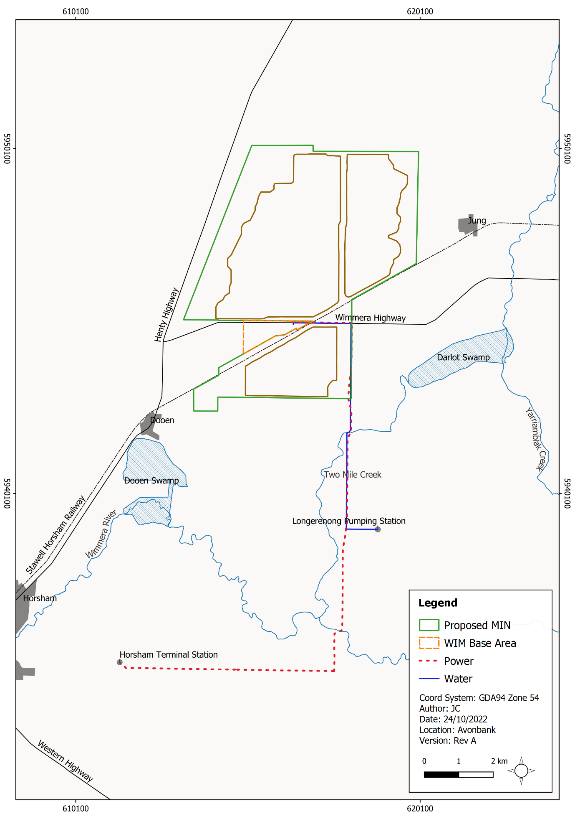
Figure 8-1: Development extent
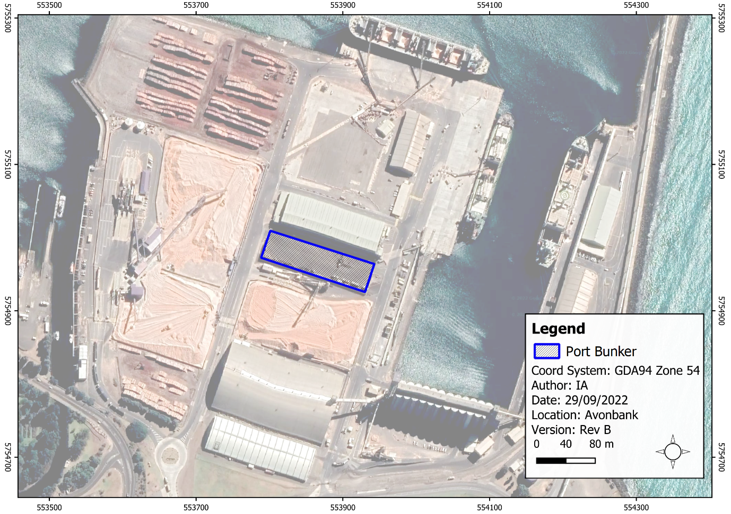
Figure 8-2: Port storage shed and bunker

Operational Context
The proposed development extent at Avonbank will total 3,546 ha comprising mining and related activities within the proposed mining licence (3,426 ha), processing within the WBA (90 ha), and a minor utilities corridor to the WBA for power and water which will extend 14 km (~30 ha). Facilities at the Port will include a storage shed and loading facilities leased from the Port of Portland Pty Ltd (PoPL). At the Port, Heavy Mineral Concentrate (HMC) will be off-loaded directly into a purpose-built fully enclosed storage shed, with a maximum approximate storage capacity of 70,000 tonnes (t).
The scope of work to be authorised under the proposed mining licence and associated work plan will include all exploration, mining, primary processing and works incidental to mining within an area covered by the mining licence to be granted under the Mineral Resources Sustainable Development Act 1990 (MRSD Act).
Key works and infrastructure considered to be within the scope of the mining licence and mining work plan include:
- mining of the mineral sands ore body;
- primary processing of the ore at the mining unit plant and screen/trommel; and
- all work incidental to mining and primary processing.
As described in Chapter 2 (Project Description), preparation for the starter pit will be undertaken in year 1, followed by progressive mining in the southern areas of the mine footprint in year 2 (Block A). Mining operations will move to Block B north of the Wimmera Highway in year 7 (refer Figure 8-3).
In years 2 and 7, overburden will be stockpiled to create a starter pit with sufficient room for the progressive placement of tails and overburden. Typically, overburden will be used to progressively backfill the mine void, along with tailings from the Wet Concentrator Plant (WCP).
Sand tailings will be returned to the mining void via a pipeline from the WCP. Once the tailings are dry, such that they are safe, stable and have sufficient strength to support machinery movement, overburden will be placed. Subsoil and topsoil will then be placed to a total depth of around 1 m.
Pipework associated with ore slurry, process water, tailings slurry, tailings return water, flocculant, and freshwater will pass under the Stawell-Horsham Railway between the WBA and mining void for Block A (refer Chapter 2, Figure 2-9).
It is expected that rehabilitation will be completed within 4 years after initial topsoil disturbance in each mining cell. At any given time over the life of mine, the extent of Project disturbance will be less than 400 ha.
Works associated with secondary processing within the WBA are situated outside the proposed mining licence, within the Special Use Zone established over the Wimmera Freight Intermodal Terminal (WIFT) Precinct for industrial purposes, including the processing, storage and handling of mineral sands. Secondary processing works within the WBA include:
- secondary processing to concentrate mineral sands; and
- all incidental works associated with secondary processing and the management of HMC product within the WBA area.
The WBA will be centrally located within the development extent for the life of the Project (refer Figure 8-1). The WCP will receive the slurried ore from the mining unit plant and will separate the valuable heavy minerals from the gangue minerals, which are relatively fine materials that are of no commercial value and will be returned to the mine void.
The outputs of this stage will be the final HMC product and tailings stream, comprising fines and sand tailings. Pipework associated with ore slurry, process water, tailings slurry, tailings return water, flocculant, and freshwater will pass under the Wimmera Highway between the WBA and mining void for Block B, C, D (refer Chapter 2, Figures 2-9, 2-10 and 2-11).
Minor utilities including power and water infrastructure from the respective terminal stations to the WBA will be located within areas of road reserve and private properties. The infrastructure will extend across areas within and outside the mining licence and will terminate at the WBA (refer Figure 8-1).
The infrastructure to the WBA will include:
- Underground pipeline (diameter 375 mm) from the Longerenong Pump station to the WBA.
- 66 kV Powerline from the Horsham Terminal Station (HOTS) to the WBA.
The water pipeline will be placed underground and may require disturbance of up to 25 m width along its length. The powerline is an upgrade of existing infrastructure that will require some underground work along Horsham-Lubeck Road and Wimmera Highway (refer Figure 8-4). The total disturbance associated with the powerline and water pipeline is expected to be up to 30 ha. The upgrade of the north–south section between Horsham-Lubeck Road and Wimmera Highway requires only minor routine pole top maintenance with no material ground disturbing works planned.
Facilities at the Port will be under a lease agreement with the Port of Portland. The works that will be undertaken at this location include.
- Unloading HMC from the haulage truck directly into the storage shed.
- Storage of HMC in a purpose built shed (6,900 m²).
- Loading product onto the freight carrier via a closed conveyor system (directly from the shed)
Further detail regarding the works to be undertaken at the Port are described in Chapter 2.
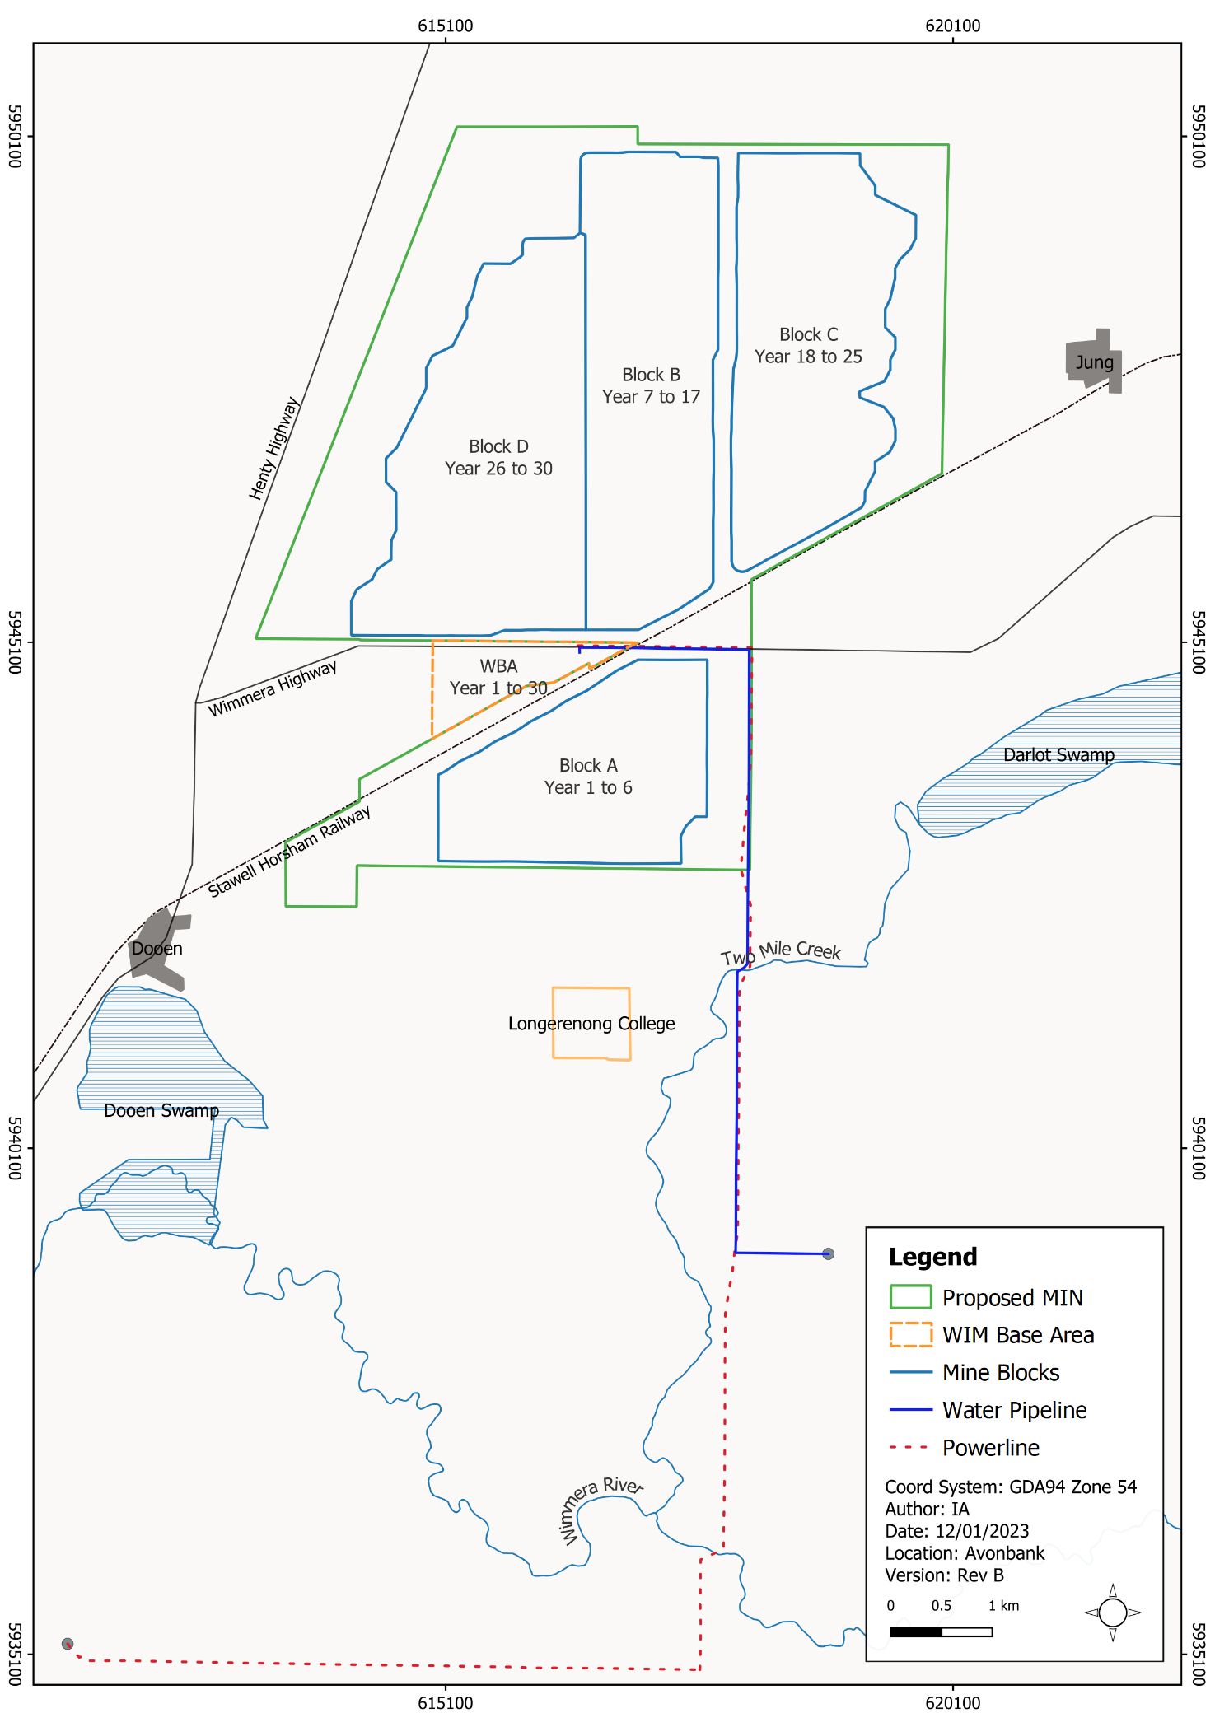
Figure 8-3: Mining blocks and development extent
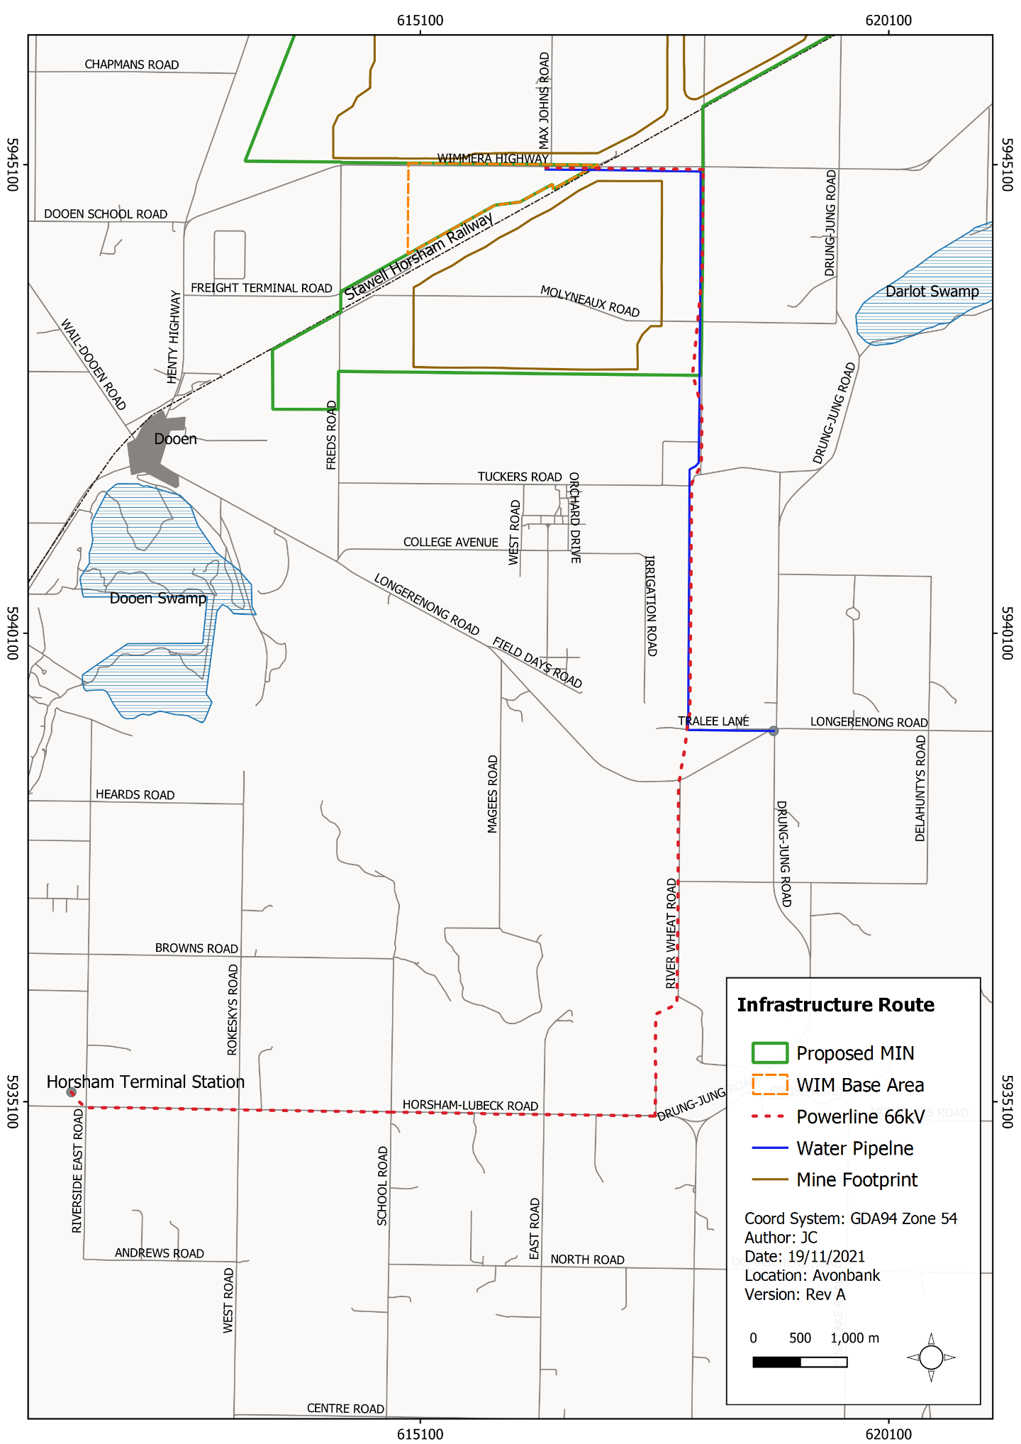
Figure 8-4: Minor utilities to the WBA

Existing Conditions

Horsham Planning Scheme
The development extent is located within the Horsham Rural City Council municipality, within which the Horsham Planning Scheme (HPS) applies. The HPS provides a framework for decisions regarding the use and development of land and applies zones, overlays and provisions relevant to the implementation of the Municipal Planning Strategy (MPS).
The MPS is intended to be a succinct expression of the overarching strategic policy direction for the HPS. Relevant to this Project, it states that the strategic direction for earth and energy resources is to ‘Encourage the use and development of land in areas of abundant mineral sand deposits for the earth and energy resources industry and associated activity’.
The MPS acknowledges that WIFT Precinct will facilitate a range of businesses and jobs for the municipality and wider region. Council’s strategic directions as outlined in the MPS for industry are to:
- Support industrial development in industrial areas.
- Avoid encroachment of sensitive land uses near land identified for industrial development.
- Provide for the staged development of the WIFT Precinct as a major intermodal freight and logistics hub for the Wimmera-Mallee region.
Further detail on the Municipal Planning Strategy is provided in Appendix B, Section 5.

Planning scheme zones
The planning scheme defines zones that are intended to meet the strategic direction of the Planning Policy Framework (PPF) and MPS. Each zone specifies the particular purpose for areas of land and details the relevant controls relating to buildings, works and subdivisions for each zone. Zones within the HPS that are intercepted by work areas associated with the development extent are described below in Table 8-1 and shown in Figure 8-5 and Figure 8-6.
Table 8-1: Planning scheme zones
Code | Land Zones and Key Purpose | Work Area
FZ | Farming Zone: To provide for the use of land for agriculture. To encourage the retention of productive agricultural land. | Mining licence, WIM Base Area, Minor utilities corridor (power/water)
SUZ9 | Special Use Zone – Schedule 9: Referred to as the Wimmera Intermodal Freight Terminal (WIFT) Precinct has been established for industrial purposes, including the processing, storage and handling of mineral sands. | WIM Base Area
SUZ3 | Special Use Zone – Schedule 3: To provide for the development of the Dooen Freight Hub as a key facility for the Wimmera region for the interchange and distribution of goods. | Mining licence
TRZ2 | Transport Zone 2 – Principal Road Network: To provide for an integrated and sustainable transport system. | Mining licence, WIM Base Area, Minor utilities corridor (power/water)
TRZ1 | Transport Zone 1 – State transport: Infrastructure: To provide for an integrated and sustainable transport system. | Mining licence, Minor utilities corridor (water),
PUZ2 | Public Use Zone – Education: To recognise public land use for public utility and community services and facilities, particularly education. | Minor utilities corridor (water)
PUZ1 | Public Use Zone - Service and utility: To recognise land use for public utility and community services and facilities and to provide for associated uses. | Minor utilities corridor (power)
PCRZ | Public Conservation and Resource Zone: To protect and conserve the natural environment and natural processes. | Minor utilities corridor (powerline pole top works – no material ground disturbance)
PPRZ | Public Park and Recreation Zone: To recognise areas for public recreation and open space. | Minor utilities corridor (powerline pole top works – no material ground disturbance)
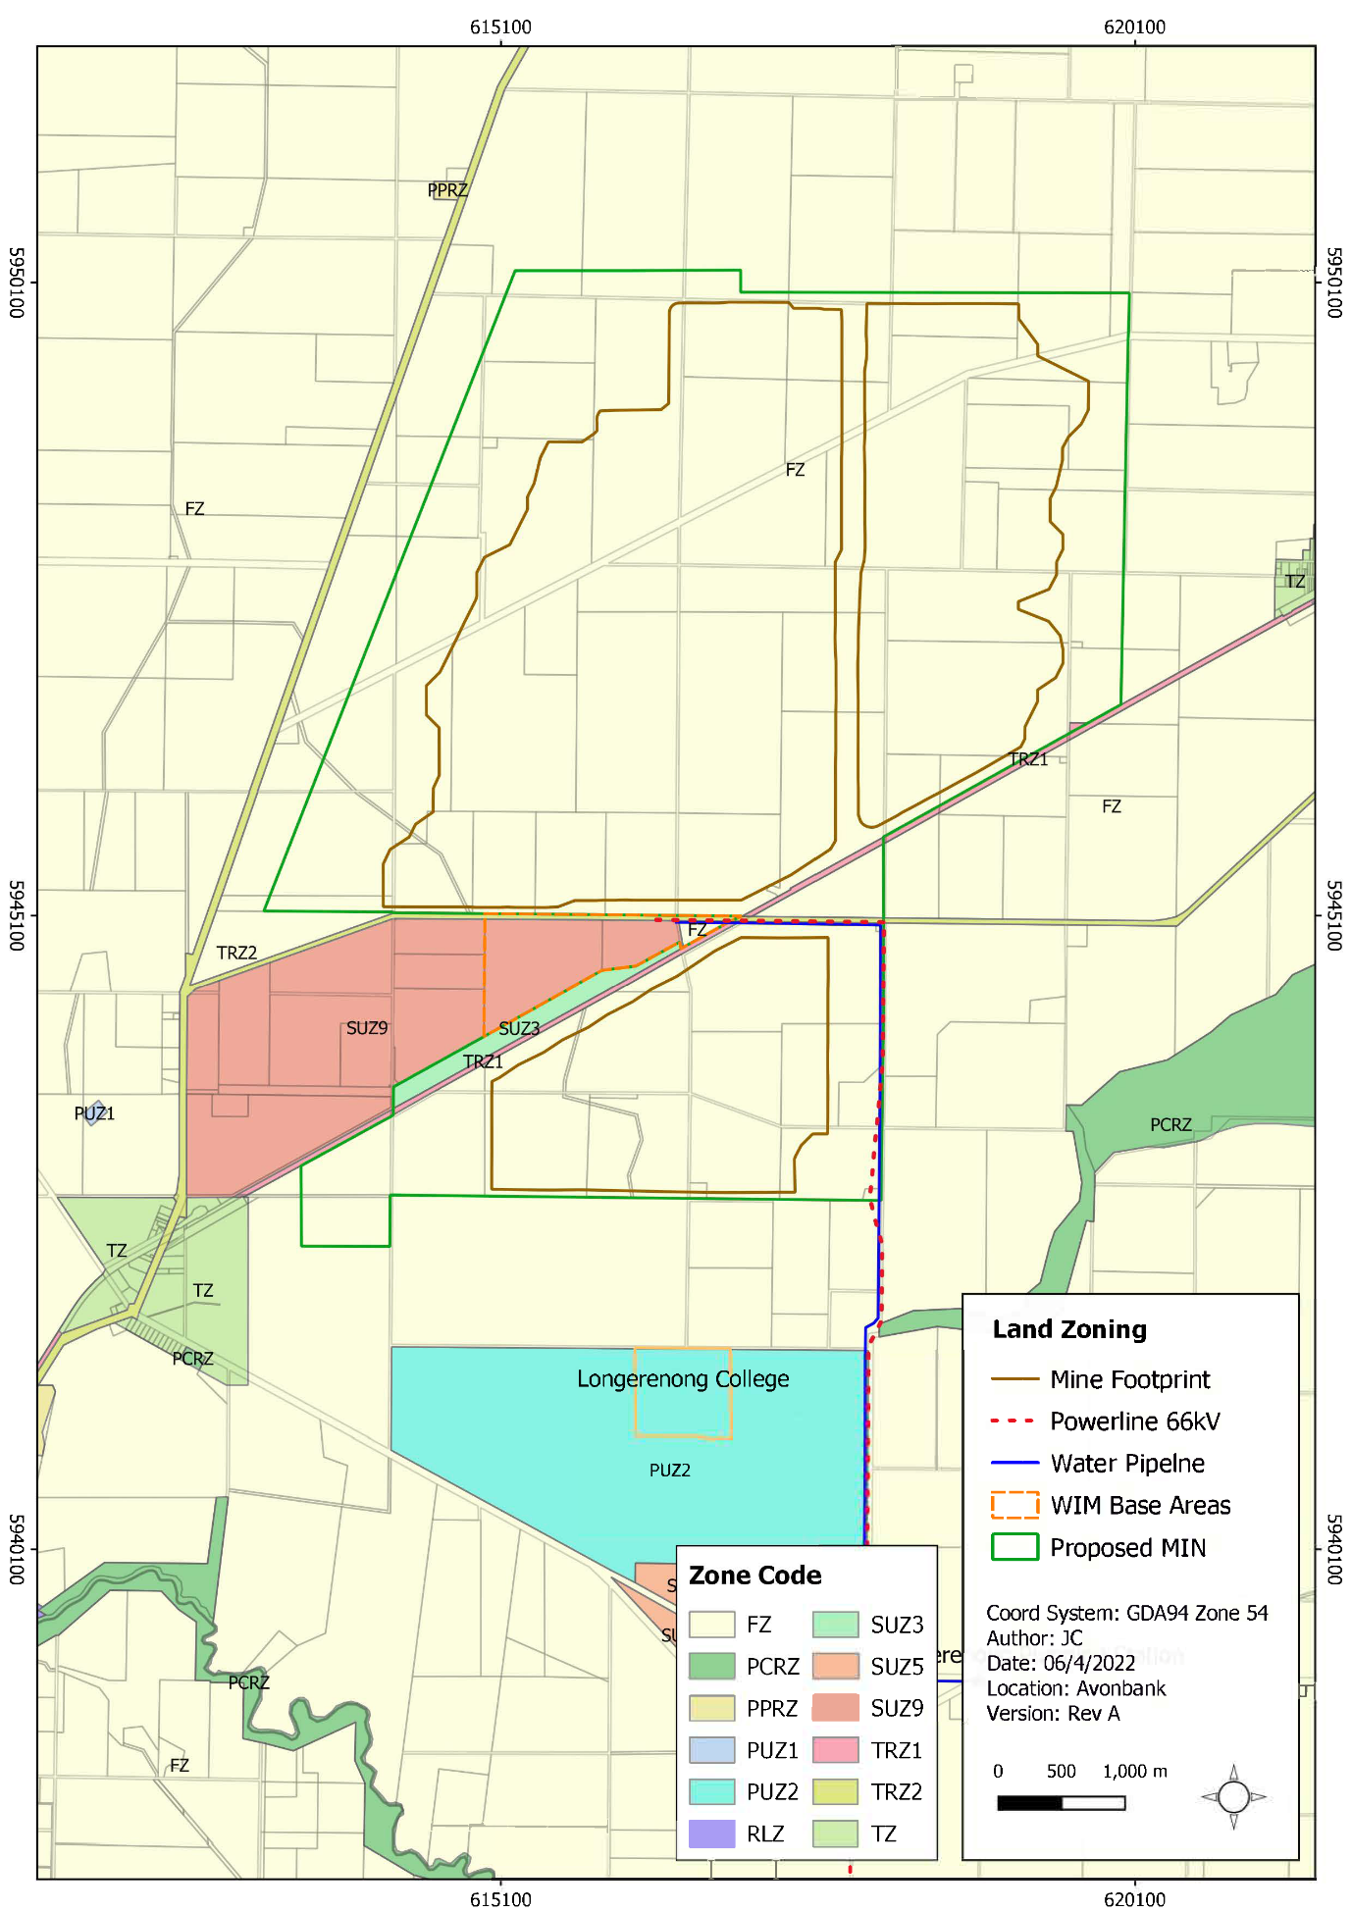
Figure 8-5: Existing planning scheme zones (north)
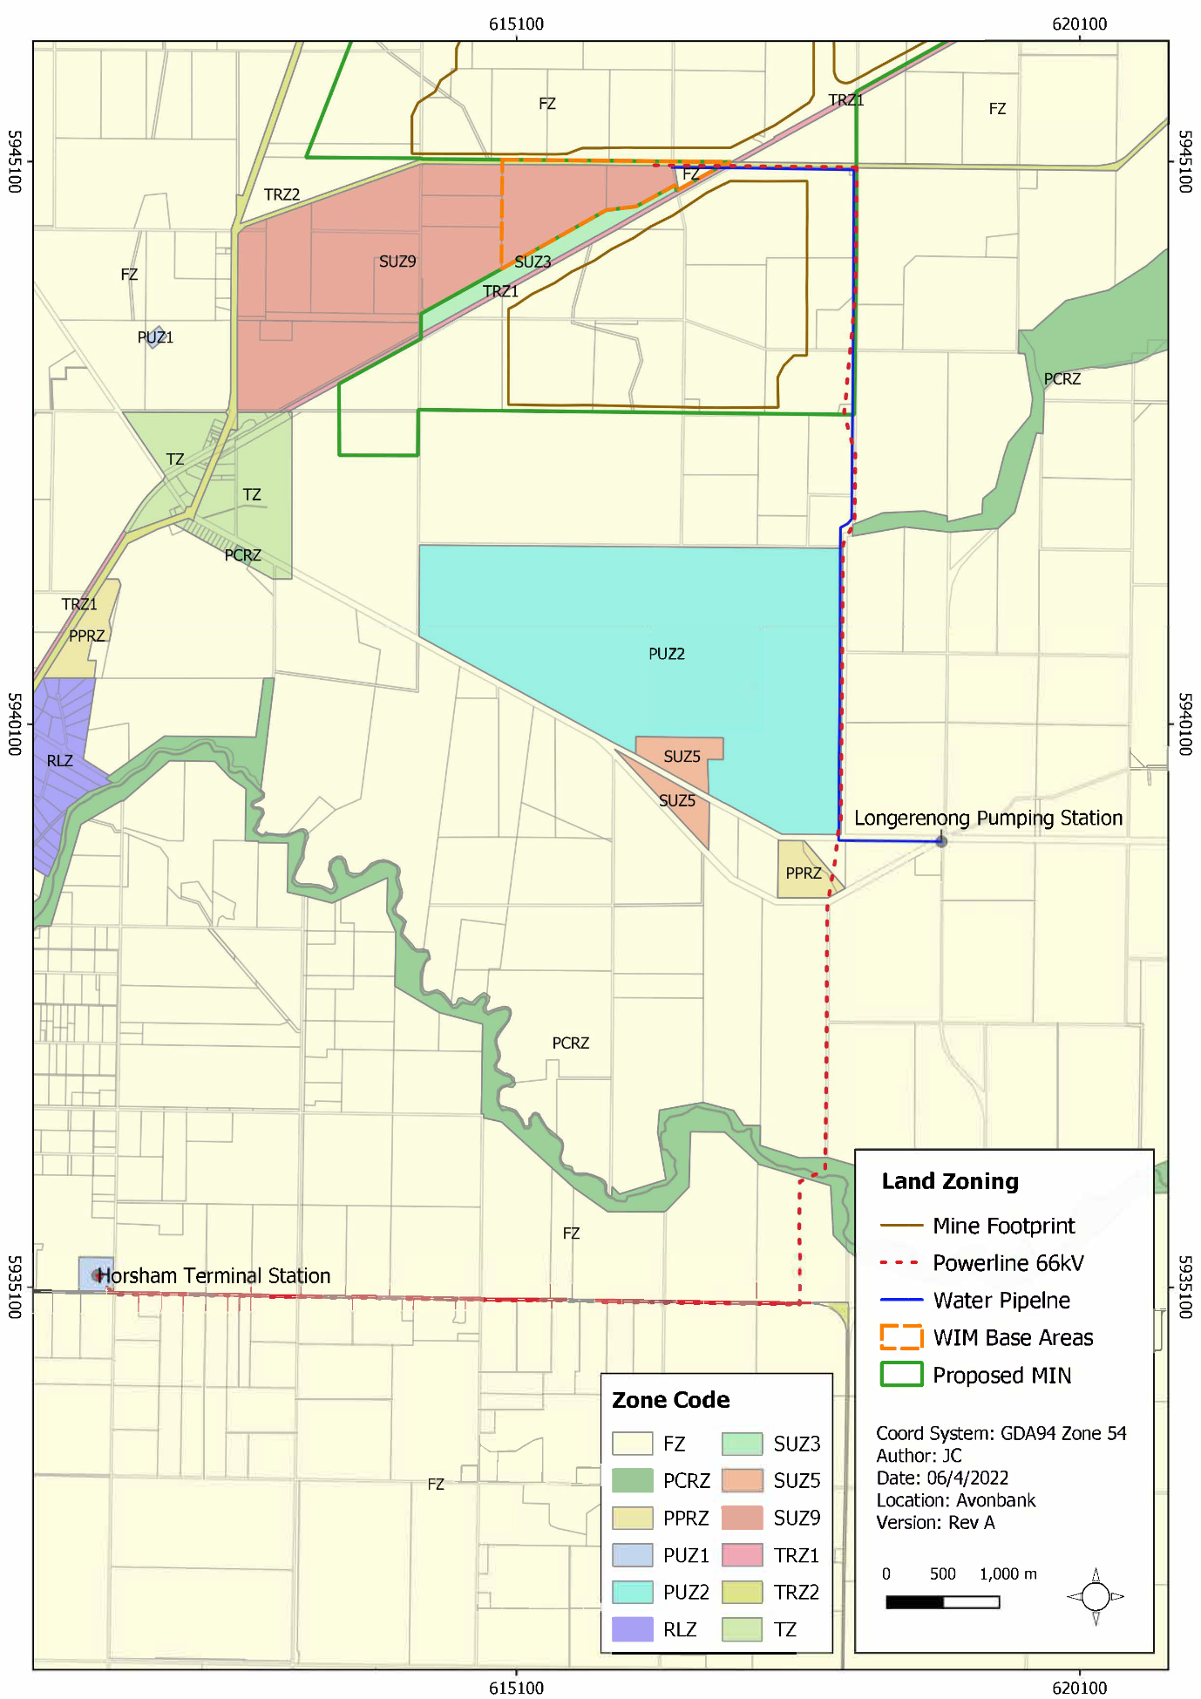
Figure 8-6: Existing planning scheme zones (south)

Planning scheme overlays
Table 8-2: Planning scheme overlays
A particular area of land can have overlay requirements in addition to the zone requirements. Generally, overlays apply to a single issue or a related set of issues (such as heritage, environmental concern, or flooding). Where more than one issue applies to land, multiple overlays can be applied. The relevant planning overlays that are intercepted by work areas associated with the development extent are listed below in Table 8-2 and shown in Figure 8-7.
Code | Overlays | Work Area
PAO2 | Public Acquisition Overlay 2: Land that is proposed to be acquired for a public purpose, including land to be acquired by GWMWater for use as a pumping station and water storage sites for the Wimmera Mallee Pipeline System. | WIM Base Area, Minor utilities (water)
LSIO | Land Subject to Inundation Overlay: To identify flood prone land in a riverine or coastal area affected by the 1 in 100 (1% Annual Exceedance Probability) year flood or any other area determined by the floodplain management authority. | Minor utilities (power, water)
ESO7 | Environmental Significance Overlay – Schedule 7: To protect the long-term development and operation of the WIFT Precinct for freight, logistics, industrial, manufacturing, and other commercial uses from the encroachment of sensitive uses, specifically dwellings. | Mining licence, WIM Base Area, Minor utilities (power, water)
DDO11 | Design and Development Overlay – Schedule 11: To achieve an attractive and integrated development within the WIFT Precinct that establishes a cohesive built form along key routes with a strong emphasis on consistent and quality landscaping and setbacks. | WIM Base Area, Minor utilities (power, water)
DPO9 | Development Plan Overlay – Schedule 9: To develop the WIFT Precinct having regard to six sub-precincts, including sub-precinct 2, which has uses associated with mineral sands operations. | WIM Base Area, Minor utilities (power, water)
BMO | Bushfire Management Overlay: To ensure that the development of land prioritises the protection of human life and strengthens community resilience to bushfires. | Minor utilities corridor (powerline pole top works – no material ground disturbance)
ESO3 | Environmental Significance Overlay: To identify areas where the development of land may be affected by environmental constraints. High-quality natural or revegetated stream frontages are important in maintaining clean water, soil stability and diversity of flora and fauna. | Minor utilities corridor (powerline pole top works – no material ground disturbance)

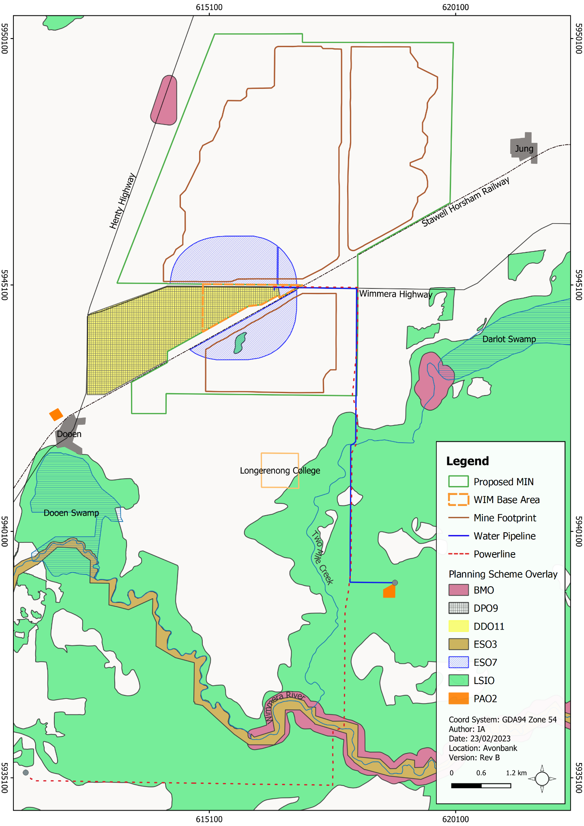
Figure 8-7: Existing planning scheme overlays

Planning controls within the development extent
This Section describes the likely planning approvals required under the HPS for the Avonbank development extent.
Mining (Mining licence)
Works and land use associated with mining conducted within the proposed mining licence will be exempt from all planning approval triggers, if the EES has been assessed by the Minister for Planning. Offsets for the removal of vegetation will be required as a condition of the mining licence.
Secondary Processing (WBA)
Works and land use associated with the secondary processing activities within the WBA are anticipated to require planning approvals. It is intended that a Specific Control Overlay (SCO) be applied by way of a planning scheme amendment to cover all activities and infrastructure within the WBA area. The SCO will cover the same extent as the WBA (refer Figure 8-3).
The SCO would exempt Project infrastructure from all planning permit triggers and authorise the development and use of WBA land in accordance with the specific controls contained in the incorporated document associated with the SCO.
It is proposed that the incorporated document include conditions that require the preparation of various management plans to the satisfaction of the responsible authority. The draft incorporated document included as Attachment 2, sets out the framework for each management plan that must be developed prior to the commencement of works.
Table 8-3 sets out the management plans listed in the draft incorporated document. These have been developed to ensure the key risks and impacts associated with the WBA can be managed appropriately in line with the commitments in this EES and objectives in the PPF. Further detail is provided in Attachment 2 (Draft Planning Scheme Amendment).
Table 8-3: Management Plans required in the Incorporated document
Management Plan | Key Elements of Each Plan  (refer Attachment 2 (Planning Amendment) for further detail)
Development Plan | Details the characteristics of existing land and describes the proposed infrastructure development and staging.
Construction Plan | Specifies details associated with the construction phase of the Project, including but not limited to hours of construction, parking and number of personnel. It also details various control measures for vehicle washdown, weed management and stormwater management.
Environmental Management Plan | Details measures to avoid and minimise environmental risks from construction and operations, so far as reasonably practicable. It includes requirements to undertake monitoring, conduct audits, and report to relevant stakeholders.
Noise and Vibration Management Plan | Details measures to avoid and minimise noise emissions during construction and operations, so far as reasonably practicable. It includes requirements to undertake monitoring and to address stakeholder complaints, incidents and non-conformities.
Native Vegetation Management Plan | Details requirements relating to the management and removal of native vegetation, including the requirement to obtain vegetation offsets.
Traffic Management Plan | Includes requirements for regular road inspection and maintenance programs to ensure roads remain fit for purpose.
Fire Management Plan | Includes requirements to control fuel loads, maintain a water supply for firefighting and consult with key stakeholders, including the Country Fire Authority.

Minor utilities corridor (power and water mains)
Works and land use associated with the minor utility installations, including water mains and powerlines less than 220 kV, are exempt from requiring planning approvals across all planning zones except for Public Conservation and Recreation Zone (PCRZ) associated with the Wimmera River.
A planning permit is generally required for buildings and works associated with minor utility installations in the PCRZ. However, a permit is not required for maintenance works where no new buildings and works are proposed. As described in Section 8.3, the proposed works are expected to involve routine minor pole top maintenance, and as such, no planning permit will be required.
A permit to remove vegetation and provide offsets may be required within the minor utilities corridor. As described in Chapter 21, it is likely that an area of around 1.9 ha of vegetation will be removed to facilitate the minor utility installation. If the vegetation cannot be avoided, a planning permit to remove vegetation may be required. In some instances, a service provider may have exemptions from this requirement for the maintenance and construction of a minor utility.

Glenelg Planning Scheme
A product storage shed will be established at the Port of Portland, which is located within the Glenelg Shire Council. The Glenelg Planning Scheme (GPS) describes the planning controls associated with the Port.
The Projects activities will be undertaken in an area leased from the PoPL, that is situated within a zone that provides for uses that derive direct benefit from co-establishing with a commercial trading port.
The proposed works and buildings, as well as land use, are consistent with the planning controls. It is not expected that a planning permit will be required for the planned works.
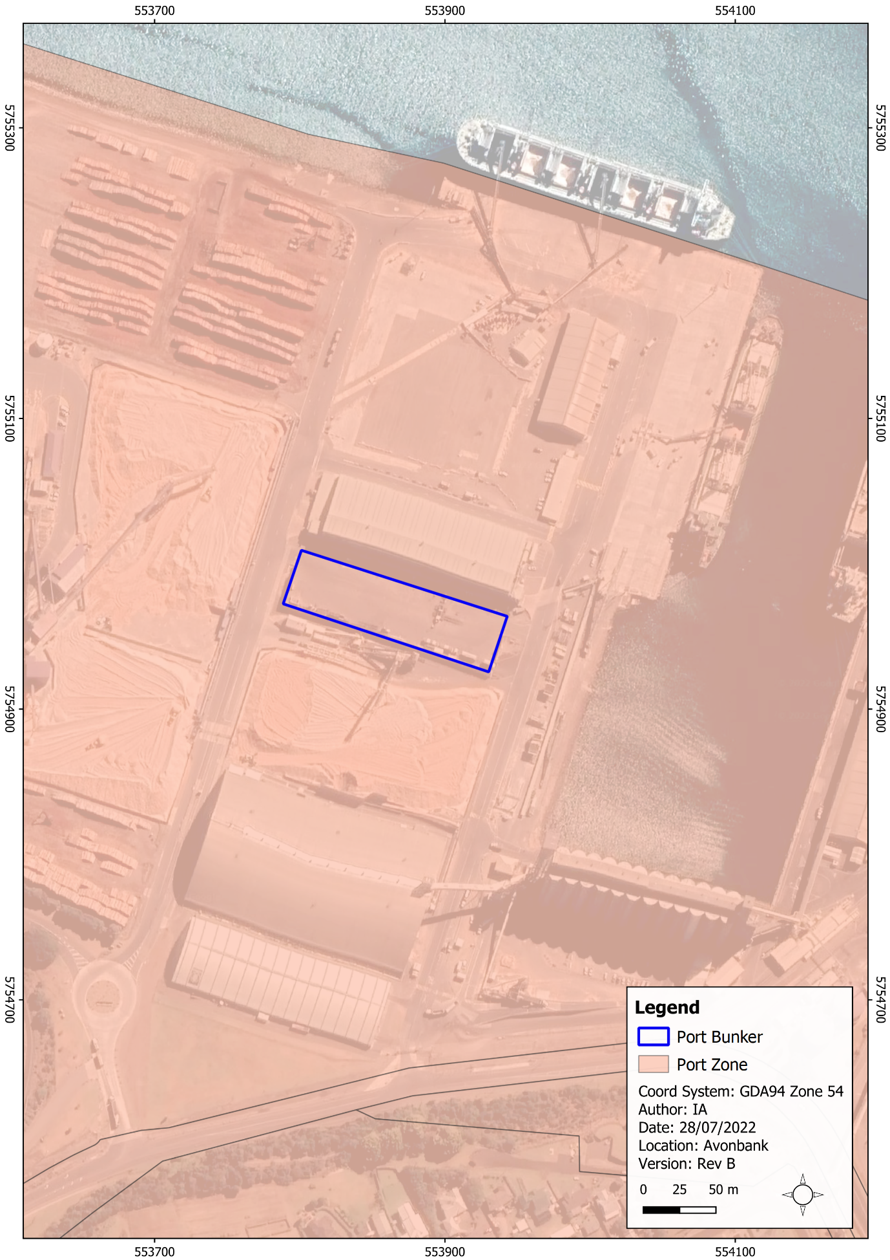
Figure 8-8: Existing planning scheme zones

Land Use Setting
The key existing land uses within the Avonbank development extent are listed in Table 8-4 and associated figures. The predominant land use is broadacre farming, intersected by public minor roads and the Wimmera Highway. The Stawell-Horsham Railway passes through the proposed mining licence area. The minor utilities corridor passes through areas used predominantly for broadacre farming and some road reserves.
Table 8-4: Land use setting
Work Area | Current Land Uses
Mining licence area | - 25 landholdings primarily used for broadacre agriculture (excluding Crown land and managed public land) (Figure 8-9).  - Four residential dwellings (Figure 8-15).  - 11 minor roads (Molyneaux Road, Max Johns Road, Freds Road, Jung West Road, Drung-Jung Road, Greenhills Road; Whytes Road, Johns Road, Tuckers Road, Walcotts Road, Drovers Road) (Figure 8-10).  - Wimmera Highway (Figure 8-3).  - Stawell-Horsham Railway (Figure 8-3).
WIM Base Area | - Two landholdings primarily used for broadacre agriculture (exclude public land) (Figure 8-9).  - Wimmera Highway (Figure 8-3).
Minor utilities (power) | - 28 land parcels predominantly used for broadacre agriculture (excludes minor pole top works) Figure 8-11.  - Horsham-Lubeck Road, Wimmera Highway (Figure 8-4).  - Horsham terminal station (Figure 8-6).
Minor utilities (water) | - 12 land parcels predominantly used for broadacre agriculture (Figure 8-11).  - Tralee Lane; Tuckers Road, Wimmera Highway (Figure 8-4).  - Longerenong pumping station (Figure 8-6).
In the vicinity of the development extent, within around 2 km, the predominant land use is broadacre cropping. There are a variety of land uses associated with the townships of Dooen and Jung, including residential properties and businesses. The Longerenong College and accommodation buildings are situated around 2 km south of the proposed mining licence area. There is a public conservation reserve associated with Darlot swamp, 1.5 km south-east of the mining licence (refer Figure 8-1 and Figure 8-6).
Stakeholders have not raised any planned land use changes within the immediate vicinity of the development extent. It is expected that over time new businesses will be attracted to the WIFT Precinct, in line with the strategic direction of the MPS.
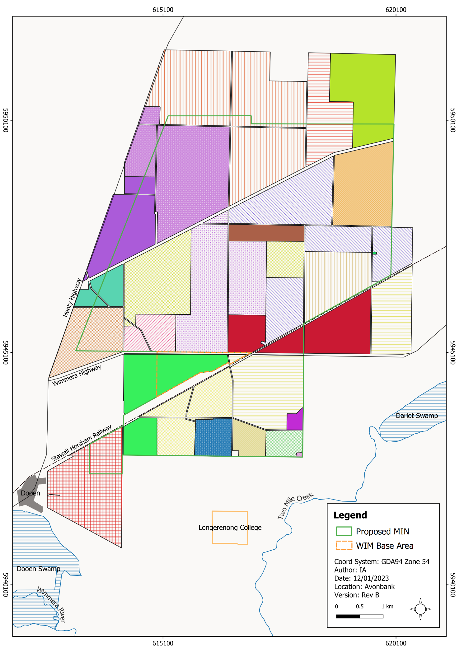
Figure 8-9: Landholdings within the mining licence and WBA (landholdings represented by a different colour)
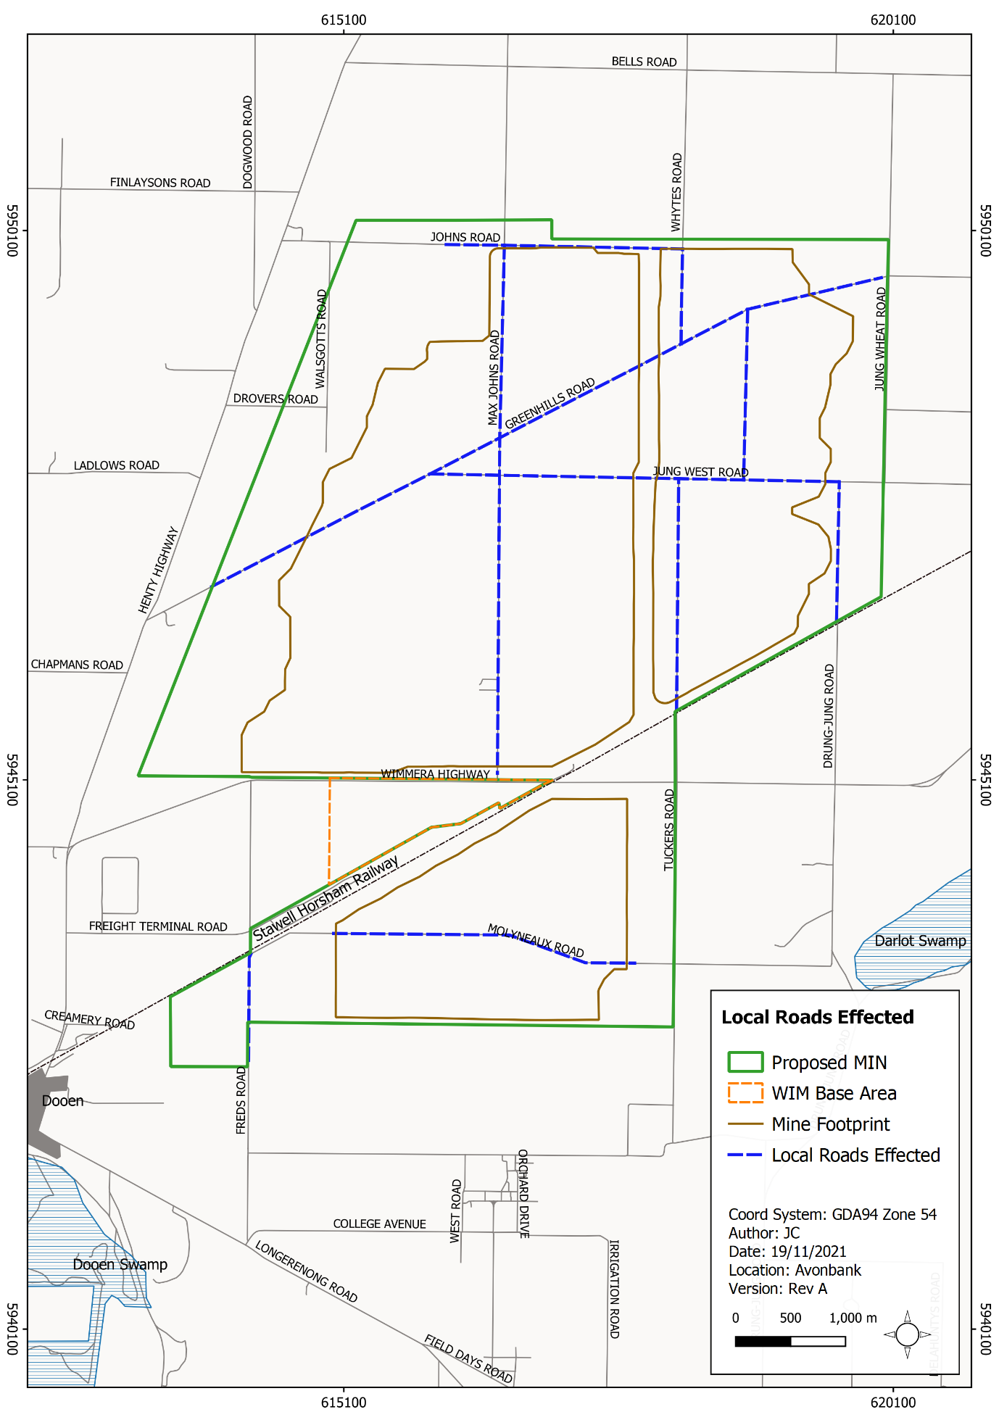
Figure 8-10: Local minor roads effected by mining
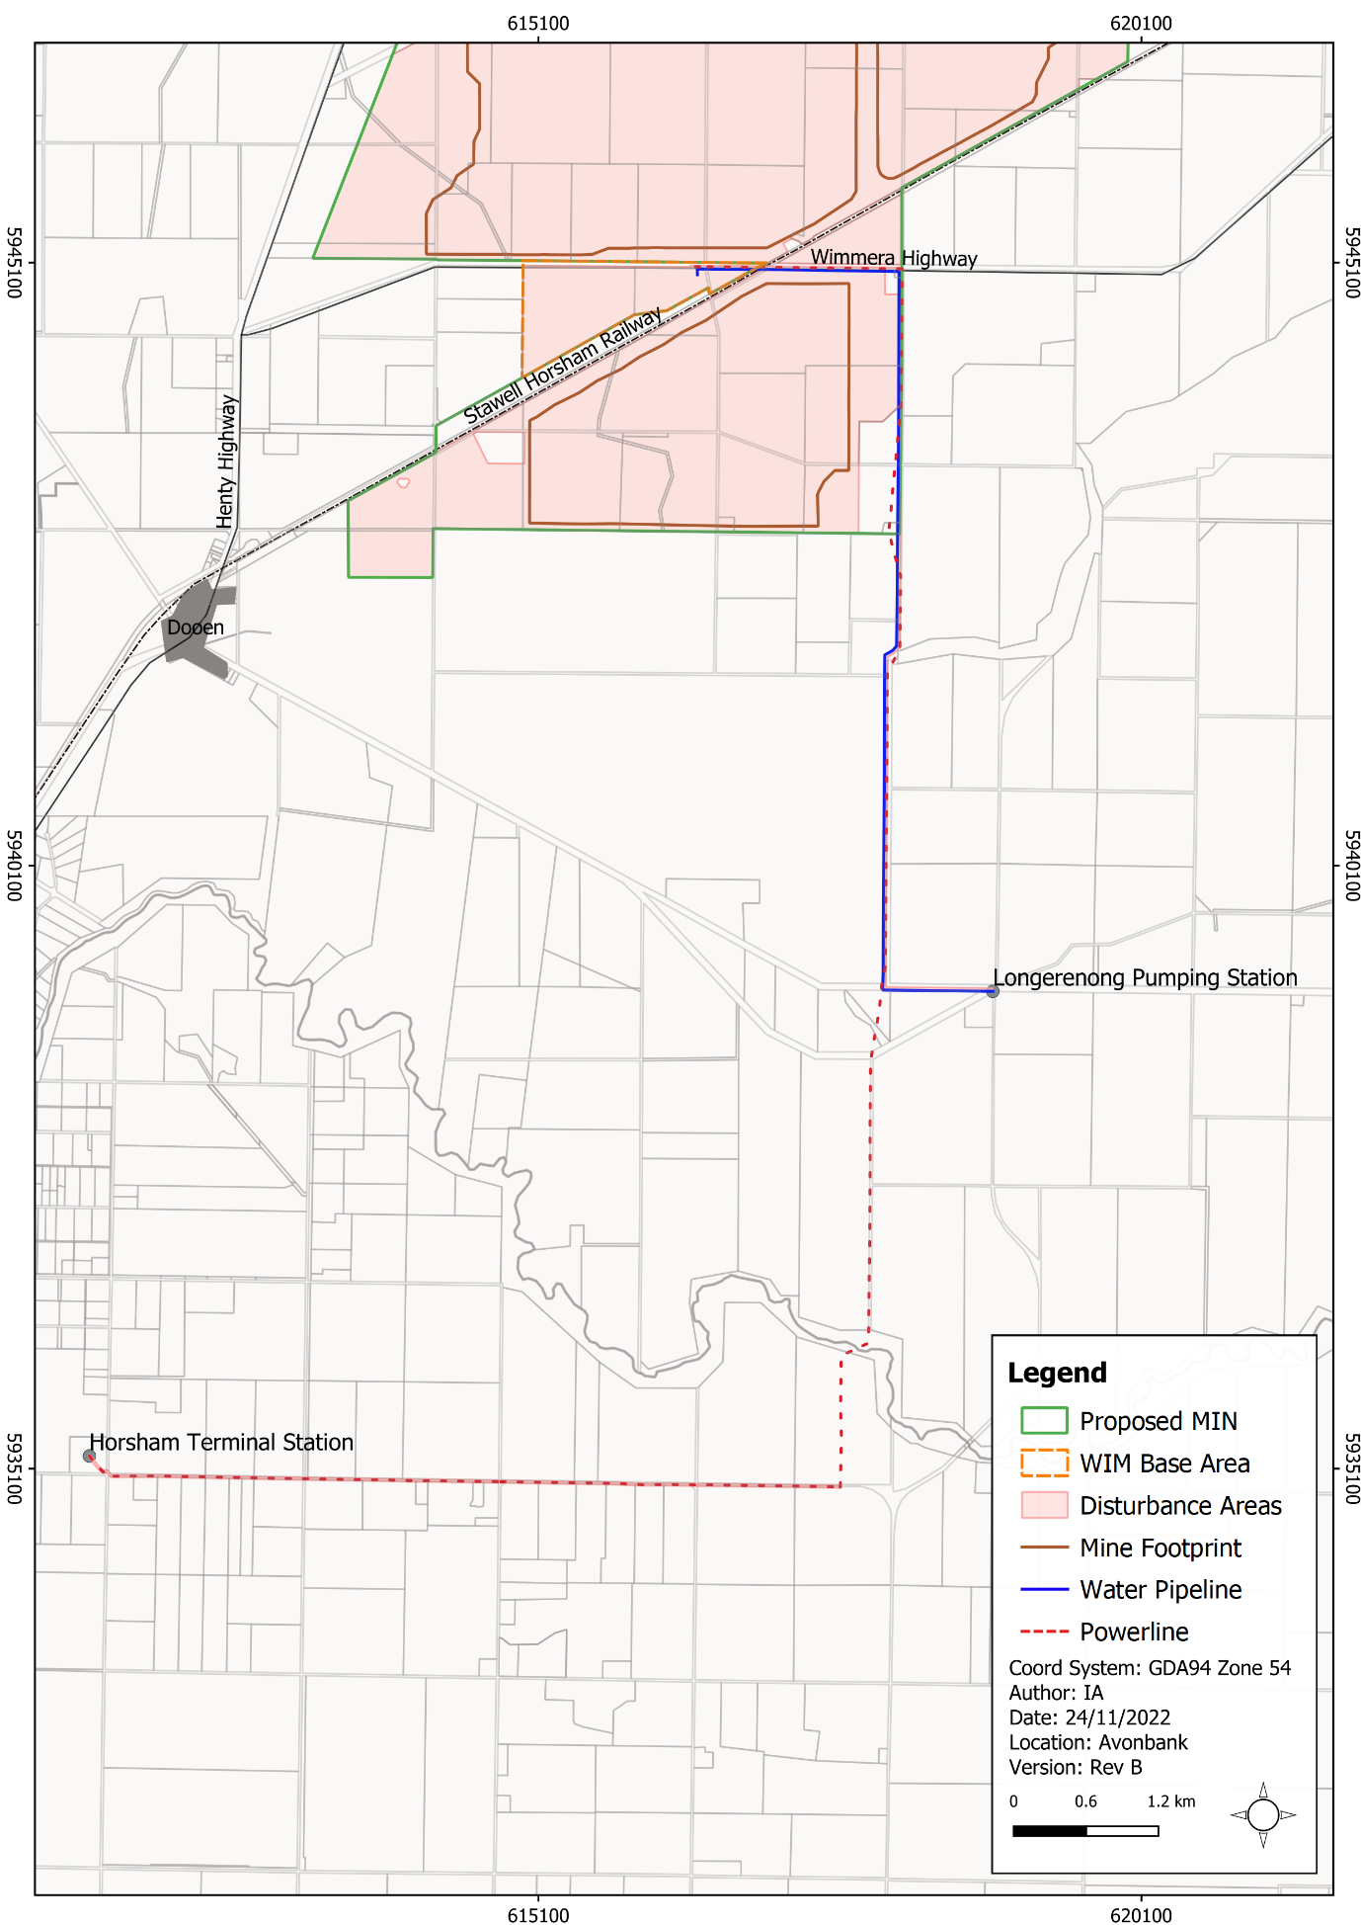
Figure 8-11: Powerline and water pipeline works

Crown Land Tenure and Managed Public Land
Crown land tenure and managed public lands that overlap with the development extent are listed in Table 8-5 (data source GeoVic 2022). As shown in Figure 8-12 and Figure 8-13, most of the Crown land tenure and managed public land is within the proposed mining licence. The WBA and ground disturbing works associated with the minor utilities intercept various government road reserves. There is no Crown land associated with the facilities at the Port of Portland.
Table 8-5: Crown land tenure within the mining licence and WIM Base area
Crown land | Description
Crown land (PFI: 102280932) | Grazing licence within the proposed mining licence.
Crown land (PFI: 102166291, 102166294, 102166332) | Unused road licence (reserve) within the proposed mining licence.
Crown land Government Roads | Throughout the proposed mining licence, WBA and minor utilities corridor.
Crown land Rail (PFI: 52577578, 53083246, 53083258, 53083271) | Stawell-Horsham Railway within the proposed mining licence.  (Note: 53083258 is adjacent the proposed mining licence.)
Managed public land | Stawell-Horsham Railway and Crown land parcel within the proposed mining licence. (PFI: 102280932)

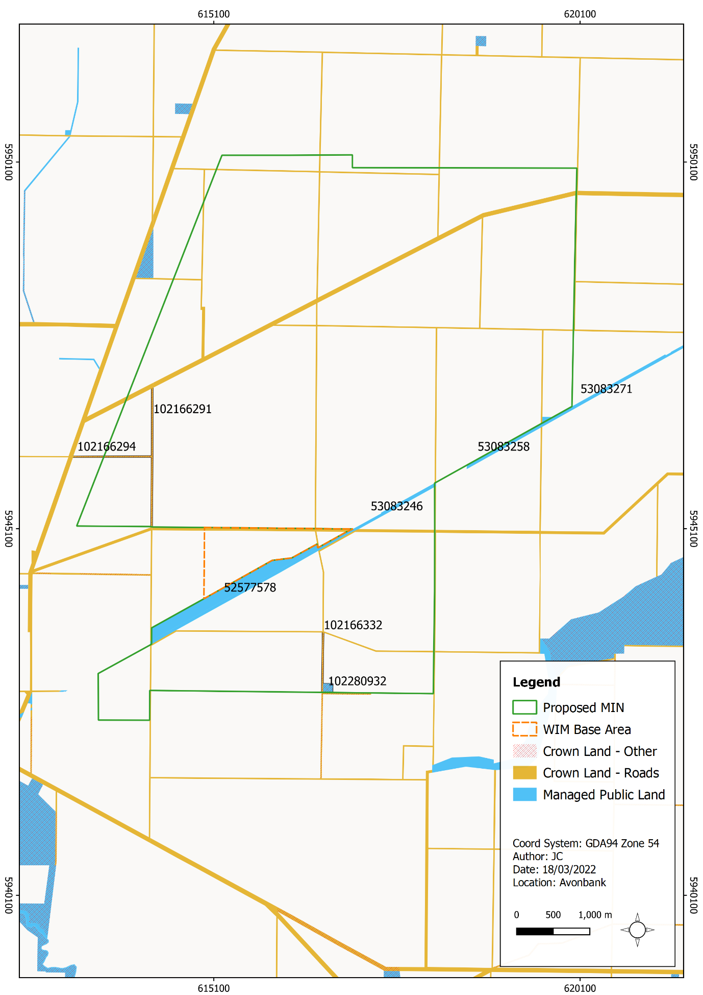
Figure 8-12: Crown land tenure and managed public land
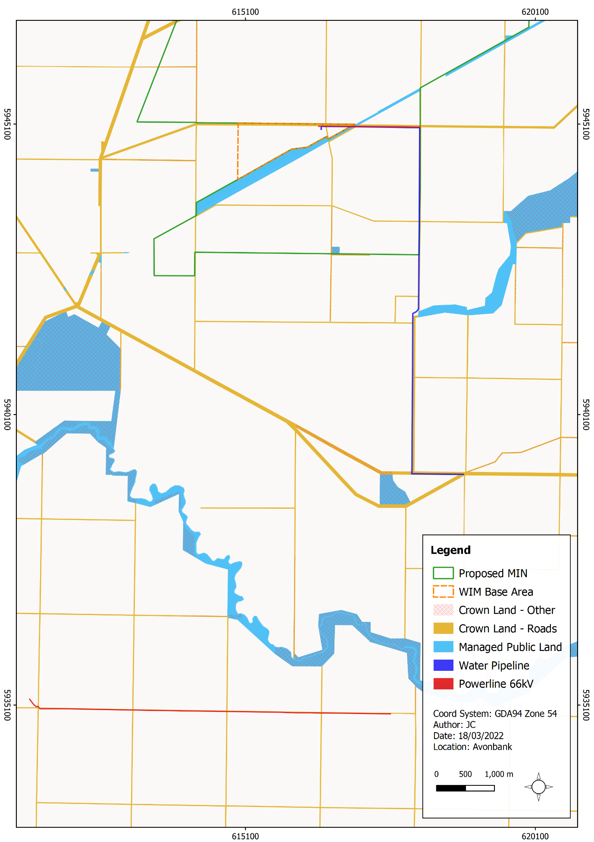
Figure 8-13: Crown land and ground disturbance works associated with minor utilities

Potential Impacts

Identified Potential Impacts
Potential impacts are identified in the LPIA with consideration to the proposed Project activities, identified sensitive receptors and relevant planning policies (refer Table 8-6).
Table 8-6: Potential impacts
Item | Potential Impacts | Phase
IP-01 | Permanent or temporary changes to land use resulting in the loss of an existing beneficial use within or adjacent the development extent. | C, O, D
IP-02 | Inconsistencies between the Project objectives and the Planning Policy Framework or Municipal Planning Strategy resulting in a misalignment with the overarching vision for the area. | C, O, D
IP-03 | Other commercial or industrial developments may be attracted to the area as an indirect effect of the Project, resulting in agglomeration impacts. | C, O, D

Sensitive Receptors
Table 8-7: Sensitive receptors
Potential sensitive receptors relevant to the LPIA are listed in Table 8-7. Sensitive receptors were considered to include the existing HPS zones and associated land use within the development extent and immediate surrounds. These were considered to include the worst-case plausible extent of potential impacts prior to undertaking the residual impact assessment, as further described in Section 8.7.

Receptor Type | Sensitive Receptors
Landholders | Landholdings and residential dwellings within the immediate vicinity of the proposed mining licence and WIM Base Area that may be subject to changes in land use (refer Figure 8-9 and Figure 8-15).
Transport (Minor roads) | Minor government roads within the proposed mining licence and WIM Base Area (refer Figure 8-11). No change in land use is planned for Wimmera Highway, Henty Highway or Stawell-Horsham Railway.
Crown land tenure | Crown land tenure parcels that may be subject to land use changes (refer Figure 8-12 and Figure 8-13).

Impact Characterisation
The residual impact assessment summarised in Section 8.7 considers impacts on the existing land use with consideration to the relevant planning scheme. The LPIA (Appendix B) describes the residual impacts in terms of the economic effects and alignment with the Planning Policy Framework and Municipal Planning Strategy. It considers the duration and spatial extent of the impacts associated with land use change.
Reference is made throughout this Chapter to other impact assessments that address matters relating to potential amenity impacts. The impact characterisation for these effects can be found in the associated Chapters including Air Quality (Chapter 13), Noise and Vibration (Chapter 12) and Traffic and Transport (Chapter 9).

Avoidance and Mitigation Measures
This Section outlines the measures identified to avoid and minimise residual impacts relating to land use and planning. Measures to mitigate amenity impacts, including air quality, noise emissions and traffic management, are dealt with in the broader EES and are not repeated in this Chapter.
It is noted that in line with the requirements of the proposed environmental management system (EMS) and relevant legislation, additional measures may be required during Project implementation to ensure risks and potential impacts have been minimised so far as reasonably practicable.

Avoidance

LP-01: WIM Base Area location
The WBA secondary processing facility is primarily situated within the Wimmera Intermodal Freight Terminal (WIFT) Precinct, which is a Special Use Zone (SUZ9) established for industrial purposes, including the processing, storage and handling of mineral sands. The placement of the secondary processing facility within the WIFT Precinct will avoid the loss of land parcels currently zoned for farming (FZ).

Minimisation

LP-02: Land Access Agreement or Land Purchase
Prior to the commencement of work on a mining licence, consent from the owners/occupiers of the land directly affected must be granted. This can be in the form of a written consent agreement or a registered compensation agreement. Such agreements are typically referred to as a Land Access and Compensation Agreement (LACA). Alternatively, land may be purchased prior to the commencement of works.
As described in the MRSD Act, the licensee and the owner/occupier of the land may enter into a written agreement regarding the amount or kind of compensation payable by the licensee for any loss or damage that has been or will be sustained as a direct, natural and reasonable consequence of the work plan. The agreement will typically include:
- a description of the licensee's proposed work, including the location and area;
- the anticipated date of commencement and anticipated duration of the proposed work;
- agreed points of entry onto and exit from the land;
- the number and type of vehicles, plant and equipment involved in the proposed work; and
- a description of the facilities the licensee will be provided on the land.
As described in the Work Plan Framework (Attachment 3), LACAs will be progressively sought or acquired over the life of the Project.
For access to land outside the mining licence (WBA or minor utilities corridor), the same process will be applied such that written agreements are entered into or the land acquired prior to works commencing.

Rehabilitation

LP-03: Rehabilitation Plan
A Rehabilitation Plan will be established for the Project that will address matters relating to progressive rehabilitation and closure. It will cover all work areas within the proposed mining licence and within the broader development extent and the Port of Portland.
The Rehabilitation Plan will include a schedule of progressive rehabilitation and will describe the strategy to establish a safe, stable, sustainable landform capable of supporting the proposed end land use. It is expected that land will be stabilised as soon as reasonably practicable after mining, typically within 4 years.
The Rehabilitation Plan will define the end land use with consideration to the views of the landholders and the broader community where appropriate.
A preliminary Rehabilitation Plan for the Project has been developed to meet the intent of the Scoping Requirements and is included with this EES as Attachment 3. This plan will be refined prior to commencement with consideration to the detailed operating plans, stakeholder and community feedback and the Minister’s assessment of the EES.

Residual Impacts
This Section describes the likely residual impacts with avoidance and mitigation measures in place. The residual impacts have been characterised as described in Section 8.5.3 and Chapter 6 (Impact Assessment Framework).

Loss of Existing Land Use
There is one potential impact (IP-01) listed in Section 8.5.1, which relates to the loss of existing land use due to the development of the Project. This Section describes the expected land use changes due to Project related activities and amenity effects.

Mining licence area
Within the proposed mining licence, the extent of Project disturbance will be less than 400 ha and will typically (on average) be less than 300 ha at any one point in time, as areas are progressively mined and rehabilitated. This will result in a change of land use from what is primarily broadacre farming to mining and ancillary uses. This will be a temporary land use change that is expected to extend up to 4 years within any one section of the mining footprint. Once rehabilitation is complete, the land will be returned to its pre-mining land use.
From an economic perspective, the loss of agricultural land during mining represents a fall in regional (Wimmera Southern Mallee region) gross revenue of $465,450 per annum inclusive of flow-on supply chain and consumption effects. The gross regional revenue from the Project is $335 million per annum, inclusive of flow-on supply chain and consumption expenditure. This represents a significant net positive regional economic effect.
There are currently 25 landholdings within the proposed mining licence which utilise the land for agricultural purposes and which may be affected by the Project. Some of these properties will be acquired over the course of the Project, and some will remain as private landholdings. For those properties that are not acquired, loss to individual landholders will be compensated through the establishment of LACAs, which must be in place prior to mining each landholding.
Of the landholdings described above, there are six that accommodate residential dwellings that will be affected by the Project. This includes one dwelling (R38) within the mining footprint that will likely be removed by mining, pending ongoing discussions with the landowner. Additionally, there will be one residential receptor (R89) within 250 m of the mining footprint and a further four (R6, R33, R34, R35) within 250 m of the disturbance footprint at times over the life of mine (refer Figure 8-15). All six landholders will be displaced for periods over the life of the Project due to their proximity to the operations. As described above, these dwellings will either be acquired or a LACA will be put in place. The social impacts associated with the displacement of residents are further described in Chapter 20 (Socioeconomics).
Aside from those properties that will be removed or vacated over the course of mining, all other receptors within the broader EES study area were assessed to experience negligible to minor amenity impacts over the course of the Project, and no change to land use was expected. Residual amenity impacts are described in Chapters 8 to 23 of this EES.
Various minor roads (Crown land) will be temporarily closed for periods due to Project activities as described in Chapter 9 (Traffic and Transport). Users of these roads will be diverted to existing roads, which will result in longer travel distances of up to 5 km. Once Project activities are complete, roads will be reinstated and reopened for use. The traffic impact assessment considered the impacts on road users to be minor.
There will be no loss of land use associated with Wimmera Highway, Stawell-Horsham Railway or the associated Public Managed Land.

WIM Base Area
The secondary processing facilities are situated within a Special Use Zone (SUZ9), which has been established for industrial purposes, including the processing, storage and handling of mineral sands. Within the WIFT Precinct (SUZ9), there are six sub-precincts, as shown in Figure 8-14.
The secondary processing infrastructure is situated primarily within Sub-precinct 2 of SUZ9, which has purposes associated with mineral sand mining operations, including the collection, storage and transfer of mineral sands and other earth resources that may require separation from food related industries. There are minor works (noise bunds) and screening trees anticipated in Sub-precinct 4, which also has purposes associated with mineral sands processing and storage handling.
The PLIA considers that provided accepted environmental and safety standards are maintained, the use of the WIFT Precinct for storage, secondary processing and distribution of processed mineral sands are consistent with the Sub-Precinct 2 and 4 purposes. Areas associated with Sub-precinct 3 and 5 within the WBA may be used for minor access tracks, tree screening, stormwater drainage and/or noise bunds as required.
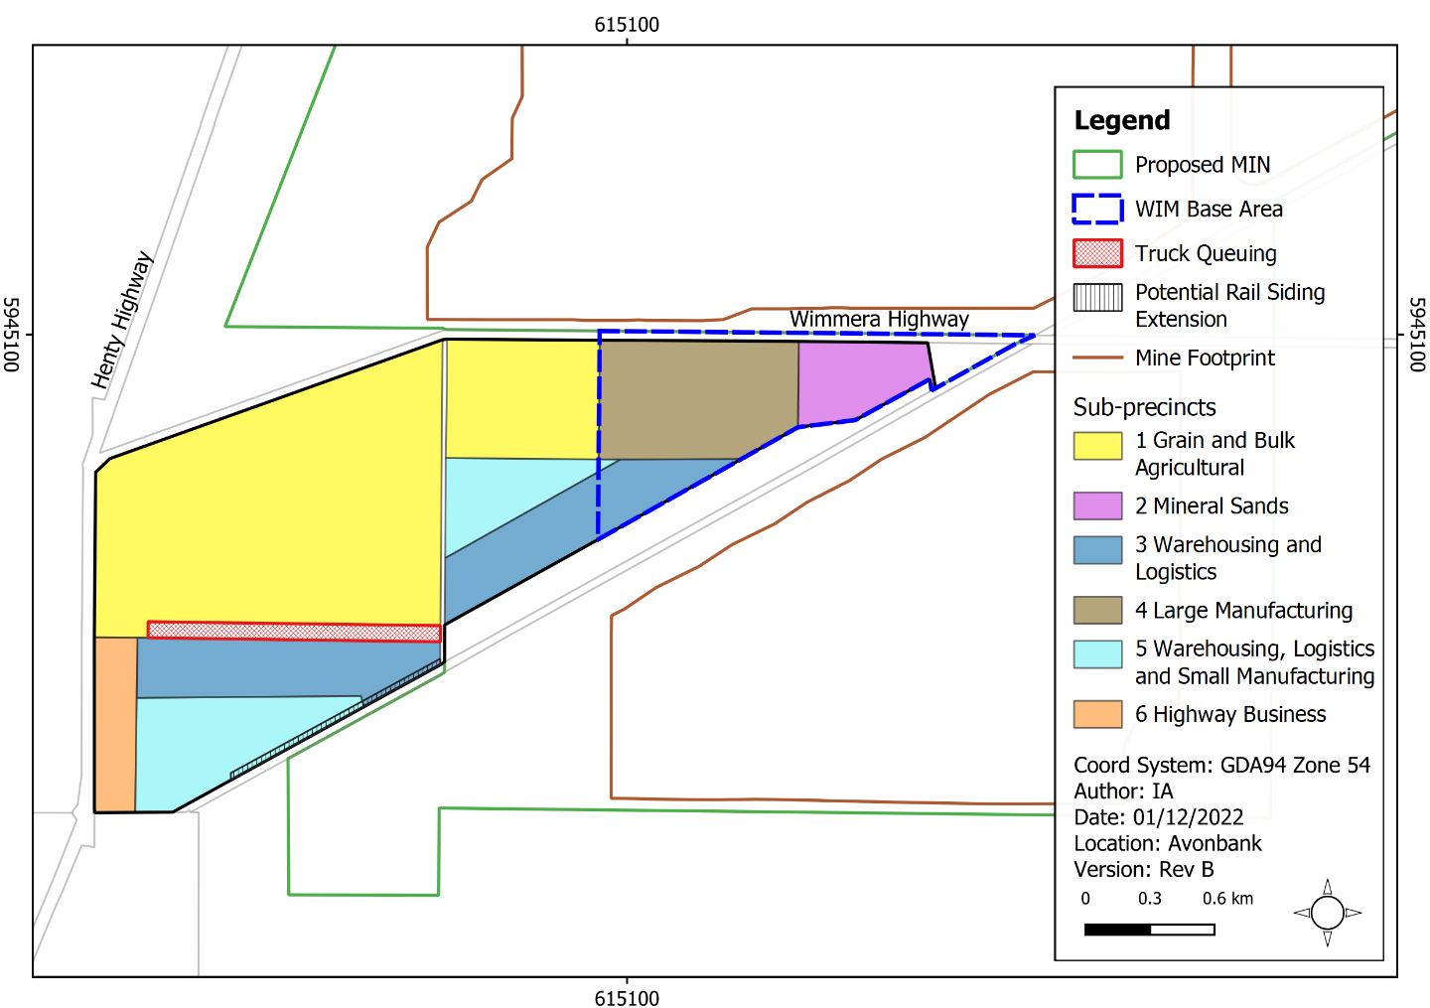
Figure 8-14: WIFT sub-precincts and WBA
There is a Development Plan Overlay (DP09) and Development and Design Overlay (DDO11) that extends across the WIFT Precinct area.
The Development Plan Overlay (DP09) requires that a Master Plan be developed for the WIFT Precinct as a part of the overarching development plan. A development plan for the area associated with the WBA has not yet been prepared.
The WBA infrastructure will occupy the eastern portion of the WIFT Precinct and its development is considered unlikely to prejudice the development of other land in the WIFT Precinct.
Other plans required under the Development Plan Overlay – Schedule 9 (DP09) will be addressed in so far as they are relevant to the Project in the incorporated document, as summarised in Table 8-8.
Table 8-8: Incorporated document Management Plans
Development Plan Overlay Control (DP09) | Related Management Plans in the Incorporated Document
Transport Management Plan | The Traffic Management Plan (TMP) will address matters relating to road maintenance, inspections, road rehabilitation and any details of road widening or amendments.
Urban Design and Landscape Master Plan | The Development Plan (DP) will address landscaping, setbacks, landscape design and other related matters.
Integrated Water Management Plan | The Environmental Management Plan (EMP) will address matters relating to stormwater management and associated surface water risks.
Infrastructure Plan | The TMP, DP and EMP will address various controls associated with the infrastructure plan.
The Design and Development Overlay – Schedule 11 (DDO11) includes an urban design and landscape concept plan, which describes built form requirements, street setbacks, landscaping, building orientation and parking locations. These matters as they are relevant to the WBA will be addressed as part of the Development Plan.
A boulevard along Freight Terminal Road between Henty Highway to the west and Wimmera Highway is envisaged under the DDO11 (and DPO9) concept plan. It is anticipated that the boulevard alignment could be established to the west of the WBA infrastructure to ensure vehicle access along Wimmera Highway can be established for public use. The boulevard’s precise location is described in the existing controls as conceptual and indicative only and is therefore subject to refinement.
The Wimmera Highway (Transport Zone - Schedule 2 (TPZ2)) will be widened during the construction phase to allow access to the WBA for Project vehicles and haulage trucks, as explained in Chapter 9 (Traffic and Transport). The current land use for the TPZ2 will not change due to the Project. Within the WBA there is a small area (4 ha) of land within the Farming Zone (FZ). There is no infrastructure planned within this area of the WBA.
The intended land use within the Special Use Zone (SUZ9) is considered to be aligned with the objectives of the Zone and will complement the intended land use, which has been established for industrial purposes, including the processing, storage and handling of mineral sands. Existing controls can be managed through the management plans defined in the incorporated document.

Other work areas
There are anticipated to be only temporary losses of land use (less than 3 months) associated with the installation and development of the minor utilities. There will be no change to land use associated with the use of facilities at the Port of Portland. Shed and loading facilities will be leased under agreement with the Port of Portland. The proposed land use will complement the existing land use within the Port zone.
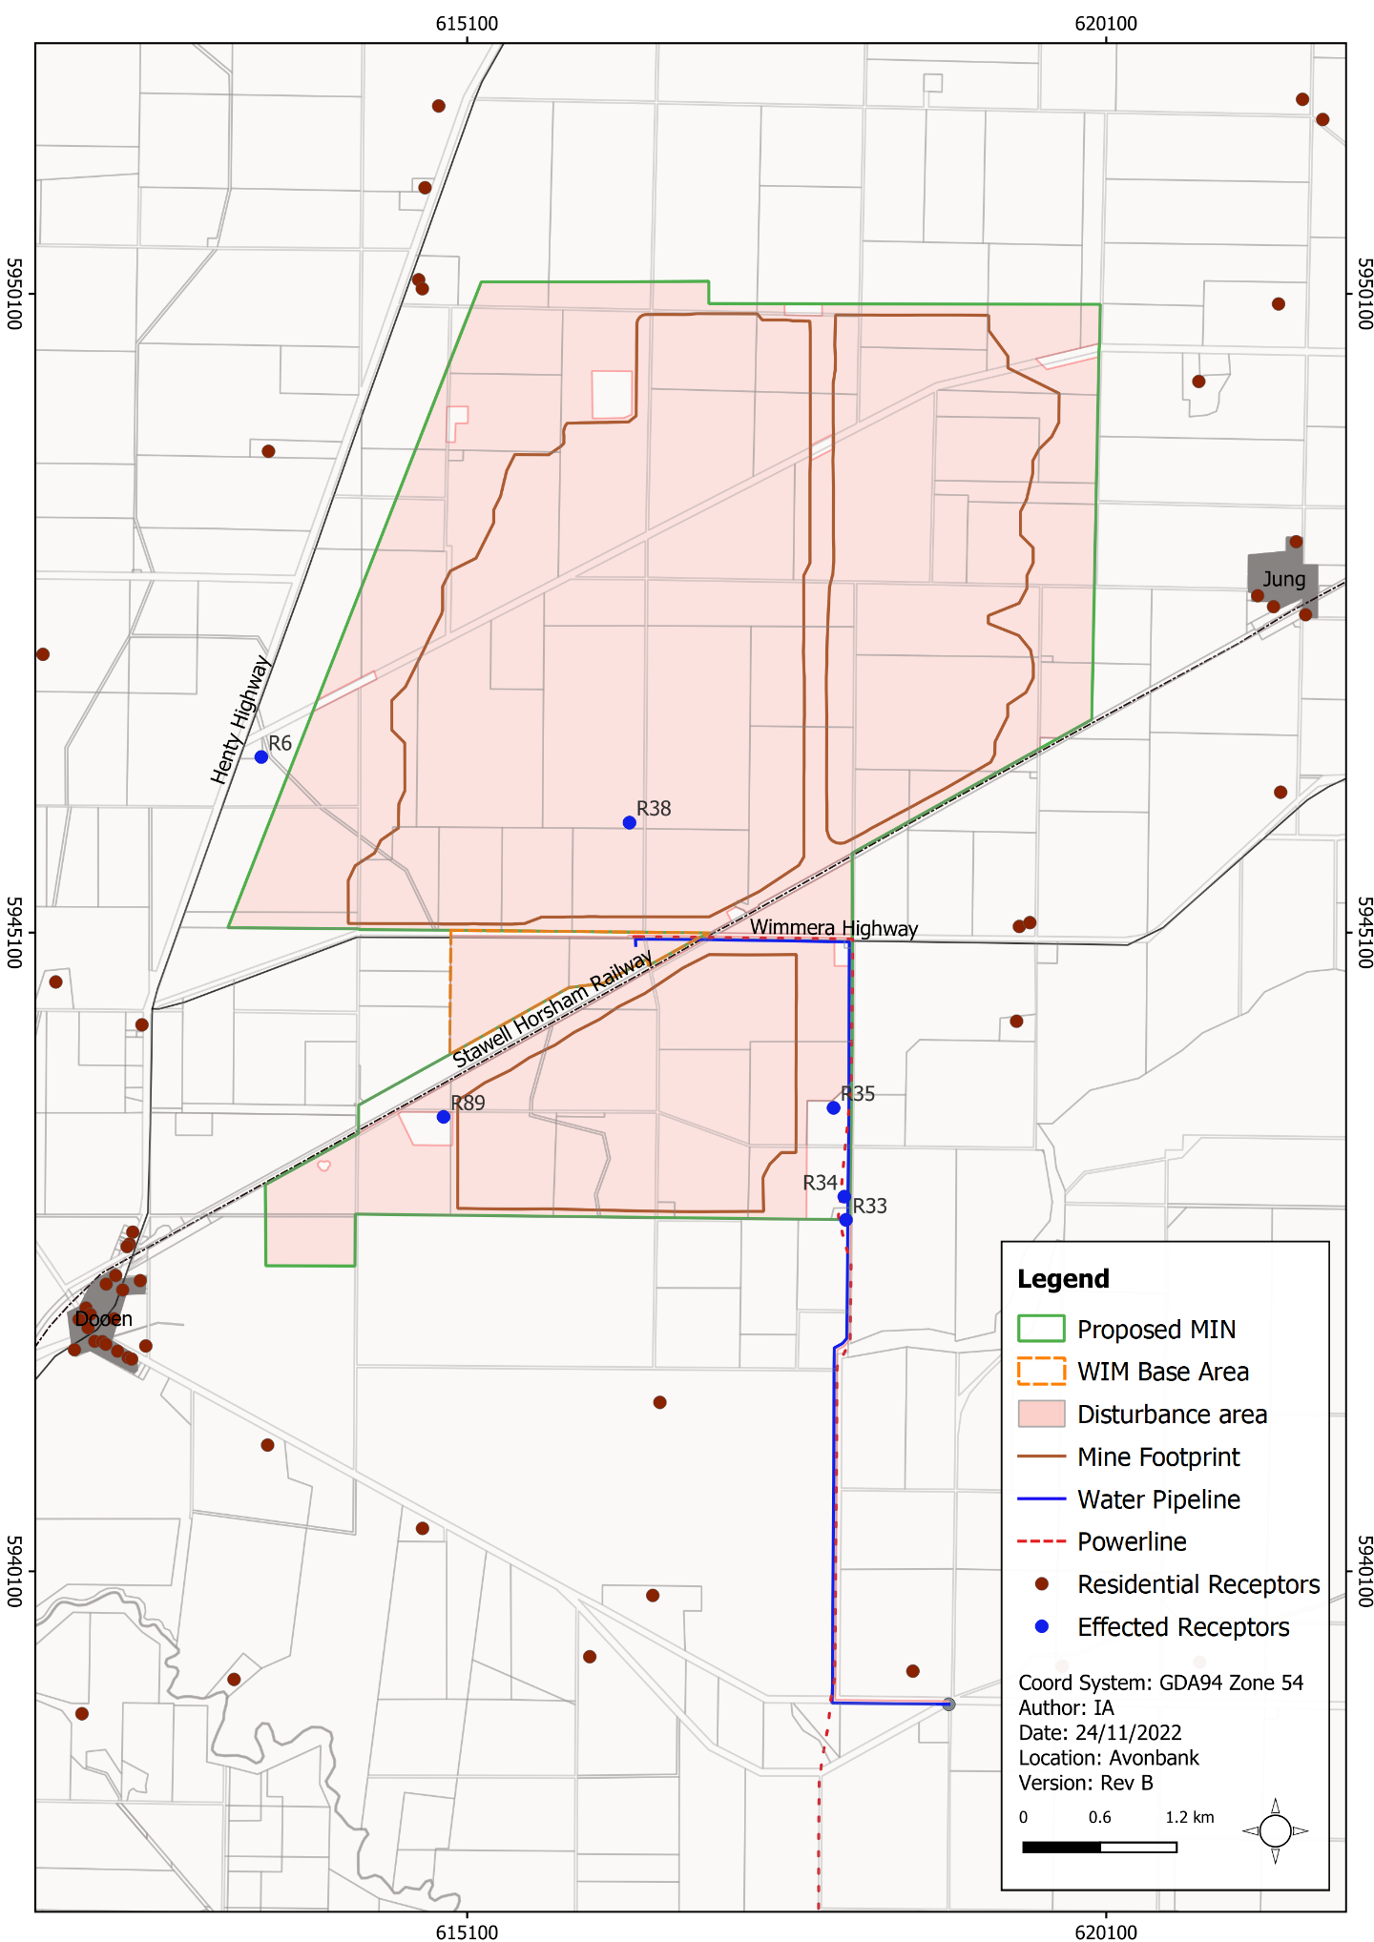
Figure 8-15: Residential receptors that may be subject to land use change over the life of the Project

Consistency with Planning Policies
There is one potential impact (IP-02) identified in Section 8.5.1 that relates to possible inconsistencies with existing planning policies. The impact assessment details the alignment against the Planning Policy Framework (refer Appendix B, Section 7.3.1).
With one minor exception, the Project is consistent with State and local planning policies. The exception relates to protection of agricultural land within the mining licence. While there will be a temporary loss of agricultural production of up to 400 ha at any one point in time, this is expected to be returned within 4 years for each mining cell.
One of the strategic aims of the MPS is to ‘Encourage the use and development of land in areas of abundant mineral sand deposits for the earth and energy resources industry and associated activity’. This is aligned with the overarching objectives of the Project, which is to develop a world-class mining operation and concentration plant to produce a premium-quality mineral concentrate for export overseas.
The WIFT Precinct has been zoned in the HPS as a Special Use Zone (SUZ9) for industrial purposes, including the processing, storage and handling of mineral sands. It is considered that the proposed WBA area is generally well aligned with this purpose. It is anticipated that certain buildings and works will however require planning approval, and as such, an SCO is proposed over the WBA.
The Planning Policy Framework seeks to ensure buildings and works are undertaken in accordance with acceptable environmental standards. It is expected that the implementation of the measures in this EES, along with the maintenance of an AS/NZS ISO 14001:2016 EMS, will meet this objective. Further detail regarding alignment with the Planning Policy Framework is described in Appendix B, Section 7.3.1.

Agglomeration Impacts
There is one potential impact (IP-03) identified in Section 8.5.1 that relates to the agglomeration of industrial or commercial developments in surrounding areas due to the Project. Agglomeration effects can result in the encroachment of new land uses into the existing environment, or they can complement the existing uses.
Such developments would be assessed under the existing Planning Policy Framework and Municipal Planning Strategy. Existing local planning policy favours a township or industrial area for new industry and commercial activities unless it is an agricultural-based industry.
It is a requirement of any planning permit application or scheme amendment that they are strategically assessed against existing State, regional and local planning policies. Each application or amendment goes through its own process of strategic planning policy justification. It is expected that the potential agglomeration effects that may be caused by the Project can be managed through the existing planning framework.

Management Framework
An AS/NZS ISO 14001:2016 EMS will be established for the Project as detailed in Chapter 24 (Environmental Management). The environmental management system will address matters relating to planning, operational control, monitoring, and continuous improvement over the life of the Project. Relevant matters relating to monitoring, auditing and corrective actions are summarised below.

Environmental Objectives
Environmental objectives will be established as part of the EMS to articulate the outcomes that must be achieved during Project implementation. These will reflect the expected and achievable outcomes based on the studies undertaken as part of this EES.
The key environmental objectives relevant to the Project during implementation are listed below:
- There will be no permanent change to land use within the development extent due to Project activities.
- Agricultural productivity and soil profile capability of the rehabilitated landform will be commensurate with surrounding unmined areas.
Performance standards will be established to measure/assess if the environmental objectives have been achieved during operations, as further discussed below.

Monitoring and Management
The monitoring and management framework for the Avonbank Project, including the proposed mining licence area, WBA, minor utilities and PoP are described in Chapter 24.
The requirements associated with the mining work plan and Incorporated Document, as well as other regulatory requirements will be integrated into the AS/NZS ISO 14001:2016 EMS to ensure implementation and verification in line with the overarching Project environmental policy.
Monitoring and management requirements for the Project are communicated in Chapters 8-23 of the EES main document and summarised in Attachment 5 (Aspects and Risks). The regulatory framework and key approvals associated with each work area are further described in Chapter 4 (Regulatory Framework).

Audits
Periodic internal and independent audits will be undertaken to assess the effectiveness of the EMS. An internal audit program will be maintained, which details the frequency, methods, responsibilities and reporting requirements.
Audits will be undertaken by a suitably qualified person to assess the effectiveness of the EMS to minimise or avoid impacts so far as reasonably practicable. Any non-conformity identified in the audit will be investigated, and corrective actions identified.
The outcomes of audits will be communicated to the Project’s Management team and records of the audit findings will be retained in the record management system. Significant findings will be reported to relevant Regulators and stakeholders where appropriate to do so.

Cumulative Impacts
Within the Wimmera and Mallee regions, there are three other mineral sands mines currently proposed, including Wimmera Mineral Sands Project, WIM150 Mineral Sands Project, and Donald Minerals Sands Project (refer Chapter 7).
Only one of the projects above is at an advanced stage of gaining approvals. Collectively the cumulative impact of agricultural land temporarily removed from agricultural production for the purpose of mineral production is relatively minor in a regional and national context.

Conclusions
This Chapter provides an overview of the Planning and Land Use Impact Assessment prepared to address the EES Scoping Requirements for the Avonbank Mineral Sands Project.
The potential impacts associated with the Project activities were assessed as part of the Matrix Planning impact assessment. Consideration was given to potential impacts associated with changes to existing land use and agglomeration effects. Consistency between the proposed Project and existing planning policies was also assessed.
Avoidance and mitigation measures were identified to reduce the residual impacts so far as reasonably practicable. The key avoidance and mitigation measures to be implemented during mining will include:
- Land Access and Compensation Agreements will be negotiated such that landholders are reasonably compensated and consent to access land is granted.
- Some landholdings may be purchased prior to works commencing.
- Land will be rehabilitated to establish a post-mining landform commensurate with the agreed end land use.
Within the proposed mining licence, the extent of Project disturbance will be up to 400 ha at any one point in time. This will result in a change of land use from what is primarily broadacre cropping to mining and ancillary uses. This will be a temporary land use change that is expected to extend up to 4 years within any one section of the mining footprint.
This represents a net positive regional economic effect, gross regional revenue from the Project of over $330 million per annum, inclusive of flow-on supply chain and consumption expenditure. There are 25 landholdings (excluding Crown land tenure and managed public land) that will be directly affected by the Project. Some of these properties will be acquired over the course of the Project and some will be retained as third-party private landholdings. For those properties that are not acquired, loss to individual landholders will be compensated through the establishment of Landholder Access and Compensation Agreements.
The secondary processing facilities are situated within a Special Use Zone (SUZ9), which has been established for industrial purposes, including the processing, storage and handling of mineral sands.
There is anticipated to be only a temporary loss of land use (less than 3 months) associated with the installation and development of the minor utilities. There will be no change to the land use associated with the establishment and use of facilities at the Port of Portland.
Industrial or commercial developments may be attracted to the area as a result of the Project. It is expected that the potential agglomeration effects that may be caused by the Project can be managed through the existing Planning Policy Framework and Municipal Planning Strategy.
There are three other proposed mineral sands projects within the region (~50 km). The cumulative impact of agricultural land temporarily removed from agricultural production is relatively minor in a regional and national context.
The proposed Project is unlikely to result in significant environmental effects and it is anticipated that the associated impacts can be managed with avoidance and mitigation measures in place to achieve the EES evaluation objectives.

Construction (C); Operations and rehabilitation (O); Decommissioning and closure (D)

